
Troop 214 Parent News | June, 2012
http://www.bsatroop214.us | Harold Hodnett Scoutmaster
Key Events This Month | Key Events Next Month
June 1-3rd Wilderness Survival Campout | July 8th ASM/Adult Leader Meeting
June 17-23rd Summer Camp | July 13-15th Tubing/Canoeing

Dates to Remember

July 2nd: Troop Meeting 7 PM
July 8th ASM/Adult Leader Meeting 7PM
July 9th Troop Meeting 7 PM
July 13-15th: Tubing/Canoeing Campout
July 16th Troop Meeting 7 PM
July 23rd Troop Meeting 7 PM
July 30th Troop Meeting 7 PM

ASM / Adult Leader Meeting: The next Assistant Scoutmaster, Adult Leader meeting will be Sunday, June 3rd at 7pm in the Scout Hut. All current leaders and prospective leaders are invited to attend. We strive to hold the meeting to about one hour.

News and Details About Upcoming Events

Wilderness Survival

Date: June 1st-3rd 2012
Friday evening departure: 5:00pm (meet at BMUMC as usual)
Location/destination: Jordan Lake (New Hope Overlook, primitive campsites)

What We’re Doing:
- Earning the Wilderness Survival Merit Badge
- Making and sleeping in primitive shelters - no tents and no sleeping bags
- Making fire with sticks and rocks
- Eating whatever we can find (mostly)
- Purifying our drinking water
- Finding direction by day and night, without a compass
- Rescue signaling
- Wilderness first aid
- ….and more!
Final Questions about this campout should be referred to Mr. Thomas, Matthew Kuwalik, Josh Jones, Josh Thomas, and/or Mr. Burdett.

Cody Brown Eagle Court of Honor Ceremony

Cody Brown sends a special thanks to everyone who has responded to his upcoming Eagle Court of Honor invitation. It will be this Saturday, June 2nd at 1:00 pm at Edenton Street United Methodist Church, 228 W. Edenton Street, Raleigh, NC. The ceremony will be in the main sanctuary with a reception to follow in Kerr Hall. He requests that all scouts arrive by 12:30 pm.

AutoBell Fundraising

Mr. Brian Skiscim notes that to all who have participated in the Autobell Fundraiser to help pay for your on-going Scout activities, he hopes you had a lot of success in raising money for yourselves.

The fundraising campaign ends at the next Scout meeting, Monday, June 4th.

Note: ALL MONEY and UNSOLD tickets MUST be turned in at this meeting. As communicated, each Scout is financially responsible for not returning any unsold tickets, so it's imperative that you sell them fast or turn them in. Should you have any questions, please contact me Brian Skiscim
bskiscim@gmail.com

Video Game Lock-In

Get ready to get your game on!!!! Video Game Lock in at Benson Memorial will be Friday, June 9th. Please contact Mr. Craig Setzer or Ms. Conita Benson for further details.

Motorboating/Water Skiing Campout

Mr. Hodnett notes that Troop 214 is pleased and grateful to be able to offer a Motorboating and Water Skiing campout again this year slated for August 10-13th. Stay tuned for more details and get psyched to have some fun and learn about motorboating safety along with the opportunity to earn the motorboating Merit Badge!

Recent Meetings and Updates:

Scout Sunday
Scout Sunday was held at Benson Memorial United Methodist Church on Sunday, May 6th. Cub Scouts, Boy Scouts, and Girl Scouts all combined to assist in both Sunday morning services. Thanks to the Boy Scouts and Adults for making dutch oven cobbler and offering refreshments after each service. Pastor Skip had many kind things to say about the Scouting ministry at Benson Memorial and you should be proud of it!

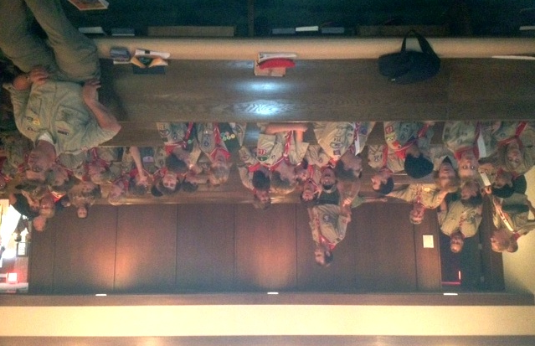
Virginia Creeper Biking Campout Recap
Asst. Scoutmaster and cycling enthusiast extraordinaire David Burdett notes that a crew of 13 Scout and 7 Scouters visited the Va. Creeper for the weekend of May 10-13th and had a great trip.
All completed the 17-mile downhill portion safely and had a lot of fun. The attached picture was taken at the start at Whitetop Station. 7 Scouts and 5 Scouters then continued on to the other end at Abingdon, VA., and back, to complete a 51-mile trip. 5 of the 7 boys were working on their Cycling MB,
and completed this most arduous requirement of the badge.
The remainder went to base camp, worked on first aid classes, and took a 2.5 mile hike in the mountainous campsite at Bear Tree RA.
It was a great weekend, and great fun for all. Thanks Mr. Burdett, for leading such a great outing!
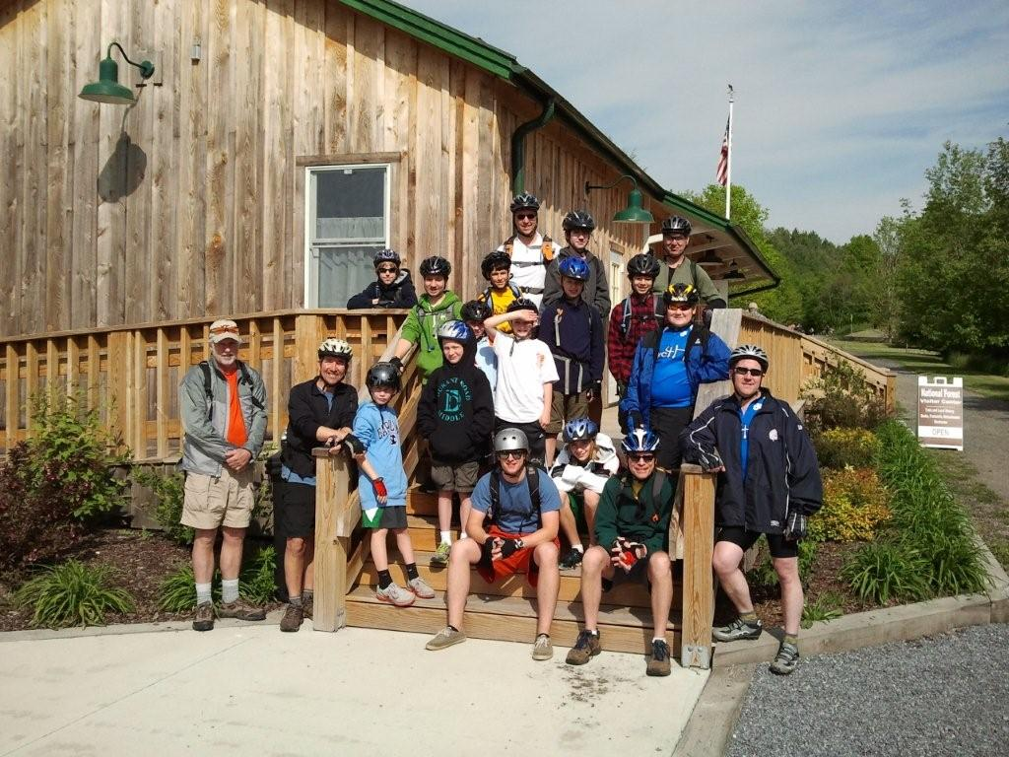
Quote of the Month

“Let me tell you the secret that has led me to my goal. My strength lies solely in my tenacity.”
Louis Pasteur (1822-1895)

Joke of the Month:
There were three men on a hill with their watches.
The first man threw his watch down the hill and it broke.
The second man threw his watch down the hill and it broke.
The third man threw his watch down the hill, walked all the way to the bottom, and caught it.
The other two men were puzzled and asked the third man how he did it.
The third man said, "Easy. My watch is 5 minutes slow!"

Thanks to Scoutmaster Mr. Harold Hodnett, adult leaders Mr. Stuart Thomas, Mr. David Burdett, Mr. Mike Jones, Mr. Don Fowler and Mr. Sam Fouse and for contributing to this month’s newsletter.
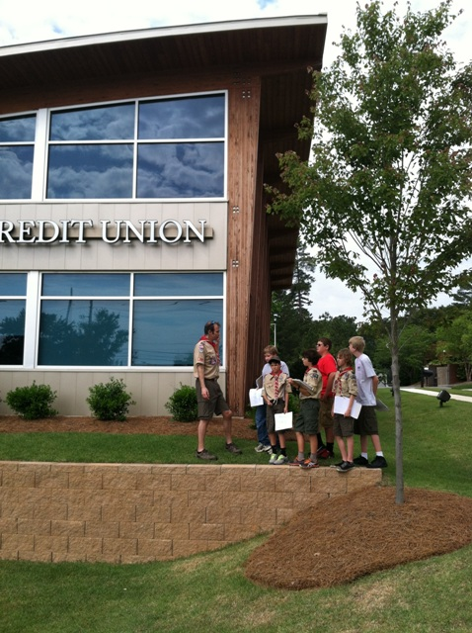
Mr. Burdett shows T214 Scouts some interesting architectural features as they work on the Architecture merit badge at MBI May 5. Thanks to Mr. Fowler for the picture.

