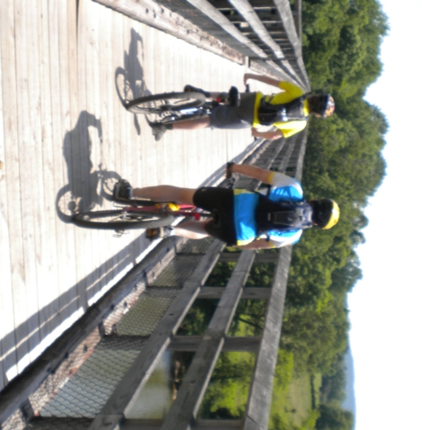  Troop 214 Parent News | May, 2012
http://www.bsatroop214.us | Harold Hodnett Scoutmaster
Key Events This Month | Key Events Next Month
May 11-14^{3h} Virginia Creeper Campout | June 1-3rd Wilderness Survival Campout
May 18-19th Spring OA Inductions | June 17-23rd Summer Camp

Dates to Remember

May 3- Roundtable 7 PM
May 6th ASM Meeting 7 PM
May 7th, Troop Committee, Troop Meeting
May 10th OA Meeting
May 11th-14th. Virginia Creeper Campout
May 14th Troop Meeting 7 PM
May 18^{th-19th} OA Spring Introductions
May 21st Troop Meeting 7 pm
May 28th Memorial Day, WCPSS Holiday, No Meeting

A Message from Scoutmaster Harold Hodnett
Troop elections were held on Monday, April 16th and we have many new elected positions. Our new Senior Patrol Leader is Matthew Fiely, who promptly appointed Andy Jones as his ASPL. All Patrols elected new leaders and the new SPL also appointed other leadership positions. I would like to take this opportunity to thank Sean Colby, outgoing SPL, for his exceptional leadership in the role.
ASM / Adult Leader Meeting: The next Assistant Scoutmaster, Adult Leader meeting will be Sunday, May 6th at 7pm in the Scout Hut. All current leaders and prospective leaders are invited to attend. We strive to hold the meeting to about one hour.

News and Details About Upcoming Events

Calendar Notes –

Scout Sunday

Scout Sunday for Troop 214, Pack 214 and
Benson’s Girl Scout Troop will be Sunday, May 6th.

Order of the Arrow:

In OA News....
April District Camporee:
Members of T-214 who are in the OA helped create and operate the very popular "Zombie Run" event at the District Camporee. An obstacle course was built along a mile-trail, and scouts dressed as zombies were stationed in hiding along the trail. Scout runners received 6 plastic strips to hang from their belts, like flags in flag football, which represented their health. As they ran the course zombies would randomly appear and try to snatch one of their flags. If all of their flags were snatched the scouts would theoretically lose their life and the zombies won. Scouts who completed the course with at least one flag were considered survivors. It was great fun for scouts and zombies alike, and was arguably the most popular event at Camporee.
The District Camporee also included the OA Tapout ceremony on Saturday night. Three scouts from T-214 were part of the 4-person OA ceremony team, attired in Native American regalia, Stephen F., Matthew F., and Sean C. Three other scouts from T-214 were torch-bearers, Andy J., Javier C. and Matthew K. Scouts from all of the troops in attendance were recognized for being elected as OA candidates in 2012, including the following scouts and one adult from T-214; Alex Casey, William Fowler, Will Hollerung, Robbie Proffitt, Ian Reetz, Dylan Skiscim, and Mr. David Burdett. Congratulations to each of those T-214 members. A picture of the ceremony team is also included in this newsletter.
April Cardinal Conclave:
A number of T-214 scouts and scouters attended the 2012 SR7B Cardinal Conclave at Camp Cherokee in Yanceyville NC. There they joined over 1,300 OA Arrowmen from all around the state including about 280 OA members from our Occoneechee Council, to share in fellowship and to compete in numerous events. Highlights included the OAX (OA 'Xperience), which consisted of a wide variety of exhibits, activities, craft booths, and gear booths. There was so much to see and do that it was impossible to cram it all in. The Occoneechee Lodge teams represented very well and won many competitions. The biggest were winning the "Quest for the Golden Arrow" (which Occoneechee has now won 3 years in a row) as well as the coveted Spirit Award (which Occoneechee hadn't won since 2006). Congratulations to Occoneechee Lodge 104 and to the T-214 scouts who helped the lodge win those awards.

May Ordeal/Spring Inductions Weekend:
Camp Durant is holding its Ordeal/Inductions weekend on May 18th-20th. Spring Inductions is an opportunity for OA members to perform service to
Camp Durant and participate in fellowship with other members. This is
the primary inductions weekend for new OA candidate members of the Occoneechee Lodge, so many of
the activities will revolve around that process.
Some of you may be asking yourself; "What is the OA"? OA stands for Order of the Arrow. It is scouting's national Honor Society, made up of scouts and scouters who dedicate themselves to supporting the scouting program - especially the outdoor program. In order to become a member of the OA scouts must; first earn the rank of First Class, camp 15 nights over a 2-year period with 5-6 of those nights being long-term camping (i.e., summer camp) and all other nights being short-term camping (weekend campouts), have their scout spirit and worthiness attested to by their Scoutmaster, and then be elected by a majority of troop members.
We anticipate that the newly elected T-214 candidates will complete their induction in May and become new OA members. All current OA members are invited to attend to help the candidates through that process. Informational letters have been distributed to all T-214 candidates. If there are any questions about the weekend please see the troop's new OA Representative Troy Sturdivant, or any other existing OA member in T-214.

Cycling Merit Badge

Breaking News: Cycling Slots are limited to the first 40 Scouts and Adults, with Scouts earning the Cycling Merit Badge given first priority, according to Merit Badge Counselor David Burdett

This year, we are making our 50-mile ride as part of the Virginia Creeper Trail Cycling Campout, May 11-13, 2012. This is about a month earlier than last year’s 50, so not the earlier ride schedule below. I look forward to advising the effort again, and hope other adults and scouts are willing to assist.
For those who remember the last trip to the Creeper, the ride is magnificent, if a bit technical, and demanding! The trail is open, in spite of the loss of a 600-foot trestle due to a tornado last year. The local municipalities razed the remaining structure, and merely paved a connection in the footings of the trestle. Expect a nice climb at each end!
Scouts interested in earning the coveted and Eagle-required Cycling badge will be required, as always, to participate in the training rides leading up to the 50-miler. I will need a signed blue card prior to the first ride. Scouts earning the badge will also assist in trip planning and provide classes during the meeting prior to the trip. To improve flexibility and ease of participation, the City of Raleigh has kindly finished the connector trail from Crabtree Valley Mall to the I-440 trail overpass. We now can travel the greenbelt from Raleigh road all the way to Cary. We will also visit our favorite, the Tobacco Trail, for a ride. We are certainly blessed to have so many safe trail assets at our disposal.
Please note the Training ride schedule. Unless noted, all rides are on Sunday afternoon:
May 5 1 PM Pullen Park-Cary-Pullen Park - 30 miles (required)
May 12 9 AM White Top-Abingdon-Damascus - 50 miles

Wilderness Survival
Mr. Stuart Thomas says that “It's time again for one of the manliest campouts a Scout can attend, and one of the manliest merit badges a Scout can earn - Wilderness Survival!” Yep, our scouts enjoyed the challenge of past year's survival campouts that they voted to put it on the calendar again for 2012. Here are the pertinent trip details.

Date: June 1st-3rd 2012
Friday evening departure: 5:00pm (meet at BMUMC as usual)
Location/destination: Jordan Lake (New Hope Overlook, primitive campsites)

What We’re Doing:
- Earning the Wilderness Survival Merit Badge
- Making and sleeping in primitive shelters - no tents and no sleeping bags
- Making fire with sticks and rocks
- Eating whatever we can find (mostly)
- Purifying our drinking water
- Finding direction by day and night, without a compass
- Rescue signaling
- Wilderness first aid
- ….and more!
Signups for this trip are due "now". Survival kit items need to be ordered online and gathered from multiple locations, and we can't afford to buy more then we need, nor less than we need. Scouts must be signed up by May 7th or they will not be able to attend this campout! The estimated total cost for the weekend is $30, which includes the survival kit gear, Saturday meals (sparse), gas fees, and a Golden Corral buffet feast on Sunday morning on the way back to the Scout Hut. Questions about this campout should be referred to Mr. Thomas, Matthew Kuwalik, Josh Jones, Josh Thomas, and/or Mr. Burdett.

Recent Meetings and Updates:

District Camporee, 2012
According to Scoutmaster Hodnett, Troop Troop 214 attended the District Camporee at Falls Lake on April 13-15 and had one of the largest Troops in attendance! The weather was beautiful and there were plenty of activities to participate in. The highlight of the weekend was the Order of the Arrow tapout ceremony on Saturday night, where three of the four featured OA actors were actually Troop 214 members! We had a large number of new Scouts and parents on the campout and it was a perfect weekend to enjoy low impact camping. Thanks to all who went!
Stream Cleanup
Adult leader Craig Setzer notes that on Saturday April 21, a group of dedicated scouts participated in Troop 214’s stream cleanup off of Six Forks Road. Exhibiting great courage, Troop 214 Scouts began their sweep and, as past participants can attest, one never knows exactly what you will find! The most unusual item reported found was a small skateboard. Several attempts were made to “ollie” the board, but were unsuccessful. Approximately two hours & seven bags of debris later, the scouts completed their task. This Service Project was concluded with a tasty lunch at Char-Grill where much food and calories were consumed! Special thanks to Robbie Proffitt, Keiran Bailey, Cameron Burdett, Alex Casey, William Fowler, Will Hollerung, Mike Kruse & Mr. Burdett for their assistance in the cleanup effort.

Quote of the Month

“Education’s purpose is to replace an empty mind with an open one.”
Malcolm Forbes 1910-1990
Joke of the Month:

If money doesn't grow on trees then why do banks have branches?
Thanks to Scoutmaster Mr. Harold Hodnett, adult leaders Mr. David Burdett, Mr. Stuart Thomas, Mr. Craig Setzer and Mr. Steve Motter for contributing to this month’s newsletter.

Photos of This Month's Events
April 28th Troop Workday
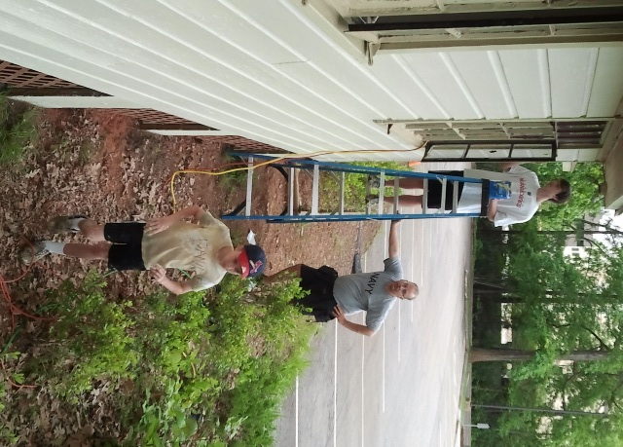 | 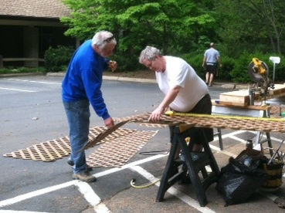
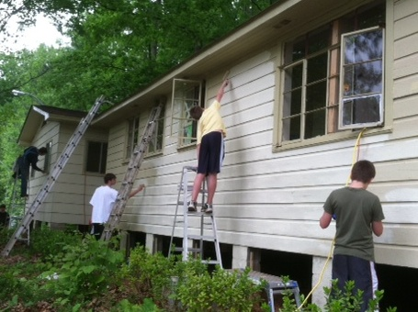 | 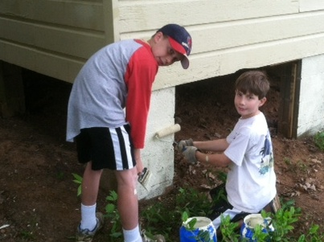

Camporee April 13-15
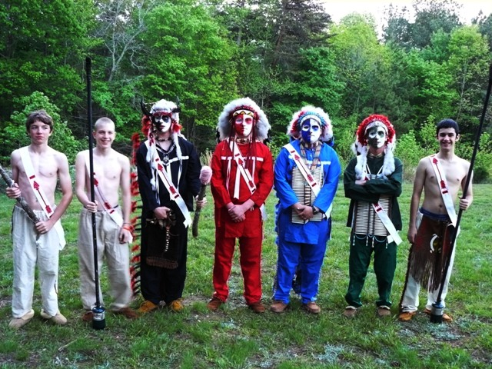 | 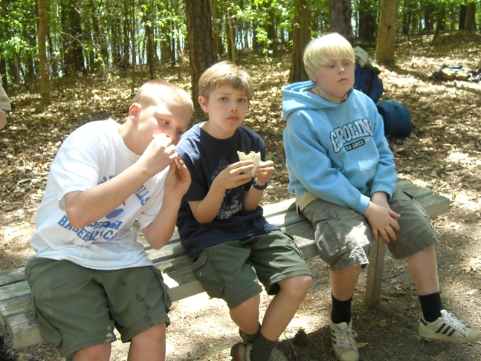
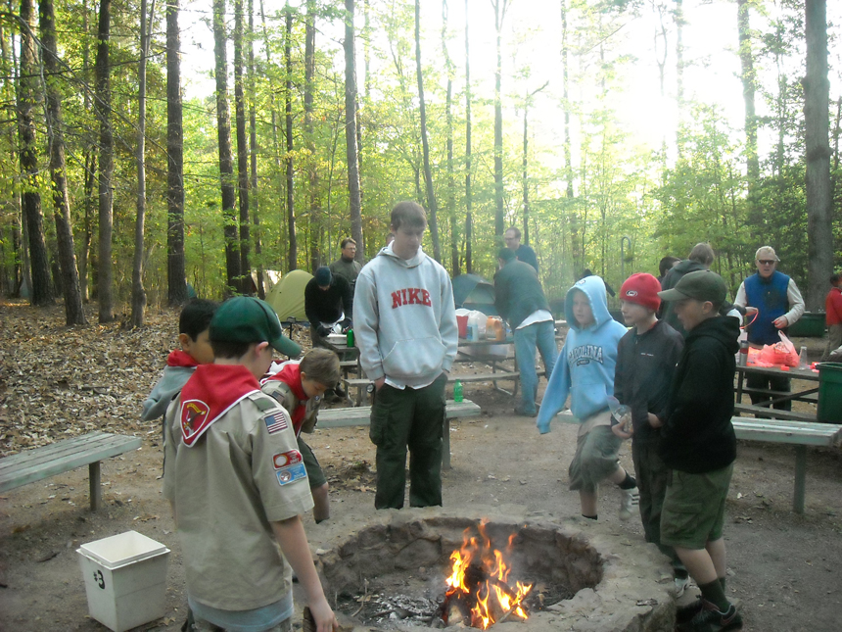 | 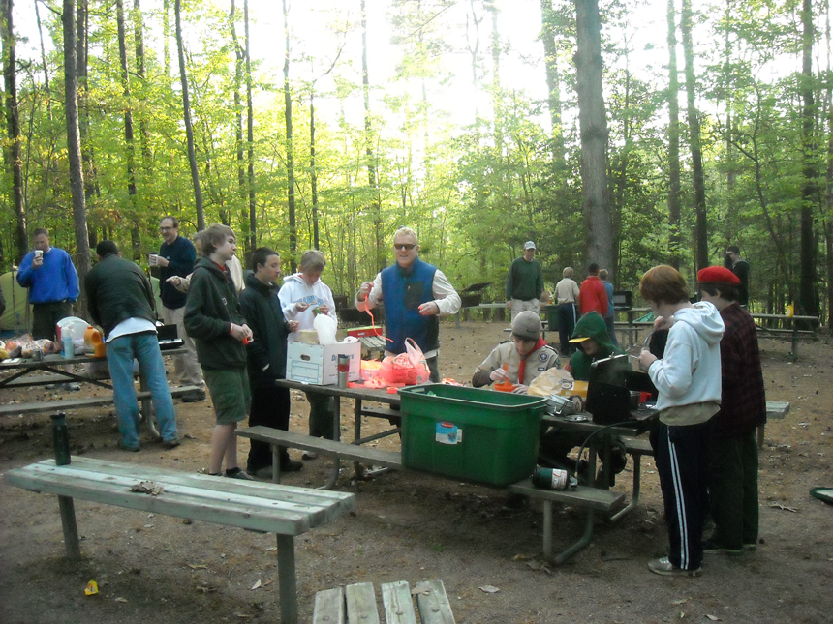
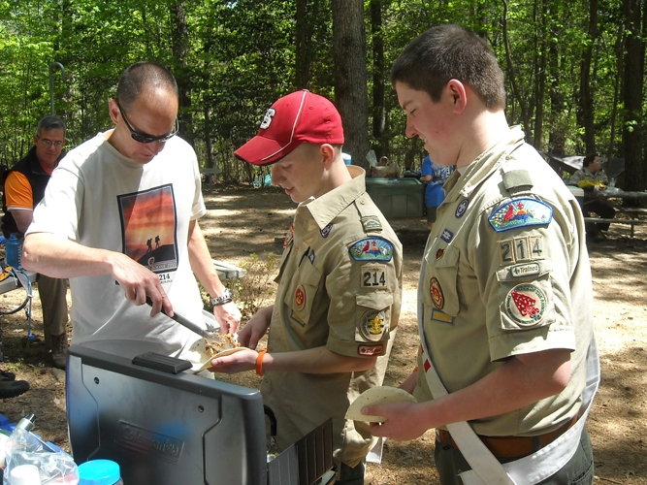 | 