Design Document

for

iPhone Developers Web Portal

Prepared by: Courtney Daley

Date: July 3, 2009

Design Document Phase 1 – iPhone Developer Web Portal Site Goal

Site Goals

To provide a web portal/content aggregation site that will display a number of RSS Feeds related to iPhone Applications and Development.

The short and long term goals of the site are to:

* Organize, store and publish feeds containing information pertaining to application development for the iPhone
* Organize, store and publish recent news about iPhone applications that are on the Apple’s Appstore

People will come to the site to obtain:

* Information about most recent Apps on the Appstore
* An overview of the top 10 paid Apps on the Appstore
* An overview of the top 10 free Apps on the Appstore
* Information on updated developers guide
* Information on updated developers programming guide

Design Document Phase 2 – iPhone Developer Web Portal Audience Definition

Audience

Developers’ goals and needs are to:

* Learn about iPhone Application Development
* Learn how to use XCODE understand related terminologies
* Review recent examples of codes for sample apps
* Learn about the iPhone Developer Web Portal
* Access learning material, terminology information

Gamers’ goals and needs are to:

* Obtain news information about most recent Apps to the Appstore
* Get news about the top 10 paid Apps on the Appstore
* Get news about the top 10 free Apps on the Appstore
* Learn about the iPhone Developer Web Portal

Administrators’ goals and needs are to:

* Provide a repository for all RSS Feeds
* Facilitate a self service environment to change the available feeds and other properties of the page (such as color, font).

Use Case Diagram

User

iPhone Developer Portal

Admin

Use Case

Name: View Feed

Version: 1

Overview: A user (developer/gamer/admin) wishes to view a feed and the system (iPhone Developer Web Portal) present a menu of feed topics and allows the user to select the topic of the feed he wish to view.

Actor: User

Pre-conditions: The user must know the url for the system

The user must use a browser later than Internet Explorer 5

The system is loaded into the browser

Post-condition: The system presents the selected feed to be viewed by the user.

Normal Course of Action:

1.) A user desires to view a feed on the system.

2.) The system presents a home page with a navigation menu (Home, Current Feeds, Login).

3.) The user selects the Current Feeds option from the navigation menu.

4.) The system loads the Current Feeds Page and presents a menu of feed topics.

5.) The user selects a topic from the menu of feed topics.

6.) The system presents the selected feed.

Scenarios

First scenario:

* Nimesh Desae a student at Rochester Institute of Technology is currently enrolled in a course called Native Application Development for the iPhone. He is doing a project and decides to use the iPhone Developer Portal as a referential resource to assist him in developing the application. He currently, has the web portal loaded into a browser and can see the home page. He selects the Current Feeds option from the navigation menu on the home page. The web portal now presents to him the Current Feeds Page. He can now see on that page the menu of feed topics from which he can select one to view. He selects the Application Development option. The web portal now presents him with the selected feed.

Second scenario:

* Courtney Daley an admin of the iPhone Developer Portal decides that he does not like the current color of the web site. He types in the url to get to the homepage of the site, logs in with his user name and password which takes him to the admin page that provides him with menu options to add and/or delete feeds as well as change page color. He clicks on the menu to change page colors. He is then presented with a dropdown list box with options to choose the colors he would like the site to display.

Competitive Analysis Summary

To develop the iPhone Developer Web Portal, a few sites were looked at and evaluated to gather ideas that could be seen as useful to incorporate in its development. Some of the sites that were looked at are:

* Apple: <http://www.apple.com/webapps/index.html>
* Leaflets: <http://getleaflets.com>

During the analysis we thought that some features of the above web sites were good to use in the design of the iPhone Developer Web Portal. The chart below outlines the finings for the two websites evaluated. Upon completion of the web portal the chart will be updated with the rating to reflect the effectiveness of its design.

**Competitive Analysis ~ 10 = best & 1 = worst ~**

| **Attribute** | **Apple** | **Leaflets** | **iPhone Developer Web Portal** |
| --- | --- | --- | --- |
| **General Site Features** |  |  |  |
| Site Design (1-10) | 9 | 8.5  (great choice of theme colors) | pending |
| Navigation (1-10) | 10  (easy to find desired links) | 6  (global nav. not completely consistent across all pages) | Thinking of incorporating apples navigation style (10) |
| Bookmarkable URLS? |  |  |  |
| Layout (1-10) | 10 | 8.5  (clean layout of navigation and content) | Thinking of two column display |
| Look & Feel (1-10) | 9 | 8  (good use of colors and images) | pending |
| Hints/Tips/FAQ’s? | ✓ | ✓ | x |
| **Personalization** |  |  |  |
| Contact Form? | ✓ | ✓ | N/A |
| Interactivity | 9 | 8.5 | Yet to be rated |

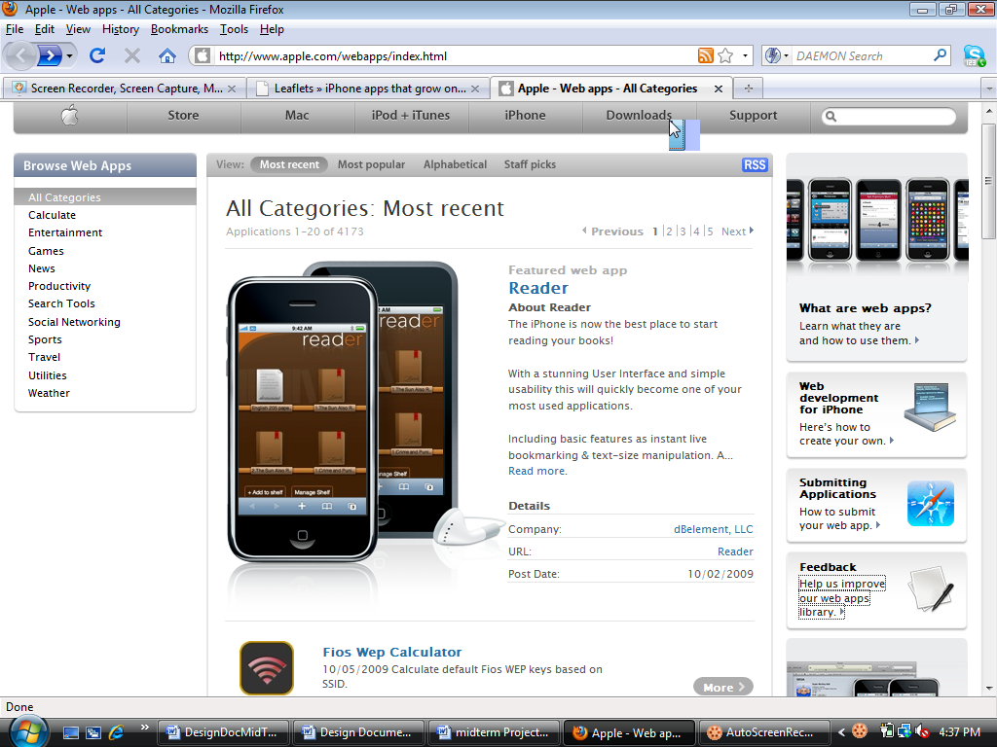Analysis of Competitors Layouts

Pros:

* Good navigation system.
* Good color theme and use of color, consistency and proximity of the modules on the site.
* The information on the screen is not clustered.
* The use of forms allows for feedback.
* Good use of images

Cons:

* None currently determined

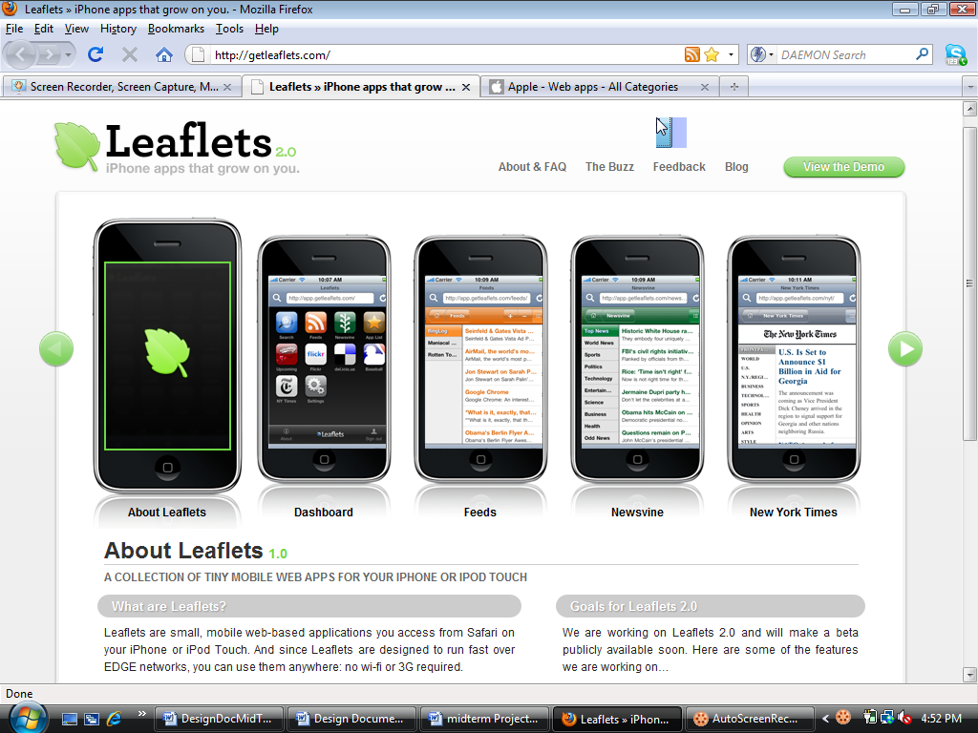

Pros:

* Good color theme and use of color, consistency and proximity of the modules on the site.
* The information on the screen is not clustered.
* The use of forms allows for feedback.
* Good choice of images

Cons:

* The global navigation is not fully consistent; if you click on the blog option in the menu, you are directed to the Leaflets blog site, which is by itself a totally different site. The drawback to this is that you cannot return to the Leaflets portal site you navigated from without press the browser back button. This is not recommended in web design.

Design Document Phase 3 – iPhone Developer Web Portal Proposed Site Content and Functional Requirements

Proposed Site:

Screen shot - Pending

The proposed features are:

* Pages
* Home:Divided into module (About Us, Login and so on) just like those shown in the Apple screen shot but in a two column layout. Text organization, thus clients can pick up the information rapidly.
* Current Feeds: Also divided into modules in a two column layout. The layout will be consistent through the site. All RSS feeds will be display on this page.
* Look and feel
* Header: Will include images of the iPhone ( they may be dynamic)
* Fonts: not yet determined
* Color Scheme: black, white, gray/silver,

Content Inventory:

* Home page (welcome page)
* Random images pertaining to iPhone
* iPhone Apps. And Developer news feeds

Functional Requirements’ Inventory:

* Store user preferences for visible feeds in browser cookie
* Login page to authenticate administrator
* Present RSS Feeds to current user

Architectural Blue Print

Home Page

(Ideveloper.com)

Module:

* Login
* News

Entity Relationship Diagram Chens Notation:

Properties Page

About Us

Admin

(homepage)

Current Feeds

FEED

USER

Page_Color

Summary of technology used:

For this project the following technologies will be used to implement the solution for the iPhone Developer Web Portal:

* MySQL to implement the database as shown in the current ER Diagram.
* PHP to access or query the implemented database through the MySQLi API and also to create and update the XML file that will be read using the XMLHTTPRequest RepsonseText property using Ajax techniques.
* External JavaScript files will be used to implement the AJAX request/response model and the JavaScript events, such as onChange will be used in XHTML tags in an XHTML document to invoke the necessary functions within these JavaScript files.
* DOM properties and methods will be used to update the required documents (xml and xhtml) that will be created in this project using both PHP and JavaScript respectively.
* CSS will be use to make the web pages presentable and aesthetically pleasing.
* RSS Feeds will be used for this web portal and the links to them will be stored in the database.