A Comparative Study of Machine Learning, Deep Learning, and Foundation Models for Short-Term Electricity Load Forecasting

Abstract — Short-term electricity load forecasting is a key task for smart-grid operation, industrial energy management, and predictive planning. This paper presents a reproducible comparative study of classical, machine-learning, deep-learning, and foundation-model approaches for hourly load forecasting. The benchmark includes SeasonalNaive, SARIMA, XGBoost, DLinear, PatchTST, iTransformer, Chronos-Bolt-Small, and TimesFM 2.5. The primary dataset is ECL with aggregate electricity load as the target; ETTh1/HUFL is used as a secondary industrial benchmark. Experiments cover 24-, 96-, and 168-hour horizons with a 336-hour context window. On ECL, the strongest models—TimesFM, Chronos-Bolt-Small, and XGBoost—are within 0.1–0.4 % MAE of one another across all horizons, and the grid-tuned SARIMA closes most of the remaining gap to the leader without any learned features. On ETTh1/HUFL, Chronos-Bolt is best at H=24 while DLinear is best at H=96 and H=168, reversing the ECL ranking. The study also evaluates latency and statistical significance, showing that foundation models are practical cold-start tools but do not universally replace strong supervised and classical baselines.
Keywords — short-term load forecasting, smart grid, time series, SARIMA, XGBoost, deep learning, foundation models, Chronos, TimesFM

Introduction
Short-term electricity load forecasting (STLF) supports dispatch planning, balancing, tariff-aware operation, maintenance planning, and anomaly-aware industrial energy management. Forecasting errors directly affect operational cost, reserve scheduling, and the reliability of downstream decision-support systems. This role is consistent with the broader load-forecasting literature, where accurate point and probabilistic forecasts are treated as core inputs for smart-grid planning and operation [1].
Modern energy systems generate large volumes of hourly and sub-hourly measurements. This makes it possible to train data-driven forecasting models, but it also creates a methodological problem: increasingly complex neural and foundation models must be compared against strong, transparent, and inexpensive baselines. Earlier residential and building-load studies showed that recurrent and deep neural models can improve forecasting accuracy under suitable data conditions [2]–[4], but they do not remove the need for classical statistical controls.
This paper presents a reproducible benchmark that compares classical statistical models, machine-learning methods, deep-learning architectures, and time-series foundation models under the same chronological evaluation protocol. The comparison is deliberately pragmatic: the goal is not to declare a universally best model, but to identify where classical SARIMA, feature-based boosting, compact neural models, and zero-shot foundation models are operationally useful.
The contributions of this paper are as follows: (i) a reproducible side-by-side benchmark of two recent time-series foundation models (TimesFM 2.5 and Chronos-Bolt-Small) against a grid-tuned SARIMA, gradient-boosted trees, and three modern neural baselines under a single STLF protocol; (ii) Diebold–Mariano significance tests on per-window absolute errors for the leading model pairs at every horizon; (iii) an accuracy–latency Pareto analysis that quantifies the deployment cost of zero-shot inference relative to supervised alternatives; and (iv) the documentation of a dataset-dependent role reversal in which XGBoost dominates SARIMA on aggregate ECL load while SARIMA dominates XGBoost on ETTh1/HUFL across all horizons.

Related Work
Classical ARIMA-family models remain widely used in industrial forecasting because they are interpretable, computationally inexpensive, and well understood. Their use follows the Box-Jenkins forecasting tradition [5], while modern automatic order-selection procedures and forecasting textbooks provide practical guidance for seasonal model identification and validation [6], [7]. Seasonal naive models are even simpler, but they form a necessary reference for load forecasting studies with strong daily or weekly seasonality.
Gradient-boosted decision trees are a strong machine-learning baseline for energy forecasting. XGBoost is particularly attractive because it combines nonlinear feature interactions, regularization, and fast training on tabular lag features [9]. Deep-learning models, including LSTM networks [10], attention-based architectures [11], and long-horizon transformer variants such as Informer, Autoformer, and FEDformer [12]–[14], are attractive for long-horizon forecasting but often require careful tuning and sufficient data.
Recent time-series foundation models introduce forecasting without task-specific training. TimesFM, Chronos, MOMENT, Moirai, and Lag-Llama represent a shift from dataset-specific supervised fitting towards pretrained sequence models for generic time-series prediction [20]–[24]. This is useful for cold-start settings, but public benchmark contamination must be acknowledged because ECL and ETT are widely used datasets and may have influenced model development.
For STLF specifically, this background implies that a useful comparison must include both domain-standard baselines and recent general-purpose models. A benchmark that contains only neural or foundation models risks overstating novelty, while a benchmark that excludes pretrained models misses a deployment pattern that is now common in industrial prototyping. Therefore, the present study evaluates classical seasonal methods, gradient boosting, compact neural architectures, and zero-shot foundation models within a single execution pipeline.
The long-sequence forecasting literature also motivates the inclusion of simple neural baselines. Linear and decomposition-based models have repeatedly shown that strong temporal biases can match or outperform more complex attention mechanisms on standard benchmarks [15]. Patch-based transformers and inverted-tokenization architectures address different weaknesses of vanilla sequence attention [16], [18], but their advantage is not guaranteed under a target-only STLF protocol. This makes DLinear, PatchTST, and iTransformer a useful compact neural set rather than an arbitrary model list.
Despite the rapid growth of time-series foundation models, side-by-side comparisons that place them next to a grid-tuned SARIMA and a feature-engineered XGBoost under a controlled latency budget remain uncommon. Existing benchmarks tend to either evaluate foundation models in relative isolation [20]–[24] or report neural-only rankings [15]–[18]. The present study addresses this gap by reporting all four families—classical, tree, compact neural, and foundation—within a single reproducible execution pipeline.

Materials and Methods
The benchmark is formulated as a univariate rolling-origin forecasting task. Given a context window of L=336 hourly observations, each model produces a multi-step point forecast for the next H values, where H ∈ {24, 96, 168}. Rolling-origin evaluation is used because it matches the operational setting in which a forecaster repeatedly receives a historical context and predicts a fixed future horizon. All trained models are evaluated on a held-out chronological test split in the original target scale after inverse standardization.
$$\hat{y_{t+1:t+H}}=f​\left(x_{t-L+1:t}\right), L=336, H∈\{24,96,168\}$$
The primary dataset is ECL (Electricity Consuming Load), aggregated across 321 clients at hourly resolution; the target is aggregate electricity load. The secondary dataset is ETTh1, where HUFL is used as the load-related target variable. The OT variable in ETTh1 is oil temperature and is therefore not interpreted as electricity load. Both datasets are common public benchmarks for long- and short-term time-series forecasting [25], which supports reproducibility but also requires a cautious interpretation of zero-shot foundation-model results.
Two classical baselines are included. SeasonalNaive repeats the most recent daily seasonal pattern and provides a deliberately simple seasonality reference. SARIMA performs an AICc-based grid search on the training split over candidate non-seasonal and seasonal orders; the selected configuration is then reused on every test window via state filtering on the new context. This follows established ARIMA forecasting methodology [5]–[7] and uses the statistical forecasting tooling reported in [27], with Python econometric infrastructure consistent with [28].
$$Φ_{P}\left(B^{s}\right) ϕ_{p}\left(B\right) {\left(1-B\right)}^{d} {\left(1-B^{s}\right)}^{D} y_{t} = Θ_{Q}\left(B^{s}\right) θ_{q}\left(B\right) ε_{t}, s=24$$
XGBoost is trained as a direct multi-output regressor with one estimator per forecast step. Features comprise lag-1, lag-24, and lag-168 values of the target; rolling means over 24 and 168 hours; and cyclic calendar encodings for hour-of-day, day-of-week, and month. This design follows the common tabular forecasting strategy of exposing seasonal structure through engineered lag features while letting gradient boosting model nonlinear interactions [9]. DLinear, PatchTST, and iTransformer are trained through NeuralForecast [26], which provides a consistent interface for the neural architectures evaluated in [15]–[18].
Two time-series foundation models are evaluated in zero-shot mode without task-specific training: Chronos-Bolt-Small and TimesFM 2.5. Both are conditioned on the same L=336 context as the trained models to keep the comparison protocol aligned. TimesFM and Chronos are representative of the recent decoder-only and tokenized foundation model direction [20], [21], while MOMENT, Moirai, and Lag-Llama show that this research line is rapidly expanding beyond a single model family [22]–[24].
Accuracy is measured with mean absolute error (MAE), root mean squared error (RMSE), symmetric mean absolute percentage error (sMAPE), and weighted mean absolute percentage error (wMAPE). These metrics are reported together because scale-dependent absolute errors are useful for operational interpretation, while percentage-style measures help compare behavior across targets with different magnitudes [6]. Efficiency is reported as training time, single-window inference latency at batch size 1, trainable parameter count, and peak GPU memory.
The comparison protocol is intentionally leakage-safe. Dataset statistics used for standardization are estimated only on the training split, validation choices are made without access to the test segment, and each test forecast uses only observations available before its forecast origin. Prophet-like or tree-based feature engineering is also restricted to lag and calendar information that would be known at prediction time. This is essential because small leakage errors can dominate benchmark rankings on public time-series datasets.
Efficiency is treated as part of the method rather than as an afterthought. Training time captures the cost of adapting a model to a new site, while single-window latency captures the cost of producing one operational forecast after deployment. These two quantities answer different engineering questions: a zero-shot model may avoid training entirely but still be expensive at inference, whereas a supervised model may require fitting once and then produce forecasts cheaply.
$$\text{MAE}=\frac{1}{N}\sum_{i=1}^{N}{\left|y_{i}-\hat{y_{i}}\right|}$$
$$\text{RMSE}=\sqrt{\frac{1}{N}\sum_{i=1}^{N}{{\left(y_{i}-\hat{y_{i}}\right)}^{2}}}$$
$$\text{sMAPE}=\frac{200}{N}\sum_{i=1}^{N}{\frac{\left|y_{i}-\hat{y_{i}}\right|}{\left|y_{i}\right|+\left|\hat{y_{i}}\right|}}$$
$$\text{wMAPE}=100⋅\frac{\sum_{i=1}^{N}{\left|y_{i}-\hat{y_{i}}\right|}}{\sum_{i=1}^{N}{\left|y_{i}\right|}}$$
Stochastically initialized models (XGBoost, DLinear, PatchTST, and iTransformer) are evaluated across five seeds {42, 43, 44, 45, 46} and reported as mean ± standard deviation. Deterministic models (SeasonalNaive, SARIMA, Chronos-Bolt, and TimesFM) are evaluated once and have a standard deviation of zero by construction. Statistical comparisons use the Diebold-Mariano test on per-window absolute errors, which is the standard test for comparing predictive accuracy between competing forecasts [8].

Results
Figure 1 summarizes the execution pipeline. The pipeline covers data validation, chronological splitting, leakage-safe preprocessing, model execution, metric calculation, statistical tests, and paper-ready artifact generation.
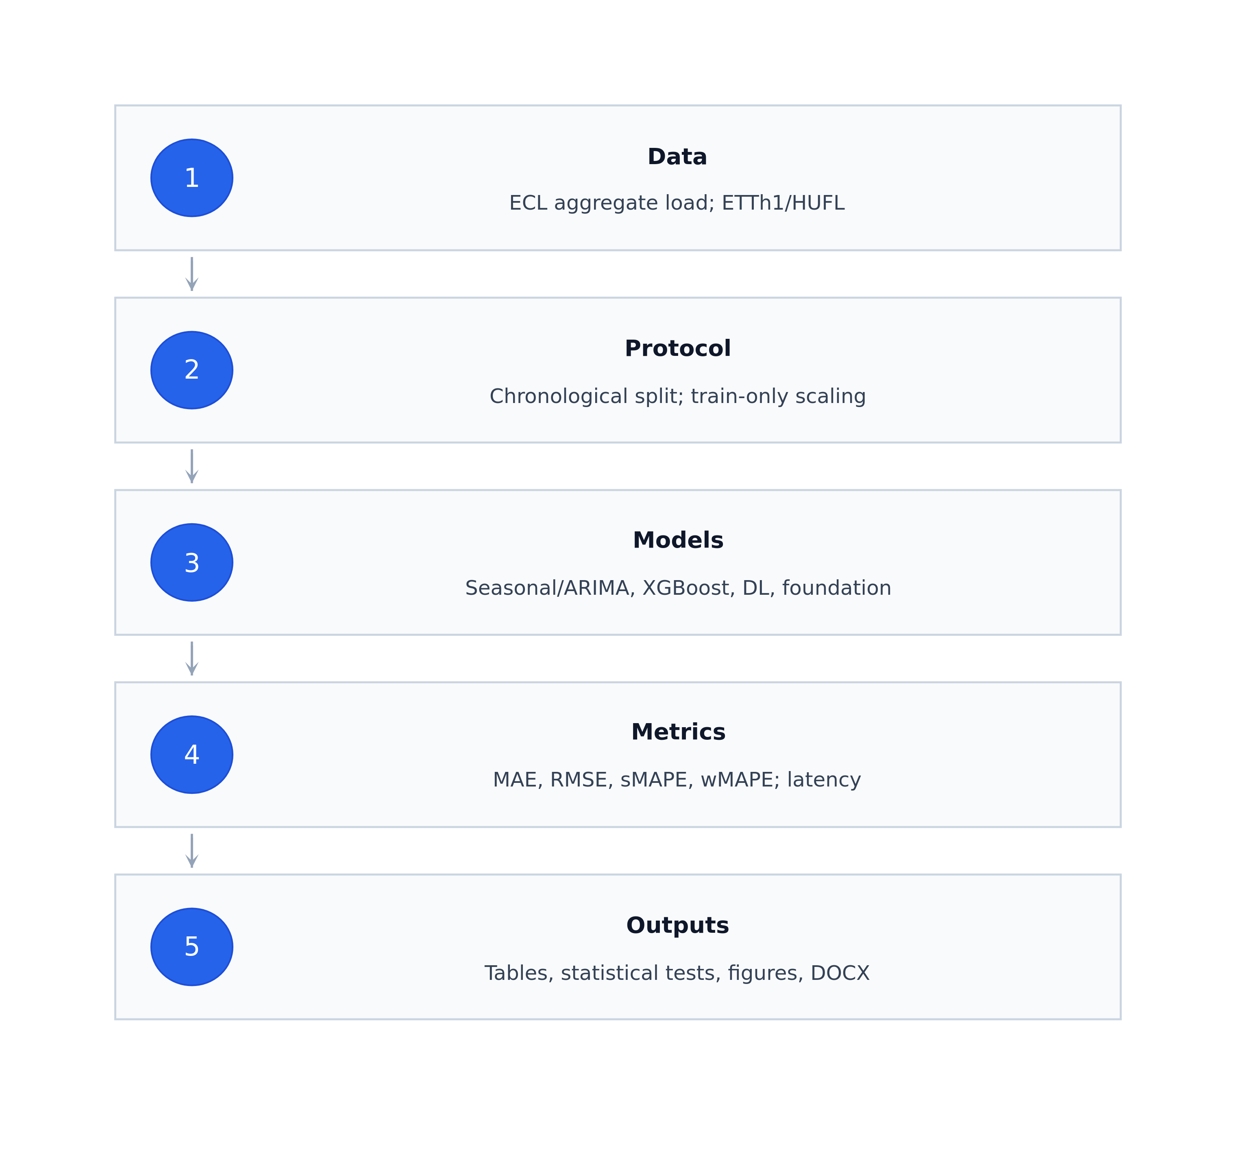
- Experimental pipeline used for the benchmark.
On ECL, the top group consists of TimesFM, Chronos-Bolt, and XGBoost. Their differences are small across all horizons. TimesFM is marginally best at H=24, while XGBoost is marginally best at H=96 and H=168. This confirms that feature-based boosting remains a difficult baseline to beat on aggregate load data when informative lag and calendar features are available [9]. SARIMA remains close to the leading group, which is important because it achieves competitive accuracy without deep representation learning.
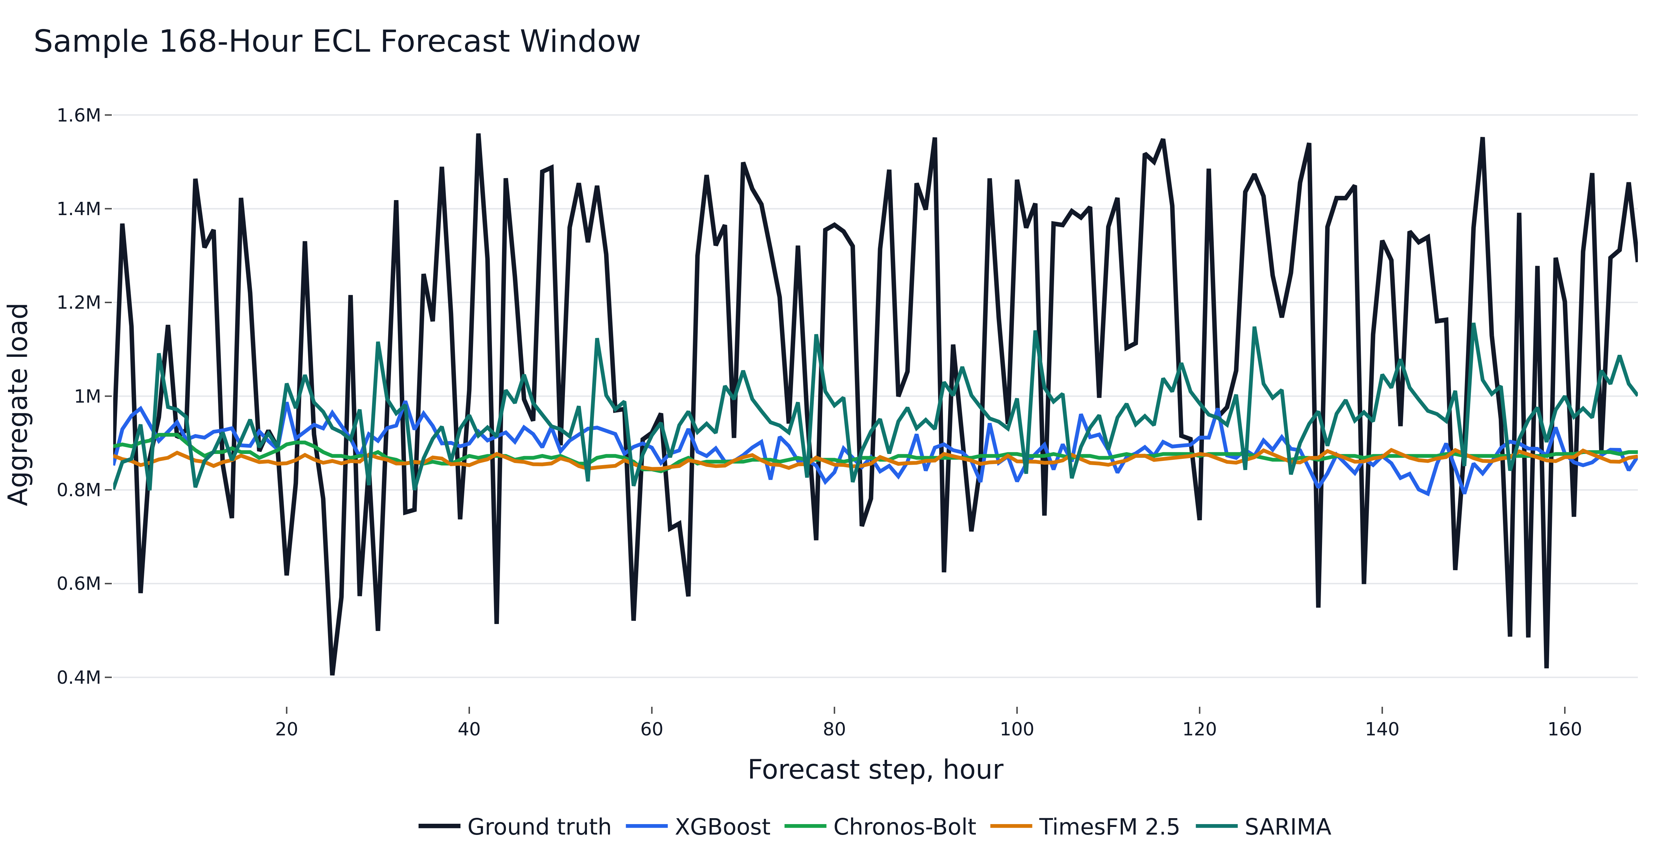
- Sample 168-hour ECL forecast window.
Dataset/H | Best model | Close competitors | Interpretation
ECL/H24 | TimesFM | Chronos-Bolt, XGBoost | Near tie
ECL/H96 | XGBoost | Chronos-Bolt, TimesFM | Tree model leads
ECL/H168 | XGBoost | Chronos-Bolt, TimesFM | Tree model robust
ETTh1/H24 | Chronos-Bolt | PatchTST, DLinear | Foundation model strongest
ETTh1/H96 | DLinear | Chronos-Bolt, PatchTST | Linear neural model wins
ETTh1/H168 | DLinear | Chronos-Bolt, TimesFM | DLinear strongest
- Summary of the main accuracy results.
On ETTh1/HUFL, the ranking changes. Chronos-Bolt is best at H=24, while DLinear is best at H=96 and H=168. This result supports the view that simple linear neural baselines can remain highly competitive against more complex transformer architectures in time-series forecasting [15]. It also demonstrates why load-forecasting claims should be reported by dataset and horizon rather than as a single global leaderboard.
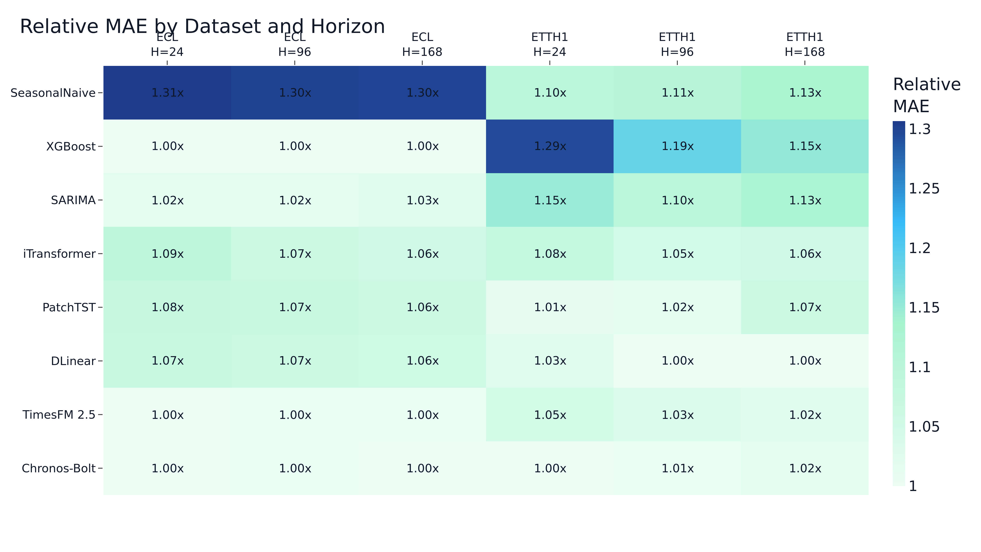
- Relative MAE by dataset and horizon.
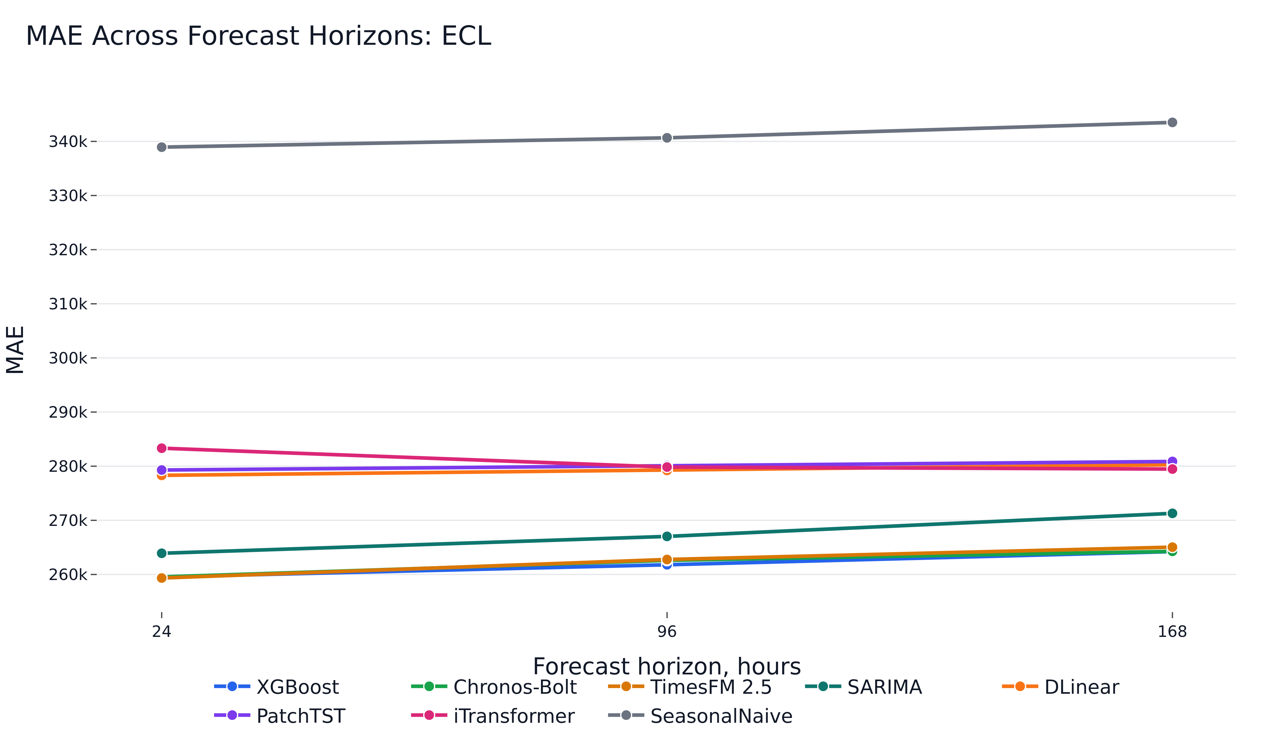
- MAE across forecast horizons on ECL.
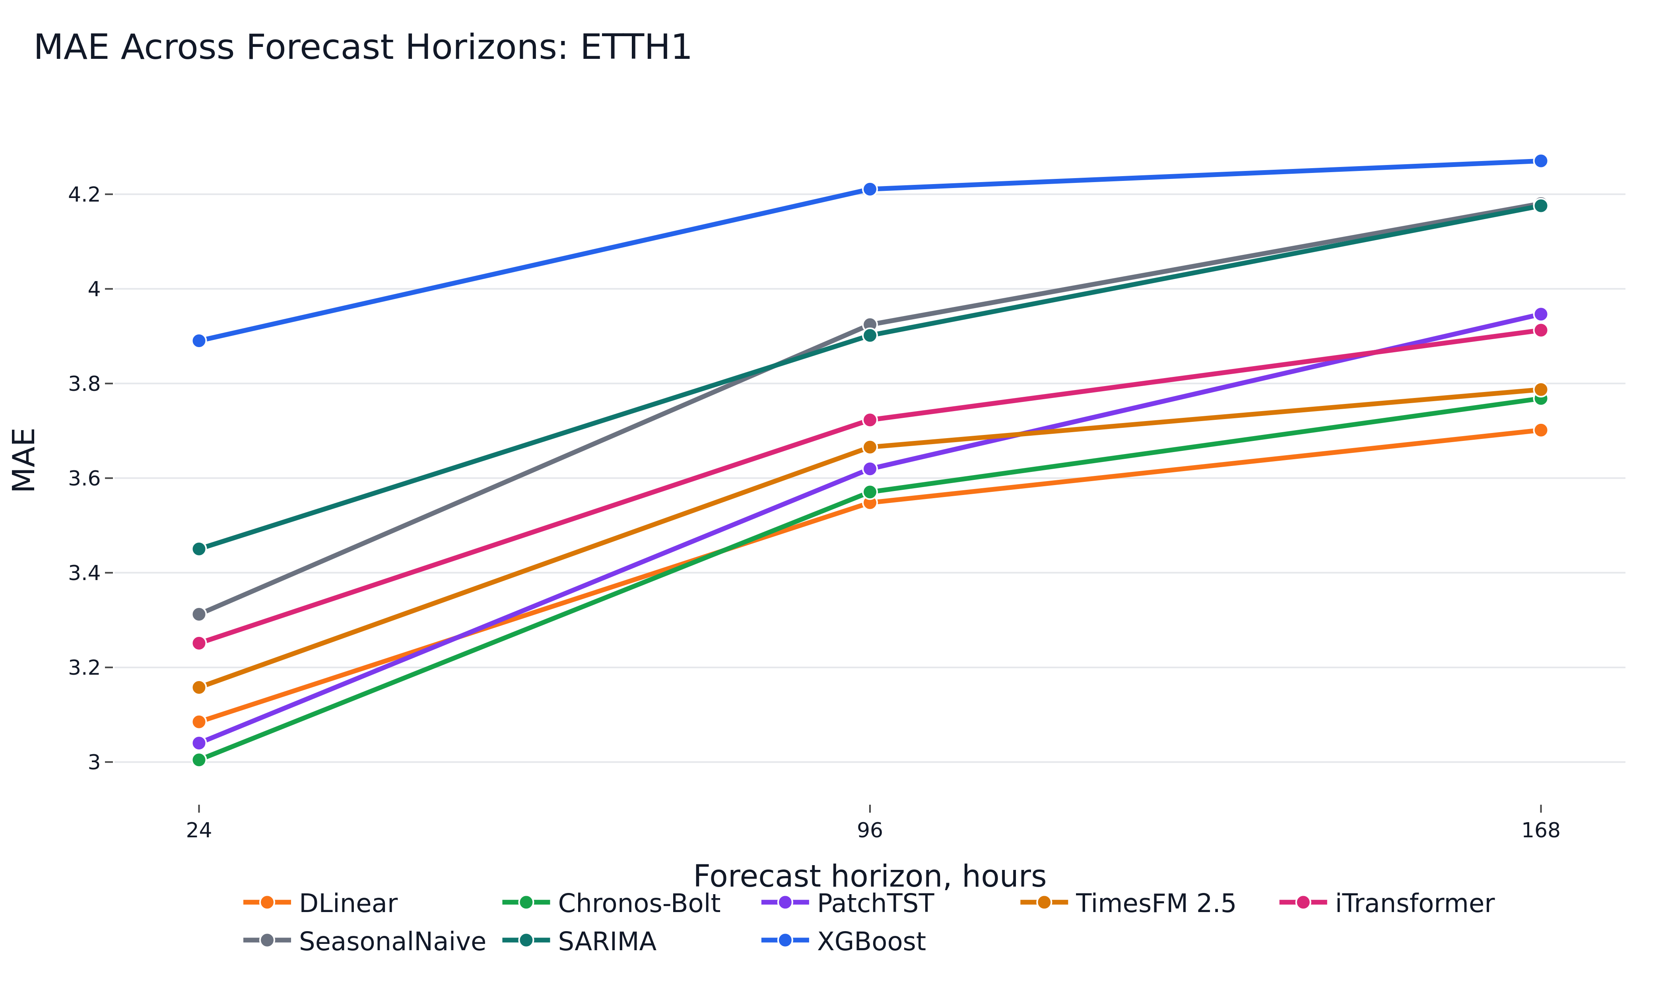
- MAE across forecast horizons on ETTh1/HUFL.
The Diebold-Mariano tests reject equal predictive accuracy for the top model pairs in all evaluated dataset-horizon combinations [8]. However, statistical significance and operational significance are not identical. On ECL, the absolute differences among the top three methods are small, so inference latency, training cost, and deployment complexity become important additional selection criteria.
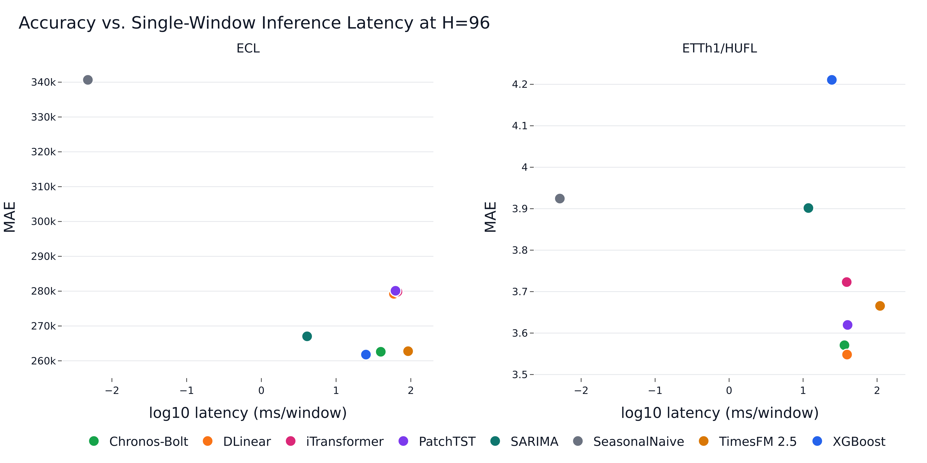
- Accuracy-latency view at H=96.
Family | Training cost | Inference profile | Practical role
SeasonalNaive/SARIMA | Low to moderate | Very low latency | Reference and fallback
XGBoost | Low | Low latency | Strong supervised baseline
DLinear/PatchTST/iTransformer | Moderate | GPU-friendly | Neural references
Chronos/TimesFM | No task-specific training | Model-dependent latency | Cold-start forecasting
- Operational interpretation of model families.
- ECL — accuracy across horizons (mean ± std over seeds where applicable).
Model | H | MAE | RMSE | sMAPE (%) | wMAPE (%)
TimesFM | 24 | 259345.28 | 307450.43 | 31.27 | 29.60
Chronos-Bolt | 24 | 259546.11 | 311466.37 | 31.32 | 29.63
XGBoost | 24 | 259549.38 ± 12.18 | 306563.19 ± 16.57 | 31.33 ± 0.00 | 29.63 ± 0.00
SARIMA | 24 | 263913.91 | 316245.26 | 31.73 | 30.12
DLinear | 24 | 278309.93 ± 70.17 | 327075.05 ± 108.63 | 34.58 ± 0.01 | 32.94 ± 0.01
PatchTST | 24 | 279295.35 ± 245.58 | 328419.63 ± 556.43 | 34.68 ± 0.03 | 33.05 ± 0.03
iTransformer | 24 | 283321.32 ± 249.36 | 335735.87 ± 571.58 | 35.11 ± 0.03 | 33.53 ± 0.03
SeasonalNaive | 24 | 338935.90 | 428088.82 | 39.98 | 38.69
XGBoost | 96 | 261792.58 ± 8.37 | 308906.88 ± 22.41 | 31.63 ± 0.00 | 29.94 ± 0.00
Chronos-Bolt | 96 | 262601.94 | 314012.89 | 31.68 | 30.03
TimesFM | 96 | 262766.32 | 311382.39 | 31.65 | 30.05
SARIMA | 96 | 267033.48 | 320436.95 | 32.07 | 30.54
DLinear | 96 | 279227.54 ± 46.94 | 327146.57 ± 48.36 | 34.69 ± 0.01 | 33.07 ± 0.01
iTransformer | 96 | 279842.21 ± 132.70 | 327663.71 ± 184.17 | 34.75 ± 0.01 | 33.14 ± 0.02
PatchTST | 96 | 280109.77 ± 84.36 | 328333.77 ± 229.61 | 34.77 ± 0.02 | 33.17 ± 0.01
SeasonalNaive | 96 | 340658.82 | 428618.32 | 40.13 | 38.96
XGBoost | 168 | 264220.96 ± 22.15 | 311145.57 ± 37.64 | 31.96 ± 0.00 | 30.30 ± 0.00
Chronos-Bolt | 168 | 264268.27 | 315996.95 | 31.91 | 30.30
TimesFM | 168 | 265044.60 | 313676.28 | 31.95 | 30.39
SARIMA | 168 | 271294.60 | 325857.78 | 32.54 | 31.11
iTransformer | 168 | 279476.02 ± 92.85 | 326253.85 ± 237.73 | 34.75 ± 0.01 | 33.15 ± 0.01
DLinear | 168 | 280272.56 ± 42.27 | 328134.31 ± 34.74 | 34.84 ± 0.01 | 33.25 ± 0.01
PatchTST | 168 | 280876.20 ± 97.69 | 328943.70 ± 235.33 | 34.88 ± 0.01 | 33.32 ± 0.01
SeasonalNaive | 168 | 343510.17 | 431537.72 | 40.48 | 39.39
- ETTh1/HUFL — accuracy across horizons (mean ± std over seeds where applicable).
Model | H | MAE | RMSE | sMAPE (%) | wMAPE (%)
Chronos-Bolt | 24 | 3.00 | 4.78 | 44.88 | 29.73
PatchTST | 24 | 3.04 ± 0.01 | 4.56 ± 0.01 | 47.47 ± 0.16 | 30.09 ± 0.10
DLinear | 24 | 3.08 ± 0.00 | 4.63 ± 0.00 | 47.95 ± 0.09 | 30.53 ± 0.04
TimesFM | 24 | 3.16 | 4.88 | 48.33 | 31.25
iTransformer | 24 | 3.25 ± 0.01 | 4.77 ± 0.04 | 49.29 ± 0.08 | 32.17 ± 0.13
SeasonalNaive | 24 | 3.31 | 5.44 | 46.07 | 32.78
SARIMA | 24 | 3.45 | 4.92 | 52.92 | 34.15
XGBoost | 24 | 3.89 ± 0.01 | 5.40 ± 0.01 | 57.47 ± 0.07 | 38.50 ± 0.06
DLinear | 96 | 3.55 ± 0.00 | 5.26 ± 0.01 | 54.11 ± 0.07 | 35.08 ± 0.02
Chronos-Bolt | 96 | 3.57 | 5.61 | 51.08 | 35.30
PatchTST | 96 | 3.62 ± 0.03 | 5.27 ± 0.02 | 54.87 ± 0.32 | 35.79 ± 0.25
TimesFM | 96 | 3.67 | 5.61 | 54.27 | 36.24
iTransformer | 96 | 3.72 ± 0.01 | 5.43 ± 0.02 | 55.56 ± 0.22 | 36.81 ± 0.11
SARIMA | 96 | 3.90 | 5.57 | 57.66 | 38.58
SeasonalNaive | 96 | 3.92 | 6.41 | 51.70 | 38.80
XGBoost | 96 | 4.21 ± 0.00 | 5.86 ± 0.01 | 61.21 ± 0.03 | 41.63 ± 0.05
DLinear | 168 | 3.70 ± 0.00 | 5.43 ± 0.01 | 56.49 ± 0.07 | 36.54 ± 0.02
Chronos-Bolt | 168 | 3.77 | 5.85 | 53.36 | 37.20
TimesFM | 168 | 3.79 | 5.75 | 55.77 | 37.38
iTransformer | 168 | 3.91 ± 0.02 | 5.62 ± 0.03 | 57.87 ± 0.20 | 38.62 ± 0.21
PatchTST | 168 | 3.95 ± 0.07 | 5.62 ± 0.07 | 58.51 ± 0.66 | 38.96 ± 0.66
SARIMA | 168 | 4.18 | 5.87 | 60.30 | 41.22
SeasonalNaive | 168 | 4.18 | 6.70 | 54.20 | 41.26
XGBoost | 168 | 4.27 ± 0.00 | 5.98 ± 0.01 | 61.54 ± 0.04 | 42.15 ± 0.05
- Computational efficiency (single-window inference at batch size 1).
Model | Data/H | Train s | Infer ms | Params | GPU MB
Chronos-Bolt | ECL/H24 | 0.00 | 15.62 | 47 718 016 | 123.3
DLinear | ECL/H24 | 11.80 | 55.86 | 16 176 | 26.3
iTransformer | ECL/H24 | 23.72 | 55.34 | 311 448 | 164.9
PatchTST | ECL/H24 | 43.08 | 55.71 | 168 280 | 608.6
SARIMA | ECL/H24 | 109.77 | 2.99 | 0 | 0.0
SeasonalNaive | ECL/H24 | 0.00 | 0.00 | 0 | 0.0
TimesFM | ECL/H24 | 0.00 | 102.23 | 200 000 000 | 895.6
XGBoost | ECL/H24 | 2.89 | 7.50 | 57 388 | 0.0
Chronos-Bolt | ECL/H96 | 0.00 | 39.64 | 47 718 016 | 345.8
DLinear | ECL/H96 | 18.84 | 59.40 | 64 704 | 29.8
iTransformer | ECL/H96 | 31.38 | 66.29 | 320 736 | 165.0
PatchTST | ECL/H96 | 49.98 | 62.40 | 361 888 | 612.4
SARIMA | ECL/H96 | 109.64 | 4.09 | 0 | 0.0
SeasonalNaive | ECL/H96 | 0.00 | 0.00 | 0 | 0.0
TimesFM | ECL/H96 | 0.00 | 91.99 | 200 000 000 | 895.6
XGBoost | ECL/H96 | 10.48 | 25.09 | 229 423 | 0.0
Chronos-Bolt | ECL/H168 | 0.00 | 45.30 | 47 718 016 | 381.4
DLinear | ECL/H168 | 26.00 | 64.16 | 113 232 | 32.7
iTransformer | ECL/H168 | 38.54 | 69.72 | 330 024 | 165.2
PatchTST | ECL/H168 | 56.94 | 75.29 | 555 496 | 617.3
SARIMA | ECL/H168 | 108.43 | 5.52 | 0 | 0.0
SeasonalNaive | ECL/H168 | 0.00 | 0.01 | 0 | 0.0
TimesFM | ECL/H168 | 0.00 | 200.35 | 200 000 000 | 896.4
XGBoost | ECL/H168 | 18.18 | 42.71 | 401 454 | 0.0
Chronos-Bolt | ETTh1/H24 | 0.00 | 13.48 | 47 718 016 | 123.3
DLinear | ETTh1/H24 | 10.70 | 39.98 | 16 176 | 26.2
iTransformer | ETTh1/H24 | 20.17 | 39.15 | 311 448 | 164.8
PatchTST | ETTh1/H24 | 39.82 | 39.10 | 168 280 | 608.3
SARIMA | ETTh1/H24 | 110.82 | 9.30 | 0 | 0.0
SeasonalNaive | ETTh1/H24 | 0.00 | 0.00 | 0 | 0.0
TimesFM | ETTh1/H24 | 0.00 | 98.19 | 200 000 000 | 895.6
XGBoost | ETTh1/H24 | 2.34 | 6.14 | 57 417 | 0.0
Chronos-Bolt | ETTh1/H96 | 0.00 | 36.24 | 47 718 016 | 345.8
DLinear | ETTh1/H96 | 9.90 | 39.29 | 64 704 | 29.8
iTransformer | ETTh1/H96 | 20.61 | 38.86 | 320 736 | 165.0
PatchTST | ETTh1/H96 | 38.60 | 39.95 | 361 888 | 612.6
SARIMA | ETTh1/H96 | 110.80 | 11.80 | 0 | 0.0
SeasonalNaive | ETTh1/H96 | 0.00 | 0.01 | 0 | 0.0
TimesFM | ETTh1/H96 | 0.00 | 109.76 | 200 000 000 | 895.6
XGBoost | ETTh1/H96 | 8.64 | 24.47 | 229 758 | 0.0
Chronos-Bolt | ETTh1/H168 | 0.00 | 64.73 | 47 718 016 | 381.4
DLinear | ETTh1/H168 | 10.09 | 40.71 | 113 232 | 32.6
iTransformer | ETTh1/H168 | 21.13 | 44.38 | 330 024 | 165.1
PatchTST | ETTh1/H168 | 39.07 | 42.39 | 555 496 | 617.0
SARIMA | ETTh1/H168 | 110.49 | 14.46 | 0 | 0.0
SeasonalNaive | ETTh1/H168 | 0.00 | 0.01 | 0 | 0.0
TimesFM | ETTh1/H168 | 0.00 | 208.51 | 200 000 000 | 896.4
XGBoost | ETTh1/H168 | 14.78 | 42.69 | 401 899 | 0.0
- Diebold-Mariano tests for the top two models by MAE at seed 42.
Data/H | Comparison | Statistic | p-value | Sig.
ECL/H24 | TimesFM vs XGBoost | 13.45 | <0.001 | yes
ECL/H96 | XGBoost vs Chronos-Bolt | -38.15 | <0.001 | yes
ECL/H168 | XGBoost vs Chronos-Bolt | -2.88 | 0.004 | yes
ETTh1/H24 | Chronos-Bolt vs PatchTST | -3.39 | <0.001 | yes
ETTh1/H96 | DLinear vs Chronos-Bolt | -2.48 | 0.013 | yes
ETTh1/H168 | DLinear vs Chronos-Bolt | -8.81 | <0.001 | yes

Discussion
The main finding is that no model family dominates across datasets and horizons. On aggregate ECL load, engineered lag features with XGBoost remain a strong and inexpensive supervised solution. SARIMA provides a competitive classical reference grounded in established forecasting methodology [5]–[7]. Foundation models are competitive without task-specific training, but their practical value depends on the deployment setting rather than on accuracy alone.
The accuracy–latency trade-offs make these observations practically actionable. On ECL/H24, TimesFM achieves a 0.08 % lower MAE than XGBoost but requires 13.6× higher single-window inference latency (102.2 ms versus 7.5 ms) and a model with 200 M parameters versus 57 k. Chronos-Bolt-Small reaches comparable accuracy with 47.7 M parameters, a 4.2× reduction relative to TimesFM. SARIMA delivers single-window inference in under 6 ms on ECL while remaining within 2.7 % MAE of the leading model, making it the most attractive low-cost backup. These differences are invisible in MAE-only rankings yet determine whether a model is deployable in latency-constrained operational environments.
Foundation models are attractive when task-specific training is undesirable, for example in cold-start industrial monitoring, rapid prototyping, or sites where historical data cannot be pooled for model training. Nevertheless, the results do not support replacing supervised baselines by default. Instead, foundation models should be treated as a complementary option alongside XGBoost, SARIMA, and compact neural models [20]–[24].
The trained transformer models should not be interpreted as generally ineffective. The study uses a compact target-only setup and a limited training budget. Broader transformer surveys and architectures show that performance can depend strongly on decomposition, patching, inverted tokenization, multivariate inputs, and hyperparameter choices [12]–[19]. The current result is therefore a statement about this reproducible protocol, not a universal rejection of transformer-based forecasting.
From a deployment perspective, the results suggest a tiered model-selection strategy. SeasonalNaive and SARIMA are useful first checks because they reveal whether the series is dominated by regular seasonality. XGBoost is an appropriate default when sufficient site history is available and feature engineering is acceptable. DLinear is a lightweight neural alternative for horizons where linear temporal structure is dominant. Foundation models are most attractive when training data are scarce, experiments must be started quickly, or the cost of maintaining site-specific models is high.
The accuracy-latency results also caution against interpreting model quality through a single metric. A model that is marginally more accurate but substantially slower may be unattractive in an online monitoring system, while a slower zero-shot model may still be useful if it eliminates training and tuning for many small assets. Consequently, the benchmark is best read as a Pareto comparison across accuracy, latency, and adaptation cost rather than as a strict ranking.

Limitations
The first limitation is public-benchmark pretraining contamination. ECL and ETT are public datasets, and they may overlap with corpora used during foundation-model development. The correct interpretation is therefore that Chronos-Bolt and TimesFM are evaluated without task-specific training in this repository; the experiment does not prove dataset-unseen generalization for private industrial sites.
The second limitation is the target-only design. Real industrial forecasting systems often include weather, calendar events, tariffs, production schedules, and operational constraints. Adding such exogenous variables may change the ranking of model families, especially for tree-based and transformer-based approaches.
The third limitation is the restricted hyperparameter budget. The comparison is intentionally reproducible and computationally bounded, but larger searches could improve neural and tree-based models. This trade-off is acceptable for a benchmark paper because the protocol is transparent and all reported conclusions are tied to the executed configuration.
A further limitation is that the study reports deterministic point forecasts. Many operational grid and industrial planning tasks require prediction intervals or full probabilistic forecasts to support reserve allocation and risk-aware scheduling. Extending the protocol to quantile losses, calibration metrics, and probabilistic foundation models would make the comparison more directly applicable to reliability-constrained decision making.
Finally, the benchmark uses two public hourly datasets. This choice supports reproducibility and allows other researchers to verify the reported results, but it does not cover all STLF regimes. Future work should repeat the protocol on private industrial sites, weather-sensitive residential feeders, and datasets with known calendar events. Such studies would clarify whether the relative strength of XGBoost, DLinear, and foundation models transfers beyond standard public benchmarks.

Conclusion
This paper presented a reproducible benchmark of classical, machine-learning, deep-learning, and foundation-model approaches for short-term electricity load forecasting. The experiments show that XGBoost, Chronos-Bolt, and TimesFM are near-tied on ECL, whereas Chronos-Bolt and DLinear dominate different horizons on ETTh1/HUFL. These findings reinforce the need to compare modern foundation models against well-tuned classical and supervised baselines.
The practical conclusion is that strong simple baselines remain necessary. SeasonalNaive and SARIMA establish a meaningful lower bound, XGBoost provides a strong low-cost supervised model, DLinear is a useful compact neural reference, and foundation models are valuable cold-start forecasters. A deployment-oriented STLF study should report accuracy, statistical significance, and computational cost together.
From a deployment perspective, the results suggest a tiered model-selection strategy. SeasonalNaive and SARIMA serve as inexpensive first-pass references that characterize seasonality and bound the achievable improvement. XGBoost is the appropriate default when sufficient site history and feature engineering are available, combining strong accuracy on ECL with low single-window latency. DLinear is a compact neural alternative that performs well on horizons dominated by linear temporal structure, as observed on ETTh1/HUFL at H=96 and H=168. Chronos-Bolt is most attractive in cold-start, rapid-prototyping, or fleet-of-small-assets scenarios where avoiding per-site training is operationally valuable. TimesFM is reserved for low-latency-tolerant settings where its accuracy advantage at the shortest horizon outweighs its substantially higher inference cost.

References
- T. Hong and S. Fan, "Probabilistic electric load forecasting: A tutorial review," International Journal of Forecasting, vol. 32, no. 3, pp. 914-938, 2016, doi: 10.1016/j.ijforecast.2015.11.011.
- W. Kong, Z. Y. Dong, Y. Jia, D. J. Hill, Y. Xu, and Y. Zhang, "Short-term residential load forecasting based on LSTM recurrent neural network," IEEE Transactions on Smart Grid, vol. 10, no. 1, pp. 841-851, 2019, doi: 10.1109/TSG.2017.2753802.
- E. Mocanu, P. H. Nguyen, M. Gibescu, and W. L. Kling, "Deep learning for estimating building energy consumption," Sustainable Energy, Grids and Networks, vol. 6, pp. 91-99, 2016, doi: 10.1016/j.segan.2016.02.005.
- D. L. Marino, K. Amarasinghe, and M. Manic, "Building energy load forecasting using deep neural networks," in Proc. 42nd Annu. Conf. IEEE Industrial Electronics Society (IECON), 2016, pp. 7046-7051, doi: 10.1109/IECON.2016.7793413.
- G. E. P. Box, G. M. Jenkins, G. C. Reinsel, and G. M. Ljung, Time Series Analysis: Forecasting and Control, 5th ed. Hoboken, NJ, USA: Wiley, 2015.
- R. J. Hyndman and G. Athanasopoulos, Forecasting: Principles and Practice, 3rd ed. Melbourne, Australia: OTexts, 2021. [Online]. Available: https://otexts.com/fpp3/
- R. J. Hyndman and Y. Khandakar, "Automatic time series forecasting: The forecast package for R," Journal of Statistical Software, vol. 27, no. 3, pp. 1-22, 2008, doi: 10.18637/jss.v027.i03.
- F. X. Diebold and R. S. Mariano, "Comparing predictive accuracy," Journal of Business & Economic Statistics, vol. 13, no. 3, pp. 253-263, 1995, doi: 10.1080/07350015.1995.10524599.
- T. Chen and C. Guestrin, "XGBoost: A scalable tree boosting system," in Proc. 22nd ACM SIGKDD Int. Conf. Knowledge Discovery and Data Mining, 2016, pp. 785-794, doi: 10.1145/2939672.2939785.
- S. Hochreiter and J. Schmidhuber, "Long short-term memory," Neural Computation, vol. 9, no. 8, pp. 1735-1780, 1997, doi: 10.1162/neco.1997.9.8.1735.
- A. Vaswani, N. Shazeer, N. Parmar, J. Uszkoreit, L. Jones, A. N. Gomez, L. Kaiser, and I. Polosukhin, "Attention is all you need," in Advances in Neural Information Processing Systems (NeurIPS), 2017.
- H. Zhou, S. Zhang, J. Peng, S. Zhang, J. Li, H. Xiong, and W. Zhang, "Informer: Beyond efficient transformer for long sequence time-series forecasting," in Proc. AAAI Conf. Artificial Intelligence, 2021, doi: 10.1609/aaai.v35i12.17325.
- H. Wu, J. Xu, J. Wang, and M. Long, "Autoformer: Decomposition transformers with auto-correlation for long-term series forecasting," in Advances in Neural Information Processing Systems (NeurIPS), 2021.
- T. Zhou, Z. Ma, Q. Wen, X. Wang, L. Sun, and R. Jin, "FEDformer: Frequency enhanced decomposed transformer for long-term series forecasting," in Proc. Int. Conf. Machine Learning (ICML), 2022.
- A. Zeng, M. Chen, L. Zhang, and Q. Xu, "Are transformers effective for time series forecasting?" in Proc. AAAI Conf. Artificial Intelligence, 2023, doi: 10.1609/aaai.v37i9.26317.
- Y. Nie, N. H. Nguyen, P. Sinthong, and J. Kalagnanam, "A time series is worth 64 words: Long-term forecasting with transformers," in Proc. Int. Conf. Learning Representations (ICLR), 2023.
- H. Wu, T. Hu, Y. Liu, H. Zhou, J. Wang, and M. Long, "TimesNet: Temporal 2D-variation modeling for general time series analysis," in Proc. Int. Conf. Learning Representations (ICLR), 2023.
- Y. Liu, T. Hu, H. Zhang, H. Wu, S. Wang, L. Ma, and M. Long, "iTransformer: Inverted transformers are effective for time series forecasting," in Proc. Int. Conf. Learning Representations (ICLR), 2024.
- Q. Wen, T. Zhou, C. Zhang, W. Chen, Z. Ma, J. Yan, and L. Sun, "Transformers in time series: A survey," in Proc. Int. Joint Conf. Artificial Intelligence (IJCAI), 2023.
- A. Das, W. Kong, R. Sen, and Y. Zhou, "A decoder-only foundation model for time-series forecasting," in Proc. Int. Conf. Machine Learning (ICML), 2024.
- A. F. Ansari et al., "Chronos: Learning the language of time series," Transactions on Machine Learning Research, 2024.
- M. Goswami, K. Szafer, A. Choudhry, Y. Cai, S. Li, and A. Dubrawski, "MOMENT: A family of open time-series foundation models," in Proc. Int. Conf. Machine Learning (ICML), 2024.
- G. Woo, C. Liu, A. Kumar, C. Xiong, S. Savarese, and D. Sahoo, "Unified training of universal time series forecasting transformers," in Proc. Int. Conf. Machine Learning (ICML), 2024.
- K. Rasul et al., "Lag-Llama: Towards foundation models for probabilistic time series forecasting," 2024, arXiv:2310.08278.
- G. Lai, W.-C. Chang, Y. Yang, and H. Liu, "Modeling long- and short-term temporal patterns with deep neural networks," in Proc. 41st Int. ACM SIGIR Conf. Research & Development in Information Retrieval, 2018, pp. 95-104, doi: 10.1145/3209978.3210006.
- K. G. Olivares, C. Challu, F. Garza, M. Mergenthaler-Canseco, and A. Dubrawski, "NeuralForecast: User friendly state-of-the-art neural forecasting models," 2022. [Online]. Available: https://github.com/Nixtla/neuralforecast
- F. Garza, M. Mergenthaler-Canseco, K. G. Olivares, and C. Challu, "StatsForecast: Lightning fast forecasting with statistical and econometric models," 2022. [Online]. Available: https://github.com/Nixtla/statsforecast
- S. Seabold and J. Perktold, "statsmodels: Econometric and statistical modeling with Python," in Proc. 9th Python in Science Conf. (SciPy), 2010, pp. 92-96.

