A Comparative Study of Intelligent Methods for Steel Surface Defect Classification in Industrial Quality Control
[Author 1 Name] Department of […] [Institution] [City, Country] [email@domain]
[Author 2 Name] Department of […] [Institution] [City, Country] [email@domain]

Abstract
Abstract — The intelligent transformation of manufacturing processes increasingly relies on automated visual and parametric inspection of intermediate products, where machine learning models classify surface defects from sensor-derived features. Despite the rapid progress of deep tabular learning architectures, the relative performance of classical ensemble methods, gradient boosting, and modern neural-attention models on small industrial datasets remains insufficiently characterized. The absence of unified comparison protocols hinders informed deployment decisions in industrial quality-control environments.
This paper presents a comparative study of five representative intelligent methods — logistic regression, Random Forest, CatBoost, a multilayer perceptron, and TabNet — applied to the classification of steel-plate surface defects across seven fault categories. A unified evaluation protocol is proposed, integrating correlation-based feature selection, synthetic minority oversampling within cross-validation folds, exhaustive grid-search hyperparameter tuning under stratified five-fold cross-validation, and held-out test-set evaluation under macro-averaged metrics. The protocol prevents data leakage at every stage and treats class imbalance through SMOTENC applied inside the resampling loop.
The experimental results show that ensemble methods — Random Forest and CatBoost — achieve closely matched leading performance (test F1-macro 0.81) that is not distinguishable under paired Wilcoxon and Student $t$-tests on the inner-fold scores, while substantially outperforming both the linear baseline and the deep tabular architectures. The multilayer perceptron and TabNet trail by 4–8 F1-macro points, consistent with recent findings on the relative weakness of deep tabular learning on small datasets. Per-class analysis identifies systematic confusion among visually similar defect categories. Feature-importance analysis attributes the predictive signal primarily to defect-size descriptors and production-line geometry. The proposed protocol provides a reproducible framework for selecting intelligent methods in resource-constrained industrial quality-control deployments.
Keywords — machine learning, gradient boosting, neural networks, TabNet, defect classification, industrial quality control, class imbalance, comparative study, tabular data, intelligent methods

I. Introduction
The digital transformation of manufacturing enterprises has accelerated the deployment of automated quality-control systems in which machine learning algorithms operate on streams of sensor-derived measurements to identify product defects in real time. In steel production, surface defects on rolled plates — including scratches, stains, and inclusions — directly determine downstream product quality and yield, and their early identification is critical to efficient operation of continuous-rolling lines [16], [17]. Traditional manual inspection is slow, subject to operator fatigue, and difficult to scale across high-throughput production environments [16]. Intelligent classification methods enable rapid and consistent assessment of defect type at scale, supporting the broader goals of digital industrial transformation.
Recent advances in machine learning offer a wide spectrum of methods applicable to tabular industrial data. Classical ensemble methods such as Random Forest [1] continue to provide strong baselines on structured measurements, while modern gradient-boosting libraries — XGBoost [2] and CatBoost [3] — have become widely adopted in industrial deployments due to their robustness, native handling of categorical variables, and competitive accuracy under limited training data. In parallel, the rise of deep learning has motivated dedicated architectures for tabular inputs, including the multilayer perceptron, TabNet [4], and FT-Transformer [5]. These architectures employ attention or feature-tokenization mechanisms intended to recover the inductive biases that make tree-based methods effective on tabular data.
Despite this rich landscape, comparative evaluations on small-to-medium industrial datasets remain inconsistent in protocol. Recent systematic comparisons [6], [7] suggest that tree-based ensembles continue to outperform deep tabular models on smaller datasets, but practical guidance for industrial-quality-control applications — where datasets typically range from a few hundred to a few thousand samples and exhibit substantial class imbalance — is limited.
This paper addresses that gap by conducting a controlled comparative study of five intelligent methods spanning four architectural families: a linear baseline (logistic regression), a bagging-based ensemble (Random Forest), a gradient-boosting method with native categorical-feature support (CatBoost), and two neural-network approaches (a dense multilayer perceptron and the attention-based TabNet). All five methods are evaluated under a single unified protocol on the standard steel-plate fault dataset [10], [11], which contains 1 941 samples described by 27 geometric and luminance features and labelled across seven fault categories. The contributions of the paper are:
- A unified evaluation protocol integrating correlation-based feature selection, SMOTENC oversampling within cross-validation folds, and exhaustive grid search under stratified inner cross-validation, with explicit leakage-prevention measures at every stage;
- A comparative analysis of five intelligent methods under this protocol, establishing the relative performance of classical, ensemble, and deep tabular approaches on small industrial data;
- A detailed diagnostic analysis of the leading model — its confusion structure across fault categories and the relative importance of feature groups — informing the practical interpretability of the chosen approach for industrial deployment.
The proposed framework is reproducible, hardware-light, and adaptable to other tabular industrial-quality-control tasks.

II. Problem Statement
Let $D=\{(x_{i},y_{i})\}_{i=1}^{N}$ denote the steel-plate surface-defect dataset, where each sample $x_{i}∈R^{d}$ is a feature vector describing geometric, luminance, and material attributes of an observed defect, and $y_{i}∈C=\{c_{1},…,c_{K}\}$ is one of $K=7$ fault categories: Pastry, Z_Scratch, K_Scatch, Stains, Dirtiness, Bumps, Other_Faults. The dataset comprises $N=1 941$ samples and $d=27$ features. The class distribution exhibits substantial imbalance: the largest category (Other_Faults) contains 35% of the samples while the smallest (Dirtiness) contains 3%.
Let $M=\{m_{1},…,m_{L}\}$ denote a candidate set of $L=5$ classification methods. Each method $m_{l}$ is parameterised by a hyperparameter vector $θ_{l}∈Θ_{l}$, where $Θ_{l}$ is a method-specific finite search grid. For a chosen $θ_{l}$, the trained classifier $f_{m_{l},θ_{l}}:R^{d^{′}}→C$ maps a (possibly preprocessed) input vector to a predicted fault category, where $d^{′}≤d$ accounts for feature selection.
The data is partitioned into a training set $D_{\text{train}}$ and a held-out test set $D_{\text{test}}$ via stratified random sampling at ratio $0.8:0.2$, ensuring class-proportion preservation. Inner cross-validation is performed only on $D_{\text{train}}$; the test set is touched exactly once per method, after final hyperparameter selection.
The model-selection problem is formulated as a two-level optimization. For each method $m_{l}$, the per-method optimal hyperparameter vector is
$$θ_{l}^{*}=arg\max_{θ∈Θ_{l}}s_{\text{CV}}(m_{l},θ,D_{\text{train}})$$
where $s_{\text{CV}}$ denotes the macro-averaged $F_{1}$ score computed over a stratified five-fold inner cross-validation:
$$s_{\text{CV}}(m,θ,D)=\frac{1}{K_{\text{CV}}}\sum_{k=1}^{K_{\text{CV}}}{F_{1}^{\text{macro}}}\left(f_{m,θ}^{(k)},D_{\text{val}}^{(k)}\right)$$
The overall winner is then determined by held-out test-set performance:
$$m^{*}=arg\max_{m_{l}∈M}s_{\text{test}}\left(m_{l},θ_{l}^{*},D_{\text{test}}\right)$$
Two structural constraints govern the protocol. First, leakage prevention: any data-dependent transformation — feature scaling, synthetic minority oversampling, feature selection — must be fitted exclusively on the training portion of each cross-validation fold and applied to the corresponding validation portion as a transform; the held-out test set $D_{\text{test}}$ must not influence any aspect of the training procedure. Second, class-balance handling: the SMOTENC oversampling operator is applied inside the cross-validation loop on the training portion of each fold only.
Thus, the problem of comparative method selection reduces to determining $m^{*}$ under a unified, leakage-free, imbalance-aware protocol, with structured reporting of per-class behaviour and feature attribution for the selected method.

III. Proposed Method
The proposed comparative method consists of four sequential stages: (A) data preparation and correlation-based feature selection, (B) per-method pipeline construction with imbalance handling, (C) hyperparameter optimization via grid search under stratified inner cross-validation, and (D) held-out test evaluation with diagnostic analysis of the winning model.

A. Data Preparation and Feature Selection
The raw dataset is first transformed by collapsing the seven one-hot target columns into a single categorical label $y$. The resulting feature matrix consists of 27 columns spanning five logical groups: geometric (boundary coordinates, perimeters, areas, conveyor and thickness measurements), luminosity (sum, minimum, maximum, and normalised luminance indices), shape index (edge, square, and orientation indices), log-transformed (logarithms of areas and extents), and categorical (the steel-type one-hot pair). Table I summarises the feature inventory.
Table I — Feature inventory by group.
Group | # features | Examples
Geometric | 9 | X_Minimum, Pixels_Areas, X_Perimeter, Length_of_Conveyer, Steel_Plate_Thickness
Luminosity | 4 | Sum_of_Luminosity, Minimum_of_Luminosity, Maximum_of_Luminosity, Luminosity_Index
Shape index | 9 | Edges_Index, Square_Index, Outside_X_Index, Orientation_Index, SigmoidOfAreas
Log-transformed | 3 | LogOfAreas, Log_X_Index, Log_Y_Index
Categorical (one-hot) | 2 | TypeOfSteel_A300, TypeOfSteel_A400
Correlation analysis on the training portion reveals clusters of near-duplicate features, particularly within the area/perimeter group. To eliminate this redundancy without arbitrary pairwise pruning, hierarchical clustering is performed on the distance matrix $1−|R|$, where $R$ is the Pearson correlation matrix, using average linkage. The resulting dendrogram is cut at distance threshold $1−τ$ with $τ=0.90$. Within each cluster, the feature with the highest mutual information against the target is retained as the representative; all other cluster members are dropped. The structural one-hot pair TypeOfSteel_A300 / TypeOfSteel_A400 is excluded from the clustering and retained unconditionally, in keeping with its role as an explicit material-type encoding. CatBoost receives this encoding collapsed into a single native-categorical column; all other methods see the original one-hot pair.
Feature selection is computed exclusively on $D_{\text{train}}$, ensuring no information from the test set influences the kept-feature list.

B. Per-Method Pipeline Construction
Each candidate method is wrapped in a leakage-safe pipeline implemented via the imblearn.Pipeline abstraction [9], which extends the scikit-learn [12] pipeline mechanism with support for resampling steps. The pipeline structure is:
$$\text{[StandardScaler]}→\text{SMOTENC}→\text{Classifier}$$
where StandardScaler is included only for methods sensitive to feature scale (logistic regression, multilayer perceptron, TabNet). SMOTENC [9], the variant of SMOTE [8] that handles mixed nominal and continuous features, is applied to the training portion of each cross-validation fold. The held-out test set is never oversampled.
Five candidate methods are compared:
- Logistic Regression [12] with $ℓ_{2}$ regularization, multinomial loss, and limited-memory BFGS optimization;
- Random Forest [1], [12] with bootstrap aggregation over decision trees;
- CatBoost [3], a gradient-boosting method with native categorical-feature handling, configured for GPU training;
- Multilayer Perceptron, a fully-connected neural network implemented in PyTorch [13] via the skorch [14] sklearn-compatibility wrapper, trained with the Adam optimizer [15], ReLU activations, and dropout regularization;
- TabNet [4], an attention-based deep tabular architecture with sequential feature-selection masks, trained with GPU acceleration.
The two neural-network methods are wrapped in scikit-learn-compatible adapters that internally encode the string class labels and convert input arrays to the appropriate dtype.

C. Hyperparameter Optimization
Hyperparameter grids are defined per method, balancing search breadth against compute cost (Table II). The training set $D_{\text{train}}$ is split into five stratified folds; for each grid configuration, the per-method pipeline is fitted on four folds and scored on the held-out fold using macro-averaged $F_{1}$. The configuration with the highest mean cross-validated score is then refit on the entire training set. The cross-validation procedure ensures that the SMOTENC oversampler is fitted on the training portion of each fold only.
Table II — Hyperparameter search grids per method.
Method | Search space | Combinations
Logistic Regression | $C∈\{0.01,0.1,1.0,10.0\}$ | 4
Random Forest | $n_\text{est}=300$, depth $∈\{\text{None},10,20\}$, min_leaf $∈\{1,3\}$ | 6
CatBoost | iter $=300$, depth $∈\{4,6,8\}$, lr $∈\{0.05,0.1\}$ | 6
MLP | hidden $∈\{(64,),(128,),(64,32),(128,64)\}$, dropout $∈\{0.1,0.3\}$ | 8
TabNet | $n_{d}=n_{a}∈\{16,32\}$, $n_{\text{steps}}∈\{3,5\}$, max_epochs $=50$ | 4
Total |  | 28

D. Evaluation and Diagnostic Analysis
Each method’s optimal pipeline is evaluated on the held-out test set $D_{\text{test}}$ exactly once, producing five reported metrics: accuracy, macro-averaged precision, macro-averaged recall, macro-averaged $F_{1}$, and one-vs-rest macro-averaged ROC-AUC. The method with the highest test $F_{1}$-macro is selected as the comparative winner.
For the winning method, additional diagnostic outputs are computed: the row-normalized confusion matrix across the seven fault categories, the per-class precision/recall/F1 report, the feature-importance vector aggregated by the five logical feature groups defined in stage (A), and the ranking of individual features by importance. These diagnostics support practical interpretation of the model’s decision behaviour for industrial deployment.

E. Implementation Details
All experiments were executed on a single workstation with an NVIDIA GeForce RTX 3070 GPU (8 GB VRAM, compute capability 8.6) and Python 3.12 under Linux. CatBoost [3] and TabNet [4] used GPU acceleration; logistic regression, Random Forest, and the multilayer perceptron ran on CPU/GPU as appropriate. A single global random seed (seed = 42) was applied to Python, NumPy, and PyTorch [13] random-number generators, and was passed explicitly to: the stratified train/test split, the inner StratifiedKFold cross-validation (shuffle=True), the SMOTENC oversampler [8], [9], the Random Forest [1], the CatBoost training procedure [3], the MLP weight-initialization routine via skorch [14], and the TabNet initialization. Software versions were: scikit-learn 1.8.0 [12], imbalanced-learn 0.14.1 [9], CatBoost 1.2.10 [3], PyTorch 2.6.0 with CUDA 12.4 [13], skorch 1.3.1 [14], pytorch-tabnet 4.1 [4]. The full pyproject.toml lock file is included in the code repository.

IV. System Architecture and Experimental Results

A. Architecture
The proposed comparative methodology is realised as a layered processing pipeline (Fig. 1), comprising five sequentially-connected stages: data ingestion, preprocessing and feature selection, train–test partitioning, per-method training under inner cross-validation with grid search, and final test-set evaluation with diagnostic analysis. Each stage exposes a stable interface to the next, and the persistence of intermediate artefacts — the kept-feature list, the fitted pipeline of each method, and the comparative-metrics tables — supports separate execution of the experimental and diagnostic phases.
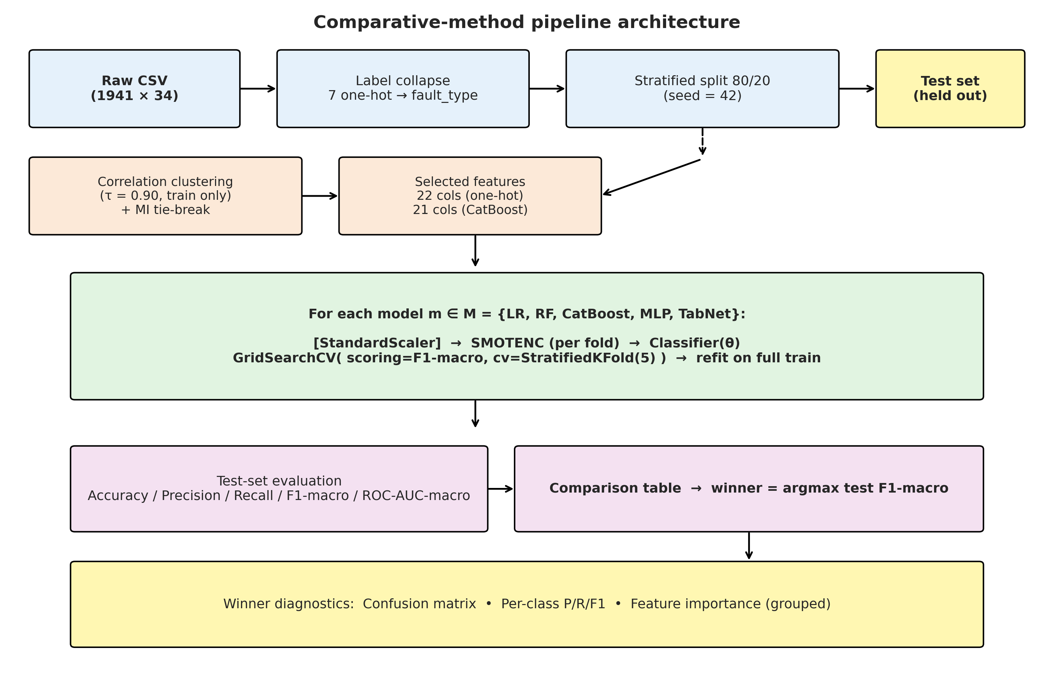
Fig. 1 — Comparative-method pipeline architecture.
Fig. 1 — Comparative-method pipeline architecture. Train/test split, correlation-clustering feature selection (computed on training data only), per-model pipeline with SMOTENC inside cross-validation folds, grid search under stratified five-fold inner CV scored on $F_{1}$-macro, and final held-out test evaluation followed by winner diagnostics.

B. Dataset Characterisation
The dataset (Fig. 2) exhibits substantial class imbalance: the Other_Faults category contains 673 samples (35%), while Dirtiness and Stains contain 55 (2.8%) and 72 (3.7%) samples respectively. This shape motivates both the use of stratified partitioning and the application of SMOTENC inside the cross-validation loop.
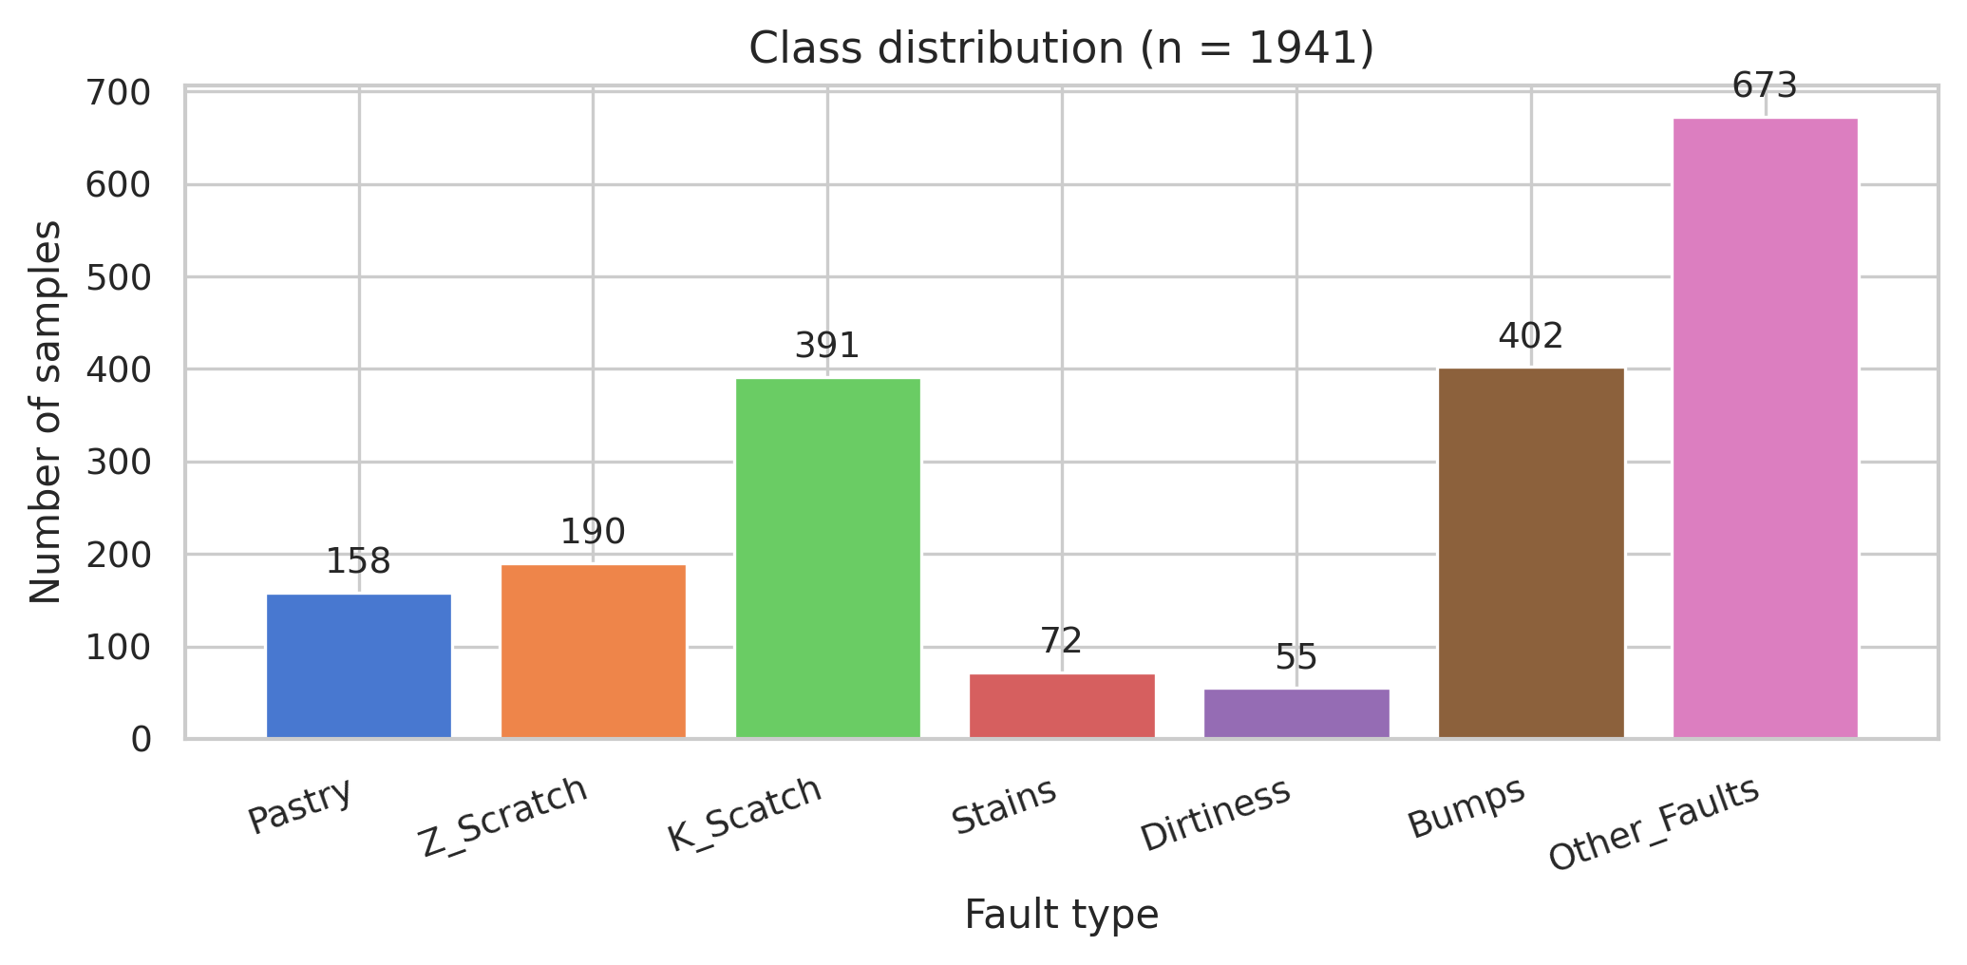
Fig. 2 — Class distribution across the seven fault categories.
Fig. 2 — Class distribution across the seven fault categories. The substantial imbalance between Other_Faults / Bumps / K_Scatch (high) and Stains / Dirtiness (low) motivates stratified partitioning and within-fold SMOTENC oversampling.
The full-feature correlation matrix (Fig. 3a) reveals a dense cluster of near-duplicate descriptors among the area, perimeter, and luminance-sum features. Hierarchical clustering at threshold $τ=0.90$ (Table III) reduces the feature set from 27 to 22 columns by dropping X_Maximum, Y_Maximum, Pixels_Areas, X_Perimeter, and Y_Perimeter — all near-duplicates of the higher-mutual-information representative Sum_of_Luminosity, which won its cluster. The post-selection correlation matrix (Fig. 3b) confirms that the most extreme redundancies are eliminated. Pair-plots of the top four features by mutual information against the target on the post-selection training set (Fig. 4) reveal class-separable structure along the Steel_Plate_Thickness, Length_of_Conveyer, Outside_X_Index, and X_Minimum dimensions, particularly for K_Scatch and Z_Scratch fault categories.
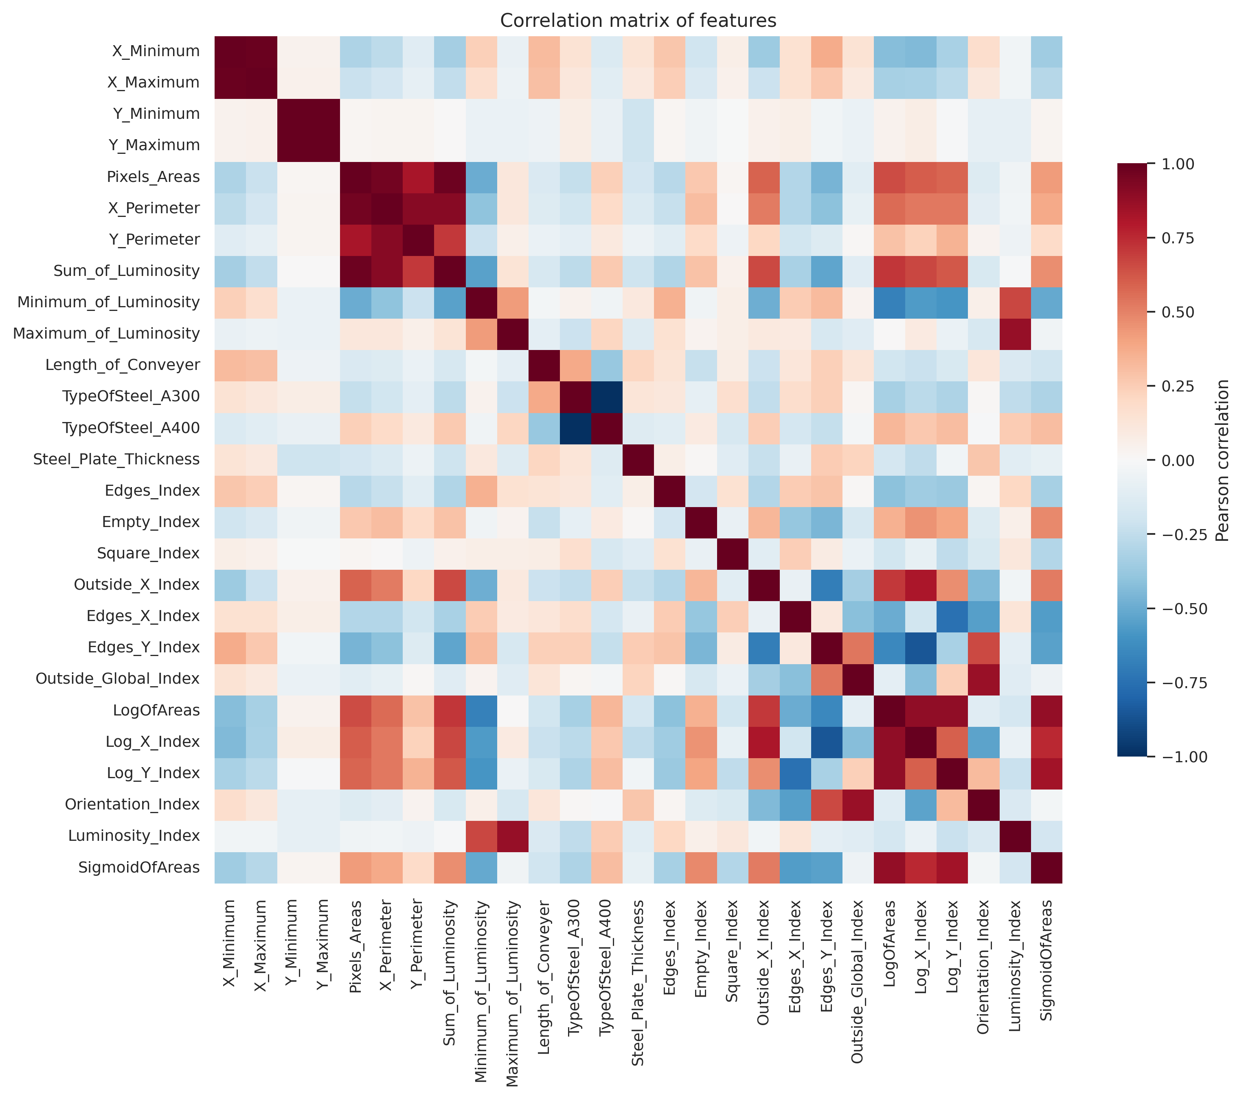
Fig. 3a — Correlation matrix on the full 27-feature set.
Fig. 3a — Pearson correlation matrix on the full 27-feature set. A dense cluster of near-duplicate descriptors is visible among the area, perimeter, and luminance-sum features.
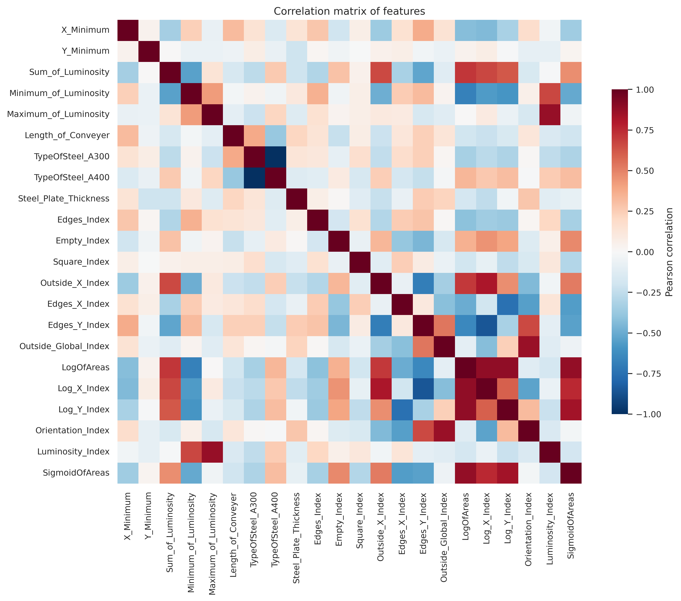
Fig. 3b — Correlation matrix after correlation-cluster selection.
Fig. 3b — Pearson correlation matrix on the 22-feature post-selection set. The most extreme redundancies are eliminated; remaining correlations stay below the 0.90 cut.
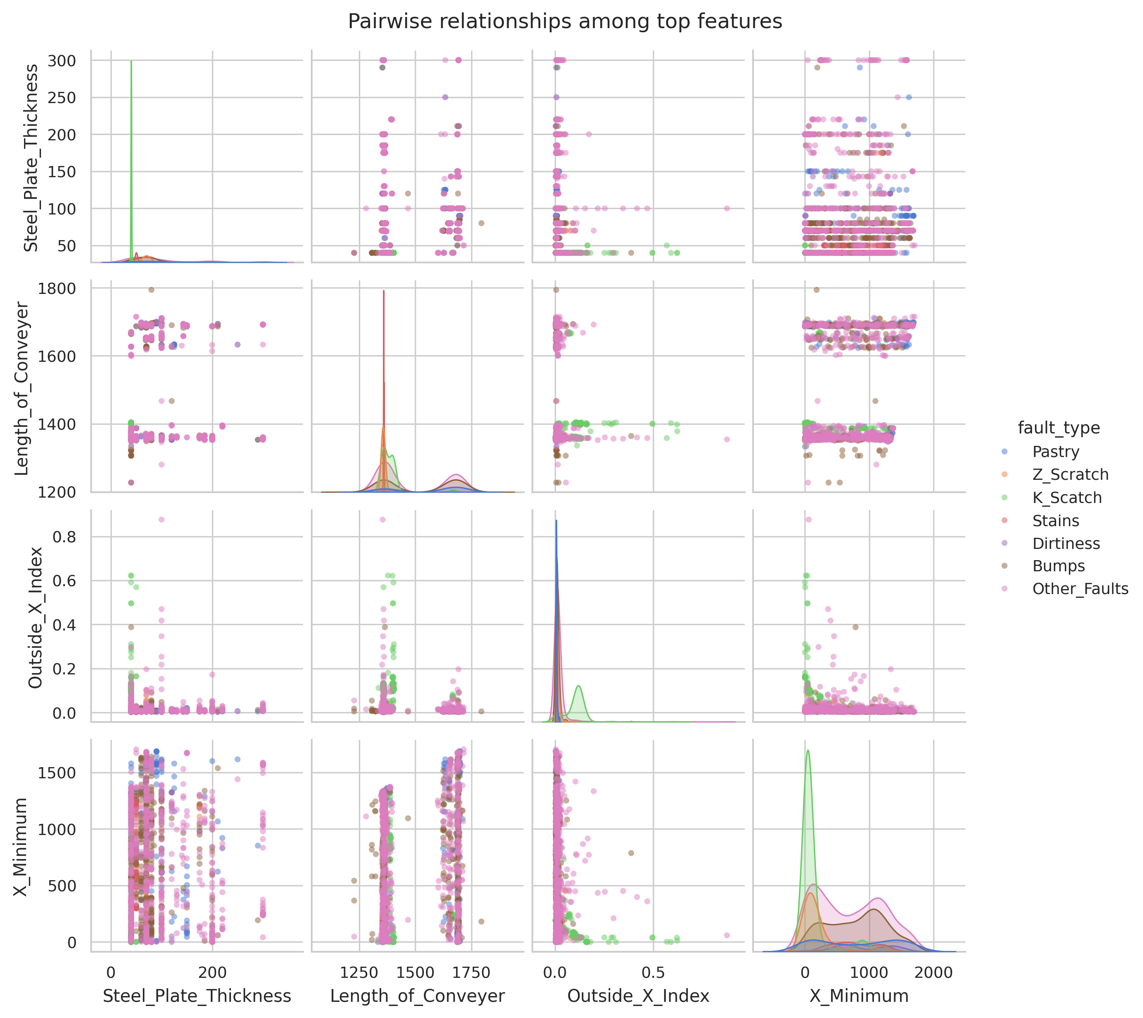
Fig. 4 — Pair plots of the top four features by mutual information.
Fig. 4 — Pair plots of the top four features (Steel_Plate_Thickness, Length_of_Conveyer, Outside_X_Index, X_Minimum) by mutual information with the target on the post-selection training set, coloured by fault category. Class-separable structure is visible particularly for K_Scatch and Z_Scratch.
Table III — Feature-selection outcome at correlation threshold $τ=0.90$.
Status | Count | Features
Kept (one-hot space) | 22 | X_Minimum, Y_Minimum, Sum_of_Luminosity, Minimum_of_Luminosity, Maximum_of_Luminosity, Length_of_Conveyer, TypeOfSteel_A300, TypeOfSteel_A400, Steel_Plate_Thickness, Edges_Index, Empty_Index, Square_Index, Outside_X_Index, Edges_X_Index, Edges_Y_Index, Outside_Global_Index, LogOfAreas, Log_X_Index, Log_Y_Index, Orientation_Index, Luminosity_Index, SigmoidOfAreas
Dropped | 5 | X_Maximum, Y_Maximum, Pixels_Areas, X_Perimeter, Y_Perimeter

C. Comparative Results
Table IV reports the test-set performance of the five methods after hyperparameter optimization. The two ensemble methods — Random Forest and CatBoost — produce closely matched leading scores: Random Forest achieves $F_{1}$-macro = 0.814 and accuracy = 0.805, while CatBoost achieves $F_{1}$-macro = 0.809 and accuracy = 0.807. CatBoost achieves the highest cross-validated $F_{1}$ (0.809) and the highest ROC-AUC (0.967). The neural-network methods follow at a noticeable distance: the multilayer perceptron reaches $F_{1}$-macro = 0.762 and TabNet $F_{1}$-macro = 0.733. The linear baseline trails substantially at $F_{1}$-macro = 0.645.
Table IV — Test-set comparison across the five intelligent methods.
Model | CV $F_{1}$-macro | Test $F_{1}$-macro | Test Acc. | ROC-AUC | Train [s]
Logistic Regression | 0.677 ± 0.011 | 0.645 | 0.656 | 0.932 | 4
Random Forest | 0.801 ± 0.015 | 0.814 | 0.805 | 0.963 | 16
CatBoost | 0.809 ± 0.012 | 0.809 | 0.807 | 0.967 | 59
Multilayer Perceptron | 0.774 ± 0.016 | 0.762 | 0.722 | 0.955 | 137
TabNet | 0.735 ± 0.009 | 0.733 | 0.704 | 0.941 | 224
To assess whether the leading methods are reliably distinguishable, a paired comparison was performed on the five inner-fold $F_{1}$-macro scores produced by each method’s selected hyperparameters under the identical StratifiedKFold(n=5, seed=42) partition. The Wilcoxon signed-rank test [9] and the paired Student $t$-test were both applied (Table V). Random Forest and CatBoost are not distinguishable under either test ($p_{\text{Wilcoxon}}=0.31$, $p_{t}=0.20$). Both ensemble methods are significantly different from the multilayer perceptron and TabNet under the paired $t$-test ($p_{t}<0.05$); the Wilcoxon test reports its boundary value of $p=0.0625$ in those cases — a known artefact of the test’s discretization at $n=5$ paired observations — so the $t$-test result is more informative. The multilayer perceptron is also significantly different from TabNet ($p_{t}=0.027$). These results should be interpreted as evidence that the test-set $F_{1}$ ranking RF ≈ CatBoost > MLP > TabNet > LR is not an artefact of the single test split, while acknowledging the limited statistical power of $n=5$ paired observations.
Table V — Paired tests on five inner-fold $F_{1}$-macro scores per method.
Comparison | $Δ\overset{‾}{F_{1}}$ | Wilcoxon $p$ | $t$-test $p$
RF vs CatBoost | $−0.008$ | 0.31 | 0.20
RF vs MLP | $+0.027$ | 0.06 | 0.02
RF vs TabNet | $+0.065$ | 0.06 | 0.001
CatBoost vs MLP | $+0.035$ | 0.06 | 0.004
CatBoost vs TabNet | $+0.074$ | 0.06 | 0.001
MLP vs TabNet | $+0.038$ | 0.06 | 0.027
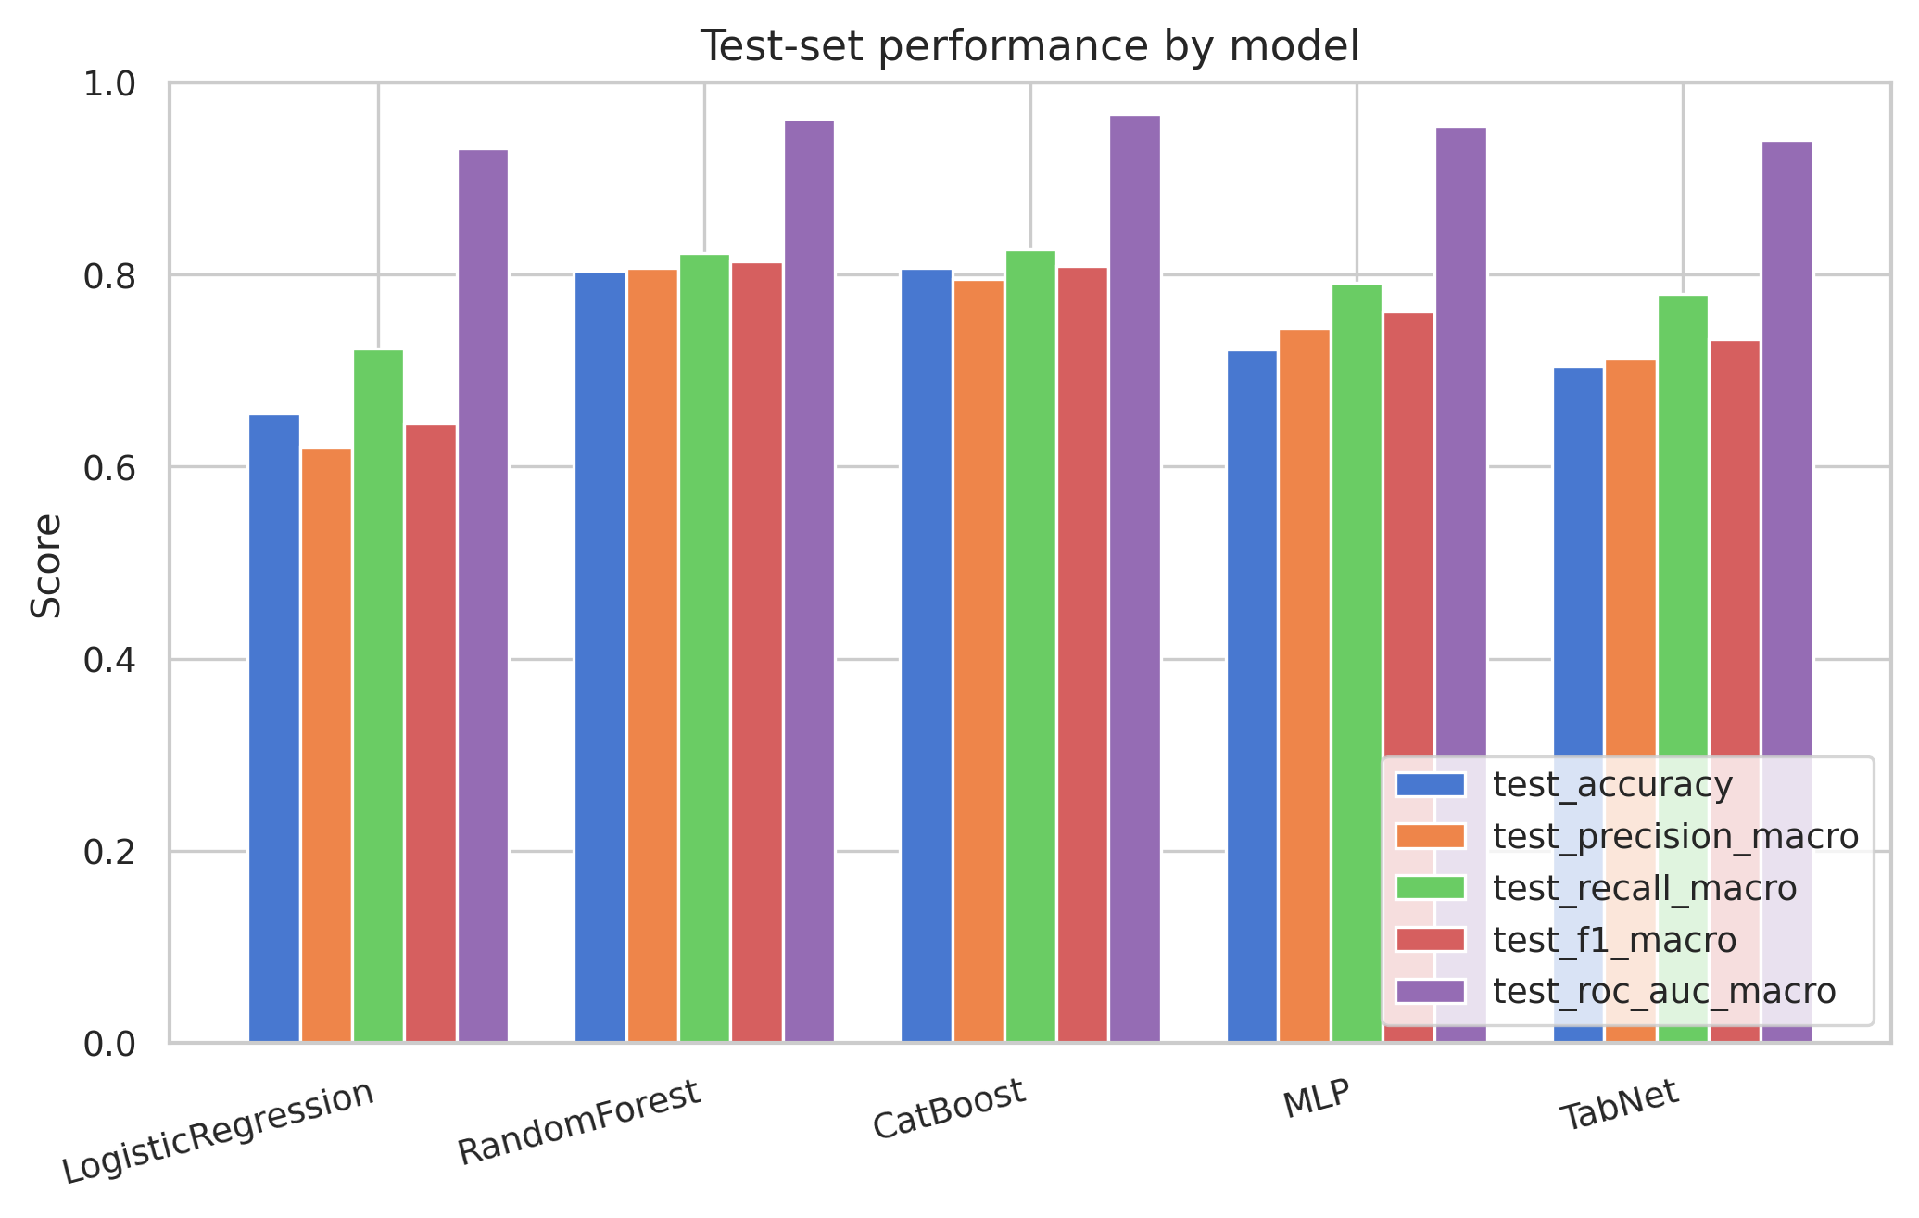
Fig. 5 — Test-set performance across the five methods.
Fig. 5 — Test-set performance across all five methods, displayed across accuracy, precision-macro, recall-macro, F1-macro, and ROC-AUC-macro. ROC-AUC values are uniformly high (> 0.93), reflecting the relatively easy separability of several fault categories.
The comparison plot (Fig. 5) visualises the spread across all five reported metrics. ROC-AUC values are uniformly high (> 0.93 for every method), reflecting the relatively easy separability of several fault categories — notably K_Scatch and Z_Scratch — under the geometric features.
The hyperparameter tuning revealed that three of the five methods chose configurations at the boundary of their search grids: CatBoost selected depth=8 (the deepest grid value), the multilayer perceptron selected the largest network architecture (128, 64) with the largest dropout rate (0.3), while TabNet selected the smaller architecture (n_d=n_a=16, n_steps=3) — preferring lower model capacity on this dataset.

D. Winner Diagnostics
The Random Forest classifier is selected as the comparative winner by test $F_{1}$-macro and analysed in detail. The row-normalised confusion matrix (Fig. 6) shows uniformly strong recall for the well-separated categories: K_Scatch 0.94, Dirtiness 0.91, Z_Scratch 0.89, Stains 0.86. The Bumps and Other_Faults categories achieve 0.74 and 0.76 recall respectively. Pastry is the weakest category, with recall of 0.66 and substantial confusion with Bumps (16%) and Other_Faults (19%). This confusion pattern — concentrated among the visually less-distinct categories — is consistent across all five evaluated methods (analysis omitted for space).
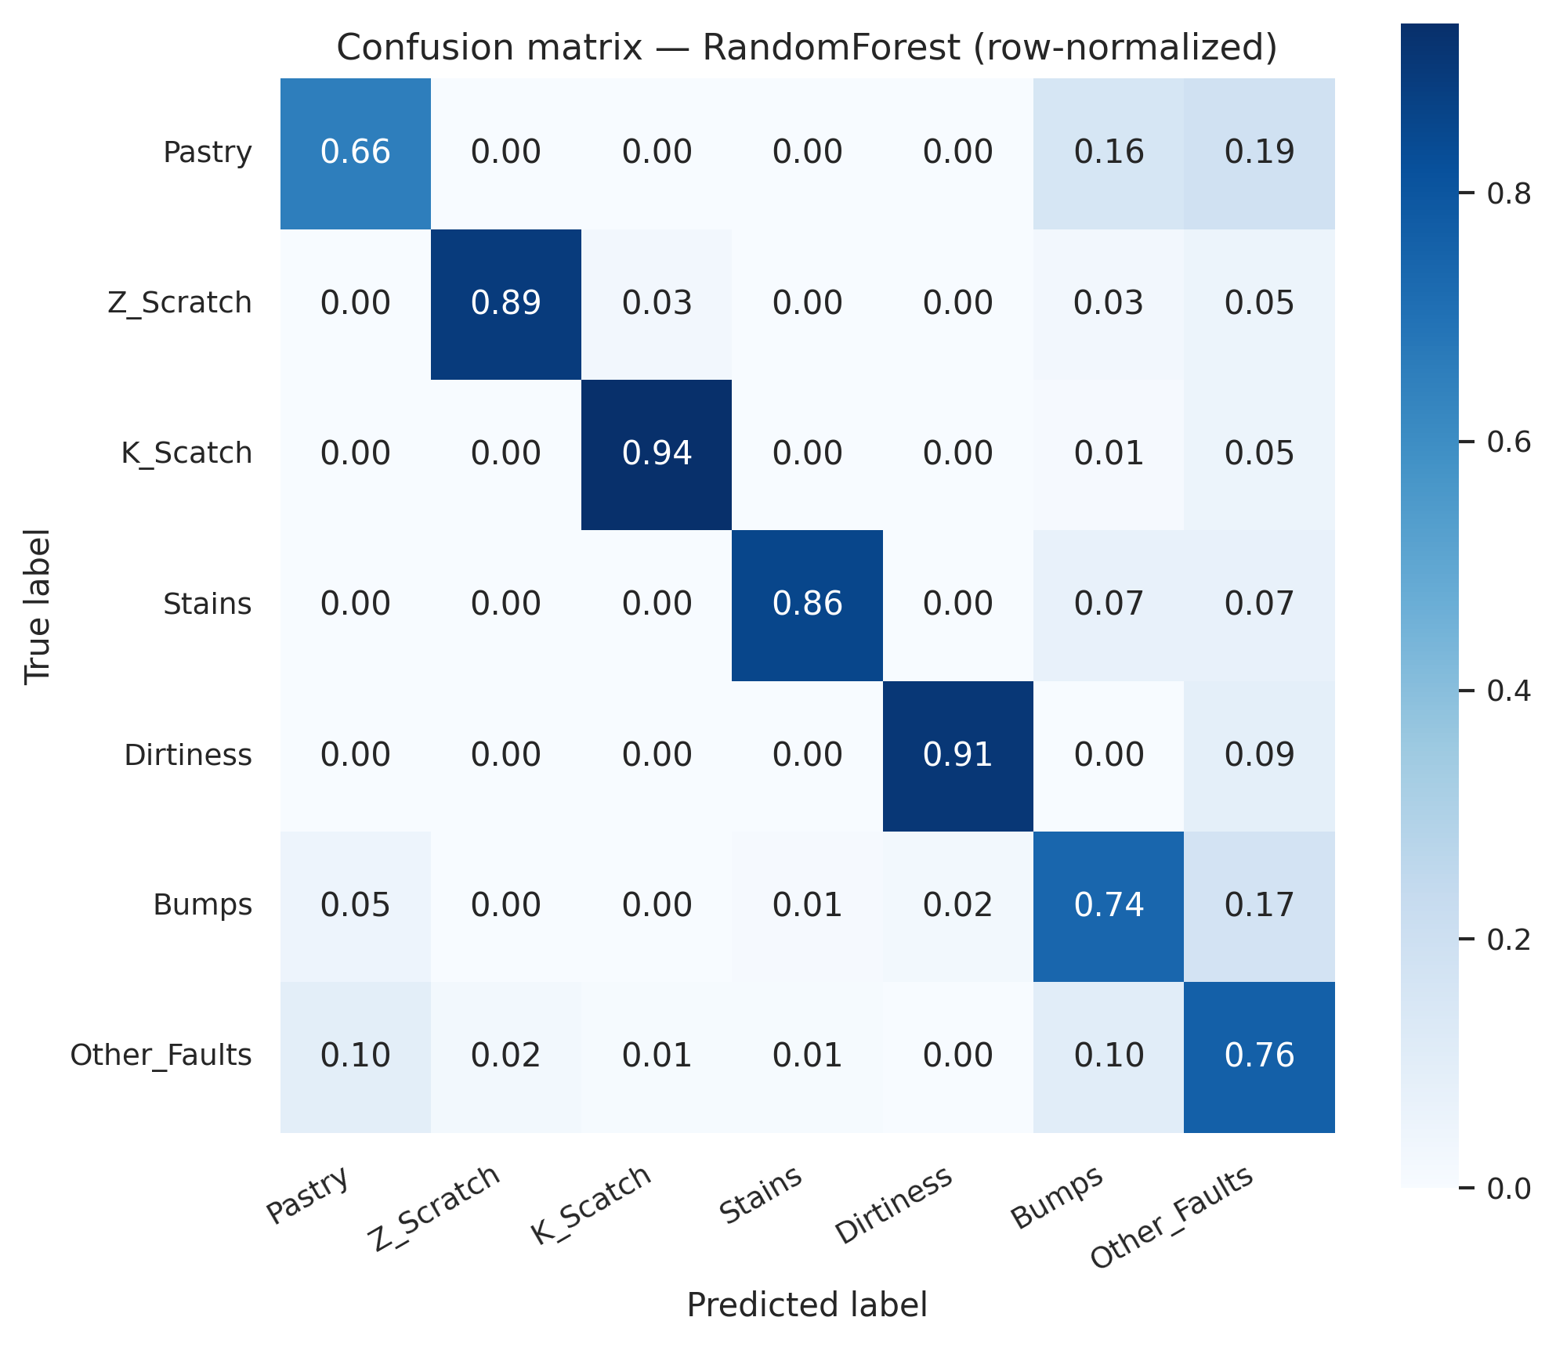
Fig. 6 — Row-normalised confusion matrix for the Random Forest winner.
Fig. 6 — Row-normalised confusion matrix for the Random Forest winner. Strong diagonal for K_Scatch, Z_Scratch, Stains, and Dirtiness; concentrated confusion among Pastry, Bumps, and Other_Faults.
The per-class precision–recall–$F_{1}$ table (Table VI) confirms that the minority categories Stains and Dirtiness, despite their small sample sizes (14 and 11 test samples), achieve $F_{1}$ scores of 0.86 and 0.87 respectively, indicating that SMOTENC oversampling effectively counteracts the class imbalance during training.
Table VI — Per-class precision, recall, and $F_{1}$ for the Random Forest winner.
Class | Precision | Recall | $F_{1}$ | Support
Pastry | 0.553 | 0.656 | 0.600 | 32
Z_Scratch | 0.919 | 0.895 | 0.907 | 38
K_Scatch | 0.973 | 0.936 | 0.954 | 78
Stains | 0.857 | 0.857 | 0.857 | 14
Dirtiness | 0.833 | 0.909 | 0.870 | 11
Bumps | 0.732 | 0.741 | 0.736 | 81
Other_Faults | 0.786 | 0.763 | 0.774 | 135
Macro avg | 0.808 | 0.822 | 0.814 | 389
Weighted avg | 0.810 | 0.805 | 0.807 | 389
Feature-importance analysis aggregated by the five logical groups (Table VII, Fig. 7) attributes 34% of total importance to shape-index features, 25% to geometric extents, 18% to luminance, 17% to log-transformed area descriptors, and 6% to the categorical steel-type encoding. The top-ranked individual features are Length_of_Conveyer (0.089), LogOfAreas (0.078), Sum_of_Luminosity (0.067), Steel_Plate_Thickness (0.059), and SigmoidOfAreas (0.054). This ranking is interpretable in industrial terms: the dominant signal arises from defect-size descriptors (areas via logarithms and the sigmoid transform), production-line geometry (conveyor length, plate thickness), and integrated luminance, which together capture both the spatial extent and the contrast of the surface anomaly.
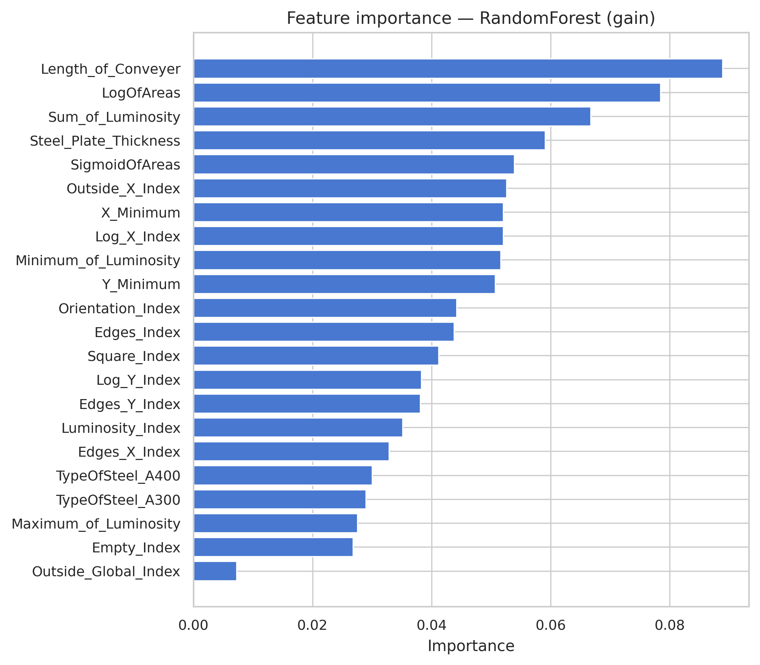
Fig. 7 — Random Forest gain-based feature importance.
Fig. 7 — Random Forest gain-based feature importance. Length_of_Conveyer, LogOfAreas, Sum_of_Luminosity, Steel_Plate_Thickness, and SigmoidOfAreas dominate.
Table VII — Aggregated feature importance by logical group.
Feature group | Sum of importance | Mean | Count | Share
Shape index | 0.341 | 0.038 | 9 | 34%
Geometric | 0.251 | 0.063 | 4 | 25%
Luminosity | 0.181 | 0.045 | 4 | 18%
Log-transformed | 0.169 | 0.056 | 3 | 17%
Categorical | 0.059 | 0.030 | 2 | 6%

V. Discussion
The principal finding of this study is the clear advantage of classical ensemble methods over deep tabular architectures on this small industrial dataset. Random Forest and CatBoost are not distinguishable in performance under either a Wilcoxon signed-rank test or a paired Student $t$-test on the inner-fold scores (Table V), and we report them as joint leaders rather than as a strict ordering. The multilayer perceptron and TabNet trail by 4–8 macro-$F_{1}$ points, a gap that is significant under the paired $t$-test despite the limited statistical power of $n=5$ paired observations. This pattern is consistent with recent systematic findings in the tabular-deep-learning literature: Grinsztajn et al. [6] demonstrated across a broad benchmark that tree-based ensembles outperform attention-based and feature-tokenization-based deep tabular models on small-to-medium tabular datasets, attributing the gap to the inductive biases of decision-tree splitting under the rotational and scale invariances typical of tabular data. The Borisov et al. survey [7] reaches the same conclusion. The result reported here confirms this pattern in an industrial defect-classification context with $N≈2 000$ samples.
A second observation concerns the asymmetric behaviour of the deep methods. The multilayer perceptron consistently outperformed TabNet, despite TabNet’s specialised attention-based feature-selection mechanism. The hyperparameter outcome is informative: TabNet selected the smaller network configuration (n_d=n_a=16, n_steps=3), suggesting that the architecture’s capacity could not be fully exploited at this dataset size and that the simpler dense baseline made better use of the available parameters under the shared training budget. This corroborates a recurring observation in tabular-DL benchmarks that architectural complexity does not automatically translate to predictive gains on small industrial inputs.
A third observation concerns the role of correlation-based feature selection. Reducing the feature set from 27 to 22 columns through hierarchical correlation clustering simplified the input space without observable harm to predictive performance, while improving interpretability of the feature-importance analysis. The persistence of the steel-type one-hot encoding in the input — despite its perfect anti-correlation — was deliberate: industrial deployments routinely benefit from explicit, interpretable categorical encodings even when statistically redundant.
The class-imbalance treatment via SMOTENC inside the cross-validation loop produced strong per-class performance for the minority categories (Stains, Dirtiness). Both achieved $F_{1}$ scores above 0.85 despite under-representation, suggesting that synthetic oversampling — when properly contained inside the training fold — is effective at this scale and does not require alternative imbalance-handling strategies.
Several limitations qualify the interpretation. First, the dataset’s feature semantics are partially opaque: while the column names of the 27 indicators are known, the original commissioning documentation does not disclose the precise physical sensor or imaging mechanisms underlying each indicator. Feature-importance interpretation is therefore confined to feature-group level rather than physical-mechanism level. Second, the absolute size of the dataset — 1 941 samples across seven categories, with 55 samples in the smallest category — places this study in a regime that strongly favours tree-based methods; results may not extrapolate to deployments with substantially larger labelled corpora. Third, the proposed protocol does not address concept drift or online adaptation, both of which are relevant for sustained industrial deployment.
The generalisability of the proposed comparative protocol — combining correlation-cluster feature selection, fold-internal SMOTENC oversampling, exhaustive grid search under stratified inner cross-validation, and held-out test evaluation — extends beyond steel-defect classification to other small-tabular industrial classification tasks where class imbalance, sensor-derived feature redundancy, and constrained training-data volumes are typical conditions.

VI. Conclusion
This paper presented a unified comparative protocol for evaluating intelligent classification methods on small industrial tabular datasets, applied to a seven-class steel-plate surface-defect classification task. Five methods spanning four architectural families were compared under identical preprocessing, oversampling, hyperparameter-search, and evaluation procedures.
The principal results are: (i) classical ensemble methods — Random Forest and CatBoost — produce closely matched leading performance that is not distinguishable under paired Wilcoxon and $t$-tests on the inner-fold scores (test $F_{1}$-macro ≈ 0.81); (ii) deep tabular architectures — multilayer perceptron and TabNet — trail by a margin that is significant under the paired $t$-test despite extensive tuning, consistent with recent benchmark findings on small tabular data; (iii) correlation-based hierarchical feature selection effectively reduces input redundancy without performance loss; and (iv) SMOTENC oversampling applied inside cross-validation folds produces strong minority-class recall.
For practical industrial deployment on datasets of comparable scale, Random Forest is recommended as the production model: it achieves leading performance, trains in 16 seconds on commodity hardware, requires no GPU acceleration, and provides interpretable feature-importance signals tied to defect-size and production-line-geometry descriptors. CatBoost remains a viable alternative when native categorical-feature handling is operationally beneficial.
Future work will extend the comparative framework to incorporate concept-drift monitoring for sustained industrial deployment, investigate transfer learning from larger surface-defect imaging corpora to compensate for limited labelled data, and evaluate the proposed protocol on additional industrial-quality-control tasks. Integration with edge-deployable inference frameworks and computational-cost-aware model selection criteria represents a further direction for resource-constrained industrial environments.

Code and Data Availability
The dataset used in this study is the publicly available Steel Plates Faults dataset from the UCI Machine Learning Repository [11], originally produced by Semeion Research Center [10]. The complete experimental code — including data-preparation utilities, the per-method pipeline definitions, the three Jupyter notebooks reproducing all reported results, and the lock file pinning every package version — is available at [repository URL to be inserted]. All experiments are reproducible from a clean environment via uv sync followed by sequential execution of 01_eda.ipynb, 02_compare_models.ipynb, and 03_winner_diagnostics.ipynb, with the global random seed 42 ensuring deterministic outcomes on hardware of equivalent compute capability.

References
[1] L. Breiman, “Random Forests,” Machine Learning, vol. 45, no. 1, pp. 5–32, 2001.
[2] T. Chen and C. Guestrin, “XGBoost: A Scalable Tree Boosting System,” in Proc. 22nd ACM SIGKDD Int. Conf. on Knowledge Discovery and Data Mining, 2016, pp. 785–794.
[3] L. Prokhorenkova, G. Gusev, A. Vorobev, A. V. Dorogush, and A. Gulin, “CatBoost: unbiased boosting with categorical features,” in Proc. 32nd Conf. Neural Information Processing Systems (NeurIPS), 2018, pp. 6638–6648.
[4] S. Ö. Arik and T. Pfister, “TabNet: Attentive Interpretable Tabular Learning,” in Proc. AAAI Conf. on Artificial Intelligence, vol. 35, no. 8, 2021, pp. 6679–6687.
[5] Y. Gorishniy, I. Rubachev, V. Khrulkov, and A. Babenko, “Revisiting Deep Learning Models for Tabular Data,” in Proc. 35th Conf. Neural Information Processing Systems (NeurIPS), 2021, pp. 18932–18943.
[6] L. Grinsztajn, E. Oyallon, and G. Varoquaux, “Why do tree-based models still outperform deep learning on tabular data?,” in Proc. 36th Conf. Neural Information Processing Systems (NeurIPS) Datasets and Benchmarks Track, 2022.
[7] V. Borisov, T. Leemann, K. Seßler, J. Haug, M. Pawelczyk, and G. Kasneci, “Deep Neural Networks and Tabular Data: A Survey,” IEEE Transactions on Neural Networks and Learning Systems, vol. 35, no. 6, pp. 7499–7519, 2024.
[8] N. V. Chawla, K. W. Bowyer, L. O. Hall, and W. P. Kegelmeyer, “SMOTE: Synthetic Minority Over-sampling Technique,” Journal of Artificial Intelligence Research, vol. 16, pp. 321–357, 2002.
[9] G. Lemaître, F. Nogueira, and C. K. Aridas, “Imbalanced-learn: A Python Toolbox to Tackle the Curse of Imbalanced Datasets in Machine Learning,” Journal of Machine Learning Research, vol. 18, no. 17, pp. 1–5, 2017.
[10] M. Buscema, S. Terzi, and W. Tastle, “A new meta-classifier,” in Proc. 2010 Annual Meeting of the North American Fuzzy Information Processing Society, IEEE, 2010, pp. 1–7.
[11] D. Dua and C. Graff, “Steel Plates Faults Data Set,” UCI Machine Learning Repository, 2010. [Online]. Available: https://archive.ics.uci.edu/ml/datasets/Steel+Plates+Faults
[12] F. Pedregosa et al., “Scikit-learn: Machine Learning in Python,” Journal of Machine Learning Research, vol. 12, pp. 2825–2830, 2011.
[13] A. Paszke et al., “PyTorch: An Imperative Style, High-Performance Deep Learning Library,” in Proc. 33rd Conf. Neural Information Processing Systems (NeurIPS), 2019, pp. 8024–8035.
[14] M. Tietz, T. J. Fan, D. Nouri, and B. Bossan, “skorch: A scikit-learn compatible neural network library that wraps PyTorch,” 2017. [Online]. Available: https://skorch.readthedocs.io/
[15] D. P. Kingma and J. Ba, “Adam: A Method for Stochastic Optimization,” in Proc. 3rd Int. Conf. on Learning Representations (ICLR), 2015.
[16] J. Zhang and Q. Yang, “Survey on Deep Learning for Industrial Applications,” IEEE Transactions on Industrial Informatics, vol. 17, no. 7, pp. 4514–4528, 2021.
[17] M. Y. Kim, S. H. Lee, and J. W. Park, “Surface Defect Classification of Steel Strip Using Convolutional Neural Networks,” IEEE Access, vol. 9, pp. 9148–9156, 2021.

