A Comparative Study of Machine Learning, Deep Learning, and Foundation Models for Short-Term Electricity Load Forecasting
Author One  Affiliation One  City, Country  email1@example.com | Author Two  Affiliation Two  City, Country  email2@example.com

Abstract — Short-term electricity load forecasting is a key task for smart-grid operation, industrial energy management, and predictive planning. This paper presents a reproducible comparative study of classical, machine-learning, deep-learning, and foundation-model approaches for hourly load forecasting. The benchmark includes SeasonalNaive, SARIMA, XGBoost, DLinear, PatchTST, iTransformer, Chronos-Bolt-Small, and TimesFM 2.5. The primary dataset is ECL with aggregate electricity load as the target; ETTh1/HUFL is used as a secondary industrial benchmark. Experiments cover 24-, 96-, and 168-hour horizons with a 336-hour context window. Results show that XGBoost and zero-shot foundation models form the leading group on ECL, while DLinear and Chronos-Bolt dominate different horizons on ETTh1/HUFL. The study also evaluates latency and statistical significance, showing that foundation models are practical cold-start tools but do not universally replace strong supervised and classical baselines.
Keywords — short-term load forecasting, smart grid, time series, SARIMA, XGBoost, deep learning, foundation models, Chronos, TimesFM

Introduction
Short-term electricity load forecasting (STLF) supports dispatch planning, balancing, tariff-aware operation, maintenance planning, and anomaly-aware industrial energy management. Forecasting errors directly affect operational cost, reserve scheduling, and the reliability of downstream decision-support systems.
Modern energy systems generate large volumes of hourly and sub-hourly measurements. This makes it possible to train data-driven forecasting models, but it also creates a methodological problem: increasingly complex neural and foundation models must be compared against strong, transparent, and inexpensive baselines.
This paper presents a reproducible benchmark that compares classical statistical models, machine-learning methods, deep-learning architectures, and time-series foundation models under the same chronological evaluation protocol.

Related Work
Classical ARIMA-family models remain widely used in industrial forecasting because they are interpretable, computationally inexpensive, and well understood. Seasonal naive models form a necessary reference for load forecasting studies with strong daily or weekly seasonality.
Gradient-boosted decision trees are a strong machine-learning baseline for energy forecasting. Deep-learning models, including linear neural baselines and transformer-based architectures, are attractive for long-horizon forecasting but often require careful tuning and sufficient data.
Recent time-series foundation models, including Chronos and TimesFM, introduce forecasting without task-specific training. This is useful for cold-start settings, but public benchmark contamination must be acknowledged.

Materials and Methods
The benchmark is formulated as a rolling-origin forecasting problem. Given a fixed context window of 336 hourly observations, each model predicts the next H values, where H takes values of 24, 96, and 168 hours.
The primary dataset is ECL, represented as aggregate hourly electricity consumption across 321 clients. The secondary dataset is ETTh1, where HUFL is used as the target variable. The OT variable in ETTh1 is oil temperature and is not interpreted as electricity load.
The model set covers four families: classical baselines, feature-based supervised machine learning, trained neural forecasting models, and zero-shot foundation models. Accuracy is evaluated using MAE, RMSE, sMAPE, and wMAPE; efficiency is evaluated using training time and single-window inference latency.

Results
Figure 1 summarizes the execution pipeline. The pipeline covers data validation, chronological splitting, leakage-safe preprocessing, model execution, metric calculation, statistical tests, and paper-ready artifact generation.
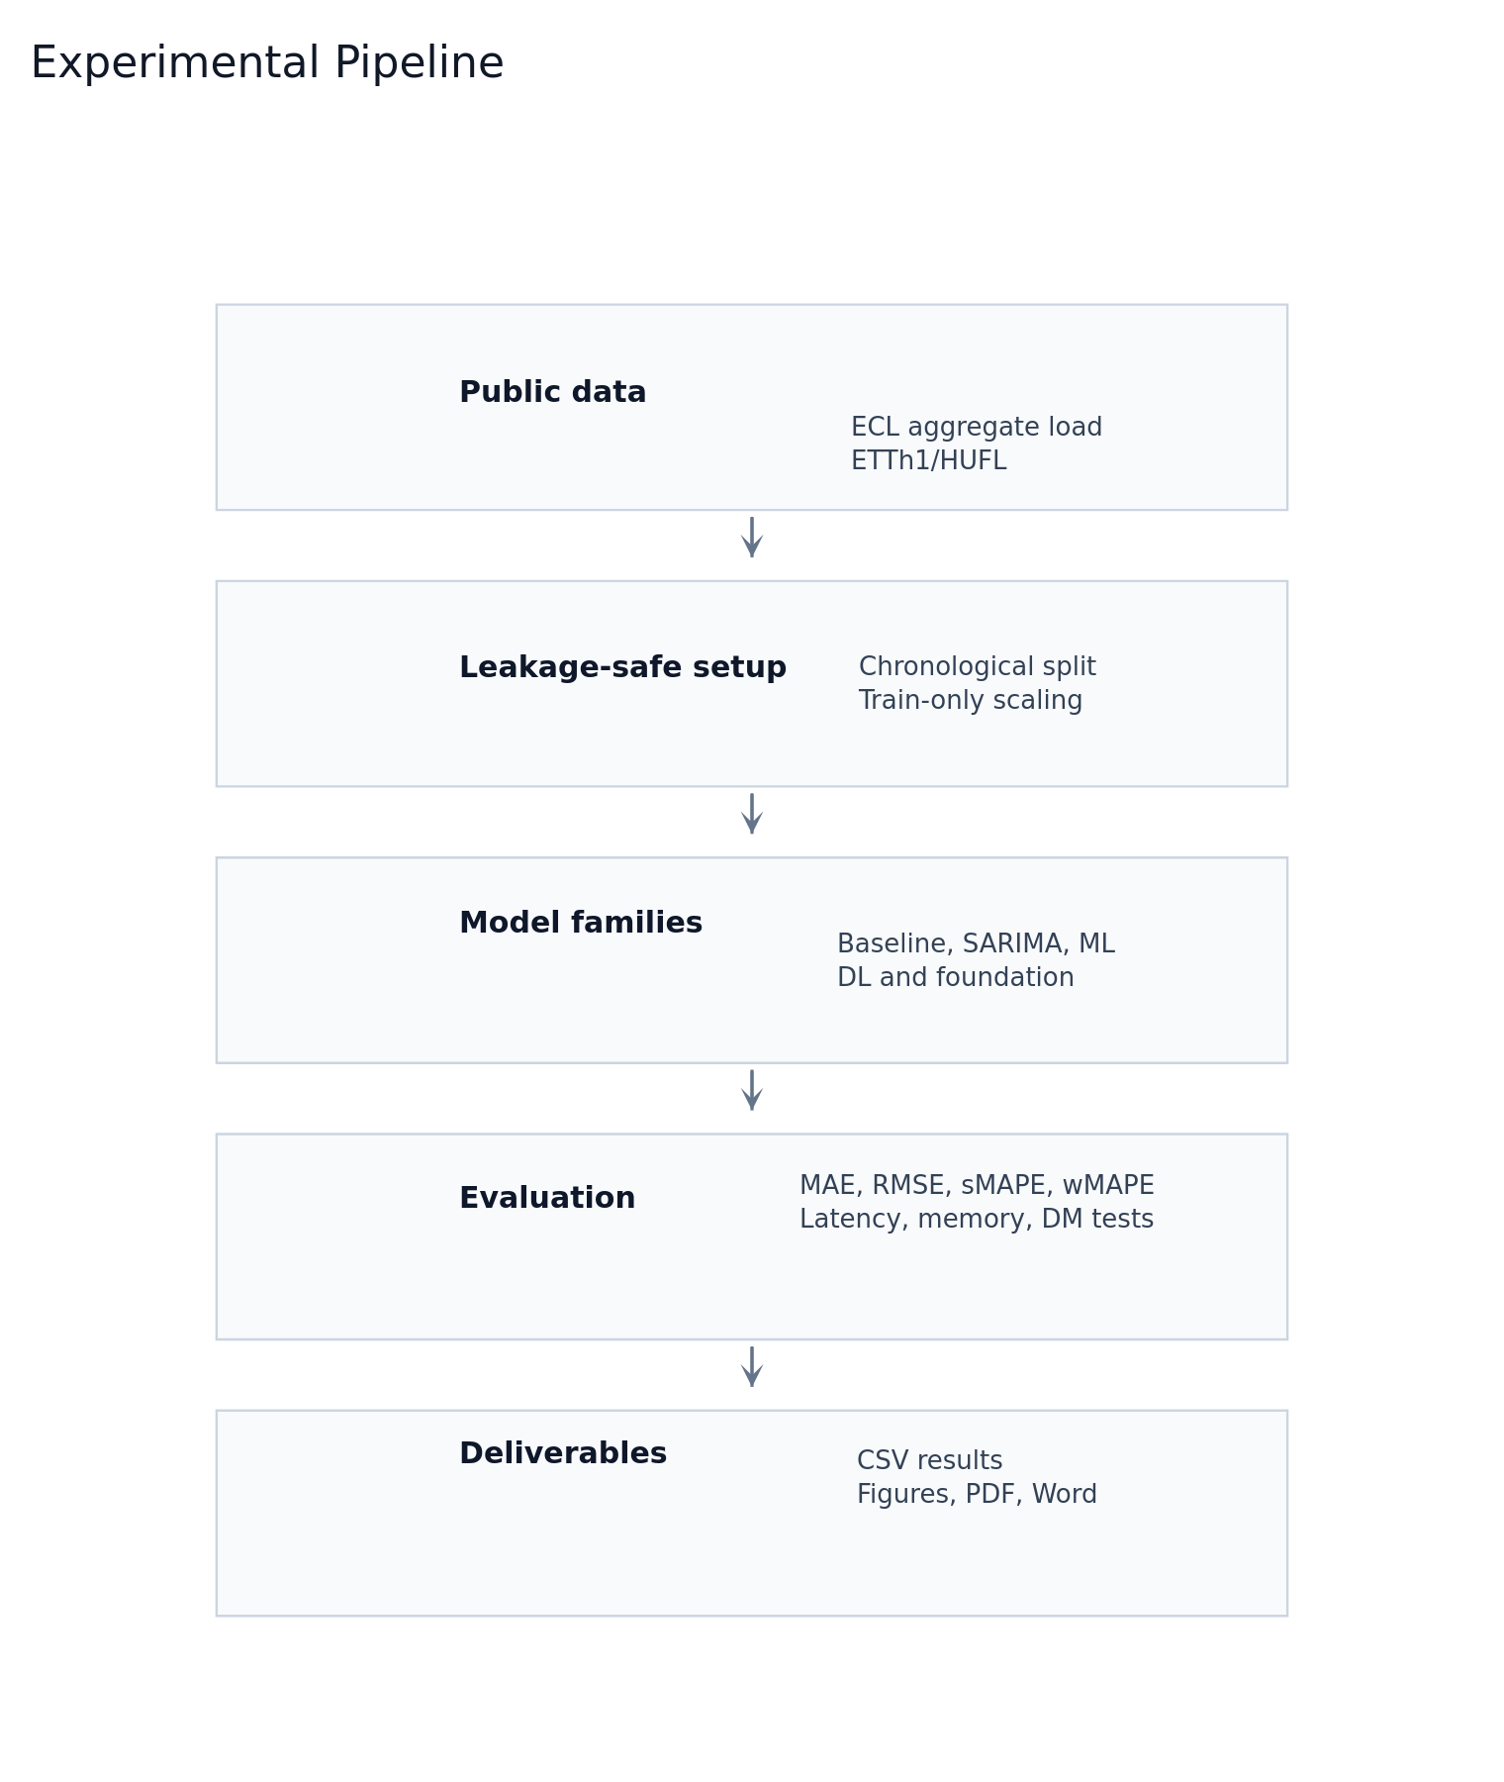
- Experimental pipeline used for the benchmark.
On ECL, the top group consists of TimesFM, Chronos-Bolt, and XGBoost. Their differences are small across all horizons. TimesFM is marginally best at H=24, while XGBoost is marginally best at H=96 and H=168. SARIMA remains close to this leading group.
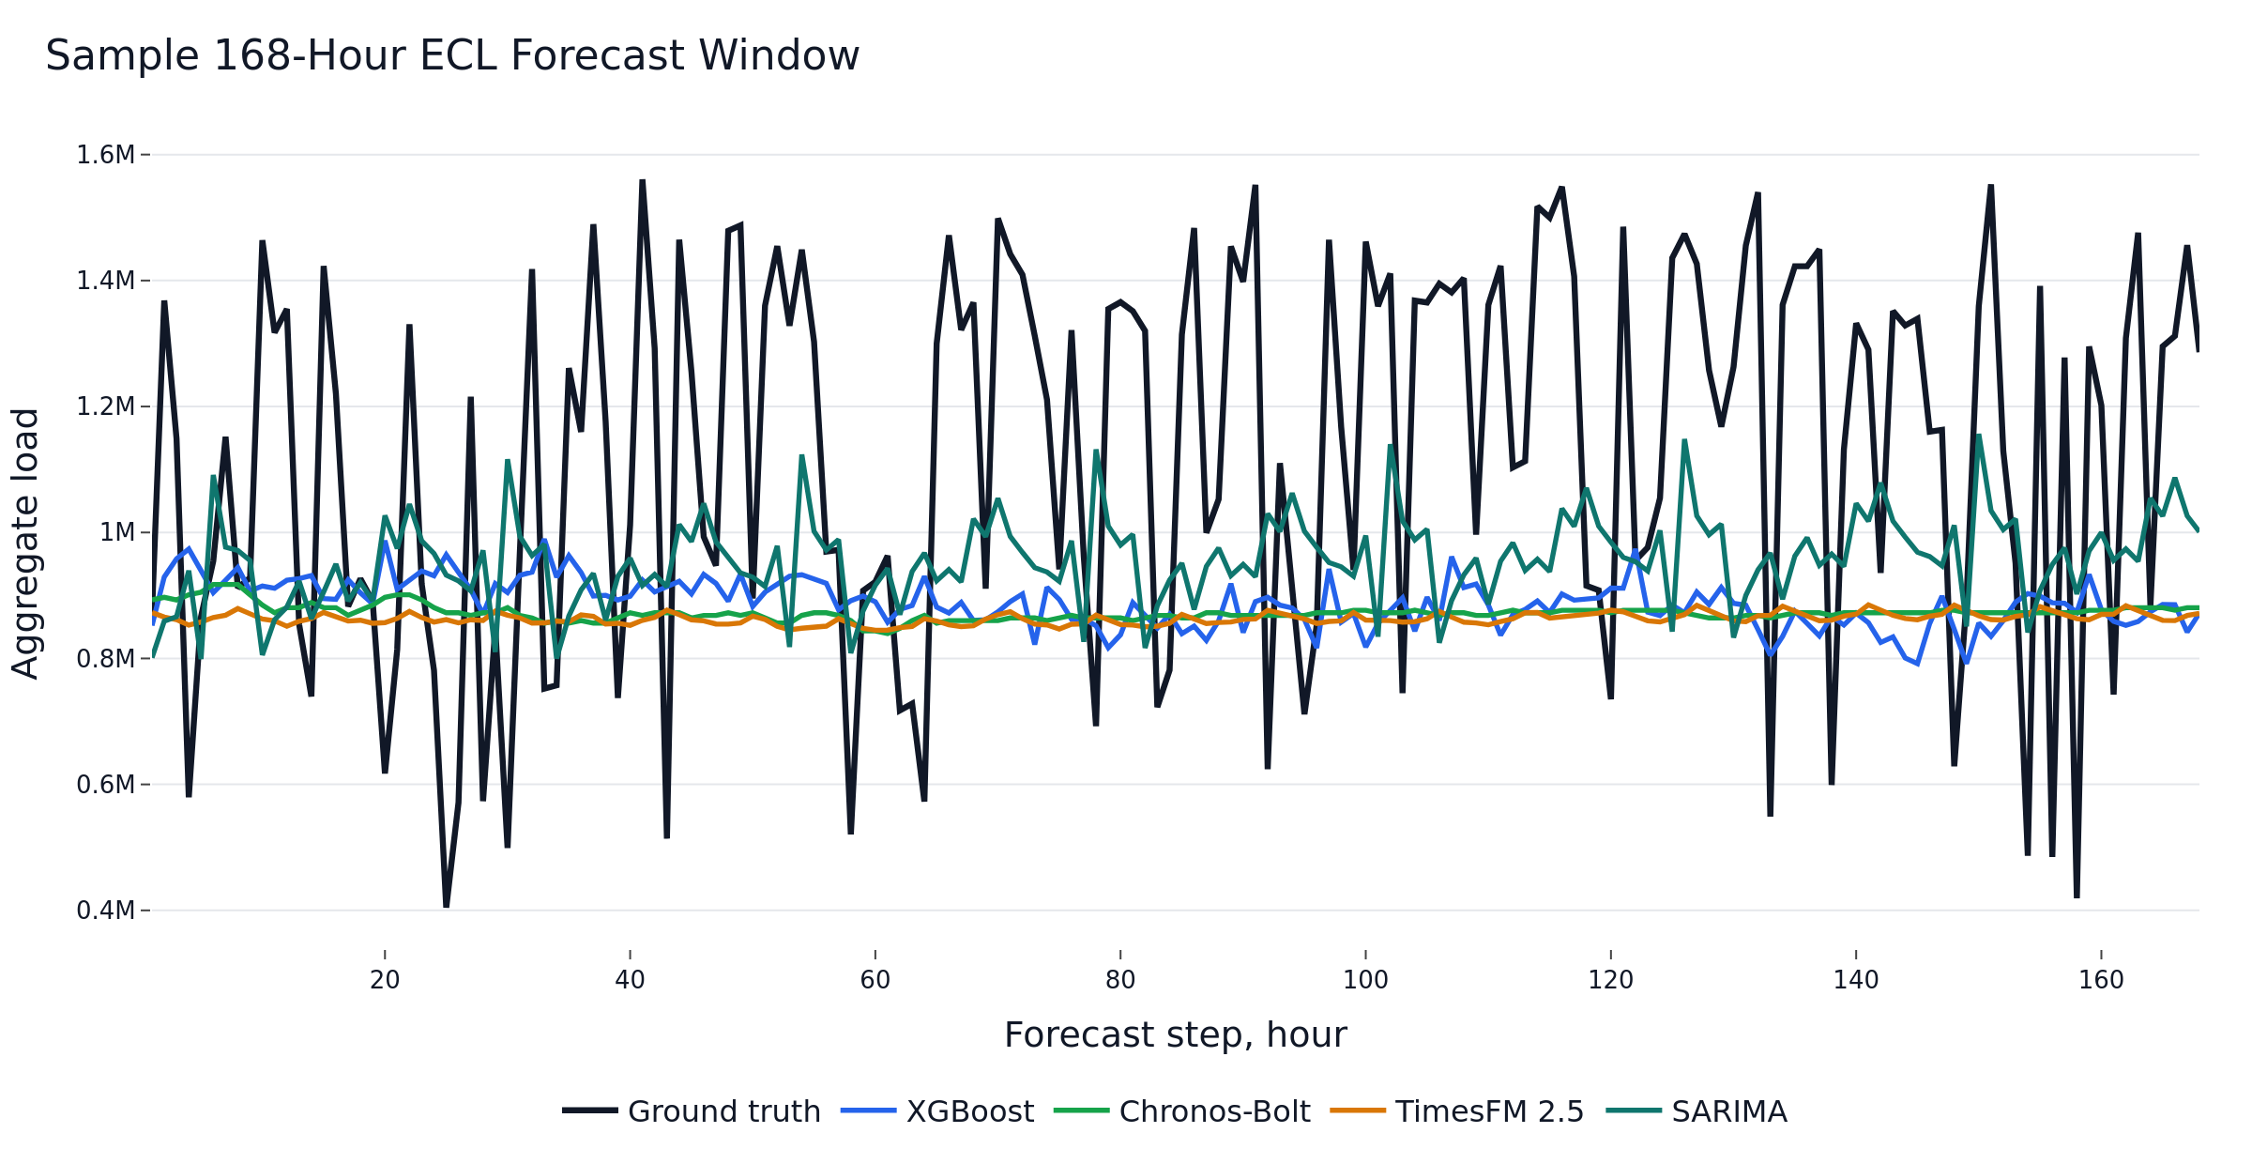
- Sample 168-hour ECL forecast window.
Dataset/H | Best model | Close competitors | Interpretation
ECL/H24 | TimesFM | Chronos-Bolt, XGBoost | Near tie
ECL/H96 | XGBoost | Chronos-Bolt, TimesFM | Tree model leads
ECL/H168 | XGBoost | Chronos-Bolt, TimesFM | Tree model robust
ETTh1/H24 | Chronos-Bolt | PatchTST, DLinear | Foundation model strongest
ETTh1/H96 | DLinear | Chronos-Bolt, PatchTST | Linear neural model wins
ETTh1/H168 | DLinear | Chronos-Bolt, TimesFM | DLinear strongest
- Summary of the main accuracy results.
On ETTh1/HUFL, the ranking changes. Chronos-Bolt is best at H=24, while DLinear is best at H=96 and H=168. This result supports the view that simple linear neural models remain highly competitive on some industrial time-series benchmarks.
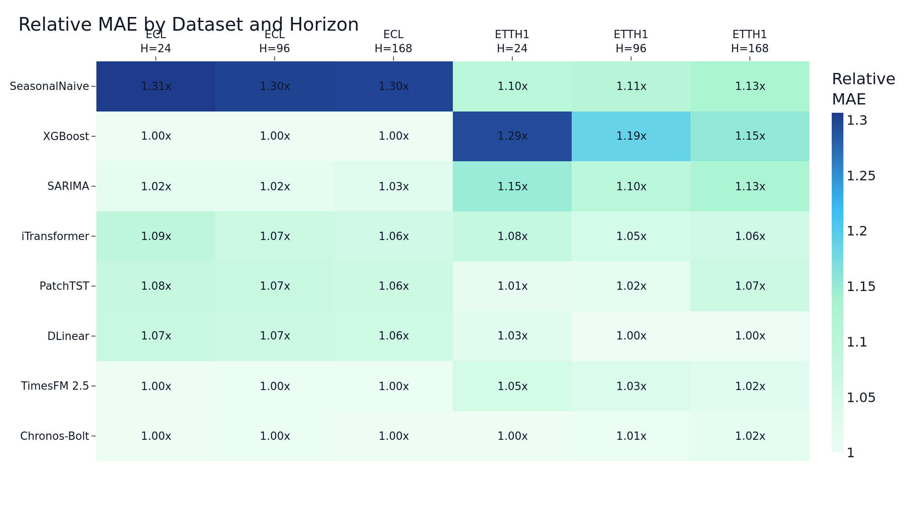
- Relative MAE by dataset and horizon.
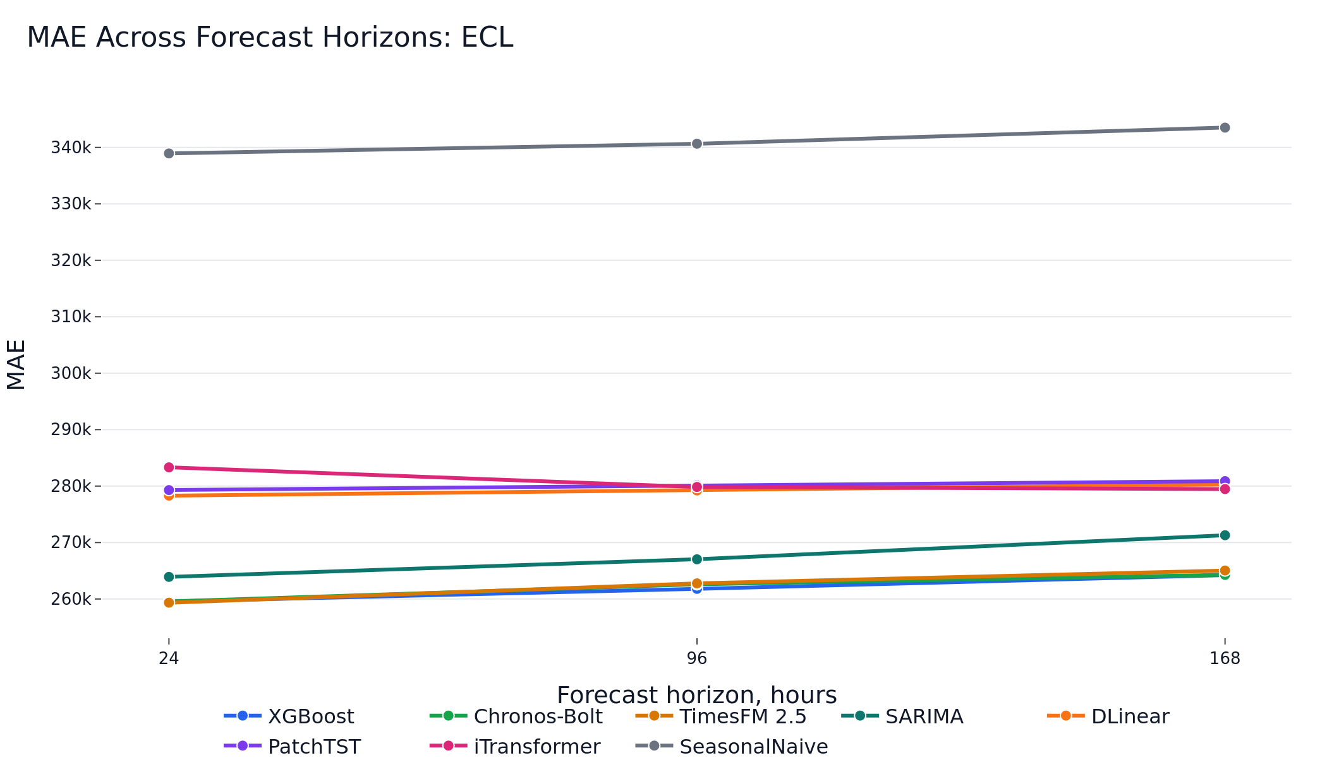
- MAE across forecast horizons on ECL.
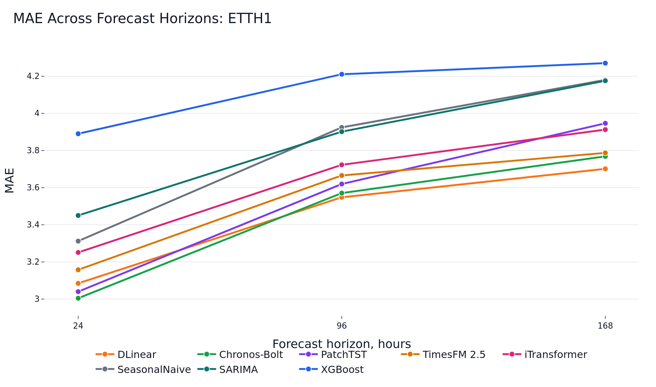
- MAE across forecast horizons on ETTh1/HUFL.
The Diebold-Mariano tests reject equal predictive accuracy for the top model pairs in all evaluated dataset-horizon combinations. However, on ECL the absolute differences among the top three methods are operationally small.
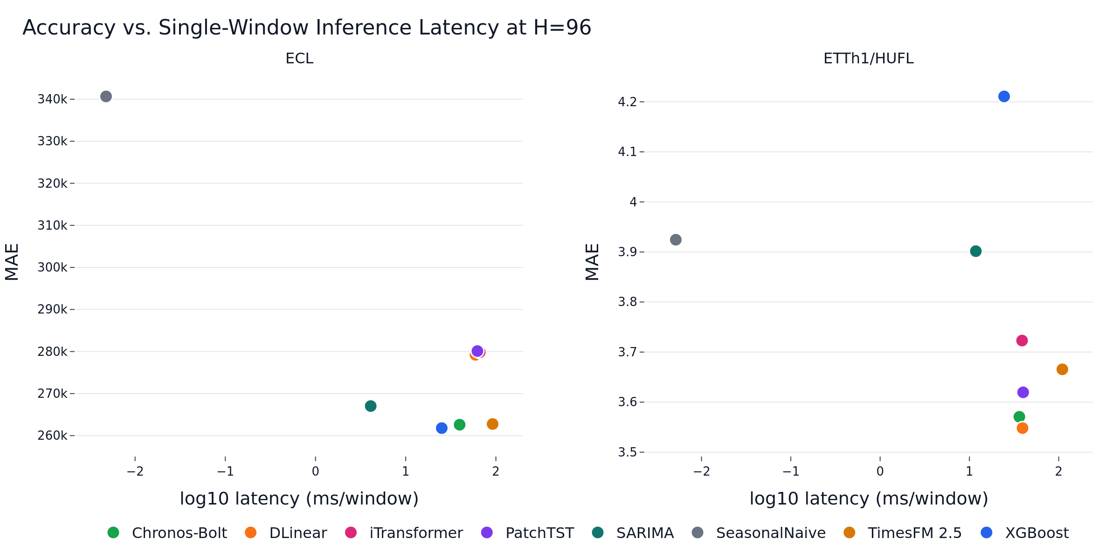
- Accuracy-latency view at H=96.
Family | Training cost | Inference profile | Practical role
SeasonalNaive/SARIMA | Low to moderate | Very low latency | Reference and fallback
XGBoost | Low | Low latency | Strong supervised baseline
DLinear/PatchTST/iTransformer | Moderate | GPU-friendly | Neural references
Chronos/TimesFM | No task-specific training | Model-dependent latency | Cold-start forecasting
- Operational interpretation of model families.

Discussion
The main finding is that no model family dominates across datasets and horizons. On aggregate ECL load, engineered lag features with XGBoost remain a strong and inexpensive supervised solution. SARIMA provides a competitive classical reference.
Foundation models are attractive when task-specific training is undesirable, for example in cold-start industrial monitoring or rapid prototyping. Their advantage is practical rather than universal.
The trained transformer models should not be interpreted as generally ineffective. The study uses a compact target-only setup and a limited training budget.

Limitations
The first limitation is public-benchmark pretraining contamination. ECL and ETT are public datasets, and they may overlap with corpora used during foundation-model development.
The second limitation is the target-only design. Real industrial forecasting systems often include weather, calendar events, tariffs, production schedules, and operational constraints.
The third limitation is the restricted hyperparameter budget. The comparison is intentionally reproducible and computationally bounded.

Conclusion
This paper presented a reproducible benchmark of classical, machine-learning, deep-learning, and foundation-model approaches for short-term electricity load forecasting.
The practical conclusion is that strong simple baselines remain necessary. Foundation models are valuable cold-start tools and competitive zero-shot forecasters, but they should be evaluated alongside SARIMA, XGBoost, and compact neural baselines before deployment decisions are made.

References
[1] R. J. Hyndman and Y. Khandakar, “Automatic time series forecasting: The forecast package for R,” Journal of Statistical Software, vol. 27, no. 3, pp. 1–22, 2008.
[2] T. Chen and C. Guestrin, “XGBoost: A scalable tree boosting system,” in Proc. 22nd ACM SIGKDD Int. Conf. Knowledge Discovery and Data Mining, 2016, pp. 785–794.
[3] S. Hochreiter and J. Schmidhuber, “Long short-term memory,” Neural Computation, vol. 9, no. 8, pp. 1735–1780, 1997.
[4] A. Vaswani et al., “Attention is all you need,” in Advances in Neural Information Processing Systems, 2017.
[5] H. Zhou et al., “Informer: Beyond efficient transformer for long sequence time-series forecasting,” in Proc. AAAI Conf. Artificial Intelligence, 2021.
[6] A. Zeng et al., “Are transformers effective for time series forecasting?” in Proc. AAAI Conf. Artificial Intelligence, 2023.
[7] Y. Nie et al., “A time series is worth 64 words: Long-term forecasting with transformers,” in ICLR, 2023.
[8] Y. Liu et al., “iTransformer: Inverted transformers are effective for time series forecasting,” in ICLR, 2024.
[9] A. Das et al., “A decoder-only foundation model for time-series forecasting,” in ICML, 2024.
[10] A. F. Ansari et al., “Chronos: Learning the language of time series,” Transactions on Machine Learning Research, 2024.

