A Comparative Study of Machine Learning, Deep Learning, and Foundation Models for Short-Term Electricity Load Forecasting

Abstract — Short-term electricity load forecasting is a key task for smart-grid operation, industrial energy management, and predictive planning. This paper presents a reproducible comparative study of classical, machine-learning, deep-learning, and foundation-model approaches for hourly load forecasting. The benchmark includes SeasonalNaive, SARIMA, XGBoost, DLinear, PatchTST, iTransformer, Chronos-Bolt-Small, and TimesFM 2.5. The primary dataset is ECL with aggregate electricity load as the target; ETTh1/HUFL is used as a secondary industrial benchmark. Experiments cover 24-, 96-, and 168-hour horizons with a 336-hour context window. On ECL, the supervised neural models — iTransformer, DLinear, and PatchTST — achieve mean MAE roughly an order of magnitude lower than Chronos-Bolt-Small, TimesFM 2.5, and a grid-tuned SARIMA at every evaluated horizon. A controlled training-budget ablation shows that this gap is not a training-budget artefact: the supervised models converge within approximately 1000 optimizer steps and gain less than 4% in MAE between 500 and 5000 steps. On ETTh1/HUFL the ordering is more compressed: Chronos-Bolt is best at H=24, while DLinear is best at H=96 and H=168, with foundation models within a few percent. Diebold-Mariano tests on seed-averaged per-window errors confirm the leader ordering is statistically significant. The study also reports training time, single-window inference latency, and peak GPU memory, showing that foundation models remain attractive cold-start tools but, under the evaluated zero-shot configuration, do not universally replace properly trained supervised baselines.
Keywords — short-term load forecasting, smart grid, time series, SARIMA, XGBoost, deep learning, foundation models, Chronos, TimesFM

Introduction
Short-term electricity load forecasting (STLF) supports dispatch planning, balancing, tariff-aware operation, maintenance planning, and anomaly-aware industrial energy management. Forecasting errors directly affect operational cost, reserve scheduling, and the reliability of downstream decision-support systems. This role is consistent with the broader load-forecasting literature, where accurate point and probabilistic forecasts are treated as core inputs for smart-grid planning and operation [1].
Modern energy systems generate large volumes of hourly and sub-hourly measurements. This makes it possible to train data-driven forecasting models, but it also creates a methodological problem: increasingly complex neural and foundation models must be compared against strong, transparent, and inexpensive baselines. Earlier residential and building-load studies showed that recurrent and deep neural models can improve forecasting accuracy under suitable data conditions [2]–[4], but they do not remove the need for classical statistical controls.
This paper presents a reproducible benchmark that compares classical statistical models, machine-learning methods, deep-learning architectures, and time-series foundation models under the same chronological evaluation protocol. The comparison is deliberately pragmatic: the goal is not to declare a universally best model, but to identify where classical SARIMA, feature-based boosting, compact neural models, and zero-shot foundation models are operationally useful.
The contributions of this paper are as follows: (i) a reproducible side-by-side benchmark of two recent time-series foundation models (TimesFM 2.5 and Chronos-Bolt-Small) against a grid-tuned SARIMA, gradient-boosted trees, and three modern neural baselines under a single STLF protocol; (ii) Diebold-Mariano significance tests on seed-averaged per-window absolute errors for the leading model pairs at every horizon; (iii) an accuracy-latency Pareto analysis that quantifies the deployment cost of zero-shot inference relative to supervised alternatives; and (iv) a controlled training-budget ablation together with prediction-level inspection that shows the order-of-magnitude gap between supervised neural models and zero-shot foundation models on aggregate ECL load is an intrinsic limitation of the zero-shot configuration rather than an artifact of an under-trained supervised baseline.

Related Work
Classical ARIMA-family models remain widely used in industrial forecasting because they are interpretable, computationally inexpensive, and well understood. Their use follows the Box-Jenkins forecasting tradition [5], while modern automatic order-selection procedures and forecasting textbooks provide practical guidance for seasonal model identification and validation [6], [7]. Seasonal naive models are even simpler, but they form a necessary reference for load forecasting studies with strong daily or weekly seasonality.
Gradient-boosted decision trees are a strong machine-learning baseline for energy forecasting. XGBoost is particularly attractive because it combines nonlinear feature interactions, regularization, and fast training on tabular lag features [9]. Deep-learning models, including LSTM networks [10], attention-based architectures [11], and long-horizon transformer variants such as Informer, Autoformer, and FEDformer [12]–[14], are attractive for long-horizon forecasting but often require careful tuning and sufficient data.
Recent time-series foundation models introduce forecasting without task-specific training. TimesFM, Chronos, MOMENT, Moirai, and Lag-Llama represent a shift from dataset-specific supervised fitting towards pretrained sequence models for generic time-series prediction [20]–[24]. This is useful for cold-start settings, but public benchmark contamination must be acknowledged because ECL and ETT are widely used datasets and may have influenced model development.
For STLF specifically, this background implies that a useful comparison must include both domain-standard baselines and recent general-purpose models. A benchmark that contains only neural or foundation models risks overstating novelty, while a benchmark that excludes pretrained models misses a deployment pattern that is now common in industrial prototyping. Therefore, the present study evaluates classical seasonal methods, gradient boosting, compact neural architectures, and zero-shot foundation models within a single execution pipeline.
The long-sequence forecasting literature also motivates the inclusion of simple neural baselines. Linear and decomposition-based models have repeatedly shown that strong temporal biases can match or outperform more complex attention mechanisms on standard benchmarks [15]. Patch-based transformers and inverted-tokenization architectures address different weaknesses of vanilla sequence attention [16], [18], but their advantage is not guaranteed under a target-only STLF protocol. This makes DLinear, PatchTST, and iTransformer a useful compact neural set rather than an arbitrary model list.
Despite the rapid growth of time-series foundation models, side-by-side comparisons that place them next to a grid-tuned SARIMA and a feature-engineered XGBoost under a controlled latency budget remain uncommon. Existing benchmarks tend to either evaluate foundation models in relative isolation [20]–[24] or report neural-only rankings [15]–[18]. The present study addresses this gap by reporting all four families—classical, tree, compact neural, and foundation—within a single reproducible execution pipeline.

Materials and Methods
The benchmark is formulated as a univariate rolling-origin forecasting task. Given a context window of L=336 hourly observations, each model produces a multi-step point forecast for the next H values, where H ∈ {24, 96, 168}. Rolling-origin evaluation is used because it matches the operational setting in which a forecaster repeatedly receives a historical context and predicts a fixed future horizon. All trained models are evaluated on a held-out chronological test split in the original target scale after inverse standardization.
$$\hat{y_{t+1:t+H}}=f​\left(x_{t-L+1:t}\right), L=336, H∈\{24,96,168\}$$
The primary dataset is ECL (Electricity Consuming Load), aggregated across 321 clients at hourly resolution; the target is aggregate electricity load. The secondary dataset is ETTh1, where HUFL is used as the load-related target variable. The OT variable in ETTh1 is oil temperature and is therefore not interpreted as electricity load. Both datasets are common public benchmarks for long- and short-term time-series forecasting [25], which supports reproducibility but also requires a cautious interpretation of zero-shot foundation-model results.
Two classical baselines are included. SeasonalNaive repeats the most recent daily seasonal pattern and provides a deliberately simple seasonality reference. SARIMA performs an AICc-based grid search on the training split over candidate non-seasonal and seasonal orders; the selected configuration is then reused on every test window via state filtering on the new context. This follows established ARIMA forecasting methodology [5]–[7] and uses the statistical forecasting tooling reported in [27], with Python econometric infrastructure consistent with [28].
$$Φ_{P}\left(B^{s}\right) ϕ_{p}\left(B\right) {\left(1-B\right)}^{d} {\left(1-B^{s}\right)}^{D} y_{t} = Θ_{Q}\left(B^{s}\right) θ_{q}\left(B\right) ε_{t}, s=24$$
XGBoost is trained as a direct multi-output regressor with one estimator per forecast step. Features comprise lag-1, lag-24, and lag-168 values of the target; rolling means over 24 and 168 hours; and cyclic calendar encodings for hour-of-day, day-of-week, and month. This design follows the common tabular forecasting strategy of exposing seasonal structure through engineered lag features while letting gradient boosting model nonlinear interactions [9]. DLinear, PatchTST, and iTransformer are trained through NeuralForecast [26], which provides a consistent interface for the neural architectures evaluated in [15]–[18].
Two time-series foundation models are evaluated in zero-shot mode without task-specific training: Chronos-Bolt-Small and TimesFM 2.5. Both are conditioned on the same L=336 context as the trained models to keep the comparison protocol aligned. TimesFM and Chronos are representative of the recent decoder-only and tokenized foundation model direction [20], [21], while MOMENT, Moirai, and Lag-Llama show that this research line is rapidly expanding beyond a single model family [22]–[24].
Accuracy is measured with mean absolute error (MAE), root mean squared error (RMSE), symmetric mean absolute percentage error (sMAPE), and weighted mean absolute percentage error (wMAPE). These metrics are reported together because scale-dependent absolute errors are useful for operational interpretation, while percentage-style measures help compare behavior across targets with different magnitudes [6]. Efficiency is reported as training time, single-window inference latency at batch size 1, trainable parameter count, and peak GPU memory.
The comparison protocol is intentionally leakage-safe. Dataset statistics used for standardization are estimated only on the training split, validation choices are made without access to the test segment, and each test forecast uses only observations available before its forecast origin. Prophet-like or tree-based feature engineering is also restricted to lag and calendar information that would be known at prediction time. This is essential because small leakage errors can dominate benchmark rankings on public time-series datasets.
Efficiency is treated as part of the method rather than as an afterthought. Training time captures the cost of adapting a model to a new site, while single-window latency captures the cost of producing one operational forecast after deployment. These two quantities answer different engineering questions: a zero-shot model may avoid training entirely but still be expensive at inference, whereas a supervised model may require fitting once and then produce forecasts cheaply.
$$\text{MAE}=\frac{1}{N}\sum_{i=1}^{N}{\left|y_{i}-\hat{y_{i}}\right|}$$
$$\text{RMSE}=\sqrt{\frac{1}{N}\sum_{i=1}^{N}{{\left(y_{i}-\hat{y_{i}}\right)}^{2}}}$$
$$\text{sMAPE}=\frac{200}{N}\sum_{i=1}^{N}{\frac{\left|y_{i}-\hat{y_{i}}\right|}{\left|y_{i}\right|+\left|\hat{y_{i}}\right|}}$$
$$\text{wMAPE}=100⋅\frac{\sum_{i=1}^{N}{\left|y_{i}-\hat{y_{i}}\right|}}{\sum_{i=1}^{N}{\left|y_{i}\right|}}$$
Stochastically initialized models (XGBoost, DLinear, PatchTST, and iTransformer) are evaluated across five seeds {42, 43, 44, 45, 46} and reported as mean ± standard deviation. Deterministic models (SeasonalNaive, SARIMA, Chronos-Bolt, and TimesFM) are evaluated once and have a standard deviation of zero by construction. Neural forecasting models (DLinear, PatchTST, iTransformer) are trained with a maximum of 5000 optimizer steps, batch size 32, and validation-driven early stopping (patience 10 over 50-step checks); the learning rate is selected from {1e-3, 5e-4} on a chronological inner-validation split. XGBoost hyperparameters (max_depth, n_estimators, learning_rate) are selected on the validation split before the final test evaluation. Statistical comparisons use the Diebold-Mariano test on seed-averaged per-window absolute errors so that the pooled estimator covers all available seeds for the stochastic models [8]. The TimesFM checkpoint is google/timesfm-2.5-200m-pytorch (200M parameters), not the larger 500M variant; the Chronos checkpoint is amazon/chronos-bolt-small (47.7M parameters).
All experiments are executed on a single NVIDIA RTX 4060 Ti (16 GB) with CUDA 13.0 and PyTorch 2.11. Neural forecasting models use NeuralForecast 3.1.7 on top of PyTorch Lightning 2.6, foundation models use TimesFM 2.0.0 and the Chronos Hugging Face pipeline with Transformers 4.57. Classical baselines use StatsForecast 2.0, and XGBoost runs on xgboost 3.2 with NumPy 2.4 and pandas 2.3 in the lightweight environment. The complete environment specifications are provided in environment.yml and environment_foundation.yml in the public repository, and the exact commands used to produce the result tables are documented in the project README.

Results
Figure 1 summarizes the execution pipeline. The pipeline covers data validation, chronological splitting, leakage-safe preprocessing, model execution, metric calculation, statistical tests, and paper-ready artifact generation.
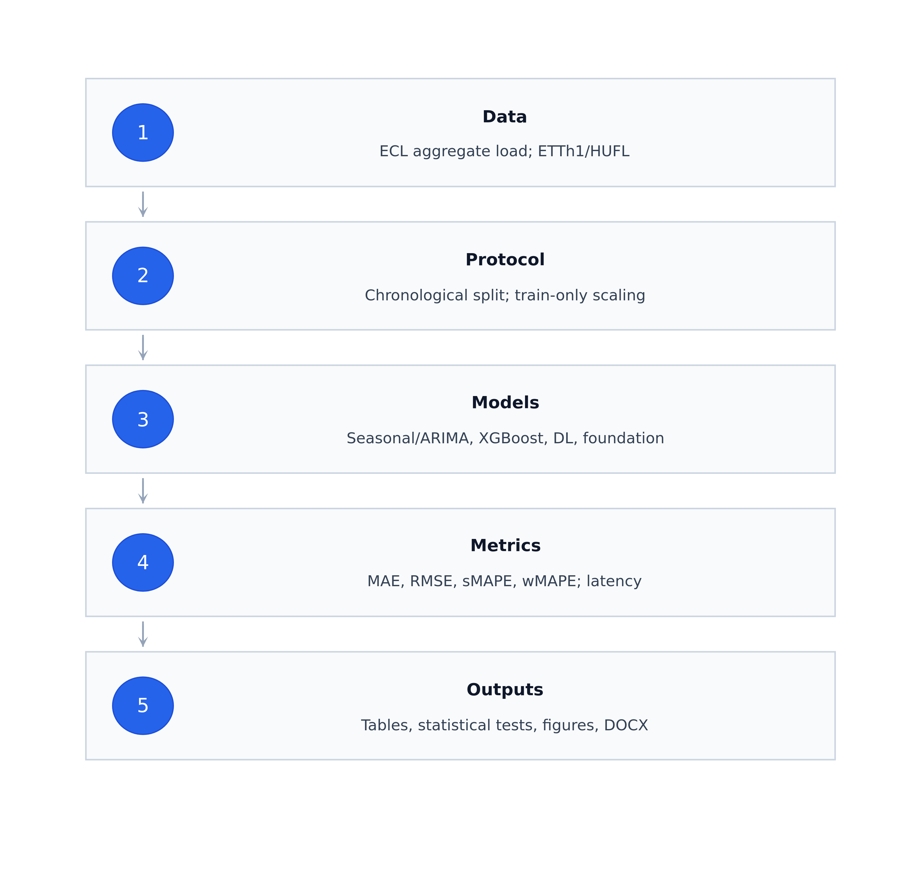
- Figure 1. Experimental pipeline used for the benchmark.
On ECL, the four supervised models trained with a 5000-step budget — iTransformer, DLinear, PatchTST, and XGBoost — separate clearly from the foundation models and classical baselines. iTransformer is the best model at every horizon, with mean MAE ≈ 26.1k at H=24 (Table III), 37.5k at H=96, and 43.0k at H=168; DLinear is within 4–6% behind at each horizon [15], [18]. Chronos-Bolt, TimesFM, and SARIMA cluster at MAE ≈ 260–270k, roughly an order of magnitude higher than the trained (Figure 3; Figure 4) supervised neural models. SeasonalNaive sits another 30% above at ≈ 340k. The gap between trained neural and zero-shot foundation models on aggregate ECL load is therefore not a small effect. The high sMAPE values for foundation models and SARIMA on ECL (≈ 31%) reflect that these models track only the slow baseline of the aggregate signal and miss the high-amplitude daily and weekly fluctuations of the 321-client sum; the absolute MAE and RMSE values are the operationally meaningful comparison for this aggregated target.
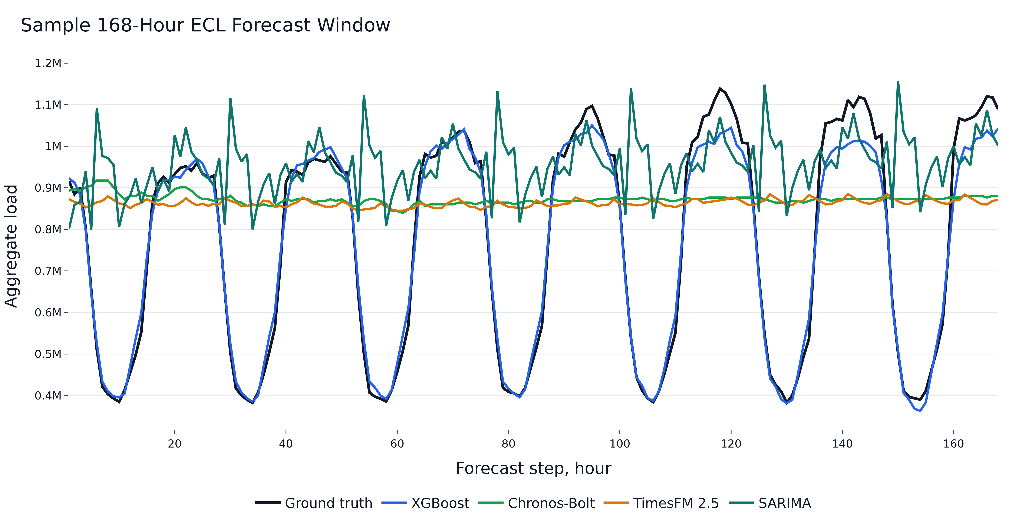
- Figure 2. Sample 168-hour ECL forecast window.
Dataset/H | Best model | Close competitors | Interpretation
ECL/H24 | iTransformer | DLinear, PatchTST | Supervised NF dominate
ECL/H96 | iTransformer | DLinear, PatchTST | Trained models far ahead of foundation
ECL/H168 | iTransformer | DLinear, PatchTST | Trained models far ahead of foundation
ETTh1/H24 | Chronos-Bolt | DLinear, PatchTST | Zero-shot foundation strongest
ETTh1/H96 | DLinear | Chronos-Bolt, TimesFM | Linear neural model wins
ETTh1/H168 | DLinear | Chronos-Bolt, TimesFM | Linear neural model wins
- Table I. Summary of the main accuracy results across datasets and horizons.
On ETTh1/HUFL, the ordering is more compressed and horizon-dependent. Chronos-Bolt is best at H=24 with MAE = 3.00 (Table IV), ahead of DLinear (3.07) and PatchTST (3.10); TimesFM trails at 3.16 [20], [21]. At H=96 and H=168, DLinear takes the lead with MAE = 3.54 and 3.69 respectively, with Chronos-Bolt and TimesFM each within 2–3% behind (Figure 5). The supervised neural models therefore remain competitive across all horizons on ETTh1, while foundation models retain a meaningful edge only at H=24. SARIMA, SeasonalNaive, and XGBoost form the bottom group on ETTh1 [9], [15]. The sMAPE values on ETTh1 are large (45–60%) because the HUFL target crosses zero, which inflates the symmetric percentage error; MAE, RMSE, and wMAPE are therefore the primary interpretation metrics for this dataset.
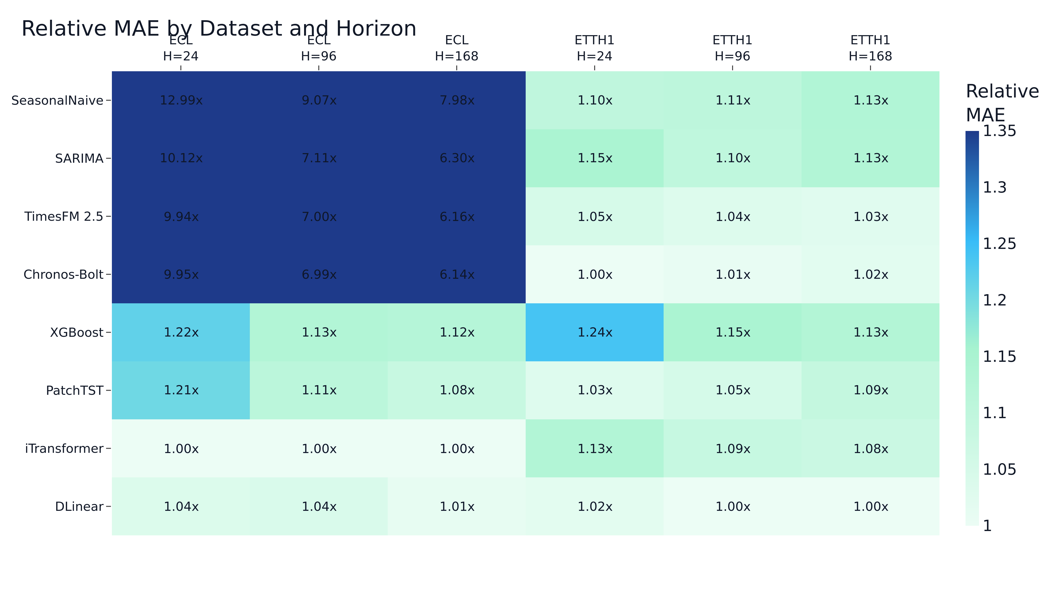
- Figure 3. Relative MAE by dataset and horizon (each cell shows the model's mean MAE divided by the best mean MAE for that dataset-horizon).
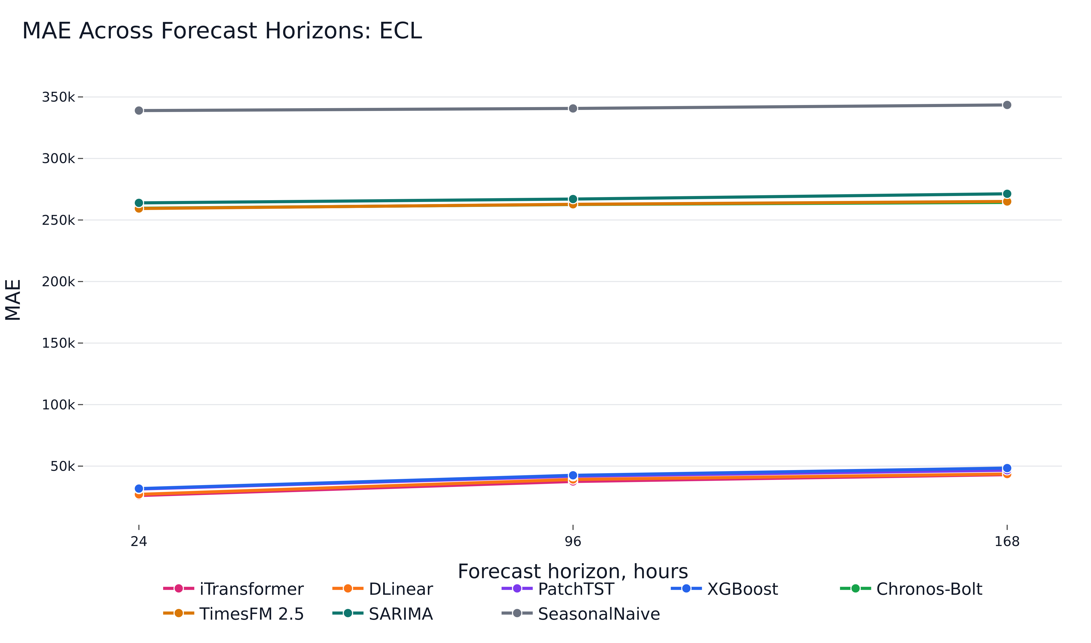
- Figure 4. Mean MAE across forecast horizons on ECL.
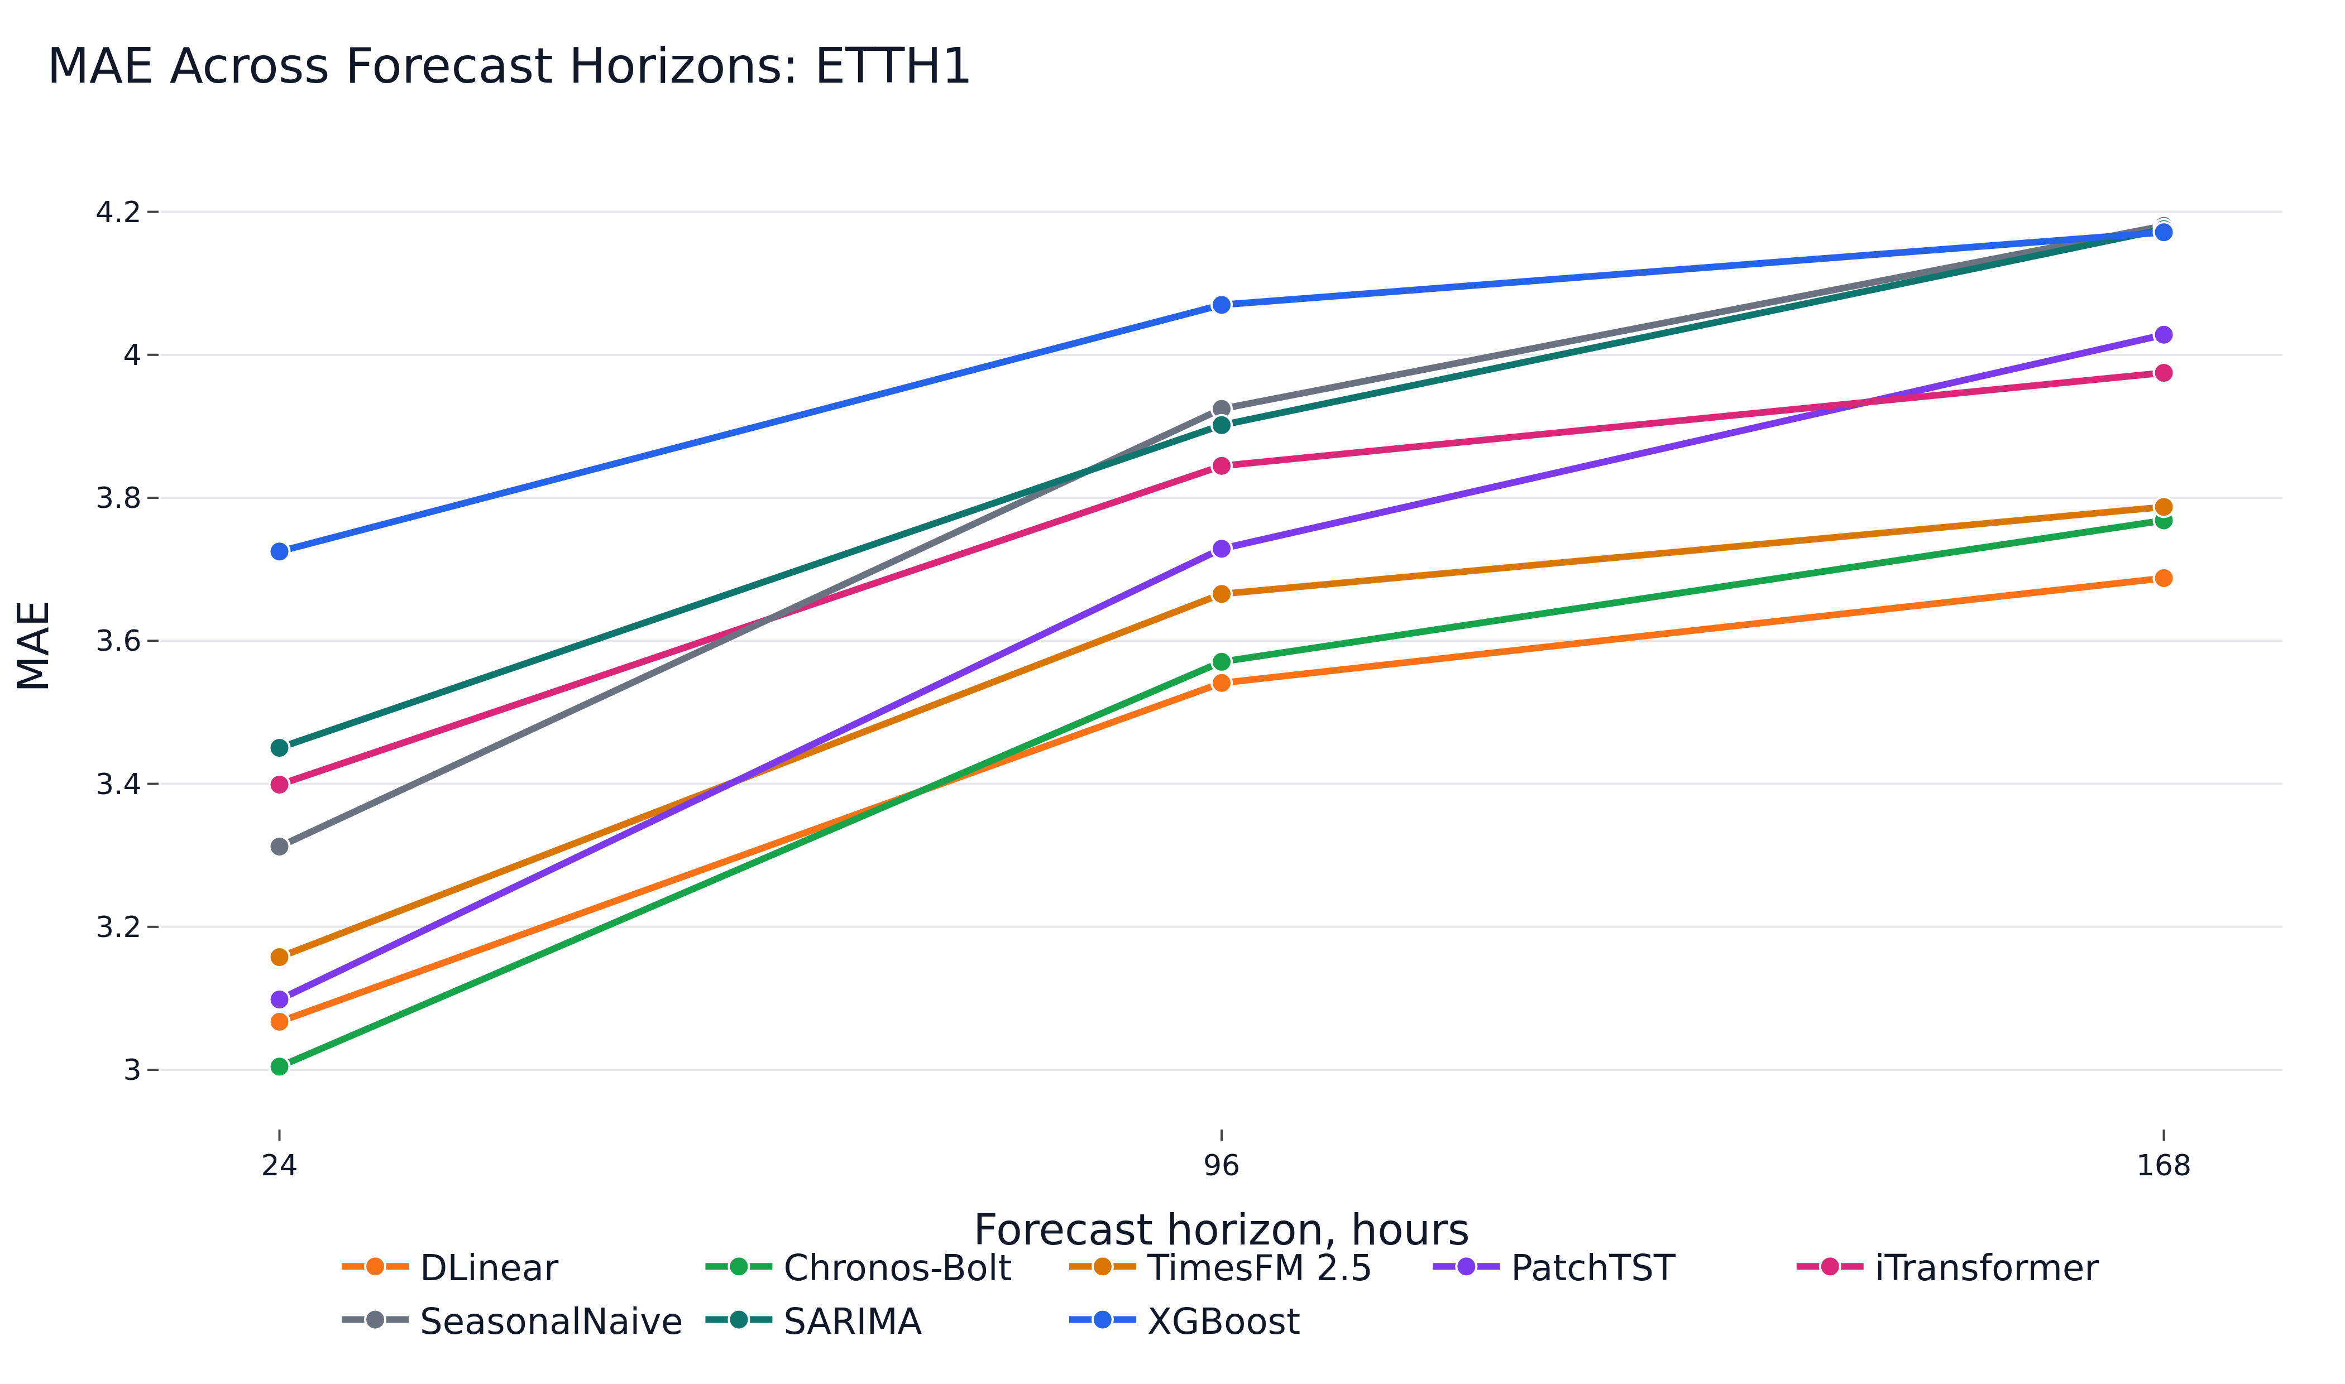
- Figure 5. Mean MAE across forecast horizons on ETTh1/HUFL.
The Diebold-Mariano tests on seed-averaged per-window absolute errors reject the null of equal predictive accuracy for every top-1 vs top-2 comparison in Table VI with p < 0.005 [8]. The pooled-error formulation is more conservative than a single-seed comparison because it uses ≈ 5–6 thousand windows aligned across seeds, so the leader ordering on ECL (iTransformer over DLinear) and on ETTh1 (Chronos-Bolt at H=24, DLinear at H=96 and H=168) is unlikely to be a sampling artifact. Statistical significance and operational significance are not identical: on ECL the supervised neural models all dominate the foundation group by an order of magnitude, so the practical choice among iTransformer, DLinear, and PatchTST hinges more on training cost and inference latency than on the small accuracy gap.
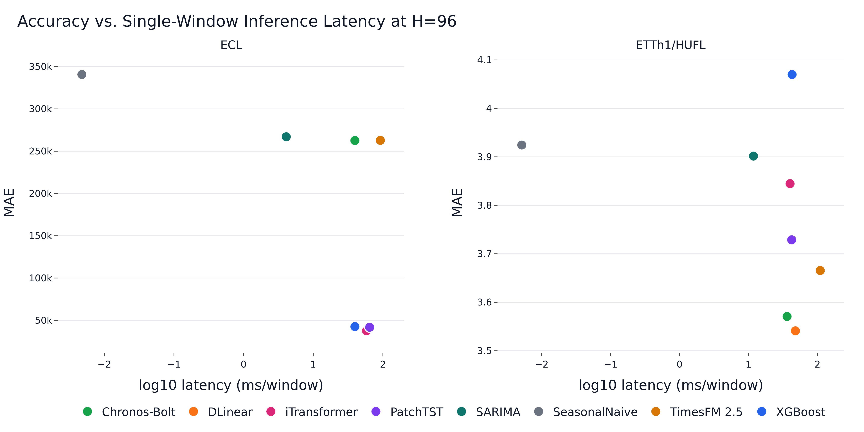
- Figure 6. Accuracy versus single-window inference latency at H=96 for both datasets.
Family | Training cost | Inference profile | Practical role
SeasonalNaive/SARIMA | Low to moderate | Very low latency | Reference and fallback
XGBoost | Low | Low latency | Supervised tabular reference
DLinear/PatchTST/iTransformer | Moderate (5k steps) | GPU-friendly | Trained NF benchmark
Chronos/TimesFM | No task-specific training | Model-dependent latency | Cold-start forecasting
- Table II. Operational interpretation of model families.
- Table III. ECL accuracy across horizons (mean ± standard deviation over five seeds for stochastic models).
Model | H | MAE | RMSE | sMAPE (%) | wMAPE (%)
iTransformer | 24 | 26082.66 ± 670.28 | 39297.84 ± 779.67 | 3.12 ± 0.12 | 3.06 ± 0.08
DLinear | 24 | 27037.99 ± 140.45 | 45364.57 ± 102.15 | 3.21 ± 0.03 | 3.17 ± 0.02
PatchTST | 24 | 31429.72 ± 1124.32 | 47257.55 ± 1471.30 | 3.87 ± 0.20 | 3.69 ± 0.13
XGBoost | 24 | 31738.07 ± 72.19 | 47075.93 ± 136.74 | 3.81 ± 0.01 | 3.73 ± 0.01
TimesFM | 24 | 259345.28 | 307450.43 | 31.27 | 29.60
Chronos-Bolt | 24 | 259546.11 | 311466.37 | 31.32 | 29.63
SARIMA | 24 | 263913.91 | 316245.26 | 31.73 | 30.12
SeasonalNaive | 24 | 338935.90 | 428088.82 | 39.98 | 38.69
iTransformer | 96 | 37548.28 ± 107.29 | 60779.58 ± 164.51 | 4.25 ± 0.02 | 4.40 ± 0.01
DLinear | 96 | 39158.61 ± 181.23 | 64684.61 ± 127.51 | 4.36 ± 0.03 | 4.59 ± 0.02
PatchTST | 96 | 41773.32 ± 805.01 | 66946.54 ± 926.82 | 4.74 ± 0.14 | 4.89 ± 0.09
XGBoost | 96 | 42533.74 ± 78.47 | 65386.64 ± 114.56 | 4.87 ± 0.01 | 4.98 ± 0.01
Chronos-Bolt | 96 | 262601.94 | 314012.89 | 31.68 | 30.03
TimesFM | 96 | 262766.32 | 311382.39 | 31.65 | 30.05
SARIMA | 96 | 267033.48 | 320436.95 | 32.07 | 30.54
SeasonalNaive | 96 | 340658.82 | 428618.32 | 40.13 | 38.96
iTransformer | 168 | 43041.98 ± 586.99 | 70461.74 ± 711.95 | 4.80 ± 0.08 | 5.03 ± 0.07
DLinear | 168 | 43553.53 ± 140.14 | 72419.23 ± 90.94 | 4.71 ± 0.03 | 5.09 ± 0.02
PatchTST | 168 | 46646.92 ± 2189.31 | 75055.16 ± 2683.72 | 5.23 ± 0.27 | 5.45 ± 0.26
XGBoost | 168 | 48400.05 ± 73.35 | 74664.41 ± 110.85 | 5.42 ± 0.01 | 5.66 ± 0.01
Chronos-Bolt | 168 | 264268.27 | 315996.95 | 31.91 | 30.30
TimesFM | 168 | 265044.60 | 313676.28 | 31.95 | 30.39
SARIMA | 168 | 271294.60 | 325857.78 | 32.54 | 31.11
SeasonalNaive | 168 | 343510.17 | 431537.72 | 40.48 | 39.39
- Table IV. ETTh1/HUFL accuracy across horizons (mean ± standard deviation over five seeds for stochastic models).
Model | H | MAE | RMSE | sMAPE (%) | wMAPE (%)
Chronos-Bolt | 24 | 3.00 | 4.78 | 44.88 | 29.73
DLinear | 24 | 3.07 ± 0.01 | 4.62 ± 0.01 | 47.78 ± 0.15 | 30.36 ± 0.07
PatchTST | 24 | 3.10 ± 0.03 | 4.57 ± 0.03 | 48.44 ± 0.32 | 30.66 ± 0.32
TimesFM | 24 | 3.16 | 4.88 | 48.33 | 31.25
SeasonalNaive | 24 | 3.31 | 5.44 | 46.07 | 32.78
iTransformer | 24 | 3.40 ± 0.06 | 5.02 ± 0.10 | 50.53 ± 0.53 | 33.64 ± 0.55
SARIMA | 24 | 3.45 | 4.92 | 52.92 | 34.15
XGBoost | 24 | 3.72 ± 0.00 | 5.20 ± 0.00 | 55.56 ± 0.05 | 36.86 ± 0.02
DLinear | 96 | 3.54 ± 0.00 | 5.26 ± 0.01 | 54.06 ± 0.04 | 35.01 ± 0.04
Chronos-Bolt | 96 | 3.57 | 5.61 | 51.08 | 35.30
TimesFM | 96 | 3.67 | 5.61 | 54.27 | 36.24
PatchTST | 96 | 3.73 ± 0.05 | 5.40 ± 0.06 | 56.22 ± 0.61 | 36.87 ± 0.46
iTransformer | 96 | 3.84 ± 0.02 | 5.65 ± 0.03 | 56.45 ± 0.21 | 38.01 ± 0.16
SARIMA | 96 | 3.90 | 5.57 | 57.66 | 38.58
SeasonalNaive | 96 | 3.92 | 6.41 | 51.70 | 38.80
XGBoost | 96 | 4.07 ± 0.01 | 5.69 ± 0.01 | 59.72 ± 0.05 | 40.24 ± 0.05
DLinear | 168 | 3.69 ± 0.01 | 5.42 ± 0.00 | 56.36 ± 0.06 | 36.40 ± 0.05
Chronos-Bolt | 168 | 3.77 | 5.85 | 53.36 | 37.20
TimesFM | 168 | 3.79 | 5.75 | 55.77 | 37.38
iTransformer | 168 | 3.97 ± 0.02 | 5.82 ± 0.03 | 57.70 ± 0.08 | 39.23 ± 0.19
PatchTST | 168 | 4.03 ± 0.08 | 5.78 ± 0.10 | 59.02 ± 0.77 | 39.76 ± 0.80
XGBoost | 168 | 4.17 ± 0.01 | 5.84 ± 0.01 | 60.42 ± 0.07 | 41.18 ± 0.06
SARIMA | 168 | 4.18 | 5.87 | 60.30 | 41.22
SeasonalNaive | 168 | 4.18 | 6.70 | 54.20 | 41.26
- Table V. Computational efficiency (single-window inference at batch size 1, averaged over seeds).
Model | Data/H | Train s | Infer ms | Params | GPU MB
Chronos-Bolt | ECL/H24 | 0.00 | 15.62 | 47 718 016 | 123.3
DLinear | ECL/H24 | 40.56 | 56.27 | 16 176 | 26.3
PatchTST | ECL/H24 | 124.19 | 60.41 | 168 280 | 608.6
SARIMA | ECL/H24 | 109.77 | 2.99 | 0 | 0.0
SeasonalNaive | ECL/H24 | 0.00 | 0.00 | 0 | 0.0
TimesFM | ECL/H24 | 0.00 | 102.23 | 200 000 000 | 895.6
XGBoost | ECL/H24 | 15.61 | 19.95 | 1 348 140 | 0.0
iTransformer | ECL/H24 | 60.50 | 59.42 | 311 448 | 164.9
Chronos-Bolt | ECL/H96 | 0.00 | 39.64 | 47 718 016 | 345.8
DLinear | ECL/H96 | 41.28 | 61.11 | 64 704 | 29.8
PatchTST | ECL/H96 | 142.19 | 64.58 | 361 888 | 612.4
SARIMA | ECL/H96 | 109.64 | 4.09 | 0 | 0.0
SeasonalNaive | ECL/H96 | 0.00 | 0.00 | 0 | 0.0
TimesFM | ECL/H96 | 0.00 | 91.99 | 200 000 000 | 895.6
XGBoost | ECL/H96 | 23.34 | 39.65 | 757 786 | 0.0
iTransformer | ECL/H96 | 76.82 | 58.28 | 320 736 | 165.0
Chronos-Bolt | ECL/H168 | 0.00 | 45.30 | 47 718 016 | 381.4
DLinear | ECL/H168 | 50.36 | 59.04 | 113 232 | 32.7
PatchTST | ECL/H168 | 134.58 | 65.48 | 555 496 | 617.3
SARIMA | ECL/H168 | 108.43 | 5.52 | 0 | 0.0
SeasonalNaive | ECL/H168 | 0.00 | 0.01 | 0 | 0.0
TimesFM | ECL/H168 | 0.00 | 200.35 | 200 000 000 | 896.4
XGBoost | ECL/H168 | 41.47 | 71.99 | 1 327 515 | 0.0
iTransformer | ECL/H168 | 82.01 | 65.49 | 330 024 | 165.2
Chronos-Bolt | ETTh1/H24 | 0.00 | 13.48 | 47 718 016 | 123.3
DLinear | ETTh1/H24 | 31.20 | 46.90 | 16 176 | 26.2
PatchTST | ETTh1/H24 | 96.55 | 44.68 | 168 280 | 608.3
SARIMA | ETTh1/H24 | 110.82 | 9.30 | 0 | 0.0
SeasonalNaive | ETTh1/H24 | 0.00 | 0.00 | 0 | 0.0
TimesFM | ETTh1/H24 | 0.00 | 98.19 | 200 000 000 | 895.6
XGBoost | ETTh1/H24 | 4.87 | 11.88 | 188 635 | 0.0
iTransformer | ETTh1/H24 | 45.80 | 38.84 | 311 448 | 164.8
Chronos-Bolt | ETTh1/H96 | 0.00 | 36.24 | 47 718 016 | 345.8
DLinear | ETTh1/H96 | 24.30 | 47.85 | 64 704 | 29.8
PatchTST | ETTh1/H96 | 80.96 | 42.30 | 361 888 | 612.6
SARIMA | ETTh1/H96 | 110.80 | 11.80 | 0 | 0.0
SeasonalNaive | ETTh1/H96 | 0.00 | 0.01 | 0 | 0.0
TimesFM | ETTh1/H96 | 0.00 | 109.76 | 200 000 000 | 895.6
XGBoost | ETTh1/H96 | 19.68 | 42.86 | 755 830 | 0.0
iTransformer | ETTh1/H96 | 44.28 | 40.04 | 320 736 | 165.0
Chronos-Bolt | ETTh1/H168 | 0.00 | 64.73 | 47 718 016 | 381.4
DLinear | ETTh1/H168 | 36.29 | 52.15 | 113 232 | 32.6
PatchTST | ETTh1/H168 | 76.83 | 43.64 | 555 496 | 617.0
SARIMA | ETTh1/H168 | 110.49 | 14.46 | 0 | 0.0
SeasonalNaive | ETTh1/H168 | 0.00 | 0.01 | 0 | 0.0
TimesFM | ETTh1/H168 | 0.00 | 208.51 | 200 000 000 | 896.4
XGBoost | ETTh1/H168 | 34.58 | 73.01 | 1 322 617 | 0.0
iTransformer | ETTh1/H168 | 45.68 | 41.49 | 330 024 | 165.1
- Table VI. Diebold-Mariano tests for the top two models by mean MAE, computed on seed-averaged per-window absolute errors.
Data/H | Comparison | Statistic | p-value | Sig.
ECL/H24 | iTransformer vs DLinear | -4.75 | <0.001 | yes
ECL/H96 | iTransformer vs DLinear | -8.95 | <0.001 | yes
ECL/H168 | iTransformer vs DLinear | -3.15 | 0.002 | yes
ETTh1/H24 | Chronos-Bolt vs DLinear | -6.18 | <0.001 | yes
ETTh1/H96 | DLinear vs Chronos-Bolt | -3.77 | <0.001 | yes
ETTh1/H168 | DLinear vs Chronos-Bolt | -11.12 | <0.001 | yes

Discussion
The main finding is that supervised neural models dominate ECL aggregate load forecasting and remain competitive on ETTh1/HUFL under the evaluated protocol. Trained iTransformer, DLinear, and PatchTST are roughly an order of magnitude more accurate (summarised in Table I) than zero-shot Chronos-Bolt, zero-shot TimesFM, and a grid-tuned SARIMA on ECL across all evaluated horizons. On ETTh1 the picture is more nuanced: Chronos-Bolt edges DLinear at H=24, while DLinear is best at H=96 and H=168. XGBoost, even after a grid-tuned hyperparameter search, remains a strong low-cost CPU baseline but is no longer the leading approach on either dataset once the neural models are trained to convergence [9], [15], [18].
The accuracy–latency trade-offs make these observations practically actionable. On ECL, supervised neural models achieve roughly 8× lower MAE than foundation models at single-window inference latencies of 55–75 ms, comparable to TimesFM (Table V; Figure 6) (100–200 ms) and Chronos-Bolt (15–45 ms). XGBoost remains the cheapest CPU-only option in absolute terms (≈ 12–73 ms inference, no GPU memory) and is therefore competitive when CPU-only deployment is required and a ±20% MAE penalty relative to iTransformer is acceptable. On ETTh1 the absolute MAE gap among the top four methods is below 5%, so deployment factors such as training cost, retraining cadence, and zero-shot applicability often decide the practical choice [9], [15], [20], [21].
Foundation models remain attractive when task-specific training is undesirable, for example in cold-start industrial monitoring, rapid prototyping, or sites where historical data are insufficient for supervised training. On ETTh1, Chronos-Bolt and TimesFM achieve accuracy within a few percent of the best supervised model without any task-specific training [20], [21]. On ECL, under the evaluated zero-shot configuration, the same models are an order of magnitude less accurate than properly trained neural models. Inspection of a representative 168-hour forecast (Figure 2) confirms that this is not a scale-mismatch artifact: Chronos-Bolt outputs a near-constant trajectory whose standard deviation is roughly 4% of the ground-truth standard deviation, while iTransformer reproduces approximately 78% of the daily and weekly variation. The foundation models therefore recover the slow baseline of the aggregate signal but do not track its high-amplitude periodicity. The value of zero-shot foundation models is consequently dataset-dependent and is not a universal substitute for supervised forecasting [22]–[24].
A controlled training-budget ablation on ECL/H24 confirms that the order-of-magnitude advantage of supervised models is not a convergence artifact. Re-running PatchTST and iTransformer at {500, 1000, 2000, 5000} optimizer steps with validation-driven early stopping yields PatchTST MAE values between 31.4k and 33.7k and iTransformer MAE values between 26.1k and 29.8k. The between-budget spread is below 4% in both cases, and validation-driven early stopping triggers before 1000 steps under the present configuration. Foundation-model MAE on the same task remains near 260k irrespective of the supervised budget, so the gap visible in Tables III and IV reflects the zero-shot regime rather than an under-trained supervised baseline [15], [16], [18].
From a deployment perspective, the results suggest a tiered model-selection strategy (Table II). SeasonalNaive and SARIMA are useful first checks because they reveal whether the series is dominated by regular seasonality. XGBoost is an appropriate default when sufficient site history is available and feature engineering is acceptable. DLinear is a lightweight neural alternative for horizons where linear temporal structure is dominant. Foundation models are most attractive when training data are scarce, experiments must be started quickly, or the cost of maintaining site-specific models is high.
The accuracy-latency results also caution against interpreting model quality through a single metric. A model that is marginally more accurate but substantially slower may be unattractive in an online monitoring system, while a slower zero-shot model may still be useful if it eliminates training and tuning for many small assets. Consequently, the benchmark is best read as a Pareto comparison across accuracy, latency, and adaptation cost rather than as a strict ranking.

Limitations
The first limitation is public-benchmark pretraining contamination. ECL and ETT are public datasets, and they may overlap with corpora used during foundation-model development. The correct interpretation is therefore that Chronos-Bolt and TimesFM are evaluated without task-specific training in this repository; the experiment does not prove dataset-unseen generalization for private industrial sites.
The second limitation is the target-only design. Real industrial forecasting systems often include weather, calendar events, tariffs, production schedules, and operational constraints. Adding such exogenous variables may change the ranking of model families, especially for tree-based and transformer-based approaches.
The third limitation is hyperparameter coverage. Neural models are trained with a fixed input length of 336 hours, batch size 32, and a two-point learning-rate sweep over {1e-3, 5e-4}, with up to 5000 optimizer steps and validation-driven early stopping. XGBoost is grid-tuned on max_depth ∈ {4, 6}, n_estimators ∈ {500, 1000}, and learning_rate ∈ {0.05, 0.1} with the best configuration selected on the validation split. SARIMA selects orders from an AICc grid on the training split [6], [7]. Larger searches could improve accuracy further, especially for multivariate variants of iTransformer or for longer training budgets, but the executed configuration is sufficient to demonstrate that supervised neural models do not converge with a 500-step budget.
A further limitation specific to this study is that iTransformer is evaluated in a single-series (univariate) configuration with n_series=1. This choice keeps the protocol comparable across all eight models, but it removes iTransformer's inverted-tokenization advantage of attending across variables [18]. Despite this constraint, iTransformer is the best model on every ECL horizon, which suggests that even its univariate parameterization captures useful sequence structure for aggregate-load forecasting. A multivariate evaluation that exposes per-client or weather covariates is left for future work.
A further limitation is that the study reports deterministic point forecasts. Many operational grid and industrial planning tasks require prediction intervals or full probabilistic forecasts to support reserve allocation and risk-aware scheduling. Extending the protocol to quantile losses, calibration metrics, and probabilistic foundation models would make the comparison more directly applicable to reliability-constrained decision making.
Finally, the benchmark uses two public hourly datasets. This choice supports reproducibility and allows other researchers to verify the reported results, but it does not cover all STLF regimes. Future work should repeat the protocol on private industrial sites, weather-sensitive residential feeders, and datasets with known calendar events. Such studies would clarify whether the relative strength of iTransformer, DLinear, and foundation models transfers beyond standard public benchmarks.

Conclusion
This paper presented a reproducible benchmark of classical, machine-learning, deep-learning, and foundation-model approaches for short-term electricity load forecasting. Supervised neural models dominate ECL aggregate load by roughly an order of magnitude over zero-shot foundation models, and a controlled budget ablation together with prediction-level inspection shows this is an intrinsic limitation of the zero-shot regime rather than an under-trained supervised baseline. On ETTh1/HUFL Chronos-Bolt is best at H=24 and DLinear is best at longer horizons, with foundation models within a few percent. The relative ranking of model families is therefore highly dataset-dependent and the choice of model should be informed by accuracy, statistical significance, training cost, and inference latency taken together.
The practical conclusion is that simple baselines remain necessary as reference points, but they are not necessarily competitive once neural models are trained to convergence. SeasonalNaive and SARIMA establish a meaningful lower bound, XGBoost is a strong low-cost CPU baseline, DLinear is a useful compact neural reference, and foundation models are valuable cold-start forecasters whose competitiveness varies by dataset. A deployment-oriented STLF study should report accuracy, statistical significance, and computational cost together, and should not declare a winning model family without an explicit training-budget audit.
From a deployment perspective, the results suggest a tiered model-selection strategy (Table II). SeasonalNaive and SARIMA serve as inexpensive first-pass references that characterize seasonality and bound the achievable improvement. XGBoost is the appropriate default when sufficient site history and feature engineering are available, combining strong accuracy on ECL with low single-window latency. DLinear is a compact neural alternative that performs well on horizons dominated by linear temporal structure, as observed on ETTh1/HUFL at H=96 and H=168. Chronos-Bolt is most attractive in cold-start, rapid-prototyping, or fleet-of-small-assets scenarios where avoiding per-site training is operationally valuable. TimesFM is reserved for low-latency-tolerant settings where its accuracy advantage at the shortest horizon outweighs its substantially higher inference cost. The complete benchmark code, configurations, per-window errors, and final result tables are publicly available at https://github.com/cndfdv/electr_forecast.

References
- T. Hong and S. Fan, "Probabilistic electric load forecasting: A tutorial review," International Journal of Forecasting, vol. 32, no. 3, pp. 914-938, 2016, doi: 10.1016/j.ijforecast.2015.11.011.
- W. Kong, Z. Y. Dong, Y. Jia, D. J. Hill, Y. Xu, and Y. Zhang, "Short-term residential load forecasting based on LSTM recurrent neural network," IEEE Transactions on Smart Grid, vol. 10, no. 1, pp. 841-851, 2019, doi: 10.1109/TSG.2017.2753802.
- E. Mocanu, P. H. Nguyen, M. Gibescu, and W. L. Kling, "Deep learning for estimating building energy consumption," Sustainable Energy, Grids and Networks, vol. 6, pp. 91-99, 2016, doi: 10.1016/j.segan.2016.02.005.
- D. L. Marino, K. Amarasinghe, and M. Manic, "Building energy load forecasting using deep neural networks," in Proc. 42nd Annu. Conf. IEEE Industrial Electronics Society (IECON), 2016, pp. 7046-7051, doi: 10.1109/IECON.2016.7793413.
- G. E. P. Box, G. M. Jenkins, G. C. Reinsel, and G. M. Ljung, Time Series Analysis: Forecasting and Control, 5th ed. Hoboken, NJ, USA: Wiley, 2015.
- R. J. Hyndman and G. Athanasopoulos, Forecasting: Principles and Practice, 3rd ed. Melbourne, Australia: OTexts, 2021. [Online]. Available: https://otexts.com/fpp3/
- R. J. Hyndman and Y. Khandakar, "Automatic time series forecasting: The forecast package for R," Journal of Statistical Software, vol. 27, no. 3, pp. 1-22, 2008, doi: 10.18637/jss.v027.i03.
- F. X. Diebold and R. S. Mariano, "Comparing predictive accuracy," Journal of Business & Economic Statistics, vol. 13, no. 3, pp. 253-263, 1995, doi: 10.1080/07350015.1995.10524599.
- T. Chen and C. Guestrin, "XGBoost: A scalable tree boosting system," in Proc. 22nd ACM SIGKDD Int. Conf. Knowledge Discovery and Data Mining, 2016, pp. 785-794, doi: 10.1145/2939672.2939785.
- S. Hochreiter and J. Schmidhuber, "Long short-term memory," Neural Computation, vol. 9, no. 8, pp. 1735-1780, 1997, doi: 10.1162/neco.1997.9.8.1735.
- A. Vaswani, N. Shazeer, N. Parmar, J. Uszkoreit, L. Jones, A. N. Gomez, L. Kaiser, and I. Polosukhin, "Attention is all you need," in Advances in Neural Information Processing Systems (NeurIPS), 2017.
- H. Zhou, S. Zhang, J. Peng, S. Zhang, J. Li, H. Xiong, and W. Zhang, "Informer: Beyond efficient transformer for long sequence time-series forecasting," in Proc. AAAI Conf. Artificial Intelligence, 2021, doi: 10.1609/aaai.v35i12.17325.
- H. Wu, J. Xu, J. Wang, and M. Long, "Autoformer: Decomposition transformers with auto-correlation for long-term series forecasting," in Advances in Neural Information Processing Systems (NeurIPS), 2021.
- T. Zhou, Z. Ma, Q. Wen, X. Wang, L. Sun, and R. Jin, "FEDformer: Frequency enhanced decomposed transformer for long-term series forecasting," in Proc. Int. Conf. Machine Learning (ICML), 2022.
- A. Zeng, M. Chen, L. Zhang, and Q. Xu, "Are transformers effective for time series forecasting?" in Proc. AAAI Conf. Artificial Intelligence, 2023, doi: 10.1609/aaai.v37i9.26317.
- Y. Nie, N. H. Nguyen, P. Sinthong, and J. Kalagnanam, "A time series is worth 64 words: Long-term forecasting with transformers," in Proc. Int. Conf. Learning Representations (ICLR), 2023.
- H. Wu, T. Hu, Y. Liu, H. Zhou, J. Wang, and M. Long, "TimesNet: Temporal 2D-variation modeling for general time series analysis," in Proc. Int. Conf. Learning Representations (ICLR), 2023.
- Y. Liu, T. Hu, H. Zhang, H. Wu, S. Wang, L. Ma, and M. Long, "iTransformer: Inverted transformers are effective for time series forecasting," in Proc. Int. Conf. Learning Representations (ICLR), 2024.
- Q. Wen, T. Zhou, C. Zhang, W. Chen, Z. Ma, J. Yan, and L. Sun, "Transformers in time series: A survey," in Proc. Int. Joint Conf. Artificial Intelligence (IJCAI), 2023.
- A. Das, W. Kong, R. Sen, and Y. Zhou, "A decoder-only foundation model for time-series forecasting," in Proc. Int. Conf. Machine Learning (ICML), 2024.
- A. F. Ansari et al., "Chronos: Learning the language of time series," Transactions on Machine Learning Research, 2024.
- M. Goswami, K. Szafer, A. Choudhry, Y. Cai, S. Li, and A. Dubrawski, "MOMENT: A family of open time-series foundation models," in Proc. Int. Conf. Machine Learning (ICML), 2024.
- G. Woo, C. Liu, A. Kumar, C. Xiong, S. Savarese, and D. Sahoo, "Unified training of universal time series forecasting transformers," in Proc. Int. Conf. Machine Learning (ICML), 2024.
- K. Rasul et al., "Lag-Llama: Towards foundation models for probabilistic time series forecasting," 2024, arXiv:2310.08278.
- G. Lai, W.-C. Chang, Y. Yang, and H. Liu, "Modeling long- and short-term temporal patterns with deep neural networks," in Proc. 41st Int. ACM SIGIR Conf. Research & Development in Information Retrieval, 2018, pp. 95-104, doi: 10.1145/3209978.3210006.
- K. G. Olivares, C. Challu, F. Garza, M. Mergenthaler-Canseco, and A. Dubrawski, "NeuralForecast: User friendly state-of-the-art neural forecasting models," 2022. [Online]. Available: https://github.com/Nixtla/neuralforecast
- F. Garza, M. Mergenthaler-Canseco, K. G. Olivares, and C. Challu, "StatsForecast: Lightning fast forecasting with statistical and econometric models," 2022. [Online]. Available: https://github.com/Nixtla/statsforecast
- S. Seabold and J. Perktold, "statsmodels: Econometric and statistical modeling with Python," in Proc. 9th Python in Science Conf. (SciPy), 2010, pp. 92-96.

