ФЕДЕРАЛЬНОЕ ГОСУДАРСТВЕННОЕ ОБРАЗОВАТЕЛЬНОЕ
УЧРЕЖДЕНИЕ ВЫСШЕГО ОБРАЗОВАНИЯ
РОССИЙСКИЙ УНИВЕРСИТЕТ ДРУЖБЫ НАРОДОВ
ИМЕНИ ПАТРИСА ЛУМУМБЫ

Отчет
о выполнении лабораторной работы № 4
"Глубокие сети прямого распространения"
по дисциплине "Нейронные сети"

Вариант задания № 13

Выполнил студент группы ЗФИбд-01-24
Князев А. М. __________

Проверил и принял
Леонов С. С. __________

с оценкой __________

Москва, 2026

Цель работы
изучение глубоких полносвязных нейронных сетей в задачах бинарной классификации, многоклассовой классификации и регрессии.

Основные этапы работы
1. Построить бинарный классификатор отзывов IMDB.
2. Построить многоклассовый классификатор.
3. Построить регрессионную модель с проверкой по K блокам.

Оборудование и программное обеспечение: персональный компьютер, Python 3, Jupyter Notebook, PyTorch, NumPy, Matplotlib.

Ход выполнения работы
Все расчеты выполнены в файле main.ipynb. В коде используется автоматический выбор устройства: если CUDA доступна, вычисления выполняются на GPU, иначе на CPU.

Таблица 1 — Архитектуры варианта
Этап | Архитектура | Функция потерь
IMDB | 16-32-16, relu-relu-tanh | MSE
Базовый IMDB | 16-16, relu-relu | BCEWithLogitsLoss
Многокласс | 32-64-64, tanh-mish-relu | CrossEntropyLoss
Регрессия | 32-64-64, tanh-mish-relu | MSE

Таблица 2 — Результаты проверки
Задача | Метрика
IMDB variant | test_loss = 0.0980, test_acc = 0.6179
IMDB baseline | test_loss = 0.2494, test_acc = 0.8946
Multiclass | test_loss = 0.0442, test_acc = 1.0000
Regression | MAE = [55.36, 46.31, 41.19, 59.58], mean = 50.61

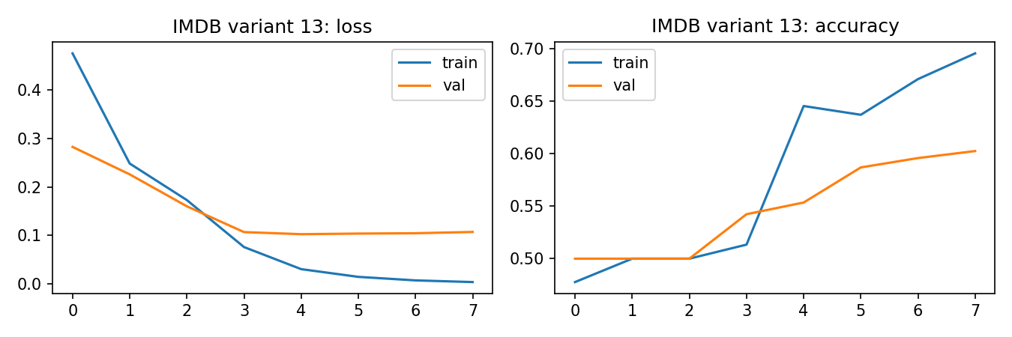
Рис. 1 — Графики loss и accuracy для IMDB

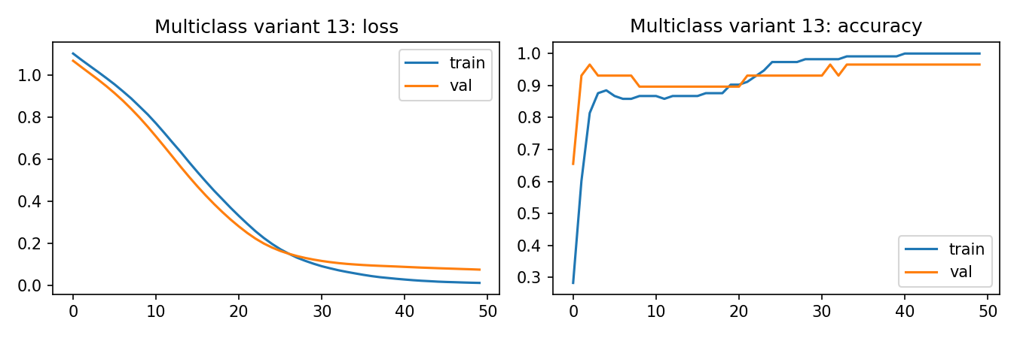
Рис. 2 — Графики loss и accuracy для многоклассовой задачи

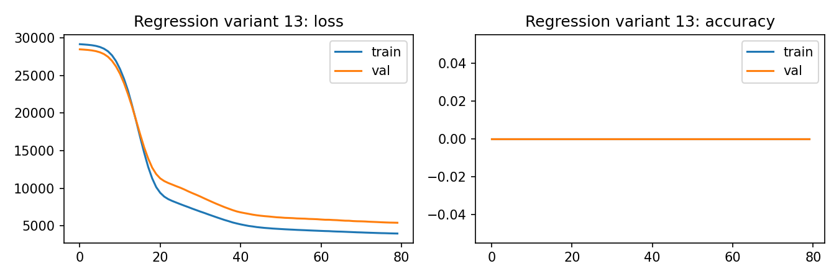
Рис. 3 — Графики обучения регрессионной модели

Код программы
from __future__ import annotations

import math
import random
import zipfile
from collections import Counter
from pathlib import Path

import matplotlib.pyplot as plt
import numpy as np
import torch
import torch.nn as nn
from sklearn.datasets import load_breast_cancer, load_diabetes, load_wine
from sklearn.feature_extraction.text import CountVectorizer
from sklearn.model_selection import KFold, train_test_split
from sklearn.preprocessing import StandardScaler
from torch.utils.data import DataLoader, TensorDataset

DEVICE = torch.device("cuda" if torch.cuda.is_available() else "cpu")
SEED = 13
random.seed(SEED)
np.random.seed(SEED)
torch.manual_seed(SEED)

def activation(name: str) -> nn.Module:
return {
"relu": nn.ReLU(),
"tanh": nn.Tanh(),
"mish": nn.Mish(),
"elu": nn.ELU(),
"leaky_relu": nn.LeakyReLU(0.1),
}[name]

def make_mlp(input_size: int, hidden: list[int], activations: list[str], output_size: int) -> nn.Sequential:
layers: list[nn.Module] = []
prev = input_size
for width, act in zip(hidden, activations):
layers.append(nn.Linear(prev, width))
layers.append(activation(act))
prev = width
layers.append(nn.Linear(prev, output_size))
return nn.Sequential(*layers)

def train_model(
model: nn.Module,
train_loader: DataLoader,
val_loader: DataLoader,
criterion: nn.Module,
epochs: int = 8,
lr: float = 1e-3,
classification: str = "binary",
) -> dict[str, list[float]]:
model.to(DEVICE)
optimizer = torch.optim.Adam(model.parameters(), lr=lr)
history = {"loss": [], "val_loss": [], "acc": [], "val_acc": []}
for _ in range(epochs):
model.train()
train_loss = 0.0
train_correct = 0
train_total = 0
for x, y in train_loader:
x, y = x.to(DEVICE), y.to(DEVICE)
optimizer.zero_grad()
logits = model(x)
loss = criterion(logits, y)
loss.backward()
optimizer.step()
train_loss += float(loss.item()) * len(x)
train_correct += count_correct(logits, y, classification)
train_total += len(x)
val_loss, val_acc = evaluate(model, val_loader, criterion, classification)
history["loss"].append(train_loss / train_total)
history["acc"].append(train_correct / train_total)
history["val_loss"].append(val_loss)
history["val_acc"].append(val_acc)
return history

def count_correct(logits: torch.Tensor, y: torch.Tensor, classification: str) -> int:
if classification == "multiclass":
return int((logits.argmax(dim=1) == y).sum().item())
pred = (torch.sigmoid(logits).view(-1) >= 0.5).float()
return int((pred == y.view(-1)).sum().item())

def evaluate(model: nn.Module, loader: DataLoader, criterion: nn.Module, classification: str) -> tuple[float, float]:
model.eval()
total_loss = 0.0
correct = 0
total = 0
with torch.no_grad():
for x, y in loader:
x, y = x.to(DEVICE), y.to(DEVICE)
logits = model(x)
loss = criterion(logits, y)
total_loss += float(loss.item()) * len(x)
correct += count_correct(logits, y, classification)
total += len(x)
return total_loss / total, correct / total

def make_loader(x: np.ndarray, y: np.ndarray, batch_size: int = 64) -> DataLoader:
dataset = TensorDataset(torch.tensor(x, dtype=torch.float32), torch.tensor(y))
return DataLoader(dataset, batch_size=batch_size, shuffle=True)

def read_imdb(zip_path: Path, max_docs_per_class: int = 700) -> tuple[list[str], np.ndarray]:
texts: list[str] = []
labels: list[int] = []
with zipfile.ZipFile(zip_path) as archive:
for split in ["train", "test"]:
for label_name, label in [("neg", 0), ("pos", 1)]:
prefix = f"aclImdb/{split}/{label_name}/"
names = [n for n in archive.namelist() if n.startswith(prefix) and n.endswith(".txt")]
for name in names[:max_docs_per_class]:
texts.append(archive.read(name).decode("utf-8", errors="ignore"))
labels.append(label)
return texts, np.array(labels, dtype=np.float32)

def plot_history(history: dict[str, list[float]], path: Path, title: str) -> None:
fig, axes = plt.subplots(1, 2, figsize=(9, 3))
axes[0].plot(history["loss"], label="train")
axes[0].plot(history["val_loss"], label="val")
axes[0].set_title(f"{title}: loss")
axes[0].legend()
axes[1].plot(history["acc"], label="train")
axes[1].plot(history["val_acc"], label="val")
axes[1].set_title(f"{title}: accuracy")
axes[1].legend()
fig.tight_layout()
fig.savefig(path, dpi=150)
plt.close(fig)

def stage_imdb() -> None:
texts, y = read_imdb(Path("IMDB/IMDB/aclImdb.zip"))
x_train_text, x_test_text, y_train, y_test = train_test_split(texts, y, test_size=0.2, stratify=y, random_state=SEED)
x_train_text, x_val_text, y_train, y_val = train_test_split(
x_train_text, y_train, test_size=0.2, stratify=y_train, random_state=SEED
)
vectorizer = CountVectorizer(max_features=5000, binary=True, stop_words="english")
x_train = vectorizer.fit_transform(x_train_text).astype("float32").toarray()
x_val = vectorizer.transform(x_val_text).astype("float32").toarray()
x_test = vectorizer.transform(x_test_text).astype("float32").toarray()

model = make_mlp(x_train.shape[1], [16, 32, 16], ["relu", "relu", "tanh"], 1)
baseline = make_mlp(x_train.shape[1], [16, 16], ["relu", "relu"], 1)
criterion = nn.MSELoss()

def wrap_targets(values: np.ndarray) -> np.ndarray:
return values.reshape(-1, 1).astype("float32")

train_loader = make_loader(x_train, wrap_targets(y_train))
val_loader = make_loader(x_val, wrap_targets(y_val))
test_loader = make_loader(x_test, wrap_targets(y_test), batch_size=128)

history = train_model(model, train_loader, val_loader, criterion, epochs=8, classification="binary")
base_history = train_model(baseline, train_loader, val_loader, nn.BCEWithLogitsLoss(), epochs=8, classification="binary")
plot_history(history, Path("lab_4/imdb_history.png"), "IMDB variant 13")
loss, acc = evaluate(model, test_loader, criterion, "binary")
base_loss, base_acc = evaluate(baseline, test_loader, nn.BCEWithLogitsLoss(), "binary")
print(f"IMDB variant: test_loss={loss:.4f}, test_acc={acc:.4f}")
print(f"IMDB baseline: test_loss={base_loss:.4f}, test_acc={base_acc:.4f}")

def stage_multiclass() -> None:
data = load_wine()
x = StandardScaler().fit_transform(data.data).astype("float32")
y = data.target.astype("int64")
x_train, x_test, y_train, y_test = train_test_split(x, y, test_size=0.2, stratify=y, random_state=SEED)
x_train, x_val, y_train, y_val = train_test_split(x_train, y_train, test_size=0.2, stratify=y_train, random_state=SEED)
model = make_mlp(x.shape[1], [32, 64, 64], ["tanh", "mish", "relu"], len(data.target_names))
criterion = nn.CrossEntropyLoss()
history = train_model(
model,
make_loader(x_train, y_train),
make_loader(x_val, y_val),
criterion,
epochs=50,
classification="multiclass",
)
plot_history(history, Path("lab_4/multiclass_history.png"), "Multiclass variant 13")
loss, acc = evaluate(model, make_loader(x_test, y_test), criterion, "multiclass")
print(f"Multiclass variant: test_loss={loss:.4f}, test_acc={acc:.4f}")

def stage_regression() -> None:
data = load_diabetes()
x = StandardScaler().fit_transform(data.data).astype("float32")
y = data.target.astype("float32").reshape(-1, 1)
kfold = KFold(n_splits=4, shuffle=True, random_state=SEED)
fold_mae: list[float] = []
for fold, (train_idx, val_idx) in enumerate(kfold.split(x), start=1):
model = make_mlp(x.shape[1], [32, 64, 64], ["tanh", "mish", "relu"], 1)
criterion = nn.MSELoss()
history = train_model(
model,
make_loader(x[train_idx], y[train_idx], batch_size=32),
make_loader(x[val_idx], y[val_idx], batch_size=32),
criterion,
epochs=80,
lr=5e-4,
classification="regression",
)
model.eval()
with torch.no_grad():
pred = model(torch.tensor(x[val_idx], dtype=torch.float32, device=DEVICE)).cpu().numpy()
mae = float(np.mean(np.abs(pred - y[val_idx])))
fold_mae.append(mae)
if fold == 1:
plot_history(history, Path("lab_4/regression_history.png"), "Regression variant 13")
print(f"Regression KFold MAE: {np.round(fold_mae, 2).tolist()}, mean={np.mean(fold_mae):.2f}")

def main() -> None:
print(f"Device: {DEVICE}")
stage_imdb()
stage_multiclass()
stage_regression()

main()

Вывод
Полносвязные сети успешно применены к трем типам задач. Базовый IMDB классификатор оказался точнее варианта с MSE, что ожидаемо для бинарной классификации, где логистическая кросс-энтропия лучше согласована с задачей.

