1. Jdk

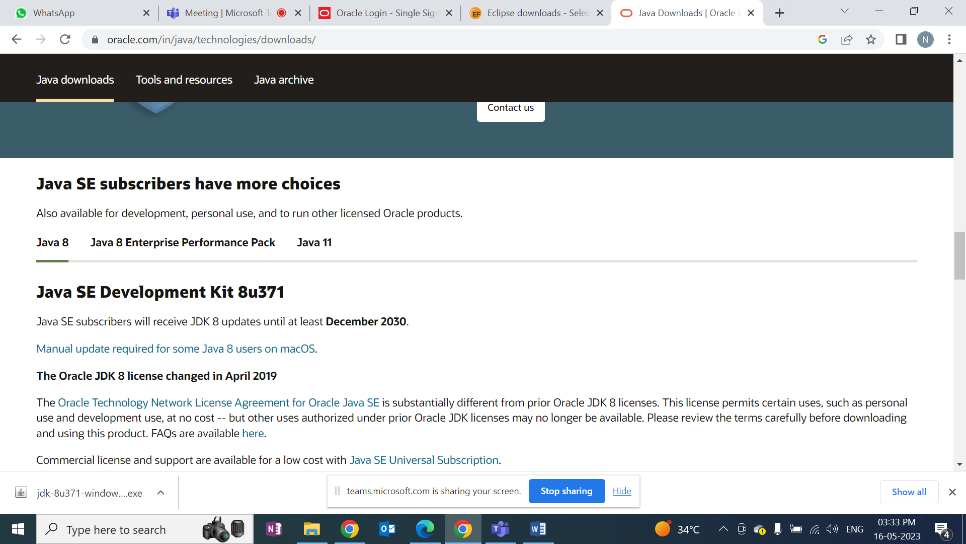

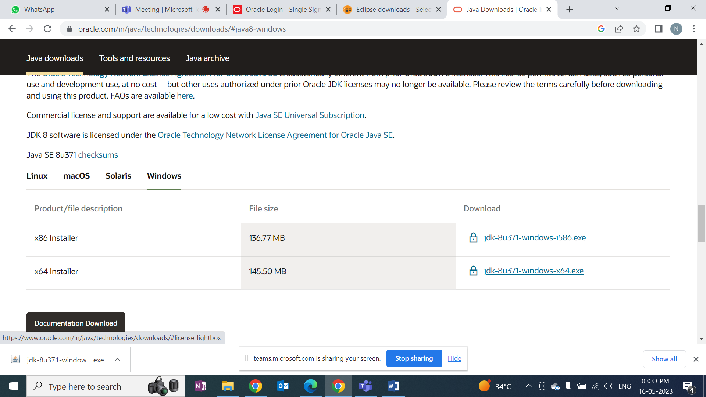

* Need to create account and then download. Username is emailid
* Run and install just next
* To check version cmd : java –version (there should be 2 files if jdk and jre, if not uninstall with control panel and check in cmd )
* 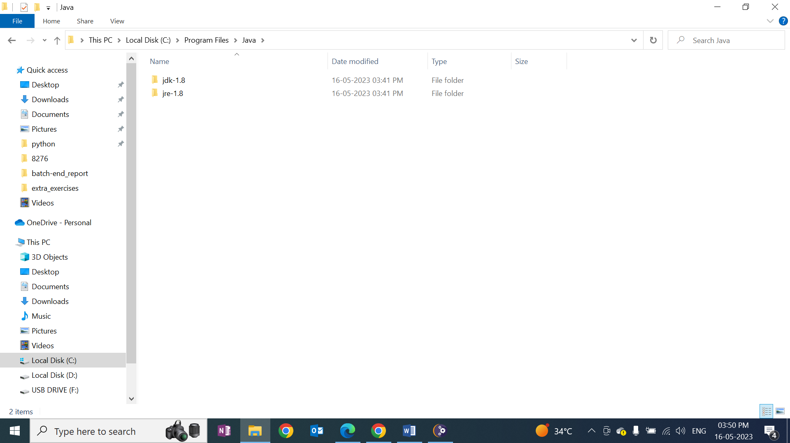

1. Eclipse Install

<https://www.eclipse.org/downloads/>

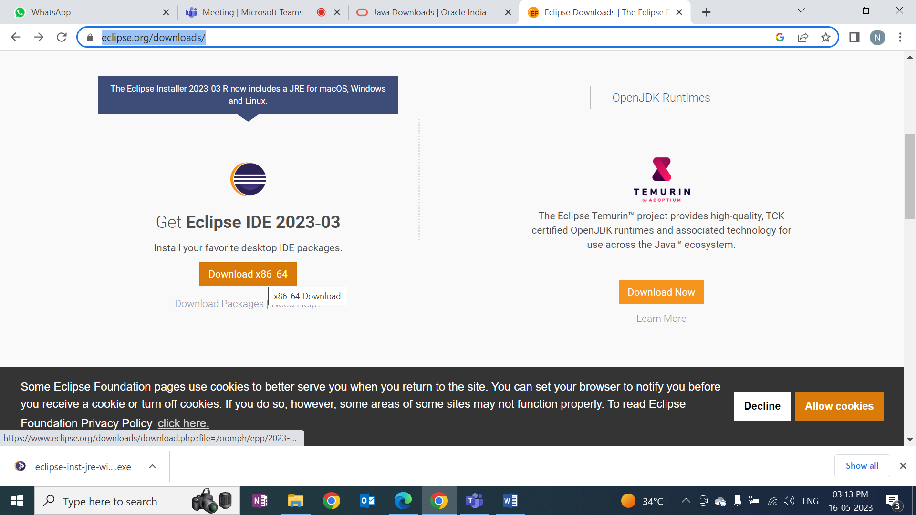

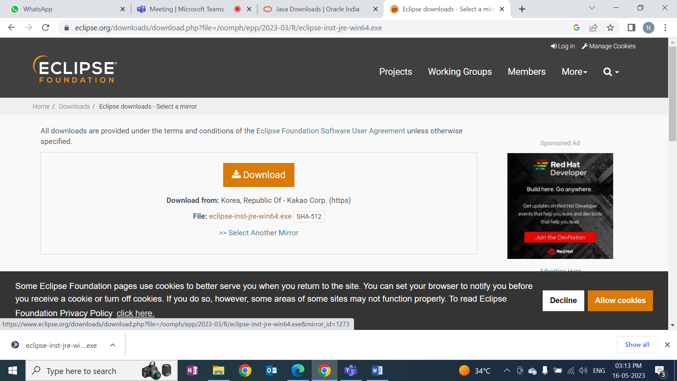

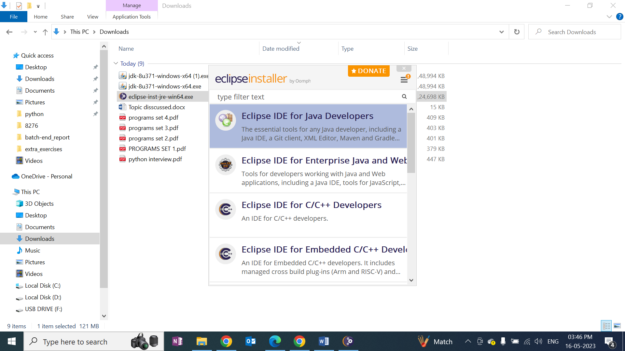

1. Open eclipse:
   1. File->new->Java project-> give name to project ok
   2. Right click on src -> give class name-> click on public and finish
   3. 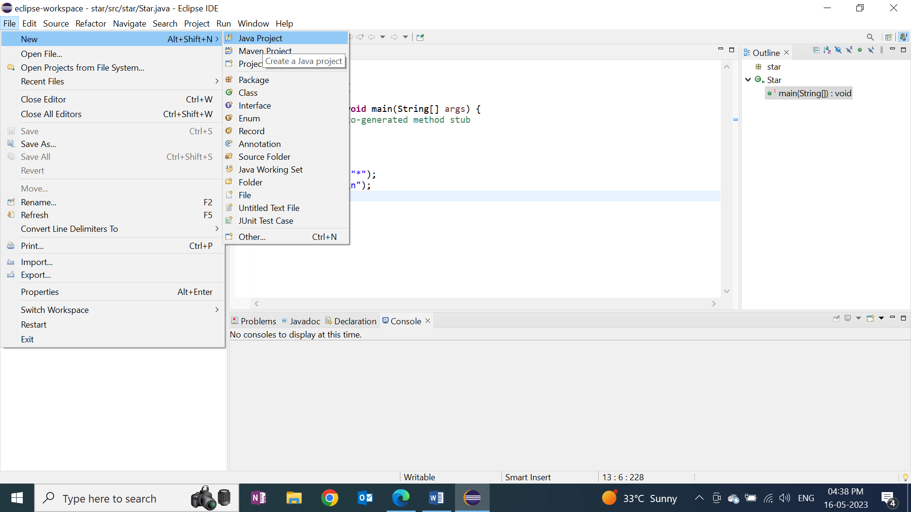
   4. 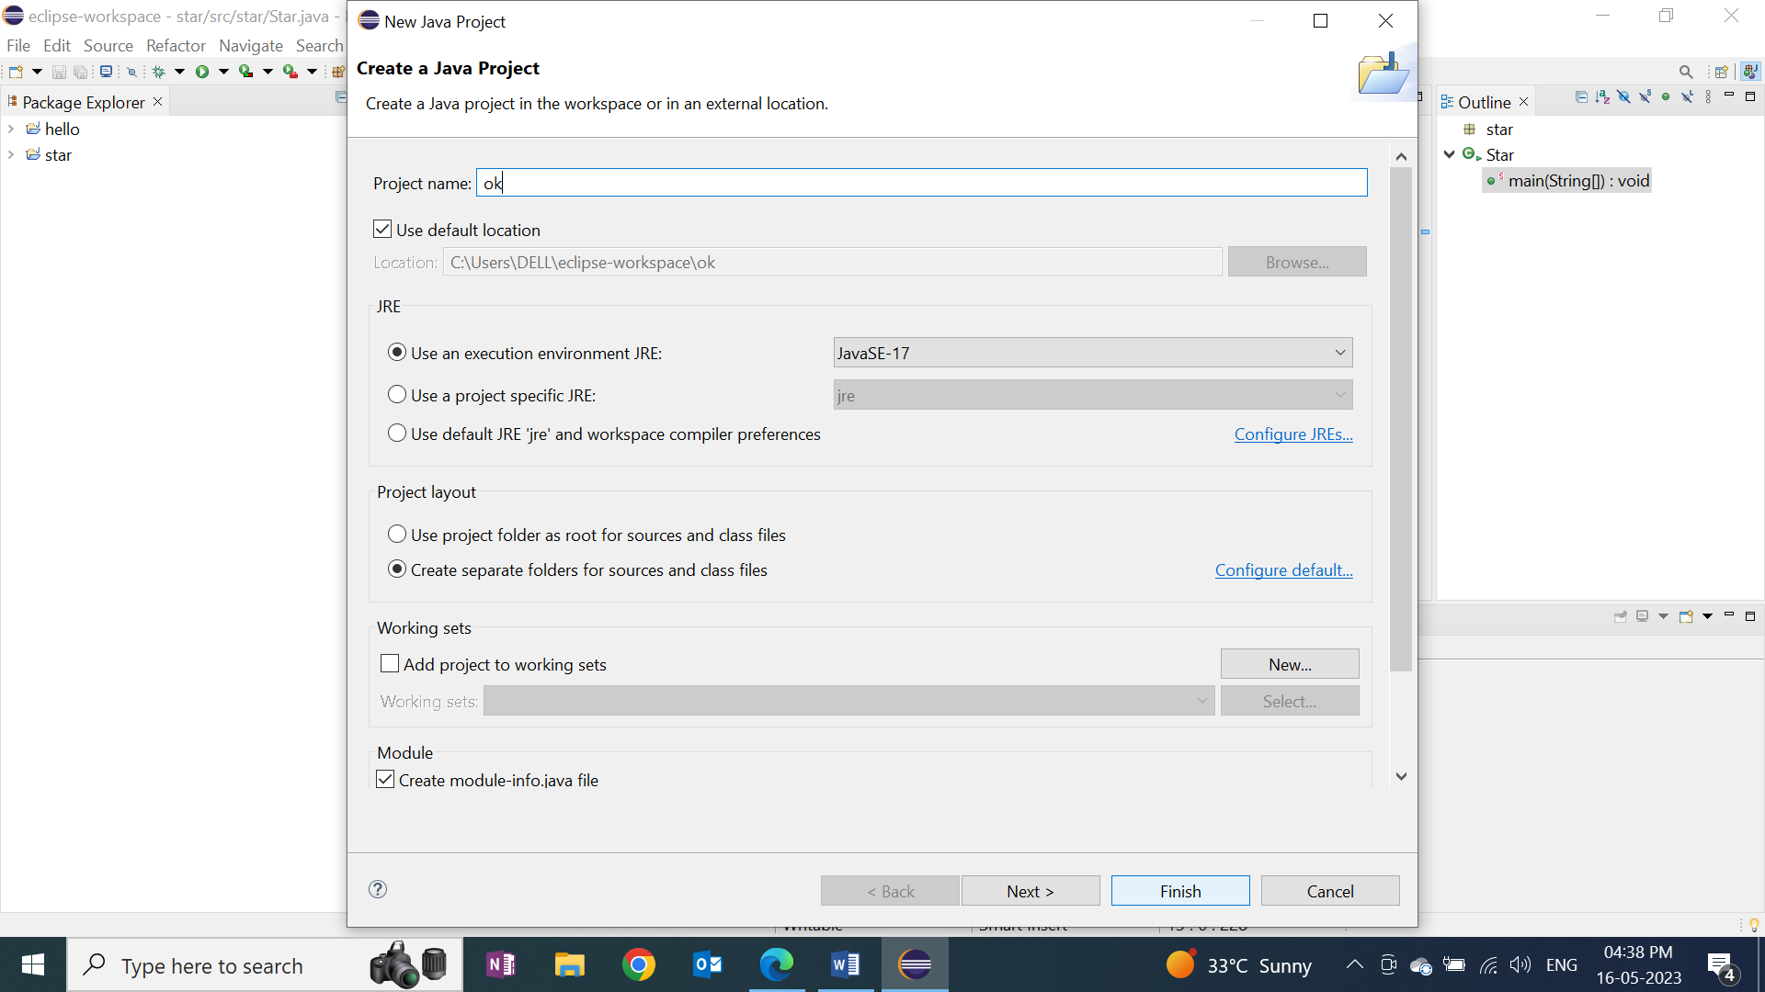
   5. 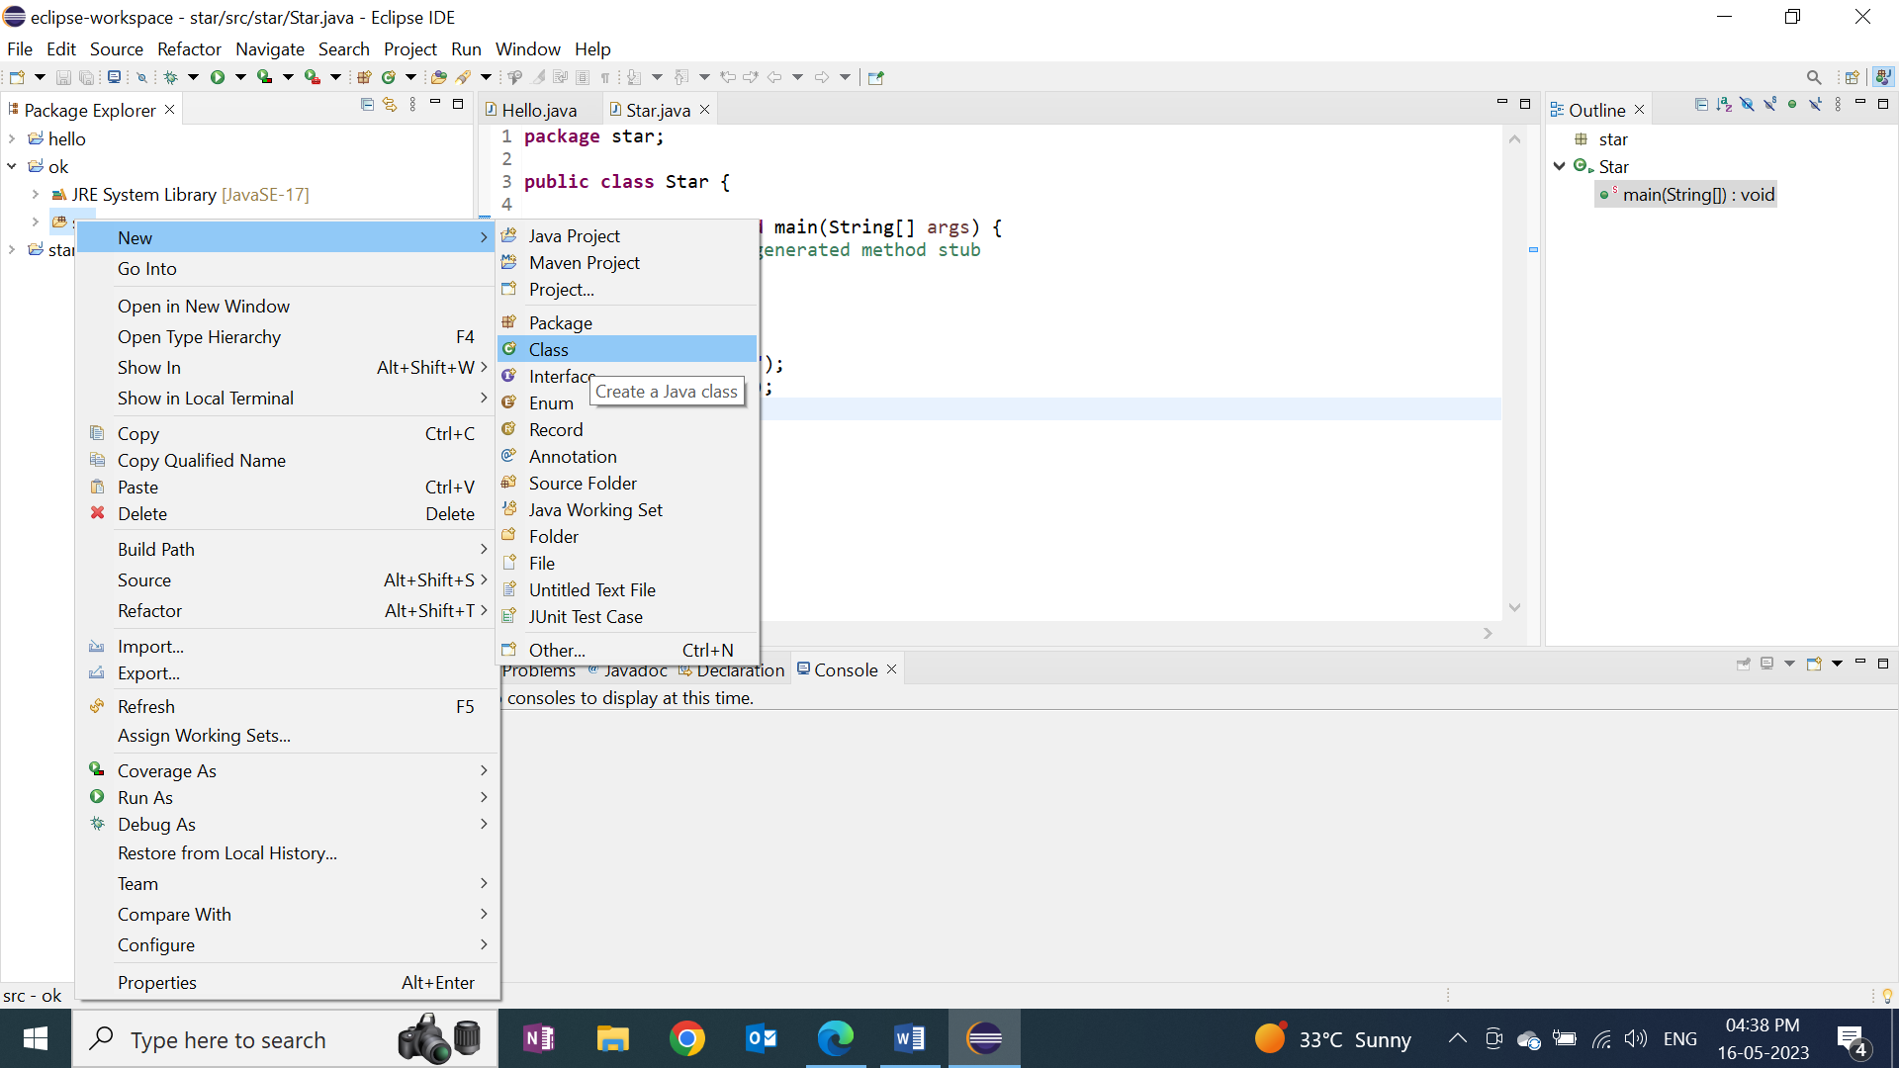

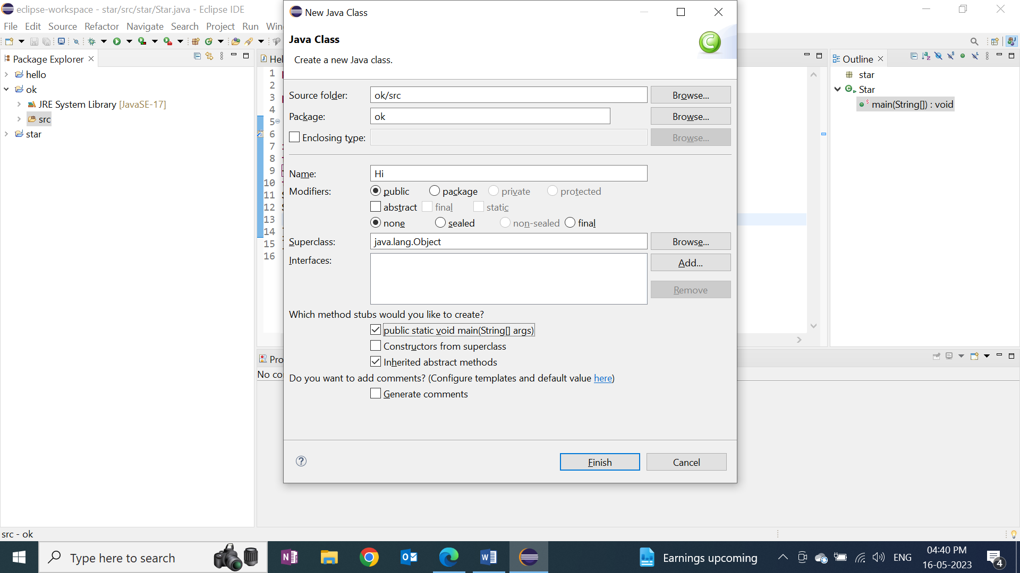

1. <https://docs.oracle.com/en/java/javase/20/docs/api/index.html>

* Write datatypes an write on one program using all datatype
* System is a built-in Java class that contains useful members, such as out, which is short for "output". The println() method, s