Министерство образования Республики Беларусь

Учреждение образования

Брестский государственный технический университет

Кафедра ИИТ

Лабораторная работа №3

За 3 семестр

По дисциплине «Технология разработки интерфейсов программных средств»

Тема: «Стили. Триггреры.»

Выполнил: студент 2 курса

Группы ПО-4(2)

Коташевич С.Н.

Проверил: Войцехович О.Ю.

Брест 2020

**Лабораторная работа №3**

**Стили. Триггеры.**

**Цель:** изучить стили и триггеры в WPF.

**Стили:**

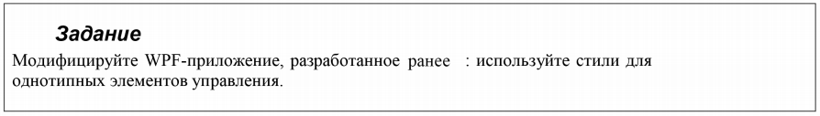

Взято приложение из лабораторной работы №2.

**Текст программы:**

<Window x:Class="Trips_lab03.MainWindow"

xmlns="http://schemas.microsoft.com/winfx/2006/xaml/presentation"

xmlns:x="http://schemas.microsoft.com/winfx/2006/xaml"

xmlns:d="http://schemas.microsoft.com/expression/blend/2008"

xmlns:mc="http://schemas.openxmlformats.org/markup-compatibility/2006"

mc:Ignorable="d"

Title="Graphics editor" Height="450" Width="800"

Background="WhiteSmoke">

<Window.Resources>

<x:Array x:Key="ChangeColor" Type="{x:Type DrawingAttributes}">

<DrawingAttributes Color="Red"/>

<DrawingAttributes Color="Green"/>

<DrawingAttributes Color="Blue"/>

</x:Array>

<x:Array x:Key="EditingMode" Type="{x:Type InkCanvasEditingMode}">

<x:Static Member="InkCanvasEditingMode.Ink"/>

<x:Static Member="InkCanvasEditingMode.EraseByStroke"/>

<x:Static Member="InkCanvasEditingMode.EraseByPoint"/>

</x:Array>

<Style TargetType="ComboBox" x:Key="smth">

<Style.Setters>

<Setter Property="SelectedIndex" Value="0"/>

<Setter Property="FontSize" Value="20"/>

<Setter Property="ItemsSource" Value="{StaticResource ChangeColor}"/>

</Style.Setters>

</Style>

<Style BasedOn="{StaticResource smth}" TargetType="ComboBox" x:Key="smth2">

<Style.Setters>

<Setter Property="ItemsSource" Value="{StaticResource EditingMode}"/>

</Style.Setters>

</Style>

<Style TargetType="TextBlock">

<Style.Setters>

<Setter Property="FontSize" Value="20"/>

</Style.Setters>

</Style>

<Style TargetType="Slider" x:Key="slider">

<Style.Setters>

<Setter Property="Height" Value="25"/>

<Setter Property="Minimum" Value="1"/>

<Setter Property="Maximum" Value="15"/>

<Setter Property="Value" Value="3"/>

<EventSetter Event="ValueChanged" Handler="Size_Brush"/>

</Style.Setters>

</Style>

</Window.Resources>

<Grid>

<TextBlock Text="Режим работы" Margin="96,0,543.8,386.8" />

<TextBlock Text="Цвет кисти" Margin="354.4,0,305.535,386.8" />

<TextBlock Text="Толщина кисти" Margin="575.189,0,44.01,389.2" />

<InkCanvas x:Name="Draw" Margin="0,66.2,0,0" DefaultDrawingAttributes="{Binding ElementName=Colors, Path=SelectedValue}"

EditingMode="{Binding ElementName=Mode, Path=SelectedValue}" Background="Aqua"/>

<ComboBox Style="{StaticResource smth}" x:Name="Colors" Margin="354.4,28.6,289.867,354.2">

<ComboBox.ItemTemplate>

<DataTemplate>

<TextBlock Text="{Binding Path=Color}"/>

</DataTemplate>

</ComboBox.ItemTemplate>

</ComboBox>

<Slider Style="{StaticResource slider}" Margin="597.189,33.6,96.41,361.8" />

<ComboBox Style="{StaticResource smth2}" x:Name="Mode" Margin="102.933,28.6,589.867,354.2"/>

</Grid>

</Window>

**Пример работы:**

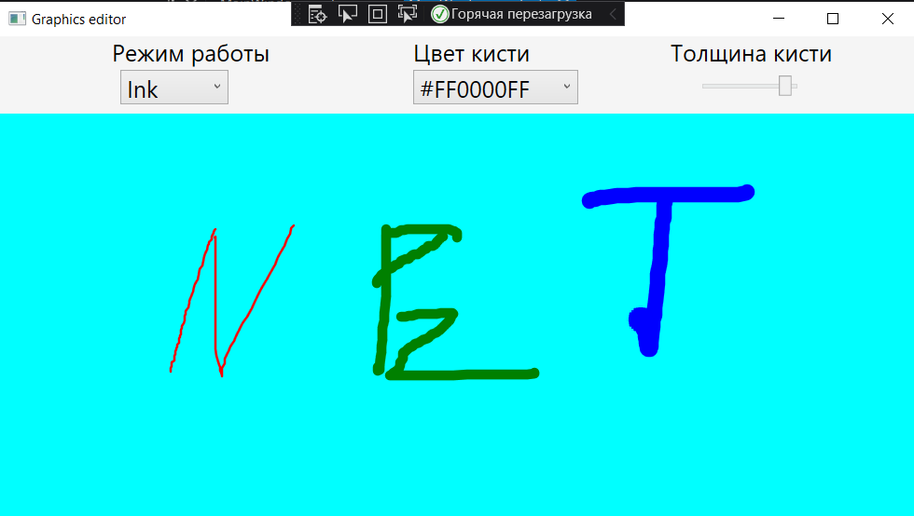

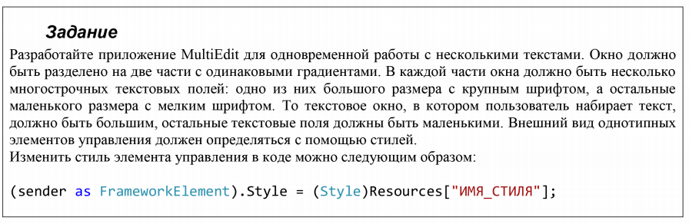

**Текст программы:**

**\*.xaml**

<Window x:Class="Trips_lab03.MainWindow"

xmlns="http://schemas.microsoft.com/winfx/2006/xaml/presentation"

xmlns:x="http://schemas.microsoft.com/winfx/2006/xaml"

xmlns:d="http://schemas.microsoft.com/expression/blend/2008"

xmlns:mc="http://schemas.openxmlformats.org/markup-compatibility/2006"

mc:Ignorable="d"

Title="MultiEdit" Height="450" Width="800"

Background="WhiteSmoke">

<Window.Resources>

<Style TargetType="TextBox" x:Key="NotSelected" >

<Style.Setters>

<Setter Property="HorizontalAlignment" Value="Left"/>

<Setter Property="VerticalAlignment" Value="Top"/>

<Setter Property="TextWrapping" Value="Wrap"/>

<Setter Property="Height" Value="30"/>

<Setter Property="FontSize" Value="10"/>

<Setter Property="Width" Value="300"/>

<EventSetter Event="MouseEnter" Handler="TextBox_MouseEnter"/>

</Style.Setters>

</Style>

<Style TargetType="TextBox" x:Key="Selected">

<Style.Setters>

<Setter Property="HorizontalAlignment" Value="Left"/>

<Setter Property="VerticalAlignment" Value="Top"/>

<Setter Property="TextWrapping" Value="Wrap"/>

<Setter Property="Height" Value="80"/>

<Setter Property="Width" Value="360"/>

<Setter Property="FontSize" Value="20"/>

<EventSetter Event="MouseLeave" Handler="TextBox_MouseLeave"/>

</Style.Setters>

</Style>

<Style TargetType="Rectangle">

<Style.Setters>

<Setter Property="HorizontalAlignment" Value="Left"/>

<Setter Property="Stroke" Value="Black"/>

<Setter Property="VerticalAlignment" Value="Top"/>

<Setter Property="Height" Value="420.4"/>

<Setter Property="Width" Value="400"/>

<Setter Property="Fill">

<Setter.Value>

<LinearGradientBrush StartPoint="0.5,0" EndPoint="0.5,1">

<LinearGradientBrush.GradientStops>

<GradientStop Color="DarkBlue" Offset="0" />

<GradientStop Color="LightBlue" Offset="0.2" />

<GradientStop Color="LightBlue" Offset="0.8" />

<GradientStop Color="DarkBlue" Offset="1" />

</LinearGradientBrush.GradientStops>

</LinearGradientBrush>

</Setter.Value>

</Setter>

</Style.Setters>

</Style>

</Window.Resources>

<Grid>

<Rectangle/>

<Rectangle Margin="400,0,-6.4,0"/>

<Path Data="M395.5,0 L395.5,480" Fill="#FFF4F4F5" HorizontalAlignment="Left" Height="481" Margin="400,0,0,-60.6" Stretch="Fill" Stroke="Black" VerticalAlignment="Top" Width="5"/>

<TextBox Style="{StaticResource NotSelected}" Margin="10,10,0,0"/>

<TextBox Style="{StaticResource NotSelected}" Margin="10,117.6,0,0"/>

<TextBox Style="{StaticResource NotSelected}" Margin="10,228,0,0"/>

<TextBox Style="{StaticResource NotSelected}" Margin="10,334.2,0,0"/>

<TextBox Style="{StaticResource NotSelected}" Margin="423.3,10,0,0"/>

<TextBox Style="{StaticResource NotSelected}" Margin="423.3,117.6,0,0"/>

<TextBox Style="{StaticResource NotSelected}" Margin="423.3,228,0,0"/>

<TextBox Style="{StaticResource NotSelected}" Margin="423.3,334.2,0,0"/>

</Grid>

</Window>

**\*.cs**

using System.Windows;

namespace Trips_lab03

{

public partial class MainWindow : Window

{

public MainWindow()

{

InitializeComponent();

}

private void TextBox_MouseEnter(object sender, System.Windows.Input.MouseEventArgs e)

{

(sender as FrameworkElement).Style = (Style)Resources["Selected"];

}

private void TextBox_MouseLeave(object sender, System.Windows.Input.MouseEventArgs e)

{

(sender as FrameworkElement).Style = (Style)Resources["NotSelected"];

}

}

}

**Пример работы:**

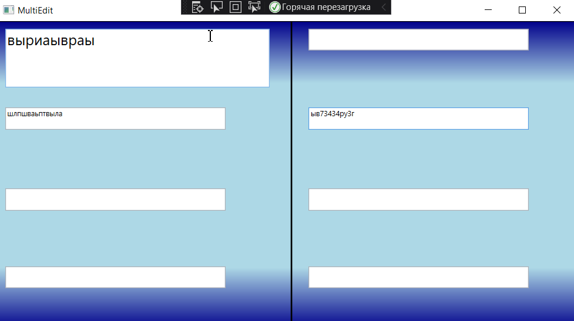

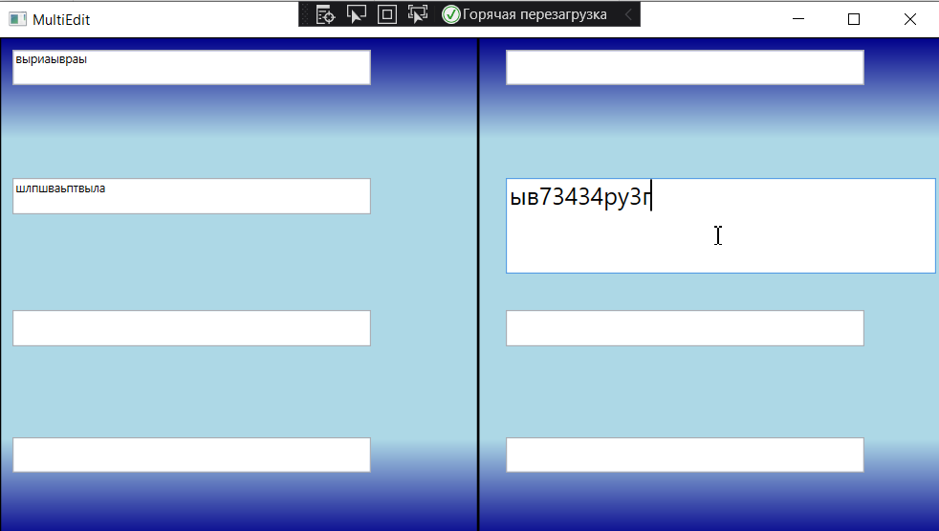

**Триггеры:**

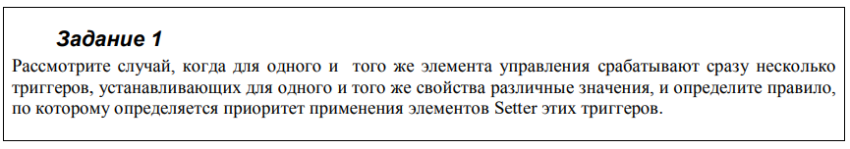

**Код программы:**

<Window x:Class="Trips_lab03.MainWindow"

xmlns="http://schemas.microsoft.com/winfx/2006/xaml/presentation"

xmlns:x="http://schemas.microsoft.com/winfx/2006/xaml"

xmlns:d="http://schemas.microsoft.com/expression/blend/2008"

xmlns:mc="http://schemas.openxmlformats.org/markup-compatibility/2006"

mc:Ignorable="d"

Title="MainWindow" Height="450" Width="800">

<Window.Resources>

<Style TargetType="Button">

<Style.Triggers>

<Trigger Property="IsMouseOver" Value="True">

<Trigger.Setters>

<Setter Property="FontSize" Value="30"/>

</Trigger.Setters>

</Trigger>

<Trigger Property="IsMouseOver" Value="True">

<Trigger.Setters>

<Setter Property="FontSize" Value="20"/>

</Trigger.Setters>

</Trigger>

</Style.Triggers>

</Style>

</Window.Resources>

<Grid Margin="174,139.2,566.4,258">

<Button Content="smth" Margin="0,0,-21.6,-18"/>

</Grid>

</Window>

**Пример работы:**

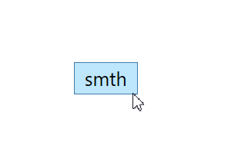

**Вывод:** из двух триггеров выполняется тот, который стоит последним.

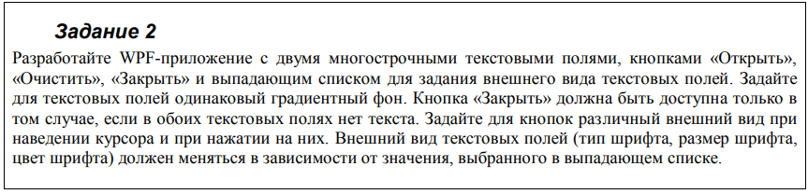

**Код программы:**

<Window x:Class="Trips_lab03.MainWindow"

xmlns="http://schemas.microsoft.com/winfx/2006/xaml/presentation"

xmlns:x="http://schemas.microsoft.com/winfx/2006/xaml"

xmlns:d="http://schemas.microsoft.com/expression/blend/2008"

xmlns:mc="http://schemas.openxmlformats.org/markup-compatibility/2006"

mc:Ignorable="d"

Title="MainWindow" Height="450" Width="800">

<Window.Resources>

<Style TargetType="Button" x:Key="Button1">

<Style.Triggers>

<Trigger Property="IsMouseOver" Value="True">

<Trigger.Setters>

<Setter Property="Foreground" Value="Green"/>

<Setter Property="FontSize" Value="20"/>

</Trigger.Setters>

</Trigger>

</Style.Triggers>

</Style>

<Style BasedOn="{StaticResource Button1}" TargetType="Button" x:Key="Bttn">

<Style.Triggers>

<Trigger Property="IsPressed" Value="True">

<Trigger.Setters>

<Setter Property="Foreground" Value="DarkRed"/>

<Setter Property="FontSize" Value="15"/>

</Trigger.Setters>

</Trigger>

</Style.Triggers>

</Style>

<Style BasedOn="{StaticResource Bttn}" TargetType="Button" x:Key="Close">

<Style.Triggers>

<MultiDataTrigger>

<MultiDataTrigger.Conditions>

<Condition Binding="{Binding ElementName=textbox1, Path=Text}" Value=""/>

<Condition Binding="{Binding ElementName=textbox2, Path=Text}" Value=""/>

</MultiDataTrigger.Conditions>

<MultiDataTrigger.Setters>

<Setter Property="IsEnabled" Value="True"/>

</MultiDataTrigger.Setters>

</MultiDataTrigger>

</Style.Triggers>

<Style.Setters>

<Setter Property="IsEnabled" Value="False"/>

</Style.Setters>

</Style>

<Style TargetType="TextBox" x:Key="value">

<Style.Setters>

<Setter Property="ItemsControl.Background">

<Setter.Value>

<LinearGradientBrush>

<LinearGradientBrush.GradientStops>

<GradientStop Color="Aqua" Offset="1"/>

<GradientStop Color="Yellow" Offset="0.5"/>

<GradientStop Color="Green" Offset="0"/>

</LinearGradientBrush.GradientStops>

</LinearGradientBrush>

</Setter.Value>

</Setter>

</Style.Setters>

<Style.Triggers>

<DataTrigger Binding="{Binding ElementName=cmbox, Path=SelectedIndex}" Value="0">

<DataTrigger.Setters>

<Setter Property="FontSize" Value="15"/>

<Setter Property="Foreground" Value="Red"/>

<Setter Property="FontFamily" Value="Times New Roman"/>

</DataTrigger.Setters>

</DataTrigger>

<DataTrigger Binding="{Binding ElementName=cmbox, Path=SelectedIndex}" Value="1">

<DataTrigger.Setters>

<Setter Property="FontSize" Value="20"/>

<Setter Property="Foreground" Value="Green"/>

<Setter Property="FontFamily" Value="Arial"/>

</DataTrigger.Setters>

</DataTrigger>

<DataTrigger Binding="{Binding ElementName=cmbox, Path=SelectedIndex}" Value="2">

<DataTrigger.Setters>

<Setter Property="FontSize" Value="25"/>

<Setter Property="Foreground" Value="Yellow"/>

<Setter Property="FontFamily" Value="Calibri"/>

</DataTrigger.Setters>

</DataTrigger>

</Style.Triggers>

</Style>

</Window.Resources>

<Grid>

<StackPanel Orientation="Horizontal" Margin="0,24,0,0">

<Button Style="{StaticResource Bttn}" Content="Открыть" HorizontalAlignment="Left" Height="40.8" VerticalAlignment="Top" Width="108" Margin="20,0,0,0"/>

<Button Style="{StaticResource Bttn}" Content="Очистить" HorizontalAlignment="Left" Height="40.8" VerticalAlignment="Top" Width="103.2" Margin="20,0,0,0"/>

<Button Style="{StaticResource Close}" Content="Закрыть" HorizontalAlignment="Left" Height="40.8" VerticalAlignment="Top" Width="111.6" Margin="20,0,0,0"/>

<ComboBox x:Name="cmbox" HorizontalAlignment="Left" Height="42.4" Margin="70.5,0,0,0" VerticalAlignment="Top" Width="138" SelectedIndex="0">

<ComboBoxItem Content="стиль 1"/>

<ComboBoxItem Content="стиль 2"/>

<ComboBoxItem Content="стиль 3"/>

</ComboBox>

</StackPanel>

<TextBox Style="{StaticResource value}" x:Name="textbox1" HorizontalAlignment="Left" Height="195.2" Margin="52,130,0,0" TextWrapping="Wrap" VerticalAlignment="Top" Width="305.6"/>

<TextBox Style="{StaticResource value}" x:Name="textbox2" HorizontalAlignment="Left" Height="195.2" Margin="410.5,130,0,0" TextWrapping="Wrap" VerticalAlignment="Top" Width="303.9"/>

</Grid>

</Window>

**Пример работы:**

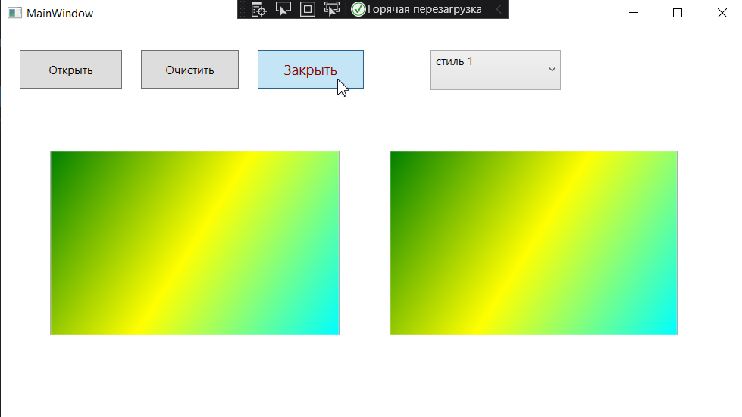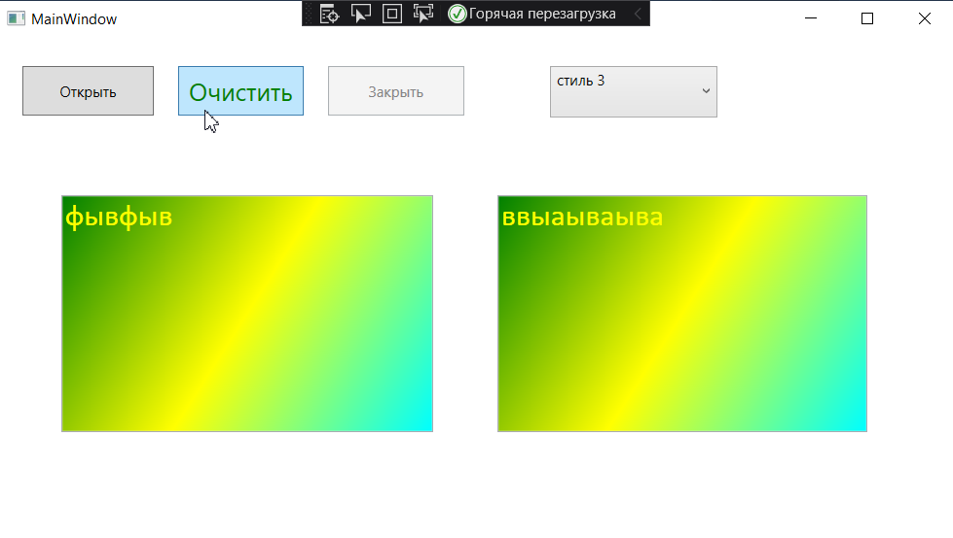

**Вывод:** в ходе работы изучил стили и триггеры.