Министерство образования Республики Беларусь

Учреждение образования

Брестский государственный технический университет

Кафедра ИИТ

Лабораторная работа №4

За 3 семестр

По дисциплине «Технология разработки интерфейсов программных средств»

Тема: «Анимации»

Выполнил: студент 2 курса

Группы ПО-4(2)

Коташевич С.Н.

Проверил: Войцехович О.Ю.

Брест 2020

**Лабораторная работа №4**

**Анимации**

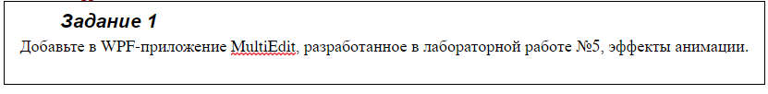

**Код *.xaml**

<Window x:Class="Trips_lab03.MainWindow"

xmlns="http://schemas.microsoft.com/winfx/2006/xaml/presentation"

xmlns:x="http://schemas.microsoft.com/winfx/2006/xaml"

xmlns:d="http://schemas.microsoft.com/expression/blend/2008"

xmlns:mc="http://schemas.openxmlformats.org/markup-compatibility/2006"

mc:Ignorable="d"

Title="MultiEdit" Height="450" Width="800"

Background="WhiteSmoke">

<Window.Resources>

<Style TargetType="TextBox" x:Key="NotSelected" >

<Style.Setters>

<Setter Property="HorizontalAlignment" Value="Left"/>

<Setter Property="VerticalAlignment" Value="Top"/>

<Setter Property="TextWrapping" Value="Wrap"/>

<Setter Property="Height" Value="30"/>

<Setter Property="FontSize" Value="10"/>

<Setter Property="Width" Value="300"/>

<EventSetter Event="MouseEnter" Handler="TextBox_MouseEnter"/>

</Style.Setters>

</Style>

<Style TargetType="TextBox" x:Key="Selected">

<Style.Setters>

<Setter Property="HorizontalAlignment" Value="Left"/>

<Setter Property="VerticalAlignment" Value="Top"/>

<Setter Property="TextWrapping" Value="Wrap"/>

<Setter Property="Height" Value="80"/>

<Setter Property="Width" Value="360"/>

<Setter Property="FontSize" Value="20"/>

<EventSetter Event="MouseLeave" Handler="TextBox_MouseLeave"/>

</Style.Setters>

</Style>

<Style TargetType="Rectangle">

<Style.Setters>

<Setter Property="HorizontalAlignment" Value="Left"/>

<Setter Property="Stroke" Value="Black"/>

<Setter Property="VerticalAlignment" Value="Top"/>

<Setter Property="Height" Value="420.4"/>

<Setter Property="Width" Value="400"/>

<Setter Property="Fill">

<Setter.Value>

<LinearGradientBrush StartPoint="0.5,0" EndPoint="0.5,1">

<LinearGradientBrush.GradientStops>

<GradientStop Color="DarkBlue" Offset="0" />

<GradientStop Color="LightBlue" Offset="0.2" />

<GradientStop Color="LightBlue" Offset="0.8" />

<GradientStop Color="DarkBlue" Offset="1" />

</LinearGradientBrush.GradientStops>

</LinearGradientBrush>

</Setter.Value>

</Setter>

</Style.Setters>

<Style.Triggers>

<EventTrigger RoutedEvent="Window.Loaded">

<BeginStoryboard>

<Storyboard>

<ColorAnimationUsingKeyFrames Storyboard.TargetProperty="Fill.GradientStops[1].Color"

Duration="0:0:1" RepeatBehavior="Forever" AutoReverse="True">

<ColorAnimationUsingKeyFrames.KeyFrames>

<LinearColorKeyFrame KeyTime="0:0:1" Value="DarkBlue"/>

</ColorAnimationUsingKeyFrames.KeyFrames>

</ColorAnimationUsingKeyFrames>

</Storyboard>

</BeginStoryboard>

</EventTrigger>

</Style.Triggers>

</Style>

</Window.Resources>

<Grid>

<Rectangle x:Name="Rect1"/>

<Rectangle x:Name="Rect2" Margin="400,0,-6.4,0"/>

<Path Data="M395.5,0 L395.5,480" Fill="#FFF4F4F5" HorizontalAlignment="Left" Height="481" Margin="400,0,0,-60.6" Stretch="Fill" Stroke="Black" VerticalAlignment="Top" Width="5"/>

<TextBox Style="{StaticResource NotSelected}" Margin="10,10,0,0"/>

<TextBox Style="{StaticResource NotSelected}" Margin="10,117.6,0,0"/>

<TextBox Style="{StaticResource NotSelected}" Margin="10,228,0,0"/>

<TextBox Style="{StaticResource NotSelected}" Margin="10,334.2,0,0"/>

<TextBox Style="{StaticResource NotSelected}" Margin="423.3,10,0,0"/>

<TextBox Style="{StaticResource NotSelected}" Margin="423.3,117.6,0,0"/>

<TextBox Style="{StaticResource NotSelected}" Margin="423.3,228,0,0"/>

<TextBox Style="{StaticResource NotSelected}" Margin="423.3,334.2,0,0"/>

</Grid>

</Window>

**Код *.cs**

using System.Windows;

namespace Trips_lab03

{

public partial class MainWindow : Window

{

public MainWindow()

{

InitializeComponent();

}

private void TextBox_MouseEnter(object sender, System.Windows.Input.MouseEventArgs e)

{

(sender as FrameworkElement).Style = (Style)Resources["Selected"];

}

private void TextBox_MouseLeave(object sender, System.Windows.Input.MouseEventArgs e)

{

(sender as FrameworkElement).Style = (Style)Resources["NotSelected"];

}

}

}

**Пример работы:**

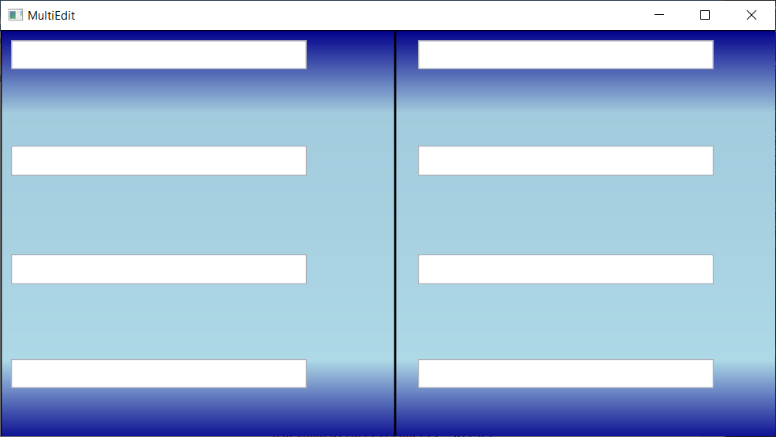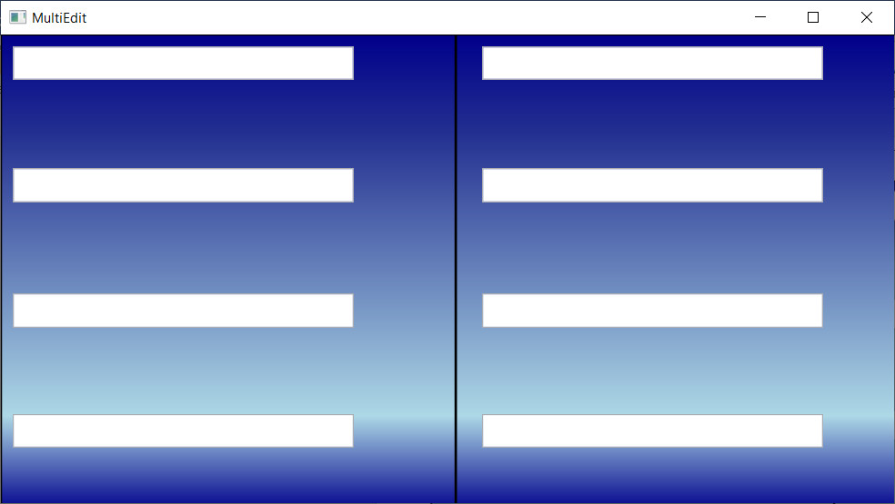

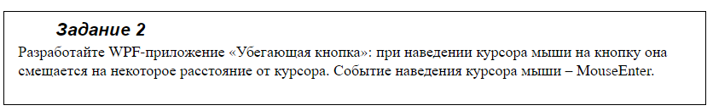

**Код *.xaml**

<Window x:Class="WPF04.MainWindow"

xmlns="http://schemas.microsoft.com/winfx/2006/xaml/presentation"

xmlns:x="http://schemas.microsoft.com/winfx/2006/xaml"

xmlns:d="http://schemas.microsoft.com/expression/blend/2008"

xmlns:mc="http://schemas.openxmlformats.org/markup-compatibility/2006"

mc:Ignorable="d"

Title="MainWindow" Height="450" Width="800">

<Grid>

<Button x:Name="helloButton" Width="70" Height="30" Content="Hello" Margin="0,0,0,0" MouseEnter="helloButton_MouseEnter"/>

</Grid>

</Window>

**Код *.cs**

using System;

using System.Windows;

using System.Windows.Input;

using System.Windows.Media.Animation;

namespace WPF04

{

public partial class MainWindow : Window

{

public MainWindow()

{

InitializeComponent();

}

Thickness[] position = new Thickness[]

{

new Thickness(100, 0, 0, 50),

new Thickness(0, 0, 100, 100),

new Thickness(0, 0, 200, 50),

new Thickness(0, 0, 0, 0),

};

int i = 0;

public Thickness GetThickness()

{

if (i == 4)

{

i = 0;

}

i++;

return position[i - 1];

}

private void helloButton_MouseEnter(object sender, MouseEventArgs e)

{

ThicknessAnimation topAnimation = new ThicknessAnimation();

topAnimation.From = helloButton.Margin;

topAnimation.To = GetThickness();

topAnimation.Duration = TimeSpan.FromSeconds(0.2);

helloButton.BeginAnimation(MarginProperty, topAnimation);

}

}

}

**Пример работы:**

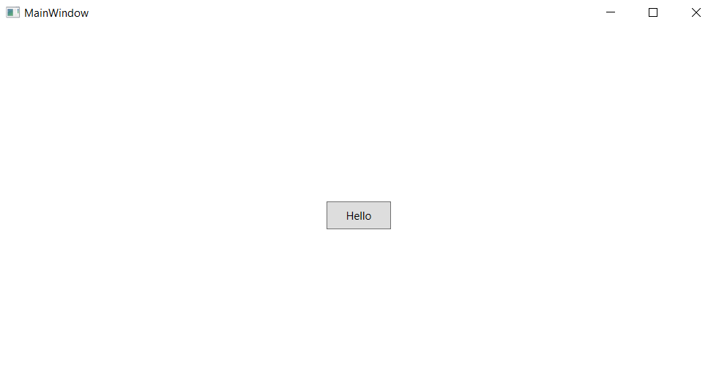 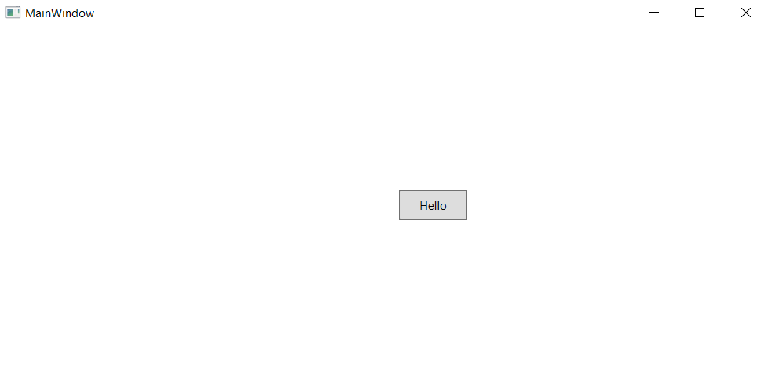 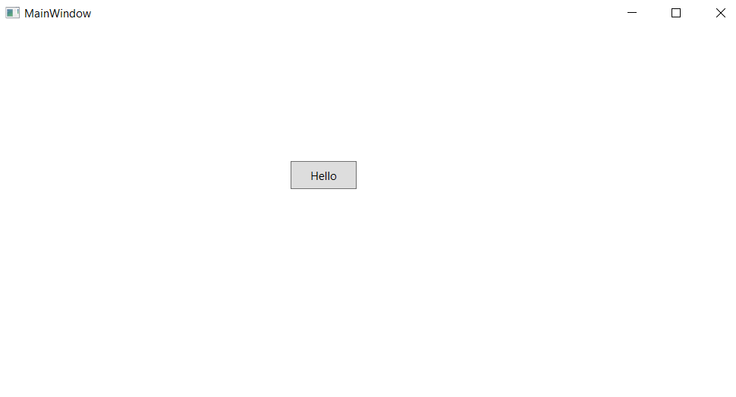

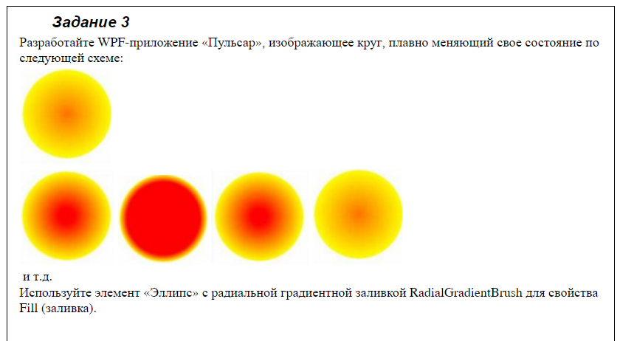

**Код *.xaml**

<Window x:Class="Trips_lab03.MainWindow"

xmlns="http://schemas.microsoft.com/winfx/2006/xaml/presentation"

xmlns:x="http://schemas.microsoft.com/winfx/2006/xaml"

xmlns:d="http://schemas.microsoft.com/expression/blend/2008"

xmlns:mc="http://schemas.openxmlformats.org/markup-compatibility/2006"

mc:Ignorable="d"

Title="MultiEdit" Height="450" Width="800"

Background="WhiteSmoke">

<Grid>

<Ellipse Width="200" Height="200">

<Ellipse.Fill>

<RadialGradientBrush GradientOrigin="0.5, 0.5">

<GradientStop Color="Yellow" Offset="1"/>

<GradientStop Color="Red" Offset="0"/>

</RadialGradientBrush>

</Ellipse.Fill>

<Ellipse.Triggers>

<EventTrigger RoutedEvent="Loaded">

<BeginStoryboard>

<Storyboard>

<ColorAnimationUsingKeyFrames Storyboard.TargetProperty="Fill.GradientStops[1].Color"

Duration="0:0:2" RepeatBehavior="Forever" AutoReverse="True">

<ColorAnimationUsingKeyFrames.KeyFrames>

<LinearColorKeyFrame KeyTime="0:0:2" Value="Orange"/>

<LinearColorKeyFrame KeyTime="0:0:2" Value="Red"/>

</ColorAnimationUsingKeyFrames.KeyFrames>

</ColorAnimationUsingKeyFrames>

</Storyboard>

</BeginStoryboard>

</EventTrigger>

</Ellipse.Triggers>

</Ellipse>

</Grid>

</Window>

**Пример работы:**

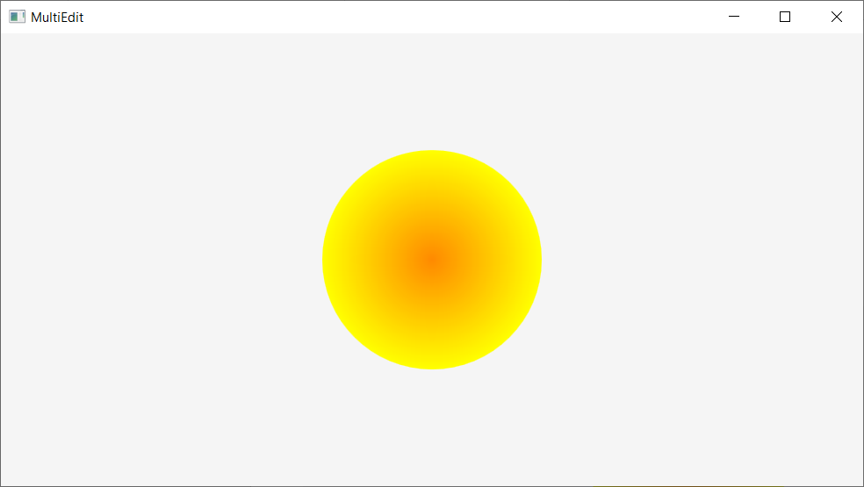

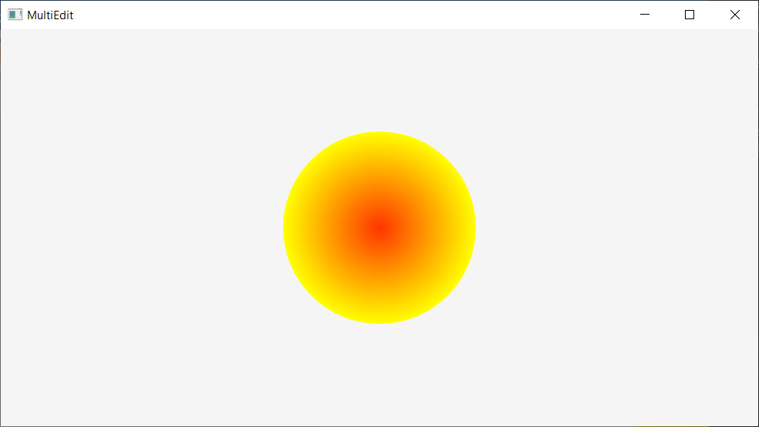

**Вывод:** в ходе работы изучил основы анимации.