View4All Documentation

1. Created the Splash Screen.



1. Created the home screen, which contain the list of video category and popular videos list.



1. Created the category screen.

Which display the list of different videos list according to the category list.



1. Created the video screen.

Video screen show the option for play video and download option, it also show the video name and time.



1. Created the Term and condition screen.

Term and condition screen show the all terms and conditions of application.

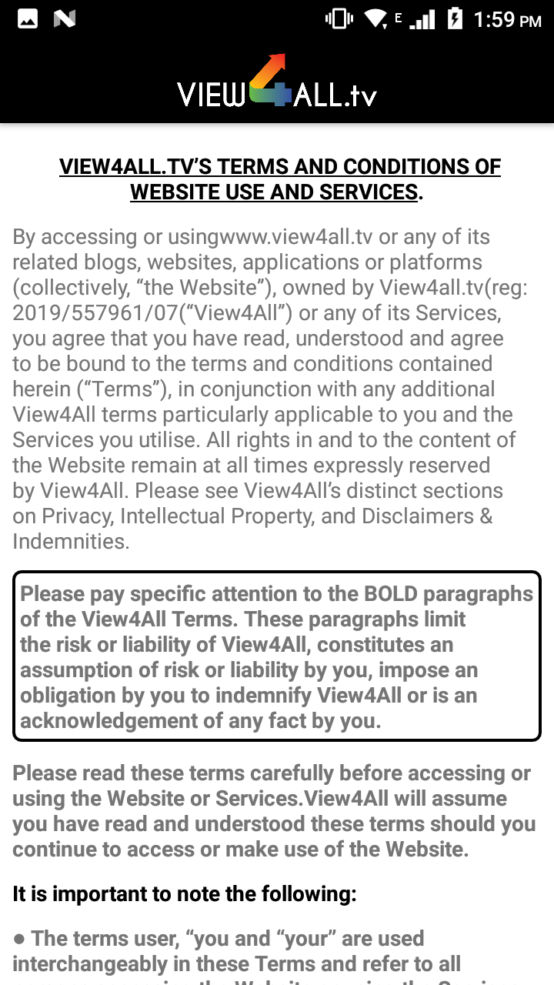

1. Created the contact us screen, now this is blank screen we will show data.

