Predicting Facility-Level Greenhouse Gas Emissions Intensity in Alberta's Oil Sands Using Operational and Technology Features
DATA 606
Group Members:
Paul Moynihan
Ifeanyi Njoku
Anmol Sharma

Revision note
This version corrects a target-leakage issue present in an earlier draft: the previous feature set included Cogen_Adjusted_Emission and a directly-derived emission/production ratio as model inputs, both mathematically entangled with the target variable, which produced an artificially inflated result. It also corrects a second issue in an intermediate draft, where the raw Facility identity was label-encoded and used directly as a predictor, causing tree-based models to memorize per-facility averages rather than learn generalizable drivers, which produced artificially poor and unstable test performance. This version uses a leakage-free feature set — production volume, extraction technology, subsector, product, time, and facility-level historical aggregates (rather than facility identity) — and reports results consistent with that feature set throughout the document.

Introduction

Background and Motivation
Alberta's oil sands are among the largest sources of greenhouse gas (GHG) emissions in Canada, accounting for a significant share of national industrial emissions (Environment and Climate Change Canada, 2023). While total emissions are commonly reported, emissions intensity (GHG emissions per unit of production) has become a key metric used by regulators and industry to evaluate operational efficiency and progress toward climate targets. However, emissions intensity varies widely across oil sands facilities due to differences in extraction methods, operational practices, and technology adoption (Charpentier et al., 2009). Current reporting and policy frameworks often fail to clearly identify which factors most strongly drive these differences, limiting the effectiveness of climate mitigation strategies.
This project applies machine learning methods to predict facility-level GHG emissions intensity using operational and technology-related features. By identifying the most influential drivers of emissions intensity, the project aims to provide data-driven insights to inform more targeted and effective climate policies.

Investigation Goal
The primary objectives of this project are to:
- Develop machine learning models to predict facility-level GHG emissions intensity in Alberta's oil sands.
- Identify and quantify the operational and technological factors that most strongly influence emissions intensity.
- Compare model performance, predictive accuracy, and interpretability across different machine learning approaches.

Data

Data Source
Data for this project was obtained from the Alberta Energy Regulator (AER). The AER is responsible for regulating the safe, responsible, and efficient development of Alberta's energy resources. All data used in the project is considered to be accurate.

Variables of Interest
Field | Description
Company | Name of company that owns the facility (categorical)
Facility | Name of site (categorical) — used only for grouping/aggregation, never as a raw model input
Subsector | In-Situ, Mining & Upgrading, or Mining Stand-Alone (categorical)
Extraction Technology | Production method: SAGD, CSS, PFT, or NFT (categorical)
Product | Crude Bitumen or Synthetic Crude Oil (categorical)
Year | 2011–2023 (numeric)
Production | Volume of oil produced in one year, m³ (numeric)
Cogen Adjusted Emissions | Tonnes of CO2e produced in one year, adjusted by the AER for offsets/credits (numeric) — used only to compute the target, never as a predictor (see Methodology)
Emission Intensity | Cogen Adjusted Emissions ÷ Production — the target variable (numeric)

Permission / Accessibility
The AER publishes all data used in this report and is accessible free of charge at: https://www1.aer.ca/ProductCatalogue/index.html

Time Frame of Data Collection
Data was collected by the AER from 2011 to 2023. At the time of writing, no publicly available data exists for 2024 or 2025.

Methodology
The analysis followed a structured machine learning workflow:
- Data preprocessing: removed 72 non-operational facility-year records (zero emissions or zero production), retaining 344 observations.
- Feature engineering: constructed a leakage-free feature set (details below); categorical variables were label-encoded.
- Exploratory data analysis: examined distributions, category comparisons, temporal trends, and feature correlations.
- Model development: six regression models were trained — Linear Regression, Elastic Net, Random Forest, Gradient Boosting, Support Vector Regression, and a Neural Network (MLP).
- Model evaluation: models were compared using RMSE, MAE, R², and 5-fold cross-validation RMSE on a held-out test set.

Avoiding Target Leakage
Emission_Intensity is defined as Cogen_Adjusted_Emission ÷ Production. An early iteration of this project included Cogen_Adjusted_Emission (and its log transform) directly as predictors. Because those features are mathematically entangled with the numerator of the target, models trained on them achieved inflated test performance that did not reflect genuine predictive ability. A subsequent iteration removed those features but introduced the raw Facility identity as a label-encoded predictor; with only 32 facilities and 344 rows, tree-based models used this as a near-unique key and effectively memorized each facility's historical average intensity, which collapsed test performance (near-zero or negative R²) because the model could not generalize an identity feature to unseen facility-years.
The feature set used throughout this document avoids both problems. It excludes any feature derived from Cogen_Adjusted_Emission and excludes raw Facility identity, replacing it with facility-level historical aggregates — Facility_Avg_Production and Facility_Years_Operating — that summarize a facility's operating history as a continuous, generalizable signal rather than an identity label.

Final Feature Set
- Production, Log_Production — production volume and its log transform
- High_Production, Very_High_Production — production-scale indicators (median / 75th-percentile thresholds)
- Year, Years_Since_Start, Year_Squared, Facility_Age_Proxy — temporal features
- Subsector_Encoded, Extraction Technology_Encoded, Product_Encoded — encoded categorical features
- Facility_Avg_Production, Facility_Years_Operating — facility-level historical aggregates (not facility identity)
- Tech_Product_Interaction, Subsector_Year_Interaction — interaction terms

Exploratory Data Analysis
The dataset contains 344 facility-year records after removing non-operational observations. In-situ production accounts for the largest share of total emissions, followed by mining and upgrading; stand-alone mining contributes only a small share of total emissions.
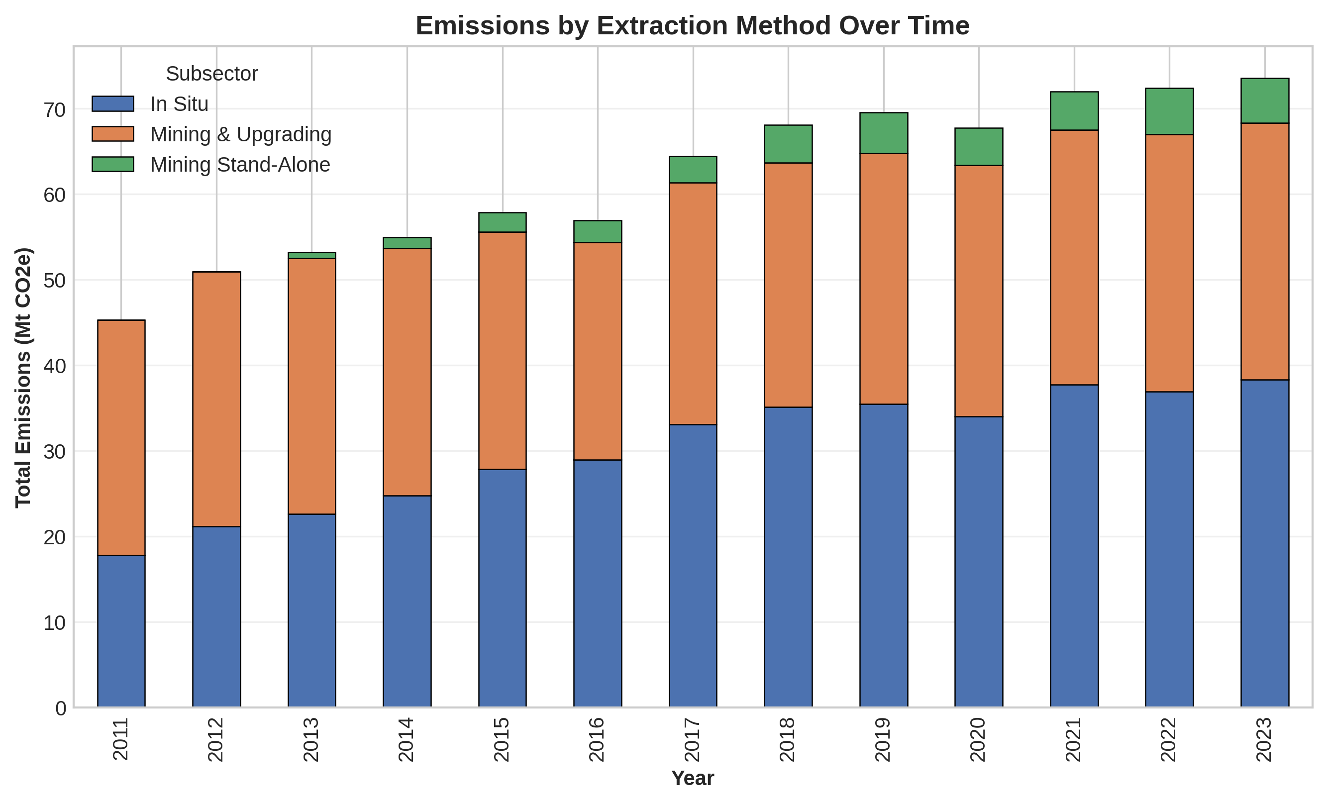
Figure 1: Emissions by extraction method over time
Emission intensity also varies by subsector. On average, in-situ production has the highest emission intensity, followed by mining and upgrading; mining stand-alone is the least intensive form of oil sands extraction.
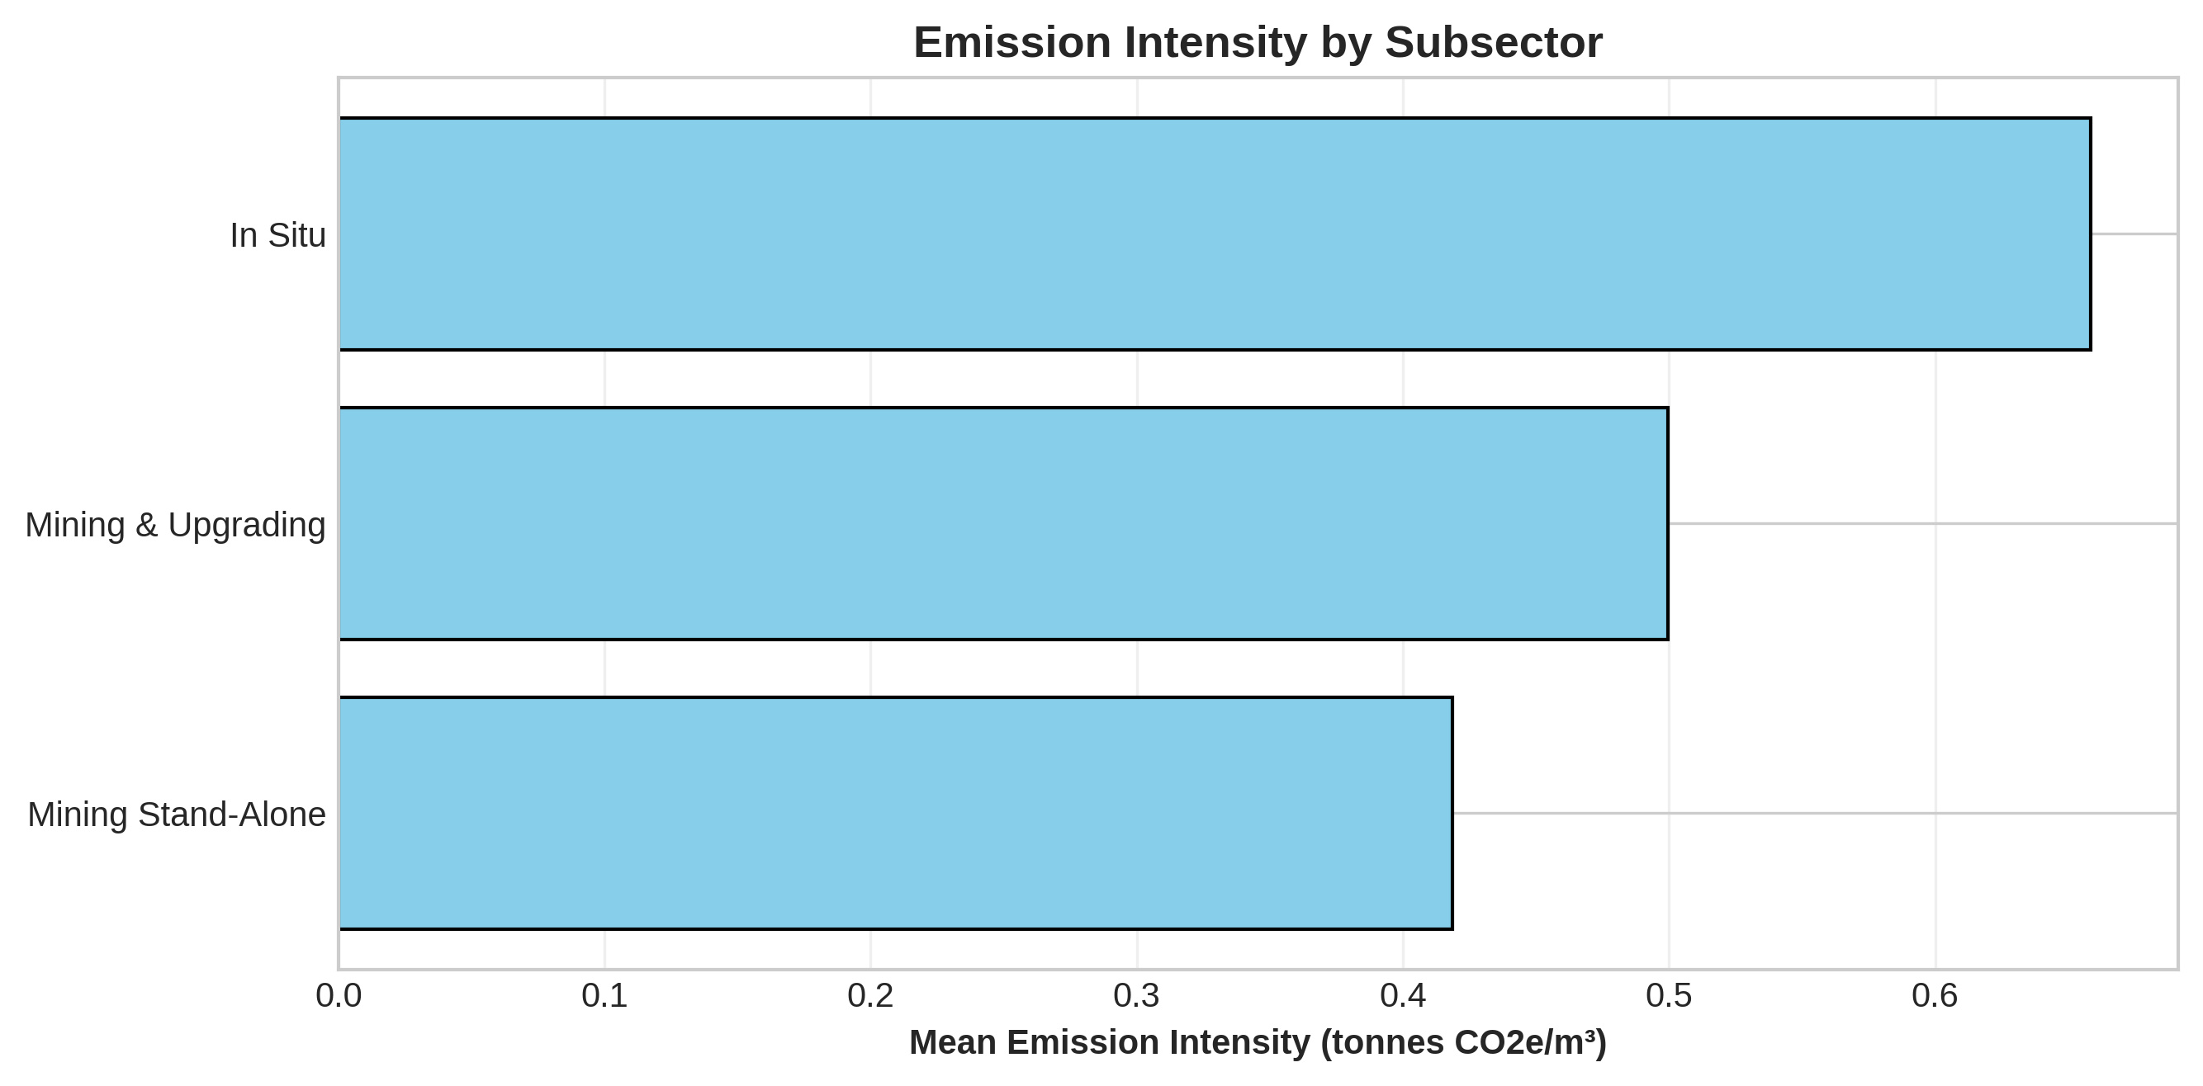
Figure 2: Emission intensity by subsector
Emission intensity varies by extraction technology as well. Cyclic Steam Stimulation (CSS) produces more emissions per unit of production than Steam-Assisted Gravity Drainage (SAGD); both are more intensive than either froth-treatment method (NFT and PFT).
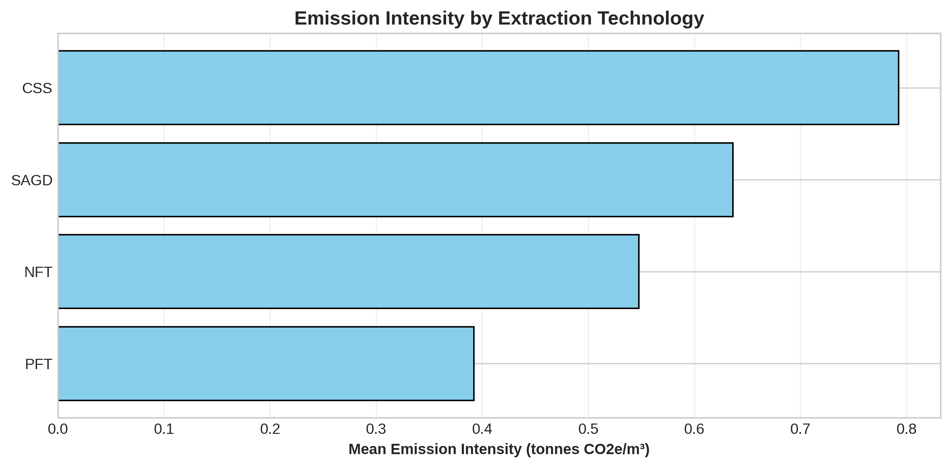
Figure 3: Emission intensity by extraction technology
The correlation matrix below shows the leakage-free feature set. Production and its log transform are moderately-to-strongly negatively correlated with emission intensity, consistent with economies of scale. Facility_Avg_Production is similarly negatively correlated with intensity, indicating that facilities with a history of high production also tend to run more efficiently.
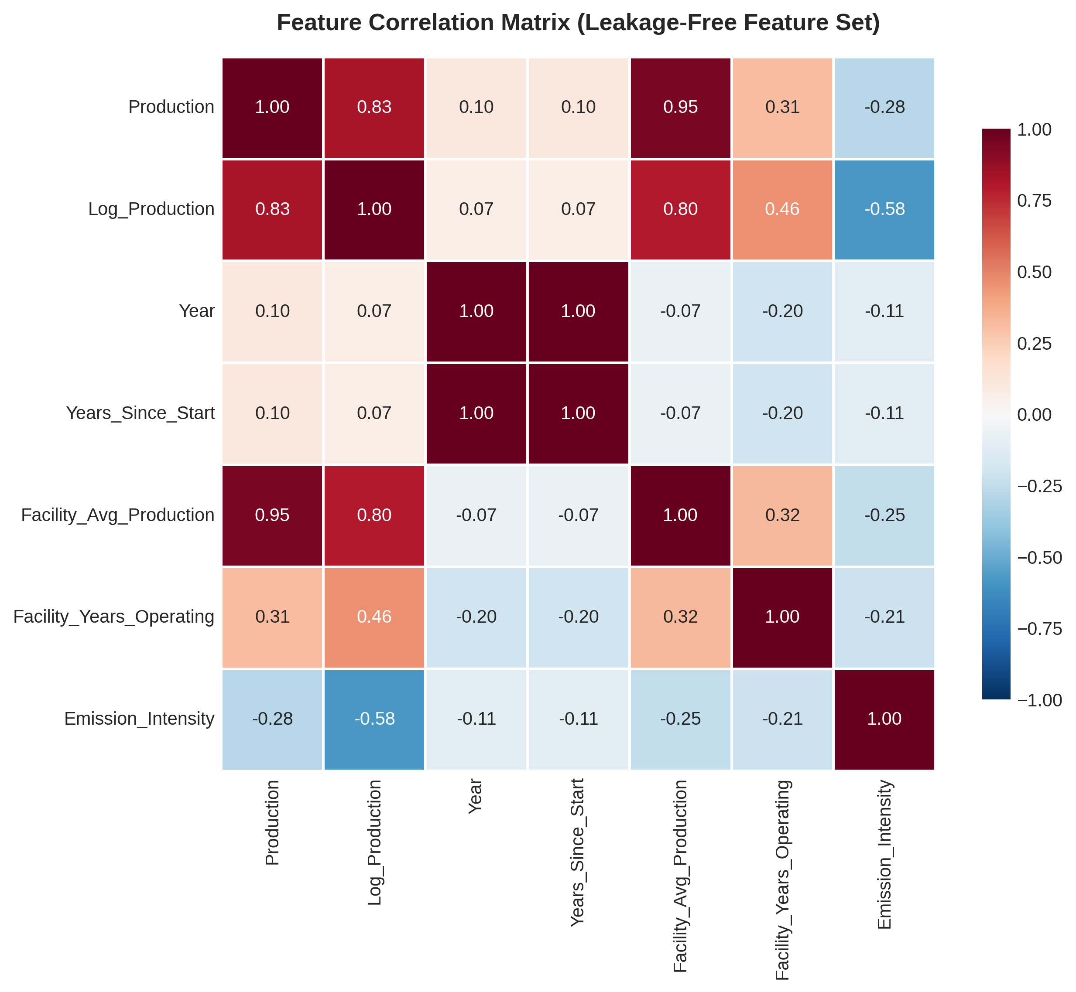
Figure 4: Correlation matrix (leakage-free feature set)

Machine Learning Models

Train-Test Split
The dataset was divided into a training set of 275 samples (79.9%) and a test set of 69 samples (20.1%) using a fixed random seed of 42. All numeric features were standardized with StandardScaler for the scale-sensitive models (Linear Regression, Elastic Net, SVR, Neural Network); tree-based models (Random Forest, Gradient Boosting) were trained on unscaled features, consistent with their scale-invariance. Hyperparameters for each model were selected via 3-fold GridSearchCV on the training set, and final performance was assessed on the held-out test set together with 5-fold cross-validation RMSE.

Models Compared
- Linear Regression
- Elastic Net
- Random Forest
- Gradient Boosting
- Support Vector Regression (SVR)
- Neural Network (Multi-Layer Perceptron)
All models show some degree of overfitting, with Gradient Boosting most pronounced (Train R² = 0.993 vs. Test R² = 0.450). Random Forest and Linear Regression show the smallest train-test gaps among the top performers.
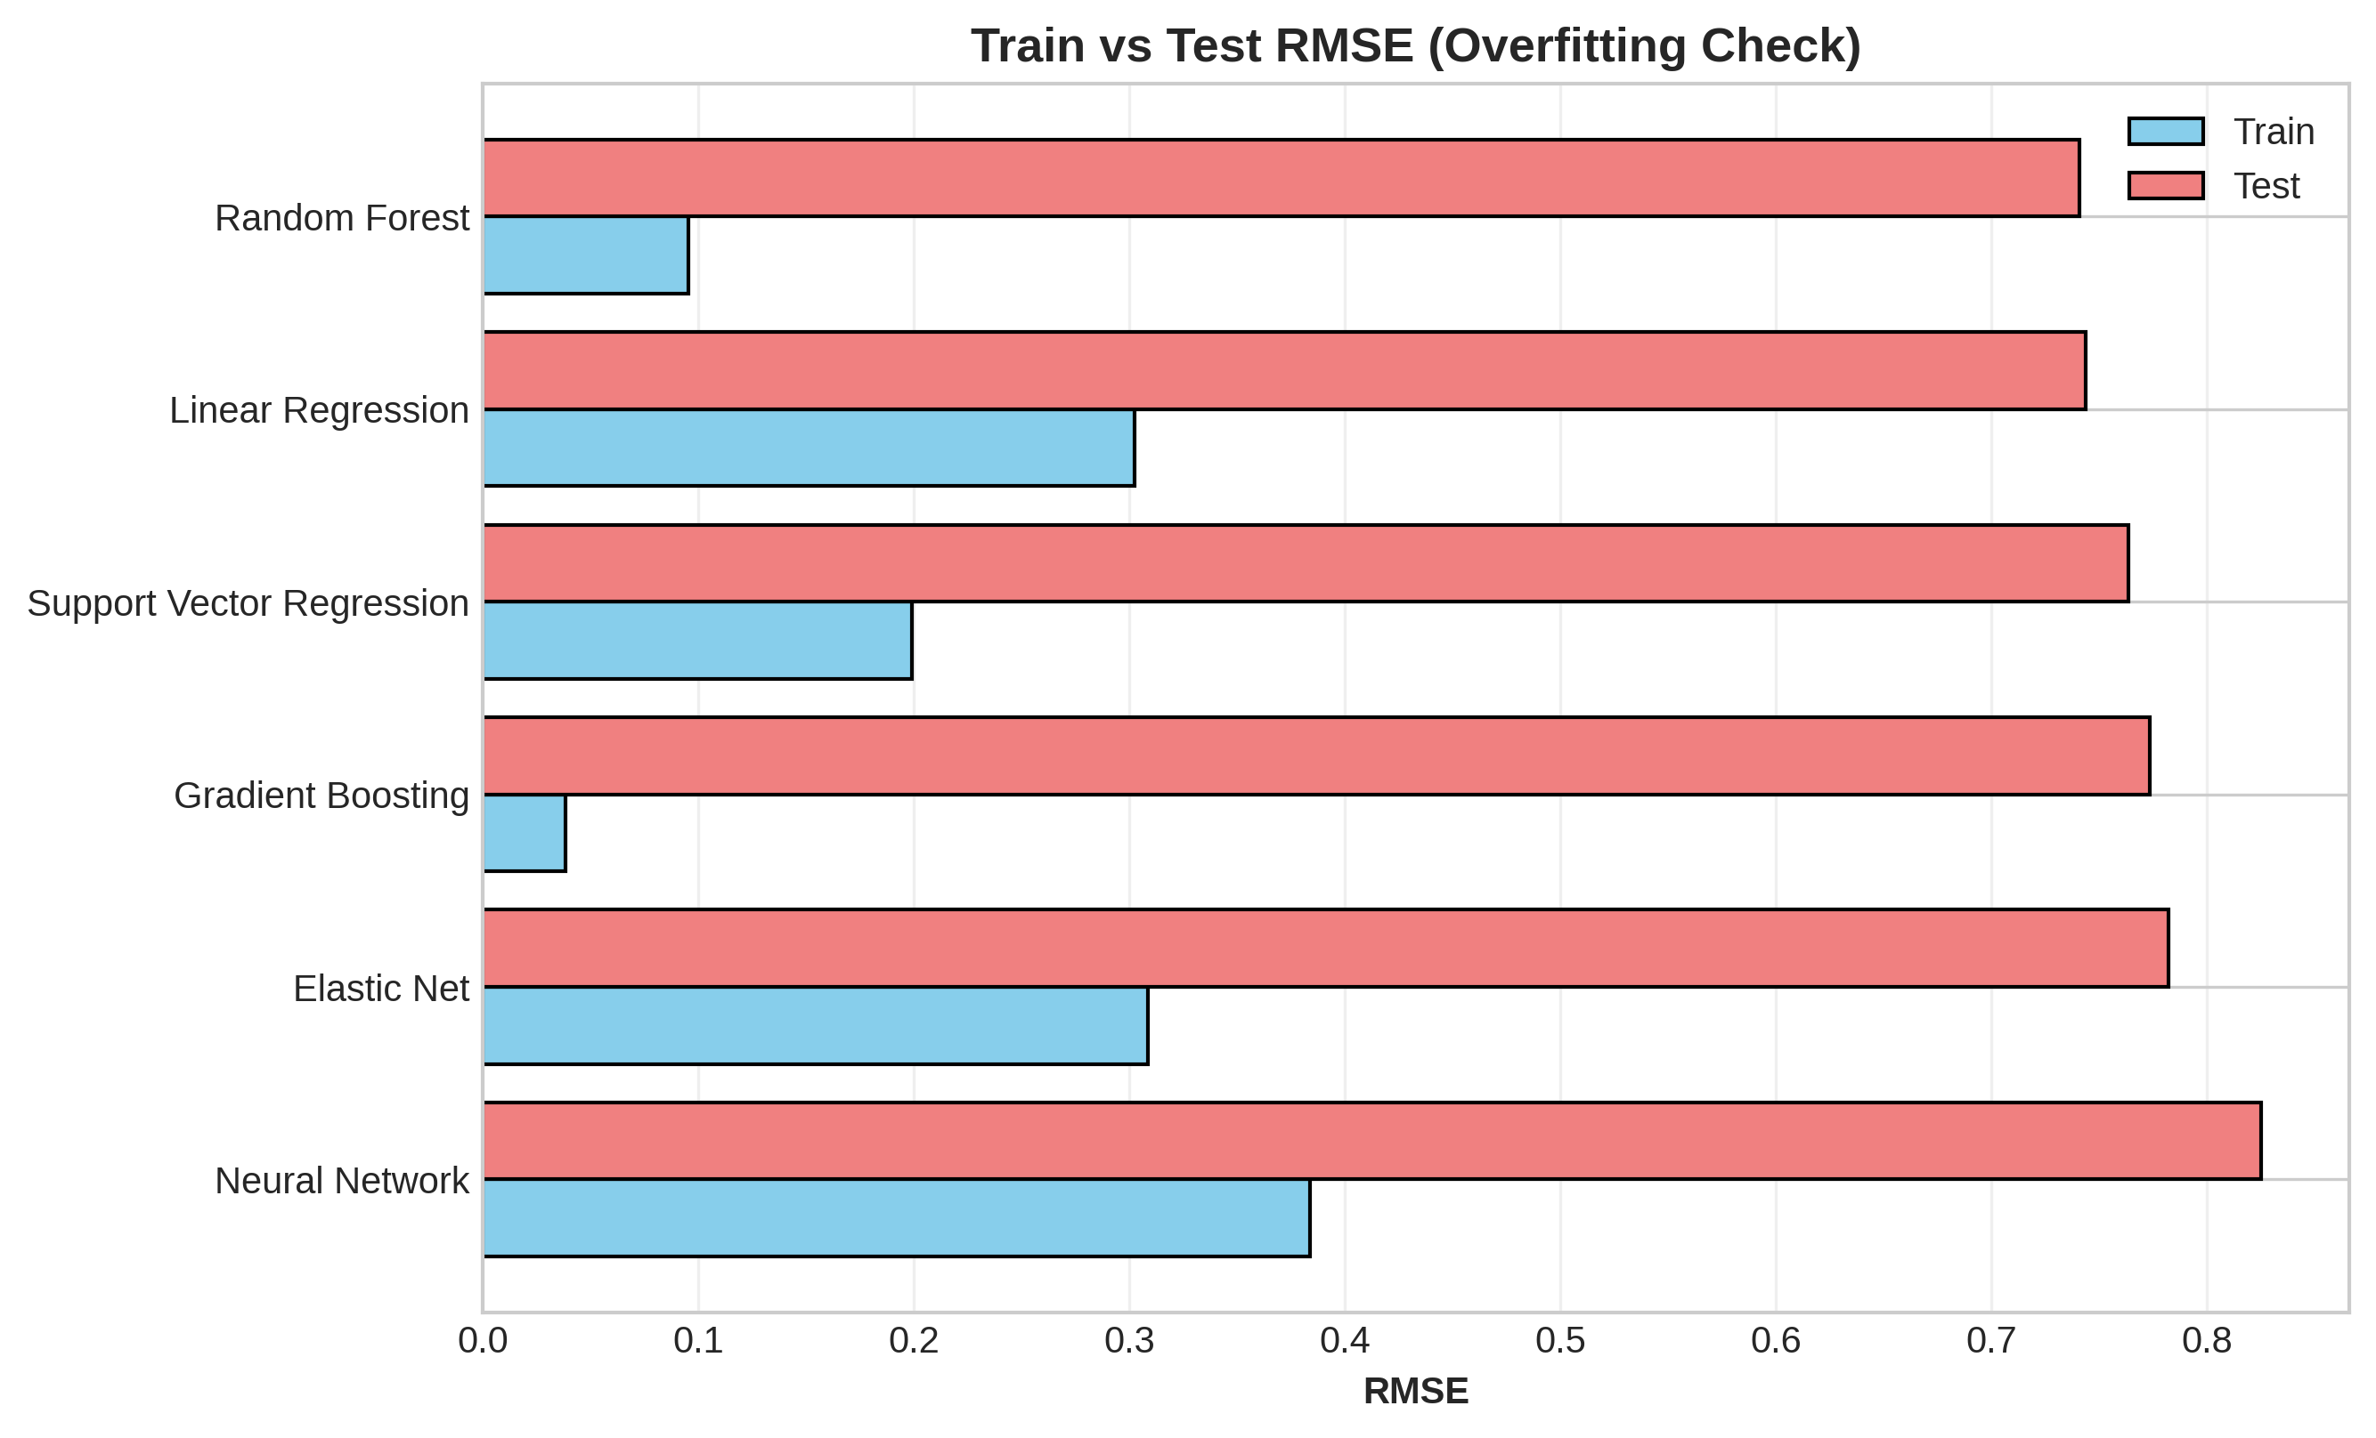
Figure 5: Train vs. test RMSE (overfitting check)

Model Performance Results
Model | Train R² | Test R² | Train RMSE | Test RMSE | Test MAE | CV RMSE
Random Forest | 0.9558 | 0.4955 | 0.0956 | 0.7410 | 0.1871 | 0.3087
Linear Regression | 0.5571 | 0.4913 | 0.3026 | 0.7440 | 0.2973 | 0.3324
Support Vector Regression | 0.8082 | 0.4641 | 0.1992 | 0.7637 | 0.2461 | 0.3439
Gradient Boosting | 0.9929 | 0.4498 | 0.0383 | 0.7737 | 0.1866 | 0.2992
Elastic Net | 0.5388 | 0.4376 | 0.3088 | 0.7823 | 0.2847 | 0.3303
Neural Network | 0.2868 | 0.3745 | 0.3840 | 0.8250 | 0.3501 | 0.3442

Best model: Random Forest — Test R² = 0.4955, Test RMSE = 0.7410, Test MAE = 0.1871, CV RMSE = 0.3087.
Random Forest achieves the best held-out performance, narrowly ahead of Linear Regression. Both explain roughly half the variance in emission intensity using only production, technology, and temporal information, which represents a realistic and defensible predictive result given the size and granularity of the dataset.
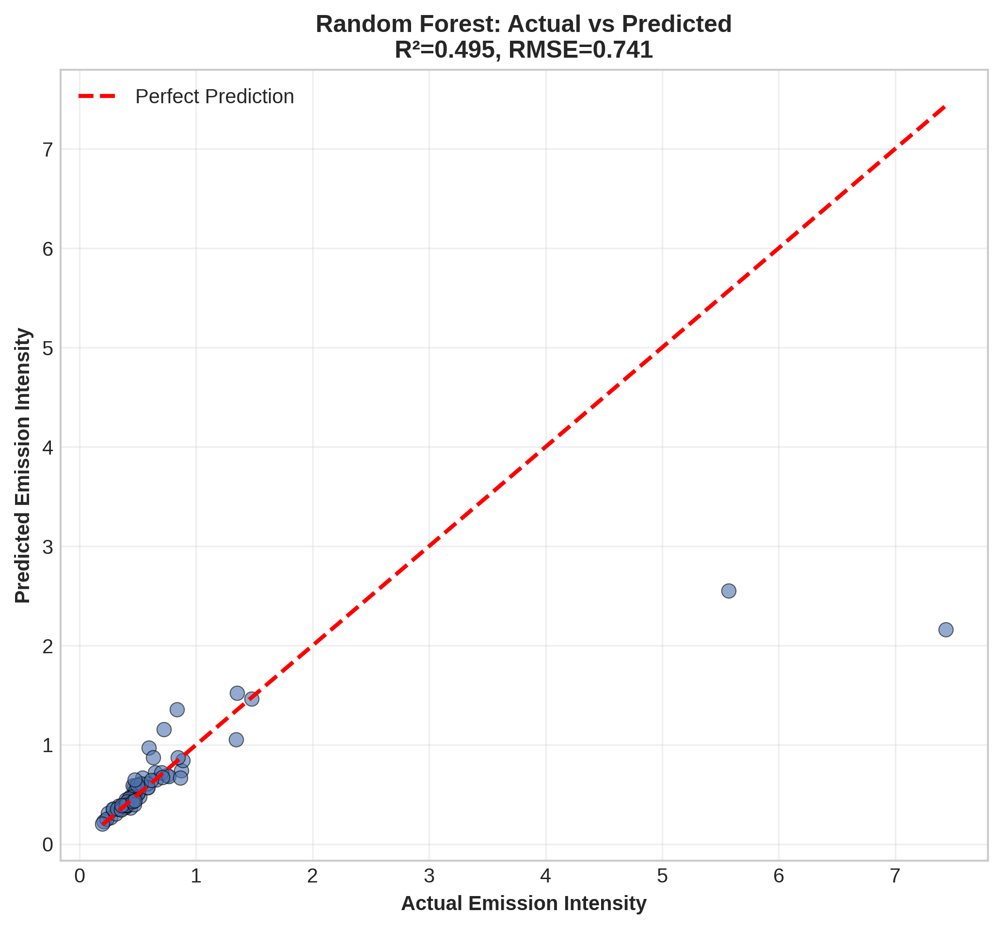
Figure 6: Actual vs. predicted emission intensity — Random Forest (best model)

Feature Importance
Feature importance from the two tree-based models is broadly consistent: production-related features dominate, followed by facility production history. Extraction technology and interaction terms contribute smaller but non-negligible signal; subsector, product, and the binary production-scale indicators contribute the least.
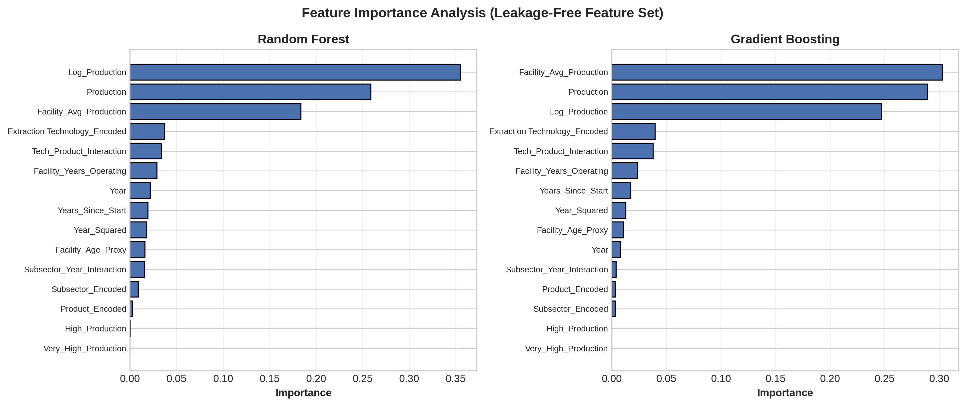
Figure 7: Feature importance — Random Forest and Gradient Boosting
- Log_Production: 0.355 (Random Forest) — the strongest predictor; production scale is the primary driver of intensity
- Production: 0.259 — raw production volume reinforces the scale effect
- Facility_Avg_Production: 0.184 — facilities with a history of higher production tend to be more efficient
- Extraction Technology_Encoded: 0.037 — technology choice contributes a smaller, secondary effect
- Tech_Product_Interaction: 0.034 — technology-product combination matters modestly
- Remaining features (temporal, subsector, product, binary indicators): each below 0.03

Conclusion
This study employed six regression models to forecast facility-specific GHG emission intensity in Alberta's oil sands, 2011–2023, using a leakage-free feature set built from production volume, extraction technology, subsector, product, temporal indicators, and facility-level historical aggregates.
Random Forest yielded the best held-out performance (Test R² = 0.496, Test RMSE = 0.741), closely followed by Linear Regression (Test R² = 0.491). Roughly half of the variance in emission intensity is explained by these operational and technological features; the remainder is likely attributable to facility-specific factors not captured in this dataset, such as equipment age, maintenance practices, energy source mix, and carbon capture deployment.
Feature importance analysis indicates that production scale (Log_Production and Production combined, ~61% of Random Forest importance) is the dominant driver of emission intensity, consistent with economies of scale in oil sands operations. Facility production history (~18%) is the second most influential factor, followed by extraction technology and technology-product interactions (~7% combined). Subsector and product type contribute comparatively little once production and facility history are accounted for.
These findings suggest that emissions policy focused on production efficiency and operational scale is likely to have more leverage than policy focused narrowly on extraction technology. They also underscore a broader methodological lesson from this project: near-perfect model performance, or a single feature dominating importance, should be treated as a signal to check for target leakage rather than as a result to report at face value; conversely, encoding a near-unique identifier (such as facility name) as a raw predictor risks the opposite failure — memorization rather than generalization. Future work should focus on collecting additional facility-level operational data (equipment specifications, maintenance schedules, energy source mix, carbon capture rates) and on panel-data methods that can exploit the repeated-measures structure of the data across years without relying on facility identity as a raw input.

References
Charpentier, A. D., Bergerson, J. A., & MacLean, H. L. (2009). Understanding the Canadian oil sands industry's greenhouse gas emissions. Environmental Research Letters, 4(1), 014005.
Environment and Climate Change Canada. (2023). National inventory report: Greenhouse gas sources and sinks in Canada. Government of Canada.
Hastie, T., Tibshirani, R., & Friedman, J. (2017). The elements of statistical learning: Data mining, inference, and prediction (2nd ed.). Springer.
National Pollutant Release Inventory. (2024). Facility-reported greenhouse gas emissions data. Government of Canada.
Alberta Energy Regulator. (2024). Oil sands operational and production data. Government of Alberta.

