|  |  |
| --- | --- |
| **Town X**  Marijuana Excise Tax Data Analysis |  |

# **Overview**

Town X has requested an evaluation of their marijuana excise tax reporting in order to investigate potential underreporting of the owed amount. The analysis will encompass the complete data cycle, including stakeholder meetings, interface design, data collection, data organization and cleaning, data analysis, dashboard development, visualization creation, recommendation formulation, and final presentation to the Town Board.

# **I. Goals**

1. Identify any potential underreporting of the owed amount in marijuana excise tax by conducting a thorough analysis.
2. Assess the accuracy and reliability of the current tax reporting system in Town X.
3. Determine the extent of underreported tax revenue and its impact on the town's finances.
4. Analyze the data cycle to identify any bottlenecks, inefficiencies, or gaps in the reporting process.
5. Design and develop an intuitive and user-friendly interface for stakeholders involved in tax reporting.
6. Collect comprehensive and accurate data related to marijuana excise tax payments and transactions.
7. Organize and clean the collected data to ensure its integrity and suitability for analysis.
8. Perform a detailed analysis of the data to uncover patterns, anomalies, and potential areas of underreporting.
9. Build a dashboard to visualize key metrics, trends, and insights related to marijuana excise tax reporting.
10. Formulate recommendations based on the analysis findings to improve tax reporting accuracy and minimize underreporting.
11. Present the analysis results and recommendations to the Town Board, highlighting the potential impact and benefits of addressing underreporting issues.
12. Facilitate informed decision-making by providing comprehensive information and insights to relevant stakeholders.
13. Enhance transparency and accountability in marijuana excise tax reporting for the benefit of the town and its constituents.
14. Ensure compliance with legal and regulatory requirements pertaining to marijuana excise tax reporting.
15. Foster a culture of proactive monitoring and continuous improvement in tax reporting processes to prevent future underreporting issues.

# **II. Specifications**

This analysis of marijuana excise tax reporting entails several key specifications. It begins with conducting stakeholder meetings to gather requirements and expectations from town officials and tax department representatives. An intuitive and user-friendly interface will be designed to facilitate easy data entry, retrieval, and validation of tax-related information, while ensuring data security. A data collection strategy will be formulated to capture relevant tax payment and transaction information, drawing from various sources such as financial records and receipts. The collected data will undergo thorough organization and cleaning processes, including removing duplicates, errors, and inconsistencies. Statistical and analytical techniques will be employed to analyze the data, identifying trends, patterns, and outliers that may indicate underreported tax amounts.

A dashboard will be developed to present key metrics and visualizations in real-time, aiding stakeholders in monitoring tax compliance and revenue. Actionable recommendations will be formulated based on the analysis findings, prioritizing measures to enhance accuracy, monitoring procedures, and address underreporting concerns. A comprehensive presentation will be prepared to summarize the analysis process, findings, and recommendations, followed by engaging in a discussion with the Town Board. Compliance with legal and regulatory requirements will be ensured, along with the implementation of robust security measures. Thorough documentation will be maintained, including methodology, data sources, cleaning procedures, and analysis techniques, as well as user manuals or guides to facilitate effective utilization of the developed interface and dashboard.

# **III. Milestones**

1. Stakeholder meetings conducted and requirements gathered.
2. Interface design finalized and development initiated.
3. Data collection strategy defined and data sources identified.
4. Data collection process initiated and relevant tax information acquired.
5. Data organization and cleaning completed, ensuring accuracy and consistency.
6. Statistical analysis performed on the cleaned data, identifying patterns and outliers.
7. Dashboard development initiated, incorporating key metrics and visualizations.
8. Analysis findings synthesized into actionable recommendations.
9. Prioritized recommendations reviewed and finalized.
10. Presentation materials prepared, summarizing analysis process, findings, and recommendations.
11. Presentation delivered to the Town Board, followed by a discussion and feedback session.
12. Compliance measures implemented to ensure adherence to legal and regulatory requirements.
13. Security measures established to protect sensitive tax data.
14. Thorough documentation created, including methodology, data sources, and analysis techniques.
15. User manuals or guides prepared to facilitate effective utilization of the interface and dashboard.

# **IV. Key Takeaways**

1. Gross Sales Tax: The gross sales tax reported to the State for the month of March amounts to $367,479. This figure represents the total sales tax revenue generated within that period.

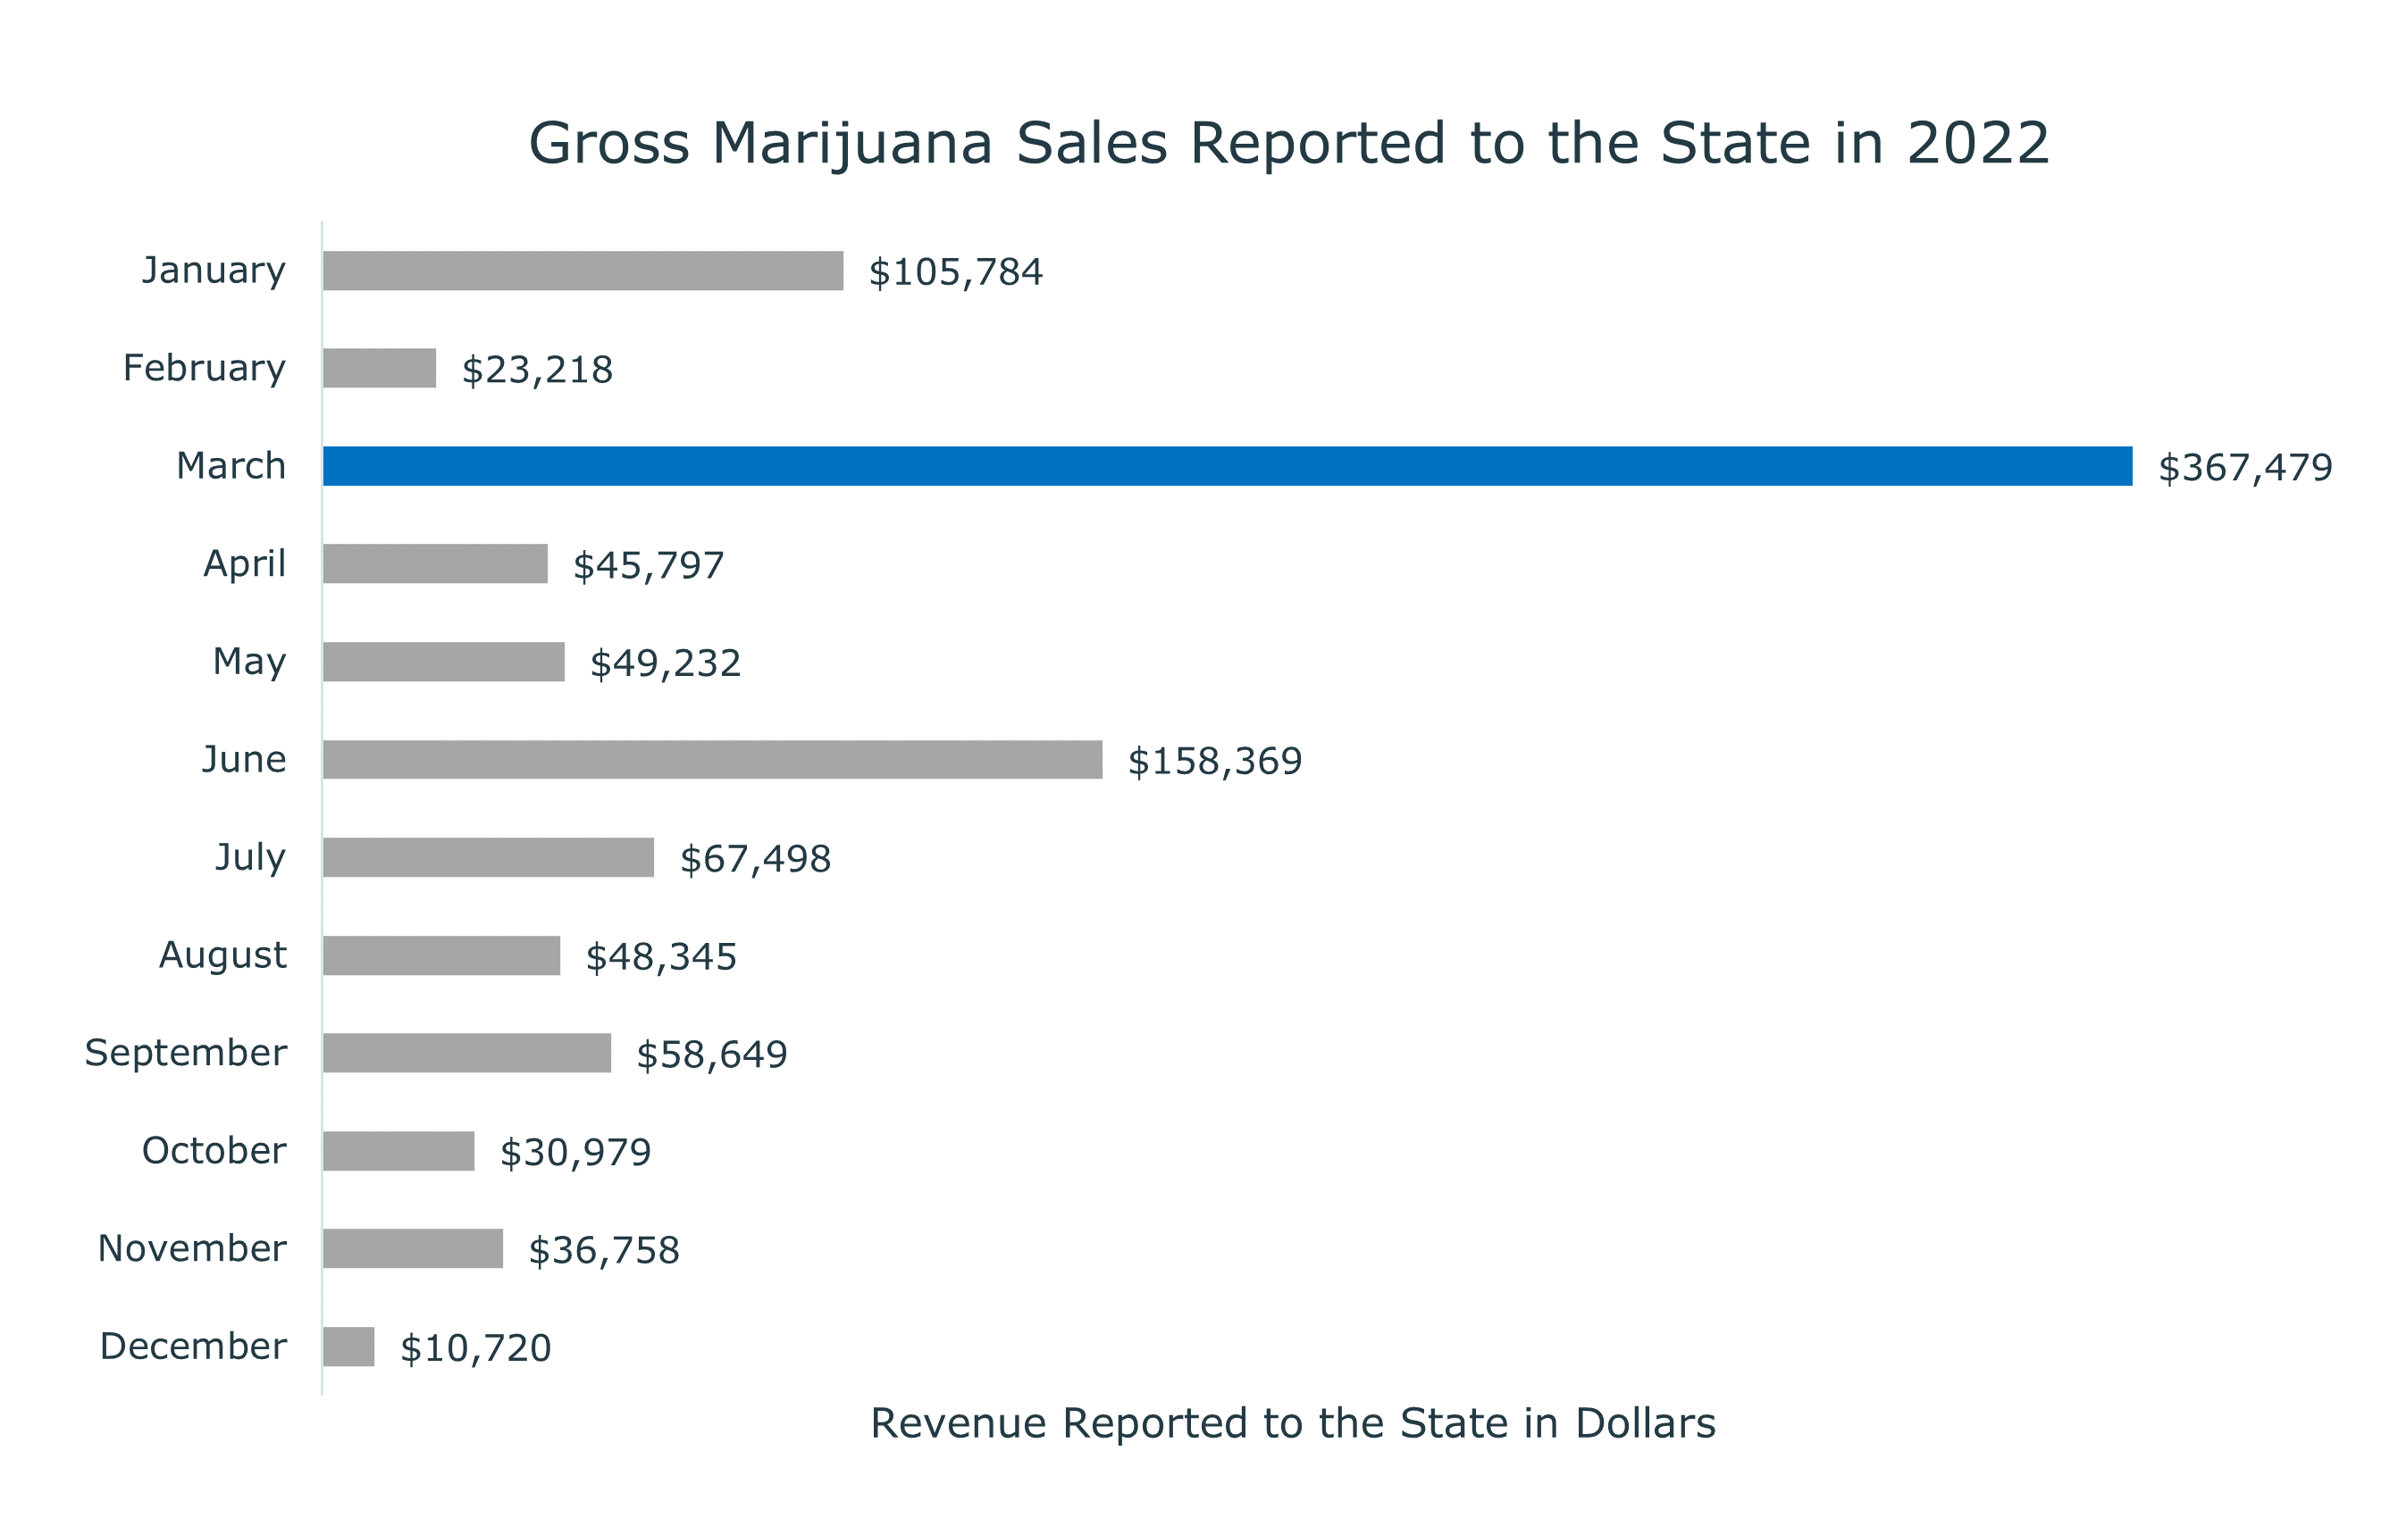

1. Revenue Concentration: Out of the 79 licensed companies, approximately 16.5% of them contribute to 100% of the Town's revenue. This suggests that a small portion of the licensed companies significantly impact the overall revenue.

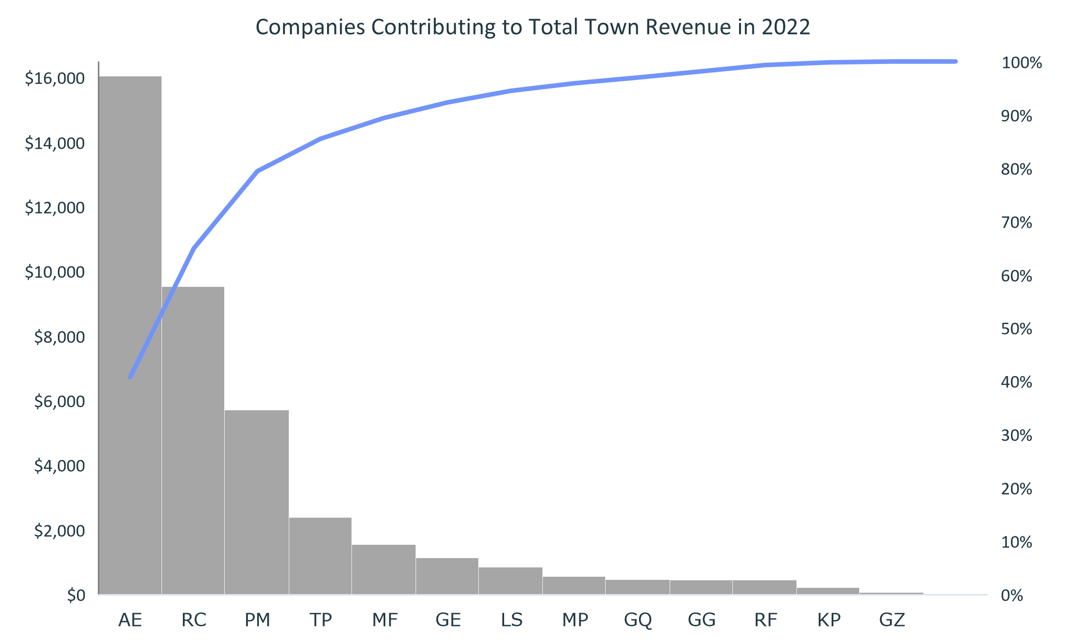

1. Quarterly Project Dependency: All quarterly projects rely on the revenue generated in March. This implies that the revenue generated in March serves as the primary source of funding for the projects conducted throughout the year.

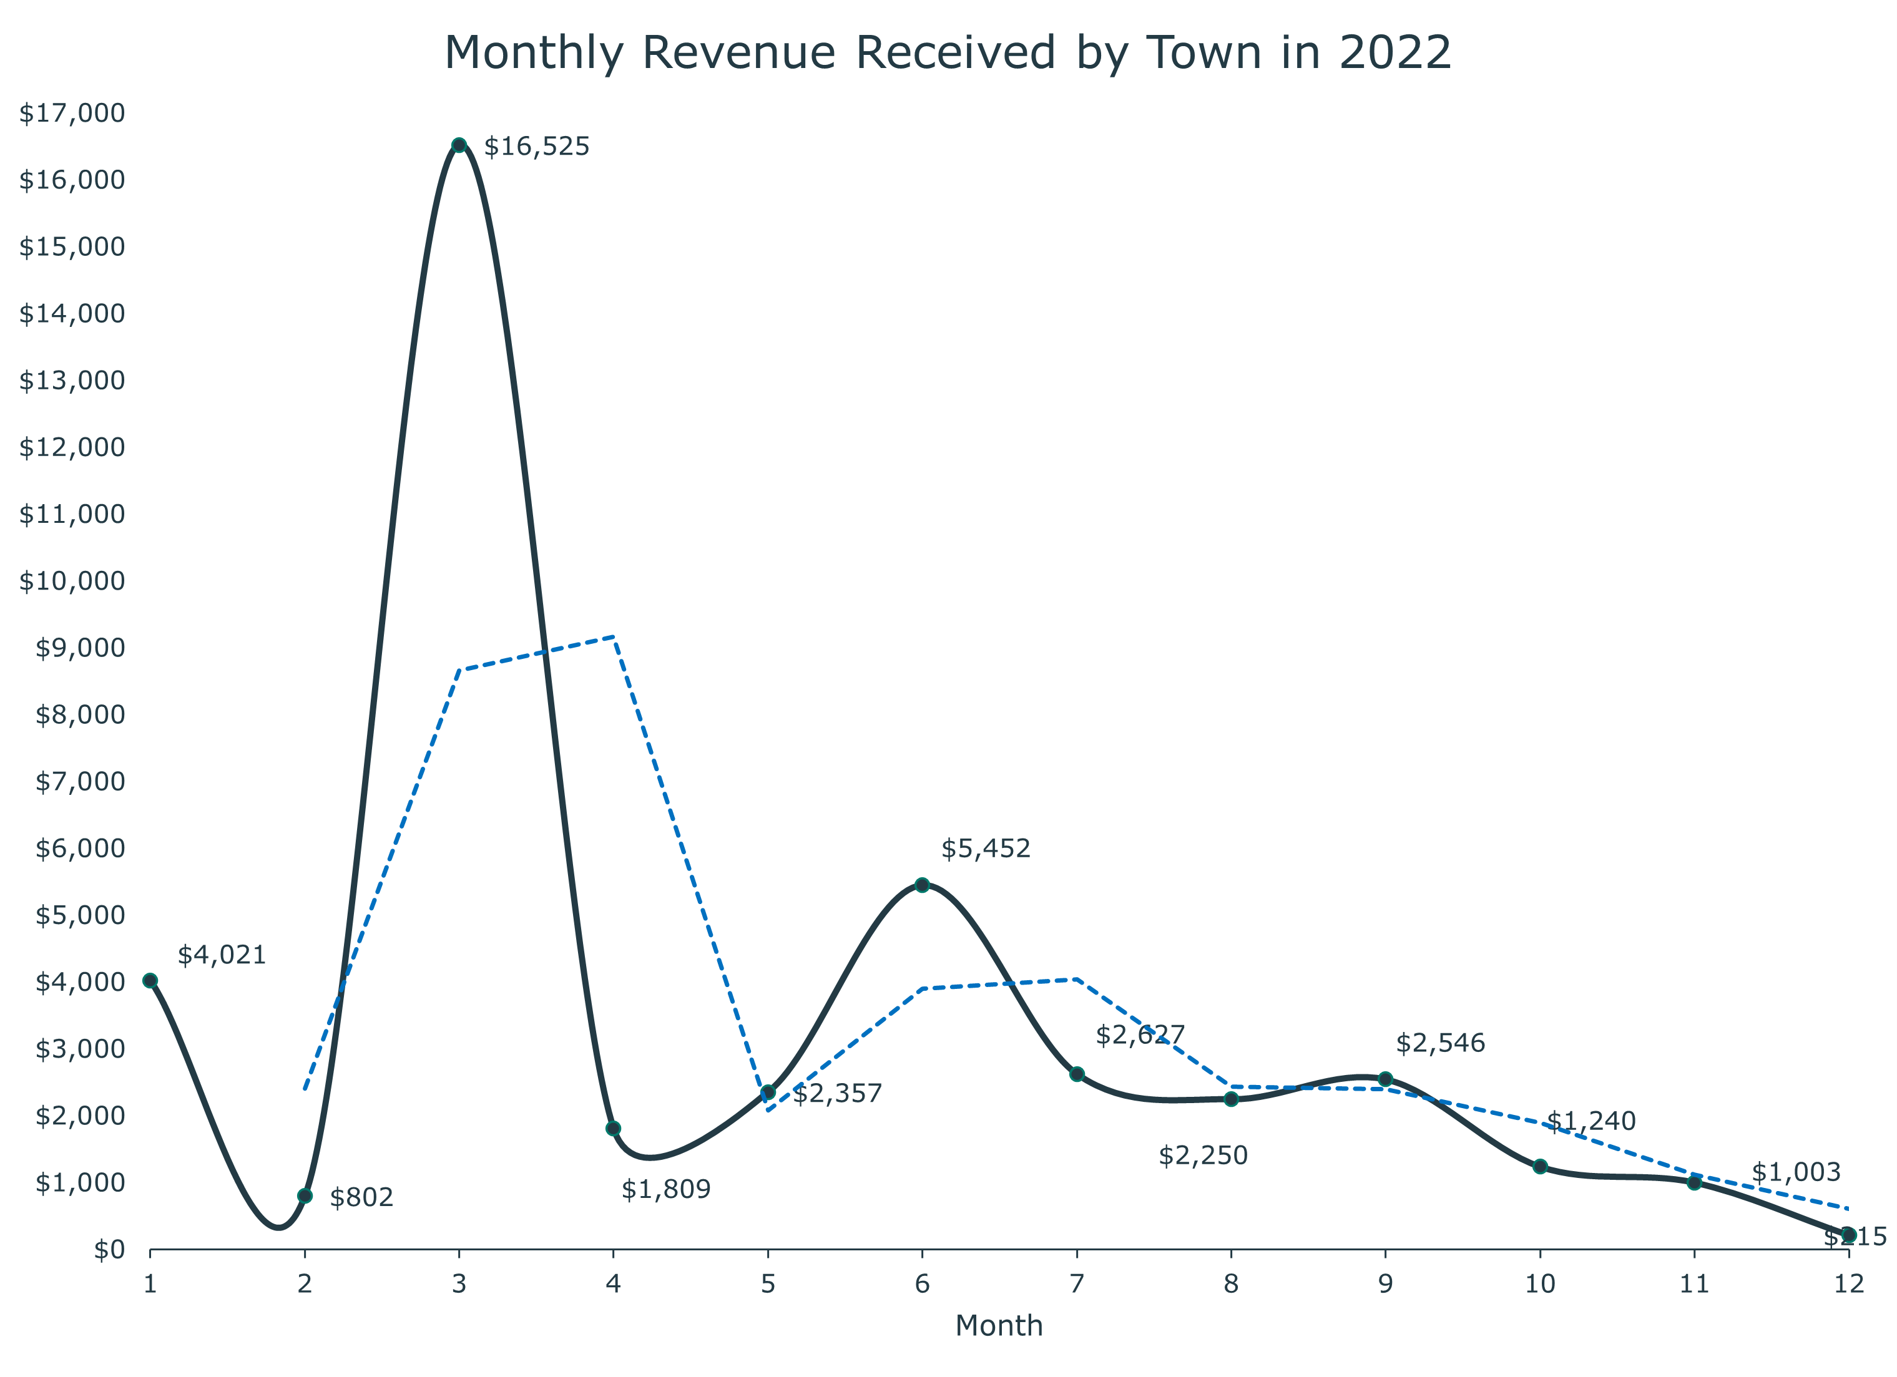

1. Even Distribution: It is recommended to distribute the revenue generated in March evenly throughout the year. This ensures a consistent and balanced allocation of funds for the quarterly projects.
2. Higher Expenditures in 2nd Quarter: Following the high point of revenue and improvement in weather, it is suggested to allocate higher expenditures in the 2nd quarter. This strategic allocation takes advantage of the increased revenue and favorable conditions during that time.

# **V. Recommendations**

1. **Online Reporting Interface:** Develop an online interface that allows licensed businesses to conveniently file their tax reports. This interface should be user-friendly, intuitive, and accessible to encourage more businesses to report accurately and on time.
2. **Collection Plan:** Implement a comprehensive plan to increase the number of reporting and contributing licensed businesses. This can involve targeted outreach, education campaigns, and incentives to encourage compliance with tax reporting requirements. The plan should address any barriers or challenges that businesses may face in meeting their reporting obligations.
3. **Interface with State Reporting:** Establish a streamlined interface with the State reporting system to monitor potential revenue more easily and efficiently. This integration would facilitate real-time data exchange and enable the Town to access accurate and up-to-date information on tax reporting and revenue. This, in turn, would enhance monitoring capabilities and ensure the Town stays informed about the overall financial landscape.
4. **Automation and Analytics:** Explore the possibility of automating certain aspects of the reporting process and implementing data analytics tools. Automation can reduce manual errors and processing time, while analytics can help identify trends, anomalies, and potential underreporting issues. Leveraging technology can significantly improve the efficiency and effectiveness of tax reporting and revenue monitoring.
5. **Training and Support:** Provide training and support to licensed businesses regarding tax reporting requirements, best practices, and the use of the online interface. Offering resources, guidance, and assistance can help businesses understand their obligations better and encourage compliance.
6. **Periodic Audits:** Conduct regular audits to verify the accuracy and completeness of reported data from licensed businesses. Audits can help detect any potential underreporting or non-compliance, ensuring fairness and maintaining the integrity of the tax system.

# **VI. Conclusions**

This analysis of marijuana excise tax reporting in Town X has provided valuable insights. The key takeaways reveal the significance of the gross sales tax reported in March, the concentration of revenue contribution from a subset of licensed businesses, and the importance of evenly distributing revenue throughout the year while strategically planning expenditures. To address the identified challenges and improve the tax reporting process, several recommendations are proposed. Building an online interface for licensed businesses would enhance convenience and encourage accurate and timely reporting. Enacting a collection plan can increase the number of reporting and contributing licensed businesses, fostering compliance. Implementing an interface with the State reporting system would streamline revenue monitoring and facilitate real-time data exchange.

Additionally, leveraging automation, analytics tools, and periodic audits can improve accuracy, efficiency, and fairness in tax reporting. Providing training and support to licensed businesses would enhance their understanding of reporting requirements and encourage compliance. By implementing these recommendations, Town X can establish a more efficient, transparent, and reliable marijuana excise tax reporting system. This will lead to improved revenue management, enhanced compliance, and better decision-making for the benefit of the town and its constituents.