COMPUTER NETWORKS LAB
1601-24-733-
Lab Task – 3



EXPERIMENT: Implementation of Cyclic Redundancy Check (CRC)

AIM
To implement the Cyclic Redundancy Check (CRC) algorithm in C for detecting errors during data transmission by generating a CRC remainder at the sender side and verifying the received codeword at the receiver side.

DESCRIPTION
Data communication involves transferring information from one device to another through a communication medium. During transmission, data may become corrupted because of noise, interference, or hardware faults. To ensure reliable communication, error detection techniques are employed.
Cyclic Redundancy Check (CRC) is one of the most efficient error detection techniques used in computer networks. It works by treating the transmitted data as a binary polynomial and dividing it by a predefined generator polynomial using modulo-2 arithmetic (XOR operation). The remainder obtained from this division is called the CRC remainder, which is appended to the original data before transmission.
At the receiver side, the received codeword is divided using the same generator polynomial. If the remainder is zero, the data is considered error-free; otherwise, a transmission error is detected.
CRC is based on binary polynomial division using modulo-2 arithmetic (XOR operation). Unlike normal division, CRC does not involve borrowing or carrying.
The sender and receiver use the same generator polynomial for encoding and verification.

Dataword
The original binary message to be transmitted. Example:1101011011

Generator Polynomial
A predefined binary divisor used for CRC calculation. Example:10011
Polynomial form:x^4 + x + 1

CRC Remainder
The remainder obtained after modulo-2 division. Example:1110

Codeword
The transmitted message formed by appending the CRC remainder to the original data. Codeword = Dataword + CRC Remainder

Modulo-2 Division
CRC uses XOR instead of subtraction.
A | B | A XOR B
0 | 0 | 0
0 | 1 | 1
1 | 0 | 1
1 | 1 | 0

COMPUTER NETWORKS LAB
1601-24-733-
Lab Task – 3

ALGORITHM

Sender Side
- Read the dataword.
- Read the generator polynomial.
- Find the lengths of the dataword and generator.
- Append (generator length − 1) zeros to the dataword.
- Copy the appended data into a temporary array.
- Perform modulo-2 (XOR) division.
- Extract the CRC remainder.
- Append the remainder to the original data.
- Display the transmitted codeword.

Receiver Side
- Read the received codeword.
- Perform modulo-2 division using the same generator.
- Check the remainder.
- If the remainder is all zeros:

Display "No Error Detected. Data Received Correctly."
- Otherwise:

Display "Error Detected in Received Data.”

SOURCE CODE
Use the following C program:
#include <stdio.h> #include <string.h>
char data[200], generator[30], temp[200], remainder[30], codeword[200]; int main()
{
int dataLen, genLen, i, j; printf("Enter Dataword: "); scanf("%s", data); printf("Enter Generator: "); scanf("%s", generator); dataLen = strlen(data); genLen = strlen(generator); strcpy(codeword, data); for(i=0; i<genLen-1; i++)
codeword[dataLen+i]='0'; codeword[dataLen+genLen-1]='\0'; strcpy(temp, codeword);
for(i=0; i<dataLen; i++)
{
if(temp[i]=='1')
{
for(j=0; j<genLen; j++)
{

COMPUTER NETWORKS LAB
1601-24-733-
Lab Task – 3

if(temp[i+j]==generator[j]) temp[i+j]='0';

else

}
}
}

temp[i+j]='1';

for(i=0; i<genLen-1; i++) remainder[i]=temp[dataLen+i];
remainder[genLen-1]='\0';
printf("\nCRC Remainder: %s", remainder); strcpy(codeword,data); strcat(codeword,remainder); printf("\nTransmitted Codeword: %s\n",codeword); printf("\nReceiver Side Verification\n"); printf("Enter Received Codeword: "); scanf("%s",temp);
for(i=0;i<dataLen;i++)
{
if(temp[i]=='1')
{
for(j=0;j<genLen;j++)
{
if(temp[i+j]==generator[j]) temp[i+j]='0';

else

}
}
}

temp[i+j]='1';

int error=0; for(i=dataLen;i<dataLen+genLen-1;i++)
{
if(temp[i]!='0')
{
error=1; break;
}
}
if(error)
printf("Error Detected in Received Data.\n"); else
printf("No Error Detected. Data Received Correctly.\n"); return 0;
}

SAMPLE OUTPUT

COMPUTER NETWORKS LAB
1601-24-733-
Lab Task – 3

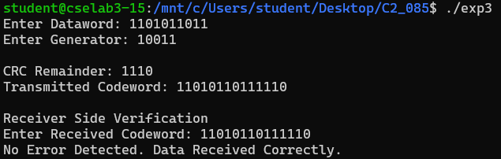
Case 1: No Error

Case 2: Error Detected
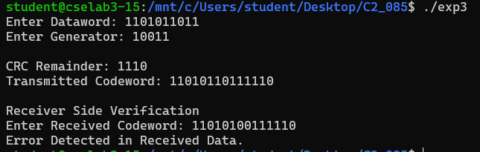

APPLICATIONS
- Ethernet (IEEE 802.3)
- USB communication
- Wi-Fi (IEEE 802.11)
- Bluetooth
- Satellite communication
- Digital television
- Hard disks and SSDs
- Computer networks
- Embedded systems

RESULT
The Cyclic Redundancy Check (CRC) algorithm was successfully implemented in C. The program generated the CRC remainder, formed the transmitted codeword, and verified the received codeword. When the remainder after verification was zero, the data was accepted as error-free; otherwise, the program correctly detected a transmission error.

CONCLUSION
The experiment was successfully implemented to demonstrate the Cyclic Redundancy Check (CRC) error detection technique. A CRC remainder was generated using the specified generator polynomial and appended to the original dataword to form the transmitted codeword. At the receiver side, the received codeword was verified using the same generator. If the remainder after division was all zeros, the data was accepted as error-free; otherwise, an error was detected. This experiment illustrates how CRC provides an efficient and reliable method for detecting transmission errors in digital communication networks.

