COMPUTER NETWORKS LAB
1601-24-733-
Lab Task - 02



Lab Task – 2
AIM: Configure Peer to Peer Network with at least three hosts.
OBJECTIVE:To configure a peer-to-peer (P2P) network using at least three hosts and verify communication between them by assigning IP addresses and testing network connectivity.
DESCRIPTION:A peer-to-peer (P2P) network is a type of network in which all computers (hosts) have equal privileges and can directly share resources such as files, printers, and folders without requiring a dedicated server. Each computer acts as both a client and a server. P2P networks are commonly used in small offices, homes, and laboratories due to their simplicity, low cost, and ease of setup.
In this experiment, three hosts are connected through a switch (or hub), assigned IP addresses within the same subnet, and configured with the same workgroup. Connectivity is verified using the ping command.

REQUIREMENTS:
- 3 Computers (Hosts)
- 1 Switch/Hub
- Ethernet (RJ-45) Cables
- Windows/Linux Operating System

CONFIGURATION
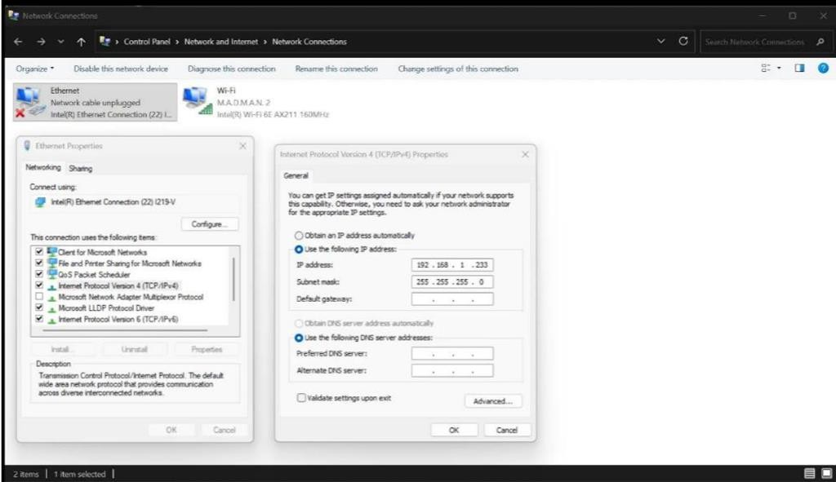

COMPUTER NETWORKS LAB
1601-24-733-
Lab Task - 02

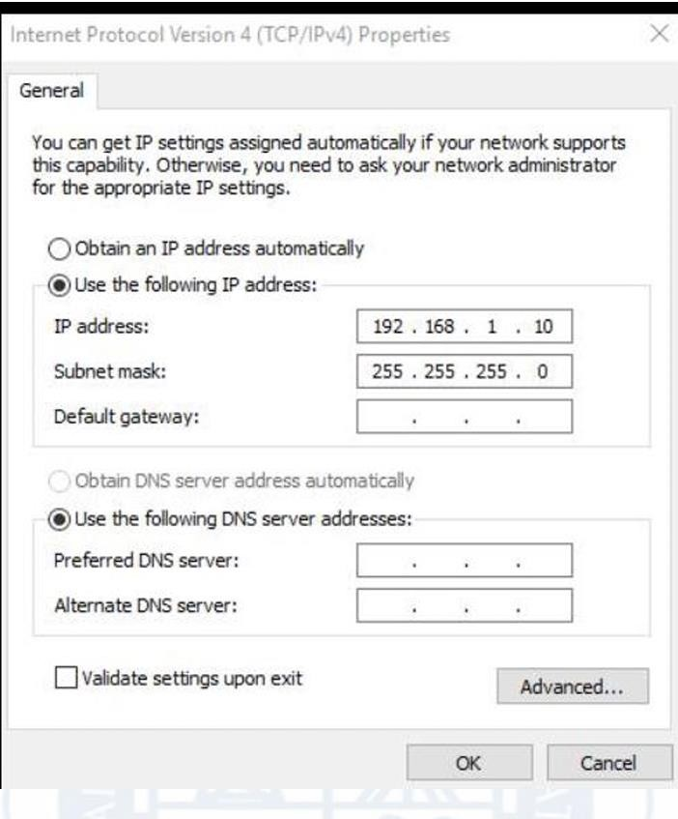
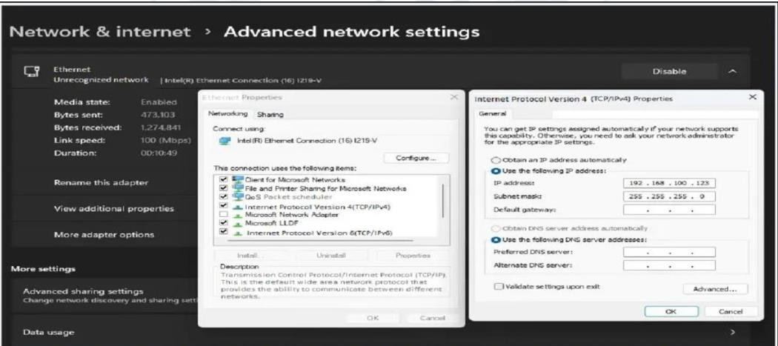
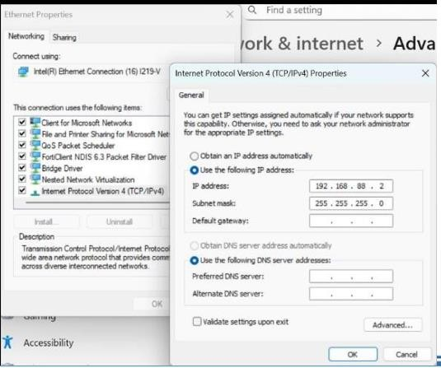

COMPUTER NETWORKS LAB
1601-24-733-
Lab Task - 02

IP ADDRESS CONFIGURATION
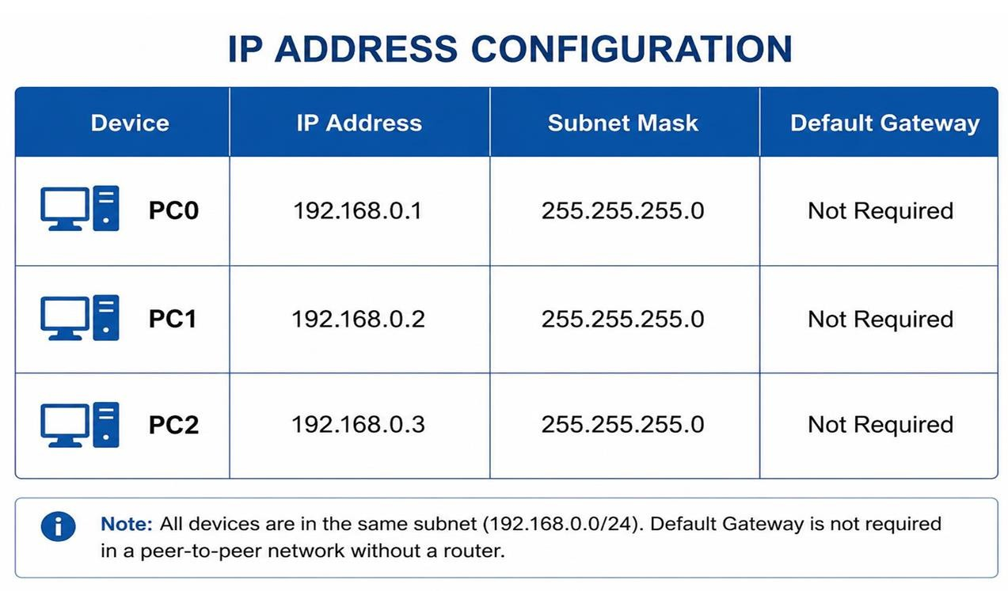

PROCEDURE

Connect the Devices
  - Connect PC0, PC1, and PC2 to a network switch using Ethernet cables.
  - Ensure that all devices are powered on and properly connected.

Configure IP Addresses
  - Open Control Panel → Network and Internet → Network Connections.
  - Select Ethernet Adapter → Properties.
  - Open Internet Protocol Version 4 (TCP/IPv4) settings.
  - Assign static IP addresses to each PC.

PC0
  - IP Address: 192.168.0.1
  - Subnet Mask: 255.255.255.0 PC1
  - IP Address: 192.168.0.2
  - Subnet Mask: 255.255.255.0 PC2
  - IP Address: 192.168.0.3
  - Subnet Mask: 255.255.255.0

COMPUTER NETWORKS LAB
1601-24-733-356
Lab Task - 02

Configure Workgroup
  - Open System Properties on each computer.
  - Assign the same workgroup name for all PCs.
  - Restart the systems if required.

Enable Network Discovery and File Sharing
  - Open Control Panel → Network and Sharing Center.
  - Turn on: Network Discovery ,File and Printer Sharing

Check Network Configuration
  - Open Command Prompt on each PC.
  - Execute the command: ipconfig
  - Verify that the assigned IP addresses are correct.

Test Connectivity Between Hosts
From PC0:
ping 192.168.0.2
ping 192.168.0.3
From PC1:
ping 192.168.0.1
ping 192.168.0.3
From PC2:
ping 192.168.0.1
ping 192.168.0.2

Verify Communication
  - Check that all ping requests receive replies.
  - Successful replies confirm that the peer-to-peer network is properly configured.

Test Resource Sharing (Optional)
  - Share a folder or printer on one PC.

COMPUTER NETWORKS LAB
1601-24-733-
Lab Task - 02

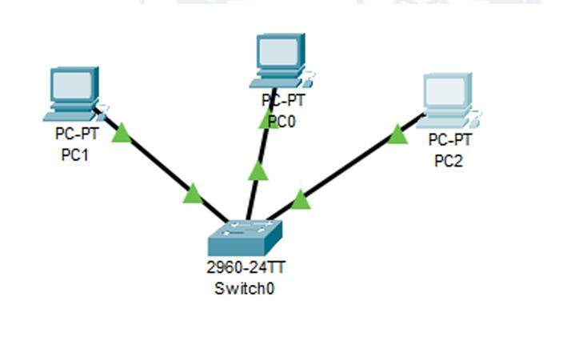
  - Access the shared resource from other PCs using the network pat

OUTPUT

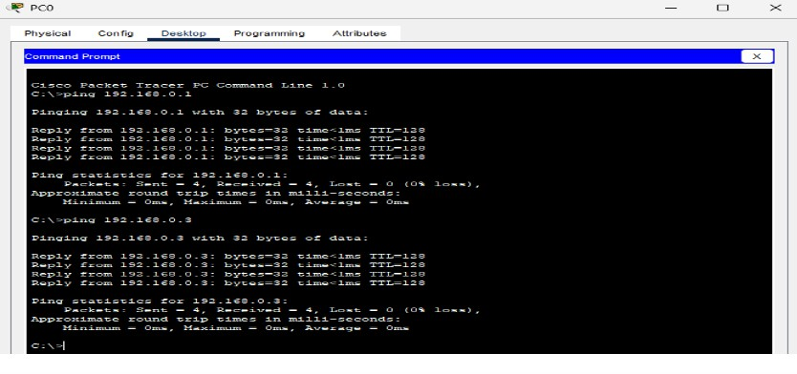
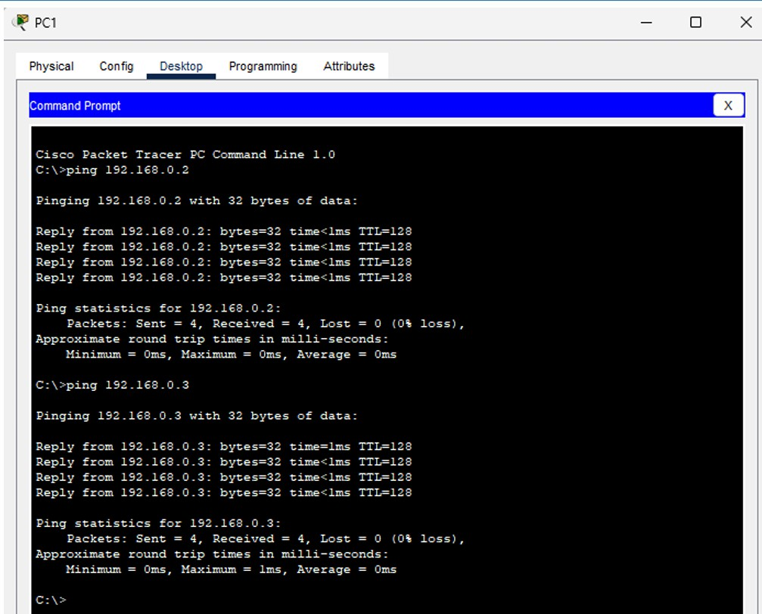

COMPUTER NETWORKS LAB
1601-24-733-
Lab Task - 02

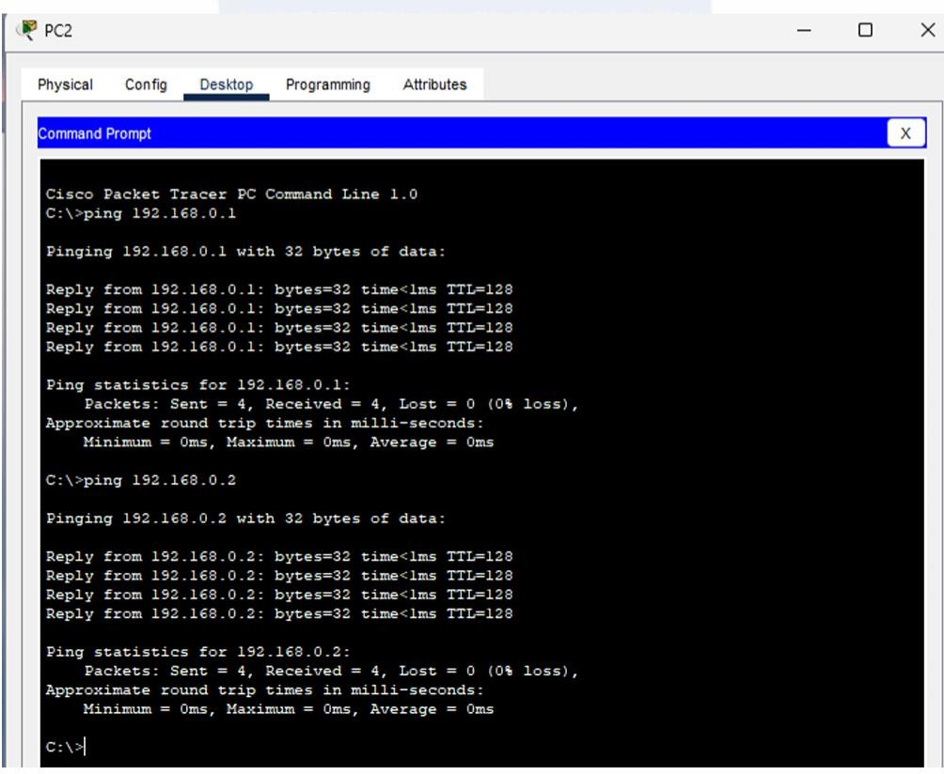

RESULT
A peer-to-peer network consisting of three hosts (PC0, PC1, and PC2) was successfully configured using a network switch. Static IP addresses 192.168.0.1, 192.168.0.2, and 192.168.0.3 were assigned to the respective hosts with the subnet mask 255.255.255.0. The connectivity between all hosts was tested using the ping command, and successful communication was established.

CONCLUSION
The experiment demonstrated the successful configuration and operation of a peer-to-peer network. All connected hosts were able to communicate directly with each other without requiring a dedicated
server. The practical implementation helped in understanding IP address configuration, network connectivity testing, and resource sharing among multiple devices in a Local Area Network (LAN).

