COMPUTER NETWORKS LAB
1601-24-733-
Lab Task - 11

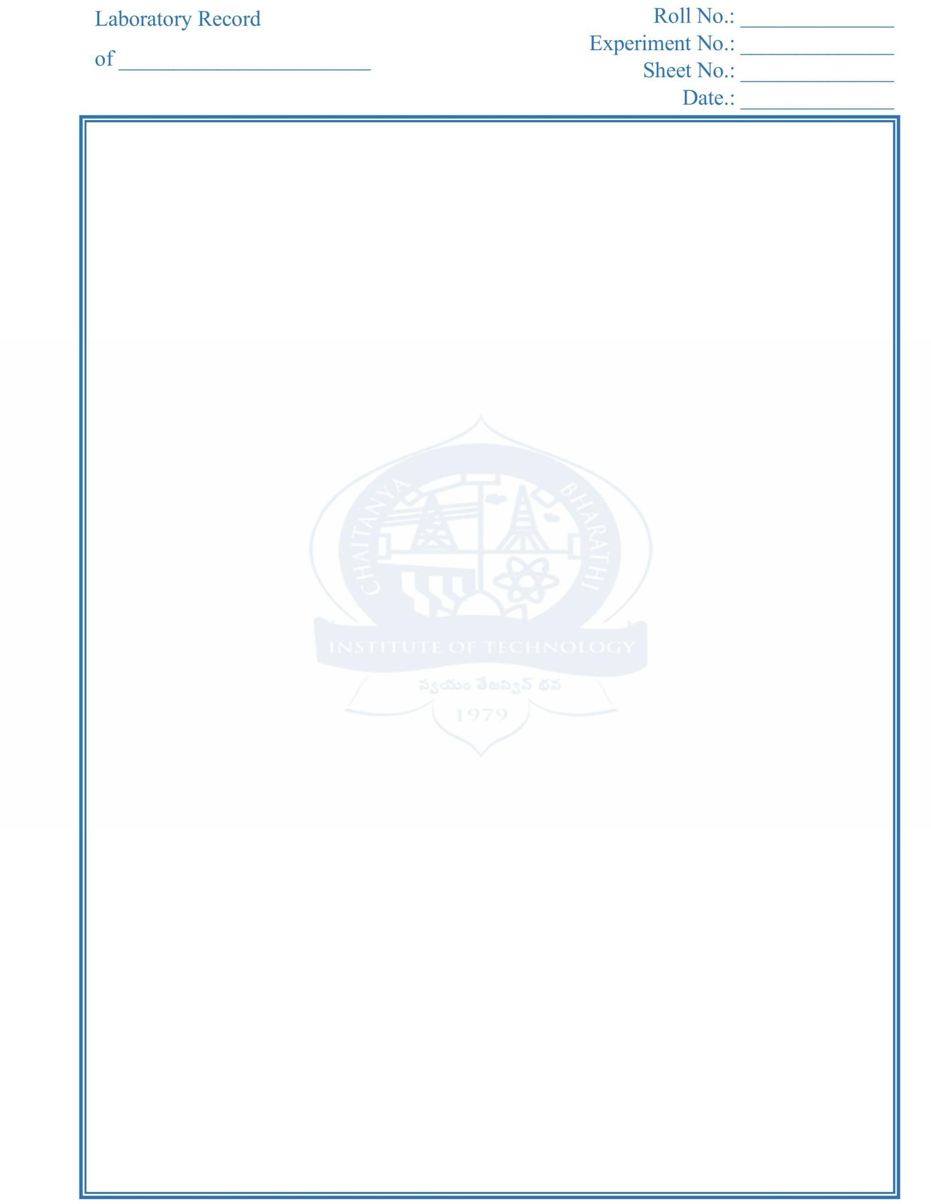

LAB TASK – 11
Aim: Implement Socket Programming.

Description:
In this we have to implement a TCP client-server program in the C programming language. Here, the client and server would exchange messages and communicate with each other in an interactive way. In addition, you will also learn about the client-server architecture and other related concepts.

A socket is a structure that allows communication between different processes on the same computer or different computers. A socket allows us to communicate by sending and receiving data over the network. In simple terms, it is a way for a computer to talk to other computers on the network.
A client-server architecture is a model in computer networking, where the server provides some service to the client. In this architecture, the client computer sends a request to the server computer through a network (internet). The server accepts this request and sends the required data to the client.
In simple terms, we can say :
- Server is a remote computer which provides some services.
- Client is the one that request the server for these services.

CODE :

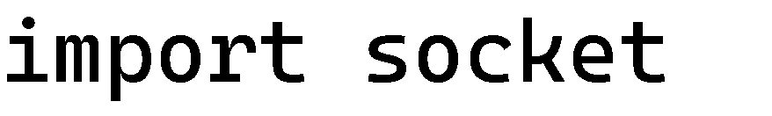


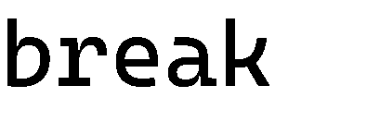
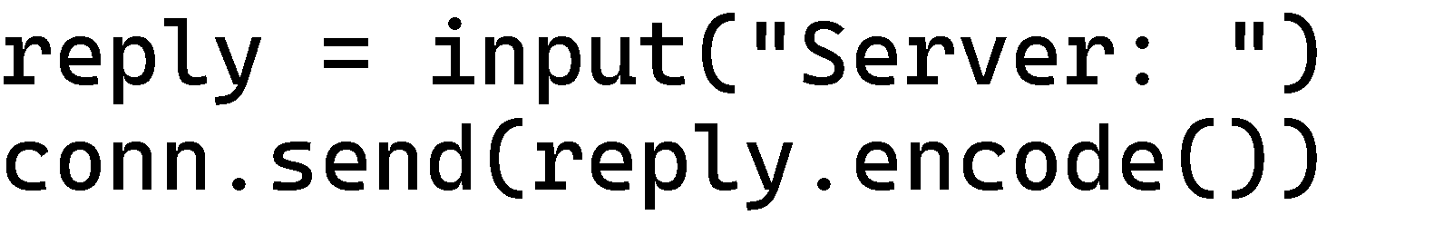
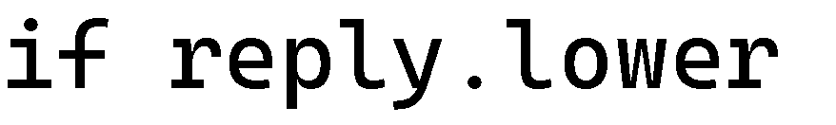
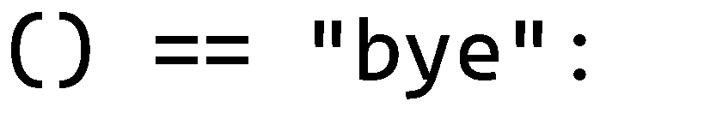

//tcp_server_chat.py

COMPUTER NETWORKS LAB
1601-24-733-
Lab Task - 11

//tcp_client_chat.py
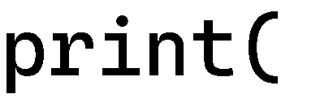

//udp_server_chat.py


COMPUTER NETWORKS LAB
1601-24-733-
Lab Task - 11

//udp_client_chat.py


