COMPUTER NETWORKS LAB
1601-24-733-
Lab Task - 7

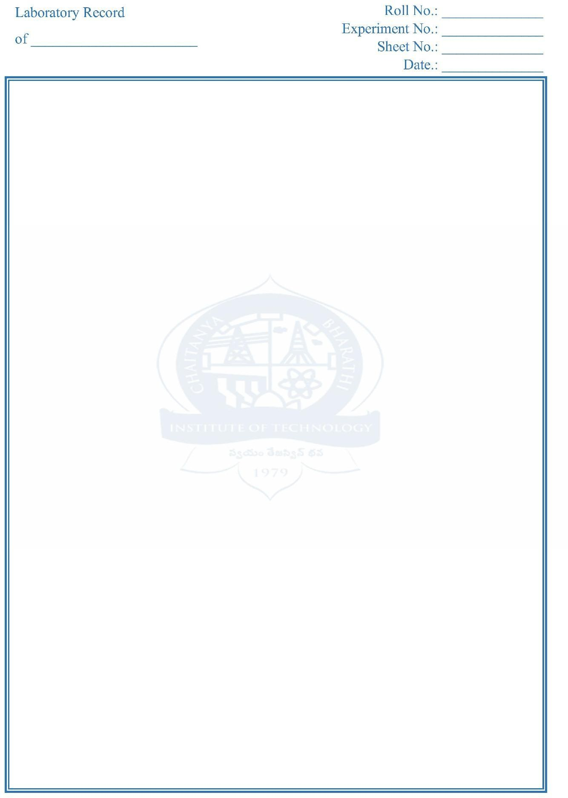

LAB TASK – 7
Aim: Simulation of Stop and Wait protocol

Description :
Stop-and-Wait is a simple flow-control and error-control protocol.
The sender transmits one frame at a time and then waits for an acknowledgment (ACK). The sender sends the next frame only after receiving the ACK for the previous frame.
If the ACK is not received within a specified time, the sender assumes that the frame or ACK was lost and retransmits the frame. However, waiting for an ACK after every frame can reduce network efficiency, especially when the propagation delay is high.

Procedure : Open Ubuntu-24.04 Terminal.
- cd ns-allinone-3.42/
- cd ns-3.42/
- sudo nano scratch/stopnwait.cc
- ./ns3 run stopnwait (or)
- ./ns3 run scratch/stopnwait
- exit
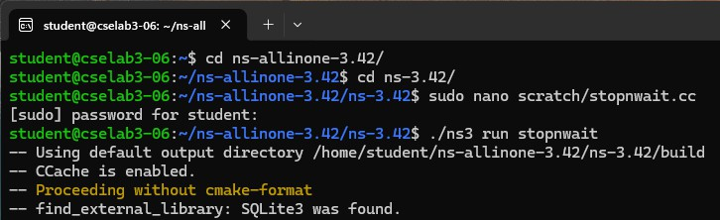
- cd ns-allinone-3.42/
- cd netanim-3.109/
- ./NetAnim
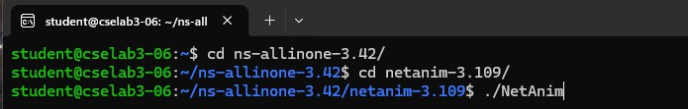
- Now the NetAnim window opens.
- At the top-left corner click on the folder symbol ( explorer )
- Click on Student -> ns-allinone-3.42 -> ns-3.42 -> stop-and-wait.xml
- Select that xml file and click on OPEN.
- Now to start the simulation: Click on PLAY button on top-left.
- The simulation starts…

COMPUTER NETWORKS LAB
1601-24-733-
Lab Task - 7

Code : stopnwait.cc

#include "ns3/core-module.h" #include "ns3/network-module.h" #include "ns3/internet-module.h" #include "ns3/point-to-point-module.h" #include "ns3/applications-module.h" #include "ns3/netanim-module.h"
using namespace ns3; Ptr<Socket> s, r;
bool ack = true;
int seq = 0, sent = 0, maxP = 5;

void Send()
{
if (sent >= maxP) return;

if (ack) {
uint8_t d = 0;
s->Send(Create<Packet>(&d, 1));
NS_LOG_UNCOND("Sender: DATA " << seq); ack = false;
} else {
uint8_t d = 0;
s->Send(Create<Packet>(&d, 1));
NS_LOG_UNCOND("Sender: Retransmit DATA " << seq);
}
Simulator::Schedule(Seconds(2), &Send);
}
void Receive(Ptr<Socket> socket)
{
Ptr<Packet> p;
while ((p = socket->Recv())) { uint8_t type;
p->CopyData(&type, 1);

if (type == 0) {
NS_LOG_UNCOND("Receiver: DATA " << seq); uint8_t a = 1;
r->Send(Create<Packet>(&a, 1)); NS_LOG_UNCOND("Receiver: ACK " << seq); seq++;
sent++;
}

COMPUTER NETWORKS LAB
1601-24-733-
Lab Task - 7

else {
NS_LOG_UNCOND("Sender: ACK received"); ack = true;
}
}
}
int main()
{
NodeContainer n; n.Create(2);

PointToPointHelper p;
p.SetDeviceAttribute("DataRate", StringValue("5Mbps")); p.SetChannelAttribute("Delay", StringValue("2ms"));

NetDeviceContainer d = p.Install(n);

InternetStackHelper stack; stack.Install(n);

Ipv4AddressHelper ip;

ip.SetBase("10.1.1.0", "255.255.255.0");
Ipv4InterfaceContainer i = ip.Assign(d);

s = Socket::CreateSocket(n.Get(0), UdpSocketFactory::GetTypeId()); r = Socket::CreateSocket(n.Get(1), UdpSocketFactory::GetTypeId());

s->Bind(InetSocketAddress(Ipv4Address::GetAny(), 8080));
r->Bind(InetSocketAddress(Ipv4Address::GetAny(), 8080));

s->Connect(InetSocketAddress(i.GetAddress(1), 8080));
r->Connect(InetSocketAddress(i.GetAddress(0), 8080));

s->SetRecvCallback(MakeCallback(&Receive)); r->SetRecvCallback(MakeCallback(&Receive));
AnimationInterface anim("stop-and-wait.xml"); anim.SetConstantPosition(n.Get(0), 10, 30);
anim.SetConstantPosition(n.Get(1), 50, 30);
Simulator::Schedule(Seconds(1), &Send); Simulator::Stop(Seconds(15)); Simulator::Run();
Simulator::Destroy();
}

COMPUTER NETWORKS LAB
1601-24-733-
Lab Task - 7



