COMPUTER NETWORKS LAB
1601-24-733-
Lab Task – 4



EXPERIMENT – Configuration of Cisco Router and VLAN

AIM
To configure Virtual Local Area Networks (VLANs) on a Cisco Switch and establish Inter-VLAN Routing using a Cisco Router (Router-on-a-Stick topology) in Cisco Packet Tracer, and verify end-to-end communication between hosts in different subnets using the ping command.

DESCRIPTION
A Virtual Local Area Network (VLAN) is a logical grouping of network devices that isolates broadcast domains at Layer 2 (Data Link Layer) regardless of their physical location. By default, devices on different VLANs cannot communicate directly with each other because they reside in separate broadcast domains.
To enable communication between different VLANs, a Layer 3 device (Router or Layer 3 Switch) is required. This process is called Inter-VLAN Routing.
In this experiment, the Router-on-a-Stick (ROAS) architecture is used:
- Access Ports: Connect end devices (PC1 and PC2) to the switch ports and carry untagged traffic assigned to a specific VLAN.
- Trunk Port: Connects the switch to the router via a single physical link capable of carrying traffic for multiple VLANs using IEEE 802.1Q frame tagging.
- Router Subinterfaces: Virtual interfaces created on a single physical router port. Each subinterface is assigned an IP address that acts as the Default Gateway for its respective VLAN and processes 802.1Q tagged frames.

NETWORK CONFIGURATION
Device Name | Interface | Remote Port | IP Address | Subnet Mask | Default Gateway | Assigne d VLAN /  Mode
PC1 | FastEthernet0 | Switch Fa0/1 | 192.168.10.  10 | 255.255.255  .0 | 192.168.10.  1 | VLAN 10  (Sales)
PC2 | FastEthernet0 | Switch Fa0/2 | 192.168.20.  10 | 255.255.255  .0 | 192.168.20.  1 | VLAN 20 (HR)
Switch 1 | FastEthernet0/1 | PC1 NIC | N/A | N/A | N/A | Access  (VLAN 10)
Switch 1 | FastEthernet0/2 | PC2 NIC | N/A | N/A | N/A | Access (VLAN  20)

COMPUTER NETWORKS LAB
1601-24-733-
Lab Task – 4

Switch 1 | GigabitEthernet0/1 | Router Gi0/0  /0 | N/A | N/A | N/A | Trunk (VLAN 10, 20)
Router 1 | GigabitEthernet0/0/0 | Switch Gi0/1 | Unassigned | N/A | N/A | Physica l Trunk Interfac  e
Router 1 | GigabitEthernet0/0/0. 10 | Switch Gi0/1 | 192.168.10.  1 | 255.255.255  .0 | N/A | VLAN 10  Gatewa y  (dot1Q)
Router 1 | GigabitEthernet0/0/0. 20 | Switch Gi0/1 | 192.168.20.  1 | 255.255.255  .0 | N/A | VLAN 20  Gatewa  y (dot1Q)

PROCEDURE
- Open Cisco Packet Tracer.
- Drag and place 1 Switch (2960), 1 Router (2911 or 4331), and 2 PCs (PC1, PC2) onto the workspace.
- Connect the devices using Copper Straight-Through Cables:
  - PC1 FastEthernet0 > Switch1 FastEthernet0/1
  - PC2 FastEthernet0 > Switch1 FastEthernet0/2
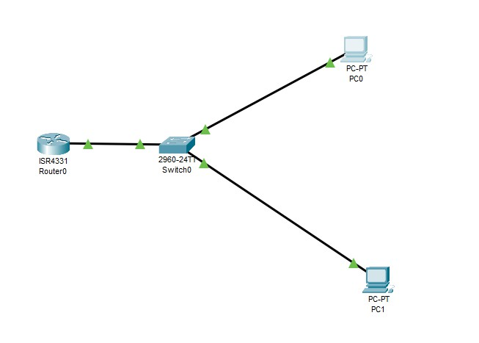
  - Switch1 GigabitEthernet0/1 > Router1 GigabitEthernet0/0/0

- Assign static IP addresses to end devices:
  - Click PC1 > Desktop > IP Configuration:

COMPUTER NETWORKS LAB
1601-24-733-
Lab Task – 4

  - IP Address: 192.168.10.10
  - Subnet Mask: 255.255.255.0
  - Default Gateway: 192.168.10.1
  - Click PC2 > Desktop > IP Configuration:
  - IP Address: 192.168.20.10
  - Subnet Mask: 255.255.255.0
  - Default Gateway: 192.168.20.1
- Configure VLANs and Access Ports on Switch1:
  - Click Switch1 > CLI tab.
  - Create VLAN 10 (Sales) and VLAN 20 (HR).
  - Assign Fa0/1 to VLAN 10 and Fa0/2 to VLAN 20.
  - Configure Gi0/1 as an 802.1Q Trunk Port.
- Configure Router-on-a-Stick Subinterfaces on Router1:
  - Click Router1 > CLI tab.
  - Enable the main interface GigabitEthernet0/0/0 using no shutdown.
  - Create subinterface GigabitEthernet0/0/0.10, set 802.1Q encapsulation for VLAN 10, and assign IP 192.168.10.1.
  - Create subinterface GigabitEthernet0/0/0.20, set 802.1Q encapsulation for VLAN 20, and assign IP 192.168.20.1.
- Wait for all switch link lights to turn green.
- Test inter-VLAN connectivity:
  - Click PC1 > Desktop > Command Prompt.
  - Execute: ping 192.168.20.10

COMMANDS USED

Switch Configuration Commands (Switch1)
Switch1> enable
Switch1# configure terminal
Enter configuration commands, one per line. End with CNTL/Z.

! Creating VLAN 10 (Sales) Switch1(config)# vlan 10 Switch1(config-vlan)# name Sales Switch1(config-vlan)# exit

! Creating VLAN 20 (HR) Switch1(config)# vlan 20 Switch1(config-vlan)# name HR Switch1(config-vlan)# exit

! Assigning FastEthernet0/1 to VLAN 10 Switch1(config)# interface FastEthernet0/1 Switch1(config-if)# switchport mode access Switch1(config-if)# switchport access vlan 10

COMPUTER NETWORKS LAB
1601-24-733-
Lab Task – 4

Switch1(config-if)# no shutdown Switch1(config-if)# exit

! Assigning FastEthernet0/2 to VLAN 20 Switch1(config)# interface FastEthernet0/2 Switch1(config-if)# switchport mode access Switch1(config-if)# switchport access vlan 20 Switch1(config-if)# no shutdown Switch1(config-if)# exit

! Configuring Trunk Port towards Router Switch1(config)# interface GigabitEthernet0/1 Switch1(config-if)# switchport mode trunk Switch1(config-if)# switchport trunk allowed vlan 10,20 Switch1(config-if)# no shutdown
Switch1(config-if)# exit

! Saving Switch Configuration Switch1(config)# exit
Switch1# copy running-config startup-config Destination filename [startup-config]?
Building configuration... [OK]

Router Configuration Commands (Router1)
Router1> enable
Router1# configure terminal
Enter configuration commands, one per line. End with CNTL/Z.

! Enabling physical main interface Router1(config)# interface GigabitEthernet0/0/0 Router1(config-if)# no shutdown
Router1(config-if)# exit

! Configuring Subinterface for VLAN 10 Router1(config)# interface GigabitEthernet0/0/0.10 Router1(config-subif)# encapsulation dot1Q 10
Router1(config-subif)# ip address 192.168.10.1 255.255.255.0 Router1(config-subif)# exit

! Configuring Subinterface for VLAN 20 Router1(config)# interface GigabitEthernet0/0/0.20 Router1(config-subif)# encapsulation dot1Q 20
Router1(config-subif)# ip address 192.168.20.1 255.255.255.0 Router1(config-subif)# exit

! Saving Router Configuration

COMPUTER NETWORKS LAB
1601-24-733-
Lab Task – 4

Router1(config)# exit
Router1# copy running-config startup-config Destination filename [startup-config]?
Building configuration... [OK]

Verification Commands

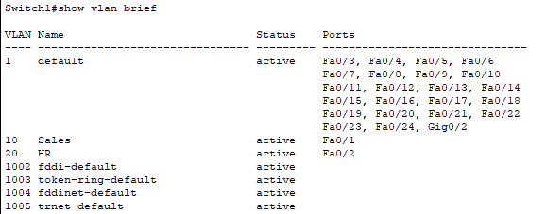
Verify VLAN Database on Switch1
  - Verify Trunk Interface on Switch1
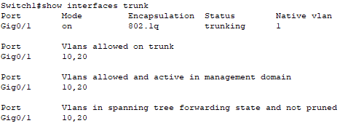

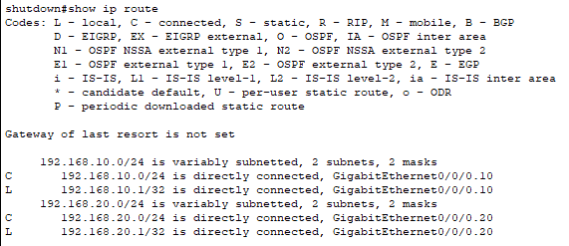
Verify Routing Table on Router1

COMPUTER NETWORKS LAB
1601-24-733-
Lab Task – 4

SAMPLE OUTPUT / VERIFICATION

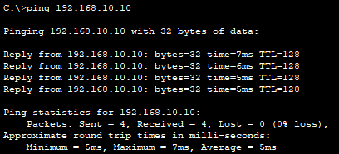
Ping Output from PC1 (192.168.10.10) to PC1 (192.168.10.10)
Ping Output from PC1 (192.168.10.10) to PC1 (192.168.20.10) – Which Doesn’t Reply At the first due to ARP
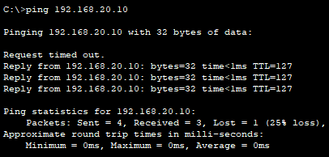
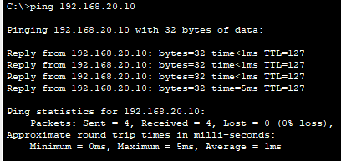
Ping Output from PC1 (192.168.10.10) to PC1 (192.168.20.10) With Reply

RESULT
VLAN 10 and VLAN 20 were successfully configured on the Cisco Switch, and access ports were assigned accordingly. An 802.1Q trunk link was established between the Switch and the Router. Virtual subinterfaces were configured on the Cisco Router to handle Inter-VLAN traffic routing. Successful ICMP ping replies confirmed full cross-VLAN communication between PC1 (192.168.10.10) and PC2 (192.168.20.10).

