System Health Alert
Monitoring Utility (SHAMU)
User Guide

For the CHDR System



SHAMU v4.0.018
Document Version 2.1
May 2013

Department of Veterans Affairs
Office of Information & Technology (OIT)
Virtual Lifetime Electronic Health Record (VLER)

Revision History
The revision history cycle begins once changes or enhancements are requested after the SHAMU User Guide has been completed and baselined.

Date | Version | Description of Change | Author Information
5/2013 | 2.1 | Update with the message replay service. Added Document Conventions and Requirements to Introduction. Added Alt text to graphics.  Updated Edit Job under Job Listing option under Admin menu. Move appropriate sections under the Admin menu. Replaced CRON with Quartz. | Kathy Stark, Tech writer, Cris Shupp and Greg Bowman, CHDR Developers
12/7/2012 | 2.1 | Revise and update for SHAMU 4.0 running JRuby on WebLogic against Oracle. | Kathy Stark, Tech writer, Cris Shupp and Greg Bowman, CHDR Developers
1/23/2012 | 2.0 | Revise and Update for SHAMU 2.3. Include new section describing Historical Charting. | Cris Shupp and Greg Bowman, CHDR Developers  Steven Claassen, Tech Writer
10/13/2010 | 1.0 | Initial draft | Cris Shupp, Greg Bowman, Paul LeMaster, CHDR Support Developers  Kathy Stark, Tech Writer  Dick Rickard, CHDR Product Manager

Table of Contents

Introduction 4
Partner Products/Services 4
Document Purpose 5
System Requirements 5
Document Conventions 5
Related Documentation 5
SHAMU Basics 6
Menu Options 6
Jobs/Services 7
Trackables (Alerts) Jobs 7
Services Listing 9
Job Status Legend 10
Job Listing Legend 11
Page Navigation 11
Basic User Functions 12
Access SHAMU 12
Login 12
Sign Up 13
Edit User Information 13
Logout 13
View Job Log 14
View Trackables 15
DoD ADC Automation High Alert (GREEN) Example 16
HDR Alert (YELLOW) Example 16
MPI Alert (GREEN) Example 17
View Services Listing 18
Administrator User Functions 19
List Users 19
Set Job Credentials 20
Stop Job Engine 20
View Job Listing 21
Edit a Job 21
Short Description/ Job Description 22
Active / Max Execution Time 22
Run as a Service/Service Settings 22
E-Mail Job Results 22
Track Status Changes 23
Escalation Information 23
Introscope Information 24
Edit Job in Job Listing 25
View Job Schedules 26
Edit Schedule 26
Historical Charting 27
Java Requirements 27
View Historical Charts 27
Z-Message Tabs for Filter Criteria 29
Example Line Chart 29
Visible/Not Visible Plot Lines 30
Change Plot Line Color 31
Example Pie Chart 32
Example Bar Chart 32
Advanced Features 33
Show the Data Table 33
Zoom 33
Missing Dates 35
Real Time Charting 38
Java Requirements 38
View Real Time Charting 38
Verify VA is Receiving DoD Data 38
Verify DoD Data is Stored into HDR 39
Verify VA Data is Flowing from VistA to CHDR 40
Glossary 41
Appendix A – Services/Alert Troubleshooting 42
Appendix B – Trackables/Alert Troubleshooting 43
Appendix C – Example: Hourly Breakdown E-Mail Report 46
Appendix C – Starting SHAMU 47
Index 48

Introduction
The VA and DoD, in partnership, designed and implemented the Clinical Data Repository/Health Data Repository (CHDR) system, which generates standards-based, computable electronic health records (EHRs). CHDR shares and exchanges the EHRs for patients being treated or who will be treated at both departments, also known as an Active Dual Consumers (ADC).
At DoD, medical records and patient healthcare histories are stored in the Clinical Data Repository (CDR), a component of the Armed Forces Health Longitudinal Technology Application (AHLTA). Similarly, at VA, medical records for ADC patients are stored in the Health Data Repository (HDR). CHDR is a combination of these two acronyms and the link between the two repositories.
The System Health Alert Monitoring Utility (SHAMU) is a web-based utility monitoring tool that provides real-time report generation and alert notification for messages passed through the CHDR production system. SHAMU automates the monitoring of the overall system health, and provides a real-time view into the messages (EHRs) as they are exchanged and passed through the VA CHDR system. The advantage of SHAMU is the ability to assist in outage detection, verification of the termination of outages, and verification that upgrades were successfully installed.

Partner Products/Services
CHDR works with many applications, servers, and services behind the scenes to share and exchange medical data with DoD for ADC patients. For optimal performance of CHDR in the production environment, all services must be online at all times. When an application or server has system failures or goes down for scheduled or non-scheduled downtime, it affects the CHDR system. Partner products and services include, but are not limited to the following:
- Health Data Repository (HDR) – Stores the allergy and outpatient prescription data from DoD (via CHDR), and the medical data sent by VistA. For ADC patients, CHDR sends the allergy and outpatient prescription data from VistA to DoD.
- Clinical Data Services (CDS) – VistA triggered events, such as updates to the allergy or outpatient prescription data are sent to the CDS. For ADC patients, CHDR pulls the information from CDS and sends the data to DoD to synchronize the patients’ data.
- Vitria Interface Engine (VIE) – VA enterprise interface engine responsible for passing HL7 messages between DoD and VA, and between internal VA systems (i.e., VA CHDR and HDR, HDR and CDS, and between the HDR and VistA).
- Enterprise Terminology Services (ETS)/ Standards & Terminology Service (STS) – Provides terminology standardization of VistA data and standardized drug names used by VA and DoD.
- VistAWeb – Graphical User Interface (GUI) used by clinicians at the VA on a daily basis to view, in near real-time, the integrated VA/DoD CHDR data.
- Computerized Patient Record System (CPRS) – users can activate VistAWeb, to view the VA/DoD integrated medical data, and the drug-drug, drug-allergy interaction alerts manifest in CPRS.
The CHDR system can also be affected if the Master Patient Index (MPI) goes down, as the CHDR Administration Application (CHDR Admin GUI) uses the MPI service to lookup patients to mark as ADC for data sharing. Therefore, SHAMU is a critical tool that provides a significant look into the performance of the partner products as well as the CHDR system.

Document Purpose
This document provides information on how to use the SHAMU utility to view the real-time charts for messages shared between the two departments. This document is intended for the CHDR Production Support Team and software support personnel at the Austin Information Technology Center (AITC), and development personnel who deploy and install applications. This guide includes instructions for end-users and SHAMU administrators.

System Requirements
Being a web-based application, to use SHAUM, all you need is an Internet browser. At this time, SHAMU supports Internet Explorer and Mozilla FireFox.
To use the Real-time Charting feature, you will need Java JRE 1.6, and have Pop-Up Blockers turned off.

Document Conventions
This document uses the following conventions:
Italic text is used for document titles and emphasis.
Bold text is used for all user responses.
Courier type is used for messages that may be displayed in SHAMU.
Hyperlinks (usually shown as blue underlined text) will provide links to other sections in the document for quick access, or to VA Intranet sites for related documentation.
Icons, such as Note and Warning  are used to highlight key points or to provide an important warning.

Related Documentation
Related CHDR documents include the following:
- CHDR Systems Management Guide
- CHDR VLER Audit Service Interface Control Document (ICD)
- CHDR User Guide
The documents are located at http://vhaispwww3/warboard/anotebk.asp?proj=941&Type=Active.

Some links in this document go to the VA Intranet, and the sites or pages are not accessible from outside the VA network.

SHAMU Basics
The System Health Alert Monitoring Utility (SHAMU) can be used by the AITC Administrators and CHDR Production Support personnel to determine if messages are received from DoD, the data is being stored, and the overall health of the CHDR system. A variety of Health Level 7 (HL7) message types are used to exchange data with DoD, and include, but are not limited to the following:
- Z01- Patient ADC status change request
- Z02 - Patient ADC status change response
- Z03 - Clinical update request
- Z04 – Clinical update response
For detailed descriptions of HL7 message types, see the CHDR Business Rules located on the CHDR TSPR repository at http://vhaispwww3/warboard/ProjectDocs/CHDR_VHIM.
The Z03 clinical update message is the best indication of whether DoD is sending data. Clinical updates should be arriving at all times. If data is not flowing, and an AITC Administrator has determined that VA CHDR is operational from a hardware perspective, real-time charts generated by SHAMU can help determine where the problem lies. It could be an inbound/outbound queue to the HDR, the interface engine, or VA CHDR or the DoD CHDR may be down.
SHAMU basic end-users may view the job log, reports, and historical charts. SHAMU administrators will have additional functions, such being able to seed the job engine, manage user accounts, create and configure jobs, and edit the job schedules. This guide includes instructions for basic end-users and SHAMU administrators.

Menu Options
The menu options displayed are based on your user login and system access rights. Several menu options are available to all users, while others are strictly for SHAMU administrators. Click Administrator User Functions to go directly to the Administrator Functions section of this user guide. The following is an example of the basic menu options.
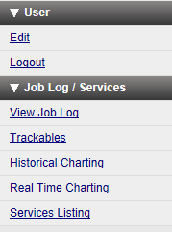
- The Login option is used to login to SHAMU. After logging in, the Edit user and Logout menu options are available.
- The Sign Up option is used to sign up as a new user.
- The View Job Log option is used to view the job log, and if an administrator perform the advanced functions.
- The Trackables option is used to view jobs setup as trackable, and provides an alert.
- The Services Listing option is used to view jobs that are set up as services, and can be executed manually to verify traffic flow.
- The Historical Charting option is used to view the historical charts (up to 30 days) of data for past performance of the CHDR system, and Real Time Charting provides a view into the HL7 messages as they are exchanged and passed through the VA CHDR system in real time. Real-time data can assist AITC and CHDR support personnel in determining the lack of message flow, and help pinpoint potential causes.

Jobs/Services
Jobs designed and configured in SHAMU can be scheduled to run via QUARTZ. QUARTZ is a time-based job scheduler used to execute a script or a sequence of scripts executed in order, and run at certain times or dates. Several types of jobs are used to monitor the overall health of the CHDR system:
- Trackables (Alerts) – runs regularly throughout the day (every 10 minutes, every 30 minutes, etc.) to verify services are online and messages are flowing between VA and DoD. If not, an alert (email) is sent to the appropriate support personnel.
For example, the NO_TRAFFIC_ALERT job runs every ten minutes with a thirty minute look-back. If no Z03/Z04 messages are received from the HDR in the past 10 minutes, an alert (red/offline) is sent. When the service is back online, another alert (green/online) is sent. As a trackable job, you can view the time interval and statistics between states (green/red).
- Report (Results) – runs at a particular time, collects data for message traffic flow, and creates a report. The report can be viewed online, or in an email depending on the job configuration.
For example, the MESSAGE_FLOW_RPT_DAILY runs every morning, and sends an email to the CHDR team to report all of the message traffic for the previous day.
- Historical Charting – provides a view into the past performance (up to 30 days) of the CHDR system. )
- Real Time Charting – provides SHAMU administrators a real-time view into the HL7 messages as they are exchanged and passed through the VA CHDR system.
- Services – enables SHAMU administrators to configure jobs as a service. These jobs can be manually executed at any time to verify traffic flow.

Trackables (Alerts) Jobs
Jobs setup as trackables can be setup to send an alert when a service (MPI, VIE, HDR, etc.) status changes, and also setup to send an email to the CHDR support personnel. Trackable jobs can also be run manually, which enables you to view the time interval and statistics between the status change.
A RED LIGHT alert is sent when there is no traffic or the maximum threshold is exceeded. The GREEN LIGHT alert is sent when messages are successfully received and are within predefined thresholds. The following table lists the jobs setup as trackables .
Job Code | Description
DOD_ADC_AUTOMATION_HIGH_ALERT | Looks at both the number of DoD ADC attempts over the look-back period (60 minutes) as well as the agreed upon threshold of ADC attempts over the same period. If the maximum threshold of ADC attempts is exceeded, an alert will fire notifying the DoD of the current ADC automation setting.
DOD_ADC_AUTOMATION_LOW_ ALERT | Looks at both the minimum number of DoD ADC attempts over the look-back period (60 minutes) as well as the agreed upon threshold of ADC attempts over the same period. If the minimum number of ADC attempts is not met an alert will fire notifying the DoD of the current ADC automation setting.
DOD_BATCH_EXCHANGE_ALERT | Ensures that the batch exchange of data between the DoDs ADC automation and the VA is performing as agreed. If the DoD is sending at least 20 activation requests in a 30-minute period and the VA responds to at least 10% of those activation requests with a Z06 we will stay green. Once this alert goes red the response rate must climb to 20% to clear. Currently, if the TRAFFIC_FLOW_ALERT_VA is red, this alert can be ignored.
DUPLICATION_ALERT | Checks for duplication of clinical data exchange (Z03/Z04) messages, reporting any requests that contain multiple responses based on the correlation id in the CHDR audited event table. If duplicating, this is an issue with V21. If the VIE team is confident the V21 is not duplicating, they should alert the CHDR support team and the DoD.
EPAGENT_CHECK | Checks the Introscope agent to see if it is currently running. If not, attempts to start it.
HDR_ALERT | Checks the count of audited messages that were sent to the HDR. If audited messages are over the reporting period, the count of messages written to HDR is recorded. An alert is fired if the percentage of audited messages written into the HDR is below the configured threshold. When alerting, this indicates an issue with V25 or V24. If the VIE team is confident the VIEs are functioning properly they should escalate the problem to the CHDR support team and HDR team.
MPI_ALERT | Checks connectivity with the MPI and is tied to the DoD ADC automation. When a Z01 is received from DoD, the MPI is queried (ADT_A24) to determine ADC status. The count of Z01, Z02, A24, and ACKs are recorded and analyzed to determine if there is connectivity with the MPI over the reporting period. When alerting, the VIE team should check V24 and V23. If the VIE team is confident the VIEs are functioning properly, they should escalate the problem to the MPI team and CHDR support team.
NO_DOD_TRAFFIC | Checks to see if we have received any Z03s or Z04s from DoD in the last ten minutes. If not, the VIE team should check V21. If they are confident V21 is functioning, they should escalate the problem to DoD via email to: mon-mhsunix@csd.disa.mil. This job runs every 10 minutes with a 10-minute look-back.
NO_Z04_MESSAGES_RECEIVED | Checks to see if any Z04s have been received from DoD. It does not go red if we have also received zero Z03s from DoD. In this case, as we are receiving Z03s from DoD, it means that DoD is requesting information from us, but not replying to VAs request for information. This alert should be escalated to DoD. Currently an alert email is sent to DoD. This alert runs every 10 minutes with a 10-minute look-back.
TRAFFIC_FLOW_ALERT_DOD | Looks at message traffic for all handshakes for messages initiated by DoD. So, when DoD sends a Z01 to VA we are analyzing the Z02 response, etc. This alert looks at the counts of messages sent and received and includes configurations for each handshake. Alerts are fired if minimums are not met or the response rate is below the configured setting for the message pairs. This indicates an issue with V21 (inbound). If V21 is fine then notify DISA (mon-mhsunix@csd.disa.mil), as this alert indicates an issue with V21 (outbound). If the VISTA_ALERT is red triage that alert first (V25), as it could indicate V25 is down.
TRAFFIC_FLOW_ALERT_VA | Looks at message traffic for all handshakes for messages initiated by VA. So, when VA sends a Z01 to DoD we are analyzing the Z02 response, etc. This alert looks at the counts of messages sent and received and includes configurations for each handshake. Alerts are fired if minimums are not met or the response rate is below the configured setting for the message pairs. If V21 is fine then notify DISA (mon-mhsunix@csd.disa.mil). If the VISTA_ALERT is red, triage that alert first, as it could indicate V25 is down.
VISTA_ALERT | Checks for clinical messages (Z03s) sent from VA to DoD over the reporting period. Alerts fire if we are below the configured low water mark and the last reported Z03 is recorded in the job result. The VIE team should check V25, (this alert) prior to checking the TRAFFIC_FLOW_ALERT_VA or TRAFFIC_FLOW_ALERT_DoD. Treat this alert before all others.
Z03_Z04_FREQ_TRAFFIC_CHECK | This job has a shorter look-back and checks for VA Z03s sent and Z04 responses received during the last 10 minutes. This alert also validates that at least one Z03/Z04 pair correlated. If this alert goes red it could indicate a traffic flow problem, but may also indicate a problem with the correlation of messages. Rely on the other alerts for traffic flow issues. This alert runs 10 minutes with a 10-minute look-back.
See “Appendix B, Trackables Alert Troubleshooting,” for additional information on how to view the trackable jobs; run a trackable job, and troubleshooting alerts.

Services Listing
Jobs configured to run as services can be manually executed at any time to verify traffic flow. Many services are configured to send an alert email to the CHDR support personnel when the job result status changes from green/up to red/down and vice versa. The following are jobs setup as services.
Job Code | Description
ADC_OVERLAY_CHARTS | This job generates a 7 and a 30 day chart of ADC patients initiated by DoD and includes a success rate line as a percentage as an overlay on the bar graphs.
EPAGENT_CHECK | Checks the Introscope agent to see if it is currently running. If not, attempts to start it.
HIST_CHARTING | This is a Java Application allowing the user to generate historical charts of clinical data flow between the VA and DoD for all currently supported message types.
HOURLY_BREAKDOWN_EMAIL | Reports on the daily production email outlining the counts or messages sent and received for the past 24-hour period.
MESSAGE_FLOW_RPT_DAILY | This job runs every morning and sends a report via email to the CHDR team on all of the message traffic for the previous day.
MESSAGE_FLOW_RPT_MONTHLY | This report is generated on the first of every month for the previous month and reports the message traffic flow analysis for the period.
MESSAGE_FLOW_RPT_TODAY | This job reports the message traffic from midnight to the current time, so this is a partial report that will be allowed to be run as a service.
MESSAGE_FLOW_RPT_WEEKLY | This is the weekly breakdown of message traffic and ADC activity for the previous week. This job is scheduled to run every Monday morning in order to pick up the previous week's activity.
MONTHLY_ADC | This job emails an attachment of a comma-separated text file with the current ADC patients from VA. This is delivered for analysis with DoD data.
Z03_SITE_ANALYSIS | This job breaks down the number of clinical updates sent by each individual VA site to the DoD for a given week. This report is scheduled to run each Monday morning for the previous weeks' message traffic.
Z03_Z04_FREQ_TRAFFIC_CHECK | Z03 / Z04 correlation traffic check. This job checks for VA Z03 sent and Z04 responses received during the last 10 minutes.
See Appendix, A, “Services/Alert Troubleshooting” for additional information on how to view the Services Listing, run a service job, and troubleshooting alerts.

Job Status Legend
This job status legend identifies the types of icons you may see when viewing the trackables listing. Trackable jobs can have three status states: running, pending (not yet started), and completed. The following table describes the icon colors used for a quick visual of the status and or alert type.
Icon | Description
 | A green icon indicates the job completed with no alerts. The server or VIEs between the CHDR and HDR, or VistA are up and running with no problems.
 | A blue icon indicates the job completed with an alert, and AITC should observe the alert status. There could be a traffic flow problem, HDR database write error, message correlation problem, or problem between the VIE and CHDR, VIE and HDR. If it is related to a VIE model pause, issue may correct itself.
 | A yellow icon indicates the job completed with an alert, and AITC should check to ensure systems are behaving normally. There could be a traffic flow problem, HDR database write error, message correlation problem, or problem between the VIE and CHDR, VIE and HDR.
 | A red icon indicates the job completed with an alert, and immediate action should be taken. There could be a traffic flow problem, HDR database write error, message correlation problem, or problem between the VIE and CHDR, VIE and HD
 | Email icon indicates an email was sent with the alert and/or job report information.
 | Question mark icon indicates the job failed to complete successfully.

Job Listing Legend
This job listing legend identifies the types of icons an administrator may see when viewing the job listing. A job could have one or more of the icons present, and provide a quick look at how the job is setup (includes an email alert, set as trackable, set to run manually, enabled for Introscope, and whether the job is active or inactive.
Icon | Description
 | The job is Active.
 | The job is inactive job; request to run is ignored.
 | The job includes email alert and/or job report information.
 | The job is set up as “trackable.” You can view the time interval and statistics between states (green/red).
 | Known as “gears”. Represents a service that can be kicked-off manually, and job will show under the Services menu.
 | Enabled for Introscope. AITC support team can view the data on their system using Introscope.

Page Navigation
To help you move from one page to another, hyperlinks and navigation buttons are available. The following examples, illustrate the use of buttons or hyperlinks to navigate through SHAMU. You just click the appropriate hyperlink or button to navigate through the pages.
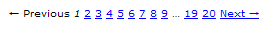
On pages where you need to enter information into fields, you can press the Tab key to advance to the next field, or press Shift+Tab to go back to the previous field.

Basic User Functions
This section includes information on the basic functions available to all users. For advanced functions, click Administrator User Functions to go directly to the Administrator Functions section.

Access SHAMU
To use SHAMU, all you need is an Internet browser. At this time, SHAMU supports Internet Explorer and Mozilla FireFox.
- Open your Internet browser, and type http://vahdrtvapp05.aac.va.gov:7011/PSTDashboard/ in the Address Bar. The Welcome to SHAMU page is displayed.
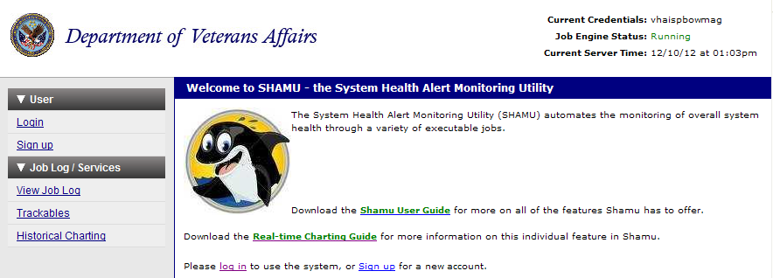
- From this page, select one of the following menu options:
- Click Login to login to SHAMU. If you are a new user, you must first sign up to receive a temporary username and password.
- Click Sign up to create a new user account.

Login
- From the Welcome to SHAMU page, click Login. The Log in to your User Account page is displayed.
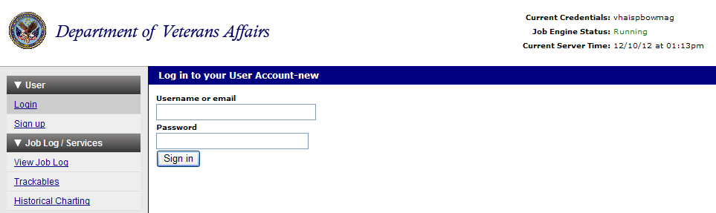
- In the Username or email field, type your login name; and in the Password field, type your password.
- Click Sign in. The Sign in Successfully message is displayed.

Sign Up
Prior to using SHAMU you must first signup as a user. Note: The Sign up menu option no longer displays in the menu after you signup.
- From the Welcome page, click Sign Up. The Create a New User Account page displays.
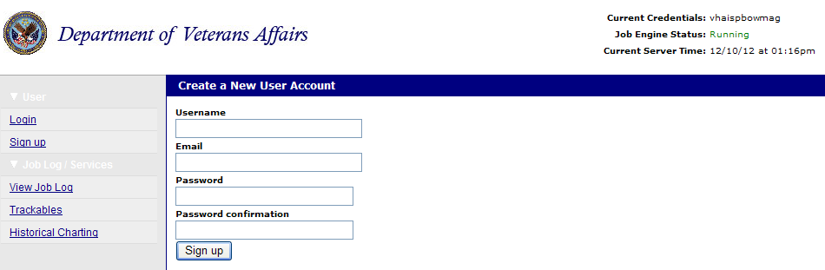
- Type your login name in the Username field, type your login name, and your email address in the Email field. For example: john.smith@va.gov.
- In the Password Confirmation field, retype your password to confirm your entry. Click Sign Up.

Edit User Information
The Edit option is used to change your Email or password.
- From the User menu, select Edit. The User Registration Edit page displays. To exit without making changes, click another menu option.
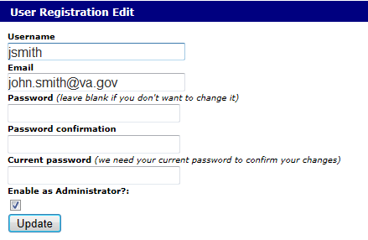
Only edit the information that needs to be changed (updated).
- Click in the appropriate field Email or Password, and type the new information.
- In the Password Confirmation field, retype your new password.
- In the Current Password field, type the password you currently use.
- Click Update. Your new password, if applicable, will be used the next time you sign in to SHAMU.

Logout
From the User menu, click Logout. The Signed out successfully message is displayed, and you are returned to the Welcome to SHAMU page.

View Job Log
The View Job Log option is used to view the job log entry listing. On this page you can also see the time the job started and finished, elapsed time, and job status ( running, pending, and completed).
To view the job log:
- From the Job Log/Services menu, select View Job Log. The Job Log Entry Listing page is displayed.
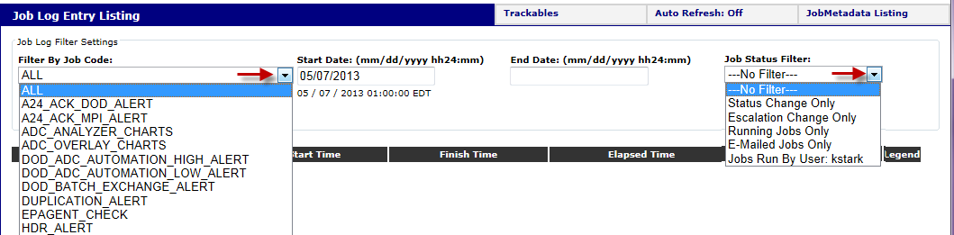
- In the Filter by Job code field, click the drop-down arrow and select the job to filter by, enter the Start Date and End Date for the search. You can also click the drop-down arrow in the Job Status Filter to further filter only by a job status (Status Change, Excalation Changes, Running Jobs, Emailed jobs, or Jobs run by User).
- Click Search. Based on your search criteria, the job listing is displayed. The following is an example listing with the Start and Stop Dates selected, and no filters by jobs code or job status selected. See the Job Listing Legend section for a description of the status legend icons.
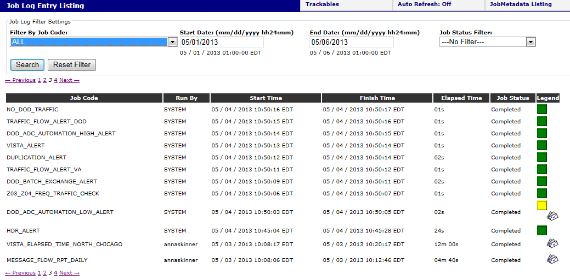
- To view additional pages, click Previous, a page number, or Next displayed at the bottom of the page. To run another listing, click Reset Filter.
- For a short cut to the Trackables, click the Trackables button at the top of the page.

View Trackables
The Trackables option under Job Log/Services is used to view the jobs set up as trackables (job provides an alert). On this page you can also see when the job last completed, status, when the alert started, and the elapsed time between alert states.
To view the trackables:
- From the Job Log/Services menu, select Trackables. The Trackables Job Listing page is displayed. The following is an example Trackables Jobs Listing which displays the job name, short description, last completion date, status (red, green, yellow, etc.), alert start time and elapsed time.
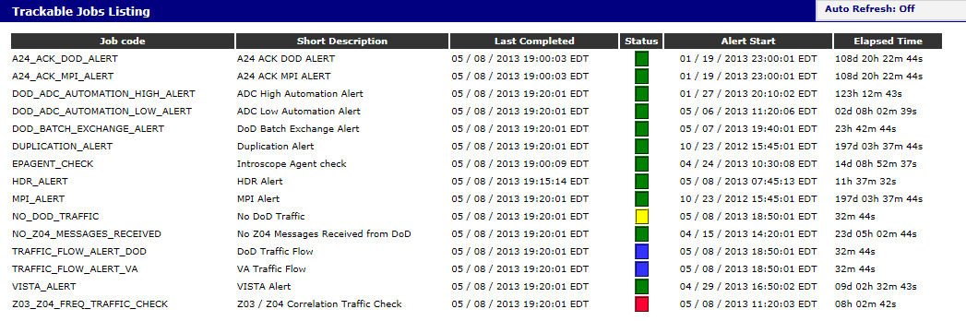
The green icon indicates the service (MPI, VIE, HDR, etc.) is online and is running within the normal parameters. The red icon indicates a service may be down, the job is in a high alert state, and immediate action should be taken to resolve the issue. See the Job Listing Legend section for additional status icon descriptions.
- Click a job to review the job results and complete job description. The following is an example of the Z03_Z04_FREQ_TRAFFIC_CHECK job with a RED light trackable status and RED escalation level. This job looks back and checks for VA Z03s sent and Z04 responses received during the last ten minutes. This alert also validates that at least one Z03/Z04 pair correlated.
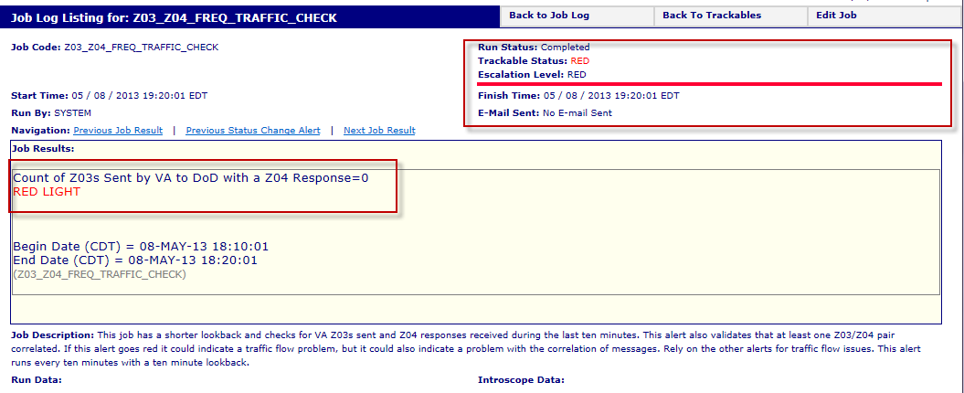
The alert could indicate a traffic flow problem, or a problem with the correlation of messages. AITC and product support should view other alerts for traffic flow issues. Note that no email was sent.
- Click a navigation hyperlink for quick access to Previous Job Result, Next Job Result, Previous Status Change Alert. You can also use Back to Job Log and Back to Trackables button to return to the appropriate job listing page.
If you have Administrator access, you can click the Edit Job button to go to the Edit Job Definition page for the job. See the SHAMU Administrator Functions: Edit a Job section for how to instructions.

DoD ADC Automation High Alert (GREEN) Example
The following is an example of the DOD_ADC_AUTOMATION_HIGH_ALERT job, in a GREEN light trackable state. This indicates the DoD patient sharing request (Z01 messages) are being received successfully, and the DoD ADC Automation numbers are within the threshold.
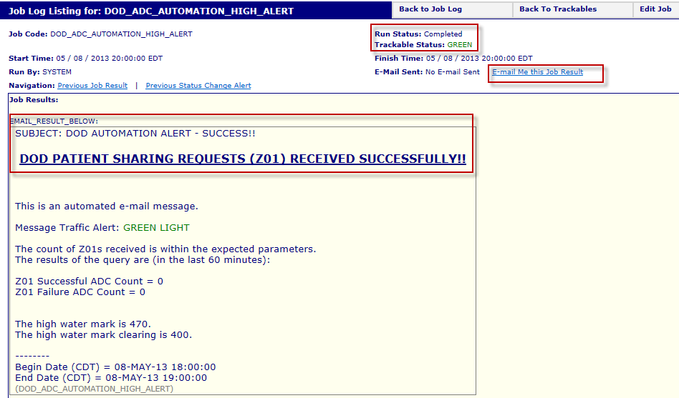
No Email is sent when in the GREEN state, but you have the option to have the results Emailed to you. When in the RED light state, and the DoD ADC attempts are over the high water mark threshold, an alert email is sent to DISA and the CHDR BHIE AHLTA support desk. No ANR should be opened.

HDR Alert (YELLOW) Example
The following is an example of the HDR Alert in the YELLOW escalation level, and RED state, indicating the percentage of the audited Z03 messages from DoD and written into the HDR is below the configured threshold. This indicates an issue with V25 or V24.
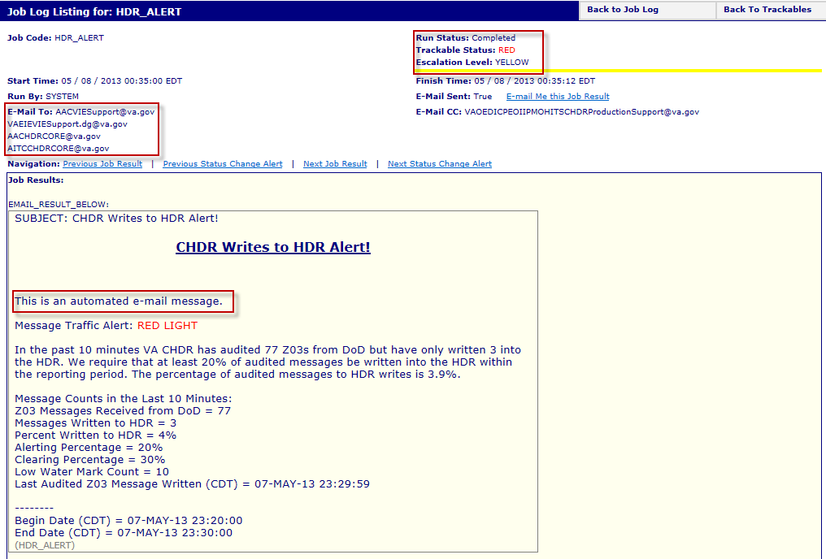
If the VIE team is confident the VIEs are functioning properly they should escalate the problem to the CHDR product support team and the HDR team.

MPI Alert (GREEN) Example
The MPI is tied to DoDs ADC Automation tool. When VA receives Z01messages from DoD, the VA CHDR sends messages to the MPI to verify the ADC status. The MPI should then send an ACK message back to the VA CHDR system to acknowledge the message was received. The following is an example of the MPI Alert in the GREEN light state.
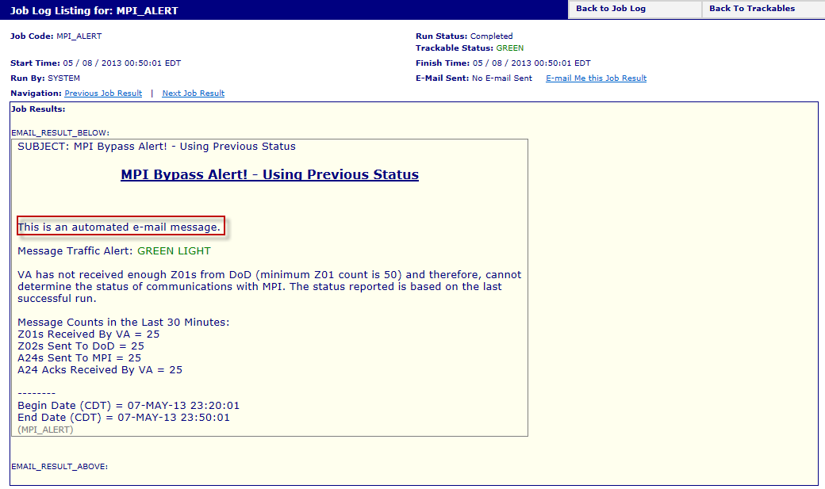
If the VA CHDR system has not received any acknowledgements (A24_ACK) messages from the MPI in the last 30 minutes check, the state goes to RED and an email is automatically send to support personnel.
When alerting RED, the VIE team should check V24 and V23. If the VIE team is confident the VIEs are functioning properly, they should escalate the problem to the MPI team and CHDR team.

View Services Listing
Services are jobs that can be run manually at any time. Many services are configured to send an alert email to the CHDR support personnel when a service (MPI, VIE, HDR, etc.) status changes from GREEN/up to RED/down, and then back up. .
To view the services listing:
- From the Services menu select Services Listing. The Services Listing page is displayed.
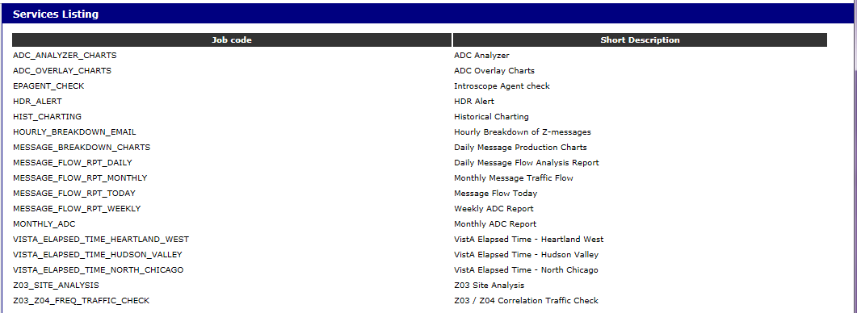
- Click a job code to view the job description and for the option to manually execute the service. The Execute Service page is displayed. The following is an example for the Execute Service Z03_Z04_FREQ_TRAFFIC_CHECK page.
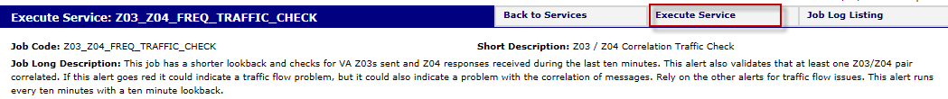
- Click Execute Service to run the job. The message, “The service has been started! The result will be emailed to you.” displays.
- Click the Back to Services or Back to Job Log button to return to the appropriate job listing page.
- If you are a SHAMU Administrator, you can click the Job Log Listing button for a shortcut to the Job Listing page.
For some jobs, such as the MESSAGE_BREAKDOWN_CHARTS job, when selected, the following screen is displayed.
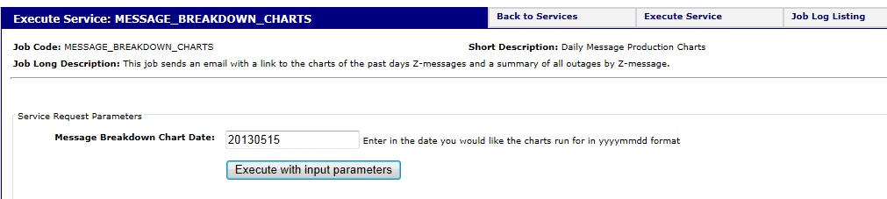
Click in the Message Breakdown Chart Date, and enter the specific date (version) of the report or task that you would like to run.
For jobs run manually, the results can be viewed by selecting the job from the Job Logs Listing.
See Appendix C, Example: Email Report for a sample of an Email sent after a job is executed manually.

Administrator User Functions
This section includes information on options available only to SHAMU Administrators. Only the SHAMU administrator can view the users’ setup information or delete a user, set job credentials, start/stop the job engine, and view and edit the job schedules.
The following Administration menu only displays for users setup as a SHAMU Administrator.
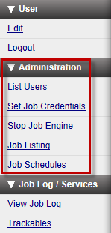
- List Users – Use this menu option to view the list of users, identify staff setup as administrators, and to delete users as necessary.
- Set Job Credentials – Before using this option, you will need your Oracle ID and password.
- Stop Job Engine – Use this menu option if you need to stop the job engine. The job engine should be stopped when you need to take SHAMU offline to install software or hardware upgrades.
- Job Listing – Use this option to view the available jobs, and edit the job metadata if needed.
- Job Schedules – Use this option to edit the scripts and to update the scheduling of when the jobs are run.
To return to the Basic User Functions section, click Basic User Functions.

List Users
The List Users option from the Administration menu enables you to view the current registered users of SHAMU, and to change the administrator rights or delete a user.
To view the list of users:
- Select the List Users option from the Administration menu. The Listing of Users page is displayed as shown in the following example.
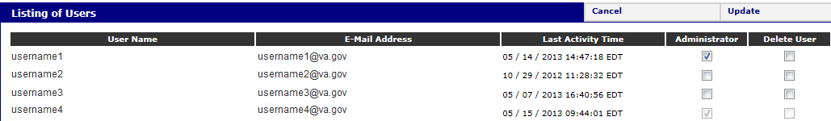
- To make a user an administrator, click in the Administrator checkbox. To remove admin rights, click to uncheck the checkbox.
- To delete a user, click the checkbox under the Delete User column for that user.
- To keep your changes, click Update in the top-right corner. To cancel your edits, click Cancel.

Set Job Credentials
The Set Job Credentials option under the Administration menu is used to seed the job engine. You will need your Oracle ID and password to enter job credentials.
The job engine must be stopped before you change job credentials.

To set job credentials:
- Select Set Job Credentials from the Jobs menu. The Job Credentials page is displayed.
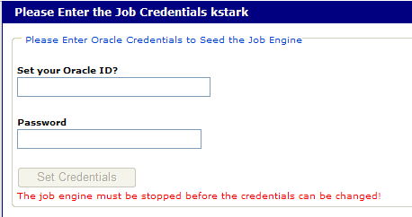
- Type your Oracle ID and Password in the appropriate fields.
- Click the Set Credentials button.

Stop Job Engine
The Stop Job Engine option under the Administration menu enables you to stop the job engine. The job engine should be stopped when you need to take SHAMU offline to install software or hardware upgrades, if there is an overall outage between VA and the DoD, or the server hosting SHAMU needs a reboot.
To stop the job engine:
- Select the Stop Job Engine option from the Jobs menu.
- The Job Engine Status displayed in the upper-right corner changes to Stopping, as shown in the following example.

View Job Listing
The Job listing page accessed from the Administration menu is used to view all available jobs, and as an administrator, edit the Job Metadata. the metadata, such as to enable the job to run as a service, setup job results to be Emailed, track status, and to integrate the job with Introscope.

Edit a Job
- Select the Job Listing option from the Administration menu. The Job Definitions Listing page is displayed.
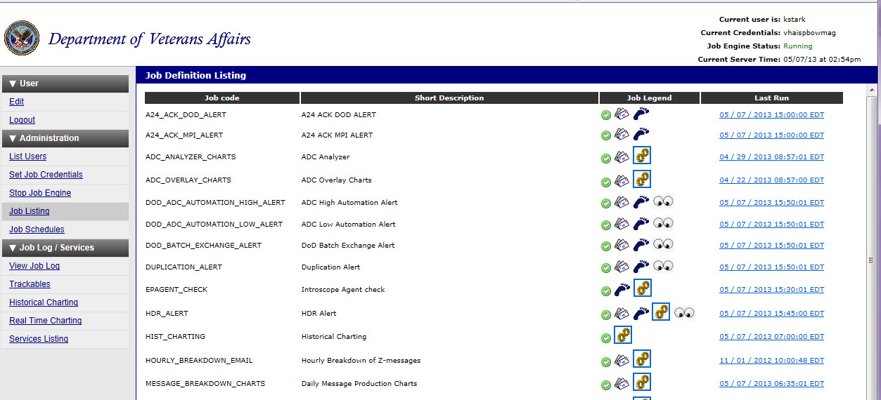
- Highlight and select the job to edit. The Edit Job Definition page is displayed. (Note the sample screen capture below shows only part of the page. Each area is broken down in the following sections.)
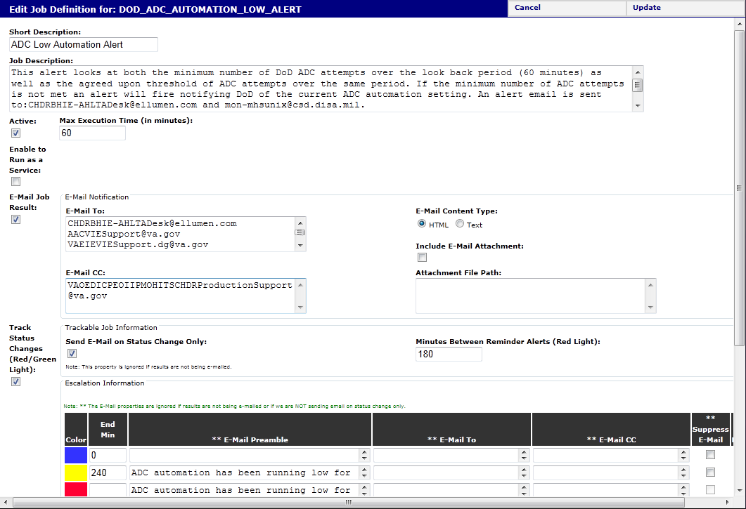
- Click in the appropriate fields to edit the information.
- Click the Update button to update the job with the new edits.
- Click the Cancel button to return to the job listing.

Short Description/ Job Description
The short description is what displays when viewing the job listing pages. The full description is used to describe what the job does, when it is run, as shown in the following example.
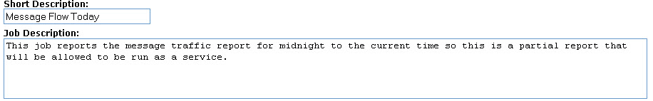
Short Description: Type the text to display in the Short Description column on the Job Listing pages.
Job Description: Type the complete description for the job, such as what data is reported, when the job is run, and if allowed to run as a service. This description is included in the job results Emails.

Active / Max Execution Time
The active status is used to set the job up, and for the system to run the job. If the checkbox is not checked the job will not run.
Active box: Place a checkmark if the job is available to run by the system.
Max Execution Time: enter the maximum number of minutes to allow for the job to run once executed. There is a job watchdog that will terminate any job that runs beyond its max execution time in order to free up the job thread and system resources.

Run as a Service/Service Settings
This option lets SHAMU know the job is a service, and the job will be run manually by the end users.
Enable to Run as a Service box: Place a checkmark if the job can be run as a service manually.
Stale Data after x minutes: Enter the number of minutes before a refresh of data occurs. This prevents multiple users from requesting the same report at the same time causing an unnecessary load on the database. If concurrent requests for the same report are made then the report will be generated one time with both users receiving the same job result.

E-Mail Job Results
This section is used to setup the E-mail names to receive the Job Results or alert, such AITC support, CHDR support, or DoD personnel. Additional email notification fields are displayed for entry.

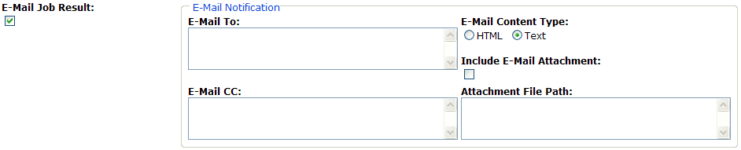
E-mail Job Results: Check the E-Mail Job Results box if the job results or alert results should be emailed to the staff setup in the E-Mail To and E-mail CC fields.
E-Mail To and E-Mail CC fields: enter the email addresses for all personnel who should receive the alert or job results.
E-Mail Content Type: Click the appropriate content type for the email (HTML or Text).
Include E-Mail Attachment: Place a checkmark if an attachment will be included with the email. Usually used for large text files.
Attachment File Path: Type the complete path location name.

Track Status Changes
If the Track Status Changes box is checked, the Trackable Job Information fields, Escalation Information fields, and Introscope Information fields are displayed for entry.
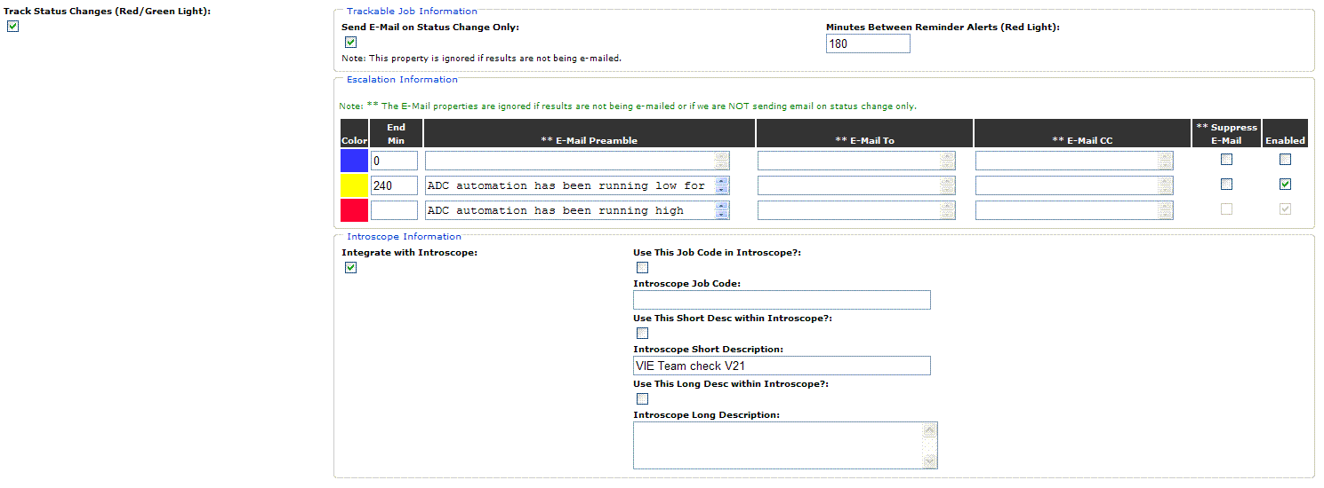
Track Status Changes: Check the box to set the job up as a Trackable Job.
Send E-Mail on Status Change Only: Place a checkmark, to send an email only when the status changes from GREEN to RED, or from RED to GREEN.
Minutes Between Reminder Alerts: Type the number of minutes to lapse before another RED LIGHT alert is fired.

Escalation Information
When a job is completed with an alert, it is assigned an escalation color that guides the appropriate action to be taken by AITC. An alert could indicate a traffic flow problem, HDR database write error, problem between the VIE and CHDR, VIE and HDR, or indicate a problem with the correlation of messages. The administrator can configure which colors are to be used, how much time may elapse before escalation color changes, the preamble of the alert email, as well as who receives the alert email if it is sent.
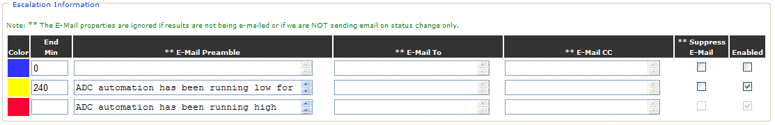
Blue indicates AITC should observe the status of this alert. Issue may correct itself if it is related to a VIE model pause.
Yellow indicates AITC should check and make sure systems are behaving normally.
Red indicates AITC should take immediate action.
End Min: Enter an amount of time in minutes that may elapse before alert will change to the next escalation color (level).
Time refers to the amount of time of a detected outage and not necessarily actual time.
E-mail Preamble: Enter a brief introduction to the alert email. Typically this option is used to concisely explain what the alert indicates about the system.
E-mail To: If e-mailing is enabled, support staff will already be receiving e-mails when this job is completed with an alert. Enter any additional e-mail addresses to receive an e-mail when an alert hits the respective escalation color (level).
E-mail CC: Enter any additional e-mail addresses to receive a copy of the e-mail when an alert hits the respective escalation color (level).
Suppress E-mail: Place a checkmark in this box to block the system from sending e-mail alerts for the respective escalation color (level). Red alerts cannot be suppressed with this option. To block all alerts for this job, uncheck the E-mail Job Result box in the above subsection.
Enabled: Place a checkmark in this box to enable the respective escalation color. Red alerts cannot be disabled with this option. To disable all escalation colors, uncheck the Track Status Changes box.

Introscope Information
The Introscope section is used when you want the data for the job to be integrated with the Introscope tool used by AITC support personnel or CHDR support.
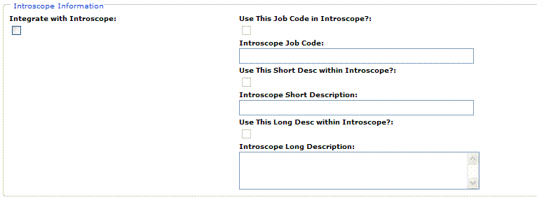
Integrate with Introscope: Click the checkbox for the data to be integrated with the Introscope.
Use This Job Code in Introscope: Click the checkbox to include the job code (name).
Introscope Job Code: Enter the job code to display if the above box is checked.
Use This Short Description: Click the checkbox to use a short description (defined in following field).
Introscope Short Description: Type the short description to display.
Use This Long Desc with Introscope: Click the checkbox to use a long description (defined in following field) for the job code.
Introscope Long Description: Type the long description (full description) for the job code.

Edit Job in Job Listing
- Click a job to review the job definitions. The Edit Job Definition page is displayed.
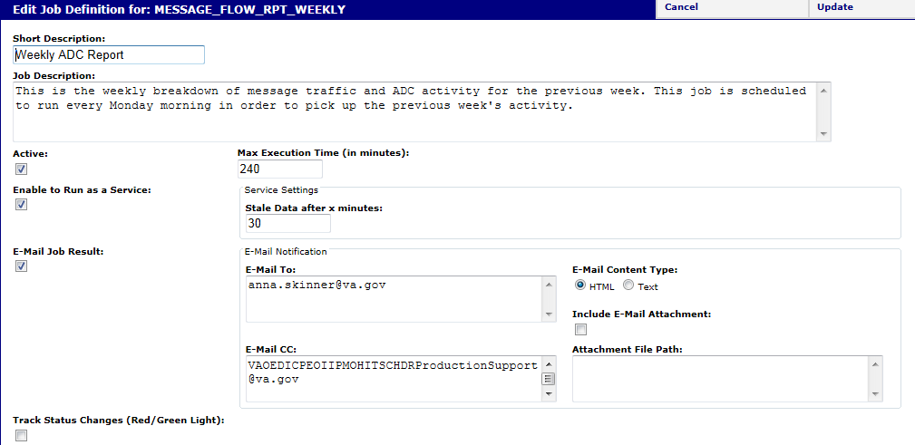
- Click in the appropriate fields to edit the information. (See the field descriptions below.)
- Click the Update button to update the job with the new edits.
- Click the Cancel button to return to the job listing.
Field Descriptions:
Short Description/ Job Description: The short description is what displays when viewing the job listing pages. The full description is used to describe what the job does, when it is run, as shown in the following example.
Active box: Place a checkmark if the job is available to run by the system.
Max Execution Time: enter the maximum number of minutes to allow for the job to run once executed. There is a job watchdog that will terminate any job that runs beyond its max execution time in order to free up the job thread and system resources.
Enable to Run as a Service box: Place a checkmark if the job can be run as a service manually.
Stale Data after x minutes: Enter the number of minutes before a refresh of data occurs. This prevents multiple users from requesting the same report at the same time causing an unnecessary load on the database. If concurrent requests for the same report are made then the report will be generated one time with both users receiving the same job result.
E-mail Job Results: Check the E-Mail Job Results box if the job results or alert results should be emailed to the staff setup in the E-Mail To and E-mail CC fields.
E-Mail To and E-Mail CC fields: enter the email addresses for all personnel who should receive the alert or job results.
E-Mail Content Type: Click the appropriate content type for the email (HTML or Text).
Include E-Mail Attachment: Place a checkmark if an attachment will be included with the email. Usually used for large text files.
Attachment File Path: Type the complete path location name.
Track Status Changes (Red/Green Light): Check the box to set the job up as a Trackable Job, and to track the job between status changes.

View Job Schedules
As the SHAMU Administrator you can use the Job Schedules option under the Administration menu to view the scheduled times for the jobs. This option is also used to edit the schedule (day and time) for a job.
Jobs designed and configured in SHAMU can be scheduled to run via QUARTZ. QUARTZ is a time-based job scheduler used to execute a script or a sequence of scripts executed in order, and run at certain times or dates.
To view the job schedules:
- From the Administration menu, select the Job Schedules option. The following window is displayed. to edit the scripts and to update the scheduling of jobs.
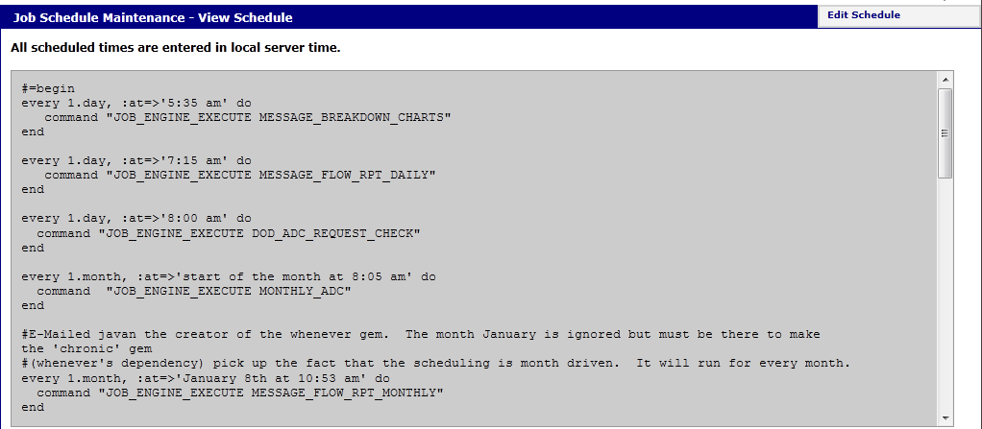

Edit Schedule
- Click Edit, page goes into edit mode (no longer shaded). The message, Note: Enter the scheduled times in local server time. is displayed at the top of the page.
- Click in the text box area and make the necessary changes to the script, and click Update.
- Click Cancel to exit without making changes.

Historical Charting
The SHAMU Historical Charting provides the opportunity to examine the past performance of the CHDR system, and to look up messages exchanged between the VA and DoD. A variety of EHRs, also known as messages/responses (Z01, Z02, Z03, etc.) are exchanged regularly between VA and DoD, and between VA CHDR and VA internal systems, such as VistA, HDR, CDS, and MPI.
A multi-day chart can be generated for different HL7 messages exchanged, as well as the HDR Writes and MPI ACK (acknowledgements) messages, to compare one 30-day period to another. The Historical Message Flow Chart and Total Message Counts Charts can be generated to compare the traffic flow during selected hours, (e.g., noon to 2:00 PM EST).
The graphical reports are used by CHDR functional analysts to see potential MPI issues, to perform routine analysis of the CHDR system, and used extensively for problem and trend analysis as to the performance of the VA internal systems as well as the CHDR system.

Java Requirements
The Historical Charting requires Java JRE 1.6 to be installed, and Pop-Up Blockers turned off. If the following security warning displays, read the warning carefully and select the choice that allows the component to run. In the following example, you can click Run.
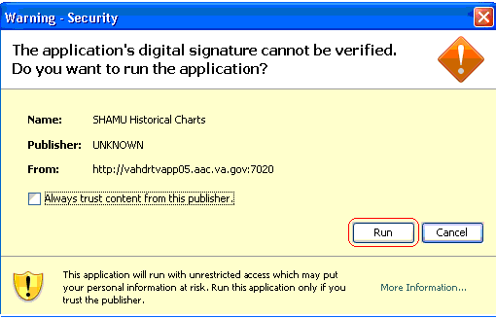
If the message, “The page you were looking for doesn’t exists. You may have mistyped the address or the page may have moved” displays, you may be too deep into the subcomponents of SHAMU.
Click the browser Back button. To avoid receiving this error, access the Historical Charting from the SHAMU home page. To return to the SHAMU home page, click the VA logo.

View Historical Charts
Charts display data in a meaningful way, and provide a visual illustration of the data. Three types of charts are available in SHAMU, and documented in this section. They are similar to charts created in Microsoft Excel, and include:
- Bar charts display category data in columns to present a series of numerical data. Bar charts are useful to show message counts, which change over a period of time.
- Line charts display continuous data over time, set against a common scale. Line charts are best to show the historical message flow for trending reports.
- Pie charts display the message ratio as a percentage of a whole pie. Each percentage of data type has a unique color or pattern and is represented in the chart legend.
This is an interactive chart, meaning, the results displayed in the charting area change based on the filter criteria selected. The extent of the changes displayed depends on the filter criteria. The data can be directly import into Microsoft Excel for Metrics generation and reporting.
The earliest date that can be plotted is the preceding day. Up to a 30-day range of data can be plotted, but a smaller range will increase performance of the Historical Charting application. There is no designated earliest start date. Data availability is contingent on the most recent purge of data for server space.
To view Historical Charting:
- From the Job Log/Services menu, select Historical Charting. The Historical Charting window opens, with a blank charting area, and defaults to the Filter Criteria tab.
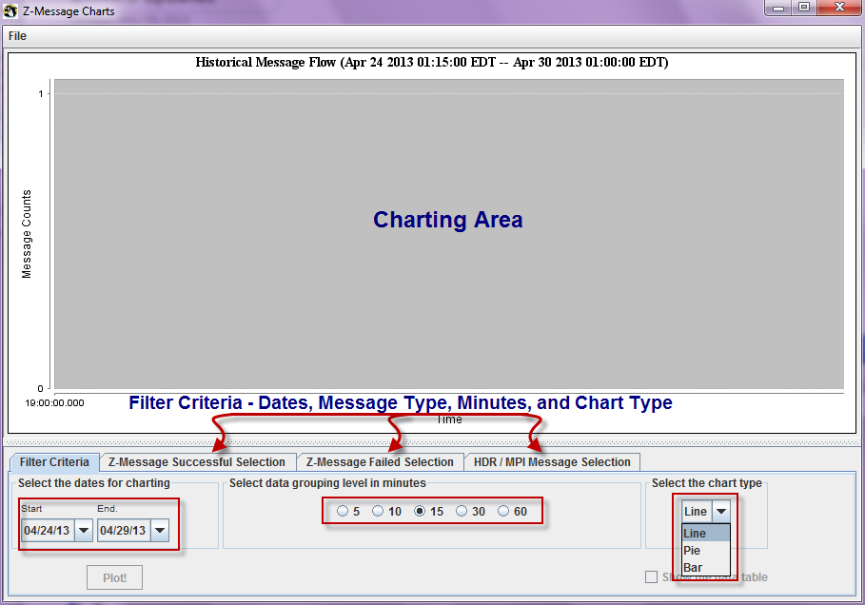
- Define dates to filter. Click on the drop down arrow in the Start and End date field. To plot only 1 day of data, leave the End date blank.
- Select data grouping minutes to plot per hour: (5 = 12 data points, 10 = 6 data points, 15 = 4 data points, 30 = 2 data points per hour, or 60 =1 data point per hour).
- Select chart type: Line for Historical Message Flow, Pie for Message Ratio, or Bar for Total Message Counts.
- Select a message type tab: Z–Message Successful for messages successfully exchanged, Z-Message Failed for messages that failed to exchange during the data range selected, or HDR/MPI Message to display data passed through the HDR and MP.
Filter criteria can be selected from any of the tabs for the same chart. For example you can select messages from the Z-Message Successful tab, and then select message types from the HDR/MPI Message tab to add to HDR and MPI messages to the chart display.
- Click Plot! The message, “The plot data is being downloaded from the illustrious SHAMU! Select some messages from the message tabs to see the results if you have not already done so.” displays. Click OK to continue.

Z-Message Tabs for Filter Criteria
The following is screen capture for the message types to select from on the Z-Message Successful tab and Z-Message Failed tab. Prefix VA - indicates messages originating from VA; whereas the prefix DoD indicates messages originating from DoD. The suffix indicates the message type.
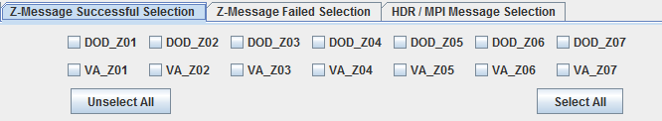
The following is a screen capture for the message types to select from on the HDR/MPI Message Selection tab.
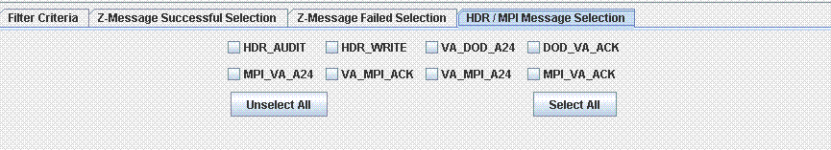
The HDR/MPI Message Selection tab shown above, can be used to select additional messages for display involving the HDR and MPI. The HDR_AUDIT and HDR_WRITE refer to audits and writes performed by HDR, respectively.
HDR Audits will no longer occur with the deployment of CHDR 2.1 into production on 12/3/11. No data will be available for HDR Audits after 12/3/11. HDR audits will continue to be available for dates prior to the deployment of CHDR 2.1.

Example Line Chart
The following example illustrates a Line Chart with DoD Z03 messages and VA Z04 message successfully exchanged.
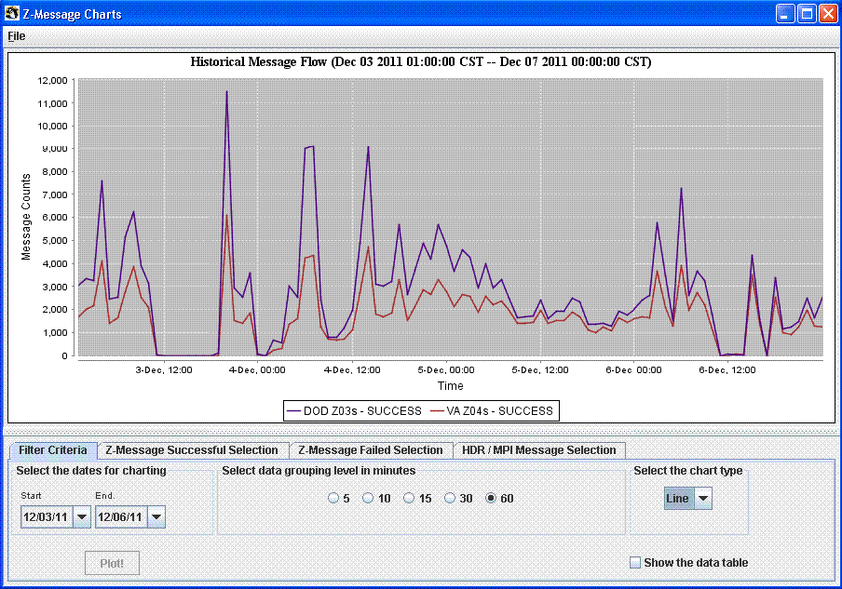

Visible/Not Visible Plot Lines
For the line chart, you have the option to make a data plot line visible or not, and change the color of the data line. Begin with the line chart from the previous example (successful DOD_Z03 messages and successful VA_Z04 messages selected).
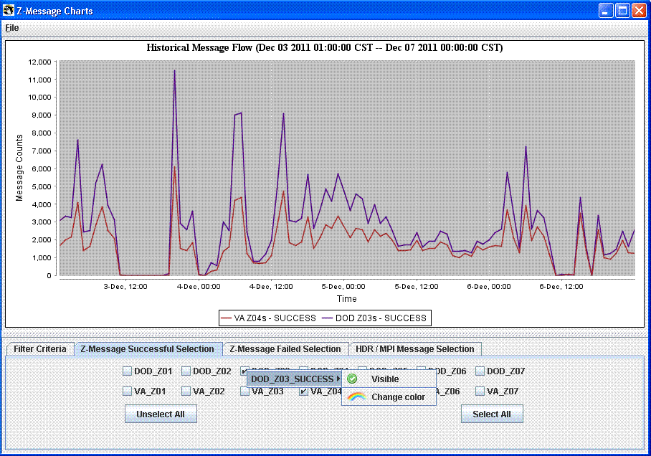
- Click on the Z–Message Successful Selection tab, and right-click on the DOD_Z03 box. Move the mouse over the DOD_Z03_ SUCCESS option. The options to change visibility and color appear.
- Click Visible. DOD_Z03 Success is still plotted on the data table, but the line is no longer visible on the chart. If DOD_Z03 was deselected, the data would no longer be plotted and the scale of the chart would change to fit the remaining selected messages. Click Visible to make the DOD_Z03 messages visible again on the chart. This feature is most useful when the user wants to maintain the scale of the chart, but focus on a specific message.
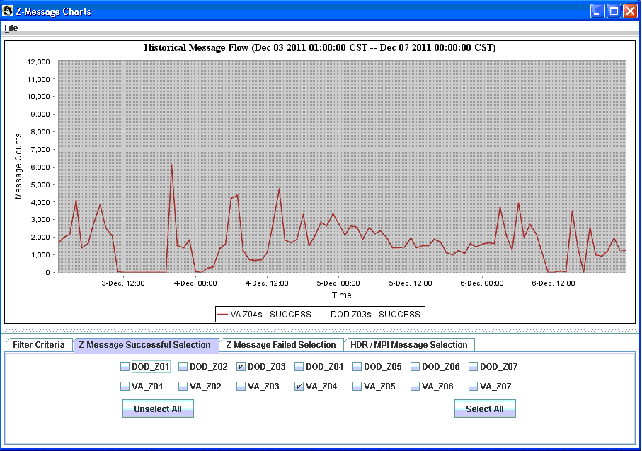

Change Plot Line Color
Begin with the line chart from the previous example (successful DOD_Z03 messages and successful VA_Z04 messages selected).
- Right click on the DOD_Z03 box again. Move the mouse over DOD_Z03 SUCCESS option. Click Change color. The Change the color window appears.
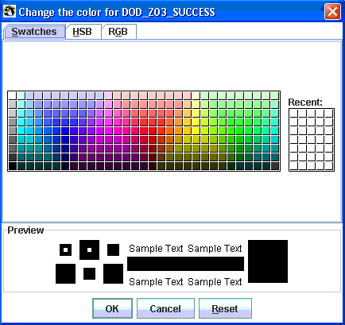
- Select the desired color. Yellow was selected in the example below.
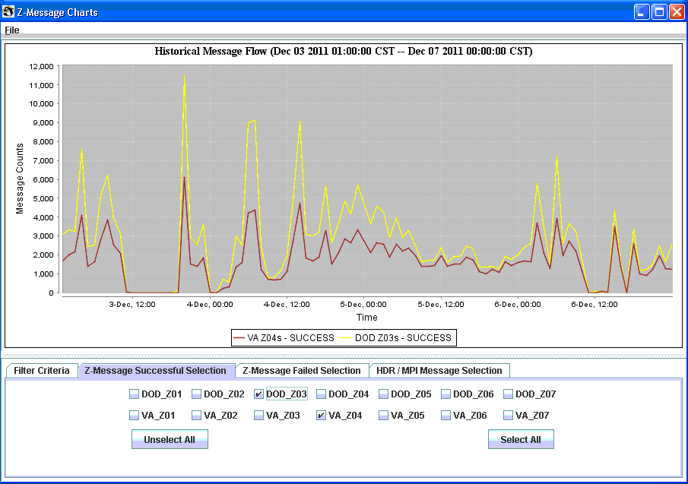

Example Pie Chart
Click the drop box under Select the chart type, and select Pie. A pie chart of the same data now displays the ratio of successful DOD_Z03 messages to successful VA_Z04 messages.
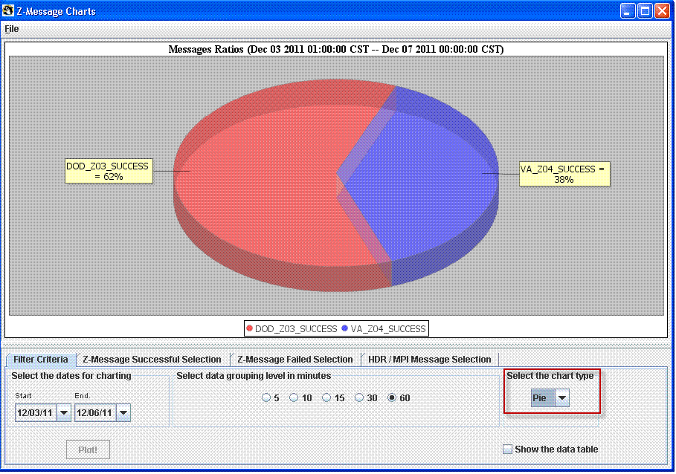

Example Bar Chart
Click the drop box under Select the chart type, and select the Bar option. A bar graph of the same data now displays the counts of successful DOD_Z03 messages and successful VA_Z04 messages.
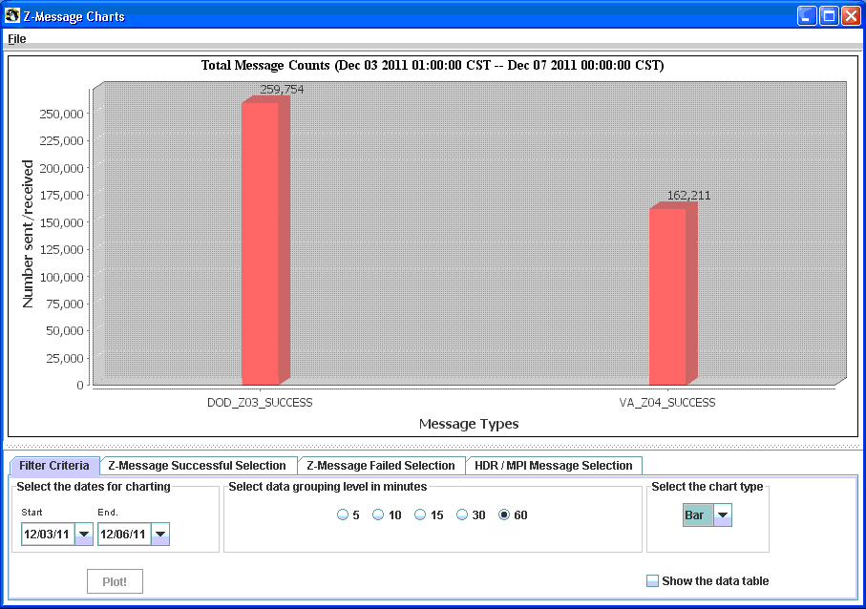
At any point, when viewing a chart, you can right-click on the chart for options to view Properties, Copy, Save or Print the chart. Options to Zoom In and Zoom Out are also available.

Advanced Features

Show the Data Table
The Show data table allows you to view a table of the numerical value of each respective data point. The information can then be copied to the clipboard for export to another application such as Microsoft Excel.
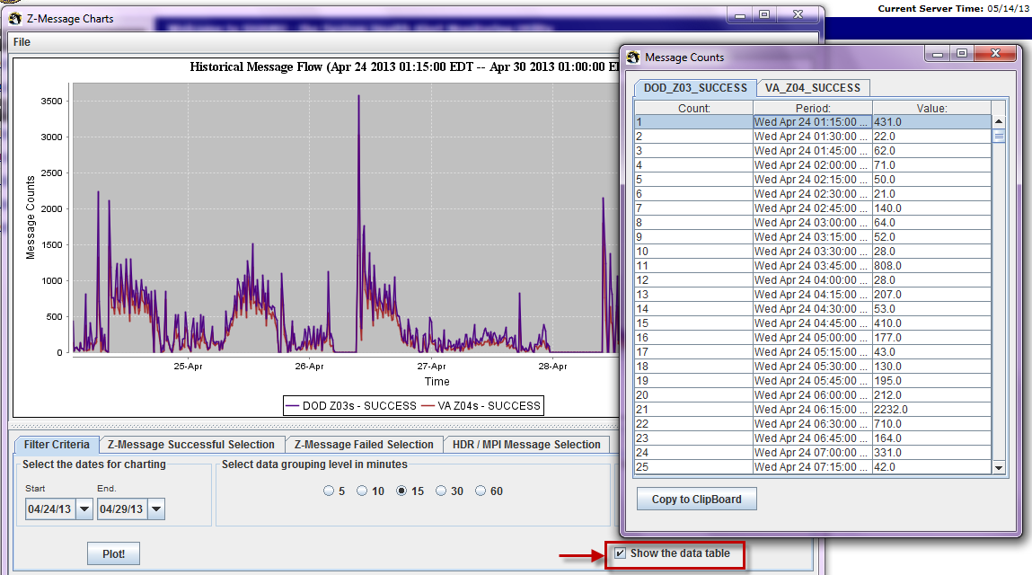
- On the Filter Criteria tab, click the box Show the data table. The data table appears, and the data is organized with a separate tab for each message type.
- To copy a portion of the data, hold down the Ctrl key and click the desired data points, right-click and select Copy. To copy the entire data table, click the Copy to Clipboard button.

Zoom
The zoom feature works with line and bar charts, but is most useful with line charts. The zoom feature lets you easily examine outages, and engaging the data table provides the exact measurement of when the outage occurred.
- To zoom in on a portion of the chart, click at the top-left portion of the desired section and drag the cursor down and to the right. This feature only works when you click and drag the cursor top-down and left to right. The selected area will be shaded as shown below.
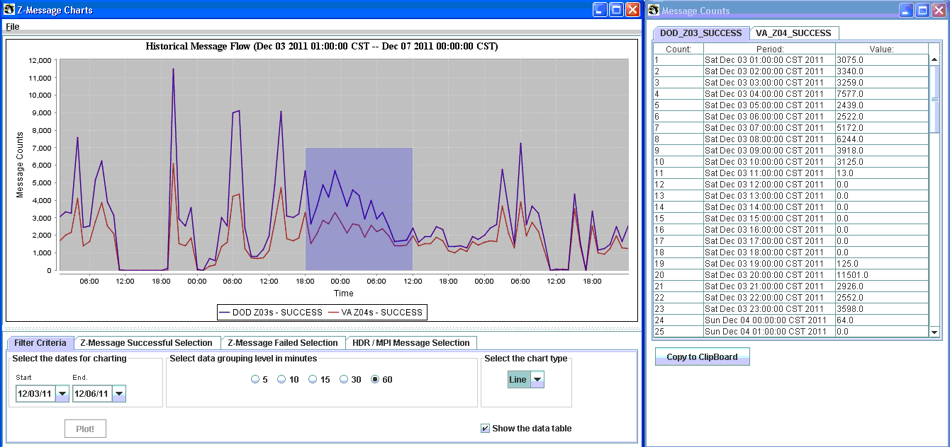
- Release the mouse and the chart will zoom in on the shaded section. Note that the chart title and data table change in sync with the zoom.
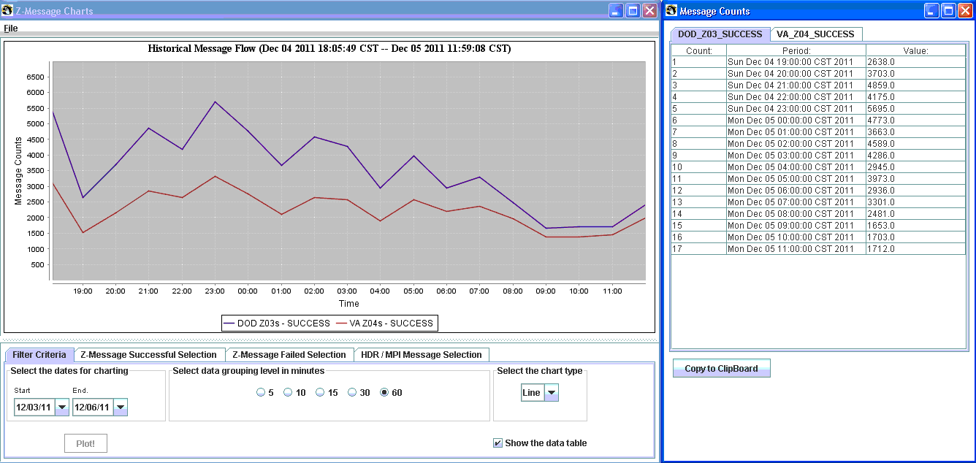
- To zoom out to the original chart, click and drag the mouse to the left and release.
If you plot a data range and nothing appears on the chart, it could mean the job did not run during that time frame. The Historical Charting application does not have the capability to alert the user when a job did not run.
You can work around this issue by using the zoom feature and the data table. The following example shows a chart and data table for a day when the requested job did not run. Note that there is only one data point for Wed Nov 30, which refers to the 11pm-12am time slot on Tue Nov 29. This indicates the job did not run on Wed Nov 30. SHAMU runs in Central Standard Time (CST) zone.
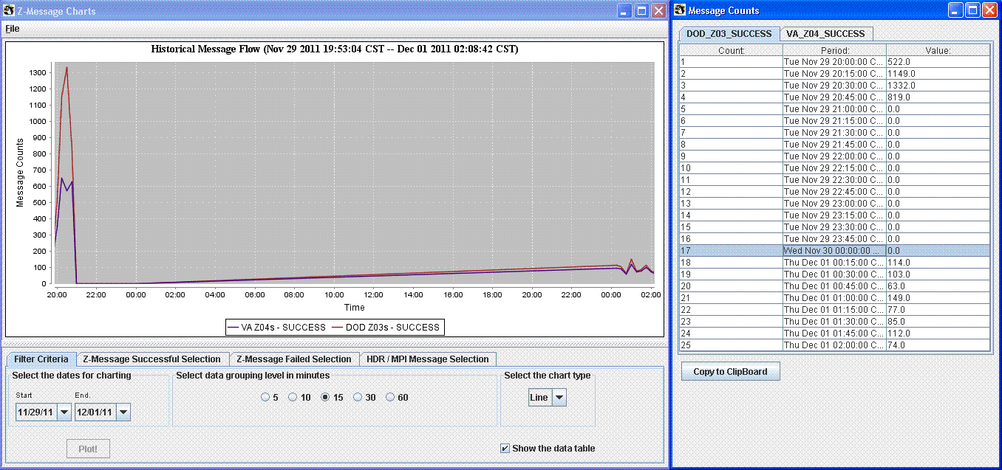
The historical chart and data table will adjust to the time zone of the user. If you are in a different time zone, this should be taken into account when determining if a job has run.

Missing Dates
The Historical Charting feature now supports an alert to missing data, and if the data is not corrupted, you can rebuild the missing data. For example, in the following screen capture, the dates 10/26/12 through 10/30/12 was selected.
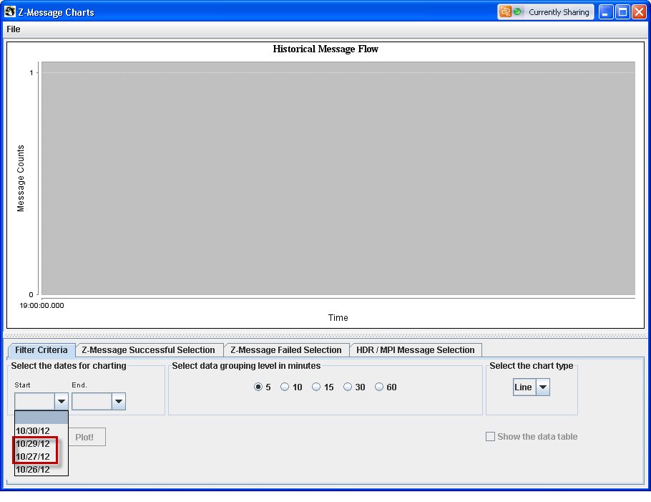
Note that the dropdown date field above is missing 10/28/12. Often times you might not notice this when selecting a date range (selecting the start and end 10/26/12-10/30/12).
When a date is missing, SHAMU will provide a warning message, “The following dates are missing: 10/28/12” as shown below.
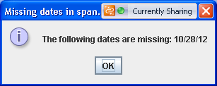
For multiple missing days, the warning message, “The following dates are missing: 10/27/12, 10/28/12” is displayed as shown below.
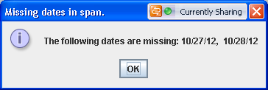
In some cases the date is available in the dropdown date field, but the data is corrupt, in this case the message, “There was no data on 10/28/12” is displays as shown below.
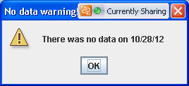
In each of these cases, you will need to chart the data by going to the Services page in SHAMU and regenerate (or generate) the data, as illustrated in the following example.
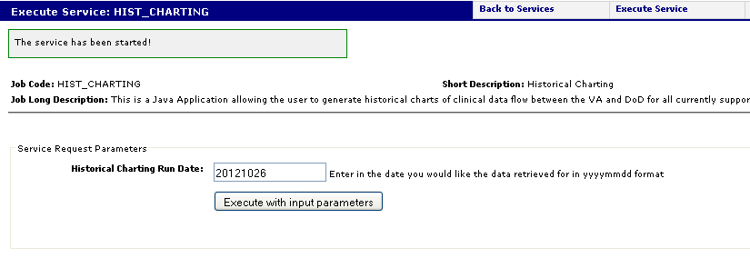
You must use the Execute with input parameters button and generate the days needed. (WARNING: the CHDR audit log is trimmed to 90 days so attempts to regenerate data older than 90 days might fail).
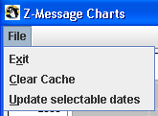
After you regenerate the needed data, you will need to select either the Update selectable dates and/or select Clear Cache options. If dates are missing in the date selector dropdowns, the Update selectable dates option motivates the application to use a JSON web service on SHAMU to get the new valid dates. The application will detect the change and display the following message.
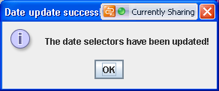
It is possible that you might make the selection before SHAMU completes the work, in this case, the following message is displayed.
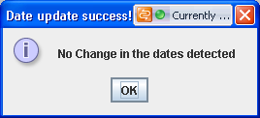
Click OK, and try again later.
If you received the ‘No data warning’, you must choose the Clear Cache option. This motivates the application to delete the current cache of data and re-download the data. If you re-run the corrupted date the application should download good data. Upon selection, the following message is displayed.
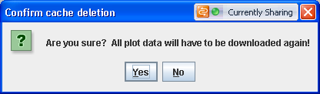
Click Yes. A message similar to the one shown below is displayed.
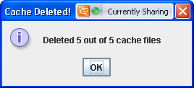
Of course the numbers may vary, based on the number of dates missing.
The following is a sample of a graph with missing data. Even though the title says data for the 27th and 28th is missing. Again, in this case, before the graph ever plots the above warnings (or combination) would have showed.
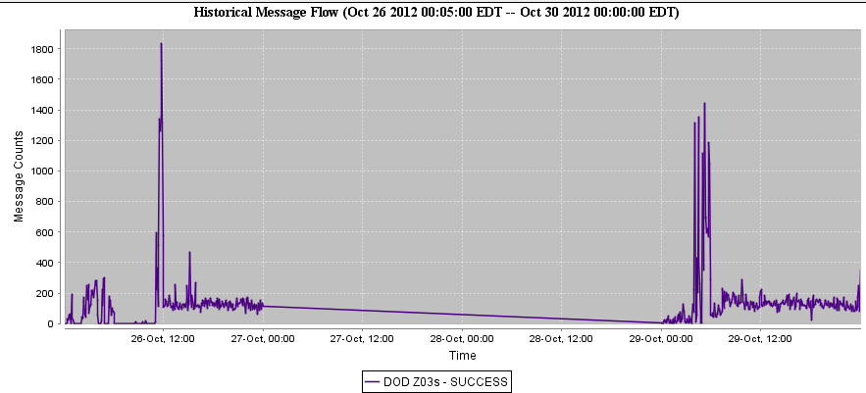

Real Time Charting
The SHAMU Real Time Charting functionality can be used to monitor, in real-time, the traffic flow through the CHDR system. A variety of EHRs, also known as messages/responses (Z01, Z02, Z03, Z04, etc.) should be flowing regularly between VA and DoD, and between VA CHDR and VA internal systems, such as VistA, HDR, CDS, and MPI. If issues occur or any system goes down, SHAMU alerts will fire and SHAMU will send an alert Email to AITC and CHDR support. Tier II support, Tier III support, and staff at AITC often use the SHAMU Real Time Charting to determine the lack of message flow, and to resolve traffic and connectivity issues with DoD and with VA systems, and help pinpoint potential causes.

Java Requirements
Real-time charting requires Java JRE 1.6 to be installed, and Pop-Up Blockers turned off. You may receive a security warning depending on which version of Java is loaded on your computer.
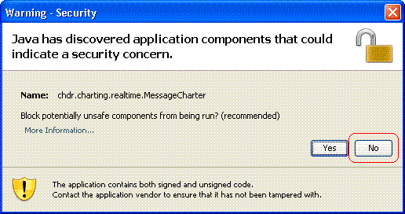
Read the warning carefully and select the choice that allows the component to run. In the example above, you would click No.

View Real Time Charting
The Real Time charts option under the Job Log/Services menu can be used to run reports in real-time to give product support confidence that the CHDR system is up as expected. Business analysts can view the daily, weekly, and monthly reports to track and analyze data traffic issues, and, if need, escalate the issue. All charts are generated from the Real time Charting: Preferences Filter page. Instructions and examples are shown for the following charts.
- Verify VA is receiving DoD data.
- Verify DoD data is being stored in HDR.
- Verify VA data is flowing from VistA to VA CHDR.

Verify VA is Receiving DoD Data
Although DoD sends a variety of messages and responses to VA, the Z03-Clinical Updates messages should be arriving at all times. Looking at the DoD Z03 message chart is the best indication as to whether or not DoD is sending data.
- From the Job Log/Services menu, select Real-Time Charting. The Real time Charting: Preferences Filter page is displayed.
- Select VA_TOTALs from the VA Chart Type(s), and select DoD_Z03 from the DoD Chart Type(s).
- Click the View Real Time Chart button. The Real Time Message Flow window displays the results. The chart below shows a healthy system with regular DoD clinical updates (Z03s) arriving.
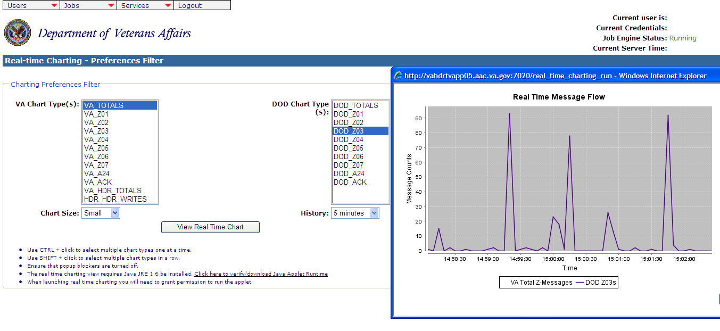

If this chart is flat lined, either DoD is down and unable to send updates, or the V21 interface engine is paused or down and is failing to forward DoD updates to VA CHDR.
E-mail AACVIEsupport@va.gov and alert them to the situation.

Verify DoD Data is Stored into HDR
To verify that data is being stored into the HDR, you’ll need to view the totals in the VA HDR, and the total writes to the HDR writes against the DoD Z03 messages received.
- From the Services menu, select Real-Time Charting. The Real time Charting - Preferences Filter page is displayed.
- Select VA_HDR_TOTALS and HDR_HDR_WRITES from the VA Chart Type(s), and select DoD_Z03 from the DoD Chart Type(s). You can press CTRL+ and click (select) multiple options.
- Click the View Real Time Chart button. The Real Time Message Flow window displays the results. The following example shows a healthy system with regular writes occurring. The VA_HDR_ TOTALS chart shows the messages VA CHDR is putting on the outbound queue to the HDR. The HDR_HDR_WRITES shows the messages HDR indicates it has written to the database. These chart lines should both be active.
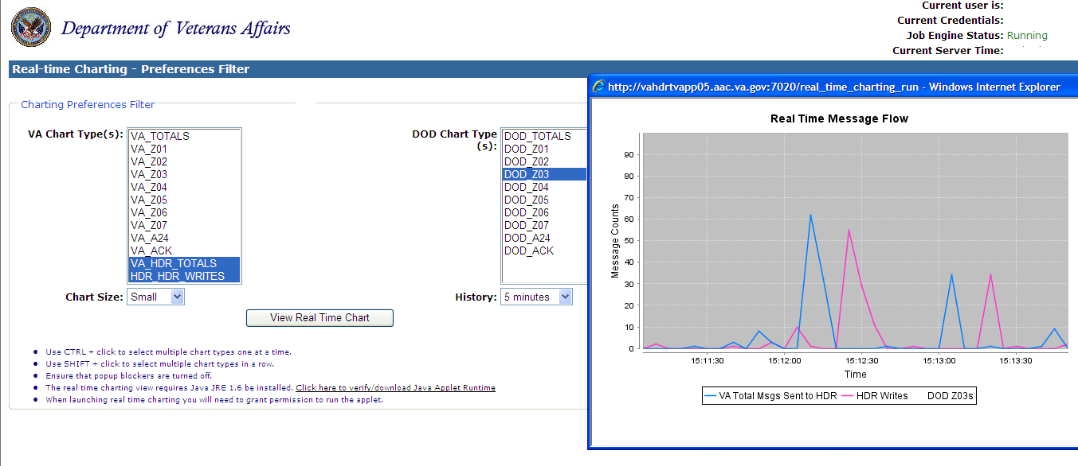
If the VA_HDR_TOTALS are flat lined, the problem is in VA CHDR or CHDR is failing to receive data from V21 or DoD. If VA_HDR_TOTALS is active and HDR_HDR_WRITES are flat lined, the problem is in the HDR or V25 interface engine (or V4, V8, or the future V24).
E-mail AACVIEsupport@va.gov and alert them to the situation.

Verify VA Data is Flowing from VistA to CHDR
VA clinical updates (Z03s) should be arriving regularly, and the V25 interface engine should be online and sending clinical updates from VistA to the CHDR system.
- From the Services menu, select Real-Time Charting. The Real time Charting: Preferences Filter page is displayed.
- Select VA_Z03 from the VA Chart Type(s), and select DoD_Z03 from the DoD Chart Type(s).
- Click the View Real Time Chart button. The Real Time Message Flow window displays the results. The chart below shows a healthy system with regular writes occurring. If this chart shows activity, it confirms that V25 is working and CHDR is processing VistA clinical updates. However, it does not confirm whether V21 picks up the updates and forwards them to DoD.
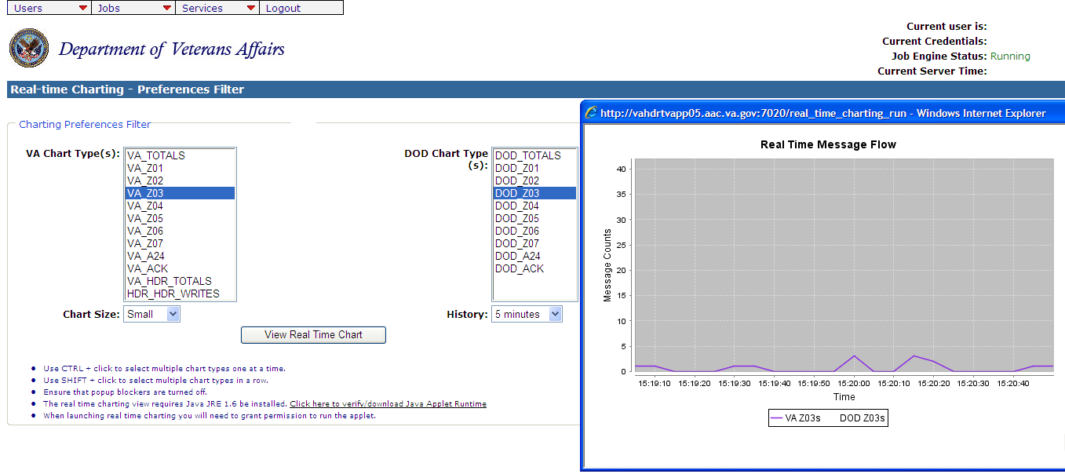
If VA Z03 is flat lined, the problem is with the V25 interface engine.
E-mail AACVIEsupport@va.gov and alert them to the situation.

Glossary

Term/Acronym | Description
ADC | Active Dual Consumer – A veteran receiving health care at both VA and DoD medical facilities. Data is exchanged for only veterans set as active.
AITC | Austin Information Technology Center
CDR | Clinical Data Repository
CHDR | The Clinical Data Repository / Health Data Repository
QUARTZ | A time-based job scheduler used to execute a script or a sequence of scripts executed in order, and run at certain times or dates.
DoD | Department of Defense
ETS | Enterprise Terminology Service that provides an interface for translating codes. The subsystem is expected to reside within the VA CHDR Application Server environment.
Filter | A filter examines certain qualifying criteria requested by the user and then displays the information accordingly.
GUI | Graphical User Interface
HDR | Health Data Repository
HL7 | Health Level 7 message
Job | Jobs that are designed and configured in SHAMU can be scheduled to run via QUARTZ.
Message | Any grouping of information that includes (but not limited to) medical history, patient name, patient identifying number.
MPI | Master Patient Index
Notification Icons | Icons that represent a notification to depict the status of a transaction.
Reports (Results) | The results (data) collected from running a job. The report can be viewed online, or depending on the job credential, may be viewed in an email.
Service | A job that can be run manually as a service.
SHAMU | System Health Alert Monitoring Utility
STS | Standards & Terminology Service (STS) Project
Trackables | Alert (Trackable) – A job that runs regularly throughout the day (every 10 minutes, every 30 minutes, etc.), and fires an alert when something is wrong. Statistics can be tracked between states (green/online or red/offline).
VA | Department of Veterans Affairs, formerly called Veterans Administration
VIE | Vitria Interface Engine - The interface messaging system used within the VA and supports all data exchanged between VA enterprise systems and external systems outside the VA Wide Area Network (VA WAN).

Appendix A – Services/Alert Troubleshooting
Jobs setup as services can also be manually executed at any time to verify traffic flow. Many services are configured to send an alert email to the CHDR support personnel when a service (MPI, VIE, HDR, etc.) status changes from green/up to red/down, and then back up. The table below illustrates the Jobs setup to run as services and action to take for an alert.
Job code | Description | Action
ADC_OVERLAY_CHARTS | This job generates a 7 and a 30 day chart of ADC patients initiated by DoD and includes a success rate line as a percentage as an overlay on the bar graphs. | This is a report. No action needed.
HIST_CHARTING | This is a Java Application allowing the user to generate historical charts of clinical data flow between the VA and DoD for all currently supported message types. | This is a report. No action needed.
HOURLY_BREAKDOWN_  EMAIL | Reports on the daily production email outlining the counts or messages sent and received for the past 24-hour period. | This is a report. No action needed.
MESSAGE_FLOW_RPT_  DAILY | This job runs every morning and sends a report via email to the CHDR team on all of the message traffic for the previous day. | This is a report. No action needed.
MESSAGE_FLOW_RPT_  MONTHLY | This report is generated on the first of every month for the previous month and reports the message traffic flow analysis for the period. | This is a report. No action needed.
MESSAGE_FLOW_RPT_ TODAY | This job reports the message traffic from midnight to the current time, so this is a partial report that will be allowed to be run as a service. | This is a report. No action needed.
MESSAGE_FLOW_RPT_  WEEKLY | This is the weekly breakdown of message traffic and ADC activity for the previous week. This job is scheduled to run every Monday morning in order to pick up the previous week's activity. | This is discussed with the DoD at the weekly interagency meeting.
MONTHLY_ADC | Reports the current ADC patients from VA. Delivered for analysis with DoD data. Sends an email with a comma separated text file attached. | This is discussed with the DoD at the weekly interagency meeting as it occurs.
Z03_SITE_ANALYSIS | This job breaks down the number of clinical updates sent by each individual VA site to the DoD for a given week. This report is scheduled to run each Monday morning for the previous weeks' message traffic. | This is a report. No action needed.

Appendix B – Trackables/Alert Troubleshooting
Trackables are jobs tracked by status change (from green to red, and from red, back to green). The results display the time intervals between status changes. The table below illustrates the Jobs setup to run as trackables and action to take for an alert.
Job code | Description | Action
DOD_ADC_AUTOMATION_HIGH_ALERT | This alert looks at both the number of DoD ADC attempts over the look back period (60 minutes) as well as the agreed upon threshold of ADC attempts over the same period. If the maximum threshold of ADC attempts is exceeded, an alert will fire notifying DoD of the current ADC automation setting. | If RED, number of attempts exceeds maximum threshold.  Notify DOD of the current ADC automation setting.
DOD_ADC_AUTOMATION_LOW_ ALERT | This alert looks at both the minimum number of DoD ADC attempts over the look back period (60 minutes) as well as the agreed upon threshold of ADC attempts over the same period. If the minimum number of ADC attempts is not met an alert will fire notifying DoD of the current ADC automation setting. | If RED, minimum number of attempts is not met.  Notify DOD of the current ADC automation setting.
DOD_BATCH_EXCHANGE_ALERT | This alert ensures that the batch exchange of data between the DoDs ADC automation and the VA is performing as designed. If the DoD is sending at least 20 activation requests in a 30 minute period and the VA responds to at least 10% of those activation requests with a Z06 we will stay green. | Once this alert goes red the response rate must climb to twenty percent to clear. Currently, we believe this alert can be ignored if the TRAFFIC_FLOW_ALERT_VA is red.
DUPLICATION_ALERT | Looks to see if there are duplications of clinical messages from DoD. | If RED, the minimum number of Z04s received exceeds 100, and if duplications are greater than or equal to 60%. To clear to GREEN the duplication rate must fall to 40% or below.  Notify DOD.
EPAGENT_CHECK | Checks the Introscope agent to see if it is currently running. If not, attempts to start it. | This alert sends an email if the epagent is down and immediately attempts to restart it. Thirty minutes later it will check that it successfully restarted the agent and clears the alert.
HDR_ALERT | The alert first checks the count of audited messages sent to the HDR, then verifies the messages write to the HDR.  Alerting Percentage = 20%  Clearing Percentage = 30% | If RED, the percentage of audited messages written into the HDR is below the configured threshold.  - Indicates an issue with VIE25.  - Alert the VIE team.
MPI_ALERT | Checks connectivity with the MPI and is tied to DoD ADC automation. When a Z01 is received from DoD, the MPI is queried (ADT_A24) to determine ADC status.  The count of Z01, Z02, A24, and ACKs are recorded and analyzed to determine if we have connectivity with MPI over the reporting period. | If RED, lost connectivity with the MPI.  Alert the MPI team.
NO_DOD_TRAFFIC | Checks to see if we have received any Z03's or Z04's from the DoD in the last 10 minutes. This job runs every 10 minutes with a 30 minute lookback. | If RED, no DOD traffic is received within the last 10 minutes.  - Check that APP02 is up.  - If confident APP02 is functioning, alert DoD.
NO_Z04_MESSAGES_RECEIVED | Checks to see if any Z04s have been received by the DoD within the past 10 minutes. This alert runs every 10 minutes with a 10 minute lookback. | Does not go RED if we also receive Z03s from DoD. If we are receiving Z03s, but no Z04s, then DoD is requesting information from us, but not replying to VA request for information.  - Notify DOD.  - Currently email staff at DoD
TRAFFIC_FLOW_ALERT_  DOD | Looks at message traffic for all handshakes for messages initiated by the DoD. When DoD sends a Z01 we analyze the Z02 response, etc. This alert looks at the counts of messages sent and received and includes configurations for each handshake. | If RED, the minimums are not met or response rate is below the configured setting for the message pairs.  - Indicates an issue with VIE21 (inbound/outbound).  - If VIE21 is fine, notify DISA (mon-mhsunix@csd.disa.mil
TRAFFIC_FLOW_ALERT_  VA | Looks at message traffic for all handshakes for messages initiated by the VA. When VA sends a Z01 to DoD we analyze the Z02 response, etc. This alert looks at the counts of messages sent and received and includes configurations for each handshake. | If RED, the minimums are not met or response rate is below the configured setting for the message pairs.  - Check VIE21.  - If VIE21 is fine, notify DISA (mon-mhsunix@csd.disa.mil).
VISTA_ALERT | Checks for clinical messages (Z03s) sent from VA to DoD over the reporting period. | If RED, if we are below the configured low water mark and the last reported Z03 is recorded in the job result.
Z03_Z04_FREQ_TRAFFIC_  CHECK | Z03 / Z04 correlation traffic check. This job has a shorter lookback and checks for VA Z03 sent and Z04 responses received during the last 10 minutes.  This alert also validates that at least one Z03 / Z04 pair correlated. | If RED, it could indicate a traffic flow problem. It could also indicate a problem with the correlation of messages.  Rely on the other alerts for traffic flow issues to determine next step.

Appendix C – Example: Hourly Breakdown E-Mail Report
The following illustrates the results sent by email for an HOURLY_BREAKDOWN_
EMAIL job executed manually to verify traffic flow.

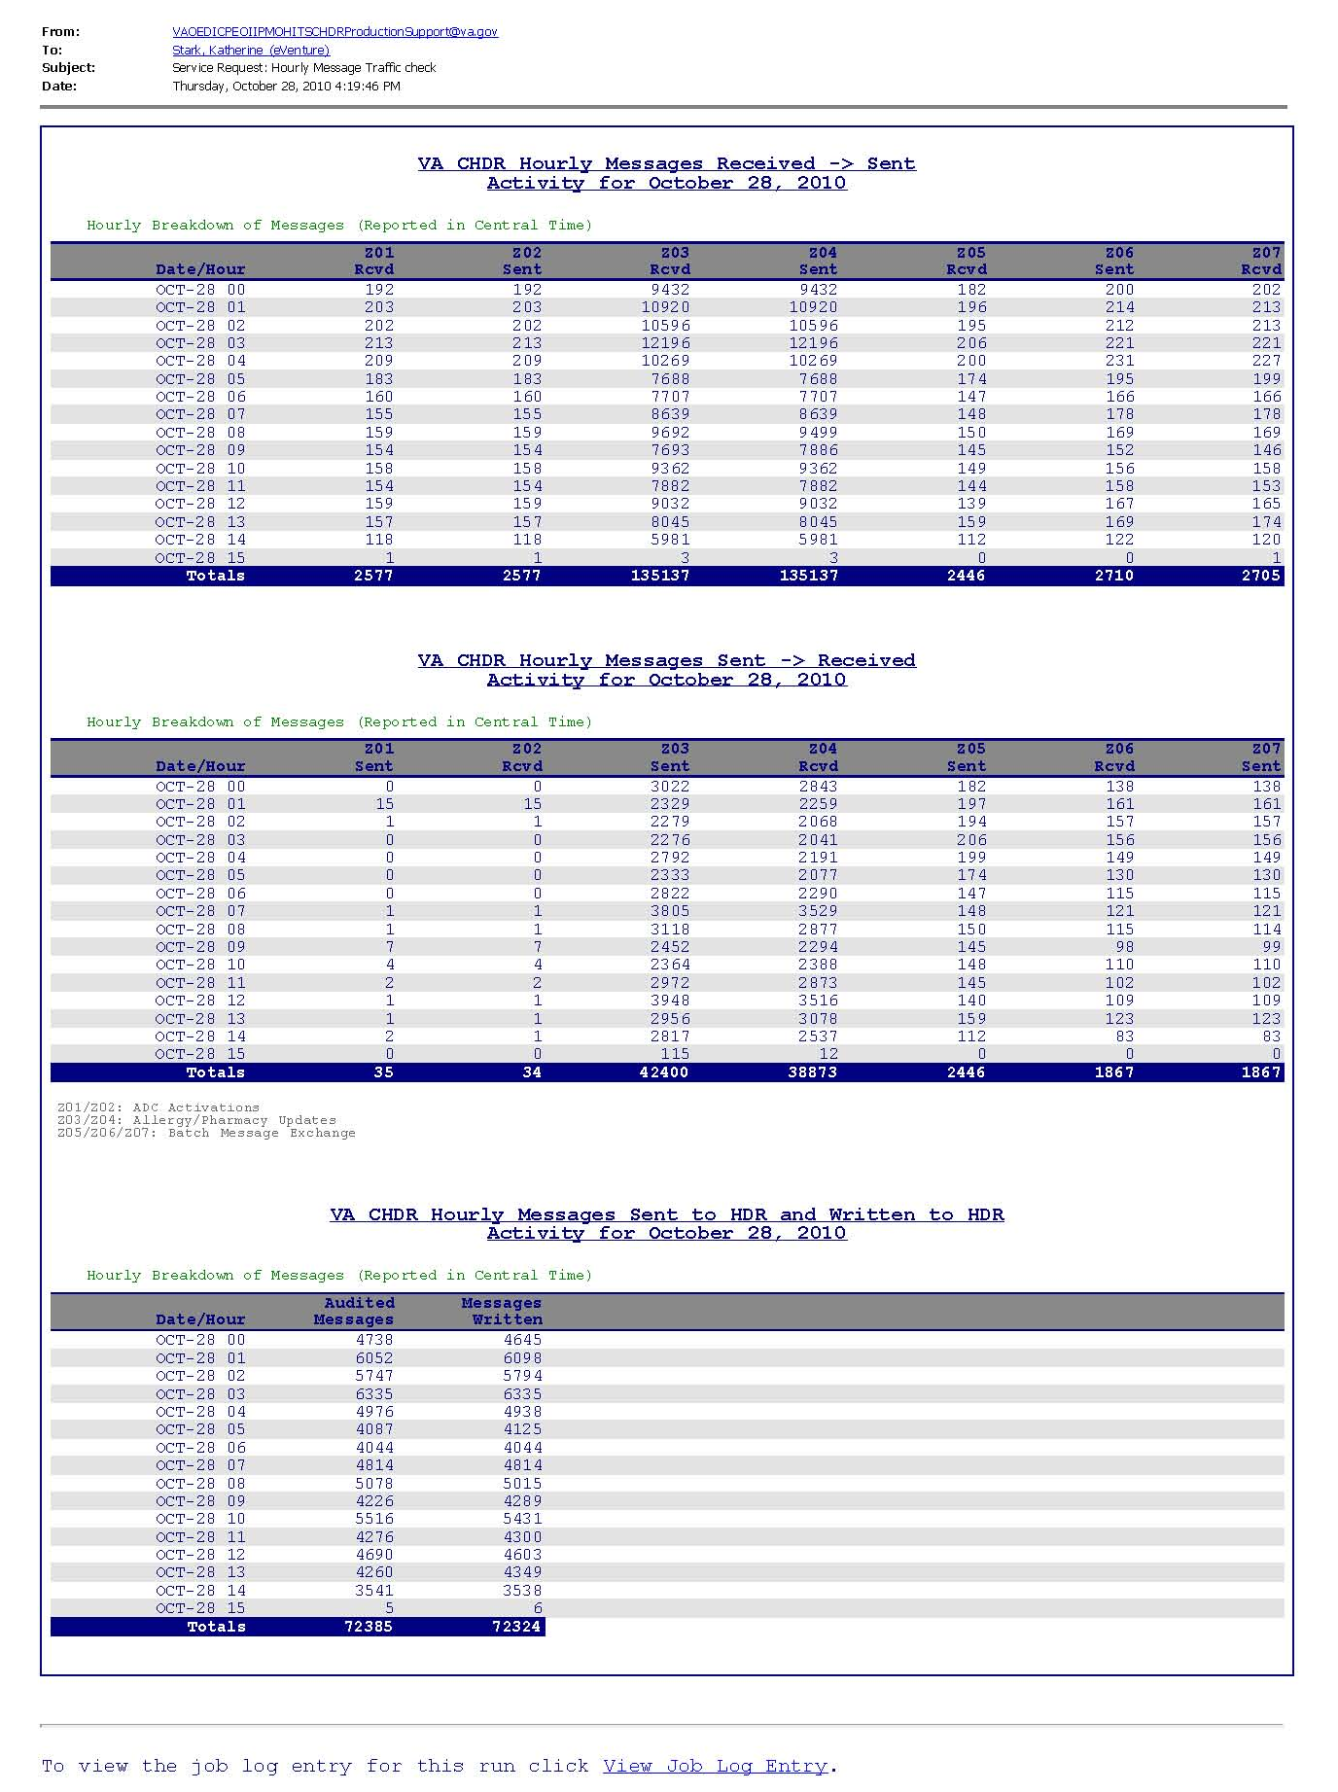

Appendix C – Starting SHAMU
The SHAMU start procedures included in this section are for the CHDR support team, and while the SHAMU application resides on App05. Eventually AITC will take ownership, after the replay services complete. At that point theses instructions will be obsolete, as Raja at AITC will know how to start the application, and not the CHDR support team.
To Start SHAMU:
- Log into App05 via (make the purple string be your App05 id):
ssh t192zcs@vahdrtvapp05.aac.va.gov
- After logging in sudo as WebLogic as so. (If your ID cannot do this contact a UNIX admin and have them add this role to your ID) via:
sudo su - weblogic
- Enter your regular password; cd into the following directory via:
cd /u01/app/domains/shamu
- Start WebLogic via:
nohup startWebLogic.sh &
- Watch WebLogic come up via:
tail –f nohup.out
- When you see a message similar to the one shown below you are up!:
<Apr 24, 2013 8:55:32 AM CDT> <Notice> <WebLogicServer> <BEA-000360> <Server started in RUNNING mode>
- Go to the WebLogic console here:
http://vahdrtvapp05.aac.va.gov:7010/console/console.portal?_nfpb=true&_pageLabel=HomePage1
shamu weblogic credentials are login id = weblogic pw = shamuwls1
- Go to the deployments section and start the application called ‘PSTDashboard’ as this is SHAMU (PST = Production Support Team).
- Hit SHAMU’s url:
http://vahdrtvapp05.aac.va.gov:7011/
- Login and start the job engine via Set Job Credentials under the Administration menu. You must have an ID to the CHDR audit log.
The list of people that can do this final step (that I know of) are Cris Shupp, Greg Bowman, and Joe Valentine.

Index

A
Access SHAMU, 12
Administrator Functions, 19
Editing a Job, 21
Job Schedules, 26
List Users, 19
Service Settings, 22
Set Job Credentials, 20
Stop Job Engine, 20
Track Status Changes, 23
trackable job information, 23
Alerts
DoD ADC Automation High GREEN Alert, 16
DUPLICATION_ALERT, 43
HDR Alert Yellow, 16
HDR_ALERT, 44
MPI Alert GREEN, 17
MPI_ALERT, 44
NO_DOD_TRAFFIC, 44
TRAFFIC_FLOW_ALERT_DOD, 44
TRAFFIC_FLOW_ALERT_VA, 45
VISTA_ALERT, 45
Z03 Z04 Freq Traffic Check Alert, 15
Z03_Z04_FREQ_TRAFFIC_CHECK, 45
B
Basic End-User Functions, 12
Basic User Functions
Edit User Information, 13
Login to SHAMU, 12
Logout, 13
View Job Log, 14
View Trackables, 15
Basic User Functions
Access SHAMU, 12
Basic User Functions
Sign Up, 13
C
QUARTZ, 7, 26
D
Data Flow
Clinical Updates, 38
DoD ADC Automation High GREEN Alert, 16
DoD to HDR, 39
HDR Alert YELLOW, 16
HDR Writes, 39
HL7 Messages, 6
Interface Engines, 39, 40
MPI Alert, 17
Receiving DoD Data, 38
VistA to CHDR, 40
Z03 Messages, 39
Z03 Z04 Freq Traffic Check Alert, 15
Z03Messages, 38
Z-Messages, 6
Document Conventions, 5
E
Edit Job Schedule, 26
Edit User Information, 13
Editing a Job, 21
E-Mail Job Results, 22, 25
End User Functions
Execute job maually, 18
View Services Listing, 18
Example
DoD ADC Automation High GREEN Alert, 16
HDR Alert YELLOW, 16
MPI Alert GREEN, 17
Z03 Z04 Freq Traffic Check Alert, 15
Example: Hourly Breakdown E-Mail Report, 46
Execute a job manually, 18
Execute a service, 18
G
Glossary, 41
H
HDR_WRITES, 39
Health Level 7 (HL7) message, 6
Historical Charting, 7
Historical Charts
Filter Criteria, 28
View Historical Charts, 28
I
Icons
Active Job, 11
Email Alert/Report, 11
Email Alert/Report Results, 10
Gears, 11
Green Alert, 10
Inactive Job, 11
Introscope Enabled, 11
Job Failed, 10
Red Alert, 10
Trackable Job, 11
Introscope Settings, 24
J
Job Credentials, 20
Job Description, 22
Job Listing, 21
Job Listing Legend, 11
Job Log/Services
Trackables, 15
View Job Log, 14
Job Metadata, 21
Job Schedules, 26
Edit Schedule, 26
Job Status Legend, 10
Jobs
Active, 11
Alerts, 7
Edit Schedule, 26
Email Alert/Report, 11
E-Mail Job Results, 22, 25
Inactive, 11
Job Description, 22
Max Execution Time, 22, 25
MetaData, 21
MPI Alert GREEN Example, 17
Report/Results, 7
Schedules, 26
Service Settings, 22
Services, 9, 18
Stop Job Engine, 20
Trackables, 7
Jobs Menu
Job Listing, 21
Set Job Credentials, 20
Stop Job Engine, 20
Jobs/Services, 7
L
List Users, 19
Login to SHAMU, 12
Logout, 13
M
Manually run a job, 18
Max Execution Time, 22
MPI Alert, 17
P
Page Navigation, 11
Partner Products/Services, 4
CDS, 4
CPRS, 4
ETS, 4
HDR, 4
Master Patient Index (MPI), 4
VIE, 4
VistAWeb, 4
R
Real Time Charting, 7
Real-time Charting
HDR writes, 39
Verify DoD data sored in HDR, 39
Real-Time Charting, 27, 38
Java Requirements, 27
Verify VA Data Flow from VistA to CHDR, 40
Verify VA is Receiving DoD Data, 38
Report (Results), 7
Reports
HOURLY_BREAKDOWN_EMAIL, 42
MONTHLY_ADC, 42
S
Scheduling Jobs, 26
Seed Job Engine, 20
Service Settings, 22
Services, 7
Services, 9
Services Listing, 18
Services/Alert Troubleshooting, 42
Set Job Credentials, 20
SHAMU Basics, 6
Job Legend/Status, 10
Job Listing Legend, 11
Jobs/Services, 7
Menu Options, 6
Page Navigation, 11
Services, 9
Trackables, 7
SHAMU Monitoring, 4
Sign Up, 13
Stop Job Engine, 20
T
Track Status Changes, 23
trackable job information fields, 23
Trackables, 7
DoD ADC Automation High Alert, 16
HDR Alert YELLOW, 16
MPI Alert, 17
Z03 Z04 Freq Traffic Check Alert, 15
Trackables/Alert Troubleshooting, 43
V
VA Data Flow from VistA to CHDR, 40
VA HDR, 39
Verify VA is Receiving DoD Data, 38
View Historical Charts, 27, 28
View Job Log, 14
View Services Listing, 18
View Trackables, 15
VistA Clinical Updates, 40
VistA to the CHDR system, 40

