CHDR Real Time Charting
Once an AITC Admin has determined VA CHDR is operational from a hardware perspective, the real-time chart steps below will help determine if data is flowing correctly and help pinpoint potential causes for lack of data flow:
- Check whether VA is receiving DoD data: Although DoD can send a variety of messages and responses to VA, the Z03 clinical update message is the best indication of whether DoD is sending data. Clinical updates should be arriving at all times. If this chart if flatlined, that indicates either that (1) DoD is down an unable to send updates or (2) the V21 interface engine is paused or down and is failing to forward DoD updates to VA CHDR.
Example: User selects DoD_Z03 to chart and hides any other selections. The chart below shows a healthy system with regular DoD clinical updates (Z03s) arriving:
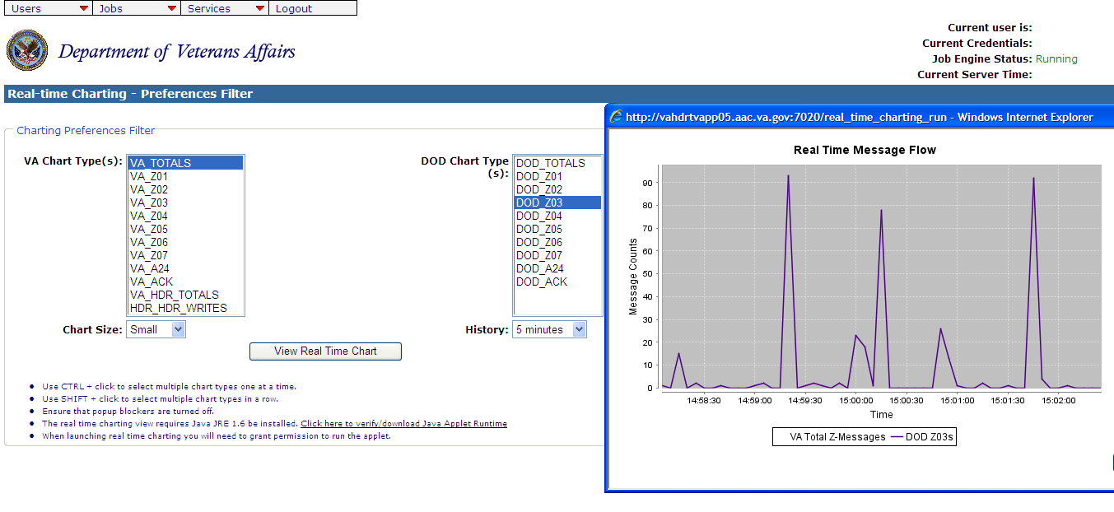

- Check whether DoD data is being stored into HDR: Use the VA_HDR_TOTALS and HDR_HDR_WRITES charts to verify whether data is being stored into HDR. The VA_HDR_TOTALS chart shows the messages VA CHDR is putting on the outbound queue to go to HDR. The HDR_HDR_WRITES shows the messages HDR indicates it has written to the database. These chart lines should both be active. If the VA_HDR_TOTALS is flatlined then the problem is in VA CHDR or CHDR is failing to receive data from V21 or DoD. If VA_HDR_TOTALS is active but HDR_HDR_WRITES is flatlined, that indicates a problem with the V25 interface engine (or v4, v8, or the future v24) or the HDR itself.
Example: User selects VA_HDR_TOTALS and HDR_HDR_WRITES and hides any other selections. The chart below shows a healthy system with regular writes occurring:
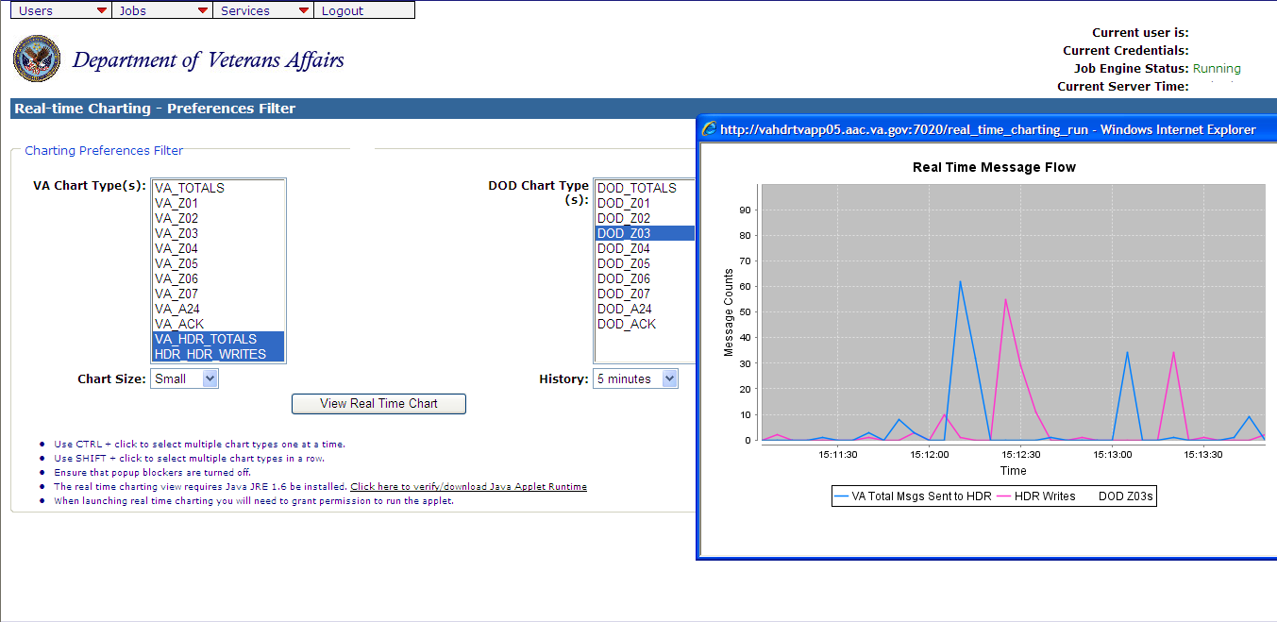
- Check whether VA data is flowing from Vista to CHDR: Use the VA_Z03 chart to verify whether data is flowing from Vista to CHDR. VA clinical updates (Z03s) should be regularly arriving. If this chart shows activity, it confirms that V25 is working and that CHDR is processing Vista clinical updates but does not confirm whether V21 picks up the updates and forwards them to DoD. If VA_Z03 is flatlined, that indicates a problem with the V25 interface engine.
Example: User selects VA_Z03 and hides any other selections. The chart below shows a healthy system with regular writes occurring:
