1. I used the code q1.py from <https://github.com/rcond002/cs532-s16/blob/master/Assignment10/Question1/A10Q1.py> with the input blogdata1.py. This was the result:

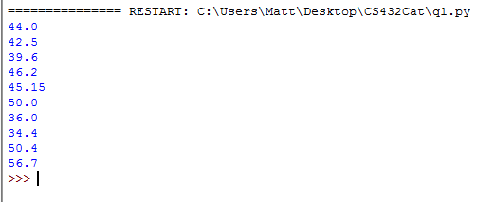

3. I used the codes twitter_part2.py and twitter_part3.py from Gabriel Marquez to gain the new memento numbers using a recovered version of my twitterLinks.txt. The original table is available in my Assignment 2 report but here is a copy:

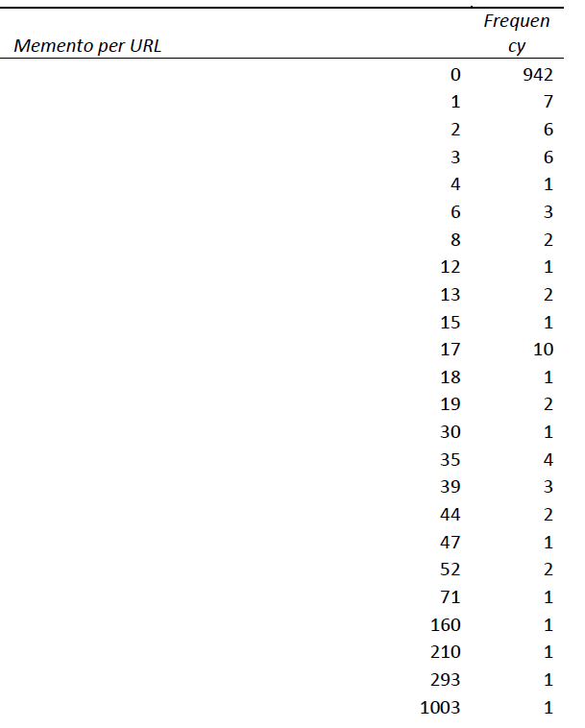

Here is the new table:

|  |  |
| --- | --- |
| Mementos per URL | Frequency |
| 0 | 963 |
| 1 | 10 |
| 2 | 1 |
| 3 | 2 |
| 9 | 1 |
| 13 | 1 |
| 15 | 1 |
| 16 | 2 |
| 17 | 5 |
| 19 | 3 |
| 27 | 1 |
| 35 | 1 |
| 37 | 1 |
| 44 | 1 |
| 47 | 1 |
| 52 | 1 |
| 71 | 1 |
| 160 | 1 |
| 227 | 1 |
| 293 | 1 |
| 1003 | 1 |

Here is the difference:

|  |  |
| --- | --- |
|  | Difference |
| 0 | 21 |
| 1 | 3 |
| 2 | -5 |
| 3 | -4 |
| 4 | -1 |
| 6 | -3 |
| 8 | -2 |
| 12 | -1 |
| 13 | -1 |
| 15 | 0 |
| 16 | 2 |
| 17 | -5 |
| 18 | -1 |
| 19 | 1 |
| 27 | 1 |
| 30 | -1 |
| 44 | -1 |
| 47 | 0 |
| 52 | -1 |
| 71 | 0 |
| 160 | 0 |
| 210 | -1 |
| 227 | 1 |
| 293 | 0 |
| 1003 | 0 |