1. I used a code from a friend of mine named Gabriel Marquez to parse the data. I entered this data into Excel and made a graph and the necessary calculations. The file is called “AS4p1.py”.

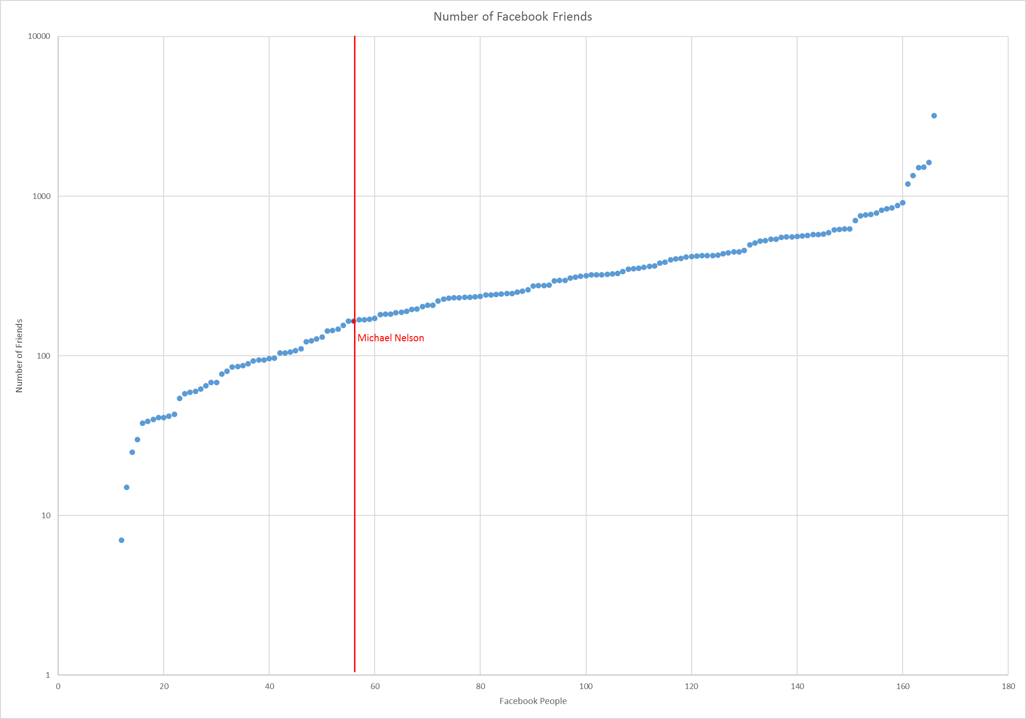

Michael Nelson is labeled on the lower end of the list, and is lower than all three calculated values, proving the friendship paradox true for him.

1. I used a set of codes developed by Kevin Clemmons called “twitter_config.json” and “twitter_friend_data.py” to extract the twitter data for Michael Nelson’s twitter followers. This code was not able to extract every follower’s followers, but nothing could as a result of restrictions. For the 182 followers whose data was extracted, I inputted the data into excel for calculations and a graph.

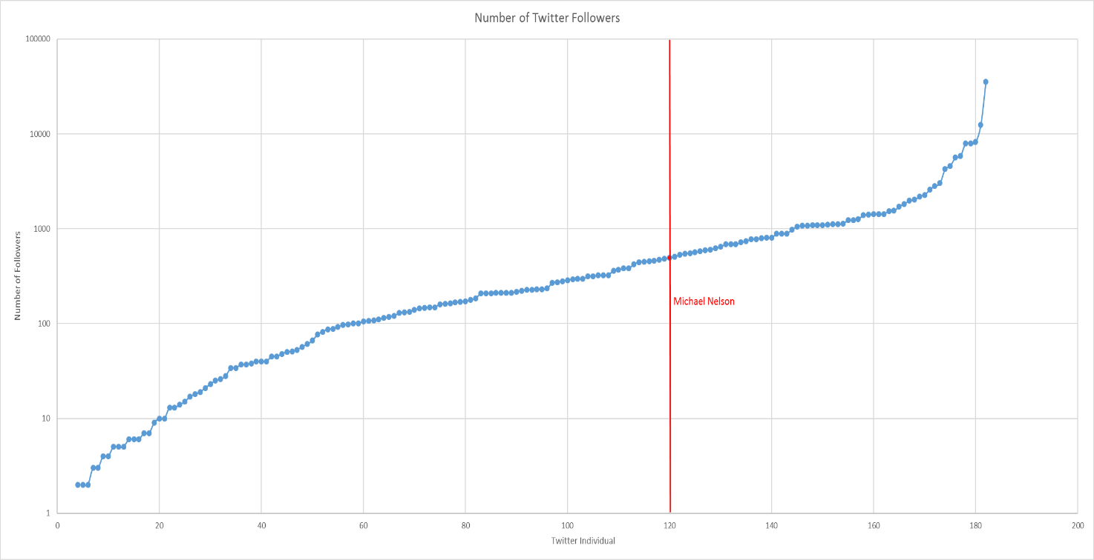

Michael Nelson is labeled in the higher end of the list, though has a lower number of followers then average as a result of some really high follower numbers for a few specific followers of his. While the friendship paradox technically holds true here because the average number of followers for his friends is higher than him, he still has more followers than most of his followers.