Catherine Nguyen

CS 432

Assignment #5

March 3, 2016

The source code that created the graphs and calculations were by Mohammed Aturban and was obtained from <https://github.com/maturban/cs595f13/blob/master/assignment9/latex/Mohamed_Aturban_Assignment_9.tex> with a gml file by Mark Newman. It uses divisive method of group partitioning.

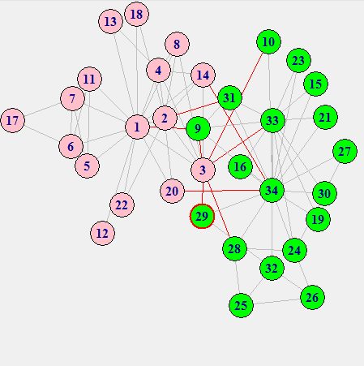The initial set is as followed:

Lines show the relationships between member and red lines indicate relationships between members who are going to be split apart.

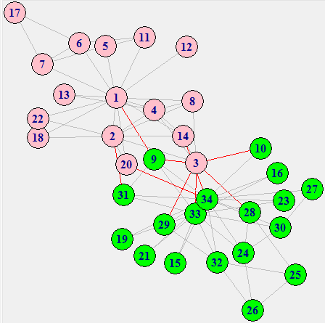

In order to group partitioning, the weakest bridge, between 1 and 3, is removed. Member 3 has a stronger relationship with other members than with Member 1.

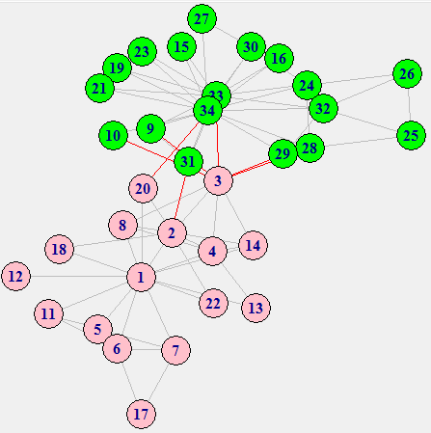

The local bridge between 14 and 34 is removed. Member 34 has a very strong connection to its side and not with Member 14.

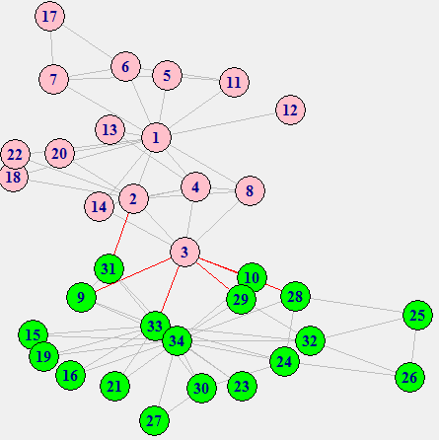

The local bridge between 34 and 20 is removed next for the same reason as the prior one.

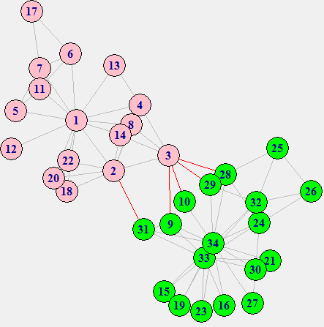

The local bridge between 33 and 3 is removed next. Member 33 has the strongest connection out of all the members that have local bridges.

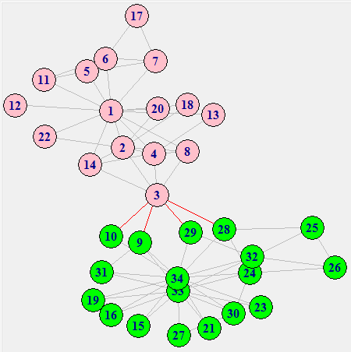

The local bridge between 2 and 31 is removed. Member 3 will be the bridging member of the group.

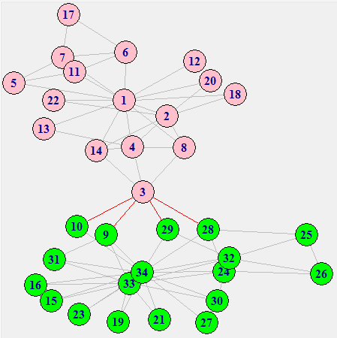

The local bridge between 2 and 3 is removed.

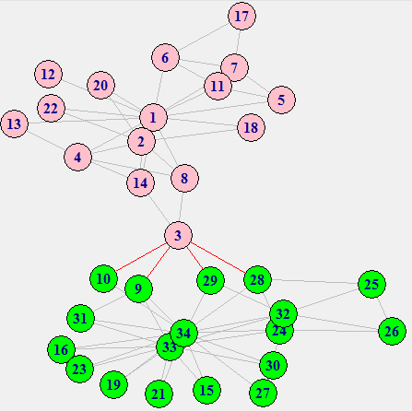

The local bridge between 3 and 4 is removed.

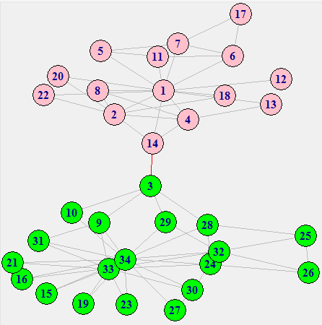

The local bridge between 3 and 8 is removed.

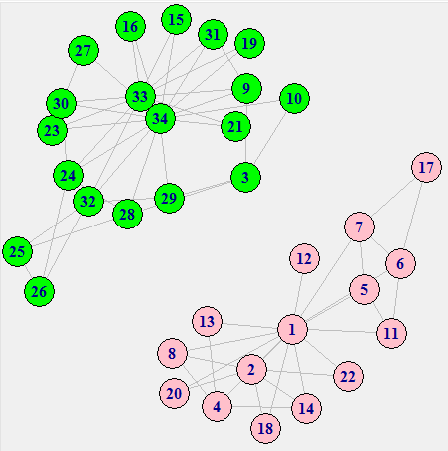

The split is finally completed when the bridge relationship between 3 and 14 is removed. This is the final computed split.

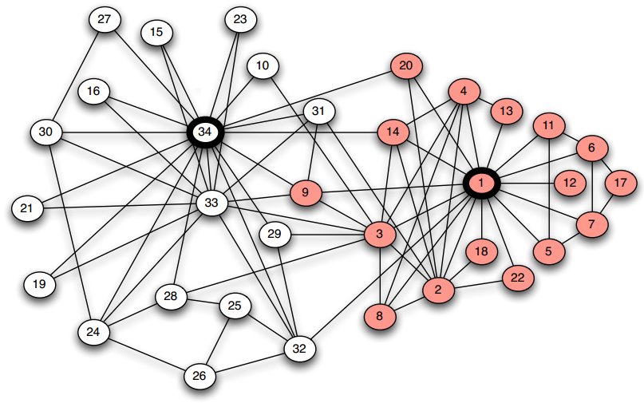

The white and red represent the two groups that they end up being split into. Members 3 and 9 were not correctly predicted to have split correctly. This leaves the results 32/34 = 94.12% accurate, which is fairly close.

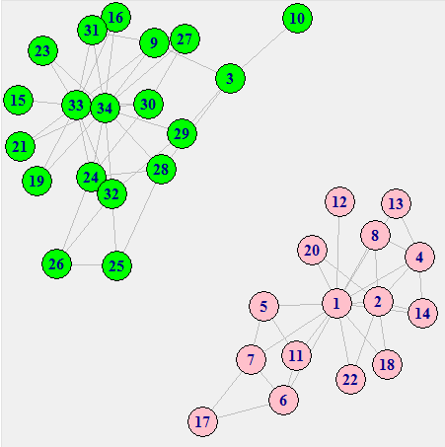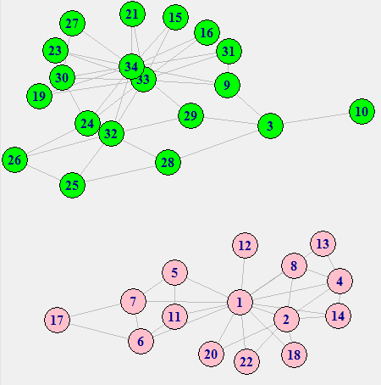Respectfully, this a step by step 3-Split:

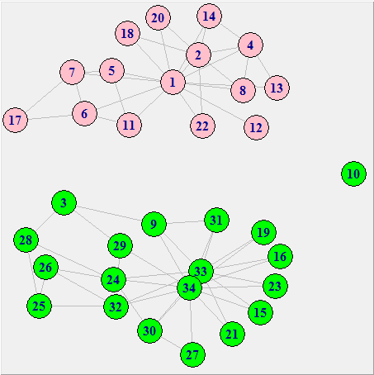

A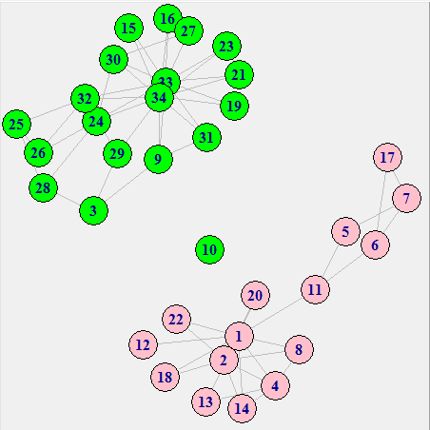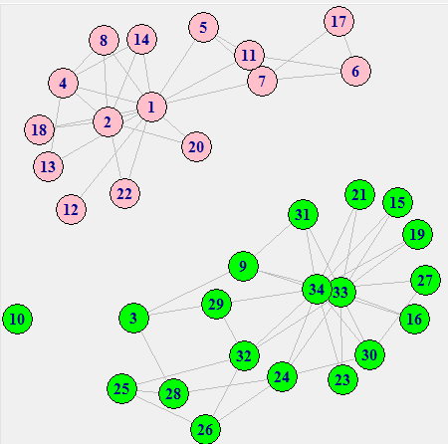 step-by-step of a 4-Split:

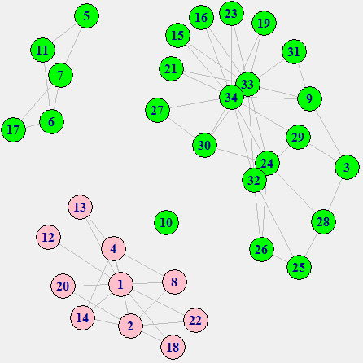

Step-by-step 5-split:

