1. A script from <http://bl.ocks.org/d3noob/5141278> is used and data collected by Kevin Clemmons was used to create my graph due to the smaller follower number. The files for this are called “Htmlgraph.html” and “Force.csv”. They are both placed inside the d3 program folder and will only work properly on the Firefox browser.

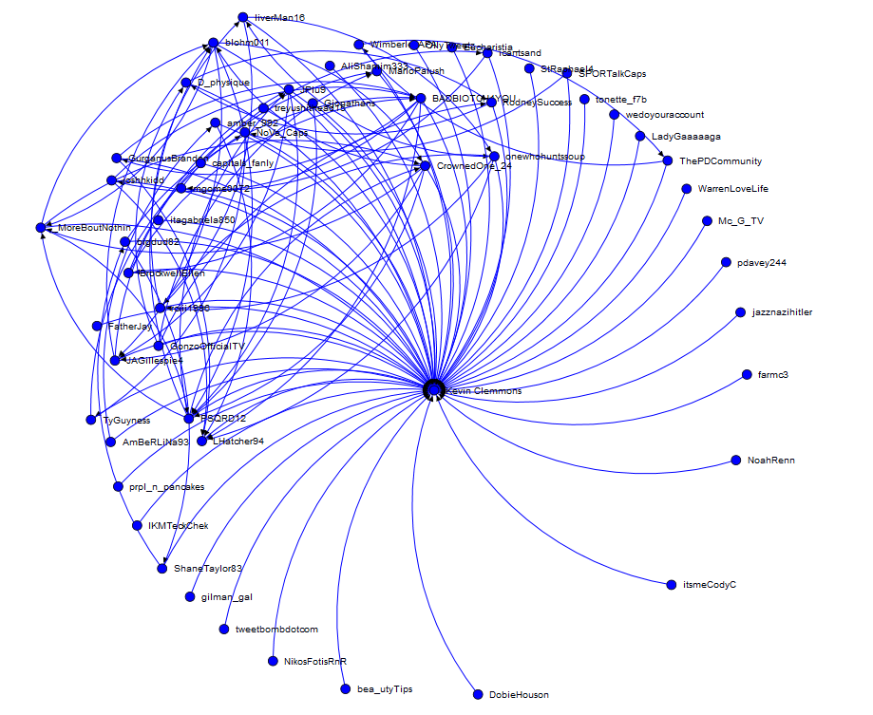

1. “Htmlgraph.html” is used to create the graph, but a small modification is made to use Kevin Clemmons data for those that had a gender called “kevin_gender_network.csv”, this was renamed “gender_graph.html”. The gender information was determined using a script Kevin Clemmons developed called “get_user_genders.py” which is in the ZIP folder “gender_network”. The resulting data is created into an excel spreadsheet named “Gender.xlsx”, which was created by Matthew Payne.



