1. For the first part, a set of codes developed by Kevin Clemmons called **data_extractor.py** and **substitute_you.py** were used to create the resulting information below.

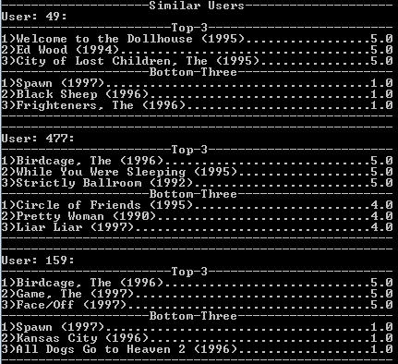

The data used entered into the code were my name ( “Catherine”), my age (“23”), my gender (“F”), and my occupation “student”. User 159 was used as my substitute because I could recognize most of their choices. (Note: I have not watched a lot of movies and do not have an opinion one way or another on these choices.)

1. Another modified code developed by Kevin Clemmons called **correlation.py** was used to find users correlating the most and least with User 159, and these were the results:

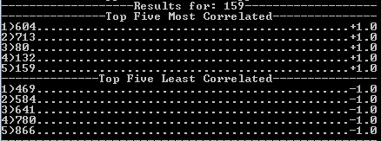

1. A modified code developed by Chevelle Taylor-Sakyi called **rate.py** found the movies that would be best and worst recommended for User 159.

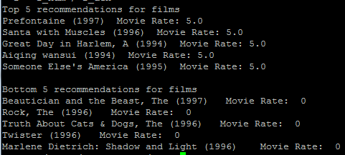

1. I chose “Men in Black” as my favorite, and “The Flinstones” as my least favorite. Another modified code developed by Chevelle Taylor-Sakyi called **like.py** was used to generate a list of correlating movies.

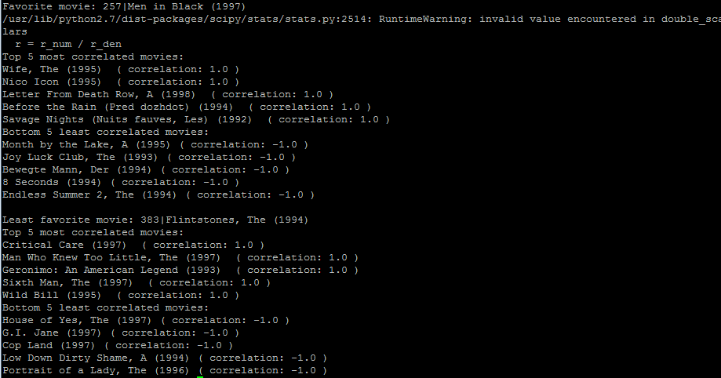

I, once again, am not a film aficionado by any means, and must say I do not know any of the titles listed off on this list. I cannot really say in one way or another if these movies are similar or not to the ones I have chosen.