CS532 Assignment 1

1.

The curl POST command:

curl --data "user=Catherine&message=What the absolute frick, man." http://webscience.zzstack.com/send_simpleform.php

The resulting response:

<!DOCTYPE html>

<html>

<script type="text/javascript">window.NREUM||(NREUM={}),__nr_require=function(e, n,t){function r(t){if(!n[t]){var o=n[t]={exports:{}};e[t][0].call(o.exports,func tion(n){var o=e[t][1][n];return r(o||n)},o,o.exports)}return n[t].exports}if("fu nction"==typeof __nr_require)return __nr_require;for(var o=0;o<t.length;o++)r(t[ o]);return r}({QJf3ax:[function(e,n){function t(e){function n(n,t,a){e&&e(n,t,a) ,a||(a={});for(var u=c(n),f=u.length,s=i(a,o,r),p=0;f>p;p++)u[p].apply(s,t);retu rn s}function a(e,n){f[e]=c(e).concat(n)}function c(e){return f[e]||[]}function u(){return t(n)}var f={};return{on:a,emit:n,create:u,listeners:c,_events:f}}func tion r(){return{}}var o="nr@context",i=e("gos");n.exports=t()},{gos:"7eSDFh"}],e e:[function(e,n){n.exports=e("QJf3ax")},{}],3:[function(e,n){function t(e){retur n function(){r(e,[(new Date).getTime()].concat(i(arguments)))}}var r=e("handle") ,o=e(1),i=e(2);"undefined"==typeof window.newrelic&&(newrelic=window.NREUM);var a=["setPageViewName","addPageAction","setCustomAttribute","finished","addToTrace ","inlineHit","noticeError"];o(a,function(e,n){window.NREUM[n]=t("api-"+n)}),n.e xports=window.NREUM},{1:12,2:13,handle:"D5DuLP"}],gos:[function(e,n){n.exports=e ("7eSDFh")},{}],"7eSDFh":[function(e,n){function t(e,n,t){if(r.call(e,n))return e[n];var o=t();if(Object.defineProperty&&Object.keys)try{return Object.definePro perty(e,n,{value:o,writable:!0,enumerable:!1}),o}catch(i){}return e[n]=o,o}var r =Object.prototype.hasOwnProperty;n.exports=t},{}],D5DuLP:[function(e,n){function t(e,n,t){return r.listeners(e).length?r.emit(e,n,t):void(r.q&&(r.q[e]||(r.q[e]= []),r.q[e].push(n)))}var r=e("ee").create();n.exports=t,t.ee=r,r.q={}},{ee:"QJf3 ax"}],handle:[function(e,n){n.exports=e("D5DuLP")},{}],XL7HBI:[function(e,n){fun ction t(e){var n=typeof e;return!e||"object"!==n&&"function"!==n?-1:e===window?0 :i(e,o,function(){return r++})}var r=1,o="nr@id",i=e("gos");n.exports=t},{gos:"7 eSDFh"}],id:[function(e,n){n.exports=e("XL7HBI")},{}],G9z0Bl:[function(e,n){func tion t(){var e=d.info=NREUM.info,n=f.getElementsByTagName("script")[0];if(e&&e.l icenseKey&&e.applicationID&&n){c(p,function(n,t){n in e||(e[n]=t)});var t="https "===s.split(":")[0]||e.sslForHttp;d.proto=t?"https://":"http://",a("mark",["onlo ad",i()]);var r=f.createElement("script");r.src=d.proto+e.agent,n.parentNode.ins ertBefore(r,n)}}function r(){"complete"===f.readyState&&o()}function o(){a("mark ",["domContent",i()])}function i(){return(new Date).getTime()}var a=e("handle"), c=e(1),u=window,f=u.document;e(2);var s=(""+location).split("?")[0],p={beacon:"b am.nr-data.net",errorBeacon:"bam.nr-data.net",agent:"js-agent.newrelic.com/nr-76 8.min.js"},d=n.exports={offset:i(),origin:s,features:{}};f.addEventListener?(f.a ddEventListener("DOMContentLoaded",o,!1),u.addEventListener("load",t,!1)):(f.att achEvent("onreadystatechange",r),u.attachEvent("onload",t)),a("mark",["firstbyte ",i()])},{1:12,2:3,handle:"D5DuLP"}],loader:[function(e,n){n.exports=e("G9z0Bl") },{}],12:[function(e,n){function t(e,n){var t=[],o="",i=0;for(o in e)r.call(e,o) &&(t[i]=n(o,e[o]),i+=1);return t}var r=Object.prototype.hasOwnProperty;n.exports =t},{}],13:[function(e,n){function t(e,n,t){n||(n=0),"undefined"==typeof t&&(t=e ?e.length:0);for(var r=-1,o=t-n||0,i=Array(0>o?0:o);++r<o;)i[r]=e[n+r];return i} n.exports=t},{}]},{},["G9z0Bl"]);</script><body>

Welcome, Catherine</p>Your message was: What the absolute frick, man.</p>Thanks for using this thing!</p>

<a href="Something.php">Return to form</a></p>

<a href=".">Return to home page</a>

<script type="text/javascript">window.NREUM||(NREUM={});NREUM.info={"beacon":"ba m.nr-data.net","licenseKey":"e0f44c4154","applicationID":"7711156","transactionN ame":"ZFRSYkADWEFVBhZeWF0eZURbTUVXWgE9RF5eQVxTVA1EXxoVCkc=","queueTime":0,"appli cationTime":0,"atts":"SBNRFAgZS08=","errorBeacon":"bam.nr-data.net","agent":"js- agent.newrelic.com\/nr-768.min.js"}</script></body>

</html>

Screenshot:

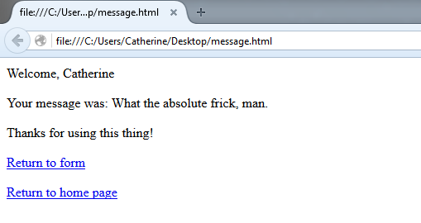

2. The code is located in a separate file uploaded titled “CS532_Assignment1” and was coded collaboratively between myself, Gabriel Marquez, and Matthew Payne. The libraries used were:

* + Urllib2
  + BeautifulSoup
  + SSL
  + Requests (<https://github.com/kennethreitz/requests>)

The results of the three test sites:

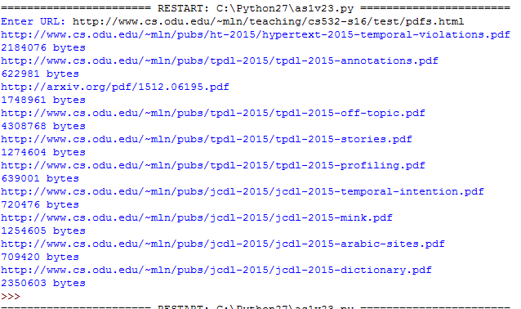

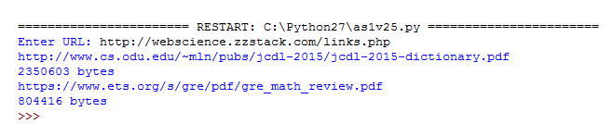



(There are no PDFS at all for this website, so this is the correct output.)

3.

IN: M, I, O, P

SCC: A, B, C, G

OUT: D, H

Tendrils: I, J, K

Tubes: N

Disconnected: E, F