Jobing Subsystem

# ERD for Jobing Subsystem

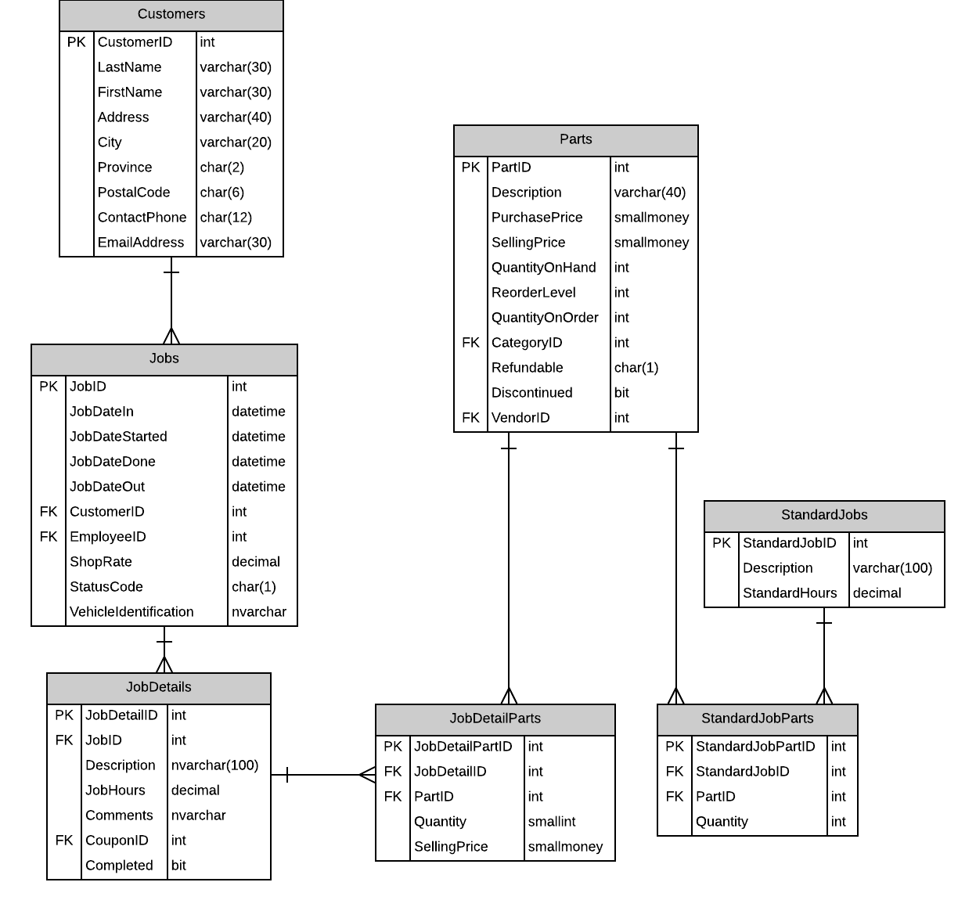

# Possible Jobing Interface

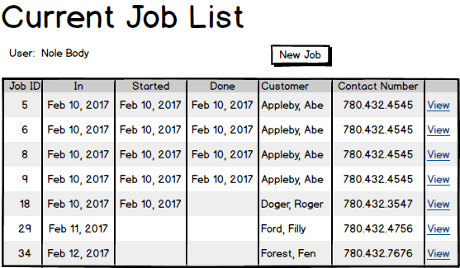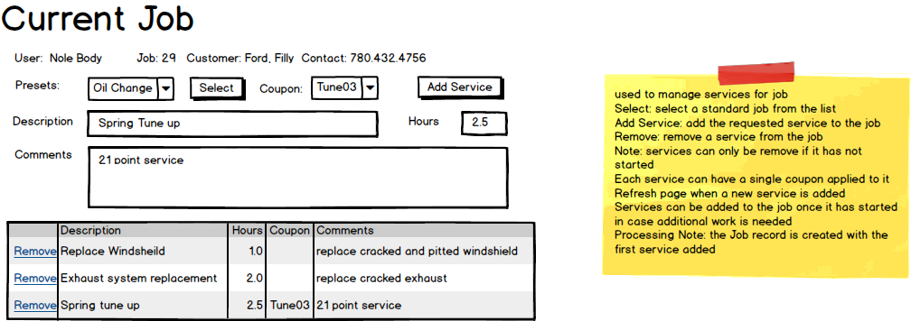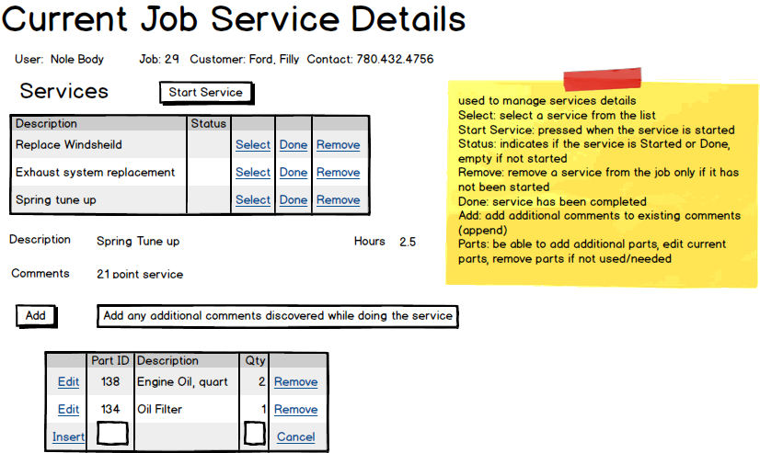

|  |  |  |
| --- | --- | --- |
| **Controls** | | **Events** |
| JobListListView | | None / Wired via ODS |
| **BBL Class(es) and Method (s)** | | |
| JobController | List<CurrentJob> List_CurrentJobs()  Retrieve a list of current jobs and job id for ListView | |
| **SQL Table(s): (C,R,U,D)** | | **Entities/DTOs/POCOs** |
| Jobs, Customer (R) | | CurrentJob (P) |

# Event and Wiring Summations

|  |  |  |
| --- | --- | --- |
| **Controls** | | **Events** |
| NewJobButton | | OnClick |
| **BBL Class(es) and Method (s)** | | |
| JobController | Void Add_Job(Job job)  Add a new job to the current job list. | |
| **SQL Table(s): (C,R,U,D)** | | **Entities/DTOs/POCOs** |
| Jobs (C) | | Job (E) |

|  |  |  |
| --- | --- | --- |
| **Controls** | | **Events** |
| PresetDropdownList | | None / Wired via ODS |
| **BBL Class(es) and Method (s)** | | |
| StandardJobController | Void List_Presets()  Retrieve a list of all standard jobs to fill the Preset Dropdown List. | |
| **SQL Table(s): (C,R,U,D)** | | **Entities/DTOs/POCOs** |
| StandardJobs (R) | | StandardJob (E) |

|  |  |  |
| --- | --- | --- |
| **Controls** | | **Events** |
| PresetButton | | OnClick |
| **BBL Class(es) and Method (s)** | | |
| StandardJobController | Void Select_Preset()  Retrieve information for the standard job and populate the Description and Hours with the information. | |
| **SQL Table(s): (C,R,U,D)** | | **Entities/DTOs/POCOs** |
| StandardJobs (R) | | StandardJob (E) |

|  |  |  |
| --- | --- | --- |
| **Controls** | | **Events** |
| CouponDropdownList | | None / Wired via ODS |
| **BBL Class(es) and Method (s)** | | |
| CouponController | Void List_Coupons()  Retrieve a list of all Coupons to fill the Coupon Dropdown List. | |
| **SQL Table(s): (C,R,U,D)** | | **Entities/DTOs/POCOs** |
| Coupons (R) | | Coupon (E) |

|  |  |  |
| --- | --- | --- |
| **Controls** | | **Events** |
| AddServiceButton | | AddServiceClicked |
| **BBL Class(es) and Method (s)** | | |
| JobDetailController | Void Add_Service(JobDetail service)  Adds a service to the current job. | |
| **SQL Table(s): (C,R,U,D)** | | **Entities/DTOs/POCOs** |
| JobDetails (C) | | JobDetail (E) |

|  |  |  |
| --- | --- | --- |
| **Controls** | | **Events** |
| CurrentServicesListView | | None / Wired through ODS |
| **BBL Class(es) and Method (s)** | | |
| JobDetailController | List<JobDetail> List_CurrentServices  Returns a list of services for the current job | |
| **SQL Table(s): (C,R,U,D)** | | **Entities/DTOs/POCOs** |
| JobDetails (R) | | JobDetail (E) |

|  |  |  |
| --- | --- | --- |
| **Controls** | | **Events** |
| CurrentServicesListView | | None / Wired through ODS |
| **BBL Class(es) and Method (s)** | | |
| JobDetailController | Void Remove_Service(JobDetail service)  Removes a selected service from the list of services for the current job. | |
| **SQL Table(s): (C,R,U,D)** | | **Entities/DTOs/POCOs** |
| JobDetails (D) | | JobDetail (E) |

|  |  |  |
| --- | --- | --- |
| **Controls** | | **Events** |
| StartServiceButton | | OnClick |
| **BBL Class(es) and Method (s)** | | |
| JobDetailController | Void StartService(int JobDetailID)  Updates the status of the selected service to Started. | |
| **SQL Table(s): (C,R,U,D)** | | **Entities/DTOs/POCOs** |
| JobDetails (U) | | JobDetail (E) |

|  |  |  |
| --- | --- | --- |
| **Controls** | | **Events** |
| CurrentJobServicesListView | | None / Wired through ODS |
| **BBL Class(es) and Method (s)** | | |
| JobDetailController | List<JobDetails> List_CurrentServices  Returns a list of services for the current job | |
| **SQL Table(s): (C,R,U,D)** | | **Entities/DTOs/POCOs** |
| JobDetails (R) | | JobDetail (E) |

|  |  |  |
| --- | --- | --- |
| **Controls** | | **Events** |
| CurrentJobServicesListView | | None / Wired through ODS |
| **BBL Class(es) and Method (s)** | | |
| JobDetailController | Void SelectService  Sets the chosen service as selected to allow updating and display parts | |
| **SQL Table(s): (C,R,U,D)** | | **Entities/DTOs/POCOs** |
|  | |  |

|  |  |  |
| --- | --- | --- |
| **Controls** | | **Events** |
| CurrentJobServicesListView | | None / Wired through ODS |
| **BBL Class(es) and Method (s)** | | |
| JobDetailController | Void ServiceDone(int JobDetailID)  Sets the selected service as done | |
| **SQL Table(s): (C,R,U,D)** | | **Entities/DTOs/POCOs** |
| JobDetails (U) | | JobDetail (E) |

|  |  |  |
| --- | --- | --- |
| **Controls** | | **Events** |
| CurrentJobServicesListView | | None / Wired through ODS |
| **BBL Class(es) and Method (s)** | | |
| JobDetailController | Void Remove_Service(int JobDetailID)  Remove the selected service from the current jobdetails | |
| **SQL Table(s): (C,R,U,D)** | | **Entities/DTOs/POCOs** |
| JobDetails (D) | | JobDetail (E) |

|  |  |  |
| --- | --- | --- |
| Controls | | Events |
| AddCommentButton | | OnClick |
| BBL Class(es) and Method (s) | | |
| JobDetailsController | AddComment()  Appends additional comments to the current service’s comments | |
| SQL Table(s): (C,R,U,D) | | Entities/DTOs/POCOs |
| JobDetails (U) | | JobDetail (E) |

|  |  |  |
| --- | --- | --- |
| Controls | | Events |
| JobDetailPartsListView | | None / Wired through ODS |
| BBL Class(es) and Method (s) | | |
| JobDetailPartController | List<JobDetailPart> List_JobDetailParts  Returns a list of parts required for current service | |
| SQL Table(s): (C,R,U,D) | | Entities/DTOs/POCOs |
| JobDetailParts (R) | | JobDetailPart (E) |

|  |  |  |
| --- | --- | --- |
| Controls | | Events |
| JobDetailsPartsListView | | None / Wired through ODS |
| BBL Class(es) and Method (s) | | |
| JobDetailPartController | Void Add_JobDetailPart(JobDetailPart part)  Adds a part to the selected service’s parts list | |
| SQL Table(s): (C,R,U,D) | | Entities/DTOs/POCOs |
| JobDetailParts (C) | | JobDetailPart (E) |

|  |  |  |
| --- | --- | --- |
| Controls | | Events |
| JobDetailsPartsListView | | None / Wired through ODS |
| BBL Class(es) and Method (s) | | |
| JobDetailPartController | Void Edit_JobDetailPart(int jobdetailpartid)  Edits a part in the selected service’s parts list | |
| SQL Table(s): (C,R,U,D) | | Entities/DTOs/POCOs |
| JobDetailParts (U) | | JobDetailPart (E) |

|  |  |  |
| --- | --- | --- |
| Controls | | Events |
| JobDetailsPartsListView | | None / Wired through ODS |
| BBL Class(es) and Method (s) | | |
| JobDetailPartController | Void Remove_JobDetailPart(int jobdetailpartid)  Removes a part from the selected service’s parts list | |
| SQL Table(s): (C,R,U,D) | | Entities/DTOs/POCOs |
| JobDetailParts (D) | | JobDetailPart (E) |

You seem to have a handle on the subsystem