Purchasing

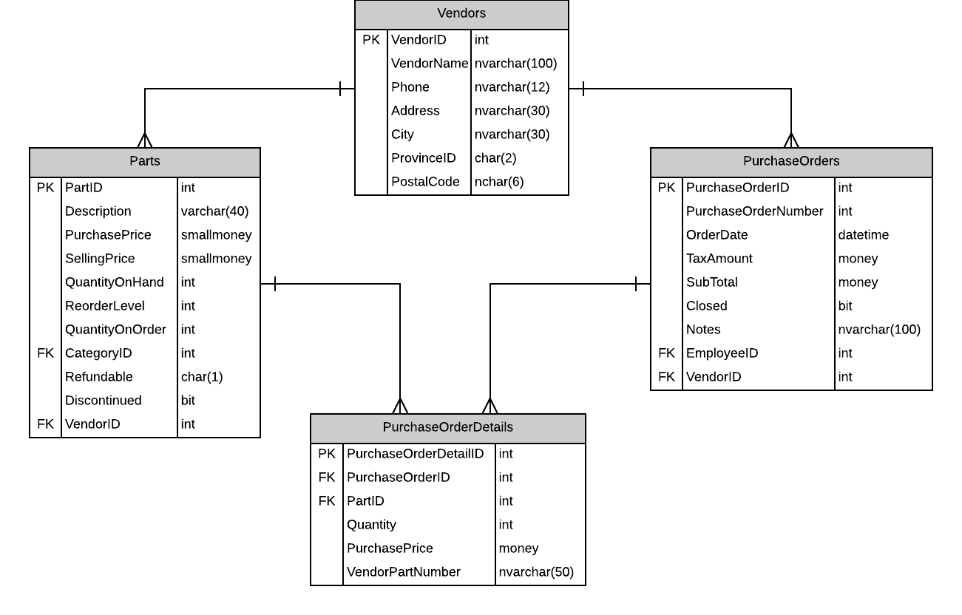

# Screen

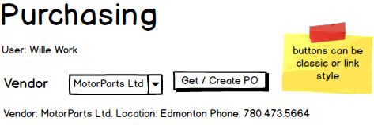

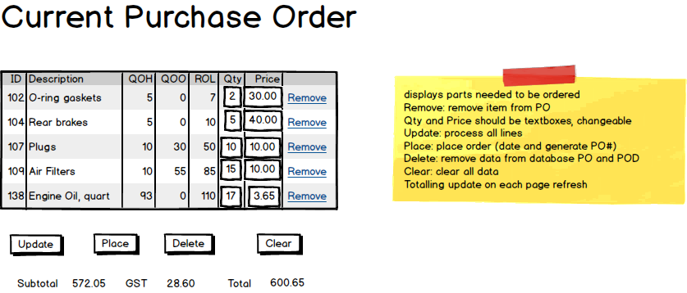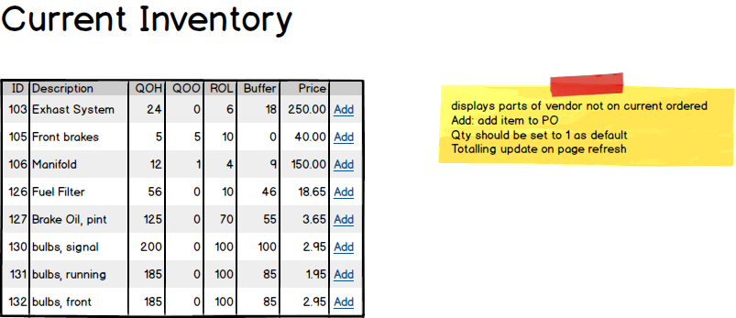

# Event and Wiring Summations

|  |  |  |  |
| --- | --- | --- | --- |
| Populate Vendor Drop Down List | | | |
| **Controls** | | | **Events** |
| * VendorDDL | | | None / wired via ObjectDataSource |
| **BBL Class** | **Methods** | | |
| VendorController | * List< VendorIdentification> List_Vendors()   + Retrieve a list of vendor names and IDs for the DDL and display them in the VendorDDL | | |
| **SQL Table(s): (C,R,U,D)** | | **Entities/DTOs/POCOs** | |
| Vendors (R) | | VendorIdentification (P) | |

|  |  |  |  |
| --- | --- | --- | --- |
| Populate Vendor Information | | | |
| **Controls** | | | **Events** |
| * VendorDDL * VendorInfoView | | | VendorSelected(DDL Item Selected)   * Bind vendor info to infoView |
| **BBL Class** | **Methods** | | |
| VendorController | * VendorInfo GetVendorInfo(int vendorID)   + Gets address, phone, name from vendor for display | | |
| **SQL Table(s): (C,R,U,D)** | | **Entities/DTOs/POCOs** | |
| None | | VendorInfo (P) | |

|  |  |  |  |
| --- | --- | --- | --- |
| Get / Create Purchase Order | | | |
| **Controls** | | | **Events** |
| * GetCreatePOButton * Refresh (CurrentPurchaseOrderView, CurrentInventoryView, OrderTotalSummaryView), | | | GetCreatePOClicked() / wired via ObjectDataSource   * Try to get order * If null, create order * Store ID hidden control * Refresh page (databind displays) |
| **BBL Class** | **Methods** | | |
| PurchaseOrderController | * Int? GetCurrentPurchaseOrder(int vendorID)   + Query database for PurchaseOrder with null OrderDate. Returns null if no open order * int CreatePurchaseOrder(int vendorID)   + Creates PurchaseOrder record. Creates PurchaseOrderDetail records based on data in the Parts table. Returns new ID | | |
| **SQL Table(s): (C,R,U,D)** | | **Entities/DTOs/POCOs** | |
| PurchaseOrders(R, C) | | PurchaseOrder (E) | |

|  |  |  |  |
| --- | --- | --- | --- |
| Populate Purchase Order | | | |
| **Controls** | | | **Events** |
| * PurchaseOrderView | | | Wired via ODS   * Get purchase order ID from hidden control |
| **BBL Class** | **Methods** | | |
| PurchaseOrderDetailController | * List<PurchaseOrderDetailItem> GetPurchaseOrderDetails(int purchaseOrderID) | | |
| **SQL Table(s): (C,R,U,D)** | | **Entities/DTOs/POCOs** | |
| PurchaseOrderDetails(R), Parts(R) | | PurchaseOrderDetailItem (P) | |

|  |  |  |  |
| --- | --- | --- | --- |
| Update Order | | | |
| **Controls** | | | **Events** |
| * UpdateOrderButton * Refresh (CurrentPurchaseOrderView, OrderTotalSummaryView) | | | UpdateClicked()   * Get detail ids, quantities and prices * Send to BLL * Update totals display |
| **BBL Class** | **Methods** | | |
| PurchaseOrderDetailController | * Void UpdatePurchaseOrderDetails (List<PurchaseOrderDetails>)   + Updates the quantity and price of the corresponding id | | |
| **SQL Table(s): (C,R,U,D)** | | **Entities/DTOs/POCOs** | |
| PurchaseOrderDetails (U), PurchaseOrders(U) | | none | |

|  |  |  |  |
| --- | --- | --- | --- |
| Populate Current Inventory | | | |
| **Controls** | | | **Events** |
| * CurrentInventoryView | | | Wired via ODS   * Get purchase order ID from hidden control |
| **BBL Class** | **Methods** | | |
| PartController | * List<PartInfo> GetPartNotOnOrder(int purchaseOrderID) * Gets info from parts table and compares against purchaseOrderDetails table | | |
| **SQL Table(s): (C,R,U,D)** | | **Entities/DTOs/POCOs** | |
| PurchaseOrderDetails(R), Parts(R) | | PartInfo (P) | |

|  |  |  |  |
| --- | --- | --- | --- |
| Add to Order | | | |
| **Controls** | | | **Events** |
| * CurrentInventoryView   + AddButton * CurrentPurchaseOrderView * OrderTotalSummaryView | | | AddItemClicked / wired via ObjectDataSource   * BLL Add * Refresh displays (data bind) |
| **BBL Class** | **Methods** | | |
| PurchaseOrderDetailController | * int CreatePurchaseOrderDetail (int partID, int purchaseOrderID, int quantity, double price)   + Create a purchaseOrderDetail, return new ID | | |
| **SQL Table(s): (C,R,U,D)** | | **Entities/DTOs/POCOs** | |
| PurchaseOrderDetail(C), PurchaseOrder(U) | | none | |

|  |  |  |  |
| --- | --- | --- | --- |
| Populate Order Total Display | | | |
| **Controls** | | | **Events** |
| * OrderTotalSummaryView | | | Wired via ODS   * Get purchase order ID from hidden control |
| **BBL Class** | **Methods** | | |
| PurchaseOrderController | * PurchaseOrderTotals GetPurchaseOrderTotals(int purchaseOrderID) * Gets GST and subtotal for the purchase order | | |
| **SQL Table(s): (C,R,U,D)** | | **Entities/DTOs/POCOs** | |
| PurchaseOrderController(R) | | PurchaseOrderTotals (P) | |

|  |  |  |  |
| --- | --- | --- | --- |
| Remove From Order | | | |
| **Controls** | | | **Events** |
| * CurrentPurchaseOrderView   + RemoveButton * CurrentInventoryView * OrderTotalSummaryView | | | RemoveItemClicked / wired via ObjectDataSource   * BLL delete * Refresh displays (data bind) |
| **BBL Class** | **Methods** | | |
| PurchaseOrderDetailController | * void DeleteOrderDetail (int id)   + delete a purchaseOrderDetail | | |
| **SQL Table(s): (C,R,U,D)** | | **Entities/DTOs/POCOs** | |
| PurchaseOrderDetail(D), PurchaseOrder(U) | | none | |

|  |  |  |  |
| --- | --- | --- | --- |
| Delete Purchase Order | | | |
| **Controls** | | | **Events** |
| * DeleteButton * CurrentPurchaseOrderView * CurrentInventoryView * OrderTotalSummaryView | | | DeleteClicked / wired via ObjectDataSource   * BLL delete * Clear hidden ID * Refresh displays (data bind) |
| **BBL Class** | **Methods** | | |
| PurchaseOrderController | * void DeletePurchaseOrder (int id)   + delete all purchaseOrderDetails associated with the purchase order, then delete the purchase order | | |
| **SQL Table(s): (C,R,U,D)** | | **Entities/DTOs/POCOs** | |
| PurchaseOrderDetail(D), PurchaseOrder(D) | | none | |

|  |  |  |  |
| --- | --- | --- | --- |
| Place Purchase Order | | | |
| **Controls** | | | **Events** |
| * PlaceOrderButton * CurrentPurchaseOrderView * CurrentInventoryView * OrderTotalSummaryView | | | PlaceOrderClicked / wired via ObjectDataSource   * BLL placeOrder * Clear hidden ID * Refresh displays (data bind) |
| **BBL Class** | **Methods** | | |
| PurchaseOrderController | * void PlacePurchaseOrder (int id)   + set the OrderDate and OrderNumber of the PurchaseOrder. Update Part QuantityOnOrders. | | |
| **SQL Table(s): (C,R,U,D)** | | **Entities/DTOs/POCOs** | |
| Parts(U), PurchaseOrder(U) | | none | |

|  |  |  |  |
| --- | --- | --- | --- |
| Clear Page | | | |
| **Controls** | | | **Events** |
| * ClearButton | | | ClearClicked   * Refresh page |
| **BBL Class** | **Methods** | | |
| None | none | | |
| **SQL Table(s): (C,R,U,D)** | | **Entities/DTOs/POCOs** | |
| none | | none | |

You seem to have a good handle on the subsystem.