Security Subsystem

# ERD for Security Subsystem

Were we given this?

# Possible Security Interface

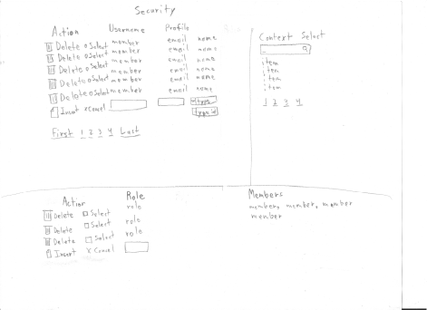

|  |  |  |
| --- | --- | --- |
| **Controls** | | **Events** |
| UsersList | | None / wired via ObjectDataSource |
| **BBL Class(es) and Method (s)** | | |
| UserManager | List<UserProfile> ListAllUsers ()  Returns a list of all users. | |
| **SQL Table(s): (C,R,U,D)** | | **Entities/DTOs/POCOs** |
|  | | UserProfile (P) |

# Event and Wiring Summations

|  |  |  |
| --- | --- | --- |
| **Controls** | | **Events** |
| UsersList | | None / wired via ObjectDataSource |
| **BBL Class(es) and Method (s)** | | |
| UserManager | Void RemoveUser (UserProfile userInfo)  Removes a selected user from the UserProfile table. | |
| **SQL Table(s): (C,R,U,D)** | | **Entities/DTOs/POCOs** |
|  | | UserProfile (P) |

|  |  |  |
| --- | --- | --- |
| **Controls** | | **Events** |
| UsersList | | None / wired via ObjectDataSource |
| **BBL Class(es) and Method (s)** | | |
| UserManager | Public void AddUser(UserProfile userInfo)  Add a new user to the UserProfile table. | |
| **SQL Table(s): (C,R,U,D)** | | **Entities/DTOs/POCOs** |
|  | | UserProfile (P) |

|  |  |  |
| --- | --- | --- |
| **Controls** | | **Events** |
| RolesList | | None / wired via ObjectDataSource |
| **BBL Class(es) and Method (s)** | | |
| RoleManager | List<RoleProfile> ListAllRoles ()  Returns a list of all roles. | |
| **SQL Table(s): (C,R,U,D)** | | **Entities/DTOs/POCOs** |
|  | | RoleProfile (P) |

|  |  |  |
| --- | --- | --- |
| **Controls** | | **Events** |
| RolesList | | None / wired via ObjectDataSource |
| **BBL Class(es) and Method (s)** | | |
| RoleManager | Void ForceRemoveRole(RoleProfile role)  Removes all users from the role and deletes the role. | |
| **SQL Table(s): (C,R,U,D)** | | **Entities/DTOs/POCOs** |
|  | | RoleProfile (P), ApplicationUser (P) |

|  |  |  |
| --- | --- | --- |
| **Controls** | | **Events** |
| RolesList | | None / wired via ObjectDataSource |
| **BBL Class(es) and Method (s)** | | |
| RoleManager | Void AddRole(RoleProfile role)  Adds the role using a role profile’s name. | |
| **SQL Table(s): (C,R,U,D)** | | **Entities/DTOs/POCOs** |
|  | | RoleProfile (P) |