Jobing Subsystem

# ERD for Jobing Subsystem

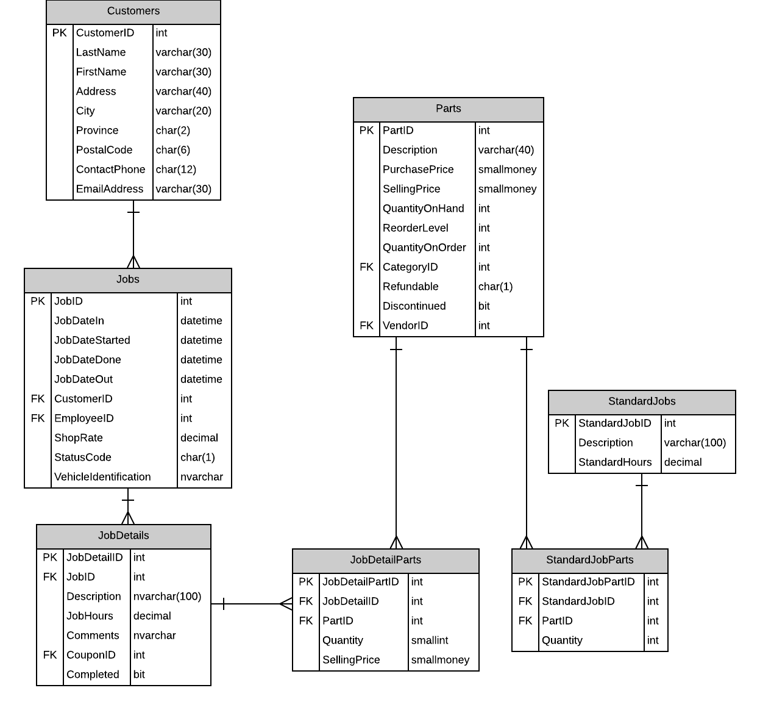

# Possible Jobing Interface

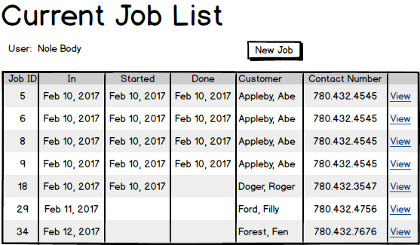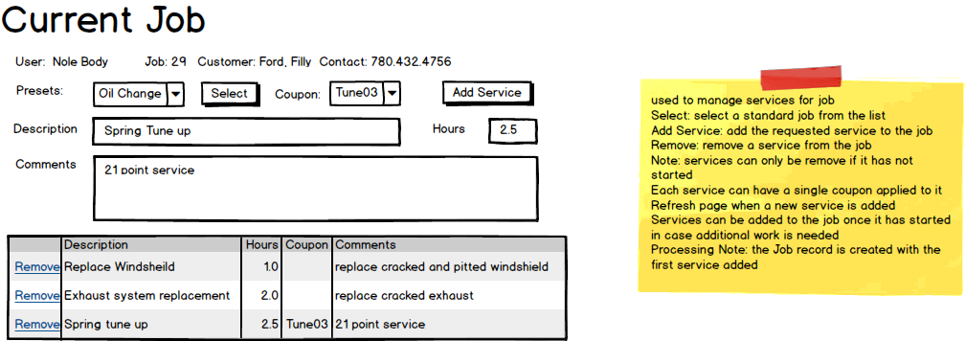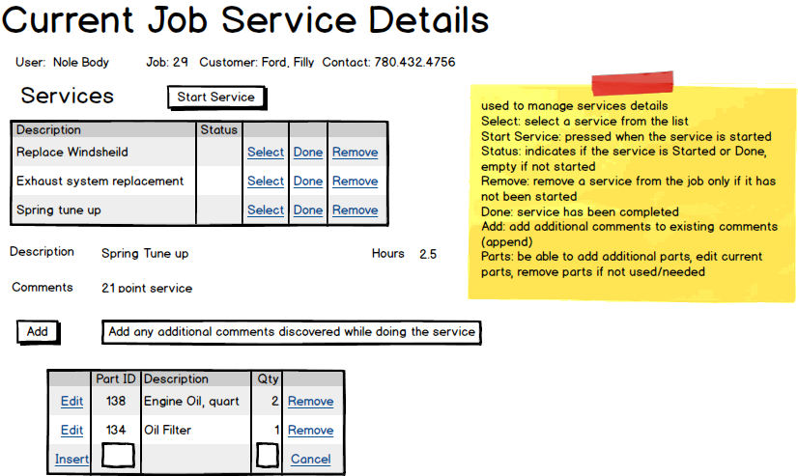

|  |  |  |
| --- | --- | --- |
| **Controls** | | **Events** |
| JobListListView | | None / Wired via ODS |
| **BBL Class(es) and Method (s)** | | |
| JobsController | List<CurrentJobs> List_CurrentJobs()  Retrieve a list of current jobs and job id for ListView | |
| **SQL Table(s): (C,R,U,D)** | | **Entities/DTOs/POCOs** |
| Jobs (R) | | CurrentJob (P) |

# Event and Wiring Summations

|  |  |  |
| --- | --- | --- |
| **Controls** | | **Events** |
| NewJobBtn | | NewJobClicked |
| **BBL Class(es) and Method (s)** | | |
| JobsController | Void Add_Job()  Add a new job to the current job list. | |
| **SQL Table(s): (C,R,U,D)** | | **Entities/DTOs/POCOs** |
| Jobs (C) | | Job (E) |

|  |  |  |
| --- | --- | --- |
| **Controls** | | **Events** |
| PresetButton | | SelectClicked |
| **BBL Class(es) and Method (s)** | | |
| StandardJobsController | Void SelectPreset()  Retrieve information for the standard job and populate the Description and Hours with the information. | |
| **SQL Table(s): (C,R,U,D)** | | **Entities/DTOs/POCOs** |
| StandardJobs (R) | | StandardJobs (E) |

|  |  |  |
| --- | --- | --- |
| **Controls** | | **Events** |
| AddServiceButton | | AddServiceClicked |
| **BBL Class(es) and Method (s)** | | |
| JobDetailsController | Void AddService()  Adds a service to the current job | |
| **SQL Table(s): (C,R,U,D)** | | **Entities/DTOs/POCOs** |
| JobDetails (C) | | JobDetails (E) |

|  |  |  |
| --- | --- | --- |
| **Controls** | | **Events** |
| CurrentServicesListView | | None / Wired through ODS |
| **BBL Class(es) and Method (s)** | | |
| JobDetailsController | List<JobDetails> List_CurrentServices  Returns a list of services for the current job | |
| **SQL Table(s): (C,R,U,D)** | | **Entities/DTOs/POCOs** |
| JobDetails (R) | | JobDetails (E) |

|  |  |  |
| --- | --- | --- |
| **Controls** | | **Events** |
| CurrentJobServicesListView | | None / Wired through ODS |
| **BBL Class(es) and Method (s)** | | |
| JobDetailsController | List<JobDetails> List_CurrentServices  Returns a list of services for the current job | |
| **SQL Table(s): (C,R,U,D)** | | **Entities/DTOs/POCOs** |
| JobDetails (R, U, D) | | JobDetails (E) |

|  |  |  |
| --- | --- | --- |
| **Controls** | | **Events** |
| StartServiceButton | | StartServiceClicked |
| **BBL Class(es) and Method (s)** | | |
| JobDetailsController | Void StartService()  Updates the status of the selected service to Started. | |
| **SQL Table(s): (C,R,U,D)** | | **Entities/DTOs/POCOs** |
| JobDetails (U) | | JobDetails (E) |

|  |  |  |
| --- | --- | --- |
| Controls | | Events |
| AddCommentButton | | AddCommentClicked |
| BBL Class(es) and Method (s) | | |
| JobDetailsController | AddComment()  Adds an additional comment to the current service | |
| SQL Table(s): (C,R,U,D) | | Entities/DTOs/POCOs |
| JobDetails (U) | | JobDetails (E) |

|  |  |  |
| --- | --- | --- |
| Controls | | Events |
| JobDetailsPartsListView | | None / Wired through ODS |
| BBL Class(es) and Method (s) | | |
| JobDetailsPartsController | List<JobDetailParts> List_JobDetailParts  Returns a list of parts required for current service | |
| SQL Table(s): (C,R,U,D) | | Entities/DTOs/POCOs |
| JobDetailsParts (C, R, U, D) | | JobDetailsParts (E) |