Purchasing

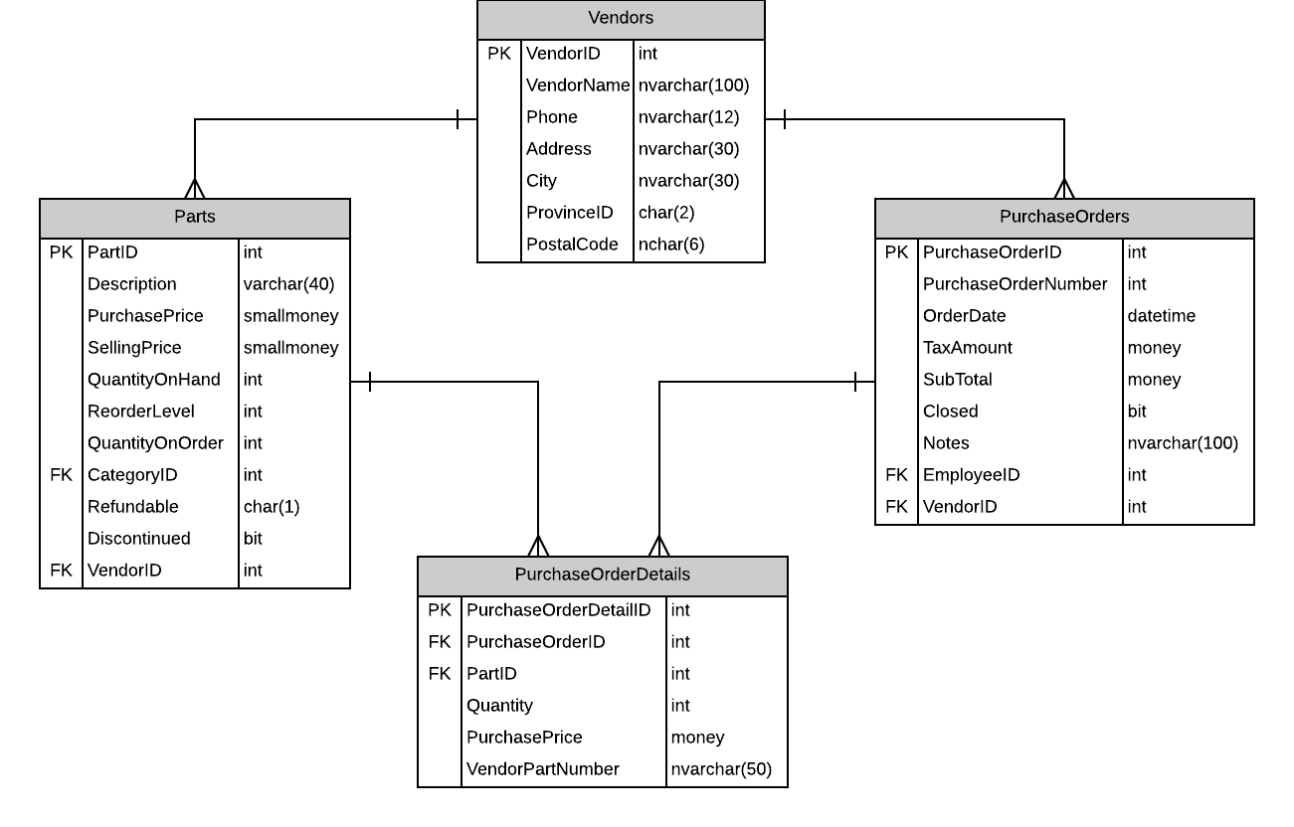

# Screen

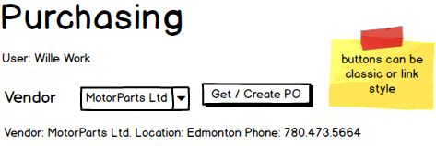

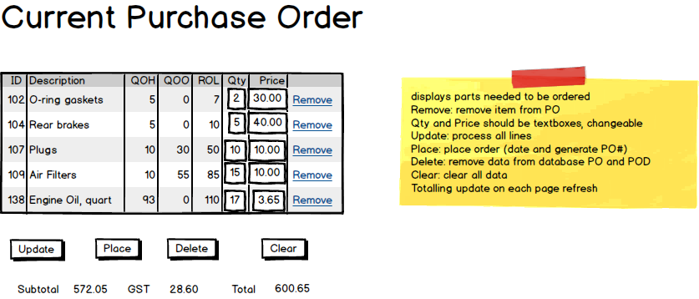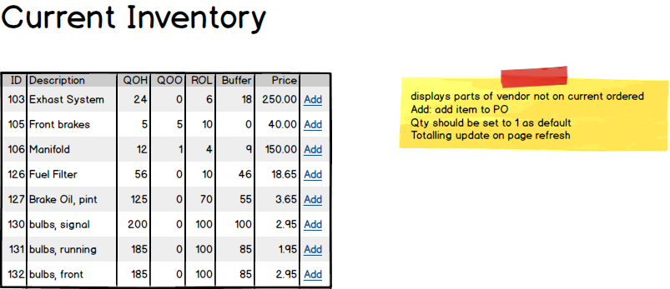

# Event and Wiring Summations

|  |  |  |  |
| --- | --- | --- | --- |
| Populate Vendor Drop Down List | | | |
| **Controls** | | | **Events** |
| * VendorDDL | | | None / wired via ObjectDataSource |
| **BBL Class** | **Methods** | | |
| VendorController | * List<Vendor> List_Vendors()   + Retrieve a list of vendor names and IDs for the DDL and display them in the VendorDDL | | |
| **SQL Table(s): (C,R,U,D)** | | **Entities/DTOs/POCOs** | |
| Vendors (R) | | Vendor (E) | |

|  |  |  |  |
| --- | --- | --- | --- |
| Populate Vendor Information | | | |
| **Controls** | | | **Events** |
| * VendorDDL * VendorInfoView | | | VendorSelected(DDL Item Selected) / wired via ObjectDataSource   * Bind vendor info to infoView |
| **BBL Class** | **Methods** | | |
| None | * Vendor info cached when DDL populated, no need to hit database here | | |
| **SQL Table(s): (C,R,U,D)** | | **Entities/DTOs/POCOs** | |
| None | | Vendor (E) | |

|  |  |  |  |
| --- | --- | --- | --- |
| Get / Create Purchase Order | | | |
| **Controls** | | | **Events** |
| * GetCreatePOButton * CurrentPurchaseOrderView * CurrentInventoryView * OrderTotalSummaryView | | | GetCreatePOClicked() / wired via ObjectDataSource   * Try to get order * If null, create order * Update purchase order display * Update current inventory display * Update total summary display |
| **BBL Class** | **Methods** | | |
| PurchaseOrderController | * PurchaseOrder? GetCurrentPurchaseOrder(int vendorID)   + Query database for PurchaseOrder with null OrderDate. Returns null if no open order * PurchaseOrder CreatePurchaseOrder(int vendorID)   + Creates PurchaseOrder record. Creates PurchaseOrderDetail records based on data in the Parts table | | |
| **SQL Table(s): (C,R,U,D)** | | **Entities/DTOs/POCOs** | |
| PurchaseOrders(R, C)  PurchaseOrderDetails(R, C)  Parts(R) | | PurchaseOrder (E) | |

|  |  |  |  |
| --- | --- | --- | --- |
| Update Order | | | |
| **Controls** | | | **Events** |
| * UpdateOrderButton * CurrentPurchaseOrderView * OrderTotalSummaryView | | | UpdateClicked() / wired via ObjectDataSource   * Get detail ids, quantities and prices * Send to BLL (loop) * Update totals display * BLL update order total |
| **BBL Class** | **Methods** | | |
| PurchaseOrderDetailController | * Void UpdatePurchaseOrderDetail (int id, int quantity, double price)   + Updates the quantity and price of the corresponding id | | |
| PurchaseOrderController | * Void UpdateTotal(int id, double gst, double subtotal)   + Updates the TaxAmount and SubTotal of the purchaseOrder | | |
| **SQL Table(s): (C,R,U,D)** | | **Entities/DTOs/POCOs** | |
| PurchaseOrderDetails (U), PurchaseOrders(U) | | none | |

|  |  |  |  |
| --- | --- | --- | --- |
| Add to Order | | | |
| **Controls** | | | **Events** |
| * CurrentInventoryView   + AddButton * CurrentPurchaseOrderView * OrderTotalSummaryView | | | AddItemClicked / wired via ObjectDataSource   * BLL Add * Add to purchase order display * Remove from inventory display * Update totals |
| **BBL Class** | **Methods** | | |
| PurchaseOrderDetailController | * int CreatePurchaseOrderDetail (int partID, int purchaseOrderID, int quantity, double price)   + Create a purchaseOrderDetail, return new ID | | |
| PurchaseOrderController | * Void UpdateTotal(int id, double gst, double subtotal)   + Updates the TaxAmount and SubTotal of the purchaseOrder | | |
| **SQL Table(s): (C,R,U,D)** | | **Entities/DTOs/POCOs** | |
| PurchaseOrderDetail(C), PurchaseOrder(U) | | none | |

|  |  |  |  |
| --- | --- | --- | --- |
| Remove From Order | | | |
| **Controls** | | | **Events** |
| * CurrentPurchaseOrderView   + RemoveButton * CurrentInventoryView * OrderTotalSummaryView | | | RemoveItemClicked / wired via ObjectDataSource   * BLL delete * Remove from purchase order display * Add to inventory display * Update totals |
| **BBL Class** | **Methods** | | |
| PurchaseOrderDetailController | * void DeleteOrderDetail (int id)   + delete a purchaseOrderDetail | | |
| PurchaseOrderController | * Void UpdateTotal(int id, double gst, double subtotal)   + Updates the TaxAmount and SubTotal of the purchaseOrder | | |
| **SQL Table(s): (C,R,U,D)** | | **Entities/DTOs/POCOs** | |
| PurchaseOrderDetail(D), PurchaseOrder(U) | | none | |

|  |  |  |  |
| --- | --- | --- | --- |
| Delete Purchase Order | | | |
| **Controls** | | | **Events** |
| * DeleteButton * CurrentPurchaseOrderView * CurrentInventoryView * OrderTotalSummaryView | | | DeleteClicked / wired via ObjectDataSource   * BLL delete * Clear purchase order display * Clear totals display * Clear inventory display |
| **BBL Class** | **Methods** | | |
| PurchaseOrderController | * void DeletePurchaseOrder (int id)   + delete all purchaseOrderDetails associated with the purchase order, then delete the purchase order | | |
| **SQL Table(s): (C,R,U,D)** | | **Entities/DTOs/POCOs** | |
| PurchaseOrderDetail(D), PurchaseOrder(D) | | none | |

|  |  |  |  |
| --- | --- | --- | --- |
| Place Purchase Order | | | |
| **Controls** | | | **Events** |
| * PlaceOrderButton * CurrentPurchaseOrderView * CurrentInventoryView * OrderTotalSummaryView | | | PlaceOrderClicked / wired via ObjectDataSource   * BLL placeOrder * Clear purchase order display * Clear totals display * Clear inventory display |
| **BBL Class** | **Methods** | | |
| PurchaseOrderController | * void PlacePurchaseOrder (int id)   + set the OrderDate and OrderNumber of the PurchaseOrder. Update Part QuantityOnOrders. | | |
| **SQL Table(s): (C,R,U,D)** | | **Entities/DTOs/POCOs** | |
| Parts(U), PurchaseOrder(U) | | none | |

|  |  |  |  |
| --- | --- | --- | --- |
| Clear Page | | | |
| **Controls** | | | **Events** |
| * ClearButton * CurrentPurchaseOrderView * CurrentInventoryView * OrderTotalSummaryView * VendorInfoDisplay | | | ClearClicked / wired via ObjectDataSource   * Clear purchase order display * Clear totals display * Clear inventory display * Clear vendor info display * Reset vendor DDL |
| **BBL Class** | **Methods** | | |
| None | none | | |
| **SQL Table(s): (C,R,U,D)** | | **Entities/DTOs/POCOs** | |
| none | | none | |