Security Subsystem

# ERD for Security Subsystem

Were we given this?

# Possible Security Interface

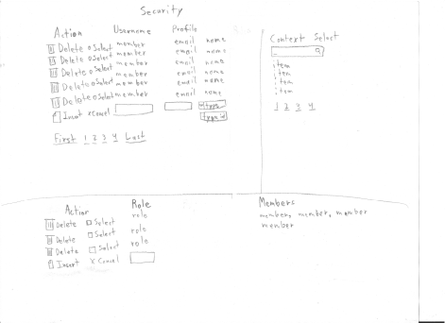

|  |  |  |
| --- | --- | --- |
| **Controls** | | **Events** |
| DeleteUserButton | | DeleteUserClicked |
| **BBL Class(es) and Method (s)** | | |
| UserManager | Public void DeleteEmployee(int userid)  Removes a selected user from the UserProfile table. | |
| **SQL Table(s): (C,R,U,D)** | | **Entities/DTOs/POCOs** |
| UserProfile (D) | | UserProfile (E) |

# Event and Wiring Summations

|  |  |  |
| --- | --- | --- |
| **Controls** | | **Events** |
| InsertUserButton | | InsertUserClicked |
| **BBL Class(es) and Method (s)** | | |
| UserManager | Public void AddEmployee()  Add a new user to the UserProfile table. | |
| **SQL Table(s): (C,R,U,D)** | | **Entities/DTOs/POCOs** |
| UserProfile (C) | | UserProfile (E) |

|  |  |  |
| --- | --- | --- |
| **Controls** | | **Events** |
| DeleteRoleButton | | DeleteRoleClicked |
| **BBL Class(es) and Method (s)** | | |
| RoleManager | Public void DeleteRole(int roleid)  Removes a select role from the RoleProfile table. | |
| **SQL Table(s): (C,R,U,D)** | | **Entities/DTOs/POCOs** |
| RoleProfile (D) | | RoleProfile (E) |

|  |  |  |
| --- | --- | --- |
| **Controls** | | **Events** |
| InsertRoleButton | | InsertRoleClicked |
| **BBL Class(es) and Method (s)** | | |
| RoleManager | Public void AddRole()  Add a new role to the RoleProfile table. | |
| **SQL Table(s): (C,R,U,D)** | | **Entities/DTOs/POCOs** |
| RoleProfile (C) | | RoleProfile (E) |