**1. Project Overview from the User Perspective (Use Cases and Mockup Screens)**

**Project Overview:**

The **PCOS Health Tracker** is designed to help women with PCOS manage their symptoms, medication, and overall well-being by offering daily tracking, medication reminders, and emotional support through motivational quotes and mindfulness sessions. Users can input and visualize their data, helping them understand the relationship between their lifestyle and PCOS symptoms.

**Use Cases:**

1. **User Registration/Login:**
   * **User Flow**: A new user signs up by entering their basic information (name, age, email) and creating a password. Registered users can log in with their credentials.
   * **Fields**: Name, email, password, confirm password, age.
   * **Buttons**: "Sign In", "Register", "Forgot Password".
2. **Daily Symptom Logging:**
   * **User Flow**: Users can log their daily symptoms such as mood, pain level, menstrual cycle, energy, and weight.
   * **Fields**: Mood (dropdown/slider), menstrual cycle status, energy level, weight, pain level (slider), and notes.
   * **Buttons**: "Submit", "Cancel".
3. **Medication Reminder and Tracking:**
   * **User Flow**: Users can add medications they are taking, set reminders, and log when they’ve taken their medication.
   * **Fields**: Medication name, dosage, schedule (time of day), reminder setting.
   * **Buttons**: "Save", "Mark as Taken".
4. **View Health Insights:**
   * **User Flow**: Users can view trends in their logged data to see correlations between symptoms and lifestyle factors.
   * **Features**: Graphs, charts, and filters for time periods and specific symptoms.
5. **Motivational Quotes & Mindfulness Sessions:**
   * **User Flow**: The user can view a daily motivational quote and choose to begin a 10-minute mindfulness or breathing session.
   * **Buttons**: "Start Session".

**Mockup Screens:**

1. **Login/Registration Screen**:
   * Fields: Name, email, password, confirm password, age.
   * 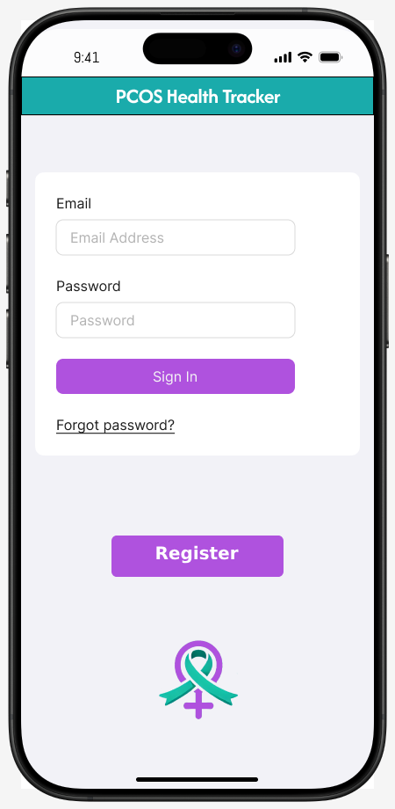Buttons: "Sign In", "Register", "Forgot Password".
2. **Home Screen/Dashboard**:
   * Sections:
     + Calendar for period tracking.
     + Buttons for logging symptoms, viewing health insights, daily tips, and support forum.
     + 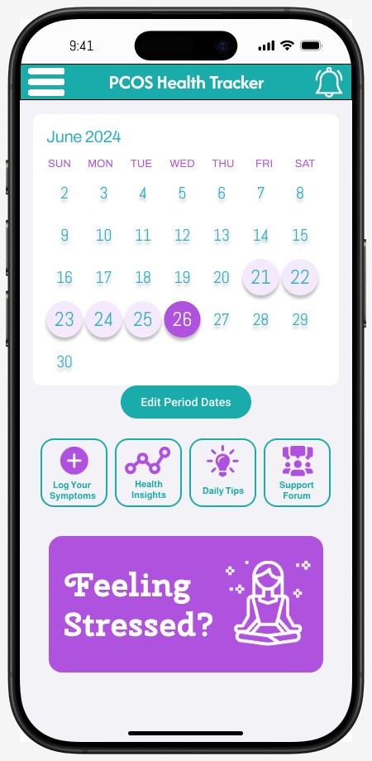Button for viewing a motivational quote and starting a breathing session.
3. **Menu Screen**:
   * Menu Options:
     + "Add Medication"
     + "Profile Settings"
     + "Notifications"
     + "Support"
     + 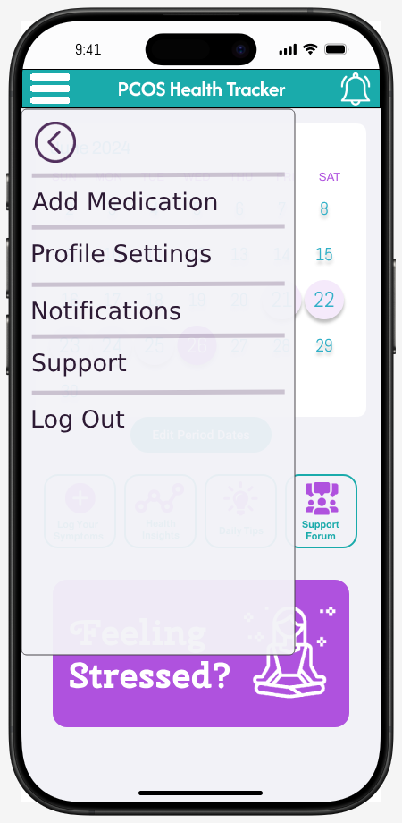"Log Out"
4. A cell phone with text on it

   Description automatically generated**Symptom Logging Screen**:
   * Fields: Mood, menstrual cycle status, energy level, weight, pain level, notes.
   * Buttons: "Submit", "Cancel".
5. **Medication Reminder Screen**:
   * Fields: Medication name, dosage, schedule, reminder setting.
   * Buttons: "Save", "Mark as Taken".
6. **Health Insights Screen**:
   * Graphs displaying data such as symptom severity vs. energy levels.
   * Filters to select different time periods and data points.
7. **Motivation Screen**:
   * Daily motivational quote.
   * Button to start a 10-minute breathing session.

**2. Business Logic (Application Flow)**

**Login/Registration Process:**

1. **App Launch**: Upon launching the app, the user is presented with a login or registration screen.
   * Existing users enter their email and password and click "Sign In".
   * New users click "Register" to fill in their name, email, password, and age.
2. **Home Screen (Dashboard)**:
   * After login, the user lands on the dashboard, which includes:
     + A calendar for period tracking.
     + Buttons to log symptoms, add medication, view health insights, and access daily tips and a support forum.
     + An option to navigate to the motivational quotes and mindfulness section.
3. **Symptom Tracking**:
   * Users click the "Log Symptoms" button, which takes them to a form where they input details about their symptoms for the day (mood, energy, pain, menstrual cycle, weight, etc.).
   * After entering the data, they click "Submit" to save the information, which updates the dashboard.
4. **Medication Tracking and Reminders**:
   * From the menu, users can click "Add Medication" to enter medication details such as name, dosage, schedule, and reminders.
   * When it’s time to take their medication, the app sends a push notification to the user.
   * After taking their medication, users can mark it as "Taken" in the app, which updates their health summary.
5. **Health Insights**:
   * Users can click the "Health Insights" button to see graphs and trends of their logged data.
   * Data is presented visually, and users can filter by specific symptoms or time periods to understand the relationship between their symptoms, medications, and lifestyle factors.
6. **Motivational Quotes & Mindfulness**:
   * The user views a daily motivational quote and has the option to start a 10-minute mindfulness or breathing session.

**3. Business Logic in Detail**

1. **Login/Registration**:
   * User opens the app → login/registration screen.
   * User inputs email and password → click "Sign In" or "Register".
   * If new, user fills out registration form and then proceeds to the dashboard.
2. **Dashboard/Home Screen**:
   * Displays:
     + Calendar with period tracking.
     + Buttons for logging symptoms, adding medication, viewing insights, tips, and support forum.
     + Daily motivational quote and mindfulness session option.
3. **Symptom Logging**:
   * User clicks "Log Symptoms" → input mood, pain level, energy, menstrual status → "Submit" → data is saved and updates dashboard.
4. **Medication Tracking**:
   * User clicks "Add Medication" → input medication details and schedule reminders → app sends notifications when medication is due → user marks medication as "Taken" → dashboard updates with status.
5. **Health Insights**:
   * User clicks "Health Insights" → graphs and charts of data trends are displayed → user can filter by time period and symptom type.
6. **Motivational & Mindfulness**:
   * User clicks "Start Session" from the motivational page → app launches a guided 10-minute mindfulness/breathing session.

**4. Assumptions and Boundaries**

**Assumptions:**

* Users will have access to smartphones or web-enabled devices to use the app.
* Users will input health data consistently for meaningful insights.

**Boundaries:**

* **Expandable Points**:
  + Advanced AI analysis of symptom patterns.
  + Integration with third-party apps and wearables for automated health tracking.
  + Direct communication with healthcare providers.
  + Real-time mental health support.
  + Access to PCOS specific workouts and dietician.

**Assumptions for Coursework:**

* Module for Login & Registration
* Module for Mindfulness

**Expandable Points:**

* Modules Coming Soon:
  + Dashboard
  + Symptom Logging
  + Medication Tracking
  + Health Insights