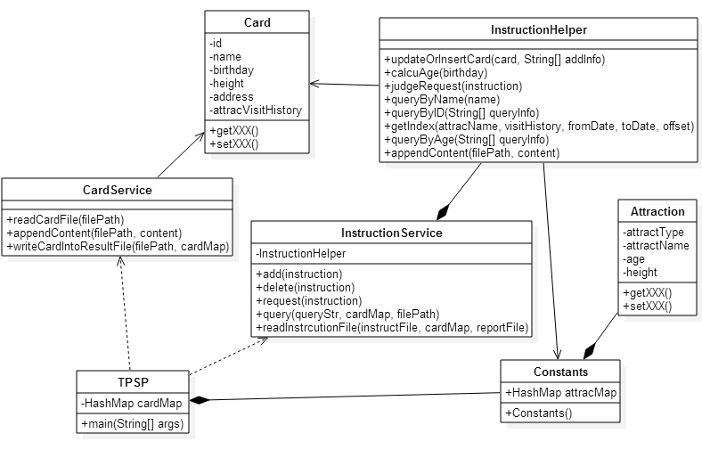

The above UML diagram shows the main classes, fields and methods of each class, as well as the relationship of the classes.

*Responsibilities* of each class:

Card: the entity class of card. Card information includes id, name, birthday, height, address and attraction visit history. It’s basis for operations of card.

Attraction: it defines the structure of default attraction type, attraction name, age restriction and height restriction for each attraction.

CardService: used to read content of card file and then store them into HashMap for card. Besides, this class provides method to write card information into result file after operations.

InstructionService: this is the important class for adding card, deleting card, requesting and querying from users. After reading instructions from specified file, appropriate operations will be done to card map automatically.

InstructionHelper: it’s a helper class for InstructionService. This class takes a role of finishing details of operations.

Constants: it declares attraction map to store default attraction restrictions.

TPSP: it’s the main class of project. This class invokes CardService and InstructionService to finish all precedures.