Project:- movie ticket booking system

Step 1: Create Database
CREATE DATABASE movie_ticket_booking;
USE movie_ticket_booking;
Step 2: Create Tables User Table
CREATE TABLE Users(user_id INT AUTO_INCREMENT PRIMARY KEY, name VARCHAR(100) NOT NULL,email VARCHAR(100) UNIQUE,phone VARCHAR(15));
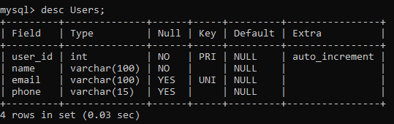
Movie Table
CREATE TABLE Movie(movie_id INT PRIMARY KEY, title VARCHAR(50), genre VARCHAR(30),duration INT);
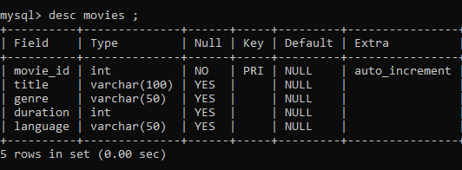
Theatre Table
CREATE TABLE Theatre(theatre_id INT PRIMARY KEY,name VARCHAR(50),location VARCHAR(50));
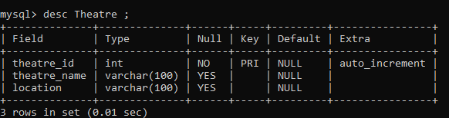
Show Table
CREATE TABLE Shows (show_id INT PRIMARY KEY,movie_id INT,theatre_id INT,show_time DATETIME,ticket_price DECIMAL(10,2),available_seats INT,FOREIGN KEY(movie_id) REFERENCES Movie(movie_id), FOREIGN KEY(theatre_id) REFERENCES Theatre(theatre_id));
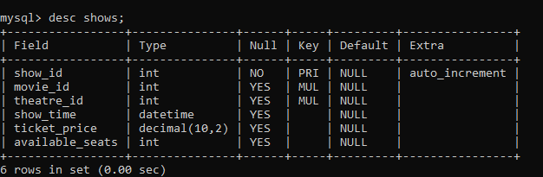
Booking Table
CREATE TABLE Booking(booking_id INT PRIMARY KEY,user_id INT,show_id INT,number_of_tickets INT,FOREIGN KEY(user_id) REFERENCES Users(user_id),
FOREIGN KEY(show_id) REFERENCES Shows(show_id));
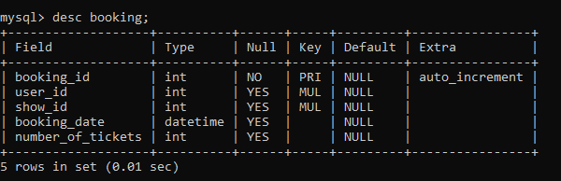
Payment Table
CREATE TABLE Payment(payment_id INT PRIMARY KEY, booking_id INT,amount DECIMAL(10,2),payment_date DATE, payment_method VARCHAR(20), FOREIGN KEY(booking_id) REFERENCES Booking(booking_id));
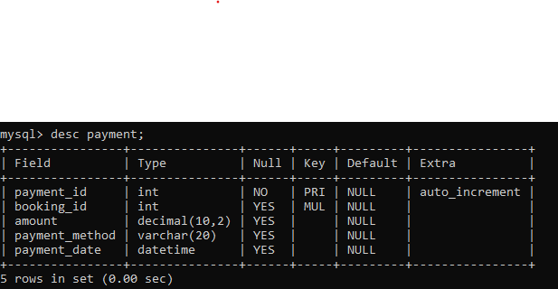
Step 3: Insert Sample Data
INSERT INTO Users VALUES(1,'Rahul','rahul@gmail.com','9876543210'),
(2,'Anita','anita@gmail.com','9876543211');
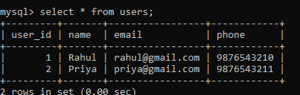
INSERT INTO Movie VALUES(101,'KGF','Action',180),(102,'Kantara','Drama',160);
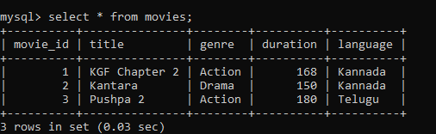
INSERT INTO Theatre VALUES(1,'PVR','Udupi'),(2,'INOX','Mangalore');
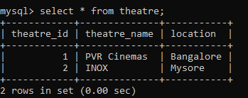
INSERT INTO Shows VALUES(201,101,1,'2026-06-15 10:00:00',250,100),
(202,102,2,'2026-06-15 14:00:00',200,80);
SELECT * FROM Movies WHERE title='Kantara';

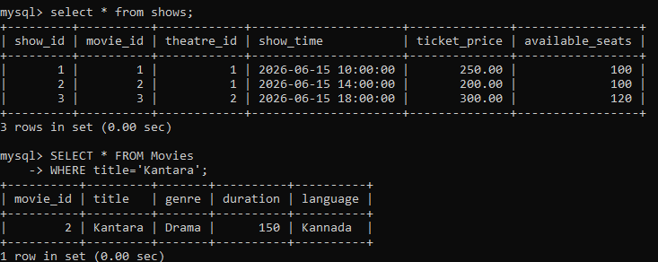
SELECT *FROM ShowsWHERE available_seats > 0;
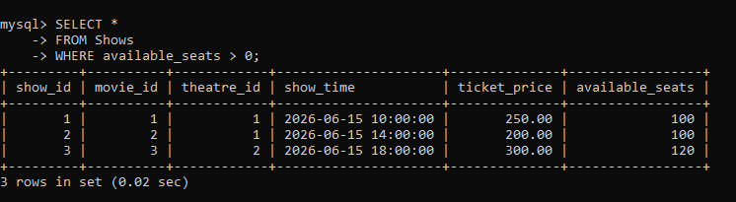
SELECT SUM(amount)AS TotalRevenue FROM Payment;
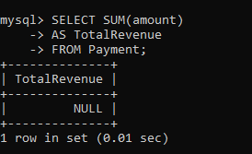

Stored Procedure
DELIMITER //
CREATE PROCEDURE GetBookingDetails(IN bookingId INT)BEGIN
SELECT b.booking_id,u.name,m.title,b.number_of_tickets FROM Booking b JOIN Users u
ON b.user_id=u.user_id JOIN Shows s ON b.show_id=s.show_idJOIN Movies m
ON s.movie_id=m.movie_id WHERE b.booking_id=bookingId;
END //
DELIMITER ;
Execute:
CALL GetBookingDetails(1);
Trigger:
DELIMITER //
CREATE TRIGGER reduce_seatsAFTER INSERT ON Booking
FOR EACH ROW BEGIN UPDATE Shows SET available_seats =
available_seats - NEW.number_of_tickets WHERE show_id=NEW.show_id;
END //
DELIMITER ;

