**NPM** (Node package manager): npm is the world's largest software registry. Open source developers from every continent use npm to share and borrow packages, and many organizations use npm to manage private development as well.

NVM : Node Version Manager (NVM), as the name implies, is a tool for managing Node versions on your device.

Different projects on your device may be using different versions of Node.

**Manually setup React Project :**

1. Create a new directory for your project:

mkdir my-react-app

cd my-react-app

2. Initialize the project with npm

npm init -y

3. Install Required Dependencies

npm install react react-dom react-scripts

4. Create the Project Structure

1. Create the following folders and files

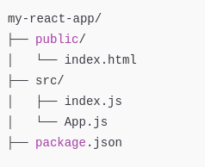

5. Add Basic File Content

public/index.html:

<!DOCTYPE html>

<html lang="en">

<head>

<meta charset="UTF-8" />

<meta name="viewport" content="width=device-width, initial-scale=1.0" />

<title>React App</title>

</head>

<body>

<div id="root"></div>

</body>

</html>

src/index.js:

import React from 'react';

import ReactDOM from 'react-dom';

import App from './App';

ReactDOM.render(<App />, document.getElementById('root'));

src/App.js:

import React from 'react';

function App() {

return (

<div>

<h1>Hello, React!</h1>

</div>

);

}

export default App;

Update package.json:

Add the start, build, and test scripts to package.json

"scripts": {

"start": "react-scripts start",

"build": "react-scripts build",

"test": "react-scripts test",

"eject": "react-scripts eject"

}

6. Start the Development Server

Run the following command to start the React app:

npm start

***issue with npx create-react-app my-app***

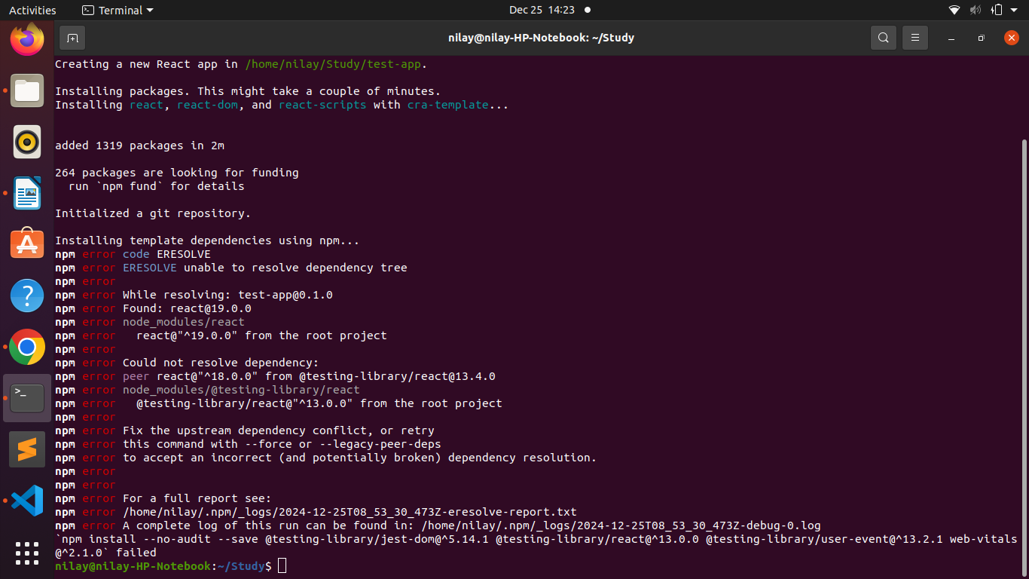

npm list : shows all the dependencies that are available within application project and run npm list inside my-app

now execute npm start and we are getting error of web-vitals in starting server. Hence we install it using **npm install web-vitals** and than execute npm start