如何使用BaseAdapter自定义Adapter
不是我夸，只要学会了自定义Adapter，不管列表项有多复杂，都可以说实现的，这个很实用，免费分享费大家
运行效果如下：
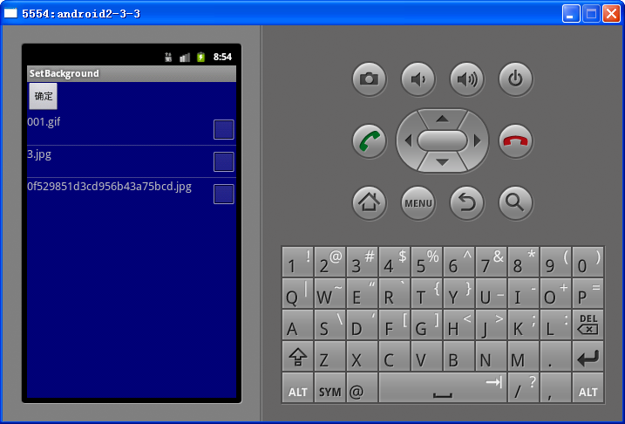
MyAdapter.java文件如下
package jiao.jiao;
import android.content.Context;
import android.view.LayoutInflater;
import android.view.View;
import android.view.ViewGroup;
import android.widget.BaseAdapter;
import android.widget.CheckBox;
import android.widget.TextView;

public class MyAdapter extends BaseAdapter {
private LayoutInflater mInflater;
String [] picturename;

public MyAdapter(Context context,String [] pictureStrings){
mInflater = LayoutInflater.from(context);
picturename=pictureStrings;

}
public int getCount() {

return picturename.length;
}

public Object getItem(int position) {
return picturename[position];
}

public long getItemId(int position) {

return position;
}

public View getView(int position, View convertView, ViewGroup parent) {
MyView myView = new MyView();
convertView=mInflater.inflate(R.layout.list, null);
myView.text=(TextView)convertView.findViewById(R.id.list_item);
myView.check=(CheckBox)convertView.findViewById(R.id.chose);
myView.text.setText(picturename[position]);
myView.check.setChecked(false);
convertView.setTag(myView);
return convertView;
}

private class MyView{
TextView text;
CheckBox check;
}

}

主Activity.java文件如下：
package jiao.jiao;
import java.io.File;
import android.app.Activity;
import android.os.Bundle;
import android.widget.Button;
import android.widget.ImageView;
import android.widget.ListView;
public class SetBackgroundActivity extends Activity {
public ListView listView;
public ImageView imageView;
public Button button;

public static final String PICTURE_PATH=new String ("/sdcard/");
/** Called when the activity is first created. */
@Override
public void onCreate(Bundle savedInstanceState) {
super.onCreate(savedInstanceState);
setContentView(R.layout.main);
findViewById();
listPicture();
}
public void findViewById(){
listView =(ListView)this.findViewById(R.id.list); button=(Button)this.findViewById(R.id.set_background);
}

public void listPicture(){
File file = new File(PICTURE_PATH);
PictureFilter pictureFilter =new PictureFilter();
File files[]=file.listFiles(pictureFilter);
String pictureString[]=new String[files.length];
if (file.listFiles(pictureFilter).length>0) {
for (int i = 0; i < file.listFiles(new PictureFilter()).length; i++) {
pictureString[i]=files[i].getName();
}
/*ArrayAdapter<String> adapter =new
ArrayAdapter<String>(SetBackgroundActivity.this,
android.R.layout.simple_list_item_1,pictureString);
listView.setAdapter(adapter);*/

MyAdapter myAdapter =new MyAdapter(this, pictureString);
listView.setAdapter(myAdapter);

}
}
}

PictureFilter.java
package jiao.jiao;
import java.io.File;
import java.io.FilenameFilter;
class PictureFilter implements FilenameFilter{
public boolean accept(File dir, String filename) {
return filename.endsWith(".jpg")||filename.endsWith(".gif");
}
}

Main.xml文件：
<?xml version="1.0" encoding="utf-8"?>
<LinearLayout xmlns:android="http://schemas.android.com/apk/res/android"
android:layout_width="fill_parent"
android:layout_height="fill_parent"
android:orientation="vertical"
android:background="#770000ff" >
<Button
android:id="@+id/set_background"
android:layout_width="wrap_content"
android:layout_height="wrap_content"
android:text="@string/setBackground"
/>
<ListView
android:id="@+id/list"
android:layout_width="fill_parent"
android:layout_height="wrap_content"
/>
</LinearLayout>

List.xml文件：
<?xml version="1.0" encoding="utf-8"?>
<RelativeLayout xmlns:android="http://schemas.android.com/apk/res/android"
android:layout_width="fill_parent"
android:layout_height="wrap_content"
android:orientation="horizontal">
<TextView
android:id="@+id/list_item"
android:layout_width="wrap_content"
android:layout_height="wrap_content"
android:textSize="8pt"
/>
<CheckBox
android:id="@+id/chose"
android:layout_width="wrap_content"
android:layout_height="wrap_content"
android:checked="false"
android:focusable="false"
android:layout_alignParentRight="true"
/>

</RelativeLayout>

