Mock Interview Questions

- Tell me a little about yourself. (ask everyone)
    - Should give an answer that clearly and concisely describes their experience related to DS and what they are looking for.
- Can you tell me about a data science problem you’ve worked on? (ask everyone)
    - Should explain a DS problem, ideally using the STAR method (Situation, Task, Action, Result).

- Technical Questions (choose 2-3 per person)
  - What is the difference between AI, machine learning and data science?
    - AI is the development of a machine that can simulate human behavior, ML is a subset of AI that involves a machine learning from data and making decisions without explicit programming, and DS is the process of using data analytics, ML, statistics, and programming to solve business problems.
  - Can you explain the difference between Bag of Words and TF-IDF?
    - Bag of Words just creates a set of vectors containing the count of word occurrences in the document, while TF-IDF gives a higher weight to more important words.
  - What is the difference between supervised & unsupervised learning? Give examples of each.
    - Supervised learning involves building a model for predicting an output based one or more inputs. ​Unsupervised learning involves learning relationships of inputs without a labeled output.
  - Name two supervised machine learning models you are familiar with. Give examples of when you’ve used each.
    - Options include gaussian naive bayes, linear regression, ridge regression, lasso regression, decision trees, random forests, XGBoost, neural networks, K-nearest neighbors
  - What is deep learning?
    - A term associated with a ML algorithm involving artificial neural networks that work to mimic neurons in the brain.
  - When might you want to use a random forest model versus a decision tree?
    - Random forests have less variance, and therefore, a lower risk of overfitting than decision trees. Decision trees are more interpretable than random forests.
  - What is a false positive? What is a false negative? Give an example when a false negative is worse than a false positive.
    - A false positive is when the model predicts the response to be positive when it in fact is negative. A false negative is when the model predicts the response to be negative when it is in fact positive. An example when a false negative is worse would be if we were predicting if someone has cancer.
  - Why would we want to use cross validation?
    - Cross validation allows us to assess our model’s performance on new data (data that were not used to train the model). It can be used to assess if the model is overfitting to the training data.
  - Say I am building a model to predict the salary of someone based on factors such as education level and industry. What error metric would be appropriate for this model and why?
    - MAE, MSE, RMSE, or RMSPE. These are all error metrics that are appropriate for a continuous response. If we are concerned about outliers, we would use MAE. If we want the error in the units of the response, we would use RMSE. If we think there is a wide range of salaries we are predicting, we may want to use RMSPE as it is scaled based on the true salary.
  - What are some ways you can handle missing data?
    - Remove columns that are mostly nulls, remove rows that have many null values, impute missing values using a summary statistic (mean/median/mode) or a constant value (e.g., 0), impute missing values using machine learning.
  - Say I want to predict whether or not someone will graduate college based on factors such as their high school gpa and their major. Name two machine learning models that may be appropriate for this problem.
    - This is a binary classification problem with both continuous and categorical predictors so we could use logistic regression, decision trees, random forests, XGBoost, or neural networks.
  - Draw a confusion matrix and explain each of the pieces.
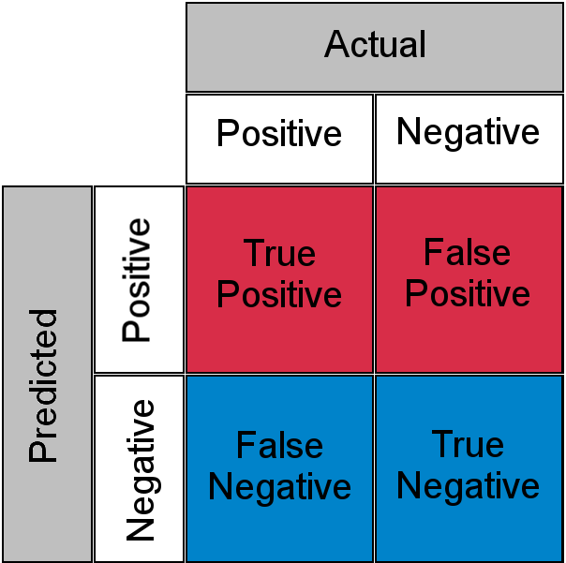
- Python white board (choose 1 per person - answers will vary)
  - Imagine I have a dataset that contains two columns – height and weight. Use pseudocode to do the following: 1) check for nulls 2) remove rows with nulls, 3) filter the data to only return the rows where the weight is over 100 lbs.
  - Imagine I have a dataset that contains ten columns. Use pseudocode to show how you could plot each column in X.
  - Use pseudocode to show how you could try to determine the best number of splits (i.e., depth) in a decision tree.
  - Say we have data saved in 5 csv files. Each csv file contains one column of data. Use pseudocode to show how you could read in the data in each of those files and combine it into one data structure.
  - Imagine X is a dataset that contains two columns – the heights and weights of 100 people. Using pseudocode, calculate the BMI for each person and add that to a new column in the data frame. Note that the formula for BMI is weight/height^2.

- SQL (choose 1 per person)
  - What is an alias in SQL? Why might you use an alias?
    - Aliases are used to give a table, or a column in a table, a temporary name. Aliases are often used to make column names more readable.
  - What SQL commands would allow you to only select dates from 2020-01-01 to 2020-12-31?
    - SELECT date FROM table WHERE date BETWEEN 2020-01-01 AND 2020-12-31
  - What type of join only returns rows that have matching values in both tables involved in the join?
    - Inner join.
  - What wildcard symbol matches zero or more characters?
    - %
  - Name one aggregate function in SQL.
    - AVG, COUNT, MIN, MAX, SUM, FIRST, LAST

