[**Project Description**](https://docs.google.com/document/d/165Cpruk2kLql2ELw0vEBrPL0biWNKjxgTf8vfZZN-ek/edit?usp=sharing)

**Have a purpose.** What problem is the bot going to solve? What is the target audience?

This is all important so that the chatbot can be emotionally rich. How would the audience ask questions? What is the style of language they would use? You want the interface and the language to be familiar to the audience so that they can use it easily.

*Chatbots must understand the intent of the user.*

**Ways to Build.** [Two basic ways:](https://rominirani.com/tutorial-getting-started-with-google-actions-with-api-ai-a3b79550a062) (more info with google)

1. Rule based approach: this involves hard coding the bot.
2. Machine learning: this involves streaming data so bot can learn on own/AI.

**Platform Matters.** Multiple platforms: Facebook Messenger, Slack, Discord, Telegram, Kik

*Question:* Are these the only platforms?

**Services used to build chatbots.** Microsoft Bot frameworks, Wit.ai, Api.ai, IBM Watson

**Development platforms for non programmers.** Chatfuel, Texit.in, Octane AI, Motion AI

[Google Cloud Platform-](https://cloudplatform.googleblog.com/2017/07/how-to-build-a-conversational-app-that-sees-listens-talks-and-translates-using-Cloud-Machine-Learning-APIs-part-1.html) article shows how to create a rule based travel chatbot

[Dialog Flow](https://www.google.com/url?sa=t&rct=j&q=&esrc=s&source=web&cd=3&cad=rja&uact=8&ved=0ahUKEwjN2P63lZDcAhXs5oMKHaJOCgcQwqsBCEswAg&url=https%3A%2F%2Fwww.youtube.com%2Fwatch%3Fv%3D5r4AAIfe4Rw&usg=AOvVaw322i2cOcWlFyWZu69dmJDB) and google video

Definition **NLP**: Neuro-Linguistic Programming.

*From: Complete Guide to Chatbots*

[*https://www.marutitech.com/complete-guide-chatbots/*](https://www.marutitech.com/complete-guide-chatbots/)

**Process:** One developers framework process:

1. The Bot Scope
2. The Chatbot Personality
3. Priority List of Must-Haves
4. The Chatbot Flow

**The Bot Scope:** This is important in the business model. What is it that the business is going to focus on. This gets to the problem being solved and the target audience.

**The Chatbot Personality:** This is key if we are going to be successful in getting users. It needs to fit the audience needs. The emotionally rich question.

**Prioritize the Must-Haves:** How to make this chatbot useful to our customers.

**The Chatbot Flow:** A flow chart that will show how the chatbot will interact with the customer in every situation.

Example of outlining the flow:

1- **Don’t know:** the users says anything the chatbot won’t ever be prepared to answer.

2- **Known category:** the users asks for a category of products the chatbot knows.

3- **Known brand:** the user asks for a category and a brand the chatbot understands.

4- **Known product:** the user asks for a category, a brand and a model the chatbot knows.

This list goes from the chatbot knows nothing to it knows everything and you need to have answers determined for each thing.

For example: scenario 1, “I don’t know anything about that product.” I can help you with these products: a, b, c, d, etc.”

You make a “decision tree”. Many options for different questions. They also talk about hiding “Easter eggs” These are little funny or unexpected things because people like to “play” with chatbots.

*From: Chatbot Magazine*

[*https://chatbotsmagazine.com/design-framework-for-chatbots-aa27060c4ea3*](https://chatbotsmagazine.com/design-framework-for-chatbots-aa27060c4ea3)

**Examples:**

Here is an example of a chatbot embedded in a website:

<https://www.foodnetwork.com/site/apps/chatbot>

100 best bots:

<https://chatbotsmagazine.com/100-best-bots-for-brands-businesses-b4f1fe09112>

**Basics on networking a Chatbot:**

Here is an example with a specific platform/program.

1. Log into your bot account (The case I looked at was twitch).

When you are in your account you need to generate a token. Grab the token and it will generate a key. Connect your twitch bot account to your stream account. Always bot first.

1. Log out of bot account and log into stream account. Do the same thing of connecting stream account to bot account.
2. Test by typing something into the bot to see if it shows up.

See the following you tube videos: <https://www.youtube.com/watch?v=aniVnZ-IwYQ>

<https://www.youtube.com/watch?v=1UF-TIoPEpM>

Not sure what we are using. The videos show features for cloud streaming. I think that is what she wants us to use, but I’m not sure where and how we will host our bot?

**Questions:** They talk about using Twitch bot and then a streaming account. What will we be using. This has everything to do with generating tokens or setting up the connectivity. This has me confused as to what we are doing.

I think for this coming week we need to have a “business” and an idea for our bot and our bot story. This might mean having the decision tree for our bot.

Should we ask her if this is what we need for our video (a decision tree)?

We won’t need to make the decisions work, but I think that is what she is going for.

Then the next series of questions is the platforms and services that we will use to connect the bots to the webpage or service, etc.

**Chatbot and Networks:**

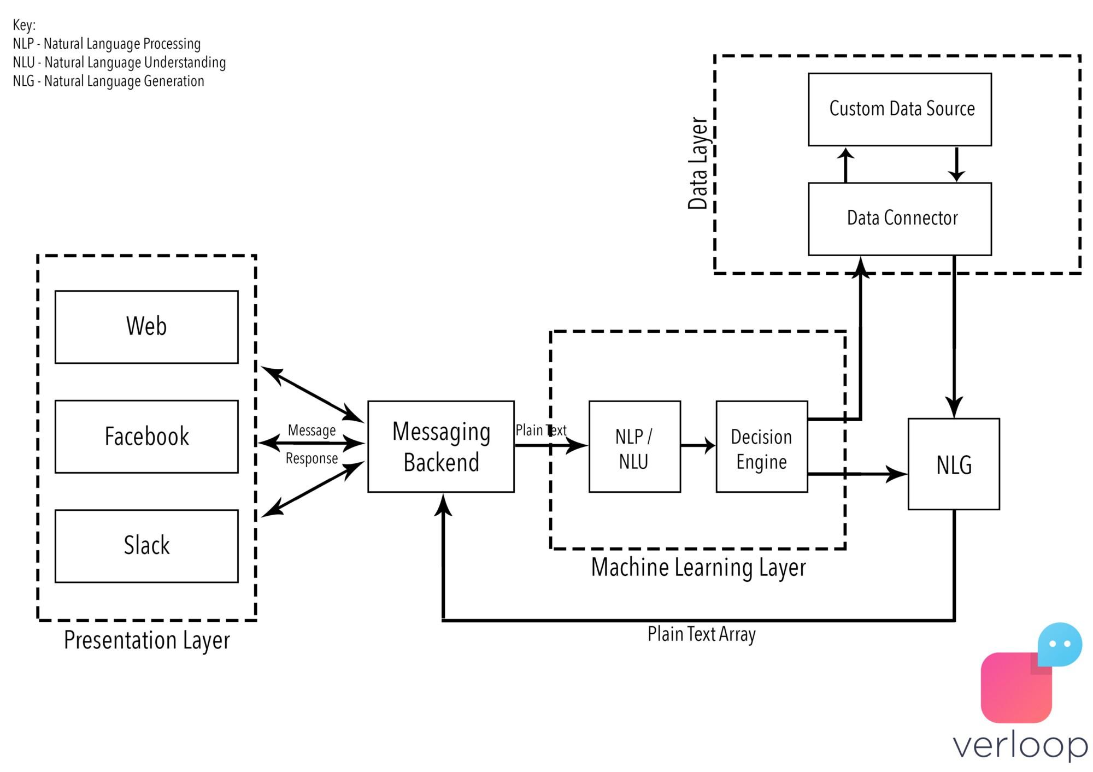

1. You find a product on Facebook’s Messenger, for the sake of consistency, let’s say it’s the same bottle of Tropicana. You only ever see the presentation layer and send the bot a message that is picked up by the backend saying you want some Tropicana.

2. Using Natural Language Processing (what happens when computers read language. NLP processes turn text into structured data) and Natural Language Understanding (a subset of NLP that deals with the more narrow but equally important facet of how to best handle unstructured inputs, like grammatical mistakes or incorrect punctuation), the machine converts this plain text request into codified commands for itself.

3. Now the chatbot throw this data into a decision engine, since in the bots mind it has certain criteria to meet to exit the conversational loop, notably, the quantity of Tropicana you want.

4. Using Natural Language Generation (what happens when computers write language. NLG processes turn structured data into text), much like you did with your mother the bot asks you how much of said Tropicana you wanted.

5. This array of responses goes back into the messaging backend and is presented to you in the form of a question. You tell the bot you want 1 litre and we go back through NLP into the decision engine.

6. The bot now analyzes pre-fed data about the product, stores, their locations and their proximity to your location. It identifies the closest store that has this product in stock and tells you what it costs.

7. It then directs you to a payment portal and after it receives confirmation from gateway, it places your order for you, and voila in one to two business days, you have 1 litre of Tropicana 100% Orange Juice.

# [**Backend Design**](https://chatbotsmagazine.com/backend-design-architecture-practices-for-chatbots-a40817ed5b70)

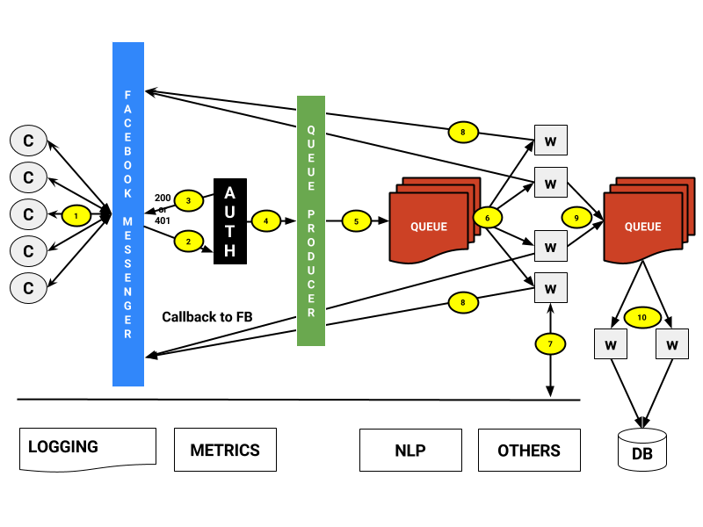

[How to build a Chatbot from scratch](https://medium.com/nativechat/anatomy-of-a-chatbot-how-much-does-it-cost-to-built-one-c7cda85c49e)

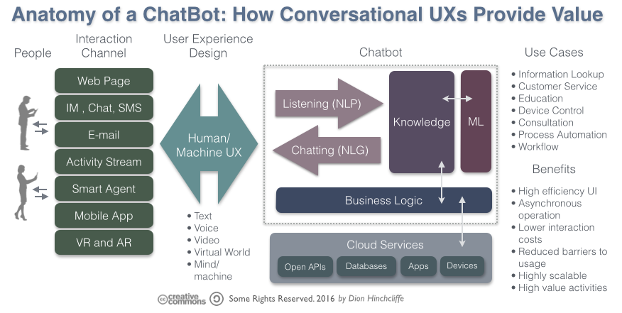

How do back-ends work?

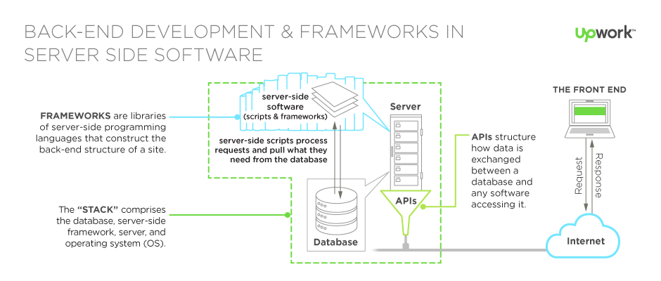

How instant messages work?

Java Notes:

<https://howtodoinjava.com/ai/java-aiml-chatbot-example/>

<https://opensourceforu.com/2017/01/create-your-own-java-based-chat-robot/>

Networking Questions:

How is cloud based networking of a chatbot different from networking LAN?