**Background and Motivation.** *Discuss your motivations and reasons for choosing this project, especially any background or research interests that may have influenced your decision.*

Three years ago, an earthquake on the sea floor of the Pacific put in motion a chain of events that lead to what is believed to be history’s largest release of radioactive materials into the Pacific Ocean. The immediate effects of the quake, and resultant tsunami, were felt by the residents of Japan, particularly those near the Fukushima Dai-ichi nuclear power station, which suffered massive flooding and core melt-down.

While this made international news at the time, scientists are continuing to monitor the long-term environmental implications of this incident. Our group has the opportunity to visualize some of the data collected by Dr. Ken Buesseler’s team, based in Wood’s Hole Oceanographic Institute.

These data describe the radioactivity of the Pacific Ocean at particular time-points of collection and may generate a compelling story of the aftermath of the 2011 earthquake and nuclear power plant disaster. The backbone of the data are 4-dimensional (lat/long, depth, time) measurements of radioactive Cesium. These data can be compared to corresponding  predictions from the model data. Additionally, there are supplemental data on radioactivity of fish and other marine life, collected from ports in Japan.

Our goal is to create visualizations that can be used to inform the public about a significant historical and environmental event, as well as educate them about the safety of their food products, and the scientific method in general.

**Project Objectives.** *Provide the primary questions you are trying to answer with your visualization. What would you like to learn and accomplish? List the benefits.*

1) How did the Fukushima Accident in 2011 affect the waters and sea life of the Pacific Ocean?

2) What is the prediction for the Cesium leaked in the accident to reach the western coast of the US?

**Data.** *From where and how are you collecting your data? If appropriate, provide a link to your data sources.*

The sources of our data are three-fold.

  - Cesium concentration in the water column from 2011 - present

  - Cesium concentration in marine animals (fish, crustaceans, mammals, seaweed, etc..) collected from 2011 - present

* Model Output for prediction of Cs concentrations up to 30yrs in the future

We obtained the data from Ken Buesseler, the lead PI on Fukushima related research at the Wood Hole Oceanographic Institution.

**Data Processing.** *Do you expect to do substantial data cleanup? What quantities do you plan to derive from your data? How will data processing be implemented?*

The data we will be looking at will not be derived, only absolute values (Cs concentrates, and possibly the associated hydrographic properties Temperature, and Salinity). The data is presently in .csv format so the data will be imported with d3.csv and processed from there.

The processing of hydrographic and cesium data will include cleaning up null/invalid/out of range values, as well as structuring into a time dependent, two dimensional grid structure.

Fish Data: The fish data is also in .csv format, but less organized. It will require some cleanup (parsing dates, grouping by fish type, etc…).

**Visualization.** *How will you display your data? Provide some general ideas that you have for the visualization design. Include sketches of your design.*

We propose a dashboard-style model to display several types of inter-related scientific and data.

A timeline at the top will allow the user to navigate the events from the date of the accident to the present. As the user changes the slider, the two visualizations below will update with the data relevant to that time period.

For the fish component, we plan on using a radial layout, which will have distance from source, time, and cs concentrations as the x (or radius), y (or theta) , and z (color) dimensions respectively.

The reasons we opted for a radial layout are as follows:

1) The radial layout is reminiscent of an explosion. So it relates, on a very abstract level, to this idea  of having something emanate from an epicenter and dissipate outwards with time.

  2)It is very conducive to our data since it allows us to explore the three dimensions we have most data on, distance from source, time elapsed and actual property (cs134/137, etc...).

 Because our data is relatively sparse in space, by combining lat and lon into one dimension (absolute distance from source) we can increase the number of points along that axis.

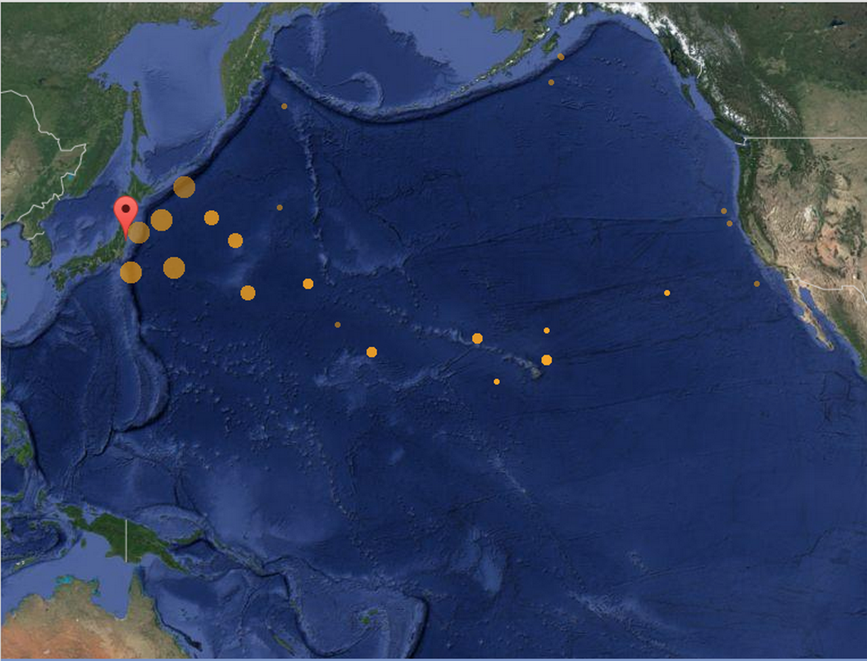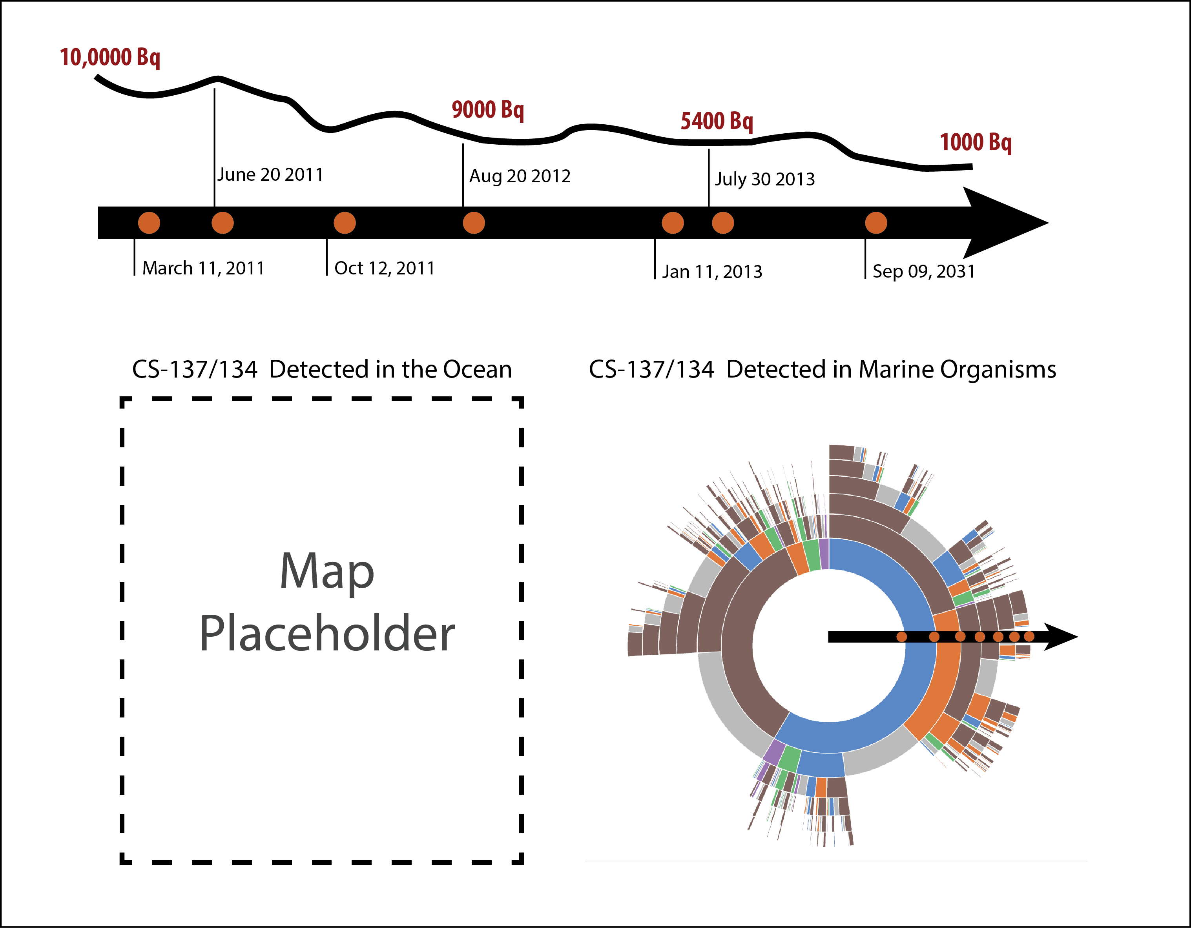

**Must-Have Features.** *These are features without which you would consider your project to be a failure.*

* Timeline of events that user can navigate through to see data specific to a certain event/time period.
* Map visualization depicting the spatio-temporal dispersion of radioactive Cesium, originating from the Fukushima power station.
  + Temporal resolution will be limited by the data collection trips, and categorized in a way that will be visually coherent, and interactive.

**Optional Features.** *Those features which you consider would be nice to have, but not critical.*

* + A layer in the map to allow for the comparison of water measurements with model-predicted values.

**Project Schedule.** *Make sure that you plan your work so that you can avoid a big rush right before the final project deadline, and delegate different modules and responsibilities among your team members. Write this in terms of weekly deadlines.*

Week of Mar 16 -  Data Wrangling, Converge on a layout

Week of Mar 23 - Implement must-have features defined above

Week of Mar 30 - Continue implementation of must have features

Week of Apr 6 - (Prototype Due on Apr 10)

Week of  Apr 13 - Incorporate TF suggestions. Implement Optional Features outlined above.

Week of Apr 20 - Continue implementation of Optional Features

Week of Apr 27 - Work on ScreenCast and final project documentation (Project Due May 1)