Combined analyses

Caitlin Nordheim-Maestas

# Compare Bd-inhibitory potency of the AE biofilms to that of the AE microorganisms

# Load in data and libraries

## read in and clean data  
library(tidyverse) # for cleaning and viewing data  
library(gt) # pretty stats tables  
library(broom) # cleaning for gt  
library(here) # for importing data  
library(car) # stats tests   
library(multcomp) # stats  
library(multcompView) # view cld  
library(emmeans) # for pairwise comparisons, especially on mixed effects models and glms  
library(ggpubr) # for making ggqq plot  
library(patchwork) # for combining figures  
  
# load wrangled data from expt2-4 quarto docs in this repo  
eb_pw_total_diff <- read.csv(here("data", "eb_pw_total_diff.csv"))  
pw_noday0 <- read.csv(here("data", "pw_noday0.csv"))  
eb_ae_bf_only <- read.csv(here("data", "eb_ae_bf_only.csv"))  
ae_noday0 <- read.csv(here("data", "ae_noday0.csv"))  
  
# Colors: these are from Paul Tol's colorblind friendly palette  
with_microbes_40_color <- "#999933"  
no_microbes_.22_color <- "#88ccee"

# Data wrangling for all datasets

# data wrangling for comparisons across experiments  
  
## EBpond water  
pw_WITH_microbes <- eb_pw_total_diff %>%  
 filter(filter != "0.22um_filter") %>%   
 mutate(treatment = "EB_PW_40um") %>%   
 rename(sample_ID = site) %>%   
 dplyr::select(sample_ID, treatment, rate_loss)  
  
## NCOS PW   
ncos_pw_WITH_microbes <- pw_noday0 %>%   
 filter(sample_ID == "PW+microorganism") %>%   
 filter(day != "Day_3" & day != "Day_5") %>%  
 dplyr::select(day, sample_ID, replicate, adh_plus_sup) %>%   
 pivot_wider(names_from = day, values_from = adh_plus_sup) %>%  
# calculate the rate loss by taking the log of each before subtracting  
 mutate(rate_loss = log(Day_1) - log(Day_7)) %>%   
 mutate(treatment = "NCOS_PW_40um") %>%   
 dplyr::select(sample_ID, treatment, rate_loss)  
  
## Field bf  
fieldbf_no_microbes <- eb_ae_bf_only %>% # no need to filter, the only treatment is no microbe water  
 filter(day != "Day_0") %>%   
 dplyr::select(day, site, bd_qty) %>%   
 pivot_wider(names_from = day, values_from = bd_qty) %>%  
# calculate the rate loss by taking the log of each before subtracting  
 mutate(rate_loss = log(Day_1) - log(Day_7)) %>%   
 rename(sample_ID = site) %>%   
 mutate(treatment = "EB_biofilm") %>%   
 dplyr::select(sample_ID, treatment, rate_loss)  
  
## NCOS version 3B ae bf with no microbes  
ncos_ae_no_microbes <- ae_noday0 %>%   
 filter(sample_ID == "PW+AEBiofilm") %>% # this is a "pond water" treatment of filtered pond water  
 filter(day != "Day_3" & day != "Day_5") %>%  
 dplyr::select(day, sample_ID, replicate, adh) %>%   
 pivot_wider(names_from = day, values_from = adh) %>%  
# calculate the rate loss by taking the log of each before subtracting  
 mutate(treatment = "NCOS_biofilm") %>%   
 mutate(rate_loss = log(Day_1) - log(Day_7)) %>%   
 dplyr::select(sample_ID, treatment, rate_loss)  
   
all_parts <- bind_rows(pw_WITH_microbes, fieldbf_no_microbes, ncos_pw_WITH_microbes, ncos_ae_no_microbes) %>%   
 mutate(location = case_when(  
 grepl("^EB", treatment) ~ "EB",  
 grepl("^NCOS", treatment) ~ "NCOS"),  
 medium = case_when(  
 grepl("PW", treatment) ~ "PW",  
 grepl("biofilm", treatment) ~ "biofilm"))  
  
# set PW 40 um as the intercept, comparing back to that one  
all_parts$treatment <- factor(all_parts$treatment,  
 levels = c("EB_PW_40um", "NCOS_PW_40um", "EB_biofilm", "NCOS_biofilm"))

# Stats and assumption testing

## Exploratory viz:

all_parts %>%   
 ggplot(aes(y= rate_loss, x = treatment)) +   
 geom_boxplot() +  
 geom_jitter(alpha = 0.5, width = 0.05) +  
 theme_classic() +  
 theme(legend.position = "bottom",  
 strip.text = element_text(face="bold"),  
 axis.title = element_text(face = "bold")) +  
 xlab("Treatment") +  
 ylab("Rate of Loss of Bd over 7 Days") +   
 ggtitle("Exploratory visualization, not final plot")

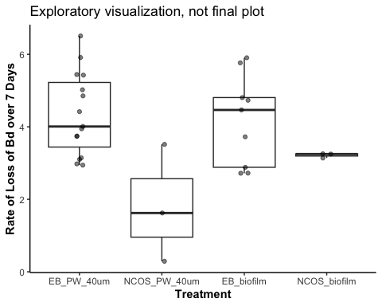

## Assumptions testing

par(mfrow = c(2,2))  
aov_5b <- aov(rate_loss~treatment, data=all_parts)  
plot(aov_5b) # diagnostic plot

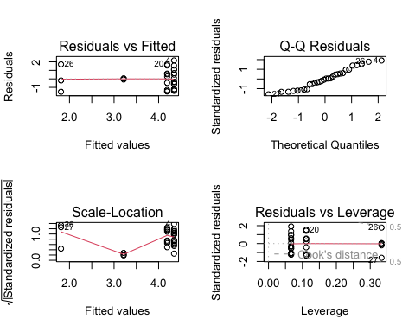

## interpret

# with microbe depleted  
summary(aov_5b) # sig effect of treatment

Df Sum Sq Mean Sq F value Pr(>F)   
treatment 3 18.23 6.077 4.424 0.0122 *  
Residuals 26 35.72 1.374   
---  
Signif. codes: 0 '***' 0.001 '**' 0.01 '*' 0.05 '.' 0.1 ' ' 1

## posthoc

TukeyHSD(aov_5b)

Tukey multiple comparisons of means  
 95% family-wise confidence level  
  
Fit: aov(formula = rate_loss ~ treatment, data = all_parts)  
  
$treatment  
 diff lwr upr p adj  
NCOS_PW_40um-EB_PW_40um -2.5364280 -4.5699791 -0.5028769 0.0104552  
EB_biofilm-EB_PW_40um -0.1544017 -1.5101025 1.2012990 0.9891809  
NCOS_biofilm-EB_PW_40um -1.1302884 -3.1638395 0.9032627 0.4377743  
EB_biofilm-NCOS_PW_40um 2.3820263 0.2384752 4.5255774 0.0252643  
NCOS_biofilm-NCOS_PW_40um 1.4061396 -1.2191635 4.0314428 0.4696326  
NCOS_biofilm-EB_biofilm -0.9758867 -3.1194377 1.1676644 0.6023819

# get compact letter display from the tukey using glht (general linear hypotheses test)  
post_hoc_rateloss <- glht(aov_5b,   
 linfct = mcp(treatment = "Tukey")) # run Tukey  
summary(post_hoc_rateloss) # show the comparisons

Simultaneous Tests for General Linear Hypotheses  
  
Multiple Comparisons of Means: Tukey Contrasts  
  
  
Fit: aov(formula = rate_loss ~ treatment, data = all_parts)  
  
Linear Hypotheses:  
 Estimate Std. Error t value Pr(>|t|)   
NCOS_PW_40um - EB_PW_40um == 0 -2.5364 0.7413 -3.422 0.00953 **  
EB_biofilm - EB_PW_40um == 0 -0.1544 0.4942 -0.312 0.98865   
NCOS_biofilm - EB_PW_40um == 0 -1.1303 0.7413 -1.525 0.42621   
EB_biofilm - NCOS_PW_40um == 0 2.3820 0.7814 3.049 0.02364 *   
NCOS_biofilm - NCOS_PW_40um == 0 1.4061 0.9570 1.469 0.45798   
NCOS_biofilm - EB_biofilm == 0 -0.9759 0.7814 -1.249 0.59136   
---  
Signif. codes: 0 '***' 0.001 '**' 0.01 '*' 0.05 '.' 0.1 ' ' 1  
(Adjusted p values reported -- single-step method)

cld(post_hoc_rateloss) # get compact letter display

EB_PW_40um NCOS_PW_40um EB_biofilm NCOS_biofilm   
 "a" "b" "a" "ab"

# export cld results as a dataframe  
cld_results_rateloss <- cld(post_hoc_rateloss) # get compact letter display (CLD) groupings for treatment comparisons  
labels_rl <- cld_results_rateloss$mcletters$Letters # extract grouping letters from cld object  
treatments_rl <- names(labels_rl) # get the treatment names corresponding to the letters  
labels_rl <- as.character(labels_rl) # set as character  
  
# df with significance data for the rate loss, will use in plotting  
sig_data_rl <- tibble(  
 treatment = treatments_rl, # treatment names from the CLD results  
 y_position = c(7,4,6.5,4), # y position (adjusted manually)  
 label = labels_rl) # CLD group letters for each treatment

# *PUBLICATION FIGURES

myCustomTheme <- function() {  
 theme_light() +  
 theme(axis.text = element_text(size = 7, family = "Helvetica", color = "black"),  
 axis.title.x = element_text(margin = margin(t = 10), size = 7, face = "plain", family = "Helvetica", color = "black"), # Add space between x-axis label and axis  
 axis.title.y = element_text(margin = margin(r = 10), size = 7, face = "plain", family = "Helvetica", color = "black"), # Add space between y-axis label and axis  
 title = element_text(size = 7, face = "bold", family = "Helvetica"),  
 plot.caption = element_text(size = 7, face = "italic", family = "Helvetica"),  
 legend.text = element_text(size = 7, family = "Helvetica"), # Increase legend text size  
 panel.grid = element_blank(), # Remove all grid lines (both major and minor)  
 # axis.line.x = element_line(color = "grey"), # Keep the x-axis line  
 # axis.line.y = element_line(color = "grey"), # Keep the y-axis line  
 axis.ticks = element_line(color = "grey", size = 0.5), # Keep tick markers  
 axis.ticks.x = element_line(color = "grey", size = 0.5), # ensure bottom axis ticks  
 axis.ticks.y = element_line(color = "grey", size = 0.5), # <- ensure side axis ticks  
 strip.text = element_text(size = 7, face = "bold", family = "Helvetica", color = "black"), # Set strip text style  
 strip.background = element_rect(fill = "white", color = "grey", size = 0.5) # Set strip background to white, outline grey  
 )  
}

# sfeb_fig <- sfeb %>%   
# ggplot(aes(y= rate_loss, x = treatment, fill = treatment)) +   
# geom_boxplot() +  
# geom_jitter(alpha = 0.3, width = 0.05) +  
# myCustomTheme() +  
# scale_fill_manual(values = c("EB_PW_40um" = "white",  
# "EB_biofilm" = "darkgrey")) +  
# theme(legend.position = "none",  
# axis.line.x = element_line(color = "grey", size = 0.5), # Keep the x-axis line  
# axis.line.y = element_line(color = "grey", size = 0.5),  
# panel.border = element_blank()) +  
# xlab("Medium") +  
# ylab("Reduction of Bd over 6 days") +   
# scale_x_discrete (labels= c("EB_PW_40um" = "microorganisms\n(n = 15)",  
# "EB_biofilm" = "biofilms\n(n = 9)")) +  
# scale_y_continuous(limits = c(0, 7))  
#   
# sfeb_fig <- sfeb_fig +  
# labs(tag = "A") +  
# theme(  
# plot.tag = element_text(family = "Helvetica", size = 20, face = "plain", hjust = -0.1, vjust = 1),  
# plot.tag.position = c(0, 1)  
# )  
#   
# sfeb_fig  
  
# ncos_fig <- ncos %>%   
# ggplot(aes(y= rate_loss, x = treatment, fill = treatment)) +   
# geom_boxplot() +  
# geom_jitter(alpha = 0.3, width = 0.05) +  
# myCustomTheme() +  
# scale_fill_manual(values = c("NCOS_PW_40um" = "white",  
# "NCOS_biofilm" = "darkgrey")) +  
# theme(legend.position = "none",  
# axis.line.x = element_line(color = "grey", size = 0.5), # Keep the x-axis line  
# axis.line.y = element_line(color = "grey", size = 0.5),  
# panel.border = element_blank()) +  
# xlab("Medium") +  
# ylab("Reduction of Bd over 6 days") +   
# scale_x_discrete (labels= c("NCOS_PW_40um" = "microorganisms\n(triplicates)",  
# "NCOS_biofilm" = "biofilms\n(triplicates)")) +  
# scale_y_continuous(limits = c(0, 7))  
#   
# ncos_fig <- ncos_fig +  
# labs(tag = "B") +  
# theme(  
# plot.tag = element_text(family = "Helvetica", size = 20, face = "plain", hjust = -0.1, vjust = 1),  
# plot.tag.position = c(0, 1)  
# )  
#   
# ncos_fig

## Fig 6

all_parts$treatment <- factor(all_parts$treatment)   
   
si_alltreat <- all_parts %>%   
 mutate(site = case_when(  
 grepl("NCOS", treatment) ~ "Santa Barbara",  
 TRUE ~ "East Bay" # Default to "east Bay"  
 )) %>%   
 ggplot(aes(y= rate_loss, x = treatment, fill = medium)) +  
 geom_boxplot() +  
 geom_jitter(alpha = 0.3, width = 0.05) +  
 myCustomTheme() +  
 # biofilm and pond water colors, both from paul tol colorblind palette  
 scale_fill_manual(values = c("PW" = "white",  
 "Biofilm" = "darkgrey")) +  
 #facet_wrap(~site, scales = "free_x") +  
 theme(legend.position = "none",  
 axis.line.x = element_line(color = "grey", size = 0.5), # Keep the x-axis line  
 axis.line.y = element_line(color = "grey", size = 0.5)) +  
 xlab("Treatment") +  
 ylab("Rate loss of Bd over 6 Days") +   
 scale_x_discrete (limits = c("EB_PW_40um", "EB_biofilm",   
 "NCOS_PW_40um", "NCOS_biofilm"), # Specify the order  
 labels= c(  
 "EB_PW_40um" = "East Bay\nPW + MO",  
 "NCOS_PW_40um" = "SB \nPW + MO",  
 "EB_biofilm" = "East Bay\nBiofilm",  
 "NCOS_biofilm" = "SB \nBiofilm")) +  
 scale_y_continuous(limits = c(0, 8)) # Set y-axis limits from 0 to 8

Warning: The `size` argument of `element_line()` is deprecated as of ggplot2 3.4.0.  
ℹ Please use the `linewidth` argument instead.

Warning: The `size` argument of `element_rect()` is deprecated as of ggplot2 3.4.0.  
ℹ Please use the `linewidth` argument instead.

sig_data_rl <- sig_data_rl %>%   
 mutate(site = case_when(  
 grepl("NCOS", treatment) ~ "Santa Barbara",  
 TRUE ~ "East Bay" # Default to "east Bay"  
 ))  
  
si_alltreat <- si_alltreat +   
 geom_text(data = sig_data_rl,   
 aes(x = treatment, y = y_position, label = label, group = site),   
 inherit.aes = FALSE,   
 size = 2.4) # Set fixed text size outside of aes()  
  
si_alltreat

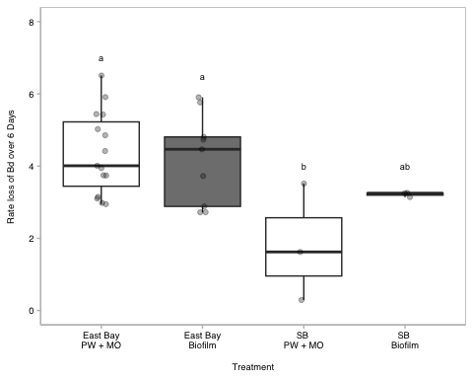

#ggsave("paper-figures/SI_combined-expts.pdf", plot = si_alltreat , width = 3.46, height = 3.46)

# Appendix

### Stats tables

anova table

# anova table  
anova_output <- tidy(aov_5b)  
  
aov_5b_tbl <- anova_output %>%  
 dplyr::select(term, df, sumsq, meansq, statistic, p.value) %>%  
 gt() %>%  
 tab_header(  
 title = "5b ANOVA Table"  
 ) %>%  
 fmt_number(  
 columns = c(sumsq, meansq, statistic),  
 decimals = 2  
 ) %>%  
 cols_label(  
 term = "Term",  
 df = "Df",  
 sumsq = "Sum Sq",  
 meansq = "Mean Sq",  
 statistic = "F value",  
 p.value = "P-value"  
 ) %>% # scientific number format for values <0.001 in p values  
 fmt_scientific(  
 columns = c(p.value),  
 decimals = 1,  
 rows = p.value < 0.001  
 ) %>%  
 # 3 decimals for p values >=0.001  
 fmt_number(  
 columns = c(p.value),  
 decimals = 3,  
 rows = p.value >= 0.001  
 )  
aov_5b_tbl

Table 1: 5b ANOVA Table

| Term | Df | Sum Sq | Mean Sq | F value | P-value |
| --- | --- | --- | --- | --- | --- |
| treatment | 3 | 18.23 | 6.08 | 4.42 | 0.012 |
| Residuals | 26 | 35.72 | 1.37 | NA | NA |

# prettier, simplified  
anova_output <- tidy(aov_5b)  
  
# Modify term to include degrees of freedom in *italics*  
anova_output <- anova_output %>%  
 mutate(term = ifelse(grepl("day:medium", term), "day x medium", term)) %>%   
 mutate (term = paste0(term, " (*df = ", df, ", ", anova_output[df == max(df), "df"], "*)")) %>%   
 filter(term != "Residuals (*df = 26, 26*)")  
  
# Create the gt table with selected columns  
aov_5b_tbl_b <- anova_output %>%  
 dplyr::select(term, statistic, p.value) %>%  
 gt() %>%  
 tab_header(  
 title = "5b ANOVA Table"  
 ) %>%  
 fmt_markdown(  
 columns = c(term)  
 ) %>%  
 fmt_number(  
 columns = c(statistic),  
 decimals = 2  
 ) %>%  
 cols_label(  
 term = "",  
 statistic = "F value",  
 p.value = "P-value"  
 ) %>%  
 fmt_scientific(  
 columns = c(p.value),  
 decimals = 1,  
 rows = p.value < 0.001  
 ) %>%  
 fmt_number(  
 columns = c(p.value),  
 decimals = 3,  
 rows = p.value >= 0.001  
 )  
  
aov_5b_tbl_b

Table 1: 5b ANOVA Table

|  | F value | P-value |
| --- | --- | --- |
| treatment (*df = 3, 26*) | 4.42 | 0.012 |

## Alternate data method: Updated stats May 2025: 2 t-tests, one for each site

New plan: Renwei requests 2 t-tests, with one for each site

**Results: There is no significant difference in the rate loss of Bd between AE microorganisms and AE biofilms within the SFEB sites (t = 0.31125, df = 22, p-value = 0.7585). There is also no significant difference in the rate loss of Bd between AE microorganisms and AE biofilms within the SBNCOS sites (t = -1.5014, df = 4, p-value = 0.2077)**

## SFEB t-test

sfeb <- all_parts %>%   
 filter(grepl("eb_", treatment, ignore.case = TRUE))  
  
# test for homogeneity of variance  
leveneTest(rate_loss ~ factor(treatment), data = sfeb) # p = 0.9628; var are similar yay!

Levene's Test for Homogeneity of Variance (center = median)  
 Df F value Pr(>F)  
group 1 0.0873 0.7704  
 22

# assumptions testing  
sfeb %>%   
 ggqqplot("rate_loss") # good

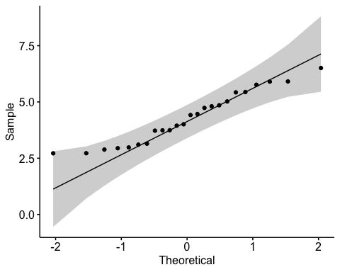

shapiro.test(sfeb$rate_loss) # normal, yay! (p-value = 0.1792)

Shapiro-Wilk normality test  
  
data: sfeb$rate_loss  
W = 0.94183, p-value = 0.1792

t.test(rate_loss ~ treatment, data = sfeb, var.equal = TRUE)

Two Sample t-test  
  
data: rate_loss by treatment  
t = 0.31125, df = 22, p-value = 0.7585  
alternative hypothesis: true difference in means between group EB_PW_40um and group EB_biofilm is not equal to 0  
95 percent confidence interval:  
 -0.8744001 1.1832035  
sample estimates:  
mean in group EB_PW_40um mean in group EB_biofilm   
 4.345978 4.191576

## NCOS t-test

ncos <- all_parts %>%   
 filter(grepl("ncos_", treatment, ignore.case = TRUE))  
  
# test for homogeneity of variance  
leveneTest(rate_loss ~ factor(treatment), data = ncos) # p = 0.1394; var are similar yay!

Levene's Test for Homogeneity of Variance (center = median)  
 Df F value Pr(>F)  
group 1 3.3902 0.1394  
 4

str(ncos)

'data.frame': 6 obs. of 5 variables:  
 $ sample_ID: chr "PW+microorganism" "PW+microorganism" "PW+microorganism" "PW+AEBiofilm" ...  
 $ treatment: Factor w/ 4 levels "EB_PW_40um","NCOS_PW_40um",..: 2 2 2 4 4 4  
 $ rate_loss: num 1.622 3.516 0.291 3.249 3.258 ...  
 $ location : chr "NCOS" "NCOS" "NCOS" "NCOS" ...  
 $ medium : chr "PW" "PW" "PW" "biofilm" ...

# assumptions testing  
sfeb %>%   
 ggqqplot("rate_loss") # good



shapiro.test(ncos$rate_loss) # barely did not pass but the qqplot is gorgeous so we will proceed (p-value = 0.04348)...also such a teeny sample size the shapiro isn't the best fit here anyway

Shapiro-Wilk normality test  
  
data: ncos$rate_loss  
W = 0.78564, p-value = 0.04348

t.test(rate_loss ~ treatment, data = ncos, var.equal = TRUE)

Two Sample t-test  
  
data: rate_loss by treatment  
t = -1.5014, df = 4, p-value = 0.2077  
alternative hypothesis: true difference in means between group NCOS_PW_40um and group NCOS_biofilm is not equal to 0  
95 percent confidence interval:  
 -4.006392 1.194113  
sample estimates:  
mean in group NCOS_PW_40um mean in group NCOS_biofilm   
 1.809550 3.215689

combined <- all_parts %>%   
 mutate(  
 medium = factor(medium), # convert to factor first  
 medium = fct_relevel(medium, "PW", "Biofilm"), # pond water first  
 # rename the location so it shows up correct in the facet   
 location = case_when(  
 location == "EB" ~ "SFEB",  
 location == "NCOS" ~ "SBNCOS",  
 TRUE ~ location)) %>%  
 ggplot(aes(y= rate_loss, x = medium, fill = medium)) +   
 geom_boxplot() +  
 geom_jitter(alpha = 0.3, width = 0.05) +  
 myCustomTheme() +  
 scale_fill_manual(values = c("PW" = "white",  
 "Biofilm" = "darkgrey")) +  
 theme(legend.position = "none",  
 axis.line.x = element_line(color = "grey", size = 0.5), # Keep the x-axis line  
 axis.line.y = element_line(color = "grey", size = 0.5),  
 panel.border = element_rect(color = "gray", size = 0.5, fill = NA)) +  
 xlab(NULL) +  
 ylab("Reduction of Bd over 6 days") +   
 scale_x_discrete (labels= c("PW" = "microorganisms",  
 "Biofilm" = "biofilms")) +  
 facet_wrap(~location) +  
 scale_y_continuous(limits = c(0, 7))

Warning: There was 1 warning in `mutate()`.  
ℹ In argument: `medium = fct_relevel(medium, "PW", "Biofilm")`.  
Caused by warning:  
! 1 unknown level in `f`: Biofilm

combined

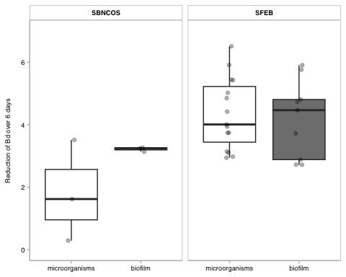

#ggsave("paper-figures/combined-expts_fig5_updated_NO SIG MARKERS.pdf", plot = combined , width = 3.46, height = 3.46)  
  
ns_data <- data.frame(  
 location = c("SFEB", "SBNCOS"),  
 x_start = 1, # corresponds to "PW"  
 x_end = 2, # corresponds to "Biofilm"  
 y = c(6.8,4.2), # where on Y we want the bar  
 label = "ns"  
)  
  
fig5_withNS <- combined +  
 geom_segment(data = ns_data,  
 aes(x = x_start, xend = x_end, y = y, yend = y),  
 inherit.aes = FALSE,  
 linewidth = 0.5) +  
 geom_text(data = ns_data,  
 aes(x = 1.5, y = y + 0.2, label = label),  
 inherit.aes = FALSE,  
 size = 3,  
 fontface = "plain")  
  
fig5_withNS

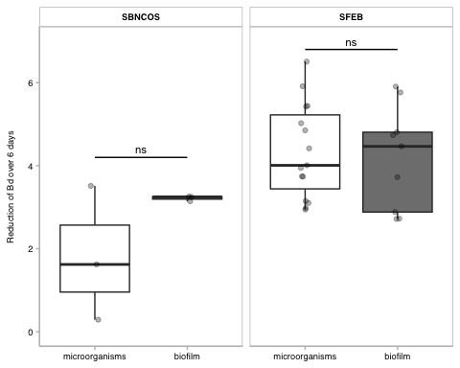

#ggsave("paper-figures/combined-expts_fig5_updated_SIG MARKERS.pdf", plot = fig5_withNS, width = 3.46, height = 3.46)