3A & B: AE Biofilm

Caitlin Nordheim-Maestas

# Experiment 3: Assessment of AE biofilms’ inhibitory impact on Bd

Data wrangling and analysis the AE biofilms using the SFEB (San Francisco East Bay) biofilms for part A (nicknamed “nine sites” in our lab) and the follow up experiment part B with SBNCOS (Santa Barbara North Campus Open Space) biofilm samples. These are the data presented in Figure 4A and 4B in the manuscript, and information is under the section “Experiment 3”.

# Load in data and libraries

## read in and clean data  
library(tidyverse) # for cleaning and viewing data  
library(gt) # pretty stats tables  
library(broom) # cleaning for gt  
library(here) # for importing data  
library(car) # stats tests  
library(multcompView) # view cld  
library(multcomp) # stats  
library(nlme) # mixed effects models  
library(emmeans) # for pairwise comparisons, especially on mixed effects models and glms  
library(ggpubr) # for making ggqq plot  
library(patchwork) # for combining figures  
  
# import data for SFEB  
ns_biofilm_bd <- read.csv(here("data", "nine-sites-biofilm-on-Bd - Sheet1.csv"))  
# import data for SBNCOS  
fig_3b_raw <- read.csv(here("data", "final_NCOS_2024_reformatted_for_R.xlsx - Fig3B.csv"))  
  
# Colors: these are from Paul Tol's colorblind friendly palette  
with_microbes_40_color <- "#999933"  
no_microbes_.22_color <- "#88ccee"  
  
# set up custom theme  
myCustomTheme <- function() {  
 theme_light() +  
 theme(axis.text = element_text(size = 7, family = "Helvetica", color = "black"),  
 axis.title.x = element_text(margin = margin(t = 10), size = 7, face = "bold", family = "Helvetica", color = "black"), # Add space between x-axis label and axis  
 axis.title.y = element_text(margin = margin(r = 10), size = 7, face = "bold", family = "Helvetica", color = "black"), # Add space between y-axis label and axis  
 title = element_text(size = 7, face = "bold", family = "Helvetica"),  
 plot.caption = element_text(size = 7, face = "italic", family = "Helvetica"),  
 legend.text = element_text(size = 7, family = "Helvetica"), # Increase legend text size  
 panel.grid = element_blank(), # Remove all grid lines (both major and minor)  
 # axis.line.x = element_line(color = "grey"), # Keep the x-axis line  
 # axis.line.y = element_line(color = "grey"), # Keep the y-axis line  
 axis.ticks = element_line(color = "grey", size = 0.5), # Keep tick markers  
 strip.text = element_text(size = 7, face = "bold", family = "Helvetica", color = "black"), # Set strip text style  
 strip.background = element_rect(fill = "white", color = "grey", size = 0.5) # Set strip background to white, outline grey  
 )  
}

# 3A

Effect of the East Bay aquatic environmental biofilm on Bd growth - “9 sites”

Does the difference in rate loss of Bd in the **adherent** AE biofilm from day 1 to day 7 differ between the two filter types?

## 3A Data Wrangling

eb_ae <- ns_biofilm_bd # rename  
  
# set as factors with levels so they appear in order in plots later  
eb_ae$site <- factor(eb_ae$site,  
 levels = c("CABIN", "GRAMPS", "WEST", "GDPND005", "GDPND006", "GDPND009", "PRPND004", "PRPND009", "PRPND010"))  
eb_ae$bd_location <- factor(eb_ae$bd_location, levels = c("supernatant", "biofilm")) # set bd location as factor  
eb_ae$day <- factor(eb_ae$day, levels = c("Day_0", "Day_1", "Day_7")) # set day as factor  
  
# Biofilm only, no supernatant, and days 1 and 7 only, no day 0  
eb_ae_bf_only <- eb_ae %>%   
 filter(bd_location == "biofilm") %>% # only the adherent fraction  
 filter(day != "Day_0") %>% # no day 0 data, decided by Renwei  
 mutate(log_qty = log(bd_qty)) # log transform (no plus one because no zeroes)  
  
# export clean data  
write.csv(eb_ae_bf_only, "data/eb_ae_bf_only.csv", row.names = FALSE)

## EDA

## Stats and assumption testing

Question:

Does the amount of Bd in the biofilm differ between day 1 and day 7?

The samples are essentially paired by site, so a paired t-test is most appropriate

$H0:μ_{differenceinBd}=0$

Assumptions:

Assumes that the observations from each group represent a random sample from the population. Assumes that the difference of the two observations follow a normal distribution.

Check assumptions

# check normality of the differences across groups let's try untransformed  
eb_ae_bf_only %>%   
 ggqqplot("bd_qty", title = "Untransformed Bd loads") +  
 facet_wrap(~day) # gotta transform the data, day 1 is not normal

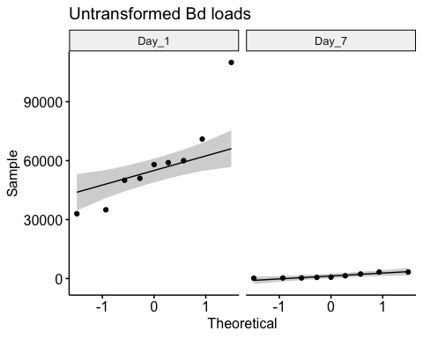

eb_ae_bf_only %>%   
 ggqqplot("log_qty", title = "Transformed Bd loads") +  
 facet_wrap(~day) # not perfect but closer

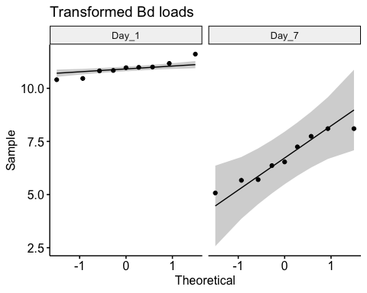

# Shapiro tests  
day_one <- eb_ae_bf_only %>%   
 filter(day == "Day_1") %>% # filter to only include day 1  
 pull(log_qty)  
  
shapiro.test(day_one) # p >> 0.05, it's normal!

Shapiro-Wilk normality test  
  
data: day_one  
W = 0.93796, p-value = 0.5606

day_seven <- eb_ae_bf_only %>%   
 filter(day == "Day_7") %>% # filter to only include day 7  
 pull(log_qty)  
  
shapiro.test(day_seven) # p >> 0.05, it's normal!

Shapiro-Wilk normality test  
  
data: day_seven  
W = 0.92235, p-value = 0.412

Stats

# Step 3: run the paired t-test  
t.test(day_one, day_seven, paired = TRUE)

Paired t-test  
  
data: day_one and day_seven  
t = 10.094, df = 8, p-value = 7.915e-06  
alternative hypothesis: true mean difference is not equal to 0  
95 percent confidence interval:  
 3.233993 5.149159  
sample estimates:  
mean difference   
 4.191576

**There is significantly more Bd in the biofilm on Day 1 than on Day 7 (t = 10.094, df = 8, p-value < 0.0001)**

# 3b NCOS AE biofilm

All microbe-depleted, NO pw microbe+ treatment. There is a treatment of tryptone broth.

## 3b Data wrangling

ae <- fig_3b_raw %>%   
 rename(sample_ID = Adherent.sample.ID) %>% # cleaner name  
 mutate(TB = case_when( # add column for TB or no  
 str_detect(sample_ID, "TB") ~ "y",  
 TRUE ~ "n")) %>%   
 mutate(PW = case_when( # add column for PW (pond water) or no  
 str_detect(sample_ID, "PW") ~ "y",  
 TRUE ~ "n")) %>%   
 mutate(day = case_when( # cleaner day name  
 day == 1 ~ "Day_1",  
 day == 3 ~ "Day_3",  
 day == 5 ~ "Day_5",  
 day == 7 ~ "Day_7",  
 day == 0 ~ "Day_0")) %>%   
 mutate(day = factor(day)) %>% # day as a factor  
 mutate(day_numeric = as.numeric(gsub("Day_", "", as.character(day)))) # day as numeric for plotting  
  
# control data for ae  
ae_control_data <- ae %>%   
 filter(day == "Day_0") %>% # no initial dose amount   
 mutate(day_numeric = as.numeric(gsub("Day_", "", as.character(day)))) %>% # day as numeric for plotting  
 dplyr::select(day, adh, day_numeric) # select only needed columns  
  
ae_summary <- ae %>%  
 group_by(day, sample_ID) %>% # this groups all the replicates of the same day and treatment together  
 reframe(mean = mean(adh), # calculate the mean  
 n = length(adh), # count the number of observations within the day and sample id  
 df = n - 1, # calculate the degrees of freedom  
 sd = sd(adh), # calculate the standard deviation  
 se = sd/sqrt(n)) %>% # calculate the standard error  
 ## Now that it is in a new summarized format, recreate the columns made above  
 mutate(TB = case_when(str_detect(sample_ID, "TB") ~ "y", TRUE ~ "n")) %>% # add column for TB or no  
 mutate(PW = case_when(str_detect(sample_ID, "PW") ~ "y", TRUE ~ "n")) %>% # add column for PW or no  
 mutate(day_numeric = as.numeric(gsub("Day_", "", as.character(day)))) # day as numeric for plotting  
  
ae_noday0 <- ae %>%   
 filter(day != "Day_0") %>% # no initial dose amount   
 mutate(log_adh = log(adh)) %>% # note: no zeroes so not log + 1'# column for medium  
 mutate(medium = sample_ID) # medium  
  
write.csv(ae_noday0, "data/ae_noday0.csv", row.names = FALSE)

## 3b EDA

Caitlin’s version AE

ae_summary %>%  
 # reorder to match Renwei's plot  
 mutate(sample_ID = factor(sample_ID,  
 levels = c("1%TB+AEbiofilm", "MQ+AEbiofilm",  
 "PW+AEBiofilm", "Added Bd" ))) %>%  
 ggplot(aes(x = day_numeric,  
 y = mean,  
 color = sample_ID)) +  
 geom_point(size = 2) +  
 geom_errorbar(aes(ymin = mean - se, # plot the standard error  
 ymax = mean + se),  
 width = 0.1) +  
 geom_line() +  
 scale_y_log10(limits = c(1e3, 1e7),  
 breaks = c(1e3, 1e4, 1e5, 1e6, 1e7)) +  
 # vibes  
 labs(x = "Day",  
 y = "Bd Quantity in AE Biofilm (ZE/well)",  
 color = "Medium with\nAE Biofilm")+ # Title for color legend  
  
 scale_color_manual(values = c("1%TB+AEbiofilm"= "#4477AA",  
 "MQ+AEbiofilm" = "#228833",  
 #"Added Bd" = "darkgrey",  
 "PW+AEBiofilm" = "#AA3377"),  
 labels = c("1%TB+AEbiofilm" = "TB Broth",  
 "MQ+AEbiofilm" = "MQ Water",  
 "PW+AEBiofilm" = "Filtered\nPond Water",  
 "Added Bd" = "Initial Bd")) + # Custom labels  
  
 myCustomTheme()+  
 scale_x_continuous(breaks = c(0, 1, 3, 5, 7),  
 labels = c("Initial\nBd", "1", "3", "5", "7"))

Warning: The `size` argument of `element_line()` is deprecated as of ggplot2 3.4.0.  
ℹ Please use the `linewidth` argument instead.

Warning: The `size` argument of `element_rect()` is deprecated as of ggplot2 3.4.0.  
ℹ Please use the `linewidth` argument instead.

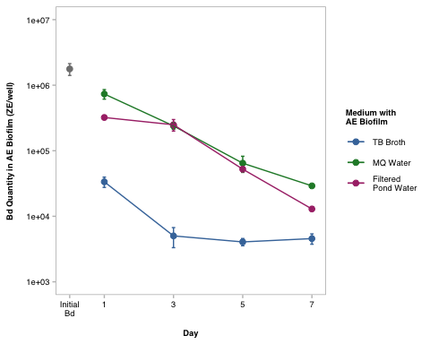

visualize y var: bd load

# untransformed  
ggqqplot(ae_noday0, "adh", title = "untransformed")

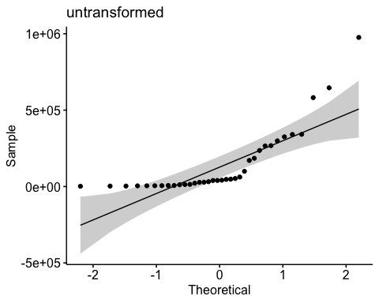

shapiro.test(ae_noday0$adh) # nope

Shapiro-Wilk normality test  
  
data: ae_noday0$adh  
W = 0.69154, p-value = 2.089e-07

# transformed  
ggqqplot(ae_noday0, "log_adh", title = "log transformed") # gorgeous

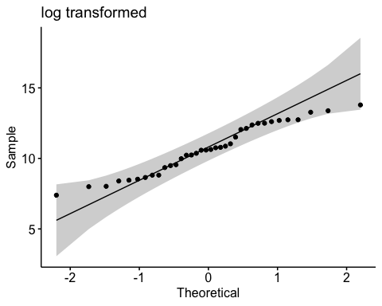

shapiro.test(ae_noday0$log_adh) # p-value = 0.1699 def normal

Shapiro-Wilk normality test  
  
data: ae_noday0$log_adh  
W = 0.95671, p-value = 0.1699

## 3b Stats

y var: amount of Bd in adherent

x vars: day & medium with the AE biofilm and Bd (MQ, TB, PW)

Bd ~ day*medium

Question: Does the amount of Bd in the aquatic environmental biofilm differ across the media tested and across the days, and do they interact with each other?

Model: 2-way ANOVA

**Summary of results**

Bd qty Day 1 > Day 3 > Day 5 > Day 7 (all p <0.005) in other words, Bd significantly reduced each day

MQ+AEbiofilm > PW+AEBiofilm > 1%TB+AEbiofilm (all p <0.005) In other words, TB plus biofilm has most Bd inhibition power, followed by pond water, then by milliQ with the least inhibition power

null

null <- lm(log_adh ~ 1,  
 data = ae_noday0)  
AIC(null) #146.5865

[1] 146.5865

## Bd ~ day*medium

Note: Not perfectly homoskedstic but “good enough”

# set day 1 as reference  
ae_noday0$day <- factor(ae_noday0$day, levels = c("Day_1", "Day_3", "Day_5", "Day_7")) # set as factor  
ae_noday0$day <- relevel(ae_noday0$day, ref = "Day_1") # set as reference  
  
# set MQ as reference  
ae_noday0$sample_ID <- factor(ae_noday0$sample_ID) # set as factor  
ae_noday0$sample_ID <- relevel(ae_noday0$sample_ID, ref = "MQ+AEbiofilm") # set as reference  
  
# build model  
aov_3b <- aov(log_adh ~ day*medium, data = ae_noday0)  
  
# diagnostic plot  
par(mfrow = c(2,2))  
plot(aov_3b) # diagnostic plot

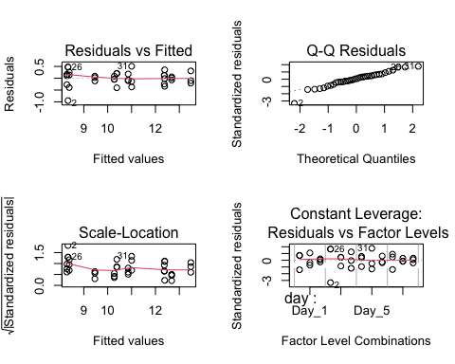

# look at results  
summary(aov_3b)

Df Sum Sq Mean Sq F value Pr(>F)   
day 3 40.24 13.413 110.10 3.64e-14 ***  
medium 2 60.07 30.036 246.55 < 2e-16 ***  
day:medium 6 7.42 1.236 10.14 1.30e-05 ***  
Residuals 24 2.92 0.122   
---  
Signif. codes: 0 '***' 0.001 '**' 0.01 '*' 0.05 '.' 0.1 ' ' 1

anova(aov_3b) # all significant and interaction sig

Analysis of Variance Table  
  
Response: log_adh  
 Df Sum Sq Mean Sq F value Pr(>F)   
day 3 40.239 13.4129 110.100 3.642e-14 ***  
medium 2 60.073 30.0364 246.553 < 2.2e-16 ***  
day:medium 6 7.415 1.2359 10.145 1.301e-05 ***  
Residuals 24 2.924 0.1218   
---  
Signif. codes: 0 '***' 0.001 '**' 0.01 '*' 0.05 '.' 0.1 ' ' 1

AIC(aov_3b) # 37.78083 better than null

[1] 37.78083

### Posthoc

Using a Tukey test on the anova model

# post hoc  
TukeyHSD(aov_3b)

Tukey multiple comparisons of means  
 95% family-wise confidence level  
  
Fit: aov(formula = log_adh ~ day * medium, data = ae_noday0)  
  
$day  
 diff lwr upr p adj  
Day_3-Day_1 -1.1493419 -1.603234 -0.6954497 0.0000018  
Day_5-Day_1 -2.1306208 -2.584513 -1.6767286 0.0000000  
Day_7-Day_1 -2.8046545 -3.258547 -2.3507623 0.0000000  
Day_5-Day_3 -0.9812789 -1.435171 -0.5273867 0.0000210  
Day_7-Day_3 -1.6553126 -2.109205 -1.2014204 0.0000000  
Day_7-Day_5 -0.6740337 -1.127926 -0.2201415 0.0021838  
  
$medium  
 diff lwr upr p adj  
MQ+AEbiofilm-1%TB+AEbiofilm 2.9323391 2.5764935 3.28818480 0.0000000  
PW+AEBiofilm-1%TB+AEbiofilm 2.4957994 2.1399538 2.85164510 0.0000000  
PW+AEBiofilm-MQ+AEbiofilm -0.4365397 -0.7923854 -0.08069402 0.0142222  
  
$`day:medium`  
 diff lwr upr  
Day_3:1%TB+AEbiofilm-Day_1:1%TB+AEbiofilm -2.04493896 -3.07249206 -1.01738586  
Day_5:1%TB+AEbiofilm-Day_1:1%TB+AEbiofilm -2.09173123 -3.11928433 -1.06417813  
Day_7:1%TB+AEbiofilm-Day_1:1%TB+AEbiofilm -1.99414642 -3.02169952 -0.96659332  
Day_1:MQ+AEbiofilm-Day_1:1%TB+AEbiofilm 3.09761537 2.07006227 4.12516848  
Day_3:MQ+AEbiofilm-Day_1:1%TB+AEbiofilm 1.98759548 0.96004238 3.01514858  
Day_5:MQ+AEbiofilm-Day_1:1%TB+AEbiofilm 0.61984147 -0.40771163 1.64739458  
Day_7:MQ+AEbiofilm-Day_1:1%TB+AEbiofilm -0.10651243 -1.13406553 0.92104068  
Day_1:PW+AEBiofilm-Day_1:1%TB+AEbiofilm 2.29587354 1.26832044 3.32342665  
Day_3:PW+AEBiofilm-Day_1:1%TB+AEbiofilm 2.00280682 0.97525371 3.03035992  
Day_5:PW+AEBiofilm-Day_1:1%TB+AEbiofilm 0.47351640 -0.55403671 1.50106950  
Day_7:PW+AEBiofilm-Day_1:1%TB+AEbiofilm -0.91981565 -1.94736875 0.10773746  
Day_5:1%TB+AEbiofilm-Day_3:1%TB+AEbiofilm -0.04679227 -1.07434537 0.98076083  
Day_7:1%TB+AEbiofilm-Day_3:1%TB+AEbiofilm 0.05079254 -0.97676056 1.07834564  
Day_1:MQ+AEbiofilm-Day_3:1%TB+AEbiofilm 5.14255433 4.11500123 6.17010744  
Day_3:MQ+AEbiofilm-Day_3:1%TB+AEbiofilm 4.03253444 3.00498134 5.06008754  
Day_5:MQ+AEbiofilm-Day_3:1%TB+AEbiofilm 2.66478043 1.63722733 3.69233354  
Day_7:MQ+AEbiofilm-Day_3:1%TB+AEbiofilm 1.93842653 0.91087343 2.96597964  
Day_1:PW+AEBiofilm-Day_3:1%TB+AEbiofilm 4.34081250 3.31325940 5.36836561  
Day_3:PW+AEBiofilm-Day_3:1%TB+AEbiofilm 4.04774578 3.02019267 5.07529888  
Day_5:PW+AEBiofilm-Day_3:1%TB+AEbiofilm 2.51845536 1.49090225 3.54600846  
Day_7:PW+AEBiofilm-Day_3:1%TB+AEbiofilm 1.12512331 0.09757021 2.15267642  
Day_7:1%TB+AEbiofilm-Day_5:1%TB+AEbiofilm 0.09758481 -0.92996829 1.12513791  
Day_1:MQ+AEbiofilm-Day_5:1%TB+AEbiofilm 5.18934660 4.16179350 6.21689970  
Day_3:MQ+AEbiofilm-Day_5:1%TB+AEbiofilm 4.07932671 3.05177361 5.10687981  
Day_5:MQ+AEbiofilm-Day_5:1%TB+AEbiofilm 2.71157270 1.68401960 3.73912581  
Day_7:MQ+AEbiofilm-Day_5:1%TB+AEbiofilm 1.98521880 0.95766570 3.01277191  
Day_1:PW+AEBiofilm-Day_5:1%TB+AEbiofilm 4.38760477 3.36005167 5.41515788  
Day_3:PW+AEBiofilm-Day_5:1%TB+AEbiofilm 4.09453805 3.06698494 5.12209115  
Day_5:PW+AEBiofilm-Day_5:1%TB+AEbiofilm 2.56524763 1.53769452 3.59280073  
Day_7:PW+AEBiofilm-Day_5:1%TB+AEbiofilm 1.17191558 0.14436248 2.19946869  
Day_1:MQ+AEbiofilm-Day_7:1%TB+AEbiofilm 5.09176179 4.06420869 6.11931489  
Day_3:MQ+AEbiofilm-Day_7:1%TB+AEbiofilm 3.98174190 2.95418880 5.00929500  
Day_5:MQ+AEbiofilm-Day_7:1%TB+AEbiofilm 2.61398789 1.58643479 3.64154100  
Day_7:MQ+AEbiofilm-Day_7:1%TB+AEbiofilm 1.88763399 0.86008089 2.91518710  
Day_1:PW+AEBiofilm-Day_7:1%TB+AEbiofilm 4.29001996 3.26246686 5.31757307  
Day_3:PW+AEBiofilm-Day_7:1%TB+AEbiofilm 3.99695324 2.96940013 5.02450634  
Day_5:PW+AEBiofilm-Day_7:1%TB+AEbiofilm 2.46766282 1.44010971 3.49521592  
Day_7:PW+AEBiofilm-Day_7:1%TB+AEbiofilm 1.07433077 0.04677767 2.10188388  
Day_3:MQ+AEbiofilm-Day_1:MQ+AEbiofilm -1.11001989 -2.13757300 -0.08246679  
Day_5:MQ+AEbiofilm-Day_1:MQ+AEbiofilm -2.47777390 -3.50532700 -1.45022079  
Day_7:MQ+AEbiofilm-Day_1:MQ+AEbiofilm -3.20412780 -4.23168090 -2.17657470  
Day_1:PW+AEBiofilm-Day_1:MQ+AEbiofilm -0.80174183 -1.82929493 0.22581127  
Day_3:PW+AEBiofilm-Day_1:MQ+AEbiofilm -1.09480855 -2.12236166 -0.06725545  
Day_5:PW+AEBiofilm-Day_1:MQ+AEbiofilm -2.62409897 -3.65165208 -1.59654587  
Day_7:PW+AEBiofilm-Day_1:MQ+AEbiofilm -4.01743102 -5.04498412 -2.98987792  
Day_5:MQ+AEbiofilm-Day_3:MQ+AEbiofilm -1.36775401 -2.39530711 -0.34020090  
Day_7:MQ+AEbiofilm-Day_3:MQ+AEbiofilm -2.09410791 -3.12166101 -1.06655480  
Day_1:PW+AEBiofilm-Day_3:MQ+AEbiofilm 0.30827806 -0.71927504 1.33583117  
Day_3:PW+AEBiofilm-Day_3:MQ+AEbiofilm 0.01521134 -1.01234177 1.04276444  
Day_5:PW+AEBiofilm-Day_3:MQ+AEbiofilm -1.51407908 -2.54163219 -0.48652598  
Day_7:PW+AEBiofilm-Day_3:MQ+AEbiofilm -2.90741113 -3.93496423 -1.87985802  
Day_7:MQ+AEbiofilm-Day_5:MQ+AEbiofilm -0.72635390 -1.75390700 0.30119920  
Day_1:PW+AEBiofilm-Day_5:MQ+AEbiofilm 1.67603207 0.64847897 2.70358517  
Day_3:PW+AEBiofilm-Day_5:MQ+AEbiofilm 1.38296534 0.35541224 2.41051845  
Day_5:PW+AEBiofilm-Day_5:MQ+AEbiofilm -0.14632508 -1.17387818 0.88122803  
Day_7:PW+AEBiofilm-Day_5:MQ+AEbiofilm -1.53965712 -2.56721022 -0.51210402  
Day_1:PW+AEBiofilm-Day_7:MQ+AEbiofilm 2.40238597 1.37483287 3.42993907  
Day_3:PW+AEBiofilm-Day_7:MQ+AEbiofilm 2.10931925 1.08176614 3.13687235  
Day_5:PW+AEBiofilm-Day_7:MQ+AEbiofilm 0.58002883 -0.44752428 1.60758193  
Day_7:PW+AEBiofilm-Day_7:MQ+AEbiofilm -0.81330322 -1.84085632 0.21424988  
Day_3:PW+AEBiofilm-Day_1:PW+AEBiofilm -0.29306673 -1.32061983 0.73448638  
Day_5:PW+AEBiofilm-Day_1:PW+AEBiofilm -1.82235715 -2.84991025 -0.79480404  
Day_7:PW+AEBiofilm-Day_1:PW+AEBiofilm -3.21568919 -4.24324229 -2.18813609  
Day_5:PW+AEBiofilm-Day_3:PW+AEBiofilm -1.52929042 -2.55684352 -0.50173732  
Day_7:PW+AEBiofilm-Day_3:PW+AEBiofilm -2.92262246 -3.95017557 -1.89506936  
Day_7:PW+AEBiofilm-Day_5:PW+AEBiofilm -1.39333205 -2.42088515 -0.36577894  
 p adj  
Day_3:1%TB+AEbiofilm-Day_1:1%TB+AEbiofilm 0.0000113  
Day_5:1%TB+AEbiofilm-Day_1:1%TB+AEbiofilm 0.0000078  
Day_7:1%TB+AEbiofilm-Day_1:1%TB+AEbiofilm 0.0000169  
Day_1:MQ+AEbiofilm-Day_1:1%TB+AEbiofilm 0.0000000  
Day_3:MQ+AEbiofilm-Day_1:1%TB+AEbiofilm 0.0000179  
Day_5:MQ+AEbiofilm-Day_1:1%TB+AEbiofilm 0.5802121  
Day_7:MQ+AEbiofilm-Day_1:1%TB+AEbiofilm 0.9999997  
Day_1:PW+AEBiofilm-Day_1:1%TB+AEbiofilm 0.0000016  
Day_3:PW+AEBiofilm-Day_1:1%TB+AEbiofilm 0.0000158  
Day_5:PW+AEBiofilm-Day_1:1%TB+AEbiofilm 0.8683022  
Day_7:PW+AEBiofilm-Day_1:1%TB+AEbiofilm 0.1093965  
Day_5:1%TB+AEbiofilm-Day_3:1%TB+AEbiofilm 1.0000000  
Day_7:1%TB+AEbiofilm-Day_3:1%TB+AEbiofilm 1.0000000  
Day_1:MQ+AEbiofilm-Day_3:1%TB+AEbiofilm 0.0000000  
Day_3:MQ+AEbiofilm-Day_3:1%TB+AEbiofilm 0.0000000  
Day_5:MQ+AEbiofilm-Day_3:1%TB+AEbiofilm 0.0000001  
Day_7:MQ+AEbiofilm-Day_3:1%TB+AEbiofilm 0.0000266  
Day_1:PW+AEBiofilm-Day_3:1%TB+AEbiofilm 0.0000000  
Day_3:PW+AEBiofilm-Day_3:1%TB+AEbiofilm 0.0000000  
Day_5:PW+AEBiofilm-Day_3:1%TB+AEbiofilm 0.0000003  
Day_7:PW+AEBiofilm-Day_3:1%TB+AEbiofilm 0.0234402  
Day_7:1%TB+AEbiofilm-Day_5:1%TB+AEbiofilm 0.9999999  
Day_1:MQ+AEbiofilm-Day_5:1%TB+AEbiofilm 0.0000000  
Day_3:MQ+AEbiofilm-Day_5:1%TB+AEbiofilm 0.0000000  
Day_5:MQ+AEbiofilm-Day_5:1%TB+AEbiofilm 0.0000001  
Day_7:MQ+AEbiofilm-Day_5:1%TB+AEbiofilm 0.0000182  
Day_1:PW+AEBiofilm-Day_5:1%TB+AEbiofilm 0.0000000  
Day_3:PW+AEBiofilm-Day_5:1%TB+AEbiofilm 0.0000000  
Day_5:PW+AEBiofilm-Day_5:1%TB+AEbiofilm 0.0000002  
Day_7:PW+AEBiofilm-Day_5:1%TB+AEbiofilm 0.0161067  
Day_1:MQ+AEbiofilm-Day_7:1%TB+AEbiofilm 0.0000000  
Day_3:MQ+AEbiofilm-Day_7:1%TB+AEbiofilm 0.0000000  
Day_5:MQ+AEbiofilm-Day_7:1%TB+AEbiofilm 0.0000001  
Day_7:MQ+AEbiofilm-Day_7:1%TB+AEbiofilm 0.0000404  
Day_1:PW+AEBiofilm-Day_7:1%TB+AEbiofilm 0.0000000  
Day_3:PW+AEBiofilm-Day_7:1%TB+AEbiofilm 0.0000000  
Day_5:PW+AEBiofilm-Day_7:1%TB+AEbiofilm 0.0000004  
Day_7:PW+AEBiofilm-Day_7:1%TB+AEbiofilm 0.0349376  
Day_3:MQ+AEbiofilm-Day_1:MQ+AEbiofilm 0.0264194  
Day_5:MQ+AEbiofilm-Day_1:MQ+AEbiofilm 0.0000004  
Day_7:MQ+AEbiofilm-Day_1:MQ+AEbiofilm 0.0000000  
Day_1:PW+AEBiofilm-Day_1:MQ+AEbiofilm 0.2352787  
Day_3:PW+AEBiofilm-Day_1:MQ+AEbiofilm 0.0297786  
Day_5:PW+AEBiofilm-Day_1:MQ+AEbiofilm 0.0000001  
Day_7:PW+AEBiofilm-Day_1:MQ+AEbiofilm 0.0000000  
Day_5:MQ+AEbiofilm-Day_3:MQ+AEbiofilm 0.0031814  
Day_7:MQ+AEbiofilm-Day_3:MQ+AEbiofilm 0.0000076  
Day_1:PW+AEBiofilm-Day_3:MQ+AEbiofilm 0.9927584  
Day_3:PW+AEBiofilm-Day_3:MQ+AEbiofilm 1.0000000  
Day_5:PW+AEBiofilm-Day_3:MQ+AEbiofilm 0.0009231  
Day_7:PW+AEBiofilm-Day_3:MQ+AEbiofilm 0.0000000  
Day_7:MQ+AEbiofilm-Day_5:MQ+AEbiofilm 0.3586125  
Day_1:PW+AEBiofilm-Day_5:MQ+AEbiofilm 0.0002348  
Day_3:PW+AEBiofilm-Day_5:MQ+AEbiofilm 0.0027988  
Day_5:PW+AEBiofilm-Day_5:MQ+AEbiofilm 0.9999930  
Day_7:PW+AEBiofilm-Day_5:MQ+AEbiofilm 0.0007432  
Day_1:PW+AEBiofilm-Day_7:MQ+AEbiofilm 0.0000007  
Day_3:PW+AEBiofilm-Day_7:MQ+AEbiofilm 0.0000067  
Day_5:PW+AEBiofilm-Day_7:MQ+AEbiofilm 0.6677092  
Day_7:PW+AEBiofilm-Day_7:MQ+AEbiofilm 0.2194307  
Day_3:PW+AEBiofilm-Day_1:PW+AEBiofilm 0.9952000  
Day_5:PW+AEBiofilm-Day_1:PW+AEBiofilm 0.0000692  
Day_7:PW+AEBiofilm-Day_1:PW+AEBiofilm 0.0000000  
Day_5:PW+AEBiofilm-Day_3:PW+AEBiofilm 0.0008115  
Day_7:PW+AEBiofilm-Day_3:PW+AEBiofilm 0.0000000  
Day_7:PW+AEBiofilm-Day_5:PW+AEBiofilm 0.0025645

Now let’s get this in a format to visualize this data. I will use the emmeans function to extract the estimated marginal means using a tukey adjustment, and from that, will use R to differentiate between the ones with significant differences, and show that with a compact letter display (cld) plot for each comparison type.

#..............................day...............................  
# perform tukey pairwise comparisons across day only & et cld letters  
em_day <- emmeans(aov_3b, ~ day)

NOTE: Results may be misleading due to involvement in interactions

tukey_day <- pairs(em_day, adjust = "tukey")  
  
#...........................medium...............................  
em_medium <- emmeans(aov_3b, ~ medium)

NOTE: Results may be misleading due to involvement in interactions

tukey_medium <- pairs(em_medium, adjust = "tukey")  
  
#..........................interaction...............................  
em_interaction <- emmeans(aov_3b, ~ day * medium)  
tukey_interaction <- pairs(em_interaction, adjust = "tukey")

#### cld

#..............................day...............................  
# perform tukey pairwise comparisons across day only & et cld letters  
cld_day <- emmeans(aov_3b, pairwise ~ day, adjust = "tukey") %>%  
 # add compact letter display (cld) to group days that are not significantly different  
 cld(Letters = letters, reverse = TRUE) # reverse = TRUE ensures "a" goes to the highest mean

NOTE: Results may be misleading due to involvement in interactions

# make a plot of estimated marginal means with CLD letters for each day  
cld_day_3b <- ggplot(cld_day, aes(x = day, y = emmean)) +  
 geom_point(size = 1) + # Plot the estimated means  
 geom_errorbar(aes(ymin = lower.CL, ymax = upper.CL), width = 0.2) + # add 95% confidence intervals  
 geom_text(aes(label = .group), nudge_y = 0.5, size = 1.75, color = "black") + # add cld group letters above points  
 xlab("Day") +  
 ylab("Estimated Marginal Means") +  
 scale_y_continuous(labels = scales::label_number(accuracy = 1)) + # format y-axis: whole numbers  
 ggtitle("Day") +  
 myCustomTheme() +  
 scale_x_discrete(labels= c("Day_1" = "1", "Day_3" = "3", "Day_5" = "5", "Day_7" = "7")) +  
 theme(axis.title.y = element_text(margin = margin(r = 1))) # give y-axis label a little breathing room  
cld_day_3b

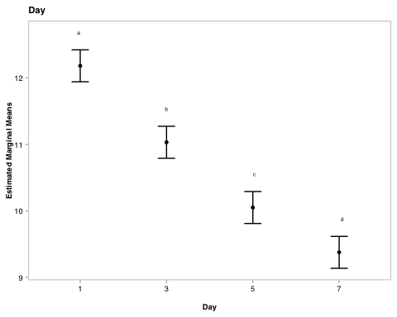

#..........................medium...............................  
## same as above but for another factor, see "day" example for code comments  
cld_medium <- emmeans(aov_3b, pairwise ~ medium, adjust = "tukey") %>%  
 cld(Letters = letters, reverse = TRUE)

NOTE: Results may be misleading due to involvement in interactions

cld_medium_3b <- ggplot(cld_medium, aes(x = factor(medium, levels = c("MQ+AEbiofilm", "PW+AEBiofilm", "1%TB+AEbiofilm")), y = emmean)) +  
 geom_point(size = 1) +   
 geom_errorbar(aes(ymin = lower.CL, ymax = upper.CL), width = 0.2) +   
 geom_text(aes(label = .group), nudge_y = 0.5, size = 1.75, color = "black") +   
 xlab("Medium with AE biofilm") +  
 ylab("Estimated Marginal Means") +  
 scale_y_continuous(labels = scales::label_number(accuracy = 1)) +  
 ggtitle("Medium") +  
 myCustomTheme() +  
 scale_x_discrete(labels= c("1%TB+AEbiofilm" = "1%TB", "PW+AEBiofilm" = "PW-MO", "MQ+AEbiofilm" = "MQ")) +  
 theme(axis.title.y = element_text(margin = margin(r = 1)))  
cld_medium_3b

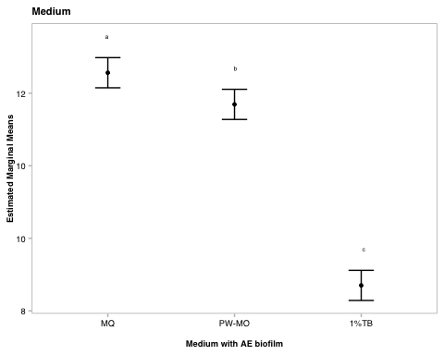

#.......................medium * day............................  
cld_day_medium <- emmeans(aov_3b, pairwise ~ day * medium, adjust = "tukey") %>%  
 cld(Letters = letters, reverse = TRUE)  
  
## make a plot of estimated marginal means across day, faceted by medium  
cld_day_medium_3b <- ggplot(cld_day_medium, aes(x = factor(day), y = emmean)) +  
 geom_point(size = 1) + # Plot the estimated means  
 geom_errorbar(aes(ymin = lower.CL, ymax = upper.CL), width = 0.2) +   
 geom_text(aes(label = .group), nudge_y = 1, size = 1.75, color = "black") +   
 facet_wrap(~ factor(medium, # facet by medium  
 levels = c("MQ+AEbiofilm", "PW+AEBiofilm", "1%TB+AEbiofilm")), # order  
 labeller = as_labeller(c("1%TB+AEbiofilm" = "1%TB", # custom labels  
 "PW+AEBiofilm" = "PW - MO",   
 "MQ+AEbiofilm" = "MQ"))) +   
 xlab("Day") +  
 ylab("Estimated Marginal Means") +  
 scale_y_continuous(labels = scales::label_number(accuracy = 1)) +  
 ggtitle("Day * Medium") +  
 myCustomTheme() +  
 scale_x_discrete(labels= c("Day_1" = "1", "Day_3" = "3", "Day_5" = "5", "Day_7" = "7")) +  
 theme(axis.title.y = element_text(margin = margin(r = 1)))  
cld_day_medium_3b

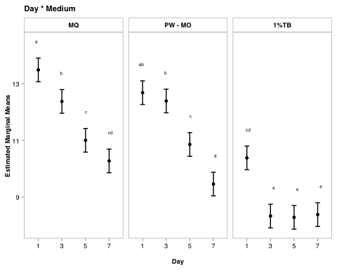

Results write up

A two-way ANOVA revealed that there was a statistically significant difference in Bd load across days (F(3, 24) = 110.100, p = p <0.0001), across the media (F(2, 24) = 246.55, p <0.0001), and the interaction between the effects of day and medium were also significant (F(6, 24) = 10.145, p = p <0.0001). Bd was significantly lower with each day (Tukey test, p <0.005 for all) and TB plus biofilm has most Bd inhibition power, followed by pond water with no microbes, then by milliQ with the least inhibition power (Tukey test, p <0.05 for all).

# *PUBLICATION FIGURES

# set up custom theme  
myCustomTheme <- function() {  
 theme_light() +  
 theme(axis.text = element_text(size = 7, family = "Helvetica", color = "black"),  
 axis.title.x = element_text(margin = margin(t = 10), size = 7, face = "plain", family = "Helvetica", color = "black"), # Add space between x-axis label and axis  
 axis.title.y = element_text(margin = margin(r = 10), size = 7, face = "plain", family = "Helvetica", color = "black"), # Add space between y-axis label and axis  
 title = element_text(size = 7, face = "bold", family = "Helvetica"),  
 plot.caption = element_text(size = 7, face = "italic", family = "Helvetica"),  
 legend.text = element_text(size = 7, family = "Helvetica"), # Increase legend text size  
 panel.grid = element_blank(), # Remove all grid lines (both major and minor)  
 # axis.line.x = element_line(color = "grey"), # Keep the x-axis line  
 # axis.line.y = element_line(color = "grey"), # Keep the y-axis line  
 axis.ticks = element_line(color = "grey", size = 0.5), # Keep tick markers  
 axis.ticks.x = element_line(color = "grey", size = 0.5), # ensure bottom axis ticks  
 axis.ticks.y = element_line(color = "grey", size = 0.5), # ensure side axis ticks  
 strip.text = element_text(size = 7, face = "bold", family = "Helvetica", color = "black"), # Set strip text style  
 strip.background = element_rect(fill = "white", color = "grey", size = 0.5) # Set strip background to white, outline grey  
 )  
}

## SFEB AE Biofilm

fig_SFEB_biofilm_boxplot <- eb_ae_bf_only %>%  
ggplot(aes(y= bd_qty, x = day)) +   
 geom_boxplot(fill = no_microbes_.22_color) +  
 geom_jitter(alpha = 0.3, width = 0.05) +  
 myCustomTheme() +  
 scale_y_log10(labels = function(x) {gsub("e", "E", scales::scientific_format()(x))},   
 # update to consistent scale per reviewer request  
 limits = c(1e+02, 1e+08),  
 breaks = c(1e2, 1e3, 1e4, 1e5, 1e6, 1e7, 1e8)) +   
 xlab("Incubation of Bd with SFEB biofilms (day)") +  
 ylab("Bd quantity in adherent fraction (ZE/well)") +  
 scale_x_discrete (labels= c("Day_1" = "1", "Day_7" = "7")) +  
   
 theme(legend.position = "none",  
 panel.border = element_blank(),  
 axis.line.x = element_line(color = "grey", size = 0.5),   
 axis.line.y = element_line(color = "grey", size = 0.5))  
  
# Let's add significance letters  
significance_data <- tibble(  
 day = factor(c("Day_1", "Day_7"), levels = c("Day_1", "Day_7")),  
 y_position = c(1.6e+05, 1.4e+04),   
 label = c("a", "b"))  
  
fig_SFEB_biofilm <- fig_SFEB_biofilm_boxplot +   
geom_text(data = significance_data, aes(x = day, y = y_position, label = label),  
 position = position_dodge(width = 0.75), vjust = 0, size = 7 / 2.85) # /2.85 to convert to the same "pt" text sizing the axes use  
  
#fig_SFEB_biofilm  
  
fig_SFEB_biofilm <- fig_SFEB_biofilm +  
 labs(tag = "A") +  
 theme(  
 plot.tag = element_text(family = "Helvetica", size = 20, face = "plain", hjust = -0.1, vjust = 1),  
 plot.tag.position = c(0, 1))  
  
fig_SFEB_biofilm

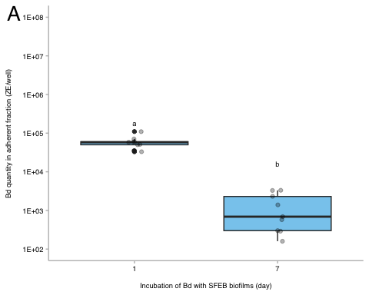

# 3a alone  
#ggsave("paper-figures/expt3-SFEB-biofilms_fig4a_updated.pdf", plot = fig_SFEB_biofilm, width = 3.46, height = 3.46)

## 3B: SBNCOS Biofilm

# add column for microbes or no  
fig_SBNCOS_biofilm <- ae_summary %>%  
 # reorder to match Renwei's plot  
 mutate(sample_ID = factor(sample_ID,  
 levels = c("1%TB+AEbiofilm", "MQ+AEbiofilm",  
 "PW+AEBiofilm", "Added Bd" ))) %>%  
  
 ggplot(aes(x = day_numeric,  
 y = mean,  
 color = sample_ID)) +  
 geom_point(size = 1) +  
 geom_errorbar(aes(ymin = mean - se, # standard error  
 ymax = mean + se), # standard error  
 width = 0.1) +  
 geom_line() +   
 ## update scale for reviewer  
 scale_y_log10(labels = function(x) {gsub("e", "E", scales::scientific_format()(x))},   
 # update to consistent scale per reviewer request  
 limits = c(1e+02, 1e+08),  
 breaks = c(1e2, 1e3, 1e4, 1e5, 1e6, 1e7, 1e8)) +   
 # vibes  
 labs(x = "Incubation of Bd with SBNCOS biofilms (day)",  
 y = "Bd quantity in adherent fraction (ZE/well)",  
 color = "Medium with\nAE Biofilm")+   
   
 scale_color_manual(values = c("1%TB+AEbiofilm"= "#4477AA",  
 "MQ+AEbiofilm" = "#228833",  
 #"Added Bd" = "darkgrey",  
 "PW+AEBiofilm" = "#AA3377"),  
 labels = c("1%TB+AEbiofilm" = "pond water + 1% TB",  
 "MQ+AEbiofilm" = "MQ",  
 "PW+AEBiofilm" = "pond water",  
 "Added Bd" = "Initial Bd")) +   
 myCustomTheme()+  
 scale_x_continuous(breaks = c(0, 1, 3, 5, 7),  
 labels = c("Initial\nBd", "1", "3", "5", "7")) +  
 theme(legend.position = "bottom",  
 panel.border = element_blank(),  
 legend.text = element_text(size = 5),   
 legend.key.size = unit(0.4, "cm"),   
 legend.spacing.y = unit(0.1, "cm"),   
 legend.margin = margin(t = 0, r = 0, b = 0, l = 0),  
 axis.line.x = element_line(color = "grey", size = 0.5),   
 axis.line.y = element_line(color = "grey", size = 0.5)) +   
guides(color = guide_legend(title = NULL))  
  
#fig_SBNCOS_biofilm  
  
fig_SBNCOS_biofilm <- fig_SBNCOS_biofilm +  
 labs(tag = "B") +  
 theme(  
 plot.tag = element_text(family = "Helvetica", size = 20, face = "plain", hjust = -0.1, vjust = 1),  
 plot.tag.position = c(0, 1)  
 )  
  
fig_SBNCOS_biofilm

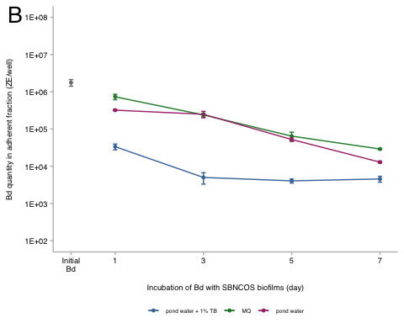

#ggsave("paper-figures/expt3-SBNCOS-biofilms_fig4b_updated.pdf", plot = fig_SBNCOS_biofilm, width = 3.46, height = 3.46)

# *SI figures and tables

## Fig S6

SI_6 <- eb_ae %>%  
 filter(bd_location == "biofilm") %>% # no supernatant  
ggplot(aes(y= bd_qty, x = site)) +   
 geom_col(fill = "darkgrey") +  
 facet_wrap(~day, labeller = labeller(day = c("Day_0" = "Day 0", "Day_1" = "Day 1", "Day_7" = "Day 7"))) +  
 scale_y_continuous(expand = c(0.01, 0.01), # get rid of weird gap  
 trans = "log", # Natural logarithmic scale  
 breaks = c(1e+01, 1e+03, 1e+05), # Set exact breaks  
 labels = scales::label_scientific()) + # Use scientific notation 1e+01, 1e+03, 1e+05  
 #scale_y_log10() + produces same as above but has weird spacing between facet and bottom of bar  
 xlab("Site") +  
 ylab("Bd Quantity \n (zoospore equivalents)") +  
 myCustomTheme() +   
 theme(axis.text.x = element_text(angle = 90, vjust = 0.5, hjust = 1),  
 panel.border = element_rect(color = "gray", size = 0.5, fill = NA))  
SI_6

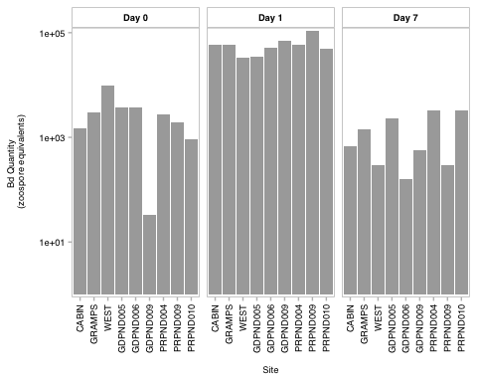

#ggsave("SI_6.pdf", plot = SI_6, width = 7.09, height = 3.46)

## Fig. S7

Here I updated the y axis limits, this is the difference from the prior cld plots in the exploratory and analysus phase

global_y_limits <- c(7, 15)  
global_y_breaks <- seq(8, 14, by = 2)  
  
# Compute CLD letters for 'day'  
cld_day_3b <- ggplot(cld_day, aes(x = day, y = emmean)) +  
 geom_point(size = 1) +  
 geom_errorbar(aes(ymin = lower.CL, ymax = upper.CL), width = 0.2) +  
 geom_text(aes(label = .group), nudge_y = 1, size = 1.75, color = "black") +  
 xlab("Day") +  
 ylab("Estimated Marginal Means") +  
 scale_y_continuous(labels = scales::label_number(accuracy = 1), limits = global_y_limits, breaks = global_y_breaks) +  
 ggtitle("Day") +  
 myCustomTheme() +  
 scale_x_discrete(labels = c("Day_1" = "1", "Day_3" = "3", "Day_5" = "5", "Day_7" = "7")) +  
 theme(axis.title.y = element_text(margin = margin(r = 1)))  
  
# Compute CLD letters for 'medium'  
cld_medium_3b <- ggplot(cld_medium, aes(x = factor(medium, levels = c("MQ+AEbiofilm", "PW+AEBiofilm", "1%TB+AEbiofilm")), y = emmean)) +  
 geom_point(size = 1) +  
 geom_errorbar(aes(ymin = lower.CL, ymax = upper.CL), width = 0.2) +  
 geom_text(aes(label = .group), nudge_y = 1, size = 1.75, color = "black") +  
 xlab("Medium with AE biofilm") +  
 ylab("Estimated Marginal Means") +  
 scale_y_continuous(labels = scales::label_number(accuracy = 1), limits = global_y_limits, breaks = global_y_breaks) +  
 ggtitle("Medium") +  
 myCustomTheme() +  
 scale_x_discrete(labels = c("1%TB+AEbiofilm" = "1%TB", "PW+AEBiofilm" = "PW-MO", "MQ+AEbiofilm" = "MQ")) +  
 theme(axis.title.y = element_text(margin = margin(r = 1)))  
  
# Compute CLD letters for 'day * medium'  
cld_day_medium_3b <- ggplot(cld_day_medium, aes(x = factor(day), y = emmean)) +  
 geom_point(size = 1) +  
 geom_errorbar(aes(ymin = lower.CL, ymax = upper.CL), width = 0.2) +  
 geom_text(aes(label = .group), nudge_y = 1, size = 1.75, color = "black") +  
 facet_wrap(~ factor(medium, levels = c("MQ+AEbiofilm", "PW+AEBiofilm", "1%TB+AEbiofilm")),   
 labeller = as_labeller(c("1%TB+AEbiofilm" = "1%TB",   
 "PW+AEBiofilm" = "PW - MO",   
 "MQ+AEbiofilm" = "MQ"))) +  
 xlab("Day") +  
 ylab("Estimated Marginal Means") +  
 scale_y_continuous(labels = scales::label_number(accuracy = 1), limits = global_y_limits, breaks = global_y_breaks) +  
 ggtitle("Day * Medium") +  
 myCustomTheme() +  
 scale_x_discrete(labels = c("Day_1" = "1", "Day_3" = "3", "Day_5" = "5", "Day_7" = "7")) +  
 theme(axis.title.y = element_text(margin = margin(r = 1)))  
  
# Combine plots  
pairwise_cld_3b <- (cld_day_3b + cld_medium_3b) / cld_day_medium_3b +  
 plot_annotation(tag_levels = 'A')  
  
pairwise_cld_3b

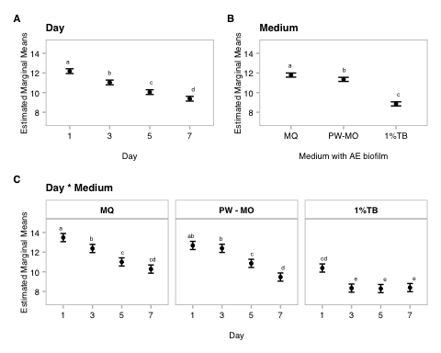

#ggsave("SI_3b_updated.pdf", plot = pairwise_cld_3b, width = 7.09, height = 3.46)

# Appendix

Not used in publication but I like these so I’ll keep them here

## anova table

# anova table  
anova_output <- tidy(aov_3b)  
  
aov_3b_tbl <- anova_output %>%  
 dplyr::select(term, df, sumsq, meansq, statistic, p.value) %>%  
 gt() %>%  
 tab_header(  
 title = "ANOVA Table"  
 ) %>%  
 fmt_number(  
 columns = c(sumsq, meansq, statistic),  
 decimals = 2  
 ) %>%  
 cols_label(  
 term = "Term",  
 df = "Df",  
 sumsq = "Sum Sq",  
 meansq = "Mean Sq",  
 statistic = "F value",  
 p.value = "P-value"  
 ) %>% # scientific number format for values <0.001 in p values  
 fmt_scientific(  
 columns = c(p.value),  
 decimals = 1,  
 rows = p.value < 0.001  
 ) %>%  
 # 3 decimals for p values >=0.001  
 fmt_number(  
 columns = c(p.value),  
 decimals = 3,  
 rows = p.value >= 0.001  
 )  
aov_3b_tbl

Table 1: ANOVA Table

| Term | Df | Sum Sq | Mean Sq | F value | P-value |
| --- | --- | --- | --- | --- | --- |
| day | 3 | 40.24 | 13.41 | 110.10 | 3.6 × 10^-14 |
| medium | 2 | 60.07 | 30.04 | 246.55 | 1.0 × 10^-16 |
| day:medium | 6 | 7.42 | 1.24 | 10.14 | 1.3 × 10^-5 |
| Residuals | 24 | 2.92 | 0.12 | NA | NA |

# prettier, simplified  
anova_output <- tidy(aov_3b)  
  
# Modify term to include degrees of freedom in *italics*  
anova_output <- anova_output %>%  
 mutate(term = ifelse(grepl("day:medium", term), "day x medium", term)) %>%   
 mutate (term = paste0(term, " (*df = ", df, ", ", anova_output[df == max(df), "df"], "*)")) %>%   
 filter(term != "Residuals (*df = 24, 24*)")  
  
# Create the gt table with selected columns  
aov_3b_tbl_b <- anova_output %>%  
 dplyr::select(term, statistic, p.value) %>%  
 gt() %>%  
 tab_header(  
 title = "ANOVA Table"  
 ) %>%  
 fmt_markdown(  
 columns = c(term)  
 ) %>%  
 fmt_number(  
 columns = c(statistic),  
 decimals = 2  
 ) %>%  
 cols_label(  
 term = "",  
 statistic = "F value",  
 p.value = "P-value"  
 ) %>%  
 fmt_scientific(  
 columns = c(p.value),  
 decimals = 1,  
 rows = p.value < 0.001  
 ) %>%  
 fmt_number(  
 columns = c(p.value),  
 decimals = 3,  
 rows = p.value >= 0.001  
 )  
  
aov_3b_tbl_b

Table 1: ANOVA Table

|  | F value | P-value |
| --- | --- | --- |
| day (*df = 3, 24*) | 110.10 | 3.6 × 10^-14 |
| medium (*df = 2, 24*) | 246.55 | 1.0 × 10^-16 |
| day x medium (*df = 6, 24*) | 10.14 | 1.3 × 10^-5 |

## posthoc table

# post hoc table  
# Convert Tukey emmeans results to data frames  
tukey_day_df <- as.data.frame(tukey_day)  
tukey_medium_df <- as.data.frame(tukey_medium)  
tukey_interaction_df <- as.data.frame(tukey_interaction)  
  
# Add labels to indicate which factor the comparison refers to  
tukey_day_df <- tukey_day_df %>% mutate(factor = "Day")  
tukey_medium_df <- tukey_medium_df %>% mutate(factor = "Medium")  
tukey_interaction_df <- tukey_interaction_df %>% mutate(factor = "Interaction")  
  
all_tukey_df <- bind_rows(tukey_day_df, tukey_medium_df, tukey_interaction_df)  
ph3b_table <- all_tukey_df %>%  
 dplyr::select(factor, contrast, estimate, SE, df, t.ratio, p.value) %>%  
 gt() %>%  
 # change column names  
 cols_label(  
 factor = "Comparison",  
 contrast = "Group Comparison",  
 estimate = "Estimate",  
 SE = "Standard Error",  
 df = "Degrees of Freedom",  
 t.ratio = "t-Ratio",  
 p.value = "p-value"  
 ) %>%  
 # update header for table  
 tab_header(  
 title = "Emmeans Post-hoc Test Results"  
 ) %>%  
 # 3 decimal places  
 fmt_number(  
 columns = c(estimate, SE, t.ratio),  
 decimals = 3  
 ) %>%  
 # scientific number format for values <0.001 in p values  
 fmt_scientific(  
 columns = c(p.value),  
 decimals = 1,  
 rows = p.value < 0.001  
 ) %>%  
 # 3 decimals for p values >=0.001  
 fmt_number(  
 columns = c(p.value),  
 decimals = 3,  
 rows = p.value >= 0.001  
 ) %>%  
 #make the headers bold  
 tab_style(  
 style = list(  
 cell_text(weight = "bold")  
 ),  
 locations = cells_column_labels(everything()))  
ph3b_table

Table 1: Emmeans Post-hoc Test Results

| Comparison | Group Comparison | Estimate | Standard Error | Degrees of Freedom | t-Ratio | p-value |
| --- | --- | --- | --- | --- | --- | --- |
| Day | Day_1 - Day_3 | 1.149 | 0.165 | 24 | 6.985 | 1.8 × 10^-6 |
| Day | Day_1 - Day_5 | 2.131 | 0.165 | 24 | 12.949 | 1.5 × 10^-11 |
| Day | Day_1 - Day_7 | 2.805 | 0.165 | 24 | 17.046 | 6.2 × 10^-14 |
| Day | Day_3 - Day_5 | 0.981 | 0.165 | 24 | 5.964 | 2.1 × 10^-5 |
| Day | Day_3 - Day_7 | 1.655 | 0.165 | 24 | 10.060 | 2.5 × 10^-9 |
| Day | Day_5 - Day_7 | 0.674 | 0.165 | 24 | 4.097 | 0.002 |
| Medium | (1%TB+AEbiofilm) - (MQ+AEbiofilm) | -2.932 | 0.142 | 24 | -20.579 | 2.1 × 10^-14 |
| Medium | (1%TB+AEbiofilm) - (PW+AEBiofilm) | -2.496 | 0.142 | 24 | -17.515 | 3.2 × 10^-14 |
| Medium | (MQ+AEbiofilm) - (PW+AEBiofilm) | 0.437 | 0.142 | 24 | 3.064 | 0.014 |
| Interaction | (Day_1 1%TB+AEbiofilm) - (Day_3 1%TB+AEbiofilm) | 2.045 | 0.285 | 24 | 7.176 | 1.1 × 10^-5 |
| Interaction | (Day_1 1%TB+AEbiofilm) - (Day_5 1%TB+AEbiofilm) | 2.092 | 0.285 | 24 | 7.340 | 7.8 × 10^-6 |
| Interaction | (Day_1 1%TB+AEbiofilm) - (Day_7 1%TB+AEbiofilm) | 1.994 | 0.285 | 24 | 6.997 | 1.7 × 10^-5 |
| Interaction | (Day_1 1%TB+AEbiofilm) - (Day_1 MQ+AEbiofilm) | -3.098 | 0.285 | 24 | -10.869 | 5.6 × 10^-9 |
| Interaction | (Day_1 1%TB+AEbiofilm) - (Day_3 MQ+AEbiofilm) | -1.988 | 0.285 | 24 | -6.974 | 1.8 × 10^-5 |
| Interaction | (Day_1 1%TB+AEbiofilm) - (Day_5 MQ+AEbiofilm) | -0.620 | 0.285 | 24 | -2.175 | 0.580 |
| Interaction | (Day_1 1%TB+AEbiofilm) - (Day_7 MQ+AEbiofilm) | 0.107 | 0.285 | 24 | 0.374 | 1.000 |
| Interaction | (Day_1 1%TB+AEbiofilm) - (Day_1 PW+AEBiofilm) | -2.296 | 0.285 | 24 | -8.056 | 1.6 × 10^-6 |
| Interaction | (Day_1 1%TB+AEbiofilm) - (Day_3 PW+AEBiofilm) | -2.003 | 0.285 | 24 | -7.028 | 1.6 × 10^-5 |
| Interaction | (Day_1 1%TB+AEbiofilm) - (Day_5 PW+AEBiofilm) | -0.474 | 0.285 | 24 | -1.662 | 0.868 |
| Interaction | (Day_1 1%TB+AEbiofilm) - (Day_7 PW+AEBiofilm) | 0.920 | 0.285 | 24 | 3.228 | 0.109 |
| Interaction | (Day_3 1%TB+AEbiofilm) - (Day_5 1%TB+AEbiofilm) | 0.047 | 0.285 | 24 | 0.164 | 1.000 |
| Interaction | (Day_3 1%TB+AEbiofilm) - (Day_7 1%TB+AEbiofilm) | -0.051 | 0.285 | 24 | -0.178 | 1.000 |
| Interaction | (Day_3 1%TB+AEbiofilm) - (Day_1 MQ+AEbiofilm) | -5.143 | 0.285 | 24 | -18.045 | 1.4 × 10^-13 |
| Interaction | (Day_3 1%TB+AEbiofilm) - (Day_3 MQ+AEbiofilm) | -4.033 | 0.285 | 24 | -14.150 | 2.3 × 10^-11 |
| Interaction | (Day_3 1%TB+AEbiofilm) - (Day_5 MQ+AEbiofilm) | -2.665 | 0.285 | 24 | -9.351 | 1.0 × 10^-7 |
| Interaction | (Day_3 1%TB+AEbiofilm) - (Day_7 MQ+AEbiofilm) | -1.938 | 0.285 | 24 | -6.802 | 2.7 × 10^-5 |
| Interaction | (Day_3 1%TB+AEbiofilm) - (Day_1 PW+AEBiofilm) | -4.341 | 0.285 | 24 | -15.232 | 4.7 × 10^-12 |
| Interaction | (Day_3 1%TB+AEbiofilm) - (Day_3 PW+AEBiofilm) | -4.048 | 0.285 | 24 | -14.203 | 2.1 × 10^-11 |
| Interaction | (Day_3 1%TB+AEbiofilm) - (Day_5 PW+AEBiofilm) | -2.518 | 0.285 | 24 | -8.837 | 3.0 × 10^-7 |
| Interaction | (Day_3 1%TB+AEbiofilm) - (Day_7 PW+AEBiofilm) | -1.125 | 0.285 | 24 | -3.948 | 0.023 |
| Interaction | (Day_5 1%TB+AEbiofilm) - (Day_7 1%TB+AEbiofilm) | -0.098 | 0.285 | 24 | -0.342 | 1.000 |
| Interaction | (Day_5 1%TB+AEbiofilm) - (Day_1 MQ+AEbiofilm) | -5.189 | 0.285 | 24 | -18.209 | 1.2 × 10^-13 |
| Interaction | (Day_5 1%TB+AEbiofilm) - (Day_3 MQ+AEbiofilm) | -4.079 | 0.285 | 24 | -14.314 | 1.8 × 10^-11 |
| Interaction | (Day_5 1%TB+AEbiofilm) - (Day_5 MQ+AEbiofilm) | -2.712 | 0.285 | 24 | -9.515 | 7.5 × 10^-8 |
| Interaction | (Day_5 1%TB+AEbiofilm) - (Day_7 MQ+AEbiofilm) | -1.985 | 0.285 | 24 | -6.966 | 1.8 × 10^-5 |
| Interaction | (Day_5 1%TB+AEbiofilm) - (Day_1 PW+AEBiofilm) | -4.388 | 0.285 | 24 | -15.396 | 3.7 × 10^-12 |
| Interaction | (Day_5 1%TB+AEbiofilm) - (Day_3 PW+AEBiofilm) | -4.095 | 0.285 | 24 | -14.368 | 1.6 × 10^-11 |
| Interaction | (Day_5 1%TB+AEbiofilm) - (Day_5 PW+AEBiofilm) | -2.565 | 0.285 | 24 | -9.001 | 2.1 × 10^-7 |
| Interaction | (Day_5 1%TB+AEbiofilm) - (Day_7 PW+AEBiofilm) | -1.172 | 0.285 | 24 | -4.112 | 0.016 |
| Interaction | (Day_7 1%TB+AEbiofilm) - (Day_1 MQ+AEbiofilm) | -5.092 | 0.285 | 24 | -17.867 | 1.7 × 10^-13 |
| Interaction | (Day_7 1%TB+AEbiofilm) - (Day_3 MQ+AEbiofilm) | -3.982 | 0.285 | 24 | -13.972 | 3.0 × 10^-11 |
| Interaction | (Day_7 1%TB+AEbiofilm) - (Day_5 MQ+AEbiofilm) | -2.614 | 0.285 | 24 | -9.172 | 1.5 × 10^-7 |
| Interaction | (Day_7 1%TB+AEbiofilm) - (Day_7 MQ+AEbiofilm) | -1.888 | 0.285 | 24 | -6.624 | 4.0 × 10^-5 |
| Interaction | (Day_7 1%TB+AEbiofilm) - (Day_1 PW+AEBiofilm) | -4.290 | 0.285 | 24 | -15.053 | 6.0 × 10^-12 |
| Interaction | (Day_7 1%TB+AEbiofilm) - (Day_3 PW+AEBiofilm) | -3.997 | 0.285 | 24 | -14.025 | 2.8 × 10^-11 |
| Interaction | (Day_7 1%TB+AEbiofilm) - (Day_5 PW+AEBiofilm) | -2.468 | 0.285 | 24 | -8.659 | 4.3 × 10^-7 |
| Interaction | (Day_7 1%TB+AEbiofilm) - (Day_7 PW+AEBiofilm) | -1.074 | 0.285 | 24 | -3.770 | 0.035 |
| Interaction | (Day_1 MQ+AEbiofilm) - (Day_3 MQ+AEbiofilm) | 1.110 | 0.285 | 24 | 3.895 | 0.026 |
| Interaction | (Day_1 MQ+AEbiofilm) - (Day_5 MQ+AEbiofilm) | 2.478 | 0.285 | 24 | 8.694 | 4.0 × 10^-7 |
| Interaction | (Day_1 MQ+AEbiofilm) - (Day_7 MQ+AEbiofilm) | 3.204 | 0.285 | 24 | 11.243 | 2.8 × 10^-9 |
| Interaction | (Day_1 MQ+AEbiofilm) - (Day_1 PW+AEBiofilm) | 0.802 | 0.285 | 24 | 2.813 | 0.235 |
| Interaction | (Day_1 MQ+AEbiofilm) - (Day_3 PW+AEBiofilm) | 1.095 | 0.285 | 24 | 3.842 | 0.030 |
| Interaction | (Day_1 MQ+AEbiofilm) - (Day_5 PW+AEBiofilm) | 2.624 | 0.285 | 24 | 9.208 | 1.4 × 10^-7 |
| Interaction | (Day_1 MQ+AEbiofilm) - (Day_7 PW+AEBiofilm) | 4.017 | 0.285 | 24 | 14.097 | 2.5 × 10^-11 |
| Interaction | (Day_3 MQ+AEbiofilm) - (Day_5 MQ+AEbiofilm) | 1.368 | 0.285 | 24 | 4.799 | 0.003 |
| Interaction | (Day_3 MQ+AEbiofilm) - (Day_7 MQ+AEbiofilm) | 2.094 | 0.285 | 24 | 7.348 | 7.6 × 10^-6 |
| Interaction | (Day_3 MQ+AEbiofilm) - (Day_1 PW+AEBiofilm) | -0.308 | 0.285 | 24 | -1.082 | 0.993 |
| Interaction | (Day_3 MQ+AEbiofilm) - (Day_3 PW+AEBiofilm) | -0.015 | 0.285 | 24 | -0.053 | 1.000 |
| Interaction | (Day_3 MQ+AEbiofilm) - (Day_5 PW+AEBiofilm) | 1.514 | 0.285 | 24 | 5.313 | 9.2 × 10^-4 |
| Interaction | (Day_3 MQ+AEbiofilm) - (Day_7 PW+AEBiofilm) | 2.907 | 0.285 | 24 | 10.202 | 1.9 × 10^-8 |
| Interaction | (Day_5 MQ+AEbiofilm) - (Day_7 MQ+AEbiofilm) | 0.726 | 0.285 | 24 | 2.549 | 0.359 |
| Interaction | (Day_5 MQ+AEbiofilm) - (Day_1 PW+AEBiofilm) | -1.676 | 0.285 | 24 | -5.881 | 2.3 × 10^-4 |
| Interaction | (Day_5 MQ+AEbiofilm) - (Day_3 PW+AEBiofilm) | -1.383 | 0.285 | 24 | -4.853 | 0.003 |
| Interaction | (Day_5 MQ+AEbiofilm) - (Day_5 PW+AEBiofilm) | 0.146 | 0.285 | 24 | 0.513 | 1.000 |
| Interaction | (Day_5 MQ+AEbiofilm) - (Day_7 PW+AEBiofilm) | 1.540 | 0.285 | 24 | 5.403 | 7.4 × 10^-4 |
| Interaction | (Day_7 MQ+AEbiofilm) - (Day_1 PW+AEBiofilm) | -2.402 | 0.285 | 24 | -8.430 | 7.0 × 10^-7 |
| Interaction | (Day_7 MQ+AEbiofilm) - (Day_3 PW+AEBiofilm) | -2.109 | 0.285 | 24 | -7.401 | 6.7 × 10^-6 |
| Interaction | (Day_7 MQ+AEbiofilm) - (Day_5 PW+AEBiofilm) | -0.580 | 0.285 | 24 | -2.035 | 0.668 |
| Interaction | (Day_7 MQ+AEbiofilm) - (Day_7 PW+AEBiofilm) | 0.813 | 0.285 | 24 | 2.854 | 0.219 |
| Interaction | (Day_1 PW+AEBiofilm) - (Day_3 PW+AEBiofilm) | 0.293 | 0.285 | 24 | 1.028 | 0.995 |
| Interaction | (Day_1 PW+AEBiofilm) - (Day_5 PW+AEBiofilm) | 1.822 | 0.285 | 24 | 6.395 | 6.9 × 10^-5 |
| Interaction | (Day_1 PW+AEBiofilm) - (Day_7 PW+AEBiofilm) | 3.216 | 0.285 | 24 | 11.284 | 2.6 × 10^-9 |
| Interaction | (Day_3 PW+AEBiofilm) - (Day_5 PW+AEBiofilm) | 1.529 | 0.285 | 24 | 5.366 | 8.1 × 10^-4 |
| Interaction | (Day_3 PW+AEBiofilm) - (Day_7 PW+AEBiofilm) | 2.923 | 0.285 | 24 | 10.255 | 1.8 × 10^-8 |
| Interaction | (Day_5 PW+AEBiofilm) - (Day_7 PW+AEBiofilm) | 1.393 | 0.285 | 24 | 4.889 | 0.003 |