Monolayer Biofilm Experiments

Caitlin Nordheim-Maestas

# Experiment 4: Assessment of AE microorganisms’ effect on monolayer-associated Bd cells

Data wrangling and analysis the Bd monolayer experiment using the SFEB (San Francisco East Bay) water samples for part A and the follow up experiment part B with SBNCOS (Santa Barbara North Campus Open Space) pond water samples. These are the data presented in Figure 7A and 7B in the manuscript, and information is under the section “Experiment 4”.

## read in and clean data  
library(tidyverse) # for cleaning and viewing data  
library(gt) # pretty stats tables  
library(broom) # cleaning for gt  
library(here) # for importing data  
library(car) # stats tests   
library(multcompView) # view cld  
library(multcomp) # stats  
library(nlme) # mixed effects models  
library(emmeans) # for pairwise comparisons, especially on mixed effects models and glms  
library(ggpubr) # for making ggqq plot  
library(patchwork) # for combining figures  
  
# data  
# SFEB  
ns_ml_pw_bd <- read.csv(here("data", "nine-sites-PW-on-MLBd - Sheet1.csv"))  
# SBNCOS  
fig_4b_raw <- read.csv(here("data", "final_NCOS_2024_reformatted_for_R.xlsx - Fig4B.csv"))  
  
# Colors: these are from Paul Tol's colorblind friendly palette  
with_microbes_40_color <- "#999933"  
no_microbes_.22_color <- "#88ccee"  
  
# set up custom theme for exploratory data  
myCustomTheme <- function() {  
 theme_light() +  
 theme(axis.text = element_text(size = 12, family = "Times", color = "black"),  
 axis.title.x = element_text(margin = margin(t = 10), size = 14, face = "bold", family = "Times", color = "black"), # Add space between x-axis label and axis  
 axis.title.y = element_text(margin = margin(r = 10), size = 14, face = "bold", family = "Times", color = "black"), # Add space between y-axis label and axis  
 title = element_text(size = 12, face = "bold", family = "Times"),  
 plot.caption = element_text(size = 10, face = "italic", family = "Times"),  
 legend.text = element_text(size = 10, family = "Times"), # Increase legend text size  
 panel.grid.major.x = element_blank(), # Remove major vertical grid lines  
 panel.grid.minor.x = element_blank(), # Remove minor vertical grid lines  
 panel.grid.major.y = element_blank(), # Remove major horizontal grid lines  
 panel.grid.minor.y = element_blank(), # Remove minor horizontal grid lines  
 strip.text = element_text(size = 12, face = "bold", family = "Times", color = "black"), # Set strip text style  
 strip.background = element_rect(fill = "white", color = "grey"), # Set strip background to white, # color = "black"  
 axis.ticks = element_blank() # Remove x and y axis ticks  
 )}

# SFEB Monolayer

Scientific Q: Is mono-strain Bd biofilm resistant to microbes in pond water

Statistical question:

Is there a difference in the **gain or loss of ADHERENT Bd over 6 days** between the **filter sizes**?

**There is a significant difference in the change in the quantity of adherent Bd from Day 1 to Day 7 across the filter types (t = -6.45, df = 7, p-value = 0.0003)**

## Data Wrangling SFEB Monolayer

eb_monolayer <- ns_ml_pw_bd %>%   
 filter(site != "MQ") %>% # remove control  
 filter(bd_location == "adherent") # only want adherent Bd data (decision by Renwei, most relevant to our scientific question)  
  
# keep control for labeling plot  
eb_ml_controls <- ns_ml_pw_bd %>%   
 filter(site =="MQ") %>% # controls only  
 filter(bd_location == "adherent") # only want adherent Bd data for controls too  
  
# Data type cleaning  
eb_monolayer$site <- factor(eb_monolayer$site,  
 levels = c("CABIN", "GRAMPS", "WEST", "GDPND005", "GDPND006", "GDPND009", "PRPND004", "PRPND009", "PRPND010"))  
eb_monolayer$day <- factor(eb_monolayer$day, levels = c("Day_1", "Day_7"))   
  
# get the total difference across days by combining both locations of Bd then subtracting across days  
eb_monolayer_diff <- eb_monolayer %>%  
 # pivot so each day has its own column  
 pivot_wider(names_from = day, values_from = bd_qty) %>%  
 # calculate the rate loss by taking the log of each before subtracting  
 mutate(rate_loss = log(Day_1) - log(Day_7))  
  
# Create subsets for each treatment  
eb_monolayer_diff_40um <- eb_monolayer_diff %>%   
 filter(filter =="40um_filter")  
eb_monolayer_diff.22um <- eb_monolayer_diff %>%   
 filter(filter =="0.22um_filter")

## EDA SFEB Monolayer

Boxplot

eb_monolayer %>%  
  
 # plot it  
 ggplot(aes(y= bd_qty, x = filter, fill = filter)) +   
 geom_boxplot() +  
 geom_jitter(width = 0.2, alpha = 0.3) +  
 scale_y_log10() +  
 facet_wrap(~day, labeller = labeller(day = c("Day_1" = "Day 1",  
 "Day_7" = "Day 7")))+  
 scale_fill_manual(values = c("40um_filter" = with_microbes_40_color,   
 "0.22um_filter" = no_microbes_.22_color)) +  
 theme_classic() +  
 theme(legend.position = "none",  
 strip.text = element_text(face="bold"),  
 axis.title = element_text(face = "bold")) +   
 scale_x_discrete (labels= c("40um_filter" = "With Microbes", "0.22um_filter" = "No Microbes")) +  
 xlab("Presence of Microbes in Pond Water Added to Monolayer Biofilm") +  
 ylab("Bd Quantity \n (zoospore equivalents)") +  
  
 # add controls ad x's  
geom_point(data = eb_ml_controls, aes(x = filter, y = bd_qty), shape = 4, size = 2)

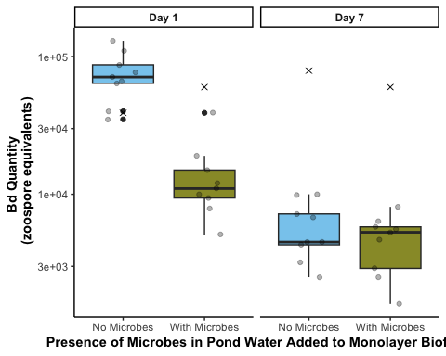

## SFEB Stats and assumption testing

Question:

Question: Does the rate loss in Bd from day 1 to day 7 (aka Bd-inhibitory potency) differ between the two filter types (40 and 0.22 um; aka AE microorganisms + and AE microorganisms -)?

The samples are essentially paired by site, so a paired t-test is most appropriate

$H0:μ_{ratelossofBd}=0$

Test: Paired t-test on rate loss of Bd between day 1 and 7

# check normality of the differences across groups  
# With microbes (40 um)  
eb_monolayer_diff_40um %>%   
 ggqqplot("rate_loss", title = "40um") # normal

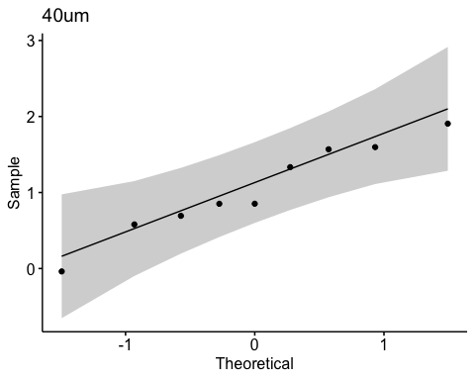

shapiro.test(eb_monolayer_diff_40um$rate_loss) # numeric check using shapiro wilks test, a p > 0.05 says the data is indeed normal

Shapiro-Wilk normality test  
  
data: eb_monolayer_diff_40um$rate_loss  
W = 0.95903, p-value = 0.7881

# Without microbes (0.22 um)  
eb_monolayer_diff.22um%>%   
 ggqqplot("rate_loss", title = "0.22um") # looks good

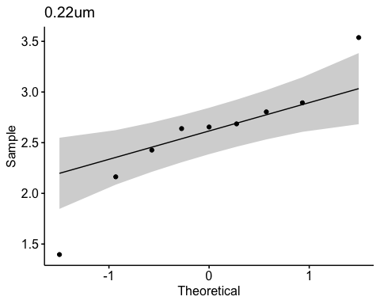

shapiro.test(eb_monolayer_diff.22um$rate_loss) # numeric check using shapiro wilks test, a p > 0.05 says the data is indeed normal

Shapiro-Wilk normality test  
  
data: eb_monolayer_diff.22um$rate_loss  
W = 0.92597, p-value = 0.4439

# visualize the comparison I am making  
eb_monolayer_diff %>%  
ggplot(aes(y= rate_loss, x = filter)) +   
 geom_boxplot() +  
 geom_jitter() +  
 ggtitle("Visualizing comparison for paired t-test on the rate_loss")

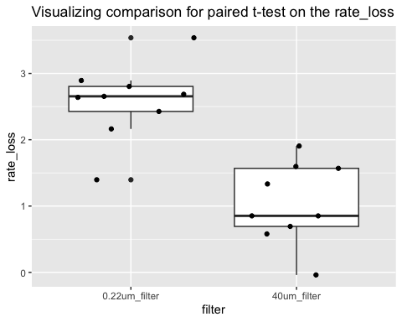

# Stats SFEB

# Step 3: run the paired t-test on the difference  
t.test(eb_monolayer_diff_40um$rate_loss, eb_monolayer_diff.22um$rate_loss, paired = TRUE)

Paired t-test  
  
data: eb_monolayer_diff_40um$rate_loss and eb_monolayer_diff.22um$rate_loss  
t = -5.3606, df = 8, p-value = 0.0006772  
alternative hypothesis: true mean difference is not equal to 0  
95 percent confidence interval:  
 -2.2020978 -0.8773797  
sample estimates:  
mean difference   
 -1.539739

### Stats results:

When monolayer Bd biofilm is exposed to pond water without microbes has a significantly greater loss of Bd between day 1 to day 7 than pond water with microbes (t = -5.4, df = 8, p = 0.0006772). The t-value is negative, which shows that the first item entered (with microbes) has a smaller loss of Bd than the second item entered (no microbes).

## Planned comparison to look at Day 1

Q: qty ~ factor(day) + microbe_treatment, random = ~1|factor(site)

Question: does the quantity of Bd differ across days and treatment while controlling for the paired site?

This will be a lme since it is a mixed effects model!

Data wrangling

eb_monolayer <- eb_monolayer %>%   
 mutate(log_bd = log(bd_qty))  
  
# Exploration: normality of transformed data  
eb_monolayer %>%   
 ggqqplot("log_bd") # normal yay

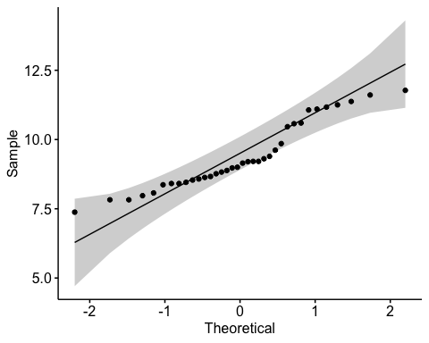

Assumptions testing

par(mfrow = c(2,2))  
# build model  
mod6 <- lme(log_bd~day*factor(filter), random = ~1|site, data=eb_monolayer)  
# model assumptions  
plot(mod6) # passes homogeneity of variances yay

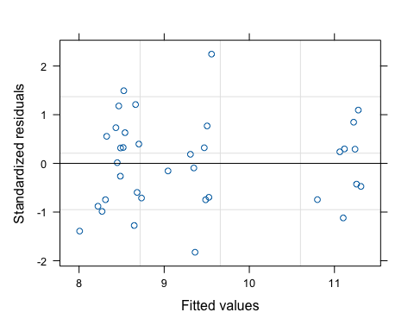

qqPlot(resid(mod6), main="QQ Plot of Residuals") # passes normality of resids yay

PRPND004 PRPND009   
 24 23

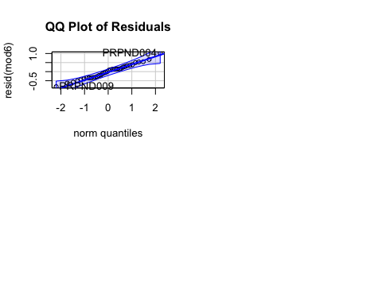

Interpret

summary(mod6)

Linear mixed-effects model fit by REML  
 Data: eb_monolayer   
 AIC BIC logLik  
 66.32921 75.12363 -27.16461  
  
Random effects:  
 Formula: ~1 | site  
 (Intercept) Residual  
StdDev: 0.2252822 0.4522353  
  
Fixed effects: log_bd ~ day * factor(filter)   
 Value Std.Error DF t-value p-value  
(Intercept) 11.155886 0.1684138 24 66.24093 0  
dayDay_7 -2.577871 0.2131858 24 -12.09214 0  
factor(filter)40um_filter -1.754991 0.2131858 24 -8.23222 0  
dayDay_7:factor(filter)40um_filter 1.539739 0.3014902 24 5.10709 0  
 Correlation:   
 (Intr) dyDy_7 f()40_  
dayDay_7 -0.633   
factor(filter)40um_filter -0.633 0.500   
dayDay_7:factor(filter)40um_filter 0.448 -0.707 -0.707  
  
Standardized Within-Group Residuals:  
 Min Q1 Med Q3 Max   
-1.8252309 -0.7197000 0.1006392 0.5741601 2.2442375   
  
Number of Observations: 36  
Number of Groups: 9

anova(mod6)

numDF denDF F-value p-value  
(Intercept) 1 24 7763.082 <.0001  
day 1 24 143.850 <.0001  
factor(filter) 1 24 42.706 <.0001  
day:factor(filter) 1 24 26.082 <.0001

emmeans::emmeans(mod6, pairwise ~ day * filter) # pairwise comparison

$emmeans  
 day filter emmean SE df lower.CL upper.CL  
 Day_1 0.22um_filter 11.16 0.168 8 10.77 11.54  
 Day_7 0.22um_filter 8.58 0.168 8 8.19 8.97  
 Day_1 40um_filter 9.40 0.168 8 9.01 9.79  
 Day_7 40um_filter 8.36 0.168 8 7.97 8.75  
  
Degrees-of-freedom method: containment   
Confidence level used: 0.95   
  
$contrasts  
 contrast estimate SE df t.ratio p.value  
 Day_1 0.22um_filter - Day_7 0.22um_filter 2.578 0.213 24 12.092 <.0001  
 Day_1 0.22um_filter - Day_1 40um_filter 1.755 0.213 24 8.232 <.0001  
 Day_1 0.22um_filter - Day_7 40um_filter 2.793 0.213 24 13.102 <.0001  
 Day_7 0.22um_filter - Day_1 40um_filter -0.823 0.213 24 -3.860 0.0039  
 Day_7 0.22um_filter - Day_7 40um_filter 0.215 0.213 24 1.010 0.7454  
 Day_1 40um_filter - Day_7 40um_filter 1.038 0.213 24 4.870 0.0003  
  
Degrees-of-freedom method: containment   
P value adjustment: tukey method for comparing a family of 4 estimates

Bd abundance was indeed significantly lower on day 1 in the presence of AE microorganisms compared to its abundance in microorganism-depleted pond water (Day_1 0.22um_filter - Day_1 40um_filter p <.0001)

# SBNCOS

## Data Wrangling SBNCOS

## Monolayer  
# add column for microbes or no  
monolayer <- fig_4b_raw %>%   
 rename(sample_ID = sample.ID) %>%   
 rename(adh_plus_sup = ahd_plus_sup) %>%   
 # rename sample_id to only include treatment, not day (we have a column for day already)  
 mutate(sample_ID = str_replace(sample_ID, "-D[0-9]+$", "")) %>%   
  
 # add columns for components y/n  
 mutate(microbes = case_when(  
 str_detect(sample_ID, "\\+microbes") ~ "y",  
 TRUE ~ "n")) %>%   
 # add column for TB or no  
 mutate(TB = case_when(  
 str_detect(sample_ID, "TB") ~ "y",  
 TRUE ~ "n")) %>%   
 mutate(day = case_when(  
 day == 1 ~ "Day_1",  
 day == 3 ~ "Day_3",  
 day == 5 ~ "Day_5",  
 day == 7 ~ "Day_7",  
 day == 0 ~ "Day_0")) %>%   
 mutate(day = factor(day)) %>%   
 mutate(day_numeric = as.numeric(gsub("Day_", "", as.character(day)))) # add day numeric for plotting  
  
monolayer_summary <- monolayer %>%   
 group_by(day, sample_ID) %>%   
 reframe(mean_adh = mean(adh), # calculate the mean  
 n = length(adh), # count the number of observations within the day and sample id  
 df = n - 1, # calculate the degrees of freedom  
 sd = sd(adh), # calculate the standard deviation  
 se = sd/sqrt(n), # calculate the standard error  
 ) %>%   
 # re-create above columns, but in the summary df  
 mutate(microbes = case_when(  
 str_detect(sample_ID, "\\+microbes") ~ "y",TRUE ~ "n")) %>%   
 # add column for TB or no  
 mutate(TB = case_when(str_detect(sample_ID, "TB") ~ "y", TRUE ~ "n")) %>%   
 mutate(day_numeric = as.numeric(gsub("Day_", "", as.character(day))))  
  
# no day 0, this is the "initial Bd", not part of the analysis  
ml_noday0 <- monolayer %>%  
 filter(day != "Day_0") %>%  
 mutate(log_adh = log(adh)) %>%   
 mutate(day = as.factor(day))  
  
# set PW-microbes as reference (no milliQ control here)  
ml_noday0$sample_ID <- factor(ml_noday0$sample_ID) # set as factor  
ml_noday0$sample_ID <- relevel(ml_noday0$sample_ID, ref = "PW-microbes") # assign reference  
  
# change the names in microbes and tb so there arent 2 levels with y and n (oops that was shortsighted of me!)  
ml_noday0 <- ml_noday0 %>%   
 mutate(  
 microbes = case_when(  
 microbes == "y" ~ "MO present",  
 microbes == "n" ~ "MO absent"),  
 TB = case_when(  
 TB == "y" ~ "TB present",  
 TB == "n" ~ "TB absent"))

## EDA SBNCOS

visualize y var: bd load

Commented out to save space, but spoiler alert: log transformed is better

# # untransformed  
# ml_noday0 <- monolayer %>%  
# filter(day != 0) %>%  
# mutate(log_adh = log(adh)) # note: no zeroes so not log + 1  
# ggqqplot(ml_noday0, "adh", title = "untransformed")  
# shapiro.test(ml_noday0$adh) # nope  
# hist(ml_noday0$adh) # note  
#   
# # transformed  
# ggqqplot(ml_noday0, "log_adh", title = "log transformed") # gorgeous  
# hist(ml_noday0$log_adh) # better

## Stats SBNCOS

y var: amount of Bd (log transformed)

Model: Bd ~ day*microbes*TB

Question: Does the amount of Bd in the sample differ across the treatments of presence of microbes, TB, and day?

Model: 3-way ANOVA

**results**

Results summary

* day (p<0.05)
  + All differ from each other except 5 and 7 (Tukey)
    - Day 1 > Day 3 > Day 5 = Day 7
* microbes (p<0.05)
  + presence microbes has less Bd (Tukey)
* TB (NOT SIG)
* day:microbes (p<0.05)
* day:TB (NOT SIG)
* microbes:TB (p<0.05)
* day:microbes:TB (NOT SIG)

## null

null <- lm(log_adh ~ 1,  
 data = ml_noday0)  
AIC(null) #205.4965

[1] 205.4965

## Bd ~ day*microbes*TB

# build model  
aov_4b <- aov(log_adh ~ day*microbes*TB,  
 data = ml_noday0)  
  
# diagnostic plot  
par(mfrow = c(2,2))  
plot(aov_4b) # looks good

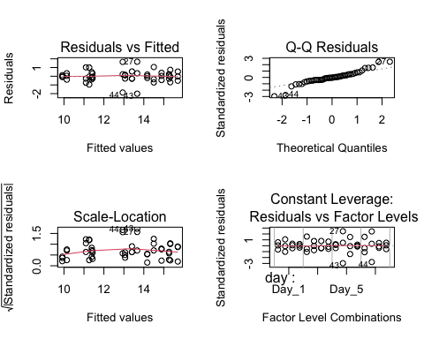

# look at results  
summary(aov_4b)

Df Sum Sq Mean Sq F value Pr(>F)   
day 3 93.76 31.25 45.336 1.26e-11 ***  
microbes 1 37.80 37.80 54.841 2.00e-08 ***  
TB 1 0.51 0.51 0.746 0.39422   
day:microbes 3 12.21 4.07 5.905 0.00252 **   
day:TB 3 0.94 0.31 0.456 0.71469   
microbes:TB 1 18.12 18.12 26.283 1.37e-05 ***  
day:microbes:TB 3 1.61 0.54 0.777 0.51570   
Residuals 32 22.06 0.69   
---  
Signif. codes: 0 '***' 0.001 '**' 0.01 '*' 0.05 '.' 0.1 ' ' 1

AIC(aov_4b) # 132.8989 better than null

[1] 132.8989

## Post hoc

Using a Tukey test on the anova model

TukeyHSD(aov_4b)

Tukey multiple comparisons of means  
 95% family-wise confidence level  
  
Fit: aov(formula = log_adh ~ day * microbes * TB, data = ml_noday0)  
  
$day  
 diff lwr upr p adj  
Day_3-Day_1 -1.1620166 -2.080368 -0.2436653 0.0087187  
Day_5-Day_1 -2.9344665 -3.852818 -2.0161153 0.0000000  
Day_7-Day_1 -3.5087930 -4.427144 -2.5904417 0.0000000  
Day_5-Day_3 -1.7724499 -2.690801 -0.8540987 0.0000581  
Day_7-Day_3 -2.3467763 -3.265128 -1.4284251 0.0000005  
Day_7-Day_5 -0.5743264 -1.492678 0.3440249 0.3431674  
  
$microbes  
 diff lwr upr p adj  
MO present-MO absent -1.774918 -2.263125 -1.286711 0  
  
$TB  
 diff lwr upr p adj  
TB present-TB absent -0.2069936 -0.6952002 0.281213 0.3942159  
  
$`day:microbes`  
 diff lwr upr p adj  
Day_3:MO absent-Day_1:MO absent -0.004871029 -1.5576434 1.54790136 1.0000000  
Day_5:MO absent-Day_1:MO absent -1.742341527 -3.2951139 -0.18956914 0.0191770  
Day_7:MO absent-Day_1:MO absent -3.085556125 -4.6383285 -1.53278374 0.0000079  
Day_1:MO present-Day_1:MO absent -0.388664202 -1.9414366 1.16410819 0.9912401  
Day_3:MO present-Day_1:MO absent -2.707826384 -4.2605988 -1.15505400 0.0000750  
Day_5:MO present-Day_1:MO absent -4.515255768 -6.0680282 -2.96248338 0.0000000  
Day_7:MO present-Day_1:MO absent -4.320693986 -5.8734664 -2.76792160 0.0000000  
Day_5:MO absent-Day_3:MO absent -1.737470497 -3.2902429 -0.18469811 0.0196728  
Day_7:MO absent-Day_3:MO absent -3.080685096 -4.6334575 -1.52791271 0.0000082  
Day_1:MO present-Day_3:MO absent -0.383793173 -1.9365656 1.16897921 0.9918720  
Day_3:MO present-Day_3:MO absent -2.702955355 -4.2557277 -1.15018297 0.0000772  
Day_5:MO present-Day_3:MO absent -4.510384738 -6.0631571 -2.95761235 0.0000000  
Day_7:MO present-Day_3:MO absent -4.315822957 -5.8685953 -2.76305057 0.0000000  
Day_7:MO absent-Day_5:MO absent -1.343214599 -2.8959870 0.20955779 0.1300131  
Day_1:MO present-Day_5:MO absent 1.353677324 -0.1990951 2.90644971 0.1243433  
Day_3:MO present-Day_5:MO absent -0.965484857 -2.5182572 0.58728753 0.4886753  
Day_5:MO present-Day_5:MO absent -2.772914241 -4.3256866 -1.22014185 0.0000509  
Day_7:MO present-Day_5:MO absent -2.578352460 -4.1311248 -1.02558007 0.0001622  
Day_1:MO present-Day_7:MO absent 2.696891923 1.1441195 4.24966431 0.0000801  
Day_3:MO present-Day_7:MO absent 0.377729742 -1.1750426 1.93050213 0.9926085  
Day_5:MO present-Day_7:MO absent -1.429699642 -2.9824720 0.12307275 0.0889994  
Day_7:MO present-Day_7:MO absent -1.235137861 -2.7879102 0.31763453 0.2015413  
Day_3:MO present-Day_1:MO present -2.319162182 -3.8719346 -0.76638979 0.0007513  
Day_5:MO present-Day_1:MO present -4.126591565 -5.6793640 -2.57381918 0.0000000  
Day_7:MO present-Day_1:MO present -3.932029784 -5.4848022 -2.37925740 0.0000001  
Day_5:MO present-Day_3:MO present -1.807429384 -3.3602018 -0.25465700 0.0135812  
Day_7:MO present-Day_3:MO present -1.612867602 -3.1656400 -0.06009522 0.0372097  
Day_7:MO present-Day_5:MO present 0.194561781 -1.3582106 1.74733417 0.9998954  
  
$`day:TB`  
 diff lwr upr p adj  
Day_3:TB absent-Day_1:TB absent -1.1235183 -2.6762907 0.42925405 0.3023905  
Day_5:TB absent-Day_1:TB absent -2.9130623 -4.4658347 -1.36028989 0.0000221  
Day_7:TB absent-Day_1:TB absent -3.8110976 -5.3638700 -2.25832525 0.0000001  
Day_1:TB present-Day_1:TB absent -0.3281947 -1.8809671 1.22457771 0.9968653  
Day_3:TB present-Day_1:TB absent -1.5287096 -3.0814819 0.02406283 0.0561428  
Day_5:TB present-Day_1:TB absent -3.2840655 -4.8368379 -1.73129311 0.0000025  
Day_7:TB present-Day_1:TB absent -3.5346830 -5.0874553 -1.98191056 0.0000006  
Day_5:TB absent-Day_3:TB absent -1.7895439 -3.3423163 -0.23677155 0.0149424  
Day_7:TB absent-Day_3:TB absent -2.6875793 -4.2403517 -1.13480691 0.0000846  
Day_1:TB present-Day_3:TB absent 0.7953237 -0.7574487 2.34809604 0.7119877  
Day_3:TB present-Day_3:TB absent -0.4051912 -1.9579636 1.14758117 0.9888085  
Day_5:TB present-Day_3:TB absent -2.1605472 -3.7133195 -0.60777477 0.0018907  
Day_7:TB present-Day_3:TB absent -2.4111646 -3.9639370 -0.85839223 0.0004372  
Day_7:TB absent-Day_5:TB absent -0.8980354 -2.4508077 0.65473703 0.5777381  
Day_1:TB present-Day_5:TB absent 2.5848676 1.0320952 4.13763999 0.0001560  
Day_3:TB present-Day_5:TB absent 1.3843527 -0.1684197 2.93712511 0.1088829  
Day_5:TB present-Day_5:TB absent -0.3710032 -1.9237756 1.18176917 0.9933635  
Day_7:TB present-Day_5:TB absent -0.6216207 -2.1743931 0.93115172 0.8933907  
Day_1:TB present-Day_7:TB absent 3.4829030 1.9301306 5.03567535 0.0000008  
Day_3:TB present-Day_7:TB absent 2.2823881 0.7296157 3.83516047 0.0009319  
Day_5:TB present-Day_7:TB absent 0.5270321 -1.0257402 2.07980453 0.9522604  
Day_7:TB present-Day_7:TB absent 0.2764147 -1.2763577 1.82918708 0.9989428  
Day_3:TB present-Day_1:TB present -1.2005149 -2.7532873 0.35225751 0.2298116  
Day_5:TB present-Day_1:TB present -2.9558708 -4.5086432 -1.40309843 0.0000171  
Day_7:TB present-Day_1:TB present -3.2064883 -4.7592607 -1.65371588 0.0000039  
Day_5:TB present-Day_3:TB present -1.7553559 -3.3081283 -0.20258355 0.0179090  
Day_7:TB present-Day_3:TB present -2.0059734 -3.5587458 -0.45320101 0.0045607  
Day_7:TB present-Day_5:TB present -0.2506175 -1.8033898 1.30215493 0.9994399  
  
$`microbes:TB`  
 diff lwr upr  
MO present:TB absent-MO absent:TB absent -0.5461759 -1.4645271 0.3721754  
MO absent:TB present-MO absent:TB absent 1.0217484 0.1033972 1.9400997  
MO present:TB present-MO absent:TB absent -1.9819115 -2.9002628 -1.0635603  
MO absent:TB present-MO present:TB absent 1.5679243 0.6495730 2.4862756  
MO present:TB present-MO present:TB absent -1.4357356 -2.3540869 -0.5173844  
MO present:TB present-MO absent:TB present -3.0036600 -3.9220112 -2.0853087  
 p adj  
MO present:TB absent-MO absent:TB absent 0.3867876  
MO absent:TB present-MO absent:TB absent 0.0245376  
MO present:TB present-MO absent:TB absent 0.0000098  
MO absent:TB present-MO present:TB absent 0.0003283  
MO present:TB present-MO present:TB absent 0.0009862  
MO present:TB present-MO absent:TB present 0.0000000  
  
$`day:microbes:TB`  
 diff lwr  
Day_3:MO absent:TB absent-Day_1:MO absent:TB absent -0.38819068 -2.90193747  
Day_5:MO absent:TB absent-Day_1:MO absent:TB absent -1.82711047 -4.34085726  
Day_7:MO absent:TB absent-Day_1:MO absent:TB absent -3.78764987 -6.30139666  
Day_1:MO present:TB absent-Day_1:MO absent:TB absent 0.37618774 -2.13755905  
Day_3:MO present:TB absent-Day_1:MO absent:TB absent -1.48265825 -3.99640505  
Day_5:MO present:TB absent-Day_1:MO absent:TB absent -3.62282635 -6.13657315  
Day_7:MO present:TB absent-Day_1:MO absent:TB absent -3.45835767 -5.97210446  
Day_1:MO absent:TB present-Day_1:MO absent:TB absent 0.43665726 -2.07708953  
Day_3:MO absent:TB present-Day_1:MO absent:TB absent 0.81510588 -1.69864091  
Day_5:MO absent:TB present-Day_1:MO absent:TB absent -1.22091533 -3.73466212  
Day_7:MO absent:TB present-Day_1:MO absent:TB absent -1.94680512 -4.46055191  
Day_1:MO present:TB present-Day_1:MO absent:TB absent -0.71685888 -3.23060567  
Day_3:MO present:TB present-Day_1:MO absent:TB absent -3.49633725 -6.01008405  
Day_5:MO present:TB present-Day_1:MO absent:TB absent -4.97102792 -7.48477471  
Day_7:MO present:TB present-Day_1:MO absent:TB absent -4.74637305 -7.26011984  
Day_5:MO absent:TB absent-Day_3:MO absent:TB absent -1.43891978 -3.95266658  
Day_7:MO absent:TB absent-Day_3:MO absent:TB absent -3.39945919 -5.91320598  
Day_1:MO present:TB absent-Day_3:MO absent:TB absent 0.76437842 -1.74936837  
Day_3:MO present:TB absent-Day_3:MO absent:TB absent -1.09446757 -3.60821436  
Day_5:MO present:TB absent-Day_3:MO absent:TB absent -3.23463567 -5.74838246  
Day_7:MO present:TB absent-Day_3:MO absent:TB absent -3.07016698 -5.58391378  
Day_1:MO absent:TB present-Day_3:MO absent:TB absent 0.82484794 -1.68889885  
Day_3:MO absent:TB present-Day_3:MO absent:TB absent 1.20329657 -1.31045023  
Day_5:MO absent:TB present-Day_3:MO absent:TB absent -0.83272464 -3.34647144  
Day_7:MO absent:TB present-Day_3:MO absent:TB absent -1.55861444 -4.07236123  
Day_1:MO present:TB present-Day_3:MO absent:TB absent -0.32866820 -2.84241499  
Day_3:MO present:TB present-Day_3:MO absent:TB absent -3.10814657 -5.62189336  
Day_5:MO present:TB present-Day_3:MO absent:TB absent -4.58283724 -7.09658403  
Day_7:MO present:TB present-Day_3:MO absent:TB absent -4.35818236 -6.87192915  
Day_7:MO absent:TB absent-Day_5:MO absent:TB absent -1.96053941 -4.47428620  
Day_1:MO present:TB absent-Day_5:MO absent:TB absent 2.20329820 -0.31044859  
Day_3:MO present:TB absent-Day_5:MO absent:TB absent 0.34445221 -2.16929458  
Day_5:MO present:TB absent-Day_5:MO absent:TB absent -1.79571589 -4.30946268  
Day_7:MO present:TB absent-Day_5:MO absent:TB absent -1.63124720 -4.14499399  
Day_1:MO absent:TB present-Day_5:MO absent:TB absent 2.26376773 -0.24997906  
Day_3:MO absent:TB present-Day_5:MO absent:TB absent 2.64221635 0.12846956  
Day_5:MO absent:TB present-Day_5:MO absent:TB absent 0.60619514 -1.90755165  
Day_7:MO absent:TB present-Day_5:MO absent:TB absent -0.11969465 -2.63344144  
Day_1:MO present:TB present-Day_5:MO absent:TB absent 1.11025159 -1.40349521  
Day_3:MO present:TB present-Day_5:MO absent:TB absent -1.66922679 -4.18297358  
Day_5:MO present:TB present-Day_5:MO absent:TB absent -3.14391745 -5.65766425  
Day_7:MO present:TB present-Day_5:MO absent:TB absent -2.91926258 -5.43300937  
Day_1:MO present:TB absent-Day_7:MO absent:TB absent 4.16383761 1.65009082  
Day_3:MO present:TB absent-Day_7:MO absent:TB absent 2.30499162 -0.20875517  
Day_5:MO present:TB absent-Day_7:MO absent:TB absent 0.16482352 -2.34892327  
Day_7:MO present:TB absent-Day_7:MO absent:TB absent 0.32929221 -2.18445459  
Day_1:MO absent:TB present-Day_7:MO absent:TB absent 4.22430713 1.71056034  
Day_3:MO absent:TB present-Day_7:MO absent:TB absent 4.60275576 2.08900897  
Day_5:MO absent:TB present-Day_7:MO absent:TB absent 2.56673455 0.05298776  
Day_7:MO absent:TB present-Day_7:MO absent:TB absent 1.84084475 -0.67290204  
Day_1:MO present:TB present-Day_7:MO absent:TB absent 3.07079099 0.55704420  
Day_3:MO present:TB present-Day_7:MO absent:TB absent 0.29131262 -2.22243417  
Day_5:MO present:TB present-Day_7:MO absent:TB absent -1.18337805 -3.69712484  
Day_7:MO present:TB present-Day_7:MO absent:TB absent -0.95872317 -3.47246996  
Day_3:MO present:TB absent-Day_1:MO present:TB absent -1.85884599 -4.37259278  
Day_5:MO present:TB absent-Day_1:MO present:TB absent -3.99901409 -6.51276088  
Day_7:MO present:TB absent-Day_1:MO present:TB absent -3.83454540 -6.34829219  
Day_1:MO absent:TB present-Day_1:MO present:TB absent 0.06046952 -2.45327727  
Day_3:MO absent:TB present-Day_1:MO present:TB absent 0.43891815 -2.07482864  
Day_5:MO absent:TB present-Day_1:MO present:TB absent -1.59710306 -4.11084985  
Day_7:MO absent:TB present-Day_1:MO present:TB absent -2.32299285 -4.83673965  
Day_1:MO present:TB present-Day_1:MO present:TB absent -1.09304662 -3.60679341  
Day_3:MO present:TB present-Day_1:MO present:TB absent -3.87252499 -6.38627178  
Day_5:MO present:TB present-Day_1:MO present:TB absent -5.34721566 -7.86096245  
Day_7:MO present:TB present-Day_1:MO present:TB absent -5.12256078 -7.63630757  
Day_5:MO present:TB absent-Day_3:MO present:TB absent -2.14016810 -4.65391489  
Day_7:MO present:TB absent-Day_3:MO present:TB absent -1.97569941 -4.48944620  
Day_1:MO absent:TB present-Day_3:MO present:TB absent 1.91931551 -0.59443128  
Day_3:MO absent:TB present-Day_3:MO present:TB absent 2.29776414 -0.21598265  
Day_5:MO absent:TB present-Day_3:MO present:TB absent 0.26174293 -2.25200386  
Day_7:MO absent:TB present-Day_3:MO present:TB absent -0.46414686 -2.97789365  
Day_1:MO present:TB present-Day_3:MO present:TB absent 0.76579937 -1.74794742  
Day_3:MO present:TB present-Day_3:MO present:TB absent -2.01367900 -4.52742579  
Day_5:MO present:TB present-Day_3:MO present:TB absent -3.48836967 -6.00211646  
Day_7:MO present:TB present-Day_3:MO present:TB absent -3.26371479 -5.77746158  
Day_7:MO present:TB absent-Day_5:MO present:TB absent 0.16446869 -2.34927810  
Day_1:MO absent:TB present-Day_5:MO present:TB absent 4.05948361 1.54573682  
Day_3:MO absent:TB present-Day_5:MO present:TB absent 4.43793224 1.92418545  
Day_5:MO absent:TB present-Day_5:MO present:TB absent 2.40191103 -0.11183576  
Day_7:MO absent:TB present-Day_5:MO present:TB absent 1.67602124 -0.83772556  
Day_1:MO present:TB present-Day_5:MO present:TB absent 2.90596747 0.39222068  
Day_3:MO present:TB present-Day_5:MO present:TB absent 0.12648910 -2.38725769  
Day_5:MO present:TB present-Day_5:MO present:TB absent -1.34820157 -3.86194836  
Day_7:MO present:TB present-Day_5:MO present:TB absent -1.12354669 -3.63729348  
Day_1:MO absent:TB present-Day_7:MO present:TB absent 3.89501493 1.38126814  
Day_3:MO absent:TB present-Day_7:MO present:TB absent 4.27346355 1.75971676  
Day_5:MO absent:TB present-Day_7:MO present:TB absent 2.23744234 -0.27630445  
Day_7:MO absent:TB present-Day_7:MO present:TB absent 1.51155255 -1.00219424  
Day_1:MO present:TB present-Day_7:MO present:TB absent 2.74149879 0.22775199  
Day_3:MO present:TB present-Day_7:MO present:TB absent -0.03797959 -2.55172638  
Day_5:MO present:TB present-Day_7:MO present:TB absent -1.51267025 -4.02641705  
Day_7:MO present:TB present-Day_7:MO present:TB absent -1.28801538 -3.80176217  
Day_3:MO absent:TB present-Day_1:MO absent:TB present 0.37844862 -2.13529817  
Day_5:MO absent:TB present-Day_1:MO absent:TB present -1.65757259 -4.17131938  
Day_7:MO absent:TB present-Day_1:MO absent:TB present -2.38346238 -4.89720917  
Day_1:MO present:TB present-Day_1:MO absent:TB present -1.15351614 -3.66726293  
Day_3:MO present:TB present-Day_1:MO absent:TB present -3.93299451 -6.44674130  
Day_5:MO present:TB present-Day_1:MO absent:TB present -5.40768518 -7.92143197  
Day_7:MO present:TB present-Day_1:MO absent:TB present -5.18303031 -7.69677710  
Day_5:MO absent:TB present-Day_3:MO absent:TB present -2.03602121 -4.54976800  
Day_7:MO absent:TB present-Day_3:MO absent:TB present -2.76191100 -5.27565779  
Day_1:MO present:TB present-Day_3:MO absent:TB present -1.53196476 -4.04571156  
Day_3:MO present:TB present-Day_3:MO absent:TB present -4.31144314 -6.82518993  
Day_5:MO present:TB present-Day_3:MO absent:TB present -5.78613380 -8.29988060  
Day_7:MO present:TB present-Day_3:MO absent:TB present -5.56147893 -8.07522572  
Day_7:MO absent:TB present-Day_5:MO absent:TB present -0.72588979 -3.23963658  
Day_1:MO present:TB present-Day_5:MO absent:TB present 0.50405645 -2.00969035  
Day_3:MO present:TB present-Day_5:MO absent:TB present -2.27542193 -4.78916872  
Day_5:MO present:TB present-Day_5:MO absent:TB present -3.75011260 -6.26385939  
Day_7:MO present:TB present-Day_5:MO absent:TB present -3.52545772 -6.03920451  
Day_1:MO present:TB present-Day_7:MO absent:TB present 1.22994624 -1.28380055  
Day_3:MO present:TB present-Day_7:MO absent:TB present -1.54953214 -4.06327893  
Day_5:MO present:TB present-Day_7:MO absent:TB present -3.02422280 -5.53796959  
Day_7:MO present:TB present-Day_7:MO absent:TB present -2.79956793 -5.31331472  
Day_3:MO present:TB present-Day_1:MO present:TB present -2.77947837 -5.29322516  
Day_5:MO present:TB present-Day_1:MO present:TB present -4.25416904 -6.76791583  
Day_7:MO present:TB present-Day_1:MO present:TB present -4.02951416 -6.54326096  
Day_5:MO present:TB present-Day_3:MO present:TB present -1.47469067 -3.98843746  
Day_7:MO present:TB present-Day_3:MO present:TB present -1.25003579 -3.76378258  
Day_7:MO present:TB present-Day_5:MO present:TB present 0.22465488 -2.28909192  
 upr p adj  
Day_3:MO absent:TB absent-Day_1:MO absent:TB absent 2.1255561 0.9999997  
Day_5:MO absent:TB absent-Day_1:MO absent:TB absent 0.6866363 0.3755310  
Day_7:MO absent:TB absent-Day_1:MO absent:TB absent -1.2739031 0.0003403  
Day_1:MO present:TB absent-Day_1:MO absent:TB absent 2.8899345 0.9999998  
Day_3:MO present:TB absent-Day_1:MO absent:TB absent 1.0310885 0.6990048  
Day_5:MO present:TB absent-Day_1:MO absent:TB absent -1.1090796 0.0006724  
Day_7:MO present:TB absent-Day_1:MO absent:TB absent -0.9446109 0.0013203  
Day_1:MO absent:TB present-Day_1:MO absent:TB absent 2.9504041 0.9999983  
Day_3:MO absent:TB present-Day_1:MO absent:TB absent 3.3288527 0.9967922  
Day_5:MO absent:TB present-Day_1:MO absent:TB absent 1.2928315 0.8984519  
Day_7:MO absent:TB present-Day_1:MO absent:TB absent 0.5669417 0.2818532  
Day_1:MO present:TB present-Day_1:MO absent:TB absent 1.7968879 0.9991923  
Day_3:MO present:TB present-Day_1:MO absent:TB absent -0.9825905 0.0011304  
Day_5:MO present:TB present-Day_1:MO absent:TB absent -2.4572811 0.0000026  
Day_7:MO present:TB present-Day_1:MO absent:TB absent -2.2326263 0.0000065  
Day_5:MO absent:TB absent-Day_3:MO absent:TB absent 1.0748270 0.7386858  
Day_7:MO absent:TB absent-Day_3:MO absent:TB absent -0.8857124 0.0016785  
Day_1:MO present:TB absent-Day_3:MO absent:TB absent 3.2781252 0.9983679  
Day_3:MO present:TB absent-Day_3:MO absent:TB absent 1.4192792 0.9536649  
Day_5:MO present:TB absent-Day_3:MO absent:TB absent -0.7208889 0.0032663  
Day_7:MO present:TB absent-Day_3:MO absent:TB absent -0.5564202 0.0062766  
Day_1:MO absent:TB present-Day_3:MO absent:TB absent 3.3385947 0.9963773  
Day_3:MO absent:TB present-Day_3:MO absent:TB absent 3.7170434 0.9078673  
Day_5:MO absent:TB present-Day_3:MO absent:TB absent 1.6810221 0.9960101  
Day_7:MO absent:TB present-Day_3:MO absent:TB absent 0.9551324 0.6268806  
Day_1:MO present:TB present-Day_3:MO absent:TB absent 2.1850786 1.0000000  
Day_3:MO present:TB present-Day_3:MO absent:TB absent -0.5943998 0.0054041  
Day_5:MO present:TB present-Day_3:MO absent:TB absent -2.0690904 0.0000126  
Day_7:MO present:TB present-Day_3:MO absent:TB absent -1.8444356 0.0000319  
Day_7:MO absent:TB absent-Day_5:MO absent:TB absent 0.5532074 0.2721586  
Day_1:MO present:TB absent-Day_5:MO absent:TB absent 4.7170450 0.1377056  
Day_3:MO present:TB absent-Day_5:MO absent:TB absent 2.8581990 0.9999999  
Day_5:MO present:TB absent-Day_5:MO absent:TB absent 0.7180309 0.4026122  
Day_7:MO present:TB absent-Day_5:MO absent:TB absent 0.8824996 0.5563124  
Day_1:MO absent:TB present-Day_5:MO absent:TB absent 4.7775145 0.1143069  
Day_3:MO absent:TB present-Day_5:MO absent:TB absent 5.1559631 0.0317235  
Day_5:MO absent:TB present-Day_5:MO absent:TB absent 3.1199419 0.9998857  
Day_7:MO absent:TB present-Day_5:MO absent:TB absent 2.3940521 1.0000000  
Day_1:MO present:TB present-Day_5:MO absent:TB absent 3.6239984 0.9482985  
Day_3:MO present:TB present-Day_5:MO absent:TB absent 0.8445200 0.5195974  
Day_5:MO present:TB present-Day_5:MO absent:TB absent -0.6301707 0.0046904  
Day_7:MO present:TB present-Day_5:MO absent:TB absent -0.4055158 0.0112834  
Day_1:MO present:TB absent-Day_7:MO absent:TB absent 6.6775844 0.0000714  
Day_3:MO present:TB absent-Day_7:MO absent:TB absent 4.8187384 0.1003436  
Day_5:MO present:TB absent-Day_7:MO absent:TB absent 2.6785703 1.0000000  
Day_7:MO present:TB absent-Day_7:MO absent:TB absent 2.8430390 1.0000000  
Day_1:MO absent:TB present-Day_7:MO absent:TB absent 6.7380539 0.0000556  
Day_3:MO absent:TB present-Day_7:MO absent:TB absent 7.1165025 0.0000116  
Day_5:MO absent:TB present-Day_7:MO absent:TB absent 5.0804813 0.0415352  
Day_7:MO absent:TB present-Day_7:MO absent:TB absent 4.3545915 0.3639880  
Day_1:MO present:TB present-Day_7:MO absent:TB absent 5.5845378 0.0062612  
Day_3:MO present:TB present-Day_7:MO absent:TB absent 2.8050594 1.0000000  
Day_5:MO present:TB present-Day_7:MO absent:TB absent 1.3303687 0.9178286  
Day_7:MO present:TB present-Day_7:MO absent:TB absent 1.5550236 0.9846687  
Day_3:MO present:TB absent-Day_1:MO present:TB absent 0.6549008 0.3491546  
Day_5:MO present:TB absent-Day_1:MO present:TB absent -1.4852673 0.0001416  
Day_7:MO present:TB absent-Day_1:MO present:TB absent -1.3207986 0.0002802  
Day_1:MO absent:TB present-Day_1:MO present:TB absent 2.5742163 1.0000000  
Day_3:MO absent:TB present-Day_1:MO present:TB absent 2.9526649 0.9999982  
Day_5:MO absent:TB present-Day_1:MO present:TB absent 0.9166437 0.5895224  
Day_7:MO absent:TB present-Day_1:MO present:TB absent 0.1907539 0.0947175  
Day_1:MO present:TB present-Day_1:MO present:TB absent 1.4207002 0.9541279  
Day_3:MO present:TB present-Day_1:MO present:TB absent -1.3587782 0.0002394  
Day_5:MO present:TB present-Day_1:MO present:TB absent -2.8334689 0.0000006  
Day_7:MO present:TB present-Day_1:MO present:TB absent -2.6088140 0.0000014  
Day_5:MO present:TB absent-Day_3:MO present:TB absent 0.3735787 0.1661611  
Day_7:MO present:TB absent-Day_3:MO present:TB absent 0.5380474 0.2617203  
Day_1:MO absent:TB present-Day_3:MO present:TB absent 4.4330623 0.3019299  
Day_3:MO absent:TB present-Day_3:MO present:TB absent 4.8115109 0.1026813  
Day_5:MO absent:TB present-Day_3:MO present:TB absent 2.7754897 1.0000000  
Day_7:MO absent:TB present-Day_3:MO present:TB absent 2.0495999 0.9999962  
Day_1:MO present:TB present-Day_3:MO present:TB absent 3.2795462 0.9983350  
Day_3:MO present:TB present-Day_3:MO present:TB absent 0.5000678 0.2367872  
Day_5:MO present:TB present-Day_3:MO present:TB absent -0.9746229 0.0011679  
Day_7:MO present:TB present-Day_3:MO present:TB absent -0.7499680 0.0029064  
Day_7:MO present:TB absent-Day_5:MO present:TB absent 2.6782155 1.0000000  
Day_1:MO absent:TB present-Day_5:MO present:TB absent 6.5732304 0.0001102  
Day_3:MO absent:TB present-Day_5:MO present:TB absent 6.9516790 0.0000229  
Day_5:MO absent:TB present-Day_5:MO present:TB absent 4.9156578 0.0731443  
Day_7:MO absent:TB present-Day_5:MO present:TB absent 4.1897680 0.5130768  
Day_1:MO present:TB present-Day_5:MO present:TB absent 5.4197143 0.0118735  
Day_3:MO present:TB present-Day_5:MO present:TB absent 2.6402359 1.0000000  
Day_5:MO present:TB present-Day_5:MO present:TB absent 1.1655452 0.8140775  
Day_7:MO present:TB present-Day_5:MO present:TB absent 1.3902001 0.9434543  
Day_1:MO absent:TB present-Day_7:MO present:TB absent 6.4087617 0.0002181  
Day_3:MO absent:TB present-Day_7:MO present:TB absent 6.7872103 0.0000453  
Day_5:MO absent:TB present-Day_7:MO present:TB absent 4.7511891 0.1240512  
Day_7:MO absent:TB present-Day_7:MO present:TB absent 4.0252993 0.6719435  
Day_1:MO present:TB present-Day_7:MO present:TB absent 5.2552456 0.0220664  
Day_3:MO present:TB present-Day_7:MO present:TB absent 2.4757672 1.0000000  
Day_5:MO present:TB present-Day_7:MO present:TB absent 1.0010765 0.6708858  
Day_7:MO present:TB present-Day_7:MO present:TB absent 1.2257314 0.8574494  
Day_3:MO absent:TB present-Day_1:MO absent:TB present 2.8921954 0.9999998  
Day_5:MO absent:TB present-Day_1:MO absent:TB present 0.8561742 0.5308207  
Day_7:MO absent:TB present-Day_1:MO absent:TB present 0.1302844 0.0777604  
Day_1:MO present:TB present-Day_1:MO absent:TB present 1.3602307 0.9314141  
Day_3:MO present:TB present-Day_1:MO absent:TB present -1.4192477 0.0001863  
Day_5:MO present:TB present-Day_1:MO absent:TB present -2.8939384 0.0000004  
Day_7:MO present:TB present-Day_1:MO absent:TB present -2.6692835 0.0000011  
Day_5:MO absent:TB present-Day_3:MO absent:TB present 0.4777256 0.2229337  
Day_7:MO absent:TB present-Day_3:MO absent:TB present -0.2481642 0.0204568  
Day_1:MO present:TB present-Day_3:MO absent:TB present 0.9817820 0.6525195  
Day_3:MO present:TB present-Day_3:MO absent:TB present -1.7976963 0.0000387  
Day_5:MO present:TB present-Day_3:MO absent:TB present -3.2723870 0.0000001  
Day_7:MO present:TB present-Day_3:MO absent:TB present -3.0477321 0.0000002  
Day_7:MO absent:TB present-Day_5:MO absent:TB present 1.7878570 0.9990715  
Day_1:MO present:TB present-Day_5:MO absent:TB present 3.0178032 0.9999887  
Day_3:MO present:TB present-Day_5:MO absent:TB present 0.2383249 0.1102026  
Day_5:MO present:TB present-Day_5:MO absent:TB present -1.2363658 0.0003976  
Day_7:MO present:TB present-Day_5:MO absent:TB present -1.0117109 0.0010033  
Day_1:MO present:TB present-Day_7:MO absent:TB present 3.7436930 0.8934059  
Day_3:MO present:TB present-Day_7:MO absent:TB present 0.9642147 0.6356474  
Day_5:MO present:TB present-Day_7:MO absent:TB present -0.5104760 0.0075145  
Day_7:MO present:TB present-Day_7:MO absent:TB present -0.2858211 0.0177729  
Day_3:MO present:TB present-Day_1:MO present:TB present -0.2657316 0.0191605  
Day_5:MO present:TB present-Day_1:MO present:TB present -1.7404222 0.0000491  
Day_7:MO present:TB present-Day_1:MO present:TB present -1.5157674 0.0001248  
Day_5:MO present:TB present-Day_3:MO present:TB present 1.0390561 0.7063594  
Day_7:MO present:TB present-Day_3:MO present:TB present 1.2637110 0.8816492  
Day_7:MO present:TB present-Day_5:MO present:TB present 2.7384017 1.0000000

Now let’s get this in a format to visualize this data. I will use the emmeans function to extract the estimated marginal means using a tukey adjustment, and from that, will use R to differentiate between the ones with significant differences, and show that with a compact letter display (cld) plot for each comparison type.

# emmeans and cld (compact letter display)  
  
#..............................day...............................  
  
# perform tukey pairwise comparisons across day only & get cld letters  
cld_day <- emmeans(aov_4b, pairwise ~ day, adjust = "tukey") %>%  
 cld(Letters = letters, reverse = TRUE)

NOTE: Results may be misleading due to involvement in interactions

# make a plot of estimated marginal means with CLD letters for each day  
cld_day_4b <- ggplot(cld_day, aes(x = day, y = emmean)) +  
 geom_point(size = 1) + # Plot the estimated means  
 geom_errorbar(aes(ymin = lower.CL, ymax = upper.CL), width = 0.2) + # Error bars  
 geom_text(aes(label = .group), nudge_y = 1, size = 1.75, color = "black") + # Add CLD letters  
 xlab("Day") +  
 ylab("Estimated Marginal Means") +  
 scale_y_continuous(labels = scales::label_number(accuracy = 1)) +  
 ggtitle("Day") +  
 scale_x_discrete(labels= c("Day_1" = "1", "Day_3" = "3", "Day_5" = "5", "Day_7" = "7")) +  
 myCustomTheme() + # Use minimal theme for clean look  
 theme(axis.title.y = element_text(margin = margin(r = 1)))  
cld_day_4b

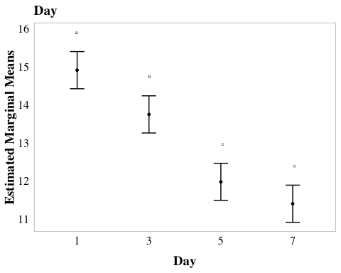

#.........................microbes...............................  
  
cld_microbes <- emmeans(aov_4b, pairwise ~ microbes, adjust = "tukey") %>%  
 cld(Letters = letters, reverse = TRUE)

NOTE: Results may be misleading due to involvement in interactions

cld_microbes_4b <- ggplot(cld_microbes, aes(x = microbes, y = emmean)) +  
 geom_point(size = 1) + # Plot the estimated means  
 geom_errorbar(aes(ymin = lower.CL, ymax = upper.CL), width = 0.2) +   
 geom_text(aes(label = .group), nudge_y = 0.5, size = 1.75, color = "black") +   
 xlab("Microbes present") +  
 ylab("Estimated Marginal Means") +  
 scale_y_continuous(labels = scales::label_number(accuracy = 1)) +  
 ggtitle("Microbes") +  
 scale_x_discrete(labels= c("1%TB+AEbiofilm" = "1%TB", "PW+AEBiofilm" = "PW - MO", "MQ+AEbiofilm" = "MQ")) +  
 myCustomTheme() +   
theme(axis.title.y = element_text(margin = margin(r = 1)))  
cld_microbes_4b

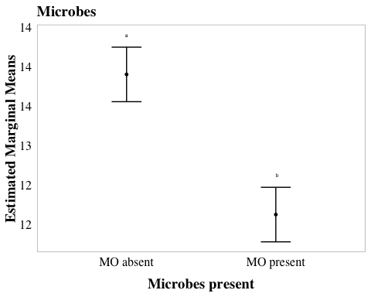

#.....................day*microbes...............................  
  
cld_day_microbes <- emmeans(aov_4b, pairwise ~ day * microbes, adjust = "tukey") %>%  
 cld(Letters = letters, reverse = TRUE)

NOTE: Results may be misleading due to involvement in interactions

cld_day_microbes_4b <- ggplot(cld_day_microbes, aes(x = day, y = emmean)) +  
 geom_point(size = 1) +   
 geom_errorbar(aes(ymin = lower.CL, ymax = upper.CL), width = 0.2) +   
 geom_text(aes(label = .group), nudge_y = 1, size = 1.75, color = "black") +   
facet_wrap(~ factor(microbes)) +   
 xlab("Day") +  
 ylab("Estimated Marginal Means") +  
 scale_y_continuous(labels = scales::label_number(accuracy = 1)) +  
 ggtitle("Day * Microbes") +  
 scale_x_discrete(labels= c("Day_1" = "1", "Day_3" = "3", "Day_5" = "5", "Day_7" = "7")) +  
 myCustomTheme() +   
theme(axis.title.y = element_text(margin = margin(r = 1)))  
cld_day_microbes_4b

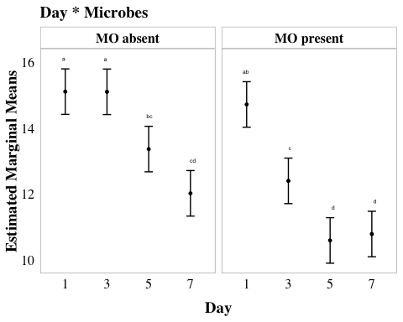

#.....................microbes*tb...............................  
  
cld_TB_microbes <- emmeans(aov_4b, pairwise ~ TB * microbes, adjust = "tukey") %>%  
 cld(Letters = letters, reverse = TRUE)

NOTE: Results may be misleading due to involvement in interactions

cld_TB_microbes_4b <- ggplot(cld_TB_microbes, aes(x = TB, y = emmean)) +  
 geom_point(size = 1) +   
 geom_errorbar(aes(ymin = lower.CL, ymax = upper.CL), width = 0.2) +   
 geom_text(aes(label = .group), nudge_y = 1, size = 1.75, color = "black") +   
facet_wrap(~ factor(microbes)) +   
 xlab("TB Presence") +  
 ylab("Estimated Marginal Means") +  
 scale_y_continuous(labels = scales::label_number(accuracy = 1)) +  
 ggtitle("Microbes * TB") +  
 scale_x_discrete(labels= c("Day_1" = "1", "Day_3" = "3", "Day_5" = "5", "Day_7" = "7")) +  
 myCustomTheme() +   
theme(axis.title.y = element_text(margin = margin(r = 1)))  
cld_TB_microbes_4b

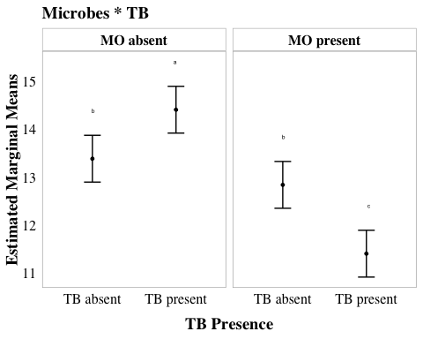

# plot them all together  
# cld_day_4b + cld_microbes_4b + cld_day_microbes_4b + cld_TB_microbes_4b

# get the stats for each comparison  
f4b_tukey_day <- emmeans(aov_4b, pairwise ~ day, adjust = "tukey")$contrasts

NOTE: Results may be misleading due to involvement in interactions

f4b_tukey_microbes <- emmeans(aov_4b, pairwise ~ microbes, adjust = "tukey")$contrasts

NOTE: Results may be misleading due to involvement in interactions

f4b_tukey_microbe_TB <- emmeans(aov_4b, pairwise ~ microbes * TB, adjust = "tukey")$contrasts

NOTE: Results may be misleading due to involvement in interactions

f4b_tukey_microbe_day <- emmeans(aov_4b, pairwise ~ microbes * day, adjust = "tukey")$contrasts

NOTE: Results may be misleading due to involvement in interactions

# print the values  
f4b_tukey_day

contrast estimate SE df t.ratio p.value  
 Day_1 - Day_3 1.162 0.339 32 3.428 0.0087  
 Day_1 - Day_5 2.934 0.339 32 8.657 <.0001  
 Day_1 - Day_7 3.509 0.339 32 10.352 <.0001  
 Day_3 - Day_5 1.772 0.339 32 5.229 0.0001  
 Day_3 - Day_7 2.347 0.339 32 6.924 <.0001  
 Day_5 - Day_7 0.574 0.339 32 1.694 0.3432  
  
Results are averaged over the levels of: microbes, TB   
P value adjustment: tukey method for comparing a family of 4 estimates

f4b_tukey_microbes

contrast estimate SE df t.ratio p.value  
 MO absent - MO present 1.77 0.24 32 7.405 <.0001  
  
Results are averaged over the levels of: day, TB

f4b_tukey_microbe_TB

contrast estimate SE df t.ratio p.value  
 MO absent TB absent - MO present TB absent 0.546 0.339 32 1.611 0.3868  
 MO absent TB absent - MO absent TB present -1.022 0.339 32 -3.014 0.0245  
 MO absent TB absent - MO present TB present 1.982 0.339 32 5.847 <.0001  
 MO present TB absent - MO absent TB present -1.568 0.339 32 -4.626 0.0003  
 MO present TB absent - MO present TB present 1.436 0.339 32 4.236 0.0010  
 MO absent TB present - MO present TB present 3.004 0.339 32 8.862 <.0001  
  
Results are averaged over the levels of: day   
P value adjustment: tukey method for comparing a family of 4 estimates

f4b_tukey_microbe_day

contrast estimate SE df t.ratio p.value  
 MO absent Day_1 - MO present Day_1 0.38866 0.479 32 0.811 0.9912  
 MO absent Day_1 - MO absent Day_3 0.00487 0.479 32 0.010 1.0000  
 MO absent Day_1 - MO present Day_3 2.70783 0.479 32 5.649 0.0001  
 MO absent Day_1 - MO absent Day_5 1.74234 0.479 32 3.635 0.0192  
 MO absent Day_1 - MO present Day_5 4.51526 0.479 32 9.419 <.0001  
 MO absent Day_1 - MO absent Day_7 3.08556 0.479 32 6.437 <.0001  
 MO absent Day_1 - MO present Day_7 4.32069 0.479 32 9.014 <.0001  
 MO present Day_1 - MO absent Day_3 -0.38379 0.479 32 -0.801 0.9919  
 MO present Day_1 - MO present Day_3 2.31916 0.479 32 4.838 0.0008  
 MO present Day_1 - MO absent Day_5 1.35368 0.479 32 2.824 0.1243  
 MO present Day_1 - MO present Day_5 4.12659 0.479 32 8.609 <.0001  
 MO present Day_1 - MO absent Day_7 2.69689 0.479 32 5.626 0.0001  
 MO present Day_1 - MO present Day_7 3.93203 0.479 32 8.203 <.0001  
 MO absent Day_3 - MO present Day_3 2.70296 0.479 32 5.639 0.0001  
 MO absent Day_3 - MO absent Day_5 1.73747 0.479 32 3.625 0.0197  
 MO absent Day_3 - MO present Day_5 4.51039 0.479 32 9.409 <.0001  
 MO absent Day_3 - MO absent Day_7 3.08068 0.479 32 6.427 <.0001  
 MO absent Day_3 - MO present Day_7 4.31582 0.479 32 9.003 <.0001  
 MO present Day_3 - MO absent Day_5 -0.96549 0.479 32 -2.014 0.4887  
 MO present Day_3 - MO present Day_5 1.80743 0.479 32 3.771 0.0136  
 MO present Day_3 - MO absent Day_7 0.37773 0.479 32 0.788 0.9926  
 MO present Day_3 - MO present Day_7 1.61287 0.479 32 3.365 0.0372  
 MO absent Day_5 - MO present Day_5 2.77291 0.479 32 5.785 0.0001  
 MO absent Day_5 - MO absent Day_7 1.34322 0.479 32 2.802 0.1300  
 MO absent Day_5 - MO present Day_7 2.57835 0.479 32 5.379 0.0002  
 MO present Day_5 - MO absent Day_7 -1.42970 0.479 32 -2.983 0.0890  
 MO present Day_5 - MO present Day_7 -0.19456 0.479 32 -0.406 0.9999  
 MO absent Day_7 - MO present Day_7 1.23514 0.479 32 2.577 0.2015  
  
Results are averaged over the levels of: TB   
P value adjustment: tukey method for comparing a family of 8 estimates

# *Publication figures

# set up custom theme  
myCustomTheme <- function() {  
 theme_light() + # base theme with light background  
 theme(axis.text = element_text(size = 7, family = "Helvetica", color = "black"), # set font for axis tick labels  
 axis.title.x = element_text(margin = margin(t = 10), # add spacing between x-axis label and plot  
 size = 7, face = "plain", family = "Helvetica", color = "black"), # Add space between x-axis label and axis  
 axis.title.y = element_text(margin = margin(r = 10), # add spacing between y-axis label and plot  
 size = 7, face = "plain", family = "Helvetica", color = "black"), # Add space between y-axis label and axis  
 title = element_text(size = 7, face = "bold", family = "Helvetica"),  
 plot.caption = element_text(size = 7, face = "italic", family = "Helvetica"),  
 legend.text = element_text(size = 7, family = "Helvetica"), # increase legend text size  
 panel.grid = element_blank(), # remove all gridlines (major and minor, x and y)  
 # axis.line.x = element_line(color = "grey"), # uncomment if axis lines are needed  
 # axis.line.y = element_line(color = "grey"), # uncomment if axis lines are needed  
 axis.ticks = element_line(color = "grey", size = 0.5), # keep tick markers  
 axis.ticks.x = element_line(color = "grey", size = 0.5), # ensure bottom axis ticks  
 axis.ticks.y = element_line(color = "grey", size = 0.5), # ensure side axis ticks  
 strip.text = element_text(size = 7, face = "bold", family = "Helvetica", color = "black"), # formatting for facet labels  
 strip.background = element_rect(fill = "white", color = "grey", size = 0.5))} # set background of facet strips to white with grey border

## Fig 7A SFEB Monolayer

fig_SFEB_monolayer <- eb_monolayer %>%   
 mutate(filter = factor(filter, levels = c("40um_filter", "0.22um_filter"))) %>% # Switch the order of levels  
 # plot it  
 ggplot(aes(y= bd_qty, x = filter, fill = filter)) +   
 geom_boxplot() +  
 geom_jitter(width = 0.2, alpha = 0.3) +  
scale_y_log10(labels = function(x) {gsub("e", "E", scales::scientific_format()(x))},   
 # update to consistent scale per reviewer request  
 limits = c(1e+02, 1e+08),  
 breaks = c(1e2, 1e3, 1e4, 1e5, 1e6, 1e7, 1e8)) +   
 facet_wrap(~day, labeller = labeller(day = c("Day_1" = "Day 1",  
 "Day_7" = "Day 7")))+  
 scale_fill_manual(values = c("40um_filter" = with_microbes_40_color,   
 "0.22um_filter" = no_microbes_.22_color)) +  
 myCustomTheme()+  
 theme(legend.position = "none",  
 strip.background = element_rect(fill = "white", color = "grey", size = 0.5)) + # Adjust the facet line thickness  
 scale_x_discrete (labels= c("40um_filter" = "+", "0.22um_filter" = "-")) +  
 xlab("AE Microorganisms in pond water") +  
 ylab("Bd quantity in monolayers (ZE/well)") +  
  
 # add controls ad x's  
geom_point(data = eb_ml_controls, aes(x = filter, y = bd_qty), shape = 4, size = 2)

Warning: The `size` argument of `element_line()` is deprecated as of ggplot2 3.4.0.  
ℹ Please use the `linewidth` argument instead.

Warning: The `size` argument of `element_rect()` is deprecated as of ggplot2 3.4.0.  
ℹ Please use the `linewidth` argument instead.

fig_SFEB_monolayer <- fig_SFEB_monolayer +  
 labs(tag = "A") +  
 theme(  
 plot.tag = element_text(family = "Helvetica", size = 20, face = "plain", hjust = -0.1, vjust = 1),  
 plot.tag.position = c(0, 1)  
 )  
  
fig_SFEB_monolayer

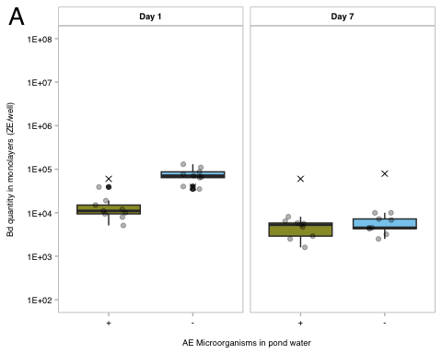

#ggsave("paper-figures/expt4-SFEB_AE_monolayer_fig4a_updated.pdf", plot = fig_SFEB_monolayer, width = 3.46, height = 3.46)

## Fig 7B SBNCOS monolayer

fig_SBNCOS_monolayer <- monolayer_summary %>%   
 # reorder to match Renwei's plot  
 mutate(sample_ID = factor(sample_ID,   
 levels = c("TB+PW+microbes","PW+microbes",  
 "TB+PW-microbes", "PW-microbes"))) %>%   
 ggplot(aes(x = day_numeric,   
 y = mean_adh,   
 color = sample_ID)) +  
 geom_point(size = 2) +  
 geom_errorbar(aes(ymin = mean_adh - se, # plot the standard error  
 ymax = mean_adh + se),  
 width = 0.1) +  
 geom_line(aes(linetype = microbes), show.legend = FALSE) +   
 scale_y_log10(labels = function(x) {gsub("e", "E", scales::scientific_format()(x))},   
 # update to consistent scale per reviewer request  
 limits = c(1e+02, 1e+08),  
 breaks = c(1e2, 1e3, 1e4, 1e5, 1e6, 1e7, 1e8)) +   
   
 # vibes  
 labs(x = "Incubation of Bd monolayers (day)",  
 y = "Bd quantity in monolayers (ZE/well)",  
 color = "Medium", # Title for color legend  
 linetype = "Microbes\nPresent") +  
 scale_color_manual(values = c("TB+PW+microbes" = "#4477AA",   
 "PW+microbes" = "#EE6677",   
 "TB+PW-microbes" = "#66CCEE",   
 "PW-microbes" = "#AA3377"),   
   
 labels = c("TB+PW+microbes" = "TB + PW + MO",  
 "PW+microbes" = "PW + MO",  
 "TB+PW-microbes" = "TB + PW - MO",  
 "PW-microbes" = "PW - MO")) + # Custom labels  
 myCustomTheme()+  
 theme(legend.position = "bottom",  
 panel.border = element_blank(),  
 legend.text = element_text(size = 5), # Set legend text font size to 5pt  
 legend.key.size = unit(0.4, "cm"), # Reduce size of legend keys  
 legend.spacing.y = unit(0.1, "cm"), # Reduce vertical spacing between legend items  
 legend.margin = margin(t = 0, r = 0, b = 0, l = 0),  
 axis.line.x = element_line(color = "grey", size = 0.5), # Keep the x-axis line  
 axis.line.y = element_line(color = "grey", size = 0.5)) + # Keep the y-axis line) + # Remove margins around legend  
guides(color = guide_legend(title = NULL)) +  
  
 scale_linetype_manual(values = c("n" = "dashed",   
 "y" = "solid"),  
 labels = c("n" = "N", "y" = "Y")) + # Change labels to uppercase N and Y  
 scale_x_continuous(breaks = c(0, 1, 3, 5, 7),  
 labels = c("Initial\nBd", "1", "3", "5", "7"))  
  
fig_SBNCOS_monolayer <- fig_SBNCOS_monolayer +  
 labs(tag = "B") +  
 theme(  
 plot.tag = element_text(family = "Helvetica", size = 20, face = "plain", hjust = -0.1, vjust = 1),  
 plot.tag.position = c(0, 1)  
 )  
  
fig_SBNCOS_monolayer

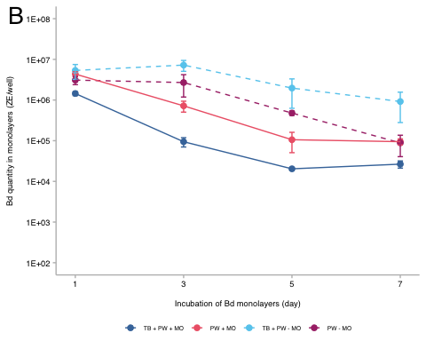

#ggsave("paper-figures/expt4-SBNCOS_AE_monolayer_fig4b_updated.pdf", plot = fig_SBNCOS_monolayer, width = 3.46, height = 3.46)

# *SI

## S8: SFEB

# df for control data  
eb_ml_controls <- eb_ml_controls %>%  
 mutate(site = case_when(  
 site == "MQ" ~ "sterile MQ", # rename mq to sterile mq so it's clear  
 TRUE ~ site)) %>%   
 mutate(filter = case_when(  
 filter == "40um_filter" ~ "sterile MQ 40um_filter", # re-label filter as sterile control  
 filter == "0.22um_filter" ~ "sterile MQ 0.22um_filter", # same for other filter  
 TRUE ~ filter))   
  
# drop column, don't need it, will allow for combining df's  
eb_monolayer_nolog <- eb_monolayer %>%  
 dplyr::select(-log_bd)   
  
# cmbine df's of experimental data and controls together  
combined_data_4 <- bind_rows(  
 eb_monolayer_nolog, # main data  
 eb_ml_controls) # control data already formatted  
  
##### plot it  
  
SI_4a <- combined_data_4 %>%  
 ggplot(aes(y = bd_qty, x = site, fill = filter)) +   
 geom_col(position = position_dodge()) + # side-by-side bars so filters don't stack  
  
 # log y axis  
 scale_y_continuous(  
 expand = c(0.01, 0.01), # small padding around bars  
 trans = "log", # log scale   
 breaks = c(1e+01, 1e+03, 1e+05), # specific breaks  
 labels = scales::label_scientific()) + # use scientific notation (the E's)  
  
 # order sites by property   
 scale_x_discrete(limits = c(  
 "CABIN", "GRAMPS", "WEST",  
 "GDPND005", "GDPND006", "GDPND009",  
 "PRPND004", "PRPND009", "PRPND010",  
 "sterile MQ")) + # put sterile MQ at the end  
  
 # facet by day  
 facet_wrap(~day, labeller = labeller(  
 day = c("Day_1" = "Day 1", "Day_7" = "Day 7"))) + # prettier facet labels  
  
 # assign custom colors to each filter type  
 scale_fill_manual(values = c(  
 "40um_filter" = with_microbes_40_color,   
 "0.22um_filter" = no_microbes_.22_color,   
 "sterile MQ 40um_filter" = "darkgray",   
 "sterile MQ 0.22um_filter" = "lightgray")) +   
  
 # apply my custom theme & some extra tweaks  
 myCustomTheme() +   
 theme(  
 axis.text.x = element_text(angle = 90, vjust = 0.5, hjust = 1), # rotate site names  
 legend.position = "bottom", # move legend under plot  
 panel.border = element_rect(color = "gray", size = 0.5, fill = NA), # outline each facet  
 legend.text = element_text(size = 5), # small font in legend  
 legend.key.size = unit(0.4, "cm"), # shrink legend keys  
 legend.spacing.y = unit(0.1, "cm"), # tighter spacing between legend items  
 legend.margin = margin(t = 0, r = 0, b = 0, l = 0)) + # remove extra padding  
 xlab("site") + # x axis label  
 ylab("bd quantity \n (zoospore equivalents)") + # y axis label (with line break)  
 guides(fill = guide_legend(title = "")) # remove legend title  
  
SI_4a

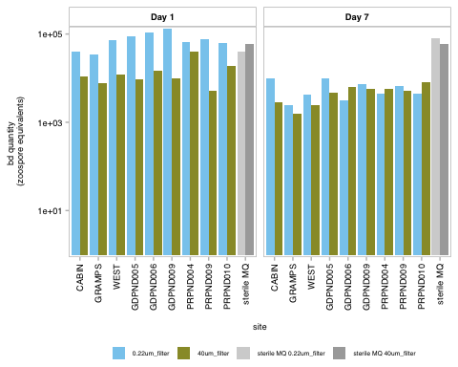

## S9: SBNCOS

# set consistent y-axis limits and breaks for all cld plots  
global_y_limits <- c(9, 18)  
global_y_breaks <- seq(10, 18, by = 2)  
  
# compact letter display plot for day  
cld_day_4b <- ggplot(cld_day, aes(x = day, y = emmean)) +  
 geom_point(size = 1) +  
 geom_errorbar(aes(ymin = lower.CL, ymax = upper.CL), width = 0.2) +  
 geom_text(aes(label = .group), nudge_y = 1.5, size = 1.75, color = "black") +  
 xlab("Day") +  
 ylab("Estimated Marginal Means") +  
 scale_y_continuous(labels = scales::label_number(accuracy = 1), limits = global_y_limits, breaks = global_y_breaks) +  
 ggtitle("Day") +  
 scale_x_discrete(labels = c("Day_1" = "1", "Day_3" = "3", "Day_5" = "5", "Day_7" = "7")) +  
 myCustomTheme() +  
 theme(axis.title.y = element_text(margin = margin(r = 1)))  
  
# compact letter display plot for microbes  
cld_microbes_4b <- ggplot(cld_microbes, aes(x = microbes, y = emmean)) +  
 geom_point(size = 1) +  
 geom_errorbar(aes(ymin = lower.CL, ymax = upper.CL), width = 0.2) +  
 geom_text(aes(label = .group), nudge_y = 1.5, size = 1.75, color = "black") +  
 xlab("Microbes present") +  
 ylab("Estimated Marginal Means") +  
 scale_y_continuous(labels = scales::label_number(accuracy = 1), limits = global_y_limits, breaks = global_y_breaks) +  
 ggtitle("Microbes") +  
 scale_x_discrete(labels = c("1%TB+AEbiofilm" = "1%TB", "PW+AEBiofilm" = "PW - MO", "MQ+AEbiofilm" = "MQ")) +  
 myCustomTheme() +  
 theme(axis.title.y = element_text(margin = margin(r = 1)))  
  
# compact letter display plot for day * microbes  
cld_day_microbes_4b <- ggplot(cld_day_microbes, aes(x = day, y = emmean)) +  
 geom_point(size = 1) +  
 geom_errorbar(aes(ymin = lower.CL, ymax = upper.CL), width = 0.2) +  
 geom_text(aes(label = .group), nudge_y = 1.5, size = 1.75, color = "black") +  
 facet_wrap(~ factor(microbes)) +  
 xlab("Day") +  
 ylab("Estimated Marginal Means") +  
 scale_y_continuous(labels = scales::label_number(accuracy = 1), limits = global_y_limits, breaks = global_y_breaks) +  
 ggtitle("Day * Microbes") +  
 scale_x_discrete(labels = c("Day_1" = "1", "Day_3" = "3", "Day_5" = "5", "Day_7" = "7")) +  
 myCustomTheme() +  
 theme(axis.title.y = element_text(margin = margin(r = 1)))  
  
# compact letter display plot for microbes * TB  
cld_TB_microbes_4b <- ggplot(cld_TB_microbes, aes(x = TB, y = emmean)) +  
 geom_point(size = 1) +  
 geom_errorbar(aes(ymin = lower.CL, ymax = upper.CL), width = 0.2) +  
 geom_text(aes(label = .group), nudge_y = 1.5, size = 1.75, color = "black") +  
 facet_wrap(~ factor(microbes)) +  
 xlab("TB Presence") +  
 ylab("Estimated Marginal Means") +  
 scale_y_continuous(labels = scales::label_number(accuracy = 1), limits = global_y_limits, breaks = global_y_breaks) +  
 ggtitle("Microbes * TB") +  
 scale_x_discrete(labels = c("Day_1" = "1", "Day_3" = "3", "Day_5" = "5", "Day_7" = "7")) +  
 myCustomTheme() +  
 theme(axis.title.y = element_text(margin = margin(r = 1)))  
  
# Combine all plots  
pairwise_cld_4b <- cld_day_4b + cld_microbes_4b + cld_day_microbes_4b + cld_TB_microbes_4b +  
 plot_annotation(tag_levels = 'A')  
pairwise_cld_4b

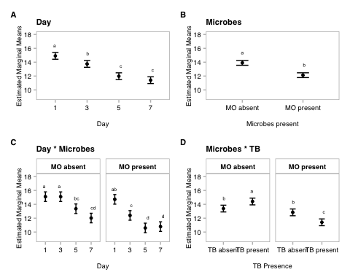

#ggsave("SI_4b_updated.pdf", plot = pairwise_cld_4b, width = 7.09, height = 3.46)

# Appendix

Not used in publication but I like these so I’ll keep them here

## anova table

anova_output4b <- tidy(aov_4b) # get model output as a tibble  
  
anova_output4b <- anova_output4b %>%  
 mutate(term = gsub(":", " x ", term)) %>% # clean up interaction terms  
 mutate(term = paste0(term, " (*df = ", df, ", ", anova_output4b[df == max(df), "df"], "*)")) %>% # move degrees of freedom into first column with the "term"  
 filter(term != "Residuals (*df = 32, 32*)") # drop residual row from table, accounted for in the max (df) above  
  
aov_4b_tbl_b <- anova_output4b %>%  
 dplyr::select(term, statistic, p.value) %>% # just keep what's needed  
 gt() %>%  
 tab_header(title = "4b ANOVA Table") %>% # give the table a title  
 fmt_markdown(columns = term) %>% # render df as italics; tells gt to interpret markdown formatting in the specified column(s), so the *'s above will be italics  
 fmt_number(columns = statistic, decimals = 2) %>% # round f value  
 cols_label( # relabel for clean display  
 term = "",  
 statistic = "F value",  
 p.value = "P-value") %>%  
 fmt_scientific(columns = p.value, decimals = 1, rows = p.value < 0.001) %>% # sci format for tiny p-value  
 fmt_number(columns = p.value, decimals = 3, rows = p.value >= 0.001) # normal format for rest of the p values  
  
aov_4b_tbl_b

Table 1: 4b ANOVA Table

|  | F value | P-value |
| --- | --- | --- |
| day (*df = 3, 32*) | 45.34 | 1.3 × 10^-11 |
| microbes (*df = 1, 32*) | 54.84 | 2.0 × 10^-8 |
| TB (*df = 1, 32*) | 0.75 | 0.394 |
| day x microbes (*df = 3, 32*) | 5.90 | 0.003 |
| day x TB (*df = 3, 32*) | 0.46 | 0.715 |
| microbes x TB (*df = 1, 32*) | 26.28 | 1.4 × 10^-5 |
| day x microbes x TB (*df = 3, 32*) | 0.78 | 0.516 |

## post hoc

# # post hoc table  
# # Convert Tukey emmeans results to data frames  
# f4b_tukey_day_df <- as.data.frame(f4b_tukey_day)  
# f4b_tukey_microbes_df <- as.data.frame(f4b_tukey_microbes)  
# f4b_tukey_int_microbe_day_df <- as.data.frame(f4b_tukey_int_microbe_day)  
# f4b_tukey_int_microbe_TB_df <- as.data.frame(f4b_tukey_int_microbe_TB)  
#   
# # Add labels to indicate which factor the comparison refers to  
# f4b_tukey_day_df <- f4b_tukey_day_df %>% mutate(factor = "Day")  
# f4b_tukey_microbes_df <- f4b_tukey_microbes_df %>% mutate(factor = "Medium")  
# f4b_tukey_int_microbe_day_df <- f4b_tukey_int_microbe_day_df %>% mutate(factor = "Day x microbes")  
# f4b_tukey_int_microbe_TB_df <- f4b_tukey_int_microbe_TB_df %>% mutate(factor = "Microbes x TB")  
#   
# f4b_all_tukey_df <- bind_rows(f4b_tukey_day_df, f4b_tukey_microbes_df, f4b_tukey_int_microbe_TB_df, f4b_tukey_int_microbe_day_df)  
#   
# f4b_all_tukey_df <- f4b_all_tukey_df %>%   
# mutate(contrast = gsub("MO present TB absent", "microbes only", contrast),  
# contrast = gsub("MO present TB present", "both microbes and TB", contrast),  
# contrast = gsub("MO absent TB absent", "neither microbes nor TB", contrast),  
# contrast = gsub("MO absent TB present", "TB only", contrast))  
#   
#   
# ph4b_table <- f4b_all_tukey_df %>%  
# dplyr::select(factor, contrast, estimate, SE, df, t.ratio, p.value) %>%  
# gt() %>%  
# # change column names  
# cols_label(  
# factor = "Comparison",  
# contrast = "Group Comparison",  
# estimate = "Estimate",  
# SE = "Standard Error",  
# df = "Degrees of Freedom",  
# t.ratio = "t-Ratio",  
# p.value = "p-value"  
# ) %>%  
# # update header for table  
# tab_header(  
# title = "4b Emmeans Post-hoc Test Results"  
# ) %>%  
# # 3 decimal places  
# fmt_number(  
# columns = c(estimate, SE, t.ratio),  
# decimals = 3  
# ) %>%  
# # scientific number format for values <0.001 in p values  
# fmt_scientific(  
# columns = c(p.value),  
# decimals = 1,  
# rows = p.value < 0.001  
# ) %>%  
# # 3 decimals for p values >=0.001  
# fmt_number(  
# columns = c(p.value),  
# decimals = 3,  
# rows = p.value >= 0.001  
# ) %>%  
# #make the headers bold  
# tab_style(  
# style = list(  
# cell_text(weight = "bold")  
# ),  
# locations = cells_column_labels(everything()))  
#   
# ph4b_table