Biofilm Bd Update

Caitlin Nordheim-Maestas

# Map of experiments

| Nickname | Experiment | Bd tested |
| --- | --- | --- |
| EB Pond water - 2A | Effect of pond water microbes from the East Bay on Bd | adherent + supernatant |
| SB Pond water - 2B | Effect of pond water microbes from Santa Barbara on Bd over time, also looking at the addition of a food source (TB) | adherent + supernatant |
| EB AE Biofilm - 3A | Effect of East Bay AE biofilm from the East Bay on Bd (incubated in microbe depleted water to isolate the microbes to only the AE biofiom) | adherent only |
| SB AE Biofilm - 3B | Effect over time of Santa Barbara AE biofilm on Bd, while looking at different incubation media (microbe depleted local pond water, MQ, and TB) | adherent only |
| EB Monolayer Biofilm- 4A | Effect of East Bay pond water microbes on a monolayer-Bd biofilm | adherent only |
| SB Monolayer Biofilm - 4B | Effect over time of Santa Barbara Pond water on Bd in a monolayer, while looking at different incubation media (MQ, and TB) | adherent only |

# Load in data and libraries

## read in and clean data  
library(tidyverse) # for cleaning and viewing data  
library(gt) # pretty stats tables  
library(broom) # cleaning for gt  
library(here) # for importing data  
library(car) # stats tests like Levene's  
library(Hmisc) # autocalculate stat summaries in ggplot  
library(multcomp) # stats  
library(nlme) # mixed effects models  
library(emmeans) # for pairwise comparisons, especially on mixed effects models and glms  
library(ggpubr) # for making ggqq plot  
library(patchwork) # for combining figures  
  
# load "East Bay" experiments data  
ns_biofilm_bd <- read.csv(here("data", "nine-sites-biofilm-on-Bd - Sheet1.csv"))  
fs_pw_bd <- read.csv(here("data", "fifteen-sites-PW-on-Bd - Sheet1.csv"))  
ns_ml_pw_bd <- read.csv(here("data", "nine-sites-PW-on-MLBd - Sheet1.csv"))  
  
fig_2b_raw <- read.csv(here("data", "final_NCOS_2024_reformatted_for_R.xlsx - Fig2B.csv"))  
fig_3b_raw <- read.csv(here("data", "final_NCOS_2024_reformatted_for_R.xlsx - Fig3B.csv"))  
fig_4b_raw <- read.csv(here("data", "final_NCOS_2024_reformatted_for_R.xlsx - Fig4B.csv"))  
  
# Colors: these are from Paul Tol's colorblind friendly palette  
with_microbes_40_color <- "#999933"  
no_microbes_.22_color <- "#88ccee"  
  
# set up custom theme  
myCustomTheme <- function() {  
 theme_light() +  
 theme(axis.text = element_text(size = 12, family = "Times", color = "black"),  
 axis.title.x = element_text(margin = margin(t = 10), size = 14, face = "bold", family = "Times", color = "black"), # Add space between x-axis label and axis  
 axis.title.y = element_text(margin = margin(r = 10), size = 14, face = "bold", family = "Times", color = "black"), # Add space between y-axis label and axis  
 title = element_text(size = 12, face = "bold", family = "Times"),  
 plot.caption = element_text(size = 10, face = "italic", family = "Times"),  
 legend.text = element_text(size = 10, family = "Times"), # Increase legend text size  
 panel.grid.major.x = element_blank(), # Remove major vertical grid lines  
 panel.grid.minor.x = element_blank(), # Remove minor vertical grid lines  
 panel.grid.major.y = element_blank(), # Remove major horizontal grid lines  
 panel.grid.minor.y = element_blank(), # Remove minor horizontal grid lines  
 strip.text = element_text(size = 12, face = "bold", family = "Times", color = "black"), # Set strip text style  
 strip.background = element_rect(fill = "white", color = "grey"), # Set strip background to white, # color = "black"  
 axis.ticks = element_blank() # Remove x and y axis ticks  
 )}

# 2A: East Bay pond water microbes

Statistical question:

Is there a difference in the **gain or loss of Bd over 6 days** between the **filter sizes** looking at the **TOTAL BD**

## 2A Data Wrangling

# remove controls  
eb_pw <- fs_pw_bd %>% filter(site != "sterile MQ")  
  
# keep control for labeling plot  
eb_pw_controls <- fs_pw_bd %>%   
 filter(site =="sterile MQ") %>%   
 pivot_wider(names_from = bd_location, values_from = bd_qty) %>%  
 mutate(combined_bd = adherent + floating) %>%   
 mutate(day = case_when(  
 day == 1 ~ "Day_1",  
 day == 7 ~ "Day_7"))  
  
# data type cleaning  
eb_pw$bd_location <- factor(eb_pw$bd_location, levels = c("floating", "adherent"))  
eb_pw$filter <- factor(eb_pw$filter,  
 levels = c("40um_filter", "0.22um_filter"))  
eb_pw$day <- factor(eb_pw$day, levels = c("1", "7"),  
 labels = c("Day_1", "Day_7"))  
eb_pw$site <- factor(eb_pw$site,  
 levels = c("BARN", "CABIN", "NORTH", "GRAMPS", "WEST", "GDPND004", "GDPND005", "GDPND006", "GDPND008", "GDPND009", "PRPND002", "PRPND003", "PRPND004", "PRPND009", "PRPND010", "sterile MQ"))  
  
# get the total difference across days by combining both locations of Bd then subtracting across days  
eb_pw_total_diff <- eb_pw %>%  
 # combine floating and adherent for total_Bd  
 pivot_wider(names_from = bd_location, values_from = bd_qty) %>%  
 mutate(combined_bd = adherent + floating) %>%   
 subset(select = -c(adherent,floating)) %>%   
  
# different metrics of difference in Bd  
 pivot_wider(names_from = day, values_from = combined_bd) %>%  
  
 # calculate the rate loss by taking the log of each before subtracting  
 mutate(rate_loss = log(Day_1) - log(Day_7))  
  
# Split into 2 data frames one for 40 and one for .22  
eb_pw_total_diff_40um <- eb_pw_total_diff %>%   
 filter(filter =="40um_filter")  
eb_pw_total_diff.22um <- eb_pw_total_diff%>%   
 filter(filter =="0.22um_filter")

## 2A EDA

# Renwei barplot remake  
eb_pw %>%  
 # combine floating and adherent for total_Bd  
 pivot_wider(names_from = bd_location, values_from = bd_qty) %>%  
 mutate(combined_bd = adherent + floating) %>%   
ggplot(aes(y= combined_bd, x = site, fill = filter)) +   
 geom_col(position = position_dodge()) +  
 scale_y_log10() +  
 facet_wrap(~day, labeller = labeller(day = c("Day_1" = "Day 1",  
 "Day_7" = "Day 7"))) +  
 scale_fill_manual(values = c("40um_filter" = with_microbes_40_color,   
 "0.22um_filter" = no_microbes_.22_color)) +  
 theme_classic() +  
 theme(axis.text.x = element_text(angle = 90),  
 legend.position = "bottom",  
 strip.text = element_text(face="bold"),  
 axis.title = element_text(face = "bold")) +   
 xlab("Site") +  
 ylab("Bd Quantity \n (zoospore equivalents)") +  
 guides(fill=guide_legend(title=""))

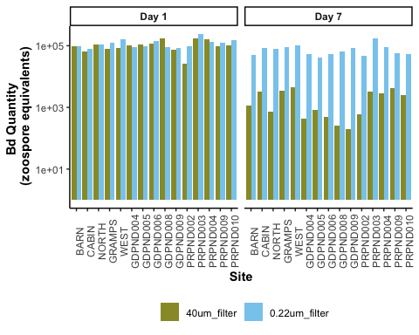

Boxplot

# eb_pw %>%  
# # combine floating and adherent for total_Bd  
# pivot_wider(names_from = bd_location, values_from = bd_qty) %>%  
# mutate(combined_bd = adherent + floating) %>%   
#   
# # create the plot  
# ggplot(aes(y= combined_bd, x = filter, fill = filter)) +   
# geom_boxplot() +  
# geom_jitter(width = 0.2, alpha = 0.3) +  
# scale_y_log10() +  
# facet_wrap(~day, labeller = labeller(day = c("Day_1" = "Day 1",  
# "Day_7" = "Day 7")))+  
# scale_fill_manual(values = c("40um_filter" = with_microbes_40_color,   
# "0.22um_filter" = no_microbes_.22_color)) +  
# theme_classic() +  
# theme(legend.position = "none",  
# strip.text = element_text(face="bold"),  
# axis.title = element_text(face = "bold")) +   
# scale_x_discrete (labels= c("40um_filter" = "With Microbes", "0.22um_filter" = "No Microbes")) +  
# xlab("Presence of Microbes in Pond Water") +  
# ylab("Bd Quantity \n (zoospore equivalents)") +  
#   
# # add controls ad x's  
# geom_point(data = eb_pw_controls, aes(x = filter, y = combined_bd), shape = 4, size = 2)

## 2A Stats and assumption testing

Question: Does the difference in Bd from day 1 to day 7 differ between the two filter types?

The samples are essentially paired by site, so a paired t-test is most appropriate

Assumptions:

Assumes that the observations from each group represent a random sample from the population. Assumes that the difference of the two observations follow a normal distribution.

Assumption testing:

# check normality of the differences across groups  
  
# numeric check  
eb_pw_40um_shapiro.test <- shapiro.test(eb_pw_total_diff_40um$rate_loss) # normal, yay!  
eb_pw_0.22um_shapiro.test <- shapiro.test(eb_pw_total_diff.22um$rate_loss) # normal, yay!  
  
# visual check  
eb_pw_40um_qq <- eb_pw_total_diff_40um %>%   
 ggqqplot("rate_loss", title = "40 um")  
  
# Histogram using ggplot2  
eb_pw_40um_hist <- eb_pw_total_diff_40um %>%   
 ggplot(aes(x = rate_loss)) +  
 geom_histogram(binwidth = 0.2) +  
 labs(title = "40 um")  
  
# visual check  
eb_pw_0.22um_qq <- eb_pw_total_diff.22um %>%   
 ggqqplot("rate_loss", title = "0.22 um")  
  
# Histogram using ggplot2  
eb_pw_0.22um_hist <- eb_pw_total_diff.22um %>%   
 ggplot(aes(x = rate_loss)) +  
 geom_histogram(binwidth = 0.2) +  
 labs(title = "0.22 um")  
  
eb_pw_40um_qq + eb_pw_40um_hist + eb_pw_0.22um_qq + eb_pw_0.22um_hist

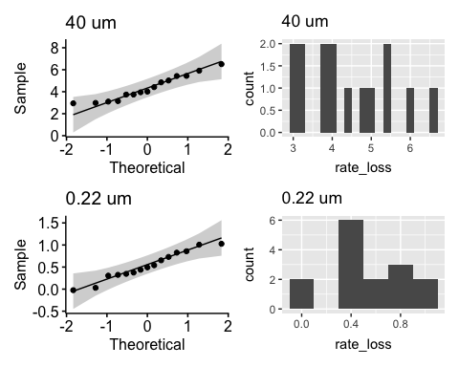

eb_pw_40um_shapiro.test

Shapiro-Wilk normality test  
  
data: eb_pw_total_diff_40um$rate_loss  
W = 0.93591, p-value = 0.3337

eb_pw_0.22um_shapiro.test

Shapiro-Wilk normality test  
  
data: eb_pw_total_diff.22um$rate_loss  
W = 0.96119, p-value = 0.7131

The data for the 40um filter is normally distributed (Shapiro-Wilk test, W = 0.93591, p = 0.3337), and so is the data for the 0.22 filter (Shapiro-Wilk test, W = 0.96119, p = 0.7131).

# Stats

# Run the paired t-test on the difference  
eb_pw_paired_ttest_result <- t.test(eb_pw_total_diff_40um$rate_loss, eb_pw_total_diff.22um$rate_loss, paired = TRUE)  
  
eb_pw_paired_ttest_result

Paired t-test  
  
data: eb_pw_total_diff_40um$rate_loss and eb_pw_total_diff.22um$rate_loss  
t = 12.449, df = 14, p-value = 5.83e-09  
alternative hypothesis: true mean difference is not equal to 0  
95 percent confidence interval:  
 3.159637 4.474996  
sample estimates:  
mean difference   
 3.817316

### 2A Stats results:

**There is a significant difference in the change in the total quantity of Bd from Day 1 to Day 7 across the filter types (t = 12.4488129, df = 14, p-value = 5.8299032^{-9})**

The t-value is positive, which shows that the first item entered (with microbes) has a larger loss of Bd than the second item entered (no microbes.) Df of 14 is expected, because it’s 15 sites.

# 3A: Effect of the East Bay aquatic environmental biofilm on Bd growth - “9 sites”

Does the difference in Bd in the adherent AE biofilm from day 1 to day 7 differ between the two filter types?

## 3A Data Wrangling

eb_ae <- ns_biofilm_bd  
  
#---- Part II  
# set as factors with levels so they appear in order in plots later  
eb_ae$site <- factor(eb_ae$site,  
 levels = c("CABIN", "GRAMPS", "WEST", "GDPND005", "GDPND006", "GDPND009", "PRPND004", "PRPND009", "PRPND010"))  
eb_ae$bd_location <- factor(eb_ae$bd_location, levels = c("supernatant", "biofilm"))  
eb_ae$day <- factor(eb_ae$day, levels = c("Day_0", "Day_1", "Day_7"))  
  
# Biofilm only, no supernatant, and days 1 and 7 only, no day 0  
eb_ae_bf_only <- eb_ae %>%   
 filter(bd_location == "biofilm") %>%   
 filter(day != "Day_0") %>%   
 #log bd qty  
 mutate(log_qty = log(bd_qty))

## PII Data Visualization

### Renwei barplot

eb_ae %>%  
ggplot(aes(y= bd_qty, x = site, fill=bd_location)) +   
 geom_col() +  
 facet_grid(.~day)+  
 theme_classic()+  
 scale_fill_manual(values = c("lightgrey", "gray45" )) +  
 theme(axis.text.x = element_text(angle = 90),  
 legend.position = "bottom") +   
 scale_y_log10() +  
 xlab("Site") +  
 ylab("Total Bd Quantity Per Well \n (zoospore equivalents)")

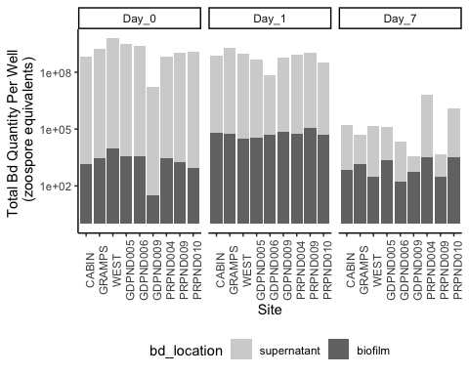

# part2 <- eb_ae_bf_only %>%  
# ggplot(aes(y= bd_qty, x = day)) +   
# geom_boxplot(fill = no_microbes_.22_color) +  
# geom_jitter(alpha = 0.3, width = 0.1) +  
# theme_classic() +  
# scale_y_log10() +  
# theme(legend.position = "none",  
# strip.text = element_text(face="bold"),  
# axis.title = element_text(face = "bold")) +   
# xlab("Time (days)") +  
# ylab("Bd Quantity \n (zoospore equivalents)") +  
# scale_x_discrete (labels= c("Day_1" = "Day 1", "Day_7" = "Day 7"))  
#   
# # Let's add significance letters  
# significance_data <- tibble(  
# day = factor(c("Day_1", "Day_7"), levels = c("Day_1", "Day_7")),  
# y_position = c(1.6e+05, 1.4e+04), # Adjust this depending on your plot's scale  
# label = c("a", "b"))  
#   
# part2 +   
# geom_text(data = significance_data, aes(x = day, y = y_position, label = label),  
# position = position_dodge(width = 0.75), vjust = 0)

## PII Assumptions testing and Stats

Question:

Does the amount of Bd in the biofilm differ between day 1 and day 7?

The samples are essentially paired by site, so a paired t-test is most appropriate

Assumptions:

Assumes that the observations from each group represent a random sample from the population. Assumes that the difference of the two observations follow a normal distribution.

Check assumptions

# check normality of the differences across groups let's try untransformed  
eb_ae_bf_only %>%   
 ggqqplot("bd_qty", title = "Untransformed Bd loads") +  
 facet_wrap(~day) # gotta transform the data, day 1 is not normal

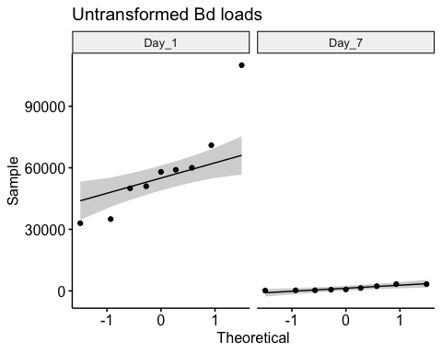

eb_ae_bf_only %>%   
 ggqqplot("log_qty", title = "Transformed Bd loads") +  
 facet_wrap(~day) # not perfect but close, let's try shapiro tests

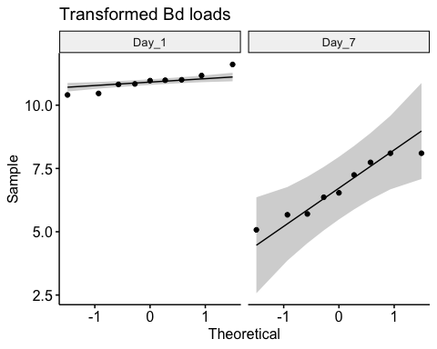

# Shapiro tests  
day_one <- eb_ae_bf_only %>%   
 filter(day == "Day_1") %>% # filter to only include day 1  
 pull(log_qty)  
  
shapiro.test(day_one) # p >> 0.05, it's normal!

Shapiro-Wilk normality test  
  
data: day_one  
W = 0.93796, p-value = 0.5606

day_seven <- eb_ae_bf_only %>%   
 filter(day == "Day_7") %>% # filter to only include day 1  
 pull(log_qty)  
  
shapiro.test(day_seven) # p >> 0.05, it's normal!

Shapiro-Wilk normality test  
  
data: day_seven  
W = 0.92235, p-value = 0.412

# Histograms for funsies  
eb_ae_bf_only %>%   
ggplot(aes(x = log_qty)) + # x-axis  
 geom_histogram(bins = 4) + # make a histogram  
 facet_wrap(~ day, # make multiple panels by day  
 scales = "free") # let the axes vary between panels

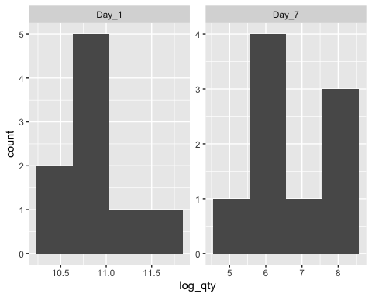

Stats

# Step 3: run the paired t-test  
t.test(day_one, day_seven, paired = TRUE)

Paired t-test  
  
data: day_one and day_seven  
t = 10.094, df = 8, p-value = 7.915e-06  
alternative hypothesis: true mean difference is not equal to 0  
95 percent confidence interval:  
 3.233993 5.149159  
sample estimates:  
mean difference   
 4.191576

**There is significantly more Bd in the biofilm on Day 1 than on Day 7 (t = 10.094, df = 8, p-value < 0.0001)**

# 4A: East Bay Monolayer

Scientific Q: Is mono-strain Bd biofilm resistant to microbes in pond water

Statistical question:

Is there a difference in the **gain or loss of ADHERENT Bd over 6 days** between the **filter sizes**?

**There is a significant difference in the change in the quantity of adherent Bd from Day 1 to Day 7 across the filter types (t = -6.45, df = 7, p-value = 0.0003)**

## PIII Data Wrangling

eb_monolayer <- ns_ml_pw_bd %>%   
 filter(site != "MQ") %>% # remove control  
 filter(bd_location == "adherent") # only want adherent Bd data  
  
# keep control for labeling plot  
eb_ml_controls <- ns_ml_pw_bd %>%   
 filter(site =="MQ") %>% # controls only  
 filter(bd_location == "adherent") # only want adherent Bd data  
  
# Data type cleaning  
eb_monolayer$site <- factor(eb_monolayer$site,  
 levels = c("CABIN", "GRAMPS", "WEST", "GDPND005", "GDPND006", "GDPND009", "PRPND004", "PRPND009", "PRPND010"))  
eb_monolayer$bd_location <- factor(eb_monolayer$bd_location, levels = c("supernatant", "adherent"))  
eb_monolayer$day <- factor(eb_monolayer$day, levels = c("Day_1", "Day_7"))   
  
# get the total difference across days by combining both locations of Bd then subtracting across days  
eb_monolayer_diff <- eb_monolayer %>%  
 # pivot so each day has its own column  
 pivot_wider(names_from = day, values_from = bd_qty) %>%  
 # calculate the rate loss by taking the log of each before subtracting  
 mutate(rate_loss = log(Day_1) - log(Day_7))  
  
# Step 2: create subsets for each treatment  
eb_monolayer_diff_40um <- eb_monolayer_diff %>%   
 filter(filter =="40um_filter")  
eb_monolayer_diff.22um <- eb_monolayer_diff %>%   
 filter(filter =="0.22um_filter")

## PIII Data visualization

### Renwei barplot

eb_monolayer %>%  
ggplot(aes(y= bd_qty, x = site, fill = filter)) +   
 geom_col(position = position_dodge()) +  
 scale_y_log10() +  
 facet_wrap(~day)+  
 scale_fill_manual(values = c("40um_filter" = with_microbes_40_color,   
 "0.22um_filter" = no_microbes_.22_color)) +  
 theme_classic() +  
 theme(axis.text.x = element_text(angle = 90),  
 legend.position = "bottom",  
 strip.text = element_text(face="bold"),  
 axis.title = element_text(face = "bold")) +   
 xlab("Site") +  
 ylab("Bd Quantity \n (zoospore equivalents)") +  
 guides(fill=guide_legend(title=""))

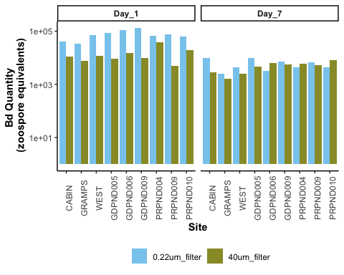

### Boxplot

eb_monolayer %>%  
  
 # plot it  
 ggplot(aes(y= bd_qty, x = filter, fill = filter)) +   
 geom_boxplot() +  
 geom_jitter(width = 0.2, alpha = 0.3) +  
 scale_y_log10() +  
 facet_wrap(~day, labeller = labeller(day = c("Day_1" = "Day 1",  
 "Day_7" = "Day 7")))+  
 scale_fill_manual(values = c("40um_filter" = with_microbes_40_color,   
 "0.22um_filter" = no_microbes_.22_color)) +  
 theme_classic() +  
 theme(legend.position = "none",  
 strip.text = element_text(face="bold"),  
 axis.title = element_text(face = "bold")) +   
 scale_x_discrete (labels= c("40um_filter" = "With Microbes", "0.22um_filter" = "No Microbes")) +  
 xlab("Presence of Microbes in Pond Water Added to Monolayer Biofilm") +  
 ylab("Bd Quantity \n (zoospore equivalents)") +  
  
 # add controls ad x's  
geom_point(data = eb_ml_controls, aes(x = filter, y = bd_qty), shape = 4, size = 2)

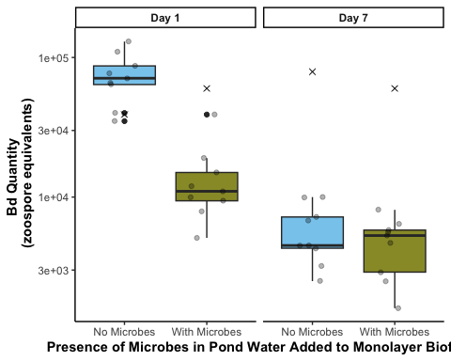

## PIII Stats and assumption testing

Question:

Does the difference in Bd from day 1 to day 7 differ between the two filter types?

The samples are essentially paired by site, so a paired t-test is most appropriate

Assumptions:

Assumes that the observations from each group represent a random sample from the population. Assumes that the difference of the two observations follow a normal distribution.

### Test: Paired t-test on the difference in total Bd between day 1 and 7

# check normality of the differences across groups  
# With microbes (40 um)  
eb_monolayer_diff_40um %>%   
 ggqqplot("rate_loss", title = "40um") # normal

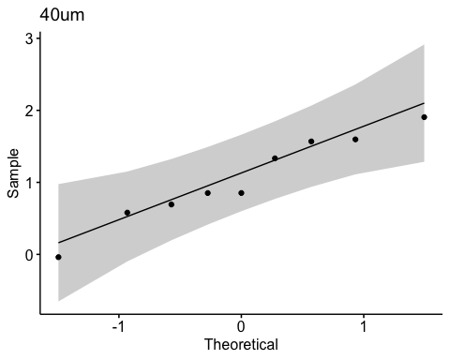

shapiro.test(eb_monolayer_diff_40um$rate_loss) # normal, yay!

Shapiro-Wilk normality test  
  
data: eb_monolayer_diff_40um$rate_loss  
W = 0.95903, p-value = 0.7881

hist(eb_monolayer_diff_40um$rate_loss) # looks good

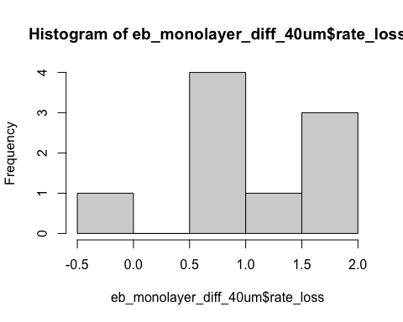

# Without microbes (0.22 um)  
eb_monolayer_diff.22um%>%   
 ggqqplot("rate_loss", title = "0.22um") # looks good

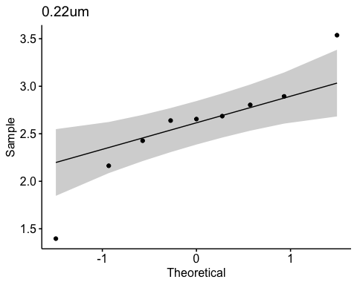

shapiro.test(eb_monolayer_diff.22um$rate_loss) # normal, yay!

Shapiro-Wilk normality test  
  
data: eb_monolayer_diff.22um$rate_loss  
W = 0.92597, p-value = 0.4439

hist(eb_monolayer_diff$rate_loss) # looks good

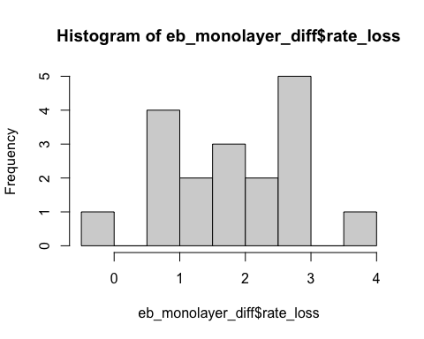

# visualize the comparison I am making  
eb_monolayer_diff %>%  
ggplot(aes(y= rate_loss, x = filter)) +   
 geom_boxplot() +  
 geom_jitter() +  
 ggtitle("Visualizing comparison for paired t-test on the rate_loss")

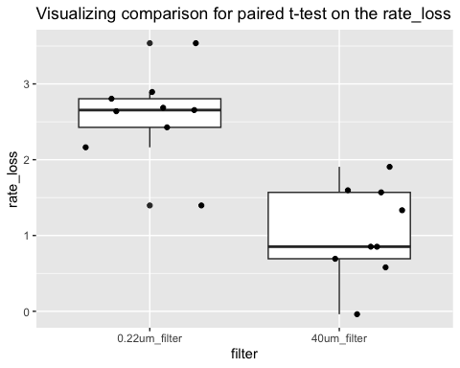

Stats:

# Step 3: run the paired t-test on the difference  
t.test(eb_monolayer_diff_40um$rate_loss, eb_monolayer_diff.22um$rate_loss, paired = TRUE)

Paired t-test  
  
data: eb_monolayer_diff_40um$rate_loss and eb_monolayer_diff.22um$rate_loss  
t = -5.3606, df = 8, p-value = 0.0006772  
alternative hypothesis: true mean difference is not equal to 0  
95 percent confidence interval:  
 -2.2020978 -0.8773797  
sample estimates:  
mean difference   
 -1.539739

### Stats results:

When monolayer Bd biofilm is exposed to pond water without microbes has a significantly greater loss of Bd between day 1 to day 7 than pond water with microbes (t = -5.4, df = 8, p = 0.0006772). The t-value is negative, which shows that the first item entered (with microbes) has a smaller loss of Bd than the second item entered (no microbes).

## Second stats Q: qty ~ factor(day) + microbe_treatment, random = ~1|factor(site)

Question: does the quantity of Bd differ across days and treatment while controlling for the paired site?

This will be a lme since it is a mixed effects model!

Data wrangling

eb_monolayer <- eb_monolayer %>%   
 mutate(log_bd = log(bd_qty))  
  
# Exploration: normality of transformed data  
eb_monolayer %>%   
 ggqqplot("log_bd") # gorgeous

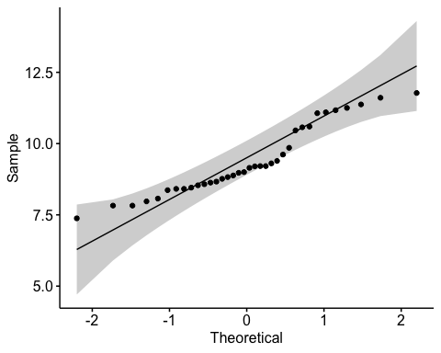

Assumptions testing

par(mfrow = c(2,2))  
# build model  
mod6 <- lme(log_bd~day*factor(filter), random = ~1|site, data=eb_monolayer)  
# model assumptions  
plot(mod6) # passes homogeneity of variances

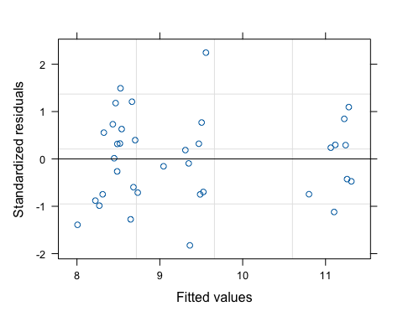

qqPlot(resid(mod6), main="QQ Plot of Residuals") # passes normality of resids

PRPND004 PRPND009   
 24 23

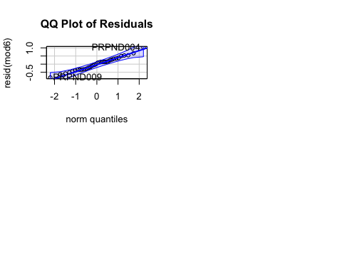

Interpret

summary(mod6)

Linear mixed-effects model fit by REML  
 Data: eb_monolayer   
 AIC BIC logLik  
 66.32921 75.12363 -27.16461  
  
Random effects:  
 Formula: ~1 | site  
 (Intercept) Residual  
StdDev: 0.2252822 0.4522353  
  
Fixed effects: log_bd ~ day * factor(filter)   
 Value Std.Error DF t-value p-value  
(Intercept) 11.155886 0.1684138 24 66.24093 0  
dayDay_7 -2.577871 0.2131858 24 -12.09214 0  
factor(filter)40um_filter -1.754991 0.2131858 24 -8.23222 0  
dayDay_7:factor(filter)40um_filter 1.539739 0.3014902 24 5.10709 0  
 Correlation:   
 (Intr) dyDy_7 f()40_  
dayDay_7 -0.633   
factor(filter)40um_filter -0.633 0.500   
dayDay_7:factor(filter)40um_filter 0.448 -0.707 -0.707  
  
Standardized Within-Group Residuals:  
 Min Q1 Med Q3 Max   
-1.8252309 -0.7197000 0.1006392 0.5741601 2.2442375   
  
Number of Observations: 36  
Number of Groups: 9

anova(mod6)

numDF denDF F-value p-value  
(Intercept) 1 24 7763.082 <.0001  
day 1 24 143.850 <.0001  
factor(filter) 1 24 42.706 <.0001  
day:factor(filter) 1 24 26.082 <.0001

emmeans::emmeans(mod6, pairwise ~ day * filter) # pairwise comparisons

$emmeans  
 day filter emmean SE df lower.CL upper.CL  
 Day_1 0.22um_filter 11.16 0.168 8 10.77 11.54  
 Day_7 0.22um_filter 8.58 0.168 8 8.19 8.97  
 Day_1 40um_filter 9.40 0.168 8 9.01 9.79  
 Day_7 40um_filter 8.36 0.168 8 7.97 8.75  
  
Degrees-of-freedom method: containment   
Confidence level used: 0.95   
  
$contrasts  
 contrast estimate SE df t.ratio p.value  
 Day_1 0.22um_filter - Day_7 0.22um_filter 2.578 0.213 24 12.092 <.0001  
 Day_1 0.22um_filter - Day_1 40um_filter 1.755 0.213 24 8.232 <.0001  
 Day_1 0.22um_filter - Day_7 40um_filter 2.793 0.213 24 13.102 <.0001  
 Day_7 0.22um_filter - Day_1 40um_filter -0.823 0.213 24 -3.860 0.0039  
 Day_7 0.22um_filter - Day_7 40um_filter 0.215 0.213 24 1.010 0.7454  
 Day_1 40um_filter - Day_7 40um_filter 1.038 0.213 24 4.870 0.0003  
  
Degrees-of-freedom method: containment   
P value adjustment: tukey method for comparing a family of 4 estimates

# Add in NCOS now

# Data reformatting and cleaning

## 2B  
pw <- fig_2b_raw %>%   
 # add column for microbes or no  
 mutate(microbes = case_when(  
 str_detect(sample_ID, "\\+microorganism") ~ "y",  
 TRUE ~ "n"  
 )) %>%   
 # # add column for water_treatment  
 mutate(water_treatment = case_when(  
 sample_ID %in% c("1%TB", "MQ", "Added Bd") ~ "sterile-water",  
 sample_ID %in% c("1%TB+PW+microorganism", "PW+microorganism") ~ "PW+MO",  
 sample_ID %in% c("1%TB+PW-microorganism", "PW-microorganism") ~ "PW-MO"  
 )) %>%   
 # add column for TB or no  
 mutate(TB = case_when(  
 str_detect(sample_ID, "TB") ~ "y",  
 TRUE ~ "n"  
 ))  
  
pw_summary <- pw %>%   
 group_by(day, sample_ID) %>%   
 reframe(mean = mean(adh_plus_sup), # calculate the mean  
 n = length(adh_plus_sup), # count the number of observations  
 df = n - 1, # calculate the degrees of freedom  
 sd = sd(adh_plus_sup), # calculate the standard deviation  
 se = sd/sqrt(n), # calculate the standard error  
 ) %>%   
 mutate(microbes = case_when(  
 str_detect(sample_ID, "\\+microorganism") ~ "y",TRUE ~ "n")) %>%   
 # add column for TB or no  
 mutate(TB = case_when(str_detect(sample_ID, "TB") ~ "y", TRUE ~ "n")) %>%   
 # add column for PW or no  
 mutate(water_treatment = case_when(  
 sample_ID %in% c("1%TB", "MQ", "Added Bd") ~ "sterile-water",  
 sample_ID %in% c("1%TB+PW+microorganism", "PW+microorganism") ~ "PW+MO",  
 sample_ID %in% c("1%TB+PW-microorganism", "PW-microorganism") ~ "PW-MO"  
 ))  
  
pw_control_data <- pw %>%  
 filter(day == 0) %>%   
 dplyr::select(day, adh_plus_sup)  
  
## aquatic environmental biofilm (4b but I think its supposed to be 3b)  
# add column for microbes or no  
ae <- fig_3b_raw %>%   
 rename(sample_ID = Adherent.sample.ID) %>%   
   
 # add columns for components y/n  
 # add column for TB or no  
 mutate(TB = case_when(  
 str_detect(sample_ID, "TB") ~ "y",  
 TRUE ~ "n"  
 )) %>%   
 # add column for PW or no  
 mutate(PW = case_when(  
 str_detect(sample_ID, "PW") ~ "y",  
 TRUE ~ "n"  
 ))  
  
# control data for ae  
ae_control_data <- ae %>%   
 filter(day == 0) %>%   
 dplyr::select(day, adh)  
  
## Monolayer (3b but I think its supposed tobe 4b)  
# add column for microbes or no  
monolayer <- fig_4b_raw %>%   
 rename(sample_ID = sample.ID) %>%   
 rename(adh_plus_sup = ahd_plus_sup) %>%   
 # rename sample_id to only include treatment, not day  
 mutate(sample_ID = str_replace(sample_ID, "-D[0-9]+$", "")) %>%   
  
 # add columns for components y/n  
 mutate(microbes = case_when(  
 str_detect(sample_ID, "\\+microbes") ~ "y",  
 TRUE ~ "n"  
 )) %>%   
 # add column for TB or no  
 mutate(TB = case_when(  
 str_detect(sample_ID, "TB") ~ "y",  
 TRUE ~ "n"  
 )) %>%   
 # add column for PW or no  
 mutate(PW = case_when(  
 str_detect(sample_ID, "PW") ~ "y",  
 TRUE ~ "n"  
 ))

For stats: no “day 0” and relevel factors

##### 2b #####  
pw_noday0 <- pw %>%  
 filter(day != 0) %>%  
 mutate(log_adh_plus_sup = log(adh_plus_sup)) # note: no zeroes so not log + 1  
  
# quick check: we want day as a FACTOR  
pw_noday0 <- pw_noday0 %>%   
 mutate(day = as.factor(day))  
str(pw_noday0$day)

Factor w/ 4 levels "1","3","5","7": 1 2 3 4 1 2 3 4 1 2 ...

# set MQ as reference  
pw_noday0$sample_ID <- factor(pw_noday0$sample_ID)  
pw_noday0$sample_ID <- relevel(pw_noday0$sample_ID, ref = "MQ")  
  
# set sterile water as reference  
pw_noday0$water_treatment <- factor(pw_noday0$water_treatment)  
pw_noday0$water_treatment <- relevel(pw_noday0$water_treatment, ref = "sterile-water")  
  
# set no TB as reference  
pw_noday0$TB <- factor(pw_noday0$TB)  
pw_noday0$TB <- relevel(pw_noday0$TB, ref = "n")  
  
# set no microbes as reference  
pw_noday0$microbes <- factor(pw_noday0$microbes)  
pw_noday0$microbes <- relevel(pw_noday0$microbes, ref = "n")

# 2b: NCOS Pond water

## Renwei’s figure

|  |
| --- |
|  |

## Caitlin’s version

fig_2b <- pw_summary %>%   
 # reorder to match Renwei's plot  
 mutate(sample_ID = factor(sample_ID,   
 levels = c("1%TB", "MQ", "1%TB+PW+microorganism", "PW+microorganism", "1%TB+PW-microorganism", "PW-microorganism", "Added Bd"))) %>%   
  
 ggplot(aes(x = day,   
 y = mean,   
 color = sample_ID)) +  
 geom_point(size = 2) +  
 geom_errorbar(aes(ymin = mean - se, # plot the standard error  
 ymax = mean + se),  
 width = 0.1) +  
 scale_y_log10(limits = c(1e3, 1e8),   
 breaks = c(1e3, 1e4, 1e5, 1e6, 1e7, 1e8)) +  
 # vibes  
 # vibes  
 labs(x = "Day",  
 y = "Bd Quantity per sample (ZE/well)",  
 color = "Medium", # Title for color legend  
 linetype = "Microbes Present" # Title for linetype legend  
 ) +  
 scale_color_manual(values = c("1%TB" = "#CCBB44",   
 "MQ" = "#228833",   
 "1%TB+PW+microorganism" = "#4477AA",   
 "PW+microorganism" = "#EE6677",   
 "1%TB+PW-microorganism" = "#66CCEE",  
 #"Added Bd" = "#BBBBBB" # removed bc not really a medium  
 "PW-microorganism" = "#AA3377"), # Assign specific colors to match RC's plot  
 labels = c("1%TB" = "TB",  
 "MQ" = "MQ",  
 "1%TB+PW+microorganism" = "TB + PW + MO",  
 "PW+microorganism" = "PW + MO",  
 "1%TB+PW-microorganism" = "TB + PW - MO",  
 "PW-microorganism" = "PW - MO",  
 "Added Bd" = "Initial Bd")) + # Custom labels for the color legend  
 geom_line(aes(linetype = microbes)) +   
 scale_linetype_manual(values = c("n" = "dashed",   
 "y" = "solid"),  
 labels = c("n" = "N", "y" = "Y")) + # Change labels to uppercase N and Y  
 myCustomTheme()+  
 scale_x_continuous(breaks = c(0, 1, 3, 5, 7),  
 labels = c("Initial\nBd", "1", "3", "5", "7"))  
 theme(legend.position = "right") # Adjust the legend position to overlap with the plot

## 2b EDA

visualize y var: bd load

log transformed will get me closer to normal, note we only need to worry about the residuals normality though, so commented out the transformation of the data for space

# untransformed  
ggqqplot(pw_noday0, "adh_plus_sup", title = "untransformed")

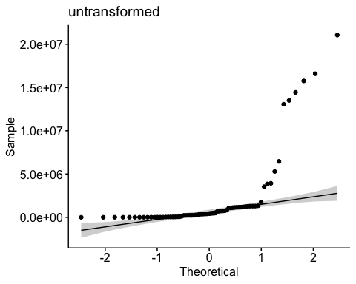

shapiro.test(pw_noday0$adh_plus_sup) # nope

Shapiro-Wilk normality test  
  
data: pw_noday0$adh_plus_sup  
W = 0.49498, p-value = 2.434e-14

hist(pw_noday0$adh_plus_sup) # note

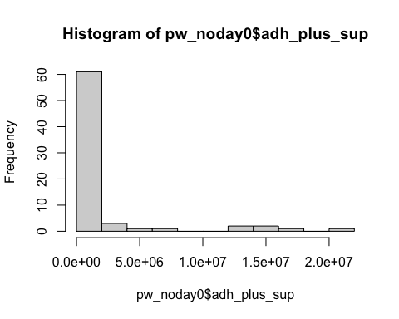

hist(sqrt(pw_noday0$adh_plus_sup)) # nope

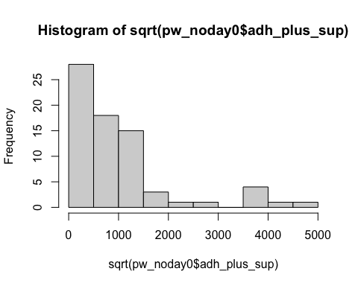

hist(log10(pw_noday0$adh_plus_sup)) # much better...?

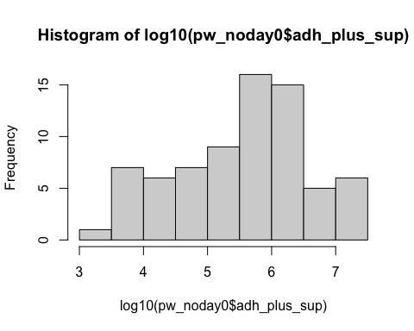

shapiro.test(log10(pw_noday0$adh_plus_sup)) # not quite

Shapiro-Wilk normality test  
  
data: log10(pw_noday0$adh_plus_sup)  
W = 0.95623, p-value = 0.01361

# transformed  
ggqqplot(pw_noday0, "log_adh_plus_sup", title = "log transformed") # gorgeous

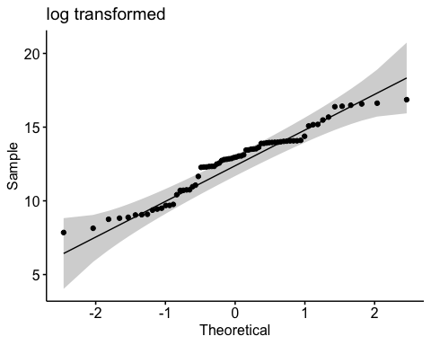

hist(pw_noday0$log_adh_plus_sup) # better

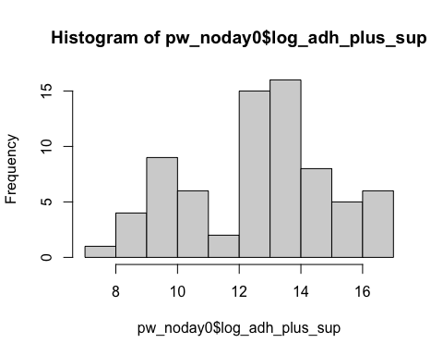

shapiro.test(pw_noday0$log_adh_plus_sup) # p-value = 0.01361, does not pass shapiro, but this has an n of 72 which is more than the recommended <50 samples

Shapiro-Wilk normality test  
  
data: pw_noday0$log_adh_plus_sup  
W = 0.95623, p-value = 0.01361

# visualize comparisons  
# TB y or n  
pw_noday0 %>%   
 ggplot(aes(x = TB,   
 y = log_adh_plus_sup)) +  
 geom_boxplot()

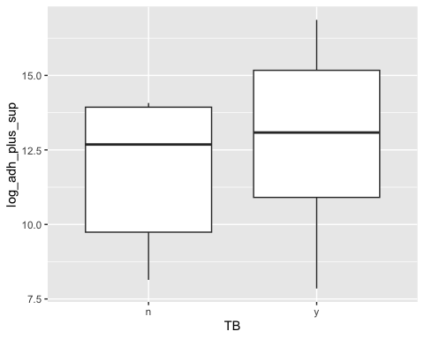

# water_treat  
pw_noday0 %>%   
 ggplot(aes(x = water_treatment,   
 y = log_adh_plus_sup)) +  
 geom_boxplot()

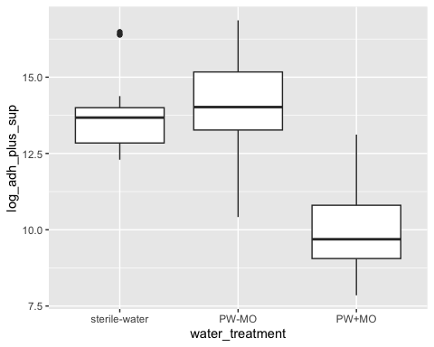

# day  
pw_noday0 %>%   
 ggplot(aes(x = day,   
 y = log_adh_plus_sup)) +  
 geom_boxplot()

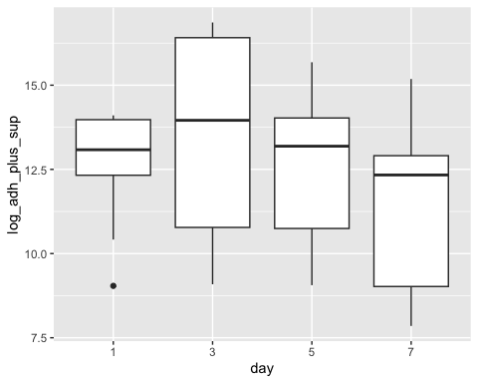

## 2b Stats

Most appropriate comaprison for study design: day*microbes*water_treatment

* y variable: amount of Bd
* x vars: day, TB y/n, water_treatment (pw with microbes, pw without, sterile water)

Question: Does the amount of Bd in the sample differ across the treatments of presence of water type (pw with microbes, pw without, sterile water), TB, and day?

Model: Linear model

Note: anovas, lm’s and glm’s are all linear models!

## null

null <- lm(log_adh_plus_sup ~ 1,  
 data = pw_noday0)  
AIC(null) #326.4356

[1] 326.4356

## Try ANOVA with interactions: Bd ~ day*TB*water_treatment

**important: does not pass anova assumption that resids are normally distributed**

I tried different transformations with no luck either :(

Note: Kruskall wallace isn’t the best move here because I want interactions, if I cut the interactions, a normal anova works, so no need for a KW

# build model  
# all interactions  
mod3 <- aov(log_adh_plus_sup ~ day*TB*water_treatment,  
 data = pw_noday0)  
  
# diagnostic plot  
par(mfrow = c(2,2))  
plot(mod3) # NOT normal...

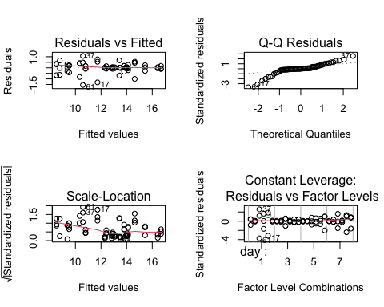

# STOP: not normally distributed resids so can't interpret

## GLM Bd ~ day*TB*water_treatment

Normal distribution GLM

**Results**

1. Day : Day 3 > Day 1 = Day 5 > Day 7
2. TB: With TB = more Bd than no TB (p <.0001)
3. Water treatment: any treatment with MO has lower Bd, sterile water and microbe free pond water are the same (p = 0.0629), pond water with microorganisms has less Bd than sterile water (p < 0.001), and pond water with MO has less Bd than pond water without (p < 0.001)
4. Interactions are all significant, except TB:water_treatment. I recommend putting these in a table, rather than listing them here, but 5 & 6 summarize them
5. Day and presence of TB: After day 1, there was less Bd in treatments without TB, but on day 1, there was no difference
6. Day and water treatment: across all days, the water treatment trend holds that presence of MO will have lower Bd than without. However, there are nuances between the sterile water and the filtered pond water.
   1. on days 5&7 sterile water had more Bd than pond water without microbes, but on day 1, sterile water had more Bd than pond water with no microbes, but on day 3, there was no difference.

# normal distribution, should be relatively the same as the anova  
mod3_glm <- glm(log_adh_plus_sup ~ day * TB * water_treatment,  
 data = pw_noday0,  
 family = gaussian(link = "identity"))  
  
par(mfrow = c(2,2))  
plot(mod3_glm) # better...!

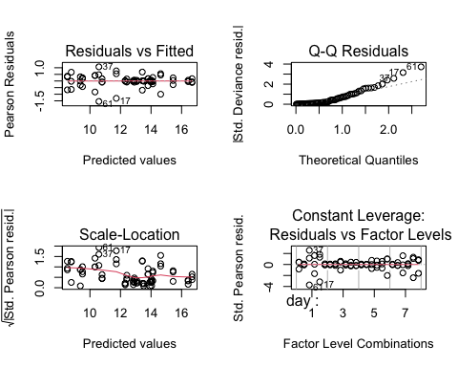

summary(mod3_glm)

Call:  
glm(formula = log_adh_plus_sup ~ day * TB * water_treatment,   
 family = gaussian(link = "identity"), data = pw_noday0)  
  
Coefficients:  
 Estimate Std. Error t value Pr(>|t|)   
(Intercept) 13.8015 0.2937 46.996 < 2e-16 ***  
day3 0.1275 0.4153 0.307 0.760206   
day5 -0.9592 0.4153 -2.310 0.025256 *   
day7 -1.4940 0.4153 -3.597 0.000758 ***  
TBy -0.3724 0.4153 -0.897 0.374400   
water_treatmentPW-MO 0.2374 0.4153 0.571 0.570329   
water_treatmentPW+MO -3.2147 0.4153 -7.740 5.45e-10 ***  
day3:TBy 2.8732 0.5873 4.892 1.16e-05 ***  
day5:TBy 1.6451 0.5873 2.801 0.007323 **   
day7:TBy 0.9745 0.5873 1.659 0.103599   
day3:water_treatmentPW-MO -0.1400 0.5873 -0.238 0.812652   
day5:water_treatmentPW-MO 0.4382 0.5873 0.746 0.459281   
day7:water_treatmentPW-MO -0.1303 0.5873 -0.222 0.825441   
day3:water_treatmentPW+MO -1.2020 0.5873 -2.046 0.046205 *   
day5:water_treatmentPW+MO -0.2553 0.5873 -0.435 0.665692   
day7:water_treatmentPW+MO -0.3156 0.5873 -0.537 0.593542   
TBy:water_treatmentPW-MO -1.9403 0.5873 -3.303 0.001810 **   
TBy:water_treatmentPW+MO 2.8541 0.5873 4.859 1.30e-05 ***  
day3:TBy:water_treatmentPW-MO 2.0997 0.8306 2.528 0.014821 *   
day5:TBy:water_treatmentPW-MO 2.5933 0.8306 3.122 0.003040 **   
day7:TBy:water_treatmentPW-MO 3.5555 0.8306 4.280 8.87e-05 ***  
day3:TBy:water_treatmentPW+MO -4.0734 0.8306 -4.904 1.12e-05 ***  
day5:TBy:water_treatmentPW+MO -3.1680 0.8306 -3.814 0.000390 ***  
day7:TBy:water_treatmentPW+MO -3.7141 0.8306 -4.471 4.75e-05 ***  
---  
Signif. codes: 0 '***' 0.001 '**' 0.01 '*' 0.05 '.' 0.1 ' ' 1  
  
(Dispersion parameter for gaussian family taken to be 0.2587316)  
  
 Null deviance: 371.319 on 71 degrees of freedom  
Residual deviance: 12.419 on 48 degrees of freedom  
AIC: 127.79  
  
Number of Fisher Scoring iterations: 2

anova(mod3_glm, test="F") # all interactions are sig except TB:water_treatment

Analysis of Deviance Table  
  
Model: gaussian, link: identity  
  
Response: log_adh_plus_sup  
  
Terms added sequentially (first to last)  
  
 Df Deviance Resid. Df Resid. Dev F Pr(>F)   
NULL 71 371.32   
day 3 35.401 68 335.92 45.6082 4.311e-14 ***  
TB 1 20.990 67 314.93 81.1274 6.924e-12 ***  
water_treatment 2 228.848 65 86.08 442.2506 < 2.2e-16 ***  
day:TB 3 11.708 62 74.37 15.0837 4.778e-07 ***  
day:water_treatment 6 37.330 56 37.04 24.0467 6.447e-13 ***  
TB:water_treatment 2 0.056 54 36.99 0.1089 0.897   
day:TB:water_treatment 6 24.566 48 12.42 15.8247 6.303e-10 ***  
---  
Signif. codes: 0 '***' 0.001 '**' 0.01 '*' 0.05 '.' 0.1 ' ' 1

# source for use of anova function on a glm: https://dshizuka.github.io/RCourse/05.1.Stats_LinearModels.html#:~:text=Since%20ANOVA%20is%20a%20linear,to%20get%20the%20F%20statistic.  
  
# all comparisons  
em <- emmeans(mod3_glm, ~ day * TB * water_treatment)  
# Perform the Tukey test for pairwise comparisons  
pairwise_comparisons <- contrast(em, method = "pairwise", adjust = "tukey")  
summary(pairwise_comparisons)

contrast estimate SE df t.ratio  
 (day1 n sterile-water) - (day3 n sterile-water) -0.1275 0.415 48 -0.307  
 (day1 n sterile-water) - (day5 n sterile-water) 0.9592 0.415 48 2.310  
 (day1 n sterile-water) - (day7 n sterile-water) 1.4940 0.415 48 3.597  
 (day1 n sterile-water) - (day1 y sterile-water) 0.3724 0.415 48 0.897  
 (day1 n sterile-water) - (day3 y sterile-water) -2.6283 0.415 48 -6.329  
 (day1 n sterile-water) - (day5 y sterile-water) -0.3135 0.415 48 -0.755  
 (day1 n sterile-water) - (day7 y sterile-water) 0.8918 0.415 48 2.147  
 (day1 n sterile-water) - (day1 n PW-MO) -0.2374 0.415 48 -0.571  
 (day1 n sterile-water) - (day3 n PW-MO) -0.2249 0.415 48 -0.541  
 (day1 n sterile-water) - (day5 n PW-MO) 0.2837 0.415 48 0.683  
 (day1 n sterile-water) - (day7 n PW-MO) 1.3869 0.415 48 3.339  
 (day1 n sterile-water) - (day1 y PW-MO) 2.0753 0.415 48 4.997  
 (day1 n sterile-water) - (day3 y PW-MO) -2.8852 0.415 48 -6.947  
 (day1 n sterile-water) - (day5 y PW-MO) -1.6421 0.415 48 -3.954  
 (day1 n sterile-water) - (day7 y PW-MO) -0.8305 0.415 48 -2.000  
 (day1 n sterile-water) - (day1 n PW+MO) 3.2147 0.415 48 7.740  
 (day1 n sterile-water) - (day3 n PW+MO) 4.2892 0.415 48 10.328  
 (day1 n sterile-water) - (day5 n PW+MO) 4.4292 0.415 48 10.665  
 (day1 n sterile-water) - (day7 n PW+MO) 5.0242 0.415 48 12.097  
 (day1 n sterile-water) - (day1 y PW+MO) 0.7330 0.415 48 1.765  
 (day1 n sterile-water) - (day3 y PW+MO) 3.0076 0.415 48 7.242  
 (day1 n sterile-water) - (day5 y PW+MO) 3.4704 0.415 48 8.356  
 (day1 n sterile-water) - (day7 y PW+MO) 5.2821 0.415 48 12.718  
 (day3 n sterile-water) - (day5 n sterile-water) 1.0867 0.415 48 2.617  
 (day3 n sterile-water) - (day7 n sterile-water) 1.6215 0.415 48 3.904  
 (day3 n sterile-water) - (day1 y sterile-water) 0.4999 0.415 48 1.204  
 (day3 n sterile-water) - (day3 y sterile-water) -2.5009 0.415 48 -6.022  
 (day3 n sterile-water) - (day5 y sterile-water) -0.1860 0.415 48 -0.448  
 (day3 n sterile-water) - (day7 y sterile-water) 1.0193 0.415 48 2.454  
 (day3 n sterile-water) - (day1 n PW-MO) -0.1099 0.415 48 -0.265  
 (day3 n sterile-water) - (day3 n PW-MO) -0.0974 0.415 48 -0.234  
 (day3 n sterile-water) - (day5 n PW-MO) 0.4112 0.415 48 0.990  
 (day3 n sterile-water) - (day7 n PW-MO) 1.5143 0.415 48 3.646  
 (day3 n sterile-water) - (day1 y PW-MO) 2.2028 0.415 48 5.304  
 (day3 n sterile-water) - (day3 y PW-MO) -2.7577 0.415 48 -6.640  
 (day3 n sterile-water) - (day5 y PW-MO) -1.5146 0.415 48 -3.647  
 (day3 n sterile-water) - (day7 y PW-MO) -0.7030 0.415 48 -1.693  
 (day3 n sterile-water) - (day1 n PW+MO) 3.3421 0.415 48 8.047  
 (day3 n sterile-water) - (day3 n PW+MO) 4.4167 0.415 48 10.634  
 (day3 n sterile-water) - (day5 n PW+MO) 4.5567 0.415 48 10.972  
 (day3 n sterile-water) - (day7 n PW+MO) 5.1517 0.415 48 12.404  
 (day3 n sterile-water) - (day1 y PW+MO) 0.8604 0.415 48 2.072  
 (day3 n sterile-water) - (day3 y PW+MO) 3.1351 0.415 48 7.549  
 (day3 n sterile-water) - (day5 y PW+MO) 3.5979 0.415 48 8.663  
 (day3 n sterile-water) - (day7 y PW+MO) 5.4096 0.415 48 13.025  
 (day5 n sterile-water) - (day7 n sterile-water) 0.5347 0.415 48 1.288  
 (day5 n sterile-water) - (day1 y sterile-water) -0.5868 0.415 48 -1.413  
 (day5 n sterile-water) - (day3 y sterile-water) -3.5876 0.415 48 -8.638  
 (day5 n sterile-water) - (day5 y sterile-water) -1.2727 0.415 48 -3.065  
 (day5 n sterile-water) - (day7 y sterile-water) -0.0674 0.415 48 -0.162  
 (day5 n sterile-water) - (day1 n PW-MO) -1.1966 0.415 48 -2.881  
 (day5 n sterile-water) - (day3 n PW-MO) -1.1841 0.415 48 -2.851  
 (day5 n sterile-water) - (day5 n PW-MO) -0.6755 0.415 48 -1.627  
 (day5 n sterile-water) - (day7 n PW-MO) 0.4276 0.415 48 1.030  
 (day5 n sterile-water) - (day1 y PW-MO) 1.1161 0.415 48 2.687  
 (day5 n sterile-water) - (day3 y PW-MO) -3.8444 0.415 48 -9.257  
 (day5 n sterile-water) - (day5 y PW-MO) -2.6013 0.415 48 -6.263  
 (day5 n sterile-water) - (day7 y PW-MO) -1.7898 0.415 48 -4.309  
 (day5 n sterile-water) - (day1 n PW+MO) 2.2554 0.415 48 5.431  
 (day5 n sterile-water) - (day3 n PW+MO) 3.3300 0.415 48 8.018  
 (day5 n sterile-water) - (day5 n PW+MO) 3.4700 0.415 48 8.355  
 (day5 n sterile-water) - (day7 n PW+MO) 4.0650 0.415 48 9.788  
 (day5 n sterile-water) - (day1 y PW+MO) -0.2263 0.415 48 -0.545  
 (day5 n sterile-water) - (day3 y PW+MO) 2.0484 0.415 48 4.932  
 (day5 n sterile-water) - (day5 y PW+MO) 2.5112 0.415 48 6.047  
 (day5 n sterile-water) - (day7 y PW+MO) 4.3229 0.415 48 10.409  
 (day7 n sterile-water) - (day1 y sterile-water) -1.1216 0.415 48 -2.701  
 (day7 n sterile-water) - (day3 y sterile-water) -4.1223 0.415 48 -9.926  
 (day7 n sterile-water) - (day5 y sterile-water) -1.8075 0.415 48 -4.352  
 (day7 n sterile-water) - (day7 y sterile-water) -0.6021 0.415 48 -1.450  
 (day7 n sterile-water) - (day1 n PW-MO) -1.7313 0.415 48 -4.169  
 (day7 n sterile-water) - (day3 n PW-MO) -1.7188 0.415 48 -4.139  
 (day7 n sterile-water) - (day5 n PW-MO) -1.2103 0.415 48 -2.914  
 (day7 n sterile-water) - (day7 n PW-MO) -0.1071 0.415 48 -0.258  
 (day7 n sterile-water) - (day1 y PW-MO) 0.5813 0.415 48 1.400  
 (day7 n sterile-water) - (day3 y PW-MO) -4.3792 0.415 48 -10.544  
 (day7 n sterile-water) - (day5 y PW-MO) -3.1361 0.415 48 -7.551  
 (day7 n sterile-water) - (day7 y PW-MO) -2.3245 0.415 48 -5.597  
 (day7 n sterile-water) - (day1 n PW+MO) 1.7207 0.415 48 4.143  
 (day7 n sterile-water) - (day3 n PW+MO) 2.7952 0.415 48 6.730  
 (day7 n sterile-water) - (day5 n PW+MO) 2.9353 0.415 48 7.068  
 (day7 n sterile-water) - (day7 n PW+MO) 3.5302 0.415 48 8.500  
 (day7 n sterile-water) - (day1 y PW+MO) -0.7610 0.415 48 -1.832  
 (day7 n sterile-water) - (day3 y PW+MO) 1.5136 0.415 48 3.645  
 (day7 n sterile-water) - (day5 y PW+MO) 1.9765 0.415 48 4.759  
 (day7 n sterile-water) - (day7 y PW+MO) 3.7881 0.415 48 9.121  
 (day1 y sterile-water) - (day3 y sterile-water) -3.0007 0.415 48 -7.225  
 (day1 y sterile-water) - (day5 y sterile-water) -0.6859 0.415 48 -1.652  
 (day1 y sterile-water) - (day7 y sterile-water) 0.5194 0.415 48 1.251  
 (day1 y sterile-water) - (day1 n PW-MO) -0.6097 0.415 48 -1.468  
 (day1 y sterile-water) - (day3 n PW-MO) -0.5972 0.415 48 -1.438  
 (day1 y sterile-water) - (day5 n PW-MO) -0.0887 0.415 48 -0.214  
 (day1 y sterile-water) - (day7 n PW-MO) 1.0145 0.415 48 2.443  
 (day1 y sterile-water) - (day1 y PW-MO) 1.7029 0.415 48 4.100  
 (day1 y sterile-water) - (day3 y PW-MO) -3.2576 0.415 48 -7.844  
 (day1 y sterile-water) - (day5 y PW-MO) -2.0145 0.415 48 -4.850  
 (day1 y sterile-water) - (day7 y PW-MO) -1.2029 0.415 48 -2.896  
 (day1 y sterile-water) - (day1 n PW+MO) 2.8423 0.415 48 6.844  
 (day1 y sterile-water) - (day3 n PW+MO) 3.9168 0.415 48 9.431  
 (day1 y sterile-water) - (day5 n PW+MO) 4.0569 0.415 48 9.768  
 (day1 y sterile-water) - (day7 n PW+MO) 4.6518 0.415 48 11.201  
 (day1 y sterile-water) - (day1 y PW+MO) 0.3606 0.415 48 0.868  
 (day1 y sterile-water) - (day3 y PW+MO) 2.6352 0.415 48 6.345  
 (day1 y sterile-water) - (day5 y PW+MO) 3.0981 0.415 48 7.460  
 (day1 y sterile-water) - (day7 y PW+MO) 4.9097 0.415 48 11.822  
 (day3 y sterile-water) - (day5 y sterile-water) 2.3148 0.415 48 5.574  
 (day3 y sterile-water) - (day7 y sterile-water) 3.5202 0.415 48 8.476  
 (day3 y sterile-water) - (day1 n PW-MO) 2.3910 0.415 48 5.757  
 (day3 y sterile-water) - (day3 n PW-MO) 2.4035 0.415 48 5.787  
 (day3 y sterile-water) - (day5 n PW-MO) 2.9120 0.415 48 7.012  
 (day3 y sterile-water) - (day7 n PW-MO) 4.0152 0.415 48 9.668  
 (day3 y sterile-water) - (day1 y PW-MO) 4.7036 0.415 48 11.325  
 (day3 y sterile-water) - (day3 y PW-MO) -0.2569 0.415 48 -0.618  
 (day3 y sterile-water) - (day5 y PW-MO) 0.9862 0.415 48 2.375  
 (day3 y sterile-water) - (day7 y PW-MO) 1.7978 0.415 48 4.329  
 (day3 y sterile-water) - (day1 n PW+MO) 5.8430 0.415 48 14.069  
 (day3 y sterile-water) - (day3 n PW+MO) 6.9175 0.415 48 16.656  
 (day3 y sterile-water) - (day5 n PW+MO) 7.0576 0.415 48 16.993  
 (day3 y sterile-water) - (day7 n PW+MO) 7.6526 0.415 48 18.426  
 (day3 y sterile-water) - (day1 y PW+MO) 3.3613 0.415 48 8.093  
 (day3 y sterile-water) - (day3 y PW+MO) 5.6359 0.415 48 13.570  
 (day3 y sterile-water) - (day5 y PW+MO) 6.0988 0.415 48 14.685  
 (day3 y sterile-water) - (day7 y PW+MO) 7.9104 0.415 48 19.047  
 (day5 y sterile-water) - (day7 y sterile-water) 1.2053 0.415 48 2.902  
 (day5 y sterile-water) - (day1 n PW-MO) 0.0762 0.415 48 0.183  
 (day5 y sterile-water) - (day3 n PW-MO) 0.0887 0.415 48 0.213  
 (day5 y sterile-water) - (day5 n PW-MO) 0.5972 0.415 48 1.438  
 (day5 y sterile-water) - (day7 n PW-MO) 1.7004 0.415 48 4.094  
 (day5 y sterile-water) - (day1 y PW-MO) 2.3888 0.415 48 5.752  
 (day5 y sterile-water) - (day3 y PW-MO) -2.5717 0.415 48 -6.192  
 (day5 y sterile-water) - (day5 y PW-MO) -1.3286 0.415 48 -3.199  
 (day5 y sterile-water) - (day7 y PW-MO) -0.5170 0.415 48 -1.245  
 (day5 y sterile-water) - (day1 n PW+MO) 3.5282 0.415 48 8.495  
 (day5 y sterile-water) - (day3 n PW+MO) 4.6027 0.415 48 11.082  
 (day5 y sterile-water) - (day5 n PW+MO) 4.7428 0.415 48 11.420  
 (day5 y sterile-water) - (day7 n PW+MO) 5.3377 0.415 48 12.852  
 (day5 y sterile-water) - (day1 y PW+MO) 1.0465 0.415 48 2.520  
 (day5 y sterile-water) - (day3 y PW+MO) 3.3211 0.415 48 7.997  
 (day5 y sterile-water) - (day5 y PW+MO) 3.7840 0.415 48 9.111  
 (day5 y sterile-water) - (day7 y PW+MO) 5.5956 0.415 48 13.473  
 (day7 y sterile-water) - (day1 n PW-MO) -1.1292 0.415 48 -2.719  
 (day7 y sterile-water) - (day3 n PW-MO) -1.1167 0.415 48 -2.689  
 (day7 y sterile-water) - (day5 n PW-MO) -0.6081 0.415 48 -1.464  
 (day7 y sterile-water) - (day7 n PW-MO) 0.4950 0.415 48 1.192  
 (day7 y sterile-water) - (day1 y PW-MO) 1.1835 0.415 48 2.850  
 (day7 y sterile-water) - (day3 y PW-MO) -3.7770 0.415 48 -9.094  
 (day7 y sterile-water) - (day5 y PW-MO) -2.5339 0.415 48 -6.101  
 (day7 y sterile-water) - (day7 y PW-MO) -1.7224 0.415 48 -4.147  
 (day7 y sterile-water) - (day1 n PW+MO) 2.3228 0.415 48 5.593  
 (day7 y sterile-water) - (day3 n PW+MO) 3.3974 0.415 48 8.180  
 (day7 y sterile-water) - (day5 n PW+MO) 3.5374 0.415 48 8.517  
 (day7 y sterile-water) - (day7 n PW+MO) 4.1324 0.415 48 9.950  
 (day7 y sterile-water) - (day1 y PW+MO) -0.1589 0.415 48 -0.383  
 (day7 y sterile-water) - (day3 y PW+MO) 2.1158 0.415 48 5.094  
 (day7 y sterile-water) - (day5 y PW+MO) 2.5786 0.415 48 6.209  
 (day7 y sterile-water) - (day7 y PW+MO) 4.3903 0.415 48 10.571  
 (day1 n PW-MO) - (day3 n PW-MO) 0.0125 0.415 48 0.030  
 (day1 n PW-MO) - (day5 n PW-MO) 0.5210 0.415 48 1.255  
 (day1 n PW-MO) - (day7 n PW-MO) 1.6242 0.415 48 3.911  
 (day1 n PW-MO) - (day1 y PW-MO) 2.3126 0.415 48 5.568  
 (day1 n PW-MO) - (day3 y PW-MO) -2.6479 0.415 48 -6.376  
 (day1 n PW-MO) - (day5 y PW-MO) -1.4047 0.415 48 -3.382  
 (day1 n PW-MO) - (day7 y PW-MO) -0.5932 0.415 48 -1.428  
 (day1 n PW-MO) - (day1 n PW+MO) 3.4520 0.415 48 8.312  
 (day1 n PW-MO) - (day3 n PW+MO) 4.5265 0.415 48 10.899  
 (day1 n PW-MO) - (day5 n PW+MO) 4.6666 0.415 48 11.236  
 (day1 n PW-MO) - (day7 n PW+MO) 5.2616 0.415 48 12.669  
 (day1 n PW-MO) - (day1 y PW+MO) 0.9703 0.415 48 2.336  
 (day1 n PW-MO) - (day3 y PW+MO) 3.2450 0.415 48 7.813  
 (day1 n PW-MO) - (day5 y PW+MO) 3.7078 0.415 48 8.928  
 (day1 n PW-MO) - (day7 y PW+MO) 5.5194 0.415 48 13.290  
 (day3 n PW-MO) - (day5 n PW-MO) 0.5086 0.415 48 1.224  
 (day3 n PW-MO) - (day7 n PW-MO) 1.6117 0.415 48 3.881  
 (day3 n PW-MO) - (day1 y PW-MO) 2.3001 0.415 48 5.538  
 (day3 n PW-MO) - (day3 y PW-MO) -2.6603 0.415 48 -6.406  
 (day3 n PW-MO) - (day5 y PW-MO) -1.4172 0.415 48 -3.412  
 (day3 n PW-MO) - (day7 y PW-MO) -0.6057 0.415 48 -1.458  
 (day3 n PW-MO) - (day1 n PW+MO) 3.4395 0.415 48 8.282  
 (day3 n PW-MO) - (day3 n PW+MO) 4.5140 0.415 48 10.869  
 (day3 n PW-MO) - (day5 n PW+MO) 4.6541 0.415 48 11.206  
 (day3 n PW-MO) - (day7 n PW+MO) 5.2491 0.415 48 12.639  
 (day3 n PW-MO) - (day1 y PW+MO) 0.9578 0.415 48 2.306  
 (day3 n PW-MO) - (day3 y PW+MO) 3.2325 0.415 48 7.783  
 (day3 n PW-MO) - (day5 y PW+MO) 3.6953 0.415 48 8.898  
 (day3 n PW-MO) - (day7 y PW+MO) 5.5070 0.415 48 13.260  
 (day5 n PW-MO) - (day7 n PW-MO) 1.1032 0.415 48 2.656  
 (day5 n PW-MO) - (day1 y PW-MO) 1.7916 0.415 48 4.314  
 (day5 n PW-MO) - (day3 y PW-MO) -3.1689 0.415 48 -7.630  
 (day5 n PW-MO) - (day5 y PW-MO) -1.9258 0.415 48 -4.637  
 (day5 n PW-MO) - (day7 y PW-MO) -1.1142 0.415 48 -2.683  
 (day5 n PW-MO) - (day1 n PW+MO) 2.9310 0.415 48 7.057  
 (day5 n PW-MO) - (day3 n PW+MO) 4.0055 0.415 48 9.644  
 (day5 n PW-MO) - (day5 n PW+MO) 4.1456 0.415 48 9.982  
 (day5 n PW-MO) - (day7 n PW+MO) 4.7405 0.415 48 11.414  
 (day5 n PW-MO) - (day1 y PW+MO) 0.4493 0.415 48 1.082  
 (day5 n PW-MO) - (day3 y PW+MO) 2.7239 0.415 48 6.559  
 (day5 n PW-MO) - (day5 y PW+MO) 3.1868 0.415 48 7.673  
 (day5 n PW-MO) - (day7 y PW+MO) 4.9984 0.415 48 12.035  
 (day7 n PW-MO) - (day1 y PW-MO) 0.6884 0.415 48 1.658  
 (day7 n PW-MO) - (day3 y PW-MO) -4.2721 0.415 48 -10.286  
 (day7 n PW-MO) - (day5 y PW-MO) -3.0290 0.415 48 -7.293  
 (day7 n PW-MO) - (day7 y PW-MO) -2.2174 0.415 48 -5.339  
 (day7 n PW-MO) - (day1 n PW+MO) 1.8278 0.415 48 4.401  
 (day7 n PW-MO) - (day3 n PW+MO) 2.9023 0.415 48 6.988  
 (day7 n PW-MO) - (day5 n PW+MO) 3.0424 0.415 48 7.325  
 (day7 n PW-MO) - (day7 n PW+MO) 3.6373 0.415 48 8.758  
 (day7 n PW-MO) - (day1 y PW+MO) -0.6539 0.415 48 -1.574  
 (day7 n PW-MO) - (day3 y PW+MO) 1.6207 0.415 48 3.902  
 (day7 n PW-MO) - (day5 y PW+MO) 2.0836 0.415 48 5.017  
 (day7 n PW-MO) - (day7 y PW+MO) 3.8952 0.415 48 9.379  
 (day1 y PW-MO) - (day3 y PW-MO) -4.9605 0.415 48 -11.944  
 (day1 y PW-MO) - (day5 y PW-MO) -3.7174 0.415 48 -8.951  
 (day1 y PW-MO) - (day7 y PW-MO) -2.9058 0.415 48 -6.997  
 (day1 y PW-MO) - (day1 n PW+MO) 1.1394 0.415 48 2.743  
 (day1 y PW-MO) - (day3 n PW+MO) 2.2139 0.415 48 5.331  
 (day1 y PW-MO) - (day5 n PW+MO) 2.3540 0.415 48 5.668  
 (day1 y PW-MO) - (day7 n PW+MO) 2.9489 0.415 48 7.100  
 (day1 y PW-MO) - (day1 y PW+MO) -1.3423 0.415 48 -3.232  
 (day1 y PW-MO) - (day3 y PW+MO) 0.9323 0.415 48 2.245  
 (day1 y PW-MO) - (day5 y PW+MO) 1.3952 0.415 48 3.359  
 (day1 y PW-MO) - (day7 y PW+MO) 3.2068 0.415 48 7.721  
 (day3 y PW-MO) - (day5 y PW-MO) 1.2431 0.415 48 2.993  
 (day3 y PW-MO) - (day7 y PW-MO) 2.0547 0.415 48 4.947  
 (day3 y PW-MO) - (day1 n PW+MO) 6.0999 0.415 48 14.687  
 (day3 y PW-MO) - (day3 n PW+MO) 7.1744 0.415 48 17.275  
 (day3 y PW-MO) - (day5 n PW+MO) 7.3144 0.415 48 17.612  
 (day3 y PW-MO) - (day7 n PW+MO) 7.9094 0.415 48 19.044  
 (day3 y PW-MO) - (day1 y PW+MO) 3.6182 0.415 48 8.712  
 (day3 y PW-MO) - (day3 y PW+MO) 5.8928 0.415 48 14.189  
 (day3 y PW-MO) - (day5 y PW+MO) 6.3556 0.415 48 15.303  
 (day3 y PW-MO) - (day7 y PW+MO) 8.1673 0.415 48 19.665  
 (day5 y PW-MO) - (day7 y PW-MO) 0.8116 0.415 48 1.954  
 (day5 y PW-MO) - (day1 n PW+MO) 4.8568 0.415 48 11.694  
 (day5 y PW-MO) - (day3 n PW+MO) 5.9313 0.415 48 14.281  
 (day5 y PW-MO) - (day5 n PW+MO) 6.0713 0.415 48 14.619  
 (day5 y PW-MO) - (day7 n PW+MO) 6.6663 0.415 48 16.051  
 (day5 y PW-MO) - (day1 y PW+MO) 2.3751 0.415 48 5.719  
 (day5 y PW-MO) - (day3 y PW+MO) 4.6497 0.415 48 11.196  
 (day5 y PW-MO) - (day5 y PW+MO) 5.1125 0.415 48 12.310  
 (day5 y PW-MO) - (day7 y PW+MO) 6.9242 0.415 48 16.672  
 (day7 y PW-MO) - (day1 n PW+MO) 4.0452 0.415 48 9.740  
 (day7 y PW-MO) - (day3 n PW+MO) 5.1197 0.415 48 12.327  
 (day7 y PW-MO) - (day5 n PW+MO) 5.2598 0.415 48 12.664  
 (day7 y PW-MO) - (day7 n PW+MO) 5.8547 0.415 48 14.097  
 (day7 y PW-MO) - (day1 y PW+MO) 1.5635 0.415 48 3.765  
 (day7 y PW-MO) - (day3 y PW+MO) 3.8381 0.415 48 9.241  
 (day7 y PW-MO) - (day5 y PW+MO) 4.3010 0.415 48 10.356  
 (day7 y PW-MO) - (day7 y PW+MO) 6.1126 0.415 48 14.718  
 (day1 n PW+MO) - (day3 n PW+MO) 1.0745 0.415 48 2.587  
 (day1 n PW+MO) - (day5 n PW+MO) 1.2146 0.415 48 2.924  
 (day1 n PW+MO) - (day7 n PW+MO) 1.8095 0.415 48 4.357  
 (day1 n PW+MO) - (day1 y PW+MO) -2.4817 0.415 48 -5.975  
 (day1 n PW+MO) - (day3 y PW+MO) -0.2071 0.415 48 -0.499  
 (day1 n PW+MO) - (day5 y PW+MO) 0.2558 0.415 48 0.616  
 (day1 n PW+MO) - (day7 y PW+MO) 2.0674 0.415 48 4.978  
 (day3 n PW+MO) - (day5 n PW+MO) 0.1401 0.415 48 0.337  
 (day3 n PW+MO) - (day7 n PW+MO) 0.7350 0.415 48 1.770  
 (day3 n PW+MO) - (day1 y PW+MO) -3.5562 0.415 48 -8.563  
 (day3 n PW+MO) - (day3 y PW+MO) -1.2816 0.415 48 -3.086  
 (day3 n PW+MO) - (day5 y PW+MO) -0.8187 0.415 48 -1.971  
 (day3 n PW+MO) - (day7 y PW+MO) 0.9929 0.415 48 2.391  
 (day5 n PW+MO) - (day7 n PW+MO) 0.5950 0.415 48 1.433  
 (day5 n PW+MO) - (day1 y PW+MO) -3.6963 0.415 48 -8.900  
 (day5 n PW+MO) - (day3 y PW+MO) -1.4216 0.415 48 -3.423  
 (day5 n PW+MO) - (day5 y PW+MO) -0.9588 0.415 48 -2.309  
 (day5 n PW+MO) - (day7 y PW+MO) 0.8528 0.415 48 2.053  
 (day7 n PW+MO) - (day1 y PW+MO) -4.2913 0.415 48 -10.332  
 (day7 n PW+MO) - (day3 y PW+MO) -2.0166 0.415 48 -4.856  
 (day7 n PW+MO) - (day5 y PW+MO) -1.5538 0.415 48 -3.741  
 (day7 n PW+MO) - (day7 y PW+MO) 0.2579 0.415 48 0.621  
 (day1 y PW+MO) - (day3 y PW+MO) 2.2746 0.415 48 5.477  
 (day1 y PW+MO) - (day5 y PW+MO) 2.7375 0.415 48 6.591  
 (day1 y PW+MO) - (day7 y PW+MO) 4.5491 0.415 48 10.953  
 (day3 y PW+MO) - (day5 y PW+MO) 0.4628 0.415 48 1.114  
 (day3 y PW+MO) - (day7 y PW+MO) 2.2745 0.415 48 5.477  
 (day5 y PW+MO) - (day7 y PW+MO) 1.8116 0.415 48 4.362  
 p.value  
 1.0000  
 0.7920  
 0.0956  
 1.0000  
 <.0001  
 1.0000  
 0.8753  
 1.0000  
 1.0000  
 1.0000  
 0.1723  
 0.0017  
 <.0001  
 0.0384  
 0.9305  
 <.0001  
 <.0001  
 <.0001  
 <.0001  
 0.9795  
 <.0001  
 <.0001  
 <.0001  
 0.5893  
 0.0438  
 0.9999  
 0.0001  
 1.0000  
 0.7014  
 1.0000  
 1.0000  
 1.0000  
 0.0849  
 0.0006  
 <.0001  
 0.0847  
 0.9871  
 <.0001  
 <.0001  
 <.0001  
 <.0001  
 0.9061  
 <.0001  
 <.0001  
 <.0001  
 0.9997  
 0.9987  
 <.0001  
 0.2981  
 1.0000  
 0.4077  
 0.4273  
 0.9919  
 1.0000  
 0.5395  
 <.0001  
 <.0001  
 0.0141  
 0.0004  
 <.0001  
 <.0001  
 <.0001  
 1.0000  
 0.0021  
 0.0001  
 <.0001  
 0.5301  
 <.0001  
 0.0124  
 0.9982  
 0.0212  
 0.0230  
 0.3867  
 1.0000  
 0.9989  
 <.0001  
 <.0001  
 0.0002  
 0.0227  
 <.0001  
 <.0001  
 <.0001  
 0.9697  
 0.0852  
 0.0036  
 <.0001  
 <.0001  
 0.9903  
 0.9998  
 0.9978  
 0.9984  
 1.0000  
 0.7091  
 0.0257  
 <.0001  
 0.0027  
 0.3979  
 <.0001  
 <.0001  
 <.0001  
 <.0001  
 1.0000  
 <.0001  
 <.0001  
 <.0001  
 0.0003  
 <.0001  
 0.0001  
 0.0001  
 <.0001  
 <.0001  
 <.0001  
 1.0000  
 0.7528  
 0.0133  
 <.0001  
 <.0001  
 <.0001  
 <.0001  
 <.0001  
 <.0001  
 <.0001  
 <.0001  
 0.3942  
 1.0000  
 1.0000  
 0.9984  
 0.0261  
 0.0001  
 <.0001  
 0.2306  
 0.9998  
 <.0001  
 <.0001  
 <.0001  
 <.0001  
 0.6570  
 <.0001  
 <.0001  
 <.0001  
 0.5174  
 0.5384  
 0.9979  
 0.9999  
 0.4283  
 <.0001  
 <.0001  
 0.0225  
 0.0002  
 <.0001  
 <.0001  
 <.0001  
 1.0000  
 0.0012  
 <.0001  
 <.0001  
 1.0000  
 0.9998  
 0.0431  
 0.0003  
 <.0001  
 0.1569  
 0.9985  
 <.0001  
 <.0001  
 <.0001  
 <.0001  
 0.7763  
 <.0001  
 <.0001  
 <.0001  
 0.9998  
 0.0467  
 0.0003  
 <.0001  
 0.1468  
 0.9980  
 <.0001  
 <.0001  
 <.0001  
 <.0001  
 0.7939  
 <.0001  
 <.0001  
 <.0001  
 0.5613  
 0.0139  
 <.0001  
 0.0053  
 0.5426  
 <.0001  
 <.0001  
 <.0001  
 <.0001  
 1.0000  
 <.0001  
 <.0001  
 <.0001  
 0.9899  
 <.0001  
 <.0001  
 0.0006  
 0.0108  
 <.0001  
 <.0001  
 <.0001  
 0.9946  
 0.0440  
 0.0016  
 <.0001  
 <.0001  
 <.0001  
 <.0001  
 0.5003  
 0.0006  
 0.0002  
 <.0001  
 0.2157  
 0.8279  
 0.1651  
 <.0001  
 0.3386  
 0.0020  
 <.0001  
 <.0001  
 <.0001  
 <.0001  
 <.0001  
 <.0001  
 <.0001  
 <.0001  
 0.9435  
 <.0001  
 <.0001  
 <.0001  
 <.0001  
 0.0002  
 <.0001  
 <.0001  
 <.0001  
 <.0001  
 <.0001  
 <.0001  
 <.0001  
 0.0631  
 <.0001  
 <.0001  
 <.0001  
 0.6100  
 0.3802  
 0.0123  
 0.0001  
 1.0000  
 1.0000  
 0.0018  
 1.0000  
 0.9789  
 <.0001  
 0.2867  
 0.9388  
 0.7427  
 0.9984  
 <.0001  
 0.1434  
 0.7926  
 0.9128  
 <.0001  
 0.0027  
 0.0670  
 1.0000  
 0.0004  
 <.0001  
 <.0001  
 1.0000  
 0.0004  
 0.0121  
  
P value adjustment: tukey method for comparing a family of 24 estimates

## First order comparisons  
  
# Pairwise comparisons for 'day'  
# Day 3 > Day 1 = Day 5 > Day 7  
pairwise_day <- emmeans(mod3_glm, pairwise ~ day, adjust = "tukey")

NOTE: Results may be misleading due to involvement in interactions

pairwise_day

$emmeans  
 day emmean SE df lower.CL upper.CL  
 1 12.8 0.12 48 12.5 13.0  
 3 13.6 0.12 48 13.3 13.8  
 5 12.6 0.12 48 12.4 12.8  
 7 11.6 0.12 48 11.4 11.8  
  
Results are averaged over the levels of: TB, water_treatment   
Confidence level used: 0.95   
  
$contrasts  
 contrast estimate SE df t.ratio p.value  
 day1 - day3 -0.788 0.17 48 -4.647 0.0002  
 day1 - day5 0.172 0.17 48 1.012 0.7435  
 day1 - day7 1.182 0.17 48 6.970 <.0001  
 day3 - day5 0.959 0.17 48 5.658 <.0001  
 day3 - day7 1.970 0.17 48 11.616 <.0001  
 day5 - day7 1.010 0.17 48 5.958 <.0001  
  
Results are averaged over the levels of: TB, water_treatment   
P value adjustment: tukey method for comparing a family of 4 estimates

plot(pairwise_day)

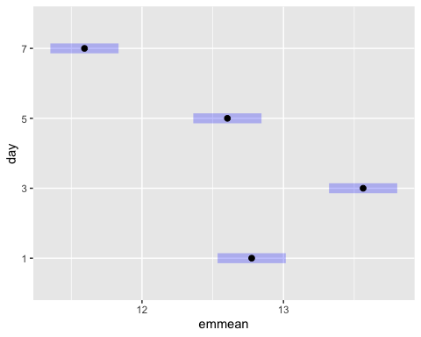

# Pairwise comparisons for 'TB'  
pairwise_TB <- emmeans(mod3_glm, pairwise ~ TB, adjust = "tukey")

NOTE: Results may be misleading due to involvement in interactions

pairwise_TB

$emmeans  
 TB emmean SE df lower.CL upper.CL  
 n 12.1 0.0848 48 11.9 12.3  
 y 13.2 0.0848 48 13.0 13.3  
  
Results are averaged over the levels of: day, water_treatment   
Confidence level used: 0.95   
  
$contrasts  
 contrast estimate SE df t.ratio p.value  
 n - y -1.08 0.12 48 -9.007 <.0001  
  
Results are averaged over the levels of: day, water_treatment

plot(pairwise_TB)

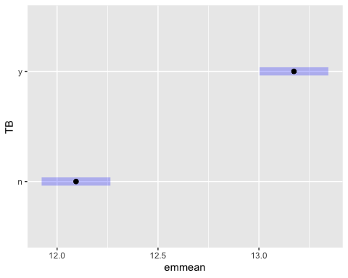

# Pairwise comparisons for 'water_treatment'  
pairwise_water_treatment <- emmeans(mod3_glm, pairwise ~ water_treatment, adjust = "tukey")

NOTE: Results may be misleading due to involvement in interactions

pairwise_water_treatment

$emmeans  
 water_treatment emmean SE df lower.CL upper.CL  
 sterile-water 13.7 0.104 48 13.51 13.9  
 PW-MO 14.1 0.104 48 13.85 14.3  
 PW+MO 10.1 0.104 48 9.91 10.3  
  
Results are averaged over the levels of: day, TB   
Confidence level used: 0.95   
  
$contrasts  
 contrast estimate SE df t.ratio p.value  
 (sterile-water) - (PW-MO) -0.34 0.147 48 -2.317 0.0629  
 (sterile-water) - (PW+MO) 3.60 0.147 48 24.519 <.0001  
 (PW-MO) - (PW+MO) 3.94 0.147 48 26.836 <.0001  
  
Results are averaged over the levels of: day, TB   
P value adjustment: tukey method for comparing a family of 3 estimates

plot(pairwise_water_treatment)

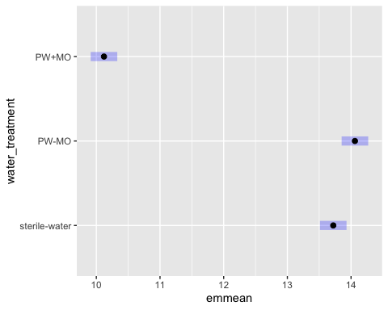

## second order comparisons  
  
# day:TB  
pairwise_day_TB <- emmeans(mod3_glm, pairwise ~ TB | day, adjust = "tukey")

NOTE: Results may be misleading due to involvement in interactions

pairwise_day_TB

$emmeans  
day = 1:  
 TB emmean SE df lower.CL upper.CL  
 n 12.8 0.17 48 12.5 13.1  
 y 12.7 0.17 48 12.4 13.1  
  
day = 3:  
 TB emmean SE df lower.CL upper.CL  
 n 12.5 0.17 48 12.1 12.8  
 y 14.6 0.17 48 14.3 15.0  
  
day = 5:  
 TB emmean SE df lower.CL upper.CL  
 n 11.9 0.17 48 11.6 12.3  
 y 13.3 0.17 48 13.0 13.6  
  
day = 7:  
 TB emmean SE df lower.CL upper.CL  
 n 11.2 0.17 48 10.8 11.5  
 y 12.0 0.17 48 11.7 12.4  
  
Results are averaged over the levels of: water_treatment   
Confidence level used: 0.95   
  
$contrasts  
day = 1:  
 contrast estimate SE df t.ratio p.value  
 n - y 0.0678 0.24 48 0.283 0.7787  
  
day = 3:  
 contrast estimate SE df t.ratio p.value  
 n - y -2.1476 0.24 48 -8.956 <.0001  
  
day = 5:  
 contrast estimate SE df t.ratio p.value  
 n - y -1.3858 0.24 48 -5.779 <.0001  
  
day = 7:  
 contrast estimate SE df t.ratio p.value  
 n - y -0.8539 0.24 48 -3.561 0.0008  
  
Results are averaged over the levels of: water_treatment

plot(pairwise_day_TB)

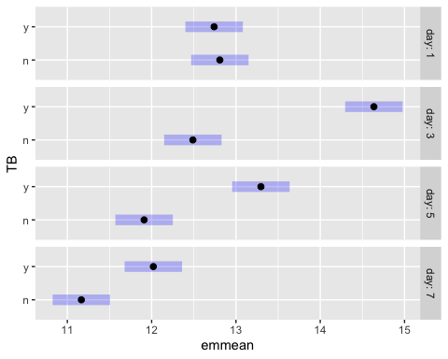

# day:water_treatment  
pairwise_water_treatment_day <- emmeans(mod3_glm, pairwise ~ water_treatment | day, adjust = "tukey")

NOTE: Results may be misleading due to involvement in interactions

pairwise_water_treatment_day

$emmeans  
day = 1:  
 water_treatment emmean SE df lower.CL upper.CL  
 sterile-water 13.62 0.208 48 13.20 14.03  
 PW-MO 12.88 0.208 48 12.46 13.30  
 PW+MO 11.83 0.208 48 11.41 12.25  
  
day = 3:  
 water_treatment emmean SE df lower.CL upper.CL  
 sterile-water 15.18 0.208 48 14.76 15.60  
 PW-MO 15.36 0.208 48 14.94 15.77  
 PW+MO 10.15 0.208 48 9.74 10.57  
  
day = 5:  
 water_treatment emmean SE df lower.CL upper.CL  
 sterile-water 13.48 0.208 48 13.06 13.90  
 PW-MO 14.48 0.208 48 14.06 14.90  
 PW+MO 9.85 0.208 48 9.43 10.27  
  
day = 7:  
 water_treatment emmean SE df lower.CL upper.CL  
 sterile-water 12.61 0.208 48 12.19 13.03  
 PW-MO 13.52 0.208 48 13.11 13.94  
 PW+MO 8.65 0.208 48 8.23 9.07  
  
Results are averaged over the levels of: TB   
Confidence level used: 0.95   
  
$contrasts  
day = 1:  
 contrast estimate SE df t.ratio p.value  
 (sterile-water) - (PW-MO) 0.733 0.294 48 2.495 0.0418  
 (sterile-water) - (PW+MO) 1.788 0.294 48 6.087 <.0001  
 (PW-MO) - (PW+MO) 1.055 0.294 48 3.592 0.0022  
  
day = 3:  
 contrast estimate SE df t.ratio p.value  
 (sterile-water) - (PW-MO) -0.177 0.294 48 -0.603 0.8191  
 (sterile-water) - (PW+MO) 5.026 0.294 48 17.115 <.0001  
 (PW-MO) - (PW+MO) 5.203 0.294 48 17.718 <.0001  
  
day = 5:  
 contrast estimate SE df t.ratio p.value  
 (sterile-water) - (PW-MO) -1.002 0.294 48 -3.412 0.0037  
 (sterile-water) - (PW+MO) 3.627 0.294 48 12.350 <.0001  
 (PW-MO) - (PW+MO) 4.629 0.294 48 15.763 <.0001  
  
day = 7:  
 contrast estimate SE df t.ratio p.value  
 (sterile-water) - (PW-MO) -0.915 0.294 48 -3.115 0.0086  
 (sterile-water) - (PW+MO) 3.960 0.294 48 13.485 <.0001  
 (PW-MO) - (PW+MO) 4.875 0.294 48 16.600 <.0001  
  
Results are averaged over the levels of: TB   
P value adjustment: tukey method for comparing a family of 3 estimates

plot(pairwise_water_treatment_day)

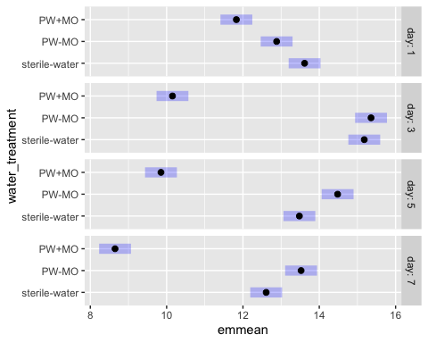

# 3b NCOS AE biofilm

All microbe-depleted, NO pw microbe+ treatment

### Renwei’s figure

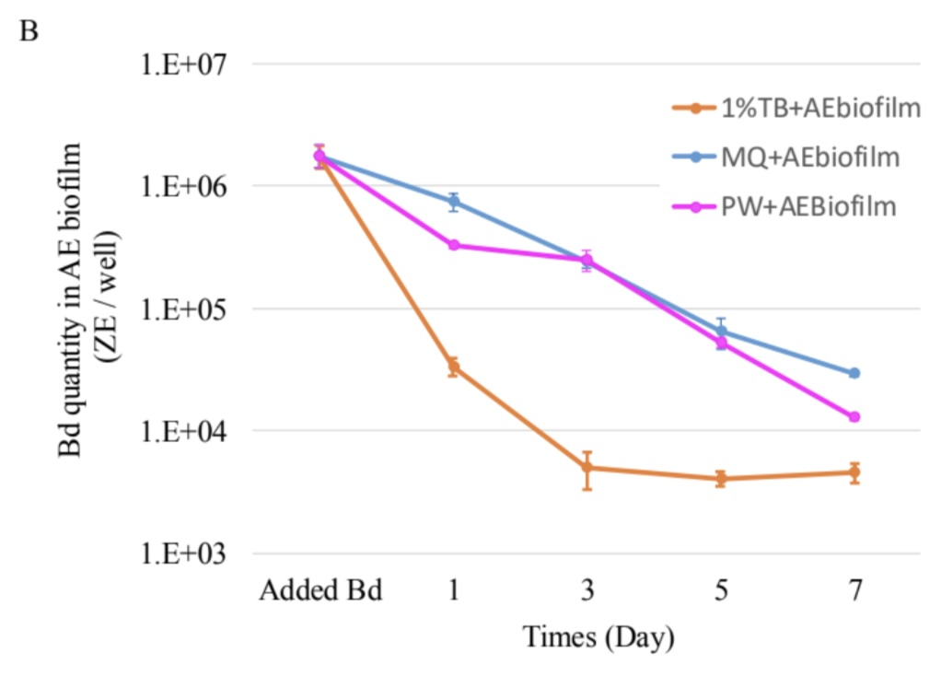

### ggplot version: replicating Renwei’s AE

ae_summary <- ae %>%  
 group_by(day, sample_ID) %>%  
 reframe(mean = mean(adh), # calculate the mean  
 n = length(adh), # count the number of observations  
 df = n - 1, # calculate the degrees of freedom  
 sd = sd(adh), # calculate the standard deviation  
 se = sd/sqrt(n), # calculate the standard error  
 ) %>%  
 # add column for TB or no  
 mutate(TB = case_when(str_detect(sample_ID, "TB") ~ "y", TRUE ~ "n")) %>%  
 # add column for PW or no  
 mutate(PW = case_when(str_detect(sample_ID, "PW") ~ "y", TRUE ~ "n"))  
  
ae_summary %>%  
 # reorder to match Renwei's plot  
 mutate(sample_ID = factor(sample_ID,  
 levels = c("1%TB+AEbiofilm", "MQ+AEbiofilm",  
 "PW+AEBiofilm", "Added Bd" ))) %>%  
  
 ggplot(aes(x = day,  
 y = mean,  
 color = sample_ID)) +  
 geom_point(size = 2) +  
 geom_errorbar(aes(ymin = mean - se, # plot the standard error  
 ymax = mean + se),  
 width = 0.1) +  
 geom_line() +   
 scale_y_log10(limits = c(1e3, 1e7),  
 breaks = c(1e3, 1e4, 1e5, 1e6, 1e7)) +  
 # vibes  
 labs(x = "Day",  
 y = "Bd Quantity per sample (ZE/well)",  
 title = "Environmental Biofilm",  
 caption = "only adherent Bd visualized here (the only data we have)") +  
 scale_color_manual(values = c("1%TB+AEbiofilm"= "orange",  
 "MQ+AEbiofilm" = "blue",  
 "PW+AEBiofilm" = "magenta",  
 "Added Bd" = "darkgrey")) + # Assign specific colors to match RC's plot  
 theme_minimal() +  
 theme(  
 panel.grid.major.x = element_blank(), # Remove major vertical grid lines  
 panel.grid.minor.x = element_blank()) + # Remove minor vertical grid lines  
 scale_x_continuous(breaks = c(0, 1, 3, 5, 7))

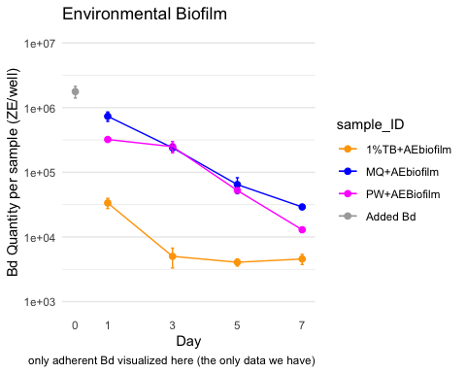

### Caitlin’s version AE

ae_summary <- ae %>%  
 group_by(day, sample_ID) %>%  
 reframe(mean = mean(adh), # calculate the mean  
 n = length(adh), # count the number of observations  
 df = n - 1, # calculate the degrees of freedom  
 sd = sd(adh), # calculate the standard deviation  
 se = sd/sqrt(n), # calculate the standard error  
 ) %>%  
 # add column for TB or no  
 mutate(TB = case_when(str_detect(sample_ID, "TB") ~ "y", TRUE ~ "n")) %>%  
 # add column for PW or no  
 mutate(PW = case_when(str_detect(sample_ID, "PW") ~ "y", TRUE ~ "n"))  
  
ae_summary %>%  
 # reorder to match Renwei's plot  
 mutate(sample_ID = factor(sample_ID,  
 levels = c("1%TB+AEbiofilm", "MQ+AEbiofilm",  
 "PW+AEBiofilm", "Added Bd" ))) %>%  
  
 ggplot(aes(x = day,  
 y = mean,  
 color = sample_ID)) +  
 geom_point(size = 2) +  
 geom_errorbar(aes(ymin = mean - se, # plot the standard error  
 ymax = mean + se),  
 width = 0.1) +  
 geom_line() +   
 scale_y_log10(limits = c(1e3, 1e7),  
 breaks = c(1e3, 1e4, 1e5, 1e6, 1e7)) +  
 # vibes  
 labs(x = "Day",  
 y = "Bd Quantity in AE Biofilm (ZE/well)",  
 color = "Medium with\nAE Biofilm")+ # Title for color legend  
   
 scale_color_manual(values = c("1%TB+AEbiofilm"= "#4477AA",  
 "MQ+AEbiofilm" = "#228833",  
 #"Added Bd" = "darkgrey",  
 "PW+AEBiofilm" = "#AA3377"),  
 labels = c("1%TB+AEbiofilm" = "TB Broth",  
 "MQ+AEbiofilm" = "MQ Water",  
 "PW+AEBiofilm" = "Filtered\nPond Water",  
 "Added Bd" = "Initial Bd")) + # Custom labels  
  
 myCustomTheme()+  
 scale_x_continuous(breaks = c(0, 1, 3, 5, 7),  
 labels = c("Initial\nBd", "1", "3", "5", "7"))

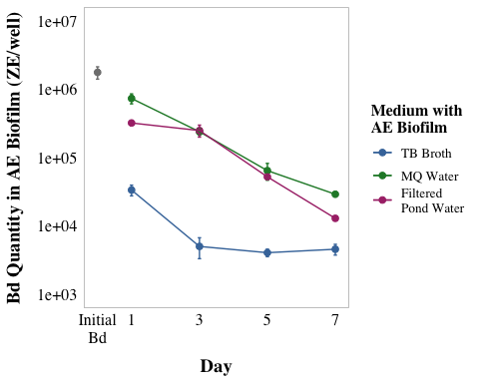

## 3b EDA

### visualize y var: bd load

# untransformed  
ae_noday0 <- ae %>%   
 filter(day != 0) %>%   
 mutate(log_adh = log(adh)) # note: no zeroes so not log + 1  
ggqqplot(ae_noday0, "adh", title = "untransformed")

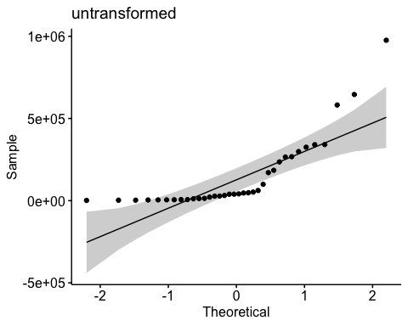

shapiro.test(ae_noday0$adh) # nope

Shapiro-Wilk normality test  
  
data: ae_noday0$adh  
W = 0.69154, p-value = 2.089e-07

hist(ae_noday0$adh) # note

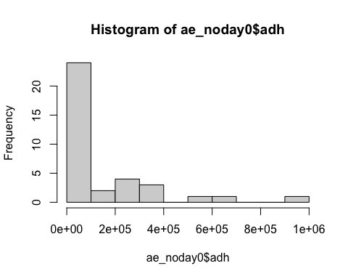

# transformed  
ggqqplot(ae_noday0, "log_adh", title = "log transformed") # gorgeous

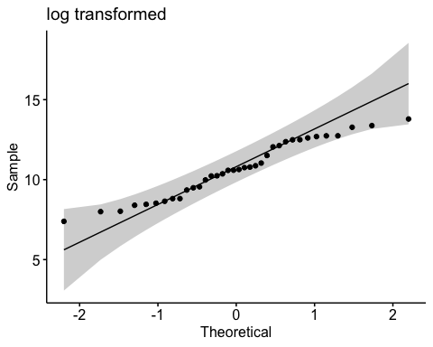

hist(ae_noday0$log_adh) # better

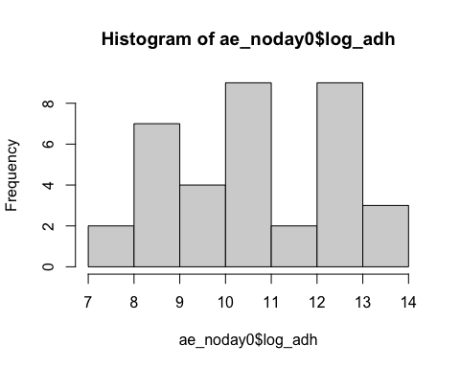

shapiro.test(ae_noday0$log_adh) # p-value = 0.1699 def normal

Shapiro-Wilk normality test  
  
data: ae_noday0$log_adh  
W = 0.95671, p-value = 0.1699

## 3b Stats

Keep interaction, skedasticity isn’t “too bad”, and will show underlying data in plot to be super transparent

y var: amount of Bd in adherent

x vars: day & medium with the AE biofilm and Bd (MQ, TB, PW)

Bd ~ day*medium

Question: Does the amount of Bd in the aquatic environmental biofilm differ across the media tested and across the days, and do they interact with each other?

Model: 2-way ANOVA

**Summary of results**

Bd qty Day 1 > Day 3 > Day 5 > Day 7 (all p <0.005) in other words, Bd significantly reduced each day

MQ+AEbiofilm > PW+AEBiofilm > 1%TB+AEbiofilm (all p <0.005) In other words, TB plus biofilm has most Bd inhibition power, followed by pond water, then by milliQ with the least inhibition power

## null

null <- lm(log_adh ~ 1,  
 data = ae_noday0)  
AIC(null) #146.5865

[1] 146.5865

## Bd ~ day*medium

Note: Not perfectly homoskedstic but “good enough”

# quick check: we want day as a FACTOR  
ae_noday0 <- ae_noday0 %>%   
 mutate(day = as.factor(day)) %>%   
# column for medium  
mutate(medium = sample_ID)  
str(ae_noday0$day)

Factor w/ 4 levels "1","3","5","7": 1 2 3 4 1 2 3 4 1 2 ...

# set MQ as reference  
ae_noday0$sample_ID <- factor(ae_noday0$sample_ID)  
ae_noday0$sample_ID <- relevel(ae_noday0$sample_ID, ref = "MQ+AEbiofilm")  
  
# build model  
aov_3b <- aov(log_adh ~ day*medium,  
 data = ae_noday0)  
  
# diagnostic plot  
par(mfrow = c(2,2))  
plot(aov_3b) # kinda not homoskedastic

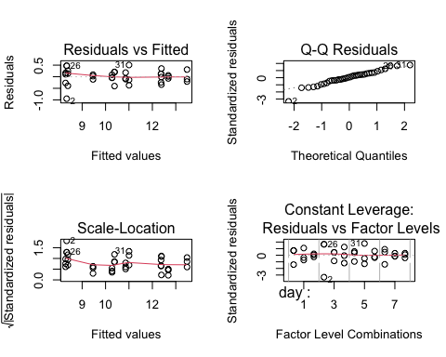

# look at results  
summary(aov_3b)

Df Sum Sq Mean Sq F value Pr(>F)   
day 3 40.24 13.413 110.10 3.64e-14 ***  
medium 2 60.07 30.036 246.55 < 2e-16 ***  
day:medium 6 7.42 1.236 10.14 1.30e-05 ***  
Residuals 24 2.92 0.122   
---  
Signif. codes: 0 '***' 0.001 '**' 0.01 '*' 0.05 '.' 0.1 ' ' 1

anova(aov_3b) # all significant and interaction sig

Analysis of Variance Table  
  
Response: log_adh  
 Df Sum Sq Mean Sq F value Pr(>F)   
day 3 40.239 13.4129 110.100 3.642e-14 ***  
medium 2 60.073 30.0364 246.553 < 2.2e-16 ***  
day:medium 6 7.415 1.2359 10.145 1.301e-05 ***  
Residuals 24 2.924 0.1218   
---  
Signif. codes: 0 '***' 0.001 '**' 0.01 '*' 0.05 '.' 0.1 ' ' 1

AIC(aov_3b) # 37.78083 better than null

[1] 37.78083

# posthoc  
TukeyHSD(aov_3b)

Tukey multiple comparisons of means  
 95% family-wise confidence level  
  
Fit: aov(formula = log_adh ~ day * medium, data = ae_noday0)  
  
$day  
 diff lwr upr p adj  
3-1 -1.1493419 -1.603234 -0.6954497 0.0000018  
5-1 -2.1306208 -2.584513 -1.6767286 0.0000000  
7-1 -2.8046545 -3.258547 -2.3507623 0.0000000  
5-3 -0.9812789 -1.435171 -0.5273867 0.0000210  
7-3 -1.6553126 -2.109205 -1.2014204 0.0000000  
7-5 -0.6740337 -1.127926 -0.2201415 0.0021838  
  
$medium  
 diff lwr upr p adj  
MQ+AEbiofilm-1%TB+AEbiofilm 2.9323391 2.5764935 3.28818480 0.0000000  
PW+AEBiofilm-1%TB+AEbiofilm 2.4957994 2.1399538 2.85164510 0.0000000  
PW+AEBiofilm-MQ+AEbiofilm -0.4365397 -0.7923854 -0.08069402 0.0142222  
  
$`day:medium`  
 diff lwr upr p adj  
3:1%TB+AEbiofilm-1:1%TB+AEbiofilm -2.04493896 -3.07249206 -1.01738586 0.0000113  
5:1%TB+AEbiofilm-1:1%TB+AEbiofilm -2.09173123 -3.11928433 -1.06417813 0.0000078  
7:1%TB+AEbiofilm-1:1%TB+AEbiofilm -1.99414642 -3.02169952 -0.96659332 0.0000169  
1:MQ+AEbiofilm-1:1%TB+AEbiofilm 3.09761537 2.07006227 4.12516848 0.0000000  
3:MQ+AEbiofilm-1:1%TB+AEbiofilm 1.98759548 0.96004238 3.01514858 0.0000179  
5:MQ+AEbiofilm-1:1%TB+AEbiofilm 0.61984147 -0.40771163 1.64739458 0.5802121  
7:MQ+AEbiofilm-1:1%TB+AEbiofilm -0.10651243 -1.13406553 0.92104068 0.9999997  
1:PW+AEBiofilm-1:1%TB+AEbiofilm 2.29587354 1.26832044 3.32342665 0.0000016  
3:PW+AEBiofilm-1:1%TB+AEbiofilm 2.00280682 0.97525371 3.03035992 0.0000158  
5:PW+AEBiofilm-1:1%TB+AEbiofilm 0.47351640 -0.55403671 1.50106950 0.8683022  
7:PW+AEBiofilm-1:1%TB+AEbiofilm -0.91981565 -1.94736875 0.10773746 0.1093965  
5:1%TB+AEbiofilm-3:1%TB+AEbiofilm -0.04679227 -1.07434537 0.98076083 1.0000000  
7:1%TB+AEbiofilm-3:1%TB+AEbiofilm 0.05079254 -0.97676056 1.07834564 1.0000000  
1:MQ+AEbiofilm-3:1%TB+AEbiofilm 5.14255433 4.11500123 6.17010744 0.0000000  
3:MQ+AEbiofilm-3:1%TB+AEbiofilm 4.03253444 3.00498134 5.06008754 0.0000000  
5:MQ+AEbiofilm-3:1%TB+AEbiofilm 2.66478043 1.63722733 3.69233354 0.0000001  
7:MQ+AEbiofilm-3:1%TB+AEbiofilm 1.93842653 0.91087343 2.96597964 0.0000266  
1:PW+AEBiofilm-3:1%TB+AEbiofilm 4.34081250 3.31325940 5.36836561 0.0000000  
3:PW+AEBiofilm-3:1%TB+AEbiofilm 4.04774578 3.02019267 5.07529888 0.0000000  
5:PW+AEBiofilm-3:1%TB+AEbiofilm 2.51845536 1.49090225 3.54600846 0.0000003  
7:PW+AEBiofilm-3:1%TB+AEbiofilm 1.12512331 0.09757021 2.15267642 0.0234402  
7:1%TB+AEbiofilm-5:1%TB+AEbiofilm 0.09758481 -0.92996829 1.12513791 0.9999999  
1:MQ+AEbiofilm-5:1%TB+AEbiofilm 5.18934660 4.16179350 6.21689970 0.0000000  
3:MQ+AEbiofilm-5:1%TB+AEbiofilm 4.07932671 3.05177361 5.10687981 0.0000000  
5:MQ+AEbiofilm-5:1%TB+AEbiofilm 2.71157270 1.68401960 3.73912581 0.0000001  
7:MQ+AEbiofilm-5:1%TB+AEbiofilm 1.98521880 0.95766570 3.01277191 0.0000182  
1:PW+AEBiofilm-5:1%TB+AEbiofilm 4.38760477 3.36005167 5.41515788 0.0000000  
3:PW+AEBiofilm-5:1%TB+AEbiofilm 4.09453805 3.06698494 5.12209115 0.0000000  
5:PW+AEBiofilm-5:1%TB+AEbiofilm 2.56524763 1.53769452 3.59280073 0.0000002  
7:PW+AEBiofilm-5:1%TB+AEbiofilm 1.17191558 0.14436248 2.19946869 0.0161067  
1:MQ+AEbiofilm-7:1%TB+AEbiofilm 5.09176179 4.06420869 6.11931489 0.0000000  
3:MQ+AEbiofilm-7:1%TB+AEbiofilm 3.98174190 2.95418880 5.00929500 0.0000000  
5:MQ+AEbiofilm-7:1%TB+AEbiofilm 2.61398789 1.58643479 3.64154100 0.0000001  
7:MQ+AEbiofilm-7:1%TB+AEbiofilm 1.88763399 0.86008089 2.91518710 0.0000404  
1:PW+AEBiofilm-7:1%TB+AEbiofilm 4.29001996 3.26246686 5.31757307 0.0000000  
3:PW+AEBiofilm-7:1%TB+AEbiofilm 3.99695324 2.96940013 5.02450634 0.0000000  
5:PW+AEBiofilm-7:1%TB+AEbiofilm 2.46766282 1.44010971 3.49521592 0.0000004  
7:PW+AEBiofilm-7:1%TB+AEbiofilm 1.07433077 0.04677767 2.10188388 0.0349376  
3:MQ+AEbiofilm-1:MQ+AEbiofilm -1.11001989 -2.13757300 -0.08246679 0.0264194  
5:MQ+AEbiofilm-1:MQ+AEbiofilm -2.47777390 -3.50532700 -1.45022079 0.0000004  
7:MQ+AEbiofilm-1:MQ+AEbiofilm -3.20412780 -4.23168090 -2.17657470 0.0000000  
1:PW+AEBiofilm-1:MQ+AEbiofilm -0.80174183 -1.82929493 0.22581127 0.2352787  
3:PW+AEBiofilm-1:MQ+AEbiofilm -1.09480855 -2.12236166 -0.06725545 0.0297786  
5:PW+AEBiofilm-1:MQ+AEbiofilm -2.62409897 -3.65165208 -1.59654587 0.0000001  
7:PW+AEBiofilm-1:MQ+AEbiofilm -4.01743102 -5.04498412 -2.98987792 0.0000000  
5:MQ+AEbiofilm-3:MQ+AEbiofilm -1.36775401 -2.39530711 -0.34020090 0.0031814  
7:MQ+AEbiofilm-3:MQ+AEbiofilm -2.09410791 -3.12166101 -1.06655480 0.0000076  
1:PW+AEBiofilm-3:MQ+AEbiofilm 0.30827806 -0.71927504 1.33583117 0.9927584  
3:PW+AEBiofilm-3:MQ+AEbiofilm 0.01521134 -1.01234177 1.04276444 1.0000000  
5:PW+AEBiofilm-3:MQ+AEbiofilm -1.51407908 -2.54163219 -0.48652598 0.0009231  
7:PW+AEBiofilm-3:MQ+AEbiofilm -2.90741113 -3.93496423 -1.87985802 0.0000000  
7:MQ+AEbiofilm-5:MQ+AEbiofilm -0.72635390 -1.75390700 0.30119920 0.3586125  
1:PW+AEBiofilm-5:MQ+AEbiofilm 1.67603207 0.64847897 2.70358517 0.0002348  
3:PW+AEBiofilm-5:MQ+AEbiofilm 1.38296534 0.35541224 2.41051845 0.0027988  
5:PW+AEBiofilm-5:MQ+AEbiofilm -0.14632508 -1.17387818 0.88122803 0.9999930  
7:PW+AEBiofilm-5:MQ+AEbiofilm -1.53965712 -2.56721022 -0.51210402 0.0007432  
1:PW+AEBiofilm-7:MQ+AEbiofilm 2.40238597 1.37483287 3.42993907 0.0000007  
3:PW+AEBiofilm-7:MQ+AEbiofilm 2.10931925 1.08176614 3.13687235 0.0000067  
5:PW+AEBiofilm-7:MQ+AEbiofilm 0.58002883 -0.44752428 1.60758193 0.6677092  
7:PW+AEBiofilm-7:MQ+AEbiofilm -0.81330322 -1.84085632 0.21424988 0.2194307  
3:PW+AEBiofilm-1:PW+AEBiofilm -0.29306673 -1.32061983 0.73448638 0.9952000  
5:PW+AEBiofilm-1:PW+AEBiofilm -1.82235715 -2.84991025 -0.79480404 0.0000692  
7:PW+AEBiofilm-1:PW+AEBiofilm -3.21568919 -4.24324229 -2.18813609 0.0000000  
5:PW+AEBiofilm-3:PW+AEBiofilm -1.52929042 -2.55684352 -0.50173732 0.0008115  
7:PW+AEBiofilm-3:PW+AEBiofilm -2.92262246 -3.95017557 -1.89506936 0.0000000  
7:PW+AEBiofilm-5:PW+AEBiofilm -1.39333205 -2.42088515 -0.36577894 0.0025645

# posthoc using emmeans  
# use emmeans package to get the t value  
# Perform pairwise comparisons for 'day'  
em_day <- emmeans(aov_3b, ~ day)

NOTE: Results may be misleading due to involvement in interactions

tukey_day <- pairs(em_day, adjust = "tukey")  
# Perform pairwise comparisons for 'medium'  
em_medium <- emmeans(aov_3b, ~ medium)

NOTE: Results may be misleading due to involvement in interactions

tukey_medium <- pairs(em_medium, adjust = "tukey")  
  
# Perform pairwise comparisons for 'day * medium' (interaction)  
em_interaction <- emmeans(aov_3b, ~ day * medium)  
tukey_interaction <- pairs(em_interaction, adjust = "tukey")

# Results write up

A two-way ANOVA revealed that there was a statistically significant difference in Bd load across days (F(3, 24) = 110.100, p = p <0.0001), across the media (F(2, 24) = 246.55, p <0.0001), and the interaction between the effects of day and medium were also significant (F(6, 24) = 10.145, p = p <0.0001). Bd was significantly lower with each day (Tukey test, p <0.005 for all) and TB plus biofilm has most Bd inhibition power, followed by pond water with no microbes, then by milliQ with the least inhibition power (Tukey test, p <0.05 for all).

# 4b NCOS Monolayer biofilm on Bd growth:

Note: only the ADHERENT Bd here!

### Renwei’s figure

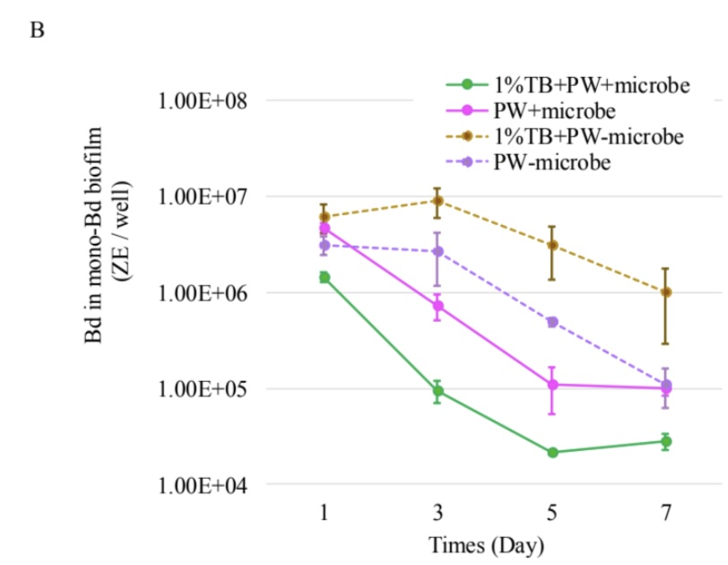

### ggplot version: replicating Renwei’s ML

monolayer_summary <- monolayer %>%   
 group_by(day, sample_ID) %>%   
 reframe(mean_adh = mean(adh), # calculate the mean  
 n = length(adh), # count the number of observations  
 df = n - 1, # calculate the degrees of freedom  
 sd = sd(adh), # calculate the standard deviation  
 se = sd/sqrt(n), # calculate the standard error  
 ) %>%   
 mutate(microbes = case_when(  
 str_detect(sample_ID, "\\+microbes") ~ "y",TRUE ~ "n")) %>%   
 # add column for TB or no  
 mutate(TB = case_when(str_detect(sample_ID, "TB") ~ "y", TRUE ~ "n")) %>%   
 # add column for PW or no  
 mutate(PW = case_when(str_detect(sample_ID, "PW") ~ "y", TRUE ~ "n"))   
  
monolayer_summary %>%   
 # reorder to match Renwei's plot  
 mutate(sample_ID = factor(sample_ID,   
 levels = c("TB+PW+microbes","PW+microbes",  
 "TB+PW-microbes", "PW-microbes"))) %>%   
 ggplot(aes(x = day,   
 y = mean_adh,   
 color = sample_ID)) +  
 geom_point(size = 2) +  
 geom_errorbar(aes(ymin = mean_adh - se, # plot the standard error  
 ymax = mean_adh + se),  
 width = 0.1) +  
 geom_line(aes(linetype = microbes)) +   
 scale_y_log10(limits = c(1e4, 1e8),   
 breaks = c(1e4, 1e5, 1e6, 1e7, 1e8)) +  
 # vibes  
 labs(x = "Day",  
 y = "Bd Quantity per sample (ZE/well)",  
 title = "Monolayer",  
 caption = "supernatant plus adherent visualized here") +  
 scale_color_manual(values = c("TB+PW+microbes" = "palegreen4",   
 "PW+microbes" = "magenta",   
 "TB+PW-microbes" = "chocolate4",   
 "PW-microbes" = "purple")) + # Assign specific colors to match RC's plot  
 scale_linetype_manual(values = c("n" = "dashed",   
 "y" = "solid")) +  
 theme_minimal() +  
 theme(  
 panel.grid.major.x = element_blank(), # Remove major vertical grid lines  
 panel.grid.minor.x = element_blank()) + # Remove minor vertical grid lines  
 scale_x_continuous(breaks = c(0, 1, 3, 5, 7))

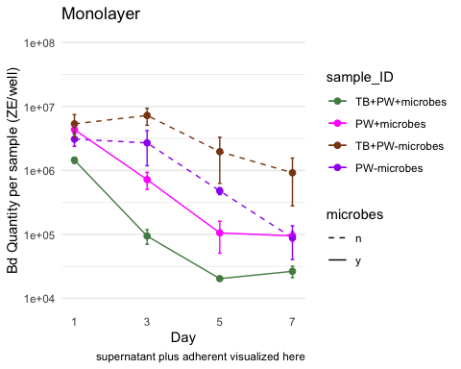

## Caitlin’s version ML

monolayer_summary %>%   
 # reorder to match Renwei's plot  
 mutate(sample_ID = factor(sample_ID,   
 levels = c("TB+PW+microbes","PW+microbes",  
 "TB+PW-microbes", "PW-microbes"))) %>%   
 ggplot(aes(x = day,   
 y = mean_adh,   
 color = sample_ID)) +  
 geom_point(size = 2) +  
 geom_errorbar(aes(ymin = mean_adh - se, # plot the standard error  
 ymax = mean_adh + se),  
 width = 0.1) +  
 geom_line(aes(linetype = microbes)) +   
 scale_y_log10(limits = c(1e4, 1e8),   
 breaks = c(1e4, 1e5, 1e6, 1e7, 1e8)) +  
   
 # vibes  
 labs(x = "Day",  
 y = "Bd in mono-Bd biofilm (ZE/well)",  
 color = "Medium", # Title for color legend  
 linetype = "Microbes Present") +  
 scale_color_manual(values = c("TB+PW+microbes" = "#4477AA",   
 "PW+microbes" = "#EE6677",   
 "TB+PW-microbes" = "#66CCEE",   
 "PW-microbes" = "#AA3377"),   
   
 labels = c("TB+PW+microbes" = "TB + PW + MO",  
 "PW+microbes" = "PW + MO",  
 "TB+PW-microbes" = "TB + PW - MO",  
 "PW-microbes" = "PW - MO")) + # Custom labels  
 myCustomTheme()+  
 scale_linetype_manual(values = c("n" = "dashed",   
 "y" = "solid"),  
 labels = c("n" = "N", "y" = "Y")) + # Change labels to uppercase N and Y  
 scale_x_continuous(breaks = c(0, 1, 3, 5, 7),  
 labels = c("Initial\nBd", "1", "3", "5", "7"))

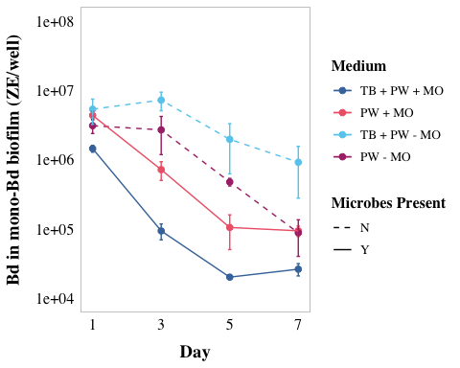

## 4b EDA

### visualize y var: bd load

Commented out to save space, log transformed is better

# # untransformed  
# ml_noday0 <- monolayer %>%  
# filter(day != 0) %>%  
# mutate(log_adh = log(adh)) # note: no zeroes so not log + 1  
# ggqqplot(ml_noday0, "adh", title = "untransformed")  
# shapiro.test(ml_noday0$adh) # nope  
# hist(ml_noday0$adh) # note  
#   
# # transformed  
# ggqqplot(ml_noday0, "log_adh", title = "log transformed") # gorgeous  
# hist(ml_noday0$log_adh) # better

## 4b Stats

y var: amount of Bd

x vars: day, treatment, microbes y/n, pw y/n, tb y/n

Best model: Bd ~ day*microbes*TB

Question: Does the amount of Bd in the sample differ across the treatments of presence of microbes, TB, and day?

Model: 3-way ANOVA

**results**

Results summary

* day (p<0.05)
  + All differ from each other except 5 and 7 (Tukey)
    - Day 1 > Day 3 > Day 5 = Day 7
* microbes (p<0.05)
  + presence microbes has less Bd (Tukey)
* TB (NOT SIG)
* day:microbes (p<0.05)
* day:TB (NOT SIG)
* microbes:TB (p<0.05)
* day:microbes:TB (NOT SIG)

ml_noday0 <- monolayer %>%  
 filter(day != 0) %>%  
 mutate(log_adh = log(adh))  
  
# quick check: we want day as a FACTOR  
ml_noday0 <- ml_noday0 %>%   
 mutate(day = as.factor(day))  
str(ml_noday0$day)

Factor w/ 4 levels "1","3","5","7": 1 2 3 4 1 2 3 4 1 2 ...

# set PW-microbes as reference (no milliQ here)  
ml_noday0$sample_ID <- factor(ml_noday0$sample_ID)  
ml_noday0$sample_ID <- relevel(ml_noday0$sample_ID, ref = "PW-microbes")  
  
# change the names in microbes and tb so there arent 2 levels with y and n  
ml_noday0 <- ml_noday0 %>%   
 mutate(  
 microbes = case_when(  
 microbes == "y" ~ "MO present",  
 microbes == "n" ~ "MO absent"),  
 TB = case_when(  
 TB == "y" ~ "TB present",  
 TB == "n" ~ "TB absent"))

## null

null <- lm(log_adh ~ 1,  
 data = ml_noday0)  
AIC(null) #205.4965

[1] 205.4965

## Bd ~ day*microbes*TB

# build model  
aov_4b <- aov(log_adh ~ day*microbes*TB,  
 data = ml_noday0)  
  
# diagnostic plot  
par(mfrow = c(2,2))  
plot(aov_4b) # looks good

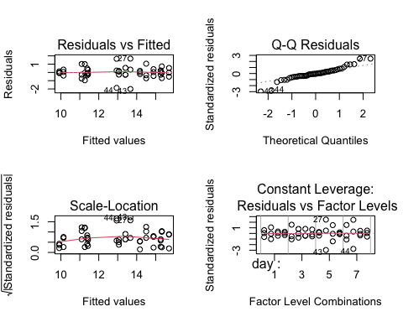

# look at results  
summary(aov_4b)

Df Sum Sq Mean Sq F value Pr(>F)   
day 3 93.76 31.25 45.336 1.26e-11 ***  
microbes 1 37.80 37.80 54.841 2.00e-08 ***  
TB 1 0.51 0.51 0.746 0.39422   
day:microbes 3 12.21 4.07 5.905 0.00252 **   
day:TB 3 0.94 0.31 0.456 0.71469   
microbes:TB 1 18.12 18.12 26.283 1.37e-05 ***  
day:microbes:TB 3 1.61 0.54 0.777 0.51570   
Residuals 32 22.06 0.69   
---  
Signif. codes: 0 '***' 0.001 '**' 0.01 '*' 0.05 '.' 0.1 ' ' 1

anova(aov_4b) # day, microbes, are significant, but TB alone is not. Interactions: day:microbes, microbes:TB are significant

Analysis of Variance Table  
  
Response: log_adh  
 Df Sum Sq Mean Sq F value Pr(>F)   
day 3 93.755 31.252 45.3357 1.255e-11 ***  
microbes 1 37.804 37.804 54.8407 2.002e-08 ***  
TB 1 0.514 0.514 0.7459 0.394216   
day:microbes 3 12.211 4.070 5.9046 0.002516 **   
day:TB 3 0.944 0.315 0.4563 0.714686   
microbes:TB 1 18.118 18.118 26.2826 1.375e-05 ***  
day:microbes:TB 3 1.606 0.535 0.7766 0.515699   
Residuals 32 22.059 0.689   
---  
Signif. codes: 0 '***' 0.001 '**' 0.01 '*' 0.05 '.' 0.1 ' ' 1

AIC(aov_4b) # 132.8989 better than null

[1] 132.8989

TukeyHSD(aov_4b)

Tukey multiple comparisons of means  
 95% family-wise confidence level  
  
Fit: aov(formula = log_adh ~ day * microbes * TB, data = ml_noday0)  
  
$day  
 diff lwr upr p adj  
3-1 -1.1620166 -2.080368 -0.2436653 0.0087187  
5-1 -2.9344665 -3.852818 -2.0161153 0.0000000  
7-1 -3.5087930 -4.427144 -2.5904417 0.0000000  
5-3 -1.7724499 -2.690801 -0.8540987 0.0000581  
7-3 -2.3467763 -3.265128 -1.4284251 0.0000005  
7-5 -0.5743264 -1.492678 0.3440249 0.3431674  
  
$microbes  
 diff lwr upr p adj  
MO present-MO absent -1.774918 -2.263125 -1.286711 0  
  
$TB  
 diff lwr upr p adj  
TB present-TB absent -0.2069936 -0.6952002 0.281213 0.3942159  
  
$`day:microbes`  
 diff lwr upr p adj  
3:MO absent-1:MO absent -0.004871029 -1.5576434 1.54790136 1.0000000  
5:MO absent-1:MO absent -1.742341527 -3.2951139 -0.18956914 0.0191770  
7:MO absent-1:MO absent -3.085556125 -4.6383285 -1.53278374 0.0000079  
1:MO present-1:MO absent -0.388664202 -1.9414366 1.16410819 0.9912401  
3:MO present-1:MO absent -2.707826384 -4.2605988 -1.15505400 0.0000750  
5:MO present-1:MO absent -4.515255768 -6.0680282 -2.96248338 0.0000000  
7:MO present-1:MO absent -4.320693986 -5.8734664 -2.76792160 0.0000000  
5:MO absent-3:MO absent -1.737470497 -3.2902429 -0.18469811 0.0196728  
7:MO absent-3:MO absent -3.080685096 -4.6334575 -1.52791271 0.0000082  
1:MO present-3:MO absent -0.383793173 -1.9365656 1.16897921 0.9918720  
3:MO present-3:MO absent -2.702955355 -4.2557277 -1.15018297 0.0000772  
5:MO present-3:MO absent -4.510384738 -6.0631571 -2.95761235 0.0000000  
7:MO present-3:MO absent -4.315822957 -5.8685953 -2.76305057 0.0000000  
7:MO absent-5:MO absent -1.343214599 -2.8959870 0.20955779 0.1300131  
1:MO present-5:MO absent 1.353677324 -0.1990951 2.90644971 0.1243433  
3:MO present-5:MO absent -0.965484857 -2.5182572 0.58728753 0.4886753  
5:MO present-5:MO absent -2.772914241 -4.3256866 -1.22014185 0.0000509  
7:MO present-5:MO absent -2.578352460 -4.1311248 -1.02558007 0.0001622  
1:MO present-7:MO absent 2.696891923 1.1441195 4.24966431 0.0000801  
3:MO present-7:MO absent 0.377729742 -1.1750426 1.93050213 0.9926085  
5:MO present-7:MO absent -1.429699642 -2.9824720 0.12307275 0.0889994  
7:MO present-7:MO absent -1.235137861 -2.7879102 0.31763453 0.2015413  
3:MO present-1:MO present -2.319162182 -3.8719346 -0.76638979 0.0007513  
5:MO present-1:MO present -4.126591565 -5.6793640 -2.57381918 0.0000000  
7:MO present-1:MO present -3.932029784 -5.4848022 -2.37925740 0.0000001  
5:MO present-3:MO present -1.807429384 -3.3602018 -0.25465700 0.0135812  
7:MO present-3:MO present -1.612867602 -3.1656400 -0.06009522 0.0372097  
7:MO present-5:MO present 0.194561781 -1.3582106 1.74733417 0.9998954  
  
$`day:TB`  
 diff lwr upr p adj  
3:TB absent-1:TB absent -1.1235183 -2.6762907 0.42925405 0.3023905  
5:TB absent-1:TB absent -2.9130623 -4.4658347 -1.36028989 0.0000221  
7:TB absent-1:TB absent -3.8110976 -5.3638700 -2.25832525 0.0000001  
1:TB present-1:TB absent -0.3281947 -1.8809671 1.22457771 0.9968653  
3:TB present-1:TB absent -1.5287096 -3.0814819 0.02406283 0.0561428  
5:TB present-1:TB absent -3.2840655 -4.8368379 -1.73129311 0.0000025  
7:TB present-1:TB absent -3.5346830 -5.0874553 -1.98191056 0.0000006  
5:TB absent-3:TB absent -1.7895439 -3.3423163 -0.23677155 0.0149424  
7:TB absent-3:TB absent -2.6875793 -4.2403517 -1.13480691 0.0000846  
1:TB present-3:TB absent 0.7953237 -0.7574487 2.34809604 0.7119877  
3:TB present-3:TB absent -0.4051912 -1.9579636 1.14758117 0.9888085  
5:TB present-3:TB absent -2.1605472 -3.7133195 -0.60777477 0.0018907  
7:TB present-3:TB absent -2.4111646 -3.9639370 -0.85839223 0.0004372  
7:TB absent-5:TB absent -0.8980354 -2.4508077 0.65473703 0.5777381  
1:TB present-5:TB absent 2.5848676 1.0320952 4.13763999 0.0001560  
3:TB present-5:TB absent 1.3843527 -0.1684197 2.93712511 0.1088829  
5:TB present-5:TB absent -0.3710032 -1.9237756 1.18176917 0.9933635  
7:TB present-5:TB absent -0.6216207 -2.1743931 0.93115172 0.8933907  
1:TB present-7:TB absent 3.4829030 1.9301306 5.03567535 0.0000008  
3:TB present-7:TB absent 2.2823881 0.7296157 3.83516047 0.0009319  
5:TB present-7:TB absent 0.5270321 -1.0257402 2.07980453 0.9522604  
7:TB present-7:TB absent 0.2764147 -1.2763577 1.82918708 0.9989428  
3:TB present-1:TB present -1.2005149 -2.7532873 0.35225751 0.2298116  
5:TB present-1:TB present -2.9558708 -4.5086432 -1.40309843 0.0000171  
7:TB present-1:TB present -3.2064883 -4.7592607 -1.65371588 0.0000039  
5:TB present-3:TB present -1.7553559 -3.3081283 -0.20258355 0.0179090  
7:TB present-3:TB present -2.0059734 -3.5587458 -0.45320101 0.0045607  
7:TB present-5:TB present -0.2506175 -1.8033898 1.30215493 0.9994399  
  
$`microbes:TB`  
 diff lwr upr  
MO present:TB absent-MO absent:TB absent -0.5461759 -1.4645271 0.3721754  
MO absent:TB present-MO absent:TB absent 1.0217484 0.1033972 1.9400997  
MO present:TB present-MO absent:TB absent -1.9819115 -2.9002628 -1.0635603  
MO absent:TB present-MO present:TB absent 1.5679243 0.6495730 2.4862756  
MO present:TB present-MO present:TB absent -1.4357356 -2.3540869 -0.5173844  
MO present:TB present-MO absent:TB present -3.0036600 -3.9220112 -2.0853087  
 p adj  
MO present:TB absent-MO absent:TB absent 0.3867876  
MO absent:TB present-MO absent:TB absent 0.0245376  
MO present:TB present-MO absent:TB absent 0.0000098  
MO absent:TB present-MO present:TB absent 0.0003283  
MO present:TB present-MO present:TB absent 0.0009862  
MO present:TB present-MO absent:TB present 0.0000000  
  
$`day:microbes:TB`  
 diff lwr  
3:MO absent:TB absent-1:MO absent:TB absent -0.38819068 -2.90193747  
5:MO absent:TB absent-1:MO absent:TB absent -1.82711047 -4.34085726  
7:MO absent:TB absent-1:MO absent:TB absent -3.78764987 -6.30139666  
1:MO present:TB absent-1:MO absent:TB absent 0.37618774 -2.13755905  
3:MO present:TB absent-1:MO absent:TB absent -1.48265825 -3.99640505  
5:MO present:TB absent-1:MO absent:TB absent -3.62282635 -6.13657315  
7:MO present:TB absent-1:MO absent:TB absent -3.45835767 -5.97210446  
1:MO absent:TB present-1:MO absent:TB absent 0.43665726 -2.07708953  
3:MO absent:TB present-1:MO absent:TB absent 0.81510588 -1.69864091  
5:MO absent:TB present-1:MO absent:TB absent -1.22091533 -3.73466212  
7:MO absent:TB present-1:MO absent:TB absent -1.94680512 -4.46055191  
1:MO present:TB present-1:MO absent:TB absent -0.71685888 -3.23060567  
3:MO present:TB present-1:MO absent:TB absent -3.49633725 -6.01008405  
5:MO present:TB present-1:MO absent:TB absent -4.97102792 -7.48477471  
7:MO present:TB present-1:MO absent:TB absent -4.74637305 -7.26011984  
5:MO absent:TB absent-3:MO absent:TB absent -1.43891978 -3.95266658  
7:MO absent:TB absent-3:MO absent:TB absent -3.39945919 -5.91320598  
1:MO present:TB absent-3:MO absent:TB absent 0.76437842 -1.74936837  
3:MO present:TB absent-3:MO absent:TB absent -1.09446757 -3.60821436  
5:MO present:TB absent-3:MO absent:TB absent -3.23463567 -5.74838246  
7:MO present:TB absent-3:MO absent:TB absent -3.07016698 -5.58391378  
1:MO absent:TB present-3:MO absent:TB absent 0.82484794 -1.68889885  
3:MO absent:TB present-3:MO absent:TB absent 1.20329657 -1.31045023  
5:MO absent:TB present-3:MO absent:TB absent -0.83272464 -3.34647144  
7:MO absent:TB present-3:MO absent:TB absent -1.55861444 -4.07236123  
1:MO present:TB present-3:MO absent:TB absent -0.32866820 -2.84241499  
3:MO present:TB present-3:MO absent:TB absent -3.10814657 -5.62189336  
5:MO present:TB present-3:MO absent:TB absent -4.58283724 -7.09658403  
7:MO present:TB present-3:MO absent:TB absent -4.35818236 -6.87192915  
7:MO absent:TB absent-5:MO absent:TB absent -1.96053941 -4.47428620  
1:MO present:TB absent-5:MO absent:TB absent 2.20329820 -0.31044859  
3:MO present:TB absent-5:MO absent:TB absent 0.34445221 -2.16929458  
5:MO present:TB absent-5:MO absent:TB absent -1.79571589 -4.30946268  
7:MO present:TB absent-5:MO absent:TB absent -1.63124720 -4.14499399  
1:MO absent:TB present-5:MO absent:TB absent 2.26376773 -0.24997906  
3:MO absent:TB present-5:MO absent:TB absent 2.64221635 0.12846956  
5:MO absent:TB present-5:MO absent:TB absent 0.60619514 -1.90755165  
7:MO absent:TB present-5:MO absent:TB absent -0.11969465 -2.63344144  
1:MO present:TB present-5:MO absent:TB absent 1.11025159 -1.40349521  
3:MO present:TB present-5:MO absent:TB absent -1.66922679 -4.18297358  
5:MO present:TB present-5:MO absent:TB absent -3.14391745 -5.65766425  
7:MO present:TB present-5:MO absent:TB absent -2.91926258 -5.43300937  
1:MO present:TB absent-7:MO absent:TB absent 4.16383761 1.65009082  
3:MO present:TB absent-7:MO absent:TB absent 2.30499162 -0.20875517  
5:MO present:TB absent-7:MO absent:TB absent 0.16482352 -2.34892327  
7:MO present:TB absent-7:MO absent:TB absent 0.32929221 -2.18445459  
1:MO absent:TB present-7:MO absent:TB absent 4.22430713 1.71056034  
3:MO absent:TB present-7:MO absent:TB absent 4.60275576 2.08900897  
5:MO absent:TB present-7:MO absent:TB absent 2.56673455 0.05298776  
7:MO absent:TB present-7:MO absent:TB absent 1.84084475 -0.67290204  
1:MO present:TB present-7:MO absent:TB absent 3.07079099 0.55704420  
3:MO present:TB present-7:MO absent:TB absent 0.29131262 -2.22243417  
5:MO present:TB present-7:MO absent:TB absent -1.18337805 -3.69712484  
7:MO present:TB present-7:MO absent:TB absent -0.95872317 -3.47246996  
3:MO present:TB absent-1:MO present:TB absent -1.85884599 -4.37259278  
5:MO present:TB absent-1:MO present:TB absent -3.99901409 -6.51276088  
7:MO present:TB absent-1:MO present:TB absent -3.83454540 -6.34829219  
1:MO absent:TB present-1:MO present:TB absent 0.06046952 -2.45327727  
3:MO absent:TB present-1:MO present:TB absent 0.43891815 -2.07482864  
5:MO absent:TB present-1:MO present:TB absent -1.59710306 -4.11084985  
7:MO absent:TB present-1:MO present:TB absent -2.32299285 -4.83673965  
1:MO present:TB present-1:MO present:TB absent -1.09304662 -3.60679341  
3:MO present:TB present-1:MO present:TB absent -3.87252499 -6.38627178  
5:MO present:TB present-1:MO present:TB absent -5.34721566 -7.86096245  
7:MO present:TB present-1:MO present:TB absent -5.12256078 -7.63630757  
5:MO present:TB absent-3:MO present:TB absent -2.14016810 -4.65391489  
7:MO present:TB absent-3:MO present:TB absent -1.97569941 -4.48944620  
1:MO absent:TB present-3:MO present:TB absent 1.91931551 -0.59443128  
3:MO absent:TB present-3:MO present:TB absent 2.29776414 -0.21598265  
5:MO absent:TB present-3:MO present:TB absent 0.26174293 -2.25200386  
7:MO absent:TB present-3:MO present:TB absent -0.46414686 -2.97789365  
1:MO present:TB present-3:MO present:TB absent 0.76579937 -1.74794742  
3:MO present:TB present-3:MO present:TB absent -2.01367900 -4.52742579  
5:MO present:TB present-3:MO present:TB absent -3.48836967 -6.00211646  
7:MO present:TB present-3:MO present:TB absent -3.26371479 -5.77746158  
7:MO present:TB absent-5:MO present:TB absent 0.16446869 -2.34927810  
1:MO absent:TB present-5:MO present:TB absent 4.05948361 1.54573682  
3:MO absent:TB present-5:MO present:TB absent 4.43793224 1.92418545  
5:MO absent:TB present-5:MO present:TB absent 2.40191103 -0.11183576  
7:MO absent:TB present-5:MO present:TB absent 1.67602124 -0.83772556  
1:MO present:TB present-5:MO present:TB absent 2.90596747 0.39222068  
3:MO present:TB present-5:MO present:TB absent 0.12648910 -2.38725769  
5:MO present:TB present-5:MO present:TB absent -1.34820157 -3.86194836  
7:MO present:TB present-5:MO present:TB absent -1.12354669 -3.63729348  
1:MO absent:TB present-7:MO present:TB absent 3.89501493 1.38126814  
3:MO absent:TB present-7:MO present:TB absent 4.27346355 1.75971676  
5:MO absent:TB present-7:MO present:TB absent 2.23744234 -0.27630445  
7:MO absent:TB present-7:MO present:TB absent 1.51155255 -1.00219424  
1:MO present:TB present-7:MO present:TB absent 2.74149879 0.22775199  
3:MO present:TB present-7:MO present:TB absent -0.03797959 -2.55172638  
5:MO present:TB present-7:MO present:TB absent -1.51267025 -4.02641705  
7:MO present:TB present-7:MO present:TB absent -1.28801538 -3.80176217  
3:MO absent:TB present-1:MO absent:TB present 0.37844862 -2.13529817  
5:MO absent:TB present-1:MO absent:TB present -1.65757259 -4.17131938  
7:MO absent:TB present-1:MO absent:TB present -2.38346238 -4.89720917  
1:MO present:TB present-1:MO absent:TB present -1.15351614 -3.66726293  
3:MO present:TB present-1:MO absent:TB present -3.93299451 -6.44674130  
5:MO present:TB present-1:MO absent:TB present -5.40768518 -7.92143197  
7:MO present:TB present-1:MO absent:TB present -5.18303031 -7.69677710  
5:MO absent:TB present-3:MO absent:TB present -2.03602121 -4.54976800  
7:MO absent:TB present-3:MO absent:TB present -2.76191100 -5.27565779  
1:MO present:TB present-3:MO absent:TB present -1.53196476 -4.04571156  
3:MO present:TB present-3:MO absent:TB present -4.31144314 -6.82518993  
5:MO present:TB present-3:MO absent:TB present -5.78613380 -8.29988060  
7:MO present:TB present-3:MO absent:TB present -5.56147893 -8.07522572  
7:MO absent:TB present-5:MO absent:TB present -0.72588979 -3.23963658  
1:MO present:TB present-5:MO absent:TB present 0.50405645 -2.00969035  
3:MO present:TB present-5:MO absent:TB present -2.27542193 -4.78916872  
5:MO present:TB present-5:MO absent:TB present -3.75011260 -6.26385939  
7:MO present:TB present-5:MO absent:TB present -3.52545772 -6.03920451  
1:MO present:TB present-7:MO absent:TB present 1.22994624 -1.28380055  
3:MO present:TB present-7:MO absent:TB present -1.54953214 -4.06327893  
5:MO present:TB present-7:MO absent:TB present -3.02422280 -5.53796959  
7:MO present:TB present-7:MO absent:TB present -2.79956793 -5.31331472  
3:MO present:TB present-1:MO present:TB present -2.77947837 -5.29322516  
5:MO present:TB present-1:MO present:TB present -4.25416904 -6.76791583  
7:MO present:TB present-1:MO present:TB present -4.02951416 -6.54326096  
5:MO present:TB present-3:MO present:TB present -1.47469067 -3.98843746  
7:MO present:TB present-3:MO present:TB present -1.25003579 -3.76378258  
7:MO present:TB present-5:MO present:TB present 0.22465488 -2.28909192  
 upr p adj  
3:MO absent:TB absent-1:MO absent:TB absent 2.1255561 0.9999997  
5:MO absent:TB absent-1:MO absent:TB absent 0.6866363 0.3755310  
7:MO absent:TB absent-1:MO absent:TB absent -1.2739031 0.0003403  
1:MO present:TB absent-1:MO absent:TB absent 2.8899345 0.9999998  
3:MO present:TB absent-1:MO absent:TB absent 1.0310885 0.6990048  
5:MO present:TB absent-1:MO absent:TB absent -1.1090796 0.0006724  
7:MO present:TB absent-1:MO absent:TB absent -0.9446109 0.0013203  
1:MO absent:TB present-1:MO absent:TB absent 2.9504041 0.9999983  
3:MO absent:TB present-1:MO absent:TB absent 3.3288527 0.9967922  
5:MO absent:TB present-1:MO absent:TB absent 1.2928315 0.8984519  
7:MO absent:TB present-1:MO absent:TB absent 0.5669417 0.2818532  
1:MO present:TB present-1:MO absent:TB absent 1.7968879 0.9991923  
3:MO present:TB present-1:MO absent:TB absent -0.9825905 0.0011304  
5:MO present:TB present-1:MO absent:TB absent -2.4572811 0.0000026  
7:MO present:TB present-1:MO absent:TB absent -2.2326263 0.0000065  
5:MO absent:TB absent-3:MO absent:TB absent 1.0748270 0.7386858  
7:MO absent:TB absent-3:MO absent:TB absent -0.8857124 0.0016785  
1:MO present:TB absent-3:MO absent:TB absent 3.2781252 0.9983679  
3:MO present:TB absent-3:MO absent:TB absent 1.4192792 0.9536649  
5:MO present:TB absent-3:MO absent:TB absent -0.7208889 0.0032663  
7:MO present:TB absent-3:MO absent:TB absent -0.5564202 0.0062766  
1:MO absent:TB present-3:MO absent:TB absent 3.3385947 0.9963773  
3:MO absent:TB present-3:MO absent:TB absent 3.7170434 0.9078673  
5:MO absent:TB present-3:MO absent:TB absent 1.6810221 0.9960101  
7:MO absent:TB present-3:MO absent:TB absent 0.9551324 0.6268806  
1:MO present:TB present-3:MO absent:TB absent 2.1850786 1.0000000  
3:MO present:TB present-3:MO absent:TB absent -0.5943998 0.0054041  
5:MO present:TB present-3:MO absent:TB absent -2.0690904 0.0000126  
7:MO present:TB present-3:MO absent:TB absent -1.8444356 0.0000319  
7:MO absent:TB absent-5:MO absent:TB absent 0.5532074 0.2721586  
1:MO present:TB absent-5:MO absent:TB absent 4.7170450 0.1377056  
3:MO present:TB absent-5:MO absent:TB absent 2.8581990 0.9999999  
5:MO present:TB absent-5:MO absent:TB absent 0.7180309 0.4026122  
7:MO present:TB absent-5:MO absent:TB absent 0.8824996 0.5563124  
1:MO absent:TB present-5:MO absent:TB absent 4.7775145 0.1143069  
3:MO absent:TB present-5:MO absent:TB absent 5.1559631 0.0317235  
5:MO absent:TB present-5:MO absent:TB absent 3.1199419 0.9998857  
7:MO absent:TB present-5:MO absent:TB absent 2.3940521 1.0000000  
1:MO present:TB present-5:MO absent:TB absent 3.6239984 0.9482985  
3:MO present:TB present-5:MO absent:TB absent 0.8445200 0.5195974  
5:MO present:TB present-5:MO absent:TB absent -0.6301707 0.0046904  
7:MO present:TB present-5:MO absent:TB absent -0.4055158 0.0112834  
1:MO present:TB absent-7:MO absent:TB absent 6.6775844 0.0000714  
3:MO present:TB absent-7:MO absent:TB absent 4.8187384 0.1003436  
5:MO present:TB absent-7:MO absent:TB absent 2.6785703 1.0000000  
7:MO present:TB absent-7:MO absent:TB absent 2.8430390 1.0000000  
1:MO absent:TB present-7:MO absent:TB absent 6.7380539 0.0000556  
3:MO absent:TB present-7:MO absent:TB absent 7.1165025 0.0000116  
5:MO absent:TB present-7:MO absent:TB absent 5.0804813 0.0415352  
7:MO absent:TB present-7:MO absent:TB absent 4.3545915 0.3639880  
1:MO present:TB present-7:MO absent:TB absent 5.5845378 0.0062612  
3:MO present:TB present-7:MO absent:TB absent 2.8050594 1.0000000  
5:MO present:TB present-7:MO absent:TB absent 1.3303687 0.9178286  
7:MO present:TB present-7:MO absent:TB absent 1.5550236 0.9846687  
3:MO present:TB absent-1:MO present:TB absent 0.6549008 0.3491546  
5:MO present:TB absent-1:MO present:TB absent -1.4852673 0.0001416  
7:MO present:TB absent-1:MO present:TB absent -1.3207986 0.0002802  
1:MO absent:TB present-1:MO present:TB absent 2.5742163 1.0000000  
3:MO absent:TB present-1:MO present:TB absent 2.9526649 0.9999982  
5:MO absent:TB present-1:MO present:TB absent 0.9166437 0.5895224  
7:MO absent:TB present-1:MO present:TB absent 0.1907539 0.0947175  
1:MO present:TB present-1:MO present:TB absent 1.4207002 0.9541279  
3:MO present:TB present-1:MO present:TB absent -1.3587782 0.0002394  
5:MO present:TB present-1:MO present:TB absent -2.8334689 0.0000006  
7:MO present:TB present-1:MO present:TB absent -2.6088140 0.0000014  
5:MO present:TB absent-3:MO present:TB absent 0.3735787 0.1661611  
7:MO present:TB absent-3:MO present:TB absent 0.5380474 0.2617203  
1:MO absent:TB present-3:MO present:TB absent 4.4330623 0.3019299  
3:MO absent:TB present-3:MO present:TB absent 4.8115109 0.1026813  
5:MO absent:TB present-3:MO present:TB absent 2.7754897 1.0000000  
7:MO absent:TB present-3:MO present:TB absent 2.0495999 0.9999962  
1:MO present:TB present-3:MO present:TB absent 3.2795462 0.9983350  
3:MO present:TB present-3:MO present:TB absent 0.5000678 0.2367872  
5:MO present:TB present-3:MO present:TB absent -0.9746229 0.0011679  
7:MO present:TB present-3:MO present:TB absent -0.7499680 0.0029064  
7:MO present:TB absent-5:MO present:TB absent 2.6782155 1.0000000  
1:MO absent:TB present-5:MO present:TB absent 6.5732304 0.0001102  
3:MO absent:TB present-5:MO present:TB absent 6.9516790 0.0000229  
5:MO absent:TB present-5:MO present:TB absent 4.9156578 0.0731443  
7:MO absent:TB present-5:MO present:TB absent 4.1897680 0.5130768  
1:MO present:TB present-5:MO present:TB absent 5.4197143 0.0118735  
3:MO present:TB present-5:MO present:TB absent 2.6402359 1.0000000  
5:MO present:TB present-5:MO present:TB absent 1.1655452 0.8140775  
7:MO present:TB present-5:MO present:TB absent 1.3902001 0.9434543  
1:MO absent:TB present-7:MO present:TB absent 6.4087617 0.0002181  
3:MO absent:TB present-7:MO present:TB absent 6.7872103 0.0000453  
5:MO absent:TB present-7:MO present:TB absent 4.7511891 0.1240512  
7:MO absent:TB present-7:MO present:TB absent 4.0252993 0.6719435  
1:MO present:TB present-7:MO present:TB absent 5.2552456 0.0220664  
3:MO present:TB present-7:MO present:TB absent 2.4757672 1.0000000  
5:MO present:TB present-7:MO present:TB absent 1.0010765 0.6708858  
7:MO present:TB present-7:MO present:TB absent 1.2257314 0.8574494  
3:MO absent:TB present-1:MO absent:TB present 2.8921954 0.9999998  
5:MO absent:TB present-1:MO absent:TB present 0.8561742 0.5308207  
7:MO absent:TB present-1:MO absent:TB present 0.1302844 0.0777604  
1:MO present:TB present-1:MO absent:TB present 1.3602307 0.9314141  
3:MO present:TB present-1:MO absent:TB present -1.4192477 0.0001863  
5:MO present:TB present-1:MO absent:TB present -2.8939384 0.0000004  
7:MO present:TB present-1:MO absent:TB present -2.6692835 0.0000011  
5:MO absent:TB present-3:MO absent:TB present 0.4777256 0.2229337  
7:MO absent:TB present-3:MO absent:TB present -0.2481642 0.0204568  
1:MO present:TB present-3:MO absent:TB present 0.9817820 0.6525195  
3:MO present:TB present-3:MO absent:TB present -1.7976963 0.0000387  
5:MO present:TB present-3:MO absent:TB present -3.2723870 0.0000001  
7:MO present:TB present-3:MO absent:TB present -3.0477321 0.0000002  
7:MO absent:TB present-5:MO absent:TB present 1.7878570 0.9990715  
1:MO present:TB present-5:MO absent:TB present 3.0178032 0.9999887  
3:MO present:TB present-5:MO absent:TB present 0.2383249 0.1102026  
5:MO present:TB present-5:MO absent:TB present -1.2363658 0.0003976  
7:MO present:TB present-5:MO absent:TB present -1.0117109 0.0010033  
1:MO present:TB present-7:MO absent:TB present 3.7436930 0.8934059  
3:MO present:TB present-7:MO absent:TB present 0.9642147 0.6356474  
5:MO present:TB present-7:MO absent:TB present -0.5104760 0.0075145  
7:MO present:TB present-7:MO absent:TB present -0.2858211 0.0177729  
3:MO present:TB present-1:MO present:TB present -0.2657316 0.0191605  
5:MO present:TB present-1:MO present:TB present -1.7404222 0.0000491  
7:MO present:TB present-1:MO present:TB present -1.5157674 0.0001248  
5:MO present:TB present-3:MO present:TB present 1.0390561 0.7063594  
7:MO present:TB present-3:MO present:TB present 1.2637110 0.8816492  
7:MO present:TB present-5:MO present:TB present 2.7384017 1.0000000

# posthoc using emmeans  
# use emmeans package to get the t value  
# Perform pairwise comparisons for 'day'  
f4b_em_day <- emmeans(aov_4b, ~ day)

NOTE: Results may be misleading due to involvement in interactions

f4b_tukey_day <- pairs(f4b_em_day, adjust = "tukey")  
f4b_tukey_day

contrast estimate SE df t.ratio p.value  
 day1 - day3 1.162 0.339 32 3.428 0.0087  
 day1 - day5 2.934 0.339 32 8.657 <.0001  
 day1 - day7 3.509 0.339 32 10.352 <.0001  
 day3 - day5 1.772 0.339 32 5.229 0.0001  
 day3 - day7 2.347 0.339 32 6.924 <.0001  
 day5 - day7 0.574 0.339 32 1.694 0.3432  
  
Results are averaged over the levels of: microbes, TB   
P value adjustment: tukey method for comparing a family of 4 estimates

# Perform pairwise comparisons for 'microbes'  
f4b_em_microbes <- emmeans(aov_4b, ~ microbes)

NOTE: Results may be misleading due to involvement in interactions

f4b_tukey_microbes <- pairs(f4b_em_microbes, adjust = "tukey")  
f4b_tukey_microbes

contrast estimate SE df t.ratio p.value  
 MO absent - MO present 1.77 0.24 32 7.405 <.0001  
  
Results are averaged over the levels of: day, TB

# Perform pairwise comparisons for microbes:TB (interaction)  
f4b_em_interaction <- emmeans(aov_4b, ~ microbes * TB)

NOTE: Results may be misleading due to involvement in interactions

f4b_tukey_interaction <- pairs(f4b_em_interaction, adjust = "tukey")  
f4b_tukey_interaction

contrast estimate SE df t.ratio p.value  
 MO absent TB absent - MO present TB absent 0.546 0.339 32 1.611 0.3868  
 MO absent TB absent - MO absent TB present -1.022 0.339 32 -3.014 0.0245  
 MO absent TB absent - MO present TB present 1.982 0.339 32 5.847 <.0001  
 MO present TB absent - MO absent TB present -1.568 0.339 32 -4.626 0.0003  
 MO present TB absent - MO present TB present 1.436 0.339 32 4.236 0.0010  
 MO absent TB present - MO present TB present 3.004 0.339 32 8.862 <.0001  
  
Results are averaged over the levels of: day   
P value adjustment: tukey method for comparing a family of 4 estimates

# COMBINE PW AND AE FOR ALL

## Fig 5 Data wrangling

# data wrangling for comparisons across experiments  
pw_WITH_microbes <- eb_pw_total_diff %>%  
 filter(filter != "0.22um_filter") %>%   
 mutate(treatment = "PW 40um") %>%   
 rename(sample_ID = site) %>%   
 dplyr::select(sample_ID, treatment, rate_loss, Day_1)  
  
## NCOS version fig 2 PW + MO  
ncos_pw_WITH_microbes <- pw_noday0 %>%   
 filter(sample_ID == "PW+microorganism") %>%   
 filter(day != "3" & day != "5") %>%  
 dplyr::select(day, sample_ID, replicate, adh_plus_sup) %>%   
 mutate(day = str_replace(as.character(day), "1", "Day_1"),  
 day = str_replace(day, "7", "Day_7")) %>%   
 pivot_wider(names_from = day, values_from = adh_plus_sup) %>%  
# calculate the rate loss by taking the log of each before subtracting  
 mutate(treatment = "NCOS PW 40 um") %>%   
 mutate(rate_loss = log(Day_1) - log(Day_7)) %>%   
 dplyr::select(sample_ID, treatment, rate_loss, Day_1)  
  
fieldbf_no_microbes <- eb_ae_bf_only %>%  
 subset(select = -c(bd_location, log_qty)) %>%   
 filter(day != "Day_0") %>%   
# calculate the difference in raw amount of Bd  
 pivot_wider(names_from = day, values_from = bd_qty) %>%  
# calculate the rate loss by taking the log of each before subtracting  
 mutate(rate_loss = log(Day_1) - log(Day_7)) %>%   
 mutate(treatment = "Field bf 0.22") %>%   
 mutate(filter = "0.22um_filter") %>%   
 rename(sample_ID = site) %>%   
 dplyr::select(sample_ID, treatment, rate_loss, Day_1)  
  
## NCOS version fig 3B ae bf with no microbes  
ncos_ae_no_microbes <- ae_noday0 %>%   
 filter(sample_ID == "PW+AEBiofilm") %>%   
 filter(day != "3" & day != "5") %>%  
 dplyr::select(day, sample_ID, replicate, adh) %>%   
 mutate(day = str_replace(as.character(day), "1", "Day_1"),  
 day = str_replace(day, "7", "Day_7")) %>%   
 pivot_wider(names_from = day, values_from = adh) %>%  
# calculate the rate loss by taking the log of each before subtracting  
 mutate(treatment = "NCOS AE 0.22um") %>%   
 mutate(rate_loss = log(Day_1) - log(Day_7)) %>%   
 dplyr::select(sample_ID, treatment, rate_loss, Day_1)  
   
all_parts<- bind_rows(pw_WITH_microbes, fieldbf_no_microbes, ncos_pw_WITH_microbes, ncos_ae_no_microbes)  
  
# set PW 40 um as the intercept, comparing back to that one  
all_parts$treatment <- factor(all_parts$treatment,  
 levels = c("PW 40um", "NCOS PW 40 um", "Field bf 0.22", "NCOS AE 0.22um"))

## 5A: Biofilm vs pond water with sites combined

t-test

# make a column for medium  
all_parts <- all_parts %>%   
 mutate(medium = case_when(  
 grepl("PW", treatment) ~ "PW",  
 grepl("Field bf", treatment) ~ "Field bf",  
 grepl("AE", treatment) ~ "Field bf"  
 ))  
  
# assumptions testing  
leveneTest(rate_loss ~ treatment, data = all_parts)

Levene's Test for Homogeneity of Variance (center = median)  
 Df F value Pr(>F)  
group 3 1.7137 0.1887  
 26

# assumptions testing  
all_parts %>%   
 ggqqplot("rate_loss") # good

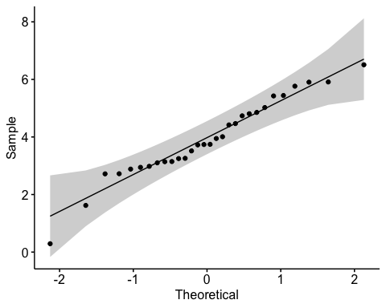

shapiro.test(all_parts$rate_loss) # normal, yay!

Shapiro-Wilk normality test  
  
data: all_parts$rate_loss  
W = 0.96583, p-value = 0.4322

hist(all_parts$rate_loss)

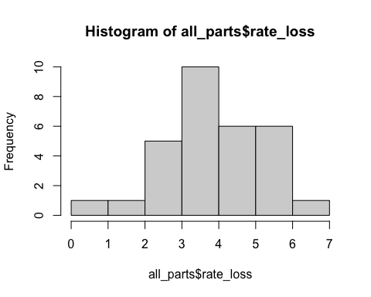

t.test(rate_loss ~ medium, data = all_parts, var.equal = TRUE)

Two Sample t-test  
  
data: rate_loss by medium  
t = 0.047102, df = 28, p-value = 0.9628  
alternative hypothesis: true difference in means between group Field bf and group PW is not equal to 0  
95 percent confidence interval:  
 -1.035228 1.083957  
sample estimates:  
mean in group Field bf mean in group PW   
 3.947604 3.923240

f5a <- all_parts %>%   
 mutate(medium = fct_relevel(medium, "PW", "Field bf")) %>%   
 ggplot(aes(y= rate_loss, x = medium, fill = medium)) +   
 geom_boxplot() +  
 geom_jitter(alpha = 0.3, width = 0.05) +  
 theme_classic() +  
 scale_fill_manual(values = c("PW" = "white",  
 "Field bf" = "darkgrey")) +  
 theme(legend.position = "none",  
 strip.text = element_text(face="bold"),  
 axis.title = element_text(face = "bold")) +  
 xlab("Treatment") +  
 ylab("Rate of Loss of Bd over 6 Days") +   
 scale_x_discrete (labels= c("PW" = "Pond water + MO",  
 "Field bf" = "AE Biofilm"))  
f5a

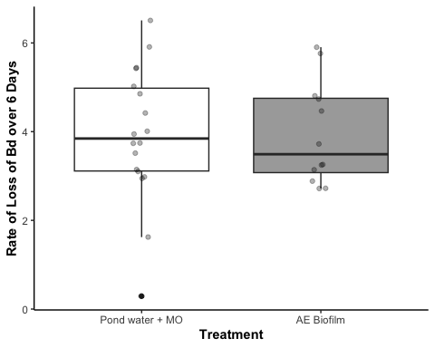

## 5B pairwise comparisons across treatments

Stats and assumption testing

Exploratory viz:

exploratory_viz <- all_parts %>%   
 ggplot(aes(y= rate_loss, x = treatment)) +   
 geom_boxplot() +  
 geom_jitter(alpha = 0.5, width = 0.05) +  
 theme_classic() +  
 theme(legend.position = "bottom",  
 strip.text = element_text(face="bold"),  
 axis.title = element_text(face = "bold")) +  
 xlab("Treatment") +  
 ylab("Rate of Loss of Bd over 7 Days") +   
 ggtitle("Exploratory visualization, not final plot")

Assumptions testing

par(mfrow = c(2,2))  
aov_5b <- aov(rate_loss~treatment, data=all_parts)  
plot(aov_5b)

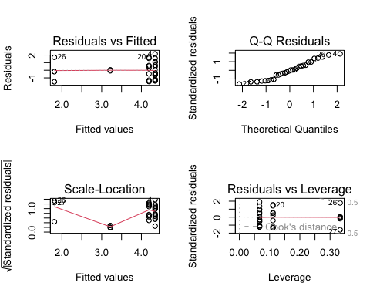

interpret

# with microbe depleted  
summary(aov_5b) # sig effect of treatment

Df Sum Sq Mean Sq F value Pr(>F)   
treatment 3 18.23 6.077 4.424 0.0122 *  
Residuals 26 35.72 1.374   
---  
Signif. codes: 0 '***' 0.001 '**' 0.01 '*' 0.05 '.' 0.1 ' ' 1

TukeyHSD(aov_5b)

Tukey multiple comparisons of means  
 95% family-wise confidence level  
  
Fit: aov(formula = rate_loss ~ treatment, data = all_parts)  
  
$treatment  
 diff lwr upr p adj  
NCOS PW 40 um-PW 40um -2.5364280 -4.5699791 -0.5028769 0.0104552  
Field bf 0.22-PW 40um -0.1544017 -1.5101025 1.2012990 0.9891809  
NCOS AE 0.22um-PW 40um -1.1302884 -3.1638395 0.9032627 0.4377743  
Field bf 0.22-NCOS PW 40 um 2.3820263 0.2384752 4.5255774 0.0252643  
NCOS AE 0.22um-NCOS PW 40 um 1.4061396 -1.2191635 4.0314428 0.4696326  
NCOS AE 0.22um-Field bf 0.22 -0.9758867 -3.1194377 1.1676644 0.6023819

post_hoc_rateloss <- glht(aov_5b, # with your ANOVA model  
 linfct = mcp(treatment = "Tukey"))  
summary(post_hoc_rateloss)

Simultaneous Tests for General Linear Hypotheses  
  
Multiple Comparisons of Means: Tukey Contrasts  
  
  
Fit: aov(formula = rate_loss ~ treatment, data = all_parts)  
  
Linear Hypotheses:  
 Estimate Std. Error t value Pr(>|t|)   
NCOS PW 40 um - PW 40um == 0 -2.5364 0.7413 -3.422 0.00989 **  
Field bf 0.22 - PW 40um == 0 -0.1544 0.4942 -0.312 0.98865   
NCOS AE 0.22um - PW 40um == 0 -1.1303 0.7413 -1.525 0.42614   
Field bf 0.22 - NCOS PW 40 um == 0 2.3820 0.7814 3.049 0.02374 *   
NCOS AE 0.22um - NCOS PW 40 um == 0 1.4061 0.9570 1.469 0.45795   
NCOS AE 0.22um - Field bf 0.22 == 0 -0.9759 0.7814 -1.249 0.59137   
---  
Signif. codes: 0 '***' 0.001 '**' 0.01 '*' 0.05 '.' 0.1 ' ' 1  
(Adjusted p values reported -- single-step method)

cld(post_hoc_rateloss)

PW 40um NCOS PW 40 um Field bf 0.22 NCOS AE 0.22um   
 "a" "b" "a" "ab"

# export cld results as a dataframe  
cld_results_rateloss <- cld(post_hoc_rateloss)  
labels_rl <- cld_results_rateloss$mcletters$Letters  
treatments_rl <- names(labels_rl)  
labels_rl <- as.character(labels_rl)  
  
sig_data_rl <- tibble(  
 treatment = treatments_rl,  
 y_position = c(7,4,6.5,4),  
 label = labels_rl)  
  
## emmeans for posthoc  
f5b_em_treat <- emmeans(aov_5b, ~ treatment)  
f5b_tukey_treat <- pairs(f5b_em_treat, adjust = "tukey")  
f5b_tukey_treat

contrast estimate SE df t.ratio p.value  
 PW 40um - NCOS PW 40 um 2.536 0.741 26 3.422 0.0105  
 PW 40um - Field bf 0.22 0.154 0.494 26 0.312 0.9892  
 PW 40um - NCOS AE 0.22um 1.130 0.741 26 1.525 0.4378  
 NCOS PW 40 um - Field bf 0.22 -2.382 0.781 26 -3.049 0.0253  
 NCOS PW 40 um - NCOS AE 0.22um -1.406 0.957 26 -1.469 0.4696  
 Field bf 0.22 - NCOS AE 0.22um 0.976 0.781 26 1.249 0.6024  
  
P value adjustment: tukey method for comparing a family of 4 estimates

Better vis

all_parts$treatment <- factor(all_parts$treatment)   
   
fig5 <- all_parts %>%   
 mutate(medium = case_when(  
 grepl("PW", treatment) ~ "PW",  
 grepl("Field bf", treatment) ~ "Field bf",  
 grepl("AE", treatment) ~ "Field bf"  
 )) %>%   
 mutate(site = case_when(  
 grepl("NCOS", treatment) ~ "Santa Barbara",  
 TRUE ~ "East Bay" # Default to "east Bay"  
 )) %>%   
 ggplot(aes(y= rate_loss, x = treatment, fill = medium)) +  
 geom_boxplot() +  
 geom_jitter(alpha = 0.3, width = 0.05) +  
 theme_classic() +  
 # biofilm and pond water colors, both from paul tol colorblind palette  
 scale_fill_manual(values = c("PW" = "white",  
 "Field bf" = "darkgrey")) +  
 facet_wrap(~site, scales = "free_x") +  
 theme(legend.position = "none",  
 strip.text = element_text(face="bold"),  
 axis.title = element_text(face = "bold")) +  
 xlab("Medium") +  
 ylab("Rate loss of Bd over 6 Days") +   
 scale_x_discrete (drop = TRUE, labels= c(  
 "PW 40um" = "East Bay\nPW + MO",  
 "NCOS PW 40 um" = "SB \nPW + MO",  
 "Field bf 0.22" = "East Bay\nBiofilm",  
 "NCOS AE 0.22um" = "SB \nBiofilm"))  
sig_data_rl <- sig_data_rl %>%   
 mutate(site = case_when(  
 grepl("NCOS", treatment) ~ "Santa Barbara",  
 TRUE ~ "East Bay" # Default to "east Bay"  
 ))  
  
f5b <- fig5 + geom_text(data = sig_data_rl, aes(x = treatment, y = y_position, label = label, group = site), inherit.aes = FALSE)   
  
f5b

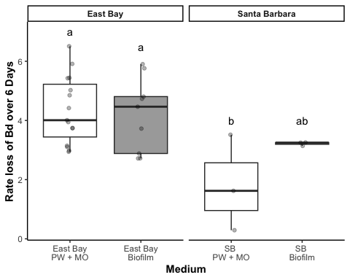

# Combine the figs

# Combine fig_2a and fig_2b side by side  
fig5ab <- f5a + f5b +   
 plot_layout(widths = c(1, 1)) + # Ensure equal widths for both plots  
 plot_annotation(tag_levels = 'A') # Adds "A" and "B" to the upper corners  
  
fig5ab

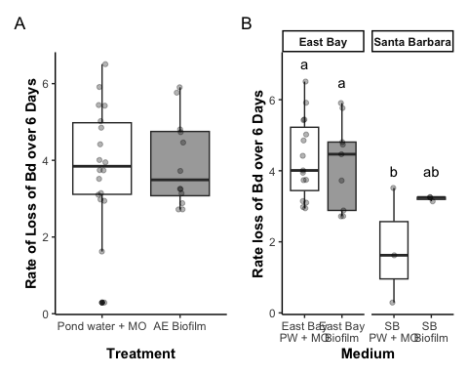

#ggsave("5a_5b.png", plot = fig5ab, width = 10, height = 5, dpi = 1000)

# *PUBLICATION FIGURES

## Fig 2

fig_2a <- eb_pw %>%  
 # combine floating and adherent for total_Bd  
 pivot_wider(names_from = bd_location, values_from = bd_qty) %>%  
 mutate(combined_bd = adherent + floating) %>%   
   
 # create the plot  
 ggplot(aes(y= combined_bd, x = filter, fill = filter)) +   
 geom_boxplot() +  
 geom_jitter(width = 0.2, alpha = 0.3) +  
 scale_y_log10() +  
 facet_wrap(~day, labeller = labeller(day = c("Day_1" = "Day 1",  
 "Day_7" = "Day 7")))+  
   
 scale_fill_manual(values = c("40um_filter" = with_microbes_40_color,   
 "0.22um_filter" = no_microbes_.22_color)) +  
 myCustomTheme() +  
 theme(legend.position = "none",  
 strip.text = element_text(face="bold"),  
 axis.title = element_text(face = "bold")) +   
 scale_x_discrete (labels= c("40um_filter" = "+ AE Microbes", "0.22um_filter" = "- AE Microbes")) +  
 xlab("Presence of Microbes in Pond Water") +  
 ylab("Bd Quantity (ZE)") +  
   
 # add controls ad x's  
 geom_point(data = eb_pw_controls, aes(x = filter, y = combined_bd), shape = 4, size = 2)

# Convert factor day to numeric while preserving original values  
pw_noday0$day <- as.numeric(as.character(pw_noday0$day))  
  
fig2B <- pw_summary %>%   
 # reorder to match Renwei's plot  
 mutate(sample_ID = factor(sample_ID,   
 levels = c("1%TB", "MQ", "1%TB+PW+microorganism", "PW+microorganism", "1%TB+PW-microorganism", "PW-microorganism", "Added Bd"))) %>%   
 mutate(day = as.numeric(day)) %>%   
 ggplot(aes(x = day,   
 y = mean,   
 color = sample_ID)) +  
 geom_point(size = 2) +  
 geom_errorbar(aes(ymin = mean - se, # plot the standard error  
 ymax = mean + se),  
 width = 0.1) +  
  
 # Adding the raw data as a layer with jitter  
 geom_point(data = pw_noday0,   
 aes(x = day,   
 y = adh_plus_sup,   
 color = sample_ID), # Raw data points  
 position = position_jitter(width = 0.1, seed = 1),  
 alpha = 0.3) +  
 # add control raw data too  
 geom_point(data = pw_control_data,   
 aes(x = day,   
 y = adh_plus_sup,   
 color = "#BBBBBB"), # Raw data points  
 position = position_jitter(width = 0.1, seed = 1),  
 alpha = 0.3) +  
   
 scale_y_log10(limits = c(1e3, 1e8),   
 breaks = c(1e3, 1e4, 1e5, 1e6, 1e7, 1e8)) +  
 labs(x = "Day",  
 y = "Bd Quantity (ZE)",  
 color = "Medium", # Title for color legend  
 linetype = "Microbes\nPresent" # Title for linetype legend  
 ) +  
 scale_color_manual(values = c("1%TB" = "#CCBB44",   
 "MQ" = "#228833",   
 "1%TB+PW+microorganism" = "#4477AA",   
 "PW+microorganism" = "#EE6677",   
 "1%TB+PW-microorganism" = "#66CCEE",  
 #"Added Bd" = "#BBBBBB" # removed bc not really a medium  
 "PW-microorganism" = "#AA3377"),   
 labels = c("1%TB" = "TB",  
 "MQ" = "MQ",  
 "1%TB+PW+microorganism" = "TB + PW + MO",  
 "PW+microorganism" = "PW + MO",  
 "1%TB+PW-microorganism" = "TB + PW - MO",  
 "PW-microorganism" = "PW - MO",  
 "Added Bd" = "Initial Bd")) + # Custom labels for the color legend  
   
 geom_line(aes(linetype = microbes)) +   
 scale_linetype_manual(values = c("n" = "dashed",   
 "y" = "solid"),  
 labels = c("n" = "N", "y" = "Y")) + # Change labels to uppercase N and Y  
 myCustomTheme()+  
 scale_x_continuous(breaks = c(0, 1, 3, 5, 7),  
 labels = c("Initial\nBd", "1", "3", "5", "7")) +  
 theme(legend.position = "right",  
 panel.grid.major.y = element_line(color = "grey"), # Add major y grid lines  
 panel.border = element_blank())

# Combine fig_2a and fig_2b side by side  
fig2 <- fig_2a + fig2B +   
 plot_layout(widths = c(1, 1)) + # Ensure equal widths for both plots  
 plot_annotation(tag_levels = 'A') # Adds "A" and "B" to the upper corners  
  
fig2

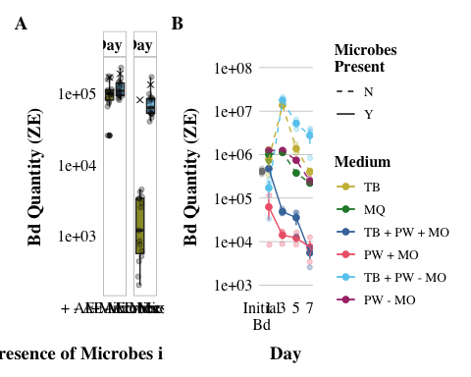

#ggsave("2a_2b.png", plot = fig2, width = 14, height = 5, dpi = 1000)

## Fig 3

3A: AE Biofilm

fig_3a_boxplot <- eb_ae_bf_only %>%  
ggplot(aes(y= bd_qty, x = day)) +   
 geom_boxplot(fill = no_microbes_.22_color) +  
 geom_jitter(alpha = 0.3, width = 0.05) +  
 myCustomTheme() +  
 scale_y_log10() +  
 theme(legend.position = "none",  
 strip.text = element_text(face="bold"),  
 axis.title = element_text(face = "bold")) +   
 xlab("Day") +  
 ylab("Bd Quantity (ZE)") +  
 scale_x_discrete (labels= c("Day_1" = "1", "Day_7" = "7"))  
  
# Let's add significance letters  
significance_data <- tibble(  
 day = factor(c("Day_1", "Day_7"), levels = c("Day_1", "Day_7")),  
 y_position = c(1.6e+05, 1.4e+04), # Adjust this depending on your plot's scale  
 label = c("a", "b"))  
  
fig_3a <- fig_3a_boxplot +   
geom_text(data = significance_data, aes(x = day, y = y_position, label = label),  
 position = position_dodge(width = 0.75), vjust = 0)   
  
fig_3a

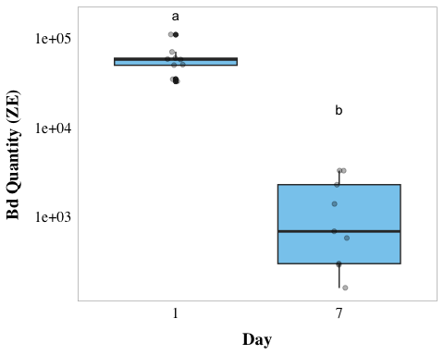

3B: AE Biofilm

# Convert factor day to numeric while preserving original values  
ae_noday0$day <- as.numeric(as.character(ae_noday0$day))  
  
  
# add column for microbes or no  
fig_3b <- ae_summary %>%  
 # reorder to match Renwei's plot  
 mutate(sample_ID = factor(sample_ID,  
 levels = c("1%TB+AEbiofilm", "MQ+AEbiofilm",  
 "PW+AEBiofilm", "Added Bd" ))) %>%  
  
 ggplot(aes(x = day,  
 y = mean,  
 color = sample_ID)) +  
 geom_point(size = 2) +  
 geom_errorbar(aes(ymin = mean - se, # plot the standard error  
 ymax = mean + se),  
 width = 0.1) +  
 geom_line() +   
   
 # Adding the raw data as a layer with jitter  
 geom_point(data = ae_noday0,   
 aes(x = day,   
 y = adh,   
 color = sample_ID), # Raw data points  
 position = position_jitter(width = 0.1, seed = 1),  
 alpha = 0.3) +  
   
 # controls raw data  
 geom_point(data = ae_control_data,   
 aes(x = day,   
 y = adh,   
 color = "#BBBBBB"), # Raw data points  
 position = position_jitter(width = 0.1, seed = 1),  
 alpha = 0.3) +  
   
 # Adding the raw data as a layer with jitter  
 geom_point(data = ae_noday0,  
 aes(x = day,  
 y = adh,  
 color = sample_ID), # Raw data points  
 position = position_jitter(width = 0.1, seed = 1),  
 alpha = 0.3) +  
   
 scale_y_log10(limits = c(1e3, 1e7),  
 breaks = c(1e3, 1e4, 1e5, 1e6, 1e7)) +  
 # vibes  
 labs(x = "Day",  
 y = "Bd Quantity (ZE)",  
 color = "Medium with\nAE Biofilm")+ # Title for color legend  
   
 scale_color_manual(values = c("1%TB+AEbiofilm"= "#4477AA",  
 "MQ+AEbiofilm" = "#228833",  
 #"Added Bd" = "darkgrey",  
 "PW+AEBiofilm" = "#AA3377"),  
 labels = c("1%TB+AEbiofilm" = "TB Broth",  
 "MQ+AEbiofilm" = "MQ Water",  
 "PW+AEBiofilm" = "Filtered\nPond Water",  
 "Added Bd" = "Initial Bd")) + # Custom labels  
  
 myCustomTheme()+  
 scale_x_continuous(breaks = c(0, 1, 3, 5, 7),  
 labels = c("Initial\nBd", "1", "3", "5", "7"))

Fig 3 combined

# Combine fig_2a and fig_2b side by side  
fig3 <- fig_3a + fig_3b +   
 plot_layout(widths = c(1, 1)) + # Ensure equal widths for both plots  
 plot_annotation(tag_levels = 'A') # Adds "A" and "B" to the upper corners  
  
fig3

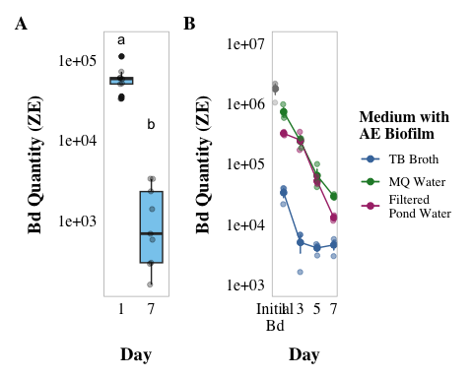

#ggsave("3a_3b.png", plot = fig3, width = 14, height = 5, dpi = 1000)

## Fig 4

fig_4a <- eb_monolayer %>%   
 # plot it  
 ggplot(aes(y= bd_qty, x = filter, fill = filter)) +   
 geom_boxplot() +  
 geom_jitter(width = 0.2, alpha = 0.3) +  
 scale_y_log10() +  
 facet_wrap(~day, labeller = labeller(day = c("Day_1" = "Day 1",  
 "Day_7" = "Day 7")))+  
 scale_fill_manual(values = c("40um_filter" = with_microbes_40_color,   
 "0.22um_filter" = no_microbes_.22_color)) +  
 myCustomTheme()+  
 theme(legend.position = "none",  
 strip.text = element_text(face="bold"),  
 axis.title = element_text(face = "bold")) +   
 scale_x_discrete (labels= c("40um_filter" = "With Microbes", "0.22um_filter" = "No Microbes")) +  
 xlab("Presence of Microbes in PW with Monolayer") +  
 ylab("Bd Quantity (ZE)") +  
  
 # add controls ad x's  
geom_point(data = eb_ml_controls, aes(x = filter, y = bd_qty), shape = 4, size = 2)

# Convert factor day to numeric while preserving original values  
ml_noday0$day <- as.numeric(as.character(ml_noday0$day))  
  
fig_4b <- monolayer_summary %>%   
 # reorder to match Renwei's plot  
 mutate(sample_ID = factor(sample_ID,   
 levels = c("TB+PW+microbes","PW+microbes",  
 "TB+PW-microbes", "PW-microbes"))) %>%   
 ggplot(aes(x = day,   
 y = mean_adh,   
 color = sample_ID)) +  
 geom_point(size = 2) +  
 geom_errorbar(aes(ymin = mean_adh - se, # plot the standard error  
 ymax = mean_adh + se),  
 width = 0.1) +  
 geom_line(aes(linetype = microbes)) +   
   
 # raw data  
 geom_point(data = ml_noday0,   
 aes(x = day,   
 y = adh_plus_sup,   
 color = sample_ID), # Raw data points  
 position = position_jitter(width = 0.1, seed = 1),  
 alpha = 0.3) +  
 scale_y_log10(limits = c(1e4, 1e8),   
 breaks = c(1e4, 1e5, 1e6, 1e7, 1e8)) +  
   
 # vibes  
 labs(x = "Day",  
 y = "Bd Quantity (ZE)",  
 color = "Medium", # Title for color legend  
 linetype = "Microbes\nPresent") +  
 scale_color_manual(values = c("TB+PW+microbes" = "#4477AA",   
 "PW+microbes" = "#EE6677",   
 "TB+PW-microbes" = "#66CCEE",   
 "PW-microbes" = "#AA3377"),   
   
 labels = c("TB+PW+microbes" = "TB + PW + MO",  
 "PW+microbes" = "PW + MO",  
 "TB+PW-microbes" = "TB + PW - MO",  
 "PW-microbes" = "PW - MO")) + # Custom labels  
 myCustomTheme()+  
 scale_linetype_manual(values = c("n" = "dashed",   
 "y" = "solid"),  
 labels = c("n" = "N", "y" = "Y")) + # Change labels to uppercase N and Y  
 scale_x_continuous(breaks = c(0, 1, 3, 5, 7),  
 labels = c("Initial\nBd", "1", "3", "5", "7"))  
  
fig_4b

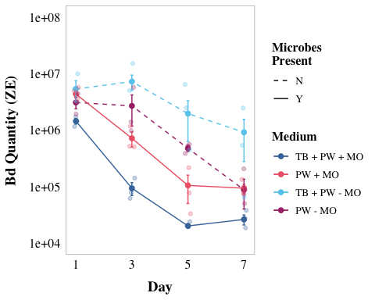

Fig 4 combined

# Combine fig_2a and fig_2b side by side  
fig4 <- fig_4a + fig_4b +   
 plot_layout(widths = c(1, 1)) + # Ensure equal widths for both plots  
 plot_annotation(tag_levels = 'A') # Adds "A" and "B" to the upper corners  
  
fig4

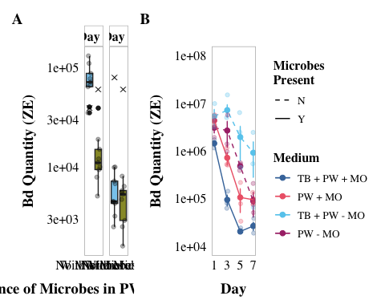

#ggsave("4a_4b.png", plot = fig4, width = 14, height = 5, dpi = 1000)

# * Stats tables

## 2B stats glm

## 3B stats 2way anova

### anova table

# anova table  
anova_output <- tidy(aov_3b)  
  
aov_3b_tbl <- anova_output %>%  
 dplyr::select(term, df, sumsq, meansq, statistic, p.value) %>%  
 gt() %>%  
 tab_header(  
 title = "ANOVA Table"  
 ) %>%  
 fmt_number(  
 columns = c(sumsq, meansq, statistic),  
 decimals = 2  
 ) %>%  
 cols_label(  
 term = "Term",  
 df = "Df",  
 sumsq = "Sum Sq",  
 meansq = "Mean Sq",  
 statistic = "F value",  
 p.value = "P-value"  
 ) %>% # scientific number format for values <0.001 in p values  
 fmt_scientific(  
 columns = c(p.value),  
 decimals = 1,  
 rows = p.value < 0.001  
 ) %>%  
 # 3 decimals for p values >=0.001  
 fmt_number(  
 columns = c(p.value),  
 decimals = 3,  
 rows = p.value >= 0.001  
 )  
aov_3b_tbl

Table 1: ANOVA Table

| Term | Df | Sum Sq | Mean Sq | F value | P-value |
| --- | --- | --- | --- | --- | --- |
| day | 3 | 40.24 | 13.41 | 110.10 | 3.6 × 10^-14 |
| medium | 2 | 60.07 | 30.04 | 246.55 | 1.0 × 10^-16 |
| day:medium | 6 | 7.42 | 1.24 | 10.14 | 1.3 × 10^-5 |
| Residuals | 24 | 2.92 | 0.12 | NA | NA |

# prettier, simplified  
anova_output <- tidy(aov_3b)  
  
# Modify term to include degrees of freedom in *italics*  
anova_output <- anova_output %>%  
 mutate(term = ifelse(grepl("day:medium", term), "day x medium", term)) %>%   
 mutate (term = paste0(term, " (*df = ", df, ", ", anova_output[df == max(df), "df"], "*)")) %>%   
 filter(term != "Residuals (*df = 24, 24*)")  
  
# Create the gt table with selected columns  
aov_3b_tbl_b <- anova_output %>%  
 dplyr::select(term, statistic, p.value) %>%  
 gt() %>%  
 tab_header(  
 title = "ANOVA Table"  
 ) %>%  
 fmt_markdown(  
 columns = c(term)  
 ) %>%  
 fmt_number(  
 columns = c(statistic),  
 decimals = 2  
 ) %>%  
 cols_label(  
 term = "",  
 statistic = "F value",  
 p.value = "P-value"  
 ) %>%  
 fmt_scientific(  
 columns = c(p.value),  
 decimals = 1,  
 rows = p.value < 0.001  
 ) %>%  
 fmt_number(  
 columns = c(p.value),  
 decimals = 3,  
 rows = p.value >= 0.001  
 )  
  
aov_3b_tbl_b

Table 1: ANOVA Table

|  | F value | P-value |
| --- | --- | --- |
| day (*df = 3, 24*) | 110.10 | 3.6 × 10^-14 |
| medium (*df = 2, 24*) | 246.55 | 1.0 × 10^-16 |
| day x medium (*df = 6, 24*) | 10.14 | 1.3 × 10^-5 |

### posthoc table

# post hoc table  
# Convert Tukey emmeans results to data frames  
tukey_day_df <- as.data.frame(tukey_day)  
tukey_medium_df <- as.data.frame(tukey_medium)  
tukey_interaction_df <- as.data.frame(tukey_interaction)  
  
# Add labels to indicate which factor the comparison refers to  
tukey_day_df <- tukey_day_df %>% mutate(factor = "Day")  
tukey_medium_df <- tukey_medium_df %>% mutate(factor = "Medium")  
tukey_interaction_df <- tukey_interaction_df %>% mutate(factor = "Interaction")  
  
all_tukey_df <- bind_rows(tukey_day_df, tukey_medium_df, tukey_interaction_df)  
ph3b_table <- all_tukey_df %>%  
 dplyr::select(factor, contrast, estimate, SE, df, t.ratio, p.value) %>%  
 gt() %>%  
 # change column names  
 cols_label(  
 factor = "Comparison",  
 contrast = "Group Comparison",  
 estimate = "Estimate",  
 SE = "Standard Error",  
 df = "Degrees of Freedom",  
 t.ratio = "t-Ratio",  
 p.value = "p-value"  
 ) %>%  
 # update header for table  
 tab_header(  
 title = "Emmeans Post-hoc Test Results"  
 ) %>%  
 # 3 decimal places  
 fmt_number(  
 columns = c(estimate, SE, t.ratio),  
 decimals = 3  
 ) %>%  
 # scientific number format for values <0.001 in p values  
 fmt_scientific(  
 columns = c(p.value),  
 decimals = 1,  
 rows = p.value < 0.001  
 ) %>%  
 # 3 decimals for p values >=0.001  
 fmt_number(  
 columns = c(p.value),  
 decimals = 3,  
 rows = p.value >= 0.001  
 ) %>%  
 #make the headers bold  
 tab_style(  
 style = list(  
 cell_text(weight = "bold")  
 ),  
 locations = cells_column_labels(everything()))  
ph3b_table

Table 1: Emmeans Post-hoc Test Results

| Comparison | Group Comparison | Estimate | Standard Error | Degrees of Freedom | t-Ratio | p-value |
| --- | --- | --- | --- | --- | --- | --- |
| Day | day1 - day3 | 1.149 | 0.165 | 24 | 6.985 | 1.8 × 10^-6 |
| Day | day1 - day5 | 2.131 | 0.165 | 24 | 12.949 | 1.5 × 10^-11 |
| Day | day1 - day7 | 2.805 | 0.165 | 24 | 17.046 | 6.2 × 10^-14 |
| Day | day3 - day5 | 0.981 | 0.165 | 24 | 5.964 | 2.1 × 10^-5 |
| Day | day3 - day7 | 1.655 | 0.165 | 24 | 10.060 | 2.5 × 10^-9 |
| Day | day5 - day7 | 0.674 | 0.165 | 24 | 4.097 | 0.002 |
| Medium | (1%TB+AEbiofilm) - (MQ+AEbiofilm) | -2.932 | 0.142 | 24 | -20.579 | 2.1 × 10^-14 |
| Medium | (1%TB+AEbiofilm) - (PW+AEBiofilm) | -2.496 | 0.142 | 24 | -17.515 | 3.2 × 10^-14 |
| Medium | (MQ+AEbiofilm) - (PW+AEBiofilm) | 0.437 | 0.142 | 24 | 3.064 | 0.014 |
| Interaction | (day1 1%TB+AEbiofilm) - (day3 1%TB+AEbiofilm) | 2.045 | 0.285 | 24 | 7.176 | 1.1 × 10^-5 |
| Interaction | (day1 1%TB+AEbiofilm) - (day5 1%TB+AEbiofilm) | 2.092 | 0.285 | 24 | 7.340 | 7.8 × 10^-6 |
| Interaction | (day1 1%TB+AEbiofilm) - (day7 1%TB+AEbiofilm) | 1.994 | 0.285 | 24 | 6.997 | 1.7 × 10^-5 |
| Interaction | (day1 1%TB+AEbiofilm) - (day1 MQ+AEbiofilm) | -3.098 | 0.285 | 24 | -10.869 | 5.6 × 10^-9 |
| Interaction | (day1 1%TB+AEbiofilm) - (day3 MQ+AEbiofilm) | -1.988 | 0.285 | 24 | -6.974 | 1.8 × 10^-5 |
| Interaction | (day1 1%TB+AEbiofilm) - (day5 MQ+AEbiofilm) | -0.620 | 0.285 | 24 | -2.175 | 0.580 |
| Interaction | (day1 1%TB+AEbiofilm) - (day7 MQ+AEbiofilm) | 0.107 | 0.285 | 24 | 0.374 | 1.000 |
| Interaction | (day1 1%TB+AEbiofilm) - (day1 PW+AEBiofilm) | -2.296 | 0.285 | 24 | -8.056 | 1.6 × 10^-6 |
| Interaction | (day1 1%TB+AEbiofilm) - (day3 PW+AEBiofilm) | -2.003 | 0.285 | 24 | -7.028 | 1.6 × 10^-5 |
| Interaction | (day1 1%TB+AEbiofilm) - (day5 PW+AEBiofilm) | -0.474 | 0.285 | 24 | -1.662 | 0.868 |
| Interaction | (day1 1%TB+AEbiofilm) - (day7 PW+AEBiofilm) | 0.920 | 0.285 | 24 | 3.228 | 0.109 |
| Interaction | (day3 1%TB+AEbiofilm) - (day5 1%TB+AEbiofilm) | 0.047 | 0.285 | 24 | 0.164 | 1.000 |
| Interaction | (day3 1%TB+AEbiofilm) - (day7 1%TB+AEbiofilm) | -0.051 | 0.285 | 24 | -0.178 | 1.000 |
| Interaction | (day3 1%TB+AEbiofilm) - (day1 MQ+AEbiofilm) | -5.143 | 0.285 | 24 | -18.045 | 1.4 × 10^-13 |
| Interaction | (day3 1%TB+AEbiofilm) - (day3 MQ+AEbiofilm) | -4.033 | 0.285 | 24 | -14.150 | 2.3 × 10^-11 |
| Interaction | (day3 1%TB+AEbiofilm) - (day5 MQ+AEbiofilm) | -2.665 | 0.285 | 24 | -9.351 | 1.0 × 10^-7 |
| Interaction | (day3 1%TB+AEbiofilm) - (day7 MQ+AEbiofilm) | -1.938 | 0.285 | 24 | -6.802 | 2.7 × 10^-5 |
| Interaction | (day3 1%TB+AEbiofilm) - (day1 PW+AEBiofilm) | -4.341 | 0.285 | 24 | -15.232 | 4.7 × 10^-12 |
| Interaction | (day3 1%TB+AEbiofilm) - (day3 PW+AEBiofilm) | -4.048 | 0.285 | 24 | -14.203 | 2.1 × 10^-11 |
| Interaction | (day3 1%TB+AEbiofilm) - (day5 PW+AEBiofilm) | -2.518 | 0.285 | 24 | -8.837 | 3.0 × 10^-7 |
| Interaction | (day3 1%TB+AEbiofilm) - (day7 PW+AEBiofilm) | -1.125 | 0.285 | 24 | -3.948 | 0.023 |
| Interaction | (day5 1%TB+AEbiofilm) - (day7 1%TB+AEbiofilm) | -0.098 | 0.285 | 24 | -0.342 | 1.000 |
| Interaction | (day5 1%TB+AEbiofilm) - (day1 MQ+AEbiofilm) | -5.189 | 0.285 | 24 | -18.209 | 1.2 × 10^-13 |
| Interaction | (day5 1%TB+AEbiofilm) - (day3 MQ+AEbiofilm) | -4.079 | 0.285 | 24 | -14.314 | 1.8 × 10^-11 |
| Interaction | (day5 1%TB+AEbiofilm) - (day5 MQ+AEbiofilm) | -2.712 | 0.285 | 24 | -9.515 | 7.5 × 10^-8 |
| Interaction | (day5 1%TB+AEbiofilm) - (day7 MQ+AEbiofilm) | -1.985 | 0.285 | 24 | -6.966 | 1.8 × 10^-5 |
| Interaction | (day5 1%TB+AEbiofilm) - (day1 PW+AEBiofilm) | -4.388 | 0.285 | 24 | -15.396 | 3.7 × 10^-12 |
| Interaction | (day5 1%TB+AEbiofilm) - (day3 PW+AEBiofilm) | -4.095 | 0.285 | 24 | -14.368 | 1.6 × 10^-11 |
| Interaction | (day5 1%TB+AEbiofilm) - (day5 PW+AEBiofilm) | -2.565 | 0.285 | 24 | -9.001 | 2.1 × 10^-7 |
| Interaction | (day5 1%TB+AEbiofilm) - (day7 PW+AEBiofilm) | -1.172 | 0.285 | 24 | -4.112 | 0.016 |
| Interaction | (day7 1%TB+AEbiofilm) - (day1 MQ+AEbiofilm) | -5.092 | 0.285 | 24 | -17.867 | 1.7 × 10^-13 |
| Interaction | (day7 1%TB+AEbiofilm) - (day3 MQ+AEbiofilm) | -3.982 | 0.285 | 24 | -13.972 | 3.0 × 10^-11 |
| Interaction | (day7 1%TB+AEbiofilm) - (day5 MQ+AEbiofilm) | -2.614 | 0.285 | 24 | -9.172 | 1.5 × 10^-7 |
| Interaction | (day7 1%TB+AEbiofilm) - (day7 MQ+AEbiofilm) | -1.888 | 0.285 | 24 | -6.624 | 4.0 × 10^-5 |
| Interaction | (day7 1%TB+AEbiofilm) - (day1 PW+AEBiofilm) | -4.290 | 0.285 | 24 | -15.053 | 6.0 × 10^-12 |
| Interaction | (day7 1%TB+AEbiofilm) - (day3 PW+AEBiofilm) | -3.997 | 0.285 | 24 | -14.025 | 2.8 × 10^-11 |
| Interaction | (day7 1%TB+AEbiofilm) - (day5 PW+AEBiofilm) | -2.468 | 0.285 | 24 | -8.659 | 4.3 × 10^-7 |
| Interaction | (day7 1%TB+AEbiofilm) - (day7 PW+AEBiofilm) | -1.074 | 0.285 | 24 | -3.770 | 0.035 |
| Interaction | (day1 MQ+AEbiofilm) - (day3 MQ+AEbiofilm) | 1.110 | 0.285 | 24 | 3.895 | 0.026 |
| Interaction | (day1 MQ+AEbiofilm) - (day5 MQ+AEbiofilm) | 2.478 | 0.285 | 24 | 8.694 | 4.0 × 10^-7 |
| Interaction | (day1 MQ+AEbiofilm) - (day7 MQ+AEbiofilm) | 3.204 | 0.285 | 24 | 11.243 | 2.8 × 10^-9 |
| Interaction | (day1 MQ+AEbiofilm) - (day1 PW+AEBiofilm) | 0.802 | 0.285 | 24 | 2.813 | 0.235 |
| Interaction | (day1 MQ+AEbiofilm) - (day3 PW+AEBiofilm) | 1.095 | 0.285 | 24 | 3.842 | 0.030 |
| Interaction | (day1 MQ+AEbiofilm) - (day5 PW+AEBiofilm) | 2.624 | 0.285 | 24 | 9.208 | 1.4 × 10^-7 |
| Interaction | (day1 MQ+AEbiofilm) - (day7 PW+AEBiofilm) | 4.017 | 0.285 | 24 | 14.097 | 2.5 × 10^-11 |
| Interaction | (day3 MQ+AEbiofilm) - (day5 MQ+AEbiofilm) | 1.368 | 0.285 | 24 | 4.799 | 0.003 |
| Interaction | (day3 MQ+AEbiofilm) - (day7 MQ+AEbiofilm) | 2.094 | 0.285 | 24 | 7.348 | 7.6 × 10^-6 |
| Interaction | (day3 MQ+AEbiofilm) - (day1 PW+AEBiofilm) | -0.308 | 0.285 | 24 | -1.082 | 0.993 |
| Interaction | (day3 MQ+AEbiofilm) - (day3 PW+AEBiofilm) | -0.015 | 0.285 | 24 | -0.053 | 1.000 |
| Interaction | (day3 MQ+AEbiofilm) - (day5 PW+AEBiofilm) | 1.514 | 0.285 | 24 | 5.313 | 9.2 × 10^-4 |
| Interaction | (day3 MQ+AEbiofilm) - (day7 PW+AEBiofilm) | 2.907 | 0.285 | 24 | 10.202 | 1.9 × 10^-8 |
| Interaction | (day5 MQ+AEbiofilm) - (day7 MQ+AEbiofilm) | 0.726 | 0.285 | 24 | 2.549 | 0.359 |
| Interaction | (day5 MQ+AEbiofilm) - (day1 PW+AEBiofilm) | -1.676 | 0.285 | 24 | -5.881 | 2.3 × 10^-4 |
| Interaction | (day5 MQ+AEbiofilm) - (day3 PW+AEBiofilm) | -1.383 | 0.285 | 24 | -4.853 | 0.003 |
| Interaction | (day5 MQ+AEbiofilm) - (day5 PW+AEBiofilm) | 0.146 | 0.285 | 24 | 0.513 | 1.000 |
| Interaction | (day5 MQ+AEbiofilm) - (day7 PW+AEBiofilm) | 1.540 | 0.285 | 24 | 5.403 | 7.4 × 10^-4 |
| Interaction | (day7 MQ+AEbiofilm) - (day1 PW+AEBiofilm) | -2.402 | 0.285 | 24 | -8.430 | 7.0 × 10^-7 |
| Interaction | (day7 MQ+AEbiofilm) - (day3 PW+AEBiofilm) | -2.109 | 0.285 | 24 | -7.401 | 6.7 × 10^-6 |
| Interaction | (day7 MQ+AEbiofilm) - (day5 PW+AEBiofilm) | -0.580 | 0.285 | 24 | -2.035 | 0.668 |
| Interaction | (day7 MQ+AEbiofilm) - (day7 PW+AEBiofilm) | 0.813 | 0.285 | 24 | 2.854 | 0.219 |
| Interaction | (day1 PW+AEBiofilm) - (day3 PW+AEBiofilm) | 0.293 | 0.285 | 24 | 1.028 | 0.995 |
| Interaction | (day1 PW+AEBiofilm) - (day5 PW+AEBiofilm) | 1.822 | 0.285 | 24 | 6.395 | 6.9 × 10^-5 |
| Interaction | (day1 PW+AEBiofilm) - (day7 PW+AEBiofilm) | 3.216 | 0.285 | 24 | 11.284 | 2.6 × 10^-9 |
| Interaction | (day3 PW+AEBiofilm) - (day5 PW+AEBiofilm) | 1.529 | 0.285 | 24 | 5.366 | 8.1 × 10^-4 |
| Interaction | (day3 PW+AEBiofilm) - (day7 PW+AEBiofilm) | 2.923 | 0.285 | 24 | 10.255 | 1.8 × 10^-8 |
| Interaction | (day5 PW+AEBiofilm) - (day7 PW+AEBiofilm) | 1.393 | 0.285 | 24 | 4.889 | 0.003 |

Simplified anova table inspiration: https://link.springer.com/article/10.1007/s11356-015-4566-8/tables/1

## 4b stats

anova table

# anova table  
anova_output4b <- tidy(aov_4b)  
  
aov_4b_tbl <- anova_output4b %>%  
 dplyr::select(term, df, sumsq, meansq, statistic, p.value) %>%  
 gt() %>%  
 tab_header(  
 title = "4b ANOVA Table"  
 ) %>%  
 fmt_number(  
 columns = c(sumsq, meansq, statistic),  
 decimals = 2  
 ) %>%  
 cols_label(  
 term = "Term",  
 df = "Df",  
 sumsq = "Sum Sq",  
 meansq = "Mean Sq",  
 statistic = "F value",  
 p.value = "P-value"  
 ) %>% # scientific number format for values <0.001 in p values  
 fmt_scientific(  
 columns = c(p.value),  
 decimals = 1,  
 rows = p.value < 0.001  
 ) %>%  
 # 3 decimals for p values >=0.001  
 fmt_number(  
 columns = c(p.value),  
 decimals = 3,  
 rows = p.value >= 0.001  
 )  
aov_4b_tbl

Table 1: 4b ANOVA Table

| Term | Df | Sum Sq | Mean Sq | F value | P-value |
| --- | --- | --- | --- | --- | --- |
| day | 3 | 93.76 | 31.25 | 45.34 | 1.3 × 10^-11 |
| microbes | 1 | 37.80 | 37.80 | 54.84 | 2.0 × 10^-8 |
| TB | 1 | 0.51 | 0.51 | 0.75 | 0.394 |
| day:microbes | 3 | 12.21 | 4.07 | 5.90 | 0.003 |
| day:TB | 3 | 0.94 | 0.31 | 0.46 | 0.715 |
| microbes:TB | 1 | 18.12 | 18.12 | 26.28 | 1.4 × 10^-5 |
| day:microbes:TB | 3 | 1.61 | 0.54 | 0.78 | 0.516 |
| Residuals | 32 | 22.06 | 0.69 | NA | NA |

# prettier, simplified  
anova_output4b <- tidy(aov_4b)  
  
# Modify term to include degrees of freedom in *italics*  
anova_output4b <- anova_output4b %>%  
 mutate(term = gsub(":", " x ", term)) %>%   
 mutate (term = paste0(term, " (*df = ", df, ", ", anova_output4b[df == max(df), "df"], "*)")) %>%  
 filter(term != "Residuals (*df = 32, 32*)")  
  
# Create the gt table with selected columns  
aov_4b_tbl_b <- anova_output4b %>%  
 dplyr::select(term, statistic, p.value) %>%  
 gt() %>%  
 tab_header(  
 title = "4b ANOVA Table"  
 ) %>%  
 fmt_markdown(  
 columns = c(term)  
 ) %>%  
 fmt_number(  
 columns = c(statistic),  
 decimals = 2  
 ) %>%  
 cols_label(  
 term = "",  
 statistic = "F value",  
 p.value = "P-value"  
 ) %>%  
 fmt_scientific(  
 columns = c(p.value),  
 decimals = 1,  
 rows = p.value < 0.001  
 ) %>%  
 fmt_number(  
 columns = c(p.value),  
 decimals = 3,  
 rows = p.value >= 0.001  
 )  
  
aov_4b_tbl_b

Table 1: 4b ANOVA Table

|  | F value | P-value |
| --- | --- | --- |
| day (*df = 3, 32*) | 45.34 | 1.3 × 10^-11 |
| microbes (*df = 1, 32*) | 54.84 | 2.0 × 10^-8 |
| TB (*df = 1, 32*) | 0.75 | 0.394 |
| day x microbes (*df = 3, 32*) | 5.90 | 0.003 |
| day x TB (*df = 3, 32*) | 0.46 | 0.715 |
| microbes x TB (*df = 1, 32*) | 26.28 | 1.4 × 10^-5 |
| day x microbes x TB (*df = 3, 32*) | 0.78 | 0.516 |

post hoc

# post hoc table  
# Convert Tukey emmeans results to data frames  
f4b_tukey_day_df <- as.data.frame(f4b_tukey_day)  
f4b_tukey_microbes_df <- as.data.frame(f4b_tukey_microbes)  
f4b_tukey_interaction_df <- as.data.frame(f4b_tukey_interaction)  
  
# Add labels to indicate which factor the comparison refers to  
f4b_tukey_day_df <- f4b_tukey_day_df %>% mutate(factor = "Day")  
f4b_tukey_microbes_df <- f4b_tukey_microbes_df %>% mutate(factor = "Medium")  
f4b_tukey_interaction_df <- f4b_tukey_interaction_df %>% mutate(factor = "Interaction")  
  
f4b_all_tukey_df <- bind_rows(f4b_tukey_day_df, f4b_tukey_microbes_df, f4b_tukey_interaction_df)  
  
f4b_all_tukey_df <- f4b_all_tukey_df %>%   
 mutate(contrast = gsub("MO present TB absent", "microbes only", contrast),  
 contrast = gsub("MO present TB present", "both microbes and TB", contrast),  
 contrast = gsub("MO absent TB absent", "neither microbes nor TB", contrast),  
 contrast = gsub("MO absent TB present", "TB only", contrast))  
  
  
ph4b_table <- f4b_all_tukey_df %>%  
 dplyr::select(factor, contrast, estimate, SE, df, t.ratio, p.value) %>%  
 gt() %>%  
 # change column names  
 cols_label(  
 factor = "Comparison",  
 contrast = "Group Comparison",  
 estimate = "Estimate",  
 SE = "Standard Error",  
 df = "Degrees of Freedom",  
 t.ratio = "t-Ratio",  
 p.value = "p-value"  
 ) %>%  
 # update header for table  
 tab_header(  
 title = "4b Emmeans Post-hoc Test Results"  
 ) %>%  
 # 3 decimal places  
 fmt_number(  
 columns = c(estimate, SE, t.ratio),  
 decimals = 3  
 ) %>%  
 # scientific number format for values <0.001 in p values  
 fmt_scientific(  
 columns = c(p.value),  
 decimals = 1,  
 rows = p.value < 0.001  
 ) %>%  
 # 3 decimals for p values >=0.001  
 fmt_number(  
 columns = c(p.value),  
 decimals = 3,  
 rows = p.value >= 0.001  
 ) %>%  
 #make the headers bold  
 tab_style(  
 style = list(  
 cell_text(weight = "bold")  
 ),  
 locations = cells_column_labels(everything()))  
  
ph4b_table

Table 1: 4b Emmeans Post-hoc Test Results

| Comparison | Group Comparison | Estimate | Standard Error | Degrees of Freedom | t-Ratio | p-value |
| --- | --- | --- | --- | --- | --- | --- |
| Day | day1 - day3 | 1.162 | 0.339 | 32 | 3.428 | 0.009 |
| Day | day1 - day5 | 2.934 | 0.339 | 32 | 8.657 | 4.0 × 10^-9 |
| Day | day1 - day7 | 3.509 | 0.339 | 32 | 10.352 | 5.7 × 10^-11 |
| Day | day3 - day5 | 1.772 | 0.339 | 32 | 5.229 | 5.8 × 10^-5 |
| Day | day3 - day7 | 2.347 | 0.339 | 32 | 6.924 | 4.5 × 10^-7 |
| Day | day5 - day7 | 0.574 | 0.339 | 32 | 1.694 | 0.343 |
| Medium | MO absent - MO present | 1.775 | 0.240 | 32 | 7.405 | 2.0 × 10^-8 |
| Interaction | neither microbes nor TB - microbes only | 0.546 | 0.339 | 32 | 1.611 | 0.387 |
| Interaction | neither microbes nor TB - TB only | -1.022 | 0.339 | 32 | -3.014 | 0.025 |
| Interaction | neither microbes nor TB - both microbes and TB | 1.982 | 0.339 | 32 | 5.847 | 9.8 × 10^-6 |
| Interaction | microbes only - TB only | -1.568 | 0.339 | 32 | -4.626 | 3.3 × 10^-4 |
| Interaction | microbes only - both microbes and TB | 1.436 | 0.339 | 32 | 4.236 | 9.9 × 10^-4 |
| Interaction | TB only - both microbes and TB | 3.004 | 0.339 | 32 | 8.862 | 2.4 × 10^-9 |

## 5B stats

anova table

# anova table  
anova_output <- tidy(aov_5b)  
  
aov_5b_tbl <- anova_output %>%  
 dplyr::select(term, df, sumsq, meansq, statistic, p.value) %>%  
 gt() %>%  
 tab_header(  
 title = "5b ANOVA Table"  
 ) %>%  
 fmt_number(  
 columns = c(sumsq, meansq, statistic),  
 decimals = 2  
 ) %>%  
 cols_label(  
 term = "Term",  
 df = "Df",  
 sumsq = "Sum Sq",  
 meansq = "Mean Sq",  
 statistic = "F value",  
 p.value = "P-value"  
 ) %>% # scientific number format for values <0.001 in p values  
 fmt_scientific(  
 columns = c(p.value),  
 decimals = 1,  
 rows = p.value < 0.001  
 ) %>%  
 # 3 decimals for p values >=0.001  
 fmt_number(  
 columns = c(p.value),  
 decimals = 3,  
 rows = p.value >= 0.001  
 )  
aov_5b_tbl

Table 1: 5b ANOVA Table

| Term | Df | Sum Sq | Mean Sq | F value | P-value |
| --- | --- | --- | --- | --- | --- |
| treatment | 3 | 18.23 | 6.08 | 4.42 | 0.012 |
| Residuals | 26 | 35.72 | 1.37 | NA | NA |

# prettier, simplified  
anova_output <- tidy(aov_5b)  
  
# Modify term to include degrees of freedom in *italics*  
anova_output <- anova_output %>%  
 mutate(term = ifelse(grepl("day:medium", term), "day x medium", term)) %>%   
 mutate (term = paste0(term, " (*df = ", df, ", ", anova_output[df == max(df), "df"], "*)")) %>%   
 filter(term != "Residuals (*df = 26, 26*)")  
  
# Create the gt table with selected columns  
aov_5b_tbl_b <- anova_output %>%  
 dplyr::select(term, statistic, p.value) %>%  
 gt() %>%  
 tab_header(  
 title = "5b ANOVA Table"  
 ) %>%  
 fmt_markdown(  
 columns = c(term)  
 ) %>%  
 fmt_number(  
 columns = c(statistic),  
 decimals = 2  
 ) %>%  
 cols_label(  
 term = "",  
 statistic = "F value",  
 p.value = "P-value"  
 ) %>%  
 fmt_scientific(  
 columns = c(p.value),  
 decimals = 1,  
 rows = p.value < 0.001  
 ) %>%  
 fmt_number(  
 columns = c(p.value),  
 decimals = 3,  
 rows = p.value >= 0.001  
 )  
  
aov_5b_tbl_b

Table 1: 5b ANOVA Table

|  | F value | P-value |
| --- | --- | --- |
| treatment (*df = 3, 26*) | 4.42 | 0.012 |

pairwise

f5b_tukey_df <-as.data.frame(f5b_tukey_treat)  
f5b_tukey_df <- f5b_tukey_df %>%   
 mutate(factor = "Treatment")  
  
ph5b_table <- f5b_tukey_df %>%  
 dplyr::select(contrast, estimate, SE, df, t.ratio, p.value) %>%  
 gt() %>%  
 # change column names  
 cols_label(  
 contrast = "Comparison",  
 estimate = "Estimate",  
 SE = "Standard Error",  
 df = "Degrees of Freedom",  
 t.ratio = "t-Ratio",  
 p.value = "p-value"  
 ) %>%  
 # update header for table  
 tab_header(  
 title = "5b Emmeans Post-hoc Test Results"  
 ) %>%  
 # 3 decimal places  
 fmt_number(  
 columns = c(estimate, SE, t.ratio),  
 decimals = 3  
 ) %>%  
 # scientific number format for values <0.001 in p values  
 fmt_scientific(  
 columns = c(p.value),  
 decimals = 1,  
 rows = p.value < 0.001  
 ) %>%  
 # 3 decimals for p values >=0.001  
 fmt_number(  
 columns = c(p.value),  
 decimals = 3,  
 rows = p.value >= 0.001  
 ) %>%  
 #make the headers bold  
 tab_style(  
 style = list(  
 cell_text(weight = "bold")  
 ),  
 locations = cells_column_labels(everything()))  
ph5b_table

Table 1: 5b Emmeans Post-hoc Test Results

| Comparison | Estimate | Standard Error | Degrees of Freedom | t-Ratio | p-value |
| --- | --- | --- | --- | --- | --- |
| PW 40um - NCOS PW 40 um | 2.536 | 0.741 | 26 | 3.422 | 0.010 |
| PW 40um - Field bf 0.22 | 0.154 | 0.494 | 26 | 0.312 | 0.989 |
| PW 40um - NCOS AE 0.22um | 1.130 | 0.741 | 26 | 1.525 | 0.438 |
| NCOS PW 40 um - Field bf 0.22 | -2.382 | 0.781 | 26 | -3.049 | 0.025 |
| NCOS PW 40 um - NCOS AE 0.22um | -1.406 | 0.957 | 26 | -1.469 | 0.470 |
| Field bf 0.22 - NCOS AE 0.22um | 0.976 | 0.781 | 26 | 1.249 | 0.602 |