Monolayer Biofilm Experiments

Caitlin Nordheim-Maestas

# Experiment 4: Assessment of AE microorganisms’ effect on monolayer-associated Bd cells

## read in and clean data  
library(tidyverse) # for cleaning and viewing data  
library(gt) # pretty stats tables  
library(broom) # cleaning for gt  
library(here) # for importing data  
library(car) # stats tests like Levene's  
library(multcompView) # view cld  
library(multcomp) # stats  
library(nlme) # mixed effects models  
library(emmeans) # for pairwise comparisons, especially on mixed effects models and glms  
library(ggpubr) # for making ggqq plot  
library(patchwork) # for combining figures  
  
# data  
# SFEB  
ns_ml_pw_bd <- read.csv(here("data", "nine-sites-PW-on-MLBd - Sheet1.csv"))  
# SBNCOS  
fig_4b_raw <- read.csv(here("data", "final_NCOS_2024_reformatted_for_R.xlsx - Fig4B.csv"))  
  
# Colors: these are from Paul Tol's colorblind friendly palette  
with_microbes_40_color <- "#999933"  
no_microbes_.22_color <- "#88ccee"  
  
# set up custom theme  
myCustomTheme <- function() {  
 theme_light() +  
 theme(axis.text = element_text(size = 12, family = "Times", color = "black"),  
 axis.title.x = element_text(margin = margin(t = 10), size = 14, face = "bold", family = "Times", color = "black"), # Add space between x-axis label and axis  
 axis.title.y = element_text(margin = margin(r = 10), size = 14, face = "bold", family = "Times", color = "black"), # Add space between y-axis label and axis  
 title = element_text(size = 12, face = "bold", family = "Times"),  
 plot.caption = element_text(size = 10, face = "italic", family = "Times"),  
 legend.text = element_text(size = 10, family = "Times"), # Increase legend text size  
 panel.grid.major.x = element_blank(), # Remove major vertical grid lines  
 panel.grid.minor.x = element_blank(), # Remove minor vertical grid lines  
 panel.grid.major.y = element_blank(), # Remove major horizontal grid lines  
 panel.grid.minor.y = element_blank(), # Remove minor horizontal grid lines  
 strip.text = element_text(size = 12, face = "bold", family = "Times", color = "black"), # Set strip text style  
 strip.background = element_rect(fill = "white", color = "grey"), # Set strip background to white, # color = "black"  
 axis.ticks = element_blank() # Remove x and y axis ticks  
 )}

# SFEB Monolayer

Scientific Q: Is mono-strain Bd biofilm resistant to microbes in pond water

Statistical question:

Is there a difference in the **gain or loss of ADHERENT Bd over 6 days** between the **filter sizes**?

**There is a significant difference in the change in the quantity of adherent Bd from Day 1 to Day 7 across the filter types (t = -6.45, df = 7, p-value = 0.0003)**

## Data Wrangling SFEB Monolayer

eb_monolayer <- ns_ml_pw_bd %>%   
 filter(site != "MQ") %>% # remove control  
 filter(bd_location == "adherent") # only want adherent Bd data  
  
# keep control for labeling plot  
eb_ml_controls <- ns_ml_pw_bd %>%   
 filter(site =="MQ") %>% # controls only  
 filter(bd_location == "adherent") # only want adherent Bd data  
  
# Data type cleaning  
eb_monolayer$site <- factor(eb_monolayer$site,  
 levels = c("CABIN", "GRAMPS", "WEST", "GDPND005", "GDPND006", "GDPND009", "PRPND004", "PRPND009", "PRPND010"))  
eb_monolayer$bd_location <- factor(eb_monolayer$bd_location, levels = c("supernatant", "adherent"))  
eb_monolayer$day <- factor(eb_monolayer$day, levels = c("Day_1", "Day_7"))   
  
# get the total difference across days by combining both locations of Bd then subtracting across days  
eb_monolayer_diff <- eb_monolayer %>%  
 # pivot so each day has its own column  
 pivot_wider(names_from = day, values_from = bd_qty) %>%  
 # calculate the rate loss by taking the log of each before subtracting  
 mutate(rate_loss = log(Day_1) - log(Day_7))  
  
# Step 2: create subsets for each treatment  
eb_monolayer_diff_40um <- eb_monolayer_diff %>%   
 filter(filter =="40um_filter")  
eb_monolayer_diff.22um <- eb_monolayer_diff %>%   
 filter(filter =="0.22um_filter")

## EDA SFEB Monolayer

Renwei barplot

eb_monolayer %>%  
ggplot(aes(y= bd_qty, x = site, fill = filter)) +   
 geom_col(position = position_dodge()) +  
 scale_y_log10() +  
 facet_wrap(~day)+  
 scale_fill_manual(values = c("40um_filter" = with_microbes_40_color,   
 "0.22um_filter" = no_microbes_.22_color)) +  
 theme_classic() +  
 theme(axis.text.x = element_text(angle = 90),  
 legend.position = "bottom",  
 strip.text = element_text(face="bold"),  
 axis.title = element_text(face = "bold")) +   
 xlab("Site") +  
 ylab("Bd Quantity \n (zoospore equivalents)") +  
 guides(fill=guide_legend(title=""))

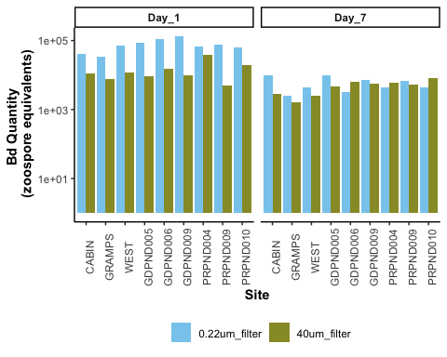

Boxplot

eb_monolayer %>%  
  
 # plot it  
 ggplot(aes(y= bd_qty, x = filter, fill = filter)) +   
 geom_boxplot() +  
 geom_jitter(width = 0.2, alpha = 0.3) +  
 scale_y_log10() +  
 facet_wrap(~day, labeller = labeller(day = c("Day_1" = "Day 1",  
 "Day_7" = "Day 7")))+  
 scale_fill_manual(values = c("40um_filter" = with_microbes_40_color,   
 "0.22um_filter" = no_microbes_.22_color)) +  
 theme_classic() +  
 theme(legend.position = "none",  
 strip.text = element_text(face="bold"),  
 axis.title = element_text(face = "bold")) +   
 scale_x_discrete (labels= c("40um_filter" = "With Microbes", "0.22um_filter" = "No Microbes")) +  
 xlab("Presence of Microbes in Pond Water Added to Monolayer Biofilm") +  
 ylab("Bd Quantity \n (zoospore equivalents)") +  
  
 # add controls ad x's  
geom_point(data = eb_ml_controls, aes(x = filter, y = bd_qty), shape = 4, size = 2)

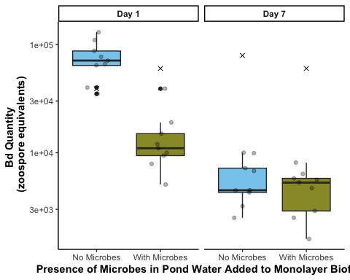

## SFEB Stats and assumption testing

Question:

Does the difference in Bd from day 1 to day 7 differ between the two filter types?

The samples are essentially paired by site, so a paired t-test is most appropriate

$H0:μ_{differenceinBd}=0$

Assumptions:

Assumes that the observations from each group represent a random sample from the population. Assumes that the difference of the two observations follow a normal distribution.

Test: Paired t-test on the difference in total Bd between day 1 and 7

# check normality of the differences across groups  
# With microbes (40 um)  
eb_monolayer_diff_40um %>%   
 ggqqplot("rate_loss", title = "40um") # normal

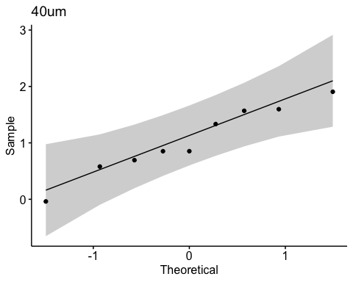

shapiro.test(eb_monolayer_diff_40um$rate_loss) # normal, yay!

Shapiro-Wilk normality test  
  
data: eb_monolayer_diff_40um$rate_loss  
W = 0.95903, p-value = 0.7881

hist(eb_monolayer_diff_40um$rate_loss) # looks good

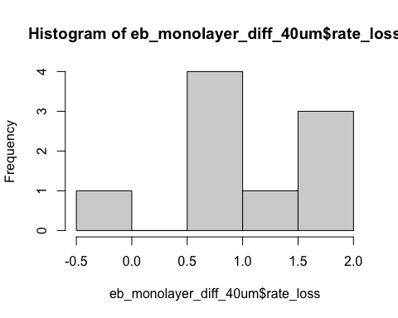

# Without microbes (0.22 um)  
eb_monolayer_diff.22um%>%   
 ggqqplot("rate_loss", title = "0.22um") # looks good

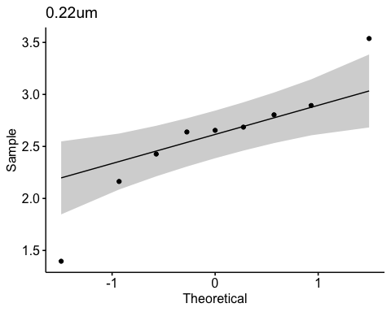

shapiro.test(eb_monolayer_diff.22um$rate_loss) # normal, yay!

Shapiro-Wilk normality test  
  
data: eb_monolayer_diff.22um$rate_loss  
W = 0.92597, p-value = 0.4439

hist(eb_monolayer_diff$rate_loss) # looks good

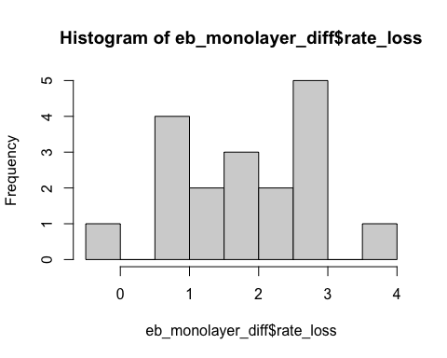

# visualize the comparison I am making  
eb_monolayer_diff %>%  
ggplot(aes(y= rate_loss, x = filter)) +   
 geom_boxplot() +  
 geom_jitter() +  
 ggtitle("Visualizing comparison for paired t-test on the rate_loss")

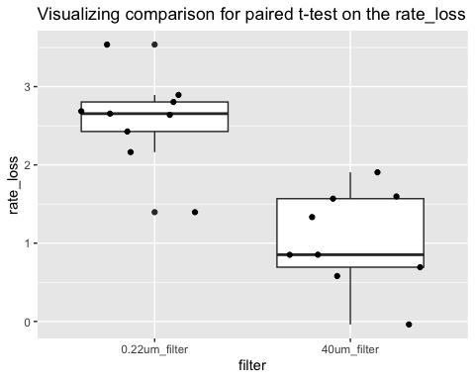

# Step 3: run the paired t-test on the difference  
t.test(eb_monolayer_diff_40um$rate_loss, eb_monolayer_diff.22um$rate_loss, paired = TRUE)

Paired t-test  
  
data: eb_monolayer_diff_40um$rate_loss and eb_monolayer_diff.22um$rate_loss  
t = -5.3606, df = 8, p-value = 0.0006772  
alternative hypothesis: true mean difference is not equal to 0  
95 percent confidence interval:  
 -2.2020978 -0.8773797  
sample estimates:  
mean difference   
 -1.539739

### Stats results:

When monolayer Bd biofilm is exposed to pond water without microbes has a significantly greater loss of Bd between day 1 to day 7 than pond water with microbes (t = -5.4, df = 8, p = 0.0006772). The t-value is negative, which shows that the first item entered (with microbes) has a smaller loss of Bd than the second item entered (no microbes).

## Planned comparison to look at Day 1

Q: qty ~ factor(day) + microbe_treatment, random = ~1|factor(site)

Question: does the quantity of Bd differ across days and treatment while controlling for the paired site?

This will be a lme since it is a mixed effects model!

Data wrangling

eb_monolayer <- eb_monolayer %>%   
 mutate(log_bd = log(bd_qty))  
  
# Exploration: normality of transformed data  
eb_monolayer %>%   
 ggqqplot("log_bd") # gorgeous

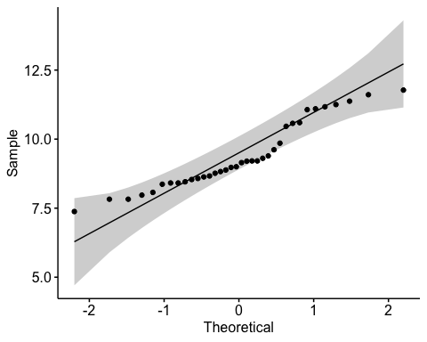

Assumptions testing

par(mfrow = c(2,2))  
# build model  
mod6 <- lme(log_bd~day*factor(filter), random = ~1|site, data=eb_monolayer)  
# model assumptions  
plot(mod6) # passes homogeneity of variances

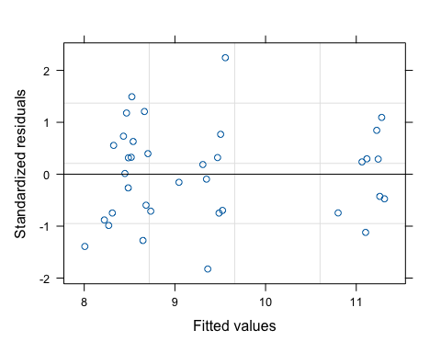

qqPlot(resid(mod6), main="QQ Plot of Residuals") # passes normality of resids

PRPND004 PRPND009   
 24 23

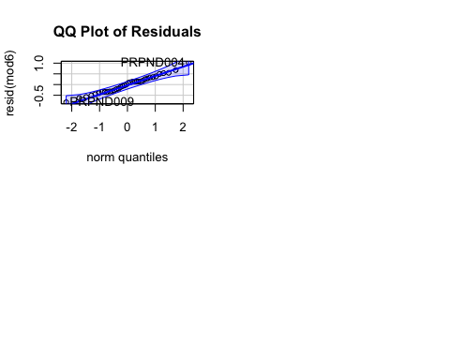

Interpret

summary(mod6)

Linear mixed-effects model fit by REML  
 Data: eb_monolayer   
 AIC BIC logLik  
 66.32921 75.12363 -27.16461  
  
Random effects:  
 Formula: ~1 | site  
 (Intercept) Residual  
StdDev: 0.2252822 0.4522353  
  
Fixed effects: log_bd ~ day * factor(filter)   
 Value Std.Error DF t-value p-value  
(Intercept) 11.155886 0.1684138 24 66.24093 0  
dayDay_7 -2.577871 0.2131858 24 -12.09214 0  
factor(filter)40um_filter -1.754991 0.2131858 24 -8.23222 0  
dayDay_7:factor(filter)40um_filter 1.539739 0.3014902 24 5.10709 0  
 Correlation:   
 (Intr) dyDy_7 f()40_  
dayDay_7 -0.633   
factor(filter)40um_filter -0.633 0.500   
dayDay_7:factor(filter)40um_filter 0.448 -0.707 -0.707  
  
Standardized Within-Group Residuals:  
 Min Q1 Med Q3 Max   
-1.8252309 -0.7197000 0.1006392 0.5741601 2.2442375   
  
Number of Observations: 36  
Number of Groups: 9

anova(mod6)

numDF denDF F-value p-value  
(Intercept) 1 24 7763.082 <.0001  
day 1 24 143.850 <.0001  
factor(filter) 1 24 42.706 <.0001  
day:factor(filter) 1 24 26.082 <.0001

emmeans::emmeans(mod6, pairwise ~ day * filter) # pairwise comparisons

$emmeans  
 day filter emmean SE df lower.CL upper.CL  
 Day_1 0.22um_filter 11.16 0.168 8 10.77 11.54  
 Day_7 0.22um_filter 8.58 0.168 8 8.19 8.97  
 Day_1 40um_filter 9.40 0.168 8 9.01 9.79  
 Day_7 40um_filter 8.36 0.168 8 7.97 8.75  
  
Degrees-of-freedom method: containment   
Confidence level used: 0.95   
  
$contrasts  
 contrast estimate SE df t.ratio p.value  
 Day_1 0.22um_filter - Day_7 0.22um_filter 2.578 0.213 24 12.092 <.0001  
 Day_1 0.22um_filter - Day_1 40um_filter 1.755 0.213 24 8.232 <.0001  
 Day_1 0.22um_filter - Day_7 40um_filter 2.793 0.213 24 13.102 <.0001  
 Day_7 0.22um_filter - Day_1 40um_filter -0.823 0.213 24 -3.860 0.0039  
 Day_7 0.22um_filter - Day_7 40um_filter 0.215 0.213 24 1.010 0.7454  
 Day_1 40um_filter - Day_7 40um_filter 1.038 0.213 24 4.870 0.0003  
  
Degrees-of-freedom method: containment   
P value adjustment: tukey method for comparing a family of 4 estimates

Bd abundance was indeed significantly lower on day 1 in the presence of AE microorganisms compared to its abundance in microorganism-depleted pond water (Day_1 0.22um_filter - Day_1 40um_filter p <.0001)

# SBNCOS

## Data Wrangling SBNCOS

## Monolayer  
# add column for microbes or no  
monolayer <- fig_4b_raw %>%   
 rename(sample_ID = sample.ID) %>%   
 rename(adh_plus_sup = ahd_plus_sup) %>%   
 # rename sample_id to only include treatment, not day  
 mutate(sample_ID = str_replace(sample_ID, "-D[0-9]+$", "")) %>%   
  
 # add columns for components y/n  
 mutate(microbes = case_when(  
 str_detect(sample_ID, "\\+microbes") ~ "y",  
 TRUE ~ "n"  
 )) %>%   
 # add column for TB or no  
 mutate(TB = case_when(  
 str_detect(sample_ID, "TB") ~ "y",  
 TRUE ~ "n"  
 )) %>%   
 # add column for PW or no  
 mutate(PW = case_when(  
 str_detect(sample_ID, "PW") ~ "y",  
 TRUE ~ "n"  
 )) %>%  
 mutate(day = case_when(  
 day == 1 ~ "Day_1",  
 day == 3 ~ "Day_3",  
 day == 5 ~ "Day_5",  
 day == 7 ~ "Day_7",  
 day == 0 ~ "Day_0" # In case you want to include Day_0 as well  
 )) %>%   
 mutate(day = factor(day)) %>%   
 # add numeric for plotting  
 mutate(day_numeric = as.numeric(gsub("Day_", "", as.character(day))))  
  
monolayer_summary <- monolayer %>%   
 group_by(day, sample_ID) %>%   
 reframe(mean_adh = mean(adh), # calculate the mean  
 n = length(adh), # count the number of observations  
 df = n - 1, # calculate the degrees of freedom  
 sd = sd(adh), # calculate the standard deviation  
 se = sd/sqrt(n), # calculate the standard error  
 ) %>%   
 mutate(microbes = case_when(  
 str_detect(sample_ID, "\\+microbes") ~ "y",TRUE ~ "n")) %>%   
 # add column for TB or no  
 mutate(TB = case_when(str_detect(sample_ID, "TB") ~ "y", TRUE ~ "n")) %>%   
 # add column for PW or no  
 mutate(PW = case_when(str_detect(sample_ID, "PW") ~ "y", TRUE ~ "n")) %>%   
 mutate(day_numeric = as.numeric(gsub("Day_", "", as.character(day))))  
  
ml_noday0 <- monolayer %>%  
 filter(day != "Day_0") %>%  
 mutate(log_adh = log(adh)) %>%   
# quick check: we want day as a FACTOR  
 mutate(day = as.factor(day))  
str(ml_noday0$day)

Factor w/ 4 levels "Day_1","Day_3",..: 1 2 3 4 1 2 3 4 1 2 ...

# set PW-microbes as reference (no milliQ here)  
ml_noday0$sample_ID <- factor(ml_noday0$sample_ID)  
ml_noday0$sample_ID <- relevel(ml_noday0$sample_ID, ref = "PW-microbes")  
  
# change the names in microbes and tb so there arent 2 levels with y and n  
ml_noday0 <- ml_noday0 %>%   
 mutate(  
 microbes = case_when(  
 microbes == "y" ~ "MO present",  
 microbes == "n" ~ "MO absent"),  
 TB = case_when(  
 TB == "y" ~ "TB present",  
 TB == "n" ~ "TB absent"))

## EDA SBNCOS

Note: only the ADHERENT Bd here!

### Renwei’s figure

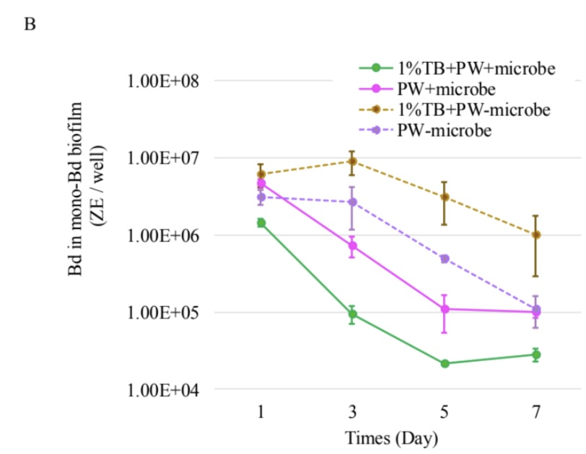

### ggplot version: replicating Renwei’s ML

rc <- monolayer_summary %>%   
 # reorder to match Renwei's plot  
 mutate(sample_ID = factor(sample_ID,   
 levels = c("TB+PW+microbes","PW+microbes",  
 "TB+PW-microbes", "PW-microbes"))) %>%   
 ggplot(aes(x = day_numeric,   
 y = mean_adh,   
 color = sample_ID)) +  
 geom_point(size = 2) +  
 geom_errorbar(aes(ymin = mean_adh - se, # plot the standard error  
 ymax = mean_adh + se),  
 width = 0.1) +  
 geom_line(aes(linetype = microbes)) +   
 scale_y_log10(limits = c(1e4, 1e8),   
 breaks = c(1e4, 1e5, 1e6, 1e7, 1e8)) +  
 # vibes  
 labs(x = "Day",  
 y = "Bd Quantity per sample (ZE/well)",  
 title = "Monolayer",  
 caption = "supernatant plus adherent visualized here") +  
 scale_color_manual(values = c("TB+PW+microbes" = "palegreen4",   
 "PW+microbes" = "magenta",   
 "TB+PW-microbes" = "chocolate4",   
 "PW-microbes" = "purple")) + # Assign specific colors to match RC's plot  
 scale_linetype_manual(values = c("n" = "dashed",   
 "y" = "solid")) +  
 theme_minimal() +  
 theme(  
 panel.grid.major.x = element_blank(), # Remove major vertical grid lines  
 panel.grid.minor.x = element_blank()) + # Remove minor vertical grid lines  
 scale_x_continuous(breaks = c(0, 1, 3, 5, 7))

## Caitlin’s version ML

cnm <- monolayer_summary %>%   
 # reorder to match Renwei's plot  
 mutate(sample_ID = factor(sample_ID,   
 levels = c("TB+PW+microbes","PW+microbes",  
 "TB+PW-microbes", "PW-microbes"))) %>%   
 ggplot(aes(x = day_numeric,   
 y = mean_adh,   
 color = sample_ID)) +  
 geom_point(size = 2) +  
 geom_errorbar(aes(ymin = mean_adh - se, # plot the standard error  
 ymax = mean_adh + se),  
 width = 0.1) +  
 geom_line(aes(linetype = microbes)) +   
 scale_y_log10(limits = c(1e4, 1e8),   
 breaks = c(1e4, 1e5, 1e6, 1e7, 1e8)) +  
   
 # vibes  
 labs(x = "Day",  
 y = "Bd in mono-Bd biofilm (ZE/well)",  
 color = "Medium", # Title for color legend  
 linetype = "Microbes Present") +  
 scale_color_manual(values = c("TB+PW+microbes" = "#4477AA",   
 "PW+microbes" = "#EE6677",   
 "TB+PW-microbes" = "#66CCEE",   
 "PW-microbes" = "#AA3377"),   
   
 labels = c("TB+PW+microbes" = "TB + PW + MO",  
 "PW+microbes" = "PW + MO",  
 "TB+PW-microbes" = "TB + PW - MO",  
 "PW-microbes" = "PW - MO")) + # Custom labels  
 myCustomTheme()+  
 scale_linetype_manual(values = c("n" = "dashed",   
 "y" = "solid"),  
 labels = c("n" = "N", "y" = "Y")) + # Change labels to uppercase N and Y  
 scale_x_continuous(breaks = c(0, 1, 3, 5, 7),  
 labels = c("Initial\nBd", "1", "3", "5", "7"))

visualize y var: bd load

Commented out to save space, log transformed is better

# # untransformed  
# ml_noday0 <- monolayer %>%  
# filter(day != 0) %>%  
# mutate(log_adh = log(adh)) # note: no zeroes so not log + 1  
# ggqqplot(ml_noday0, "adh", title = "untransformed")  
# shapiro.test(ml_noday0$adh) # nope  
# hist(ml_noday0$adh) # note  
#   
# # transformed  
# ggqqplot(ml_noday0, "log_adh", title = "log transformed") # gorgeous  
# hist(ml_noday0$log_adh) # better

## Stats SBNCOS

y var: amount of Bd

x vars: day, treatment, microbes y/n, pw y/n, tb y/n

Best model: Bd ~ day*microbes*TB

Question: Does the amount of Bd in the sample differ across the treatments of presence of microbes, TB, and day?

Model: 3-way ANOVA

**results**

Results summary

* day (p<0.05)
  + All differ from each other except 5 and 7 (Tukey)
    - Day 1 > Day 3 > Day 5 = Day 7
* microbes (p<0.05)
  + presence microbes has less Bd (Tukey)
* TB (NOT SIG)
* day:microbes (p<0.05)
* day:TB (NOT SIG)
* microbes:TB (p<0.05)
* day:microbes:TB (NOT SIG)

## null

null <- lm(log_adh ~ 1,  
 data = ml_noday0)  
AIC(null) #205.4965

[1] 205.4965

## Bd ~ day*microbes*TB

# build model  
aov_4b <- aov(log_adh ~ day*microbes*TB,  
 data = ml_noday0)  
  
# diagnostic plot  
par(mfrow = c(2,2))  
plot(aov_4b) # looks good

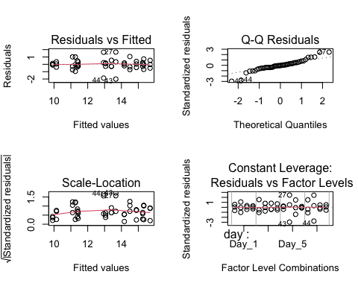

# look at results  
summary(aov_4b)

Df Sum Sq Mean Sq F value Pr(>F)   
day 3 93.76 31.25 45.336 1.26e-11 ***  
microbes 1 37.80 37.80 54.841 2.00e-08 ***  
TB 1 0.51 0.51 0.746 0.39422   
day:microbes 3 12.21 4.07 5.905 0.00252 **   
day:TB 3 0.94 0.31 0.456 0.71469   
microbes:TB 1 18.12 18.12 26.283 1.37e-05 ***  
day:microbes:TB 3 1.61 0.54 0.777 0.51570   
Residuals 32 22.06 0.69   
---  
Signif. codes: 0 '***' 0.001 '**' 0.01 '*' 0.05 '.' 0.1 ' ' 1

AIC(aov_4b) # 132.8989 better than null

[1] 132.8989

Post hoc

TukeyHSD(aov_4b)

Tukey multiple comparisons of means  
 95% family-wise confidence level  
  
Fit: aov(formula = log_adh ~ day * microbes * TB, data = ml_noday0)  
  
$day  
 diff lwr upr p adj  
Day_3-Day_1 -1.1620166 -2.080368 -0.2436653 0.0087187  
Day_5-Day_1 -2.9344665 -3.852818 -2.0161153 0.0000000  
Day_7-Day_1 -3.5087930 -4.427144 -2.5904417 0.0000000  
Day_5-Day_3 -1.7724499 -2.690801 -0.8540987 0.0000581  
Day_7-Day_3 -2.3467763 -3.265128 -1.4284251 0.0000005  
Day_7-Day_5 -0.5743264 -1.492678 0.3440249 0.3431674  
  
$microbes  
 diff lwr upr p adj  
MO present-MO absent -1.774918 -2.263125 -1.286711 0  
  
$TB  
 diff lwr upr p adj  
TB present-TB absent -0.2069936 -0.6952002 0.281213 0.3942159  
  
$`day:microbes`  
 diff lwr upr p adj  
Day_3:MO absent-Day_1:MO absent -0.004871029 -1.5576434 1.54790136 1.0000000  
Day_5:MO absent-Day_1:MO absent -1.742341527 -3.2951139 -0.18956914 0.0191770  
Day_7:MO absent-Day_1:MO absent -3.085556125 -4.6383285 -1.53278374 0.0000079  
Day_1:MO present-Day_1:MO absent -0.388664202 -1.9414366 1.16410819 0.9912401  
Day_3:MO present-Day_1:MO absent -2.707826384 -4.2605988 -1.15505400 0.0000750  
Day_5:MO present-Day_1:MO absent -4.515255768 -6.0680282 -2.96248338 0.0000000  
Day_7:MO present-Day_1:MO absent -4.320693986 -5.8734664 -2.76792160 0.0000000  
Day_5:MO absent-Day_3:MO absent -1.737470497 -3.2902429 -0.18469811 0.0196728  
Day_7:MO absent-Day_3:MO absent -3.080685096 -4.6334575 -1.52791271 0.0000082  
Day_1:MO present-Day_3:MO absent -0.383793173 -1.9365656 1.16897921 0.9918720  
Day_3:MO present-Day_3:MO absent -2.702955355 -4.2557277 -1.15018297 0.0000772  
Day_5:MO present-Day_3:MO absent -4.510384738 -6.0631571 -2.95761235 0.0000000  
Day_7:MO present-Day_3:MO absent -4.315822957 -5.8685953 -2.76305057 0.0000000  
Day_7:MO absent-Day_5:MO absent -1.343214599 -2.8959870 0.20955779 0.1300131  
Day_1:MO present-Day_5:MO absent 1.353677324 -0.1990951 2.90644971 0.1243433  
Day_3:MO present-Day_5:MO absent -0.965484857 -2.5182572 0.58728753 0.4886753  
Day_5:MO present-Day_5:MO absent -2.772914241 -4.3256866 -1.22014185 0.0000509  
Day_7:MO present-Day_5:MO absent -2.578352460 -4.1311248 -1.02558007 0.0001622  
Day_1:MO present-Day_7:MO absent 2.696891923 1.1441195 4.24966431 0.0000801  
Day_3:MO present-Day_7:MO absent 0.377729742 -1.1750426 1.93050213 0.9926085  
Day_5:MO present-Day_7:MO absent -1.429699642 -2.9824720 0.12307275 0.0889994  
Day_7:MO present-Day_7:MO absent -1.235137861 -2.7879102 0.31763453 0.2015413  
Day_3:MO present-Day_1:MO present -2.319162182 -3.8719346 -0.76638979 0.0007513  
Day_5:MO present-Day_1:MO present -4.126591565 -5.6793640 -2.57381918 0.0000000  
Day_7:MO present-Day_1:MO present -3.932029784 -5.4848022 -2.37925740 0.0000001  
Day_5:MO present-Day_3:MO present -1.807429384 -3.3602018 -0.25465700 0.0135812  
Day_7:MO present-Day_3:MO present -1.612867602 -3.1656400 -0.06009522 0.0372097  
Day_7:MO present-Day_5:MO present 0.194561781 -1.3582106 1.74733417 0.9998954  
  
$`day:TB`  
 diff lwr upr p adj  
Day_3:TB absent-Day_1:TB absent -1.1235183 -2.6762907 0.42925405 0.3023905  
Day_5:TB absent-Day_1:TB absent -2.9130623 -4.4658347 -1.36028989 0.0000221  
Day_7:TB absent-Day_1:TB absent -3.8110976 -5.3638700 -2.25832525 0.0000001  
Day_1:TB present-Day_1:TB absent -0.3281947 -1.8809671 1.22457771 0.9968653  
Day_3:TB present-Day_1:TB absent -1.5287096 -3.0814819 0.02406283 0.0561428  
Day_5:TB present-Day_1:TB absent -3.2840655 -4.8368379 -1.73129311 0.0000025  
Day_7:TB present-Day_1:TB absent -3.5346830 -5.0874553 -1.98191056 0.0000006  
Day_5:TB absent-Day_3:TB absent -1.7895439 -3.3423163 -0.23677155 0.0149424  
Day_7:TB absent-Day_3:TB absent -2.6875793 -4.2403517 -1.13480691 0.0000846  
Day_1:TB present-Day_3:TB absent 0.7953237 -0.7574487 2.34809604 0.7119877  
Day_3:TB present-Day_3:TB absent -0.4051912 -1.9579636 1.14758117 0.9888085  
Day_5:TB present-Day_3:TB absent -2.1605472 -3.7133195 -0.60777477 0.0018907  
Day_7:TB present-Day_3:TB absent -2.4111646 -3.9639370 -0.85839223 0.0004372  
Day_7:TB absent-Day_5:TB absent -0.8980354 -2.4508077 0.65473703 0.5777381  
Day_1:TB present-Day_5:TB absent 2.5848676 1.0320952 4.13763999 0.0001560  
Day_3:TB present-Day_5:TB absent 1.3843527 -0.1684197 2.93712511 0.1088829  
Day_5:TB present-Day_5:TB absent -0.3710032 -1.9237756 1.18176917 0.9933635  
Day_7:TB present-Day_5:TB absent -0.6216207 -2.1743931 0.93115172 0.8933907  
Day_1:TB present-Day_7:TB absent 3.4829030 1.9301306 5.03567535 0.0000008  
Day_3:TB present-Day_7:TB absent 2.2823881 0.7296157 3.83516047 0.0009319  
Day_5:TB present-Day_7:TB absent 0.5270321 -1.0257402 2.07980453 0.9522604  
Day_7:TB present-Day_7:TB absent 0.2764147 -1.2763577 1.82918708 0.9989428  
Day_3:TB present-Day_1:TB present -1.2005149 -2.7532873 0.35225751 0.2298116  
Day_5:TB present-Day_1:TB present -2.9558708 -4.5086432 -1.40309843 0.0000171  
Day_7:TB present-Day_1:TB present -3.2064883 -4.7592607 -1.65371588 0.0000039  
Day_5:TB present-Day_3:TB present -1.7553559 -3.3081283 -0.20258355 0.0179090  
Day_7:TB present-Day_3:TB present -2.0059734 -3.5587458 -0.45320101 0.0045607  
Day_7:TB present-Day_5:TB present -0.2506175 -1.8033898 1.30215493 0.9994399  
  
$`microbes:TB`  
 diff lwr upr  
MO present:TB absent-MO absent:TB absent -0.5461759 -1.4645271 0.3721754  
MO absent:TB present-MO absent:TB absent 1.0217484 0.1033972 1.9400997  
MO present:TB present-MO absent:TB absent -1.9819115 -2.9002628 -1.0635603  
MO absent:TB present-MO present:TB absent 1.5679243 0.6495730 2.4862756  
MO present:TB present-MO present:TB absent -1.4357356 -2.3540869 -0.5173844  
MO present:TB present-MO absent:TB present -3.0036600 -3.9220112 -2.0853087  
 p adj  
MO present:TB absent-MO absent:TB absent 0.3867876  
MO absent:TB present-MO absent:TB absent 0.0245376  
MO present:TB present-MO absent:TB absent 0.0000098  
MO absent:TB present-MO present:TB absent 0.0003283  
MO present:TB present-MO present:TB absent 0.0009862  
MO present:TB present-MO absent:TB present 0.0000000  
  
$`day:microbes:TB`  
 diff lwr  
Day_3:MO absent:TB absent-Day_1:MO absent:TB absent -0.38819068 -2.90193747  
Day_5:MO absent:TB absent-Day_1:MO absent:TB absent -1.82711047 -4.34085726  
Day_7:MO absent:TB absent-Day_1:MO absent:TB absent -3.78764987 -6.30139666  
Day_1:MO present:TB absent-Day_1:MO absent:TB absent 0.37618774 -2.13755905  
Day_3:MO present:TB absent-Day_1:MO absent:TB absent -1.48265825 -3.99640505  
Day_5:MO present:TB absent-Day_1:MO absent:TB absent -3.62282635 -6.13657315  
Day_7:MO present:TB absent-Day_1:MO absent:TB absent -3.45835767 -5.97210446  
Day_1:MO absent:TB present-Day_1:MO absent:TB absent 0.43665726 -2.07708953  
Day_3:MO absent:TB present-Day_1:MO absent:TB absent 0.81510588 -1.69864091  
Day_5:MO absent:TB present-Day_1:MO absent:TB absent -1.22091533 -3.73466212  
Day_7:MO absent:TB present-Day_1:MO absent:TB absent -1.94680512 -4.46055191  
Day_1:MO present:TB present-Day_1:MO absent:TB absent -0.71685888 -3.23060567  
Day_3:MO present:TB present-Day_1:MO absent:TB absent -3.49633725 -6.01008405  
Day_5:MO present:TB present-Day_1:MO absent:TB absent -4.97102792 -7.48477471  
Day_7:MO present:TB present-Day_1:MO absent:TB absent -4.74637305 -7.26011984  
Day_5:MO absent:TB absent-Day_3:MO absent:TB absent -1.43891978 -3.95266658  
Day_7:MO absent:TB absent-Day_3:MO absent:TB absent -3.39945919 -5.91320598  
Day_1:MO present:TB absent-Day_3:MO absent:TB absent 0.76437842 -1.74936837  
Day_3:MO present:TB absent-Day_3:MO absent:TB absent -1.09446757 -3.60821436  
Day_5:MO present:TB absent-Day_3:MO absent:TB absent -3.23463567 -5.74838246  
Day_7:MO present:TB absent-Day_3:MO absent:TB absent -3.07016698 -5.58391378  
Day_1:MO absent:TB present-Day_3:MO absent:TB absent 0.82484794 -1.68889885  
Day_3:MO absent:TB present-Day_3:MO absent:TB absent 1.20329657 -1.31045023  
Day_5:MO absent:TB present-Day_3:MO absent:TB absent -0.83272464 -3.34647144  
Day_7:MO absent:TB present-Day_3:MO absent:TB absent -1.55861444 -4.07236123  
Day_1:MO present:TB present-Day_3:MO absent:TB absent -0.32866820 -2.84241499  
Day_3:MO present:TB present-Day_3:MO absent:TB absent -3.10814657 -5.62189336  
Day_5:MO present:TB present-Day_3:MO absent:TB absent -4.58283724 -7.09658403  
Day_7:MO present:TB present-Day_3:MO absent:TB absent -4.35818236 -6.87192915  
Day_7:MO absent:TB absent-Day_5:MO absent:TB absent -1.96053941 -4.47428620  
Day_1:MO present:TB absent-Day_5:MO absent:TB absent 2.20329820 -0.31044859  
Day_3:MO present:TB absent-Day_5:MO absent:TB absent 0.34445221 -2.16929458  
Day_5:MO present:TB absent-Day_5:MO absent:TB absent -1.79571589 -4.30946268  
Day_7:MO present:TB absent-Day_5:MO absent:TB absent -1.63124720 -4.14499399  
Day_1:MO absent:TB present-Day_5:MO absent:TB absent 2.26376773 -0.24997906  
Day_3:MO absent:TB present-Day_5:MO absent:TB absent 2.64221635 0.12846956  
Day_5:MO absent:TB present-Day_5:MO absent:TB absent 0.60619514 -1.90755165  
Day_7:MO absent:TB present-Day_5:MO absent:TB absent -0.11969465 -2.63344144  
Day_1:MO present:TB present-Day_5:MO absent:TB absent 1.11025159 -1.40349521  
Day_3:MO present:TB present-Day_5:MO absent:TB absent -1.66922679 -4.18297358  
Day_5:MO present:TB present-Day_5:MO absent:TB absent -3.14391745 -5.65766425  
Day_7:MO present:TB present-Day_5:MO absent:TB absent -2.91926258 -5.43300937  
Day_1:MO present:TB absent-Day_7:MO absent:TB absent 4.16383761 1.65009082  
Day_3:MO present:TB absent-Day_7:MO absent:TB absent 2.30499162 -0.20875517  
Day_5:MO present:TB absent-Day_7:MO absent:TB absent 0.16482352 -2.34892327  
Day_7:MO present:TB absent-Day_7:MO absent:TB absent 0.32929221 -2.18445459  
Day_1:MO absent:TB present-Day_7:MO absent:TB absent 4.22430713 1.71056034  
Day_3:MO absent:TB present-Day_7:MO absent:TB absent 4.60275576 2.08900897  
Day_5:MO absent:TB present-Day_7:MO absent:TB absent 2.56673455 0.05298776  
Day_7:MO absent:TB present-Day_7:MO absent:TB absent 1.84084475 -0.67290204  
Day_1:MO present:TB present-Day_7:MO absent:TB absent 3.07079099 0.55704420  
Day_3:MO present:TB present-Day_7:MO absent:TB absent 0.29131262 -2.22243417  
Day_5:MO present:TB present-Day_7:MO absent:TB absent -1.18337805 -3.69712484  
Day_7:MO present:TB present-Day_7:MO absent:TB absent -0.95872317 -3.47246996  
Day_3:MO present:TB absent-Day_1:MO present:TB absent -1.85884599 -4.37259278  
Day_5:MO present:TB absent-Day_1:MO present:TB absent -3.99901409 -6.51276088  
Day_7:MO present:TB absent-Day_1:MO present:TB absent -3.83454540 -6.34829219  
Day_1:MO absent:TB present-Day_1:MO present:TB absent 0.06046952 -2.45327727  
Day_3:MO absent:TB present-Day_1:MO present:TB absent 0.43891815 -2.07482864  
Day_5:MO absent:TB present-Day_1:MO present:TB absent -1.59710306 -4.11084985  
Day_7:MO absent:TB present-Day_1:MO present:TB absent -2.32299285 -4.83673965  
Day_1:MO present:TB present-Day_1:MO present:TB absent -1.09304662 -3.60679341  
Day_3:MO present:TB present-Day_1:MO present:TB absent -3.87252499 -6.38627178  
Day_5:MO present:TB present-Day_1:MO present:TB absent -5.34721566 -7.86096245  
Day_7:MO present:TB present-Day_1:MO present:TB absent -5.12256078 -7.63630757  
Day_5:MO present:TB absent-Day_3:MO present:TB absent -2.14016810 -4.65391489  
Day_7:MO present:TB absent-Day_3:MO present:TB absent -1.97569941 -4.48944620  
Day_1:MO absent:TB present-Day_3:MO present:TB absent 1.91931551 -0.59443128  
Day_3:MO absent:TB present-Day_3:MO present:TB absent 2.29776414 -0.21598265  
Day_5:MO absent:TB present-Day_3:MO present:TB absent 0.26174293 -2.25200386  
Day_7:MO absent:TB present-Day_3:MO present:TB absent -0.46414686 -2.97789365  
Day_1:MO present:TB present-Day_3:MO present:TB absent 0.76579937 -1.74794742  
Day_3:MO present:TB present-Day_3:MO present:TB absent -2.01367900 -4.52742579  
Day_5:MO present:TB present-Day_3:MO present:TB absent -3.48836967 -6.00211646  
Day_7:MO present:TB present-Day_3:MO present:TB absent -3.26371479 -5.77746158  
Day_7:MO present:TB absent-Day_5:MO present:TB absent 0.16446869 -2.34927810  
Day_1:MO absent:TB present-Day_5:MO present:TB absent 4.05948361 1.54573682  
Day_3:MO absent:TB present-Day_5:MO present:TB absent 4.43793224 1.92418545  
Day_5:MO absent:TB present-Day_5:MO present:TB absent 2.40191103 -0.11183576  
Day_7:MO absent:TB present-Day_5:MO present:TB absent 1.67602124 -0.83772556  
Day_1:MO present:TB present-Day_5:MO present:TB absent 2.90596747 0.39222068  
Day_3:MO present:TB present-Day_5:MO present:TB absent 0.12648910 -2.38725769  
Day_5:MO present:TB present-Day_5:MO present:TB absent -1.34820157 -3.86194836  
Day_7:MO present:TB present-Day_5:MO present:TB absent -1.12354669 -3.63729348  
Day_1:MO absent:TB present-Day_7:MO present:TB absent 3.89501493 1.38126814  
Day_3:MO absent:TB present-Day_7:MO present:TB absent 4.27346355 1.75971676  
Day_5:MO absent:TB present-Day_7:MO present:TB absent 2.23744234 -0.27630445  
Day_7:MO absent:TB present-Day_7:MO present:TB absent 1.51155255 -1.00219424  
Day_1:MO present:TB present-Day_7:MO present:TB absent 2.74149879 0.22775199  
Day_3:MO present:TB present-Day_7:MO present:TB absent -0.03797959 -2.55172638  
Day_5:MO present:TB present-Day_7:MO present:TB absent -1.51267025 -4.02641705  
Day_7:MO present:TB present-Day_7:MO present:TB absent -1.28801538 -3.80176217  
Day_3:MO absent:TB present-Day_1:MO absent:TB present 0.37844862 -2.13529817  
Day_5:MO absent:TB present-Day_1:MO absent:TB present -1.65757259 -4.17131938  
Day_7:MO absent:TB present-Day_1:MO absent:TB present -2.38346238 -4.89720917  
Day_1:MO present:TB present-Day_1:MO absent:TB present -1.15351614 -3.66726293  
Day_3:MO present:TB present-Day_1:MO absent:TB present -3.93299451 -6.44674130  
Day_5:MO present:TB present-Day_1:MO absent:TB present -5.40768518 -7.92143197  
Day_7:MO present:TB present-Day_1:MO absent:TB present -5.18303031 -7.69677710  
Day_5:MO absent:TB present-Day_3:MO absent:TB present -2.03602121 -4.54976800  
Day_7:MO absent:TB present-Day_3:MO absent:TB present -2.76191100 -5.27565779  
Day_1:MO present:TB present-Day_3:MO absent:TB present -1.53196476 -4.04571156  
Day_3:MO present:TB present-Day_3:MO absent:TB present -4.31144314 -6.82518993  
Day_5:MO present:TB present-Day_3:MO absent:TB present -5.78613380 -8.29988060  
Day_7:MO present:TB present-Day_3:MO absent:TB present -5.56147893 -8.07522572  
Day_7:MO absent:TB present-Day_5:MO absent:TB present -0.72588979 -3.23963658  
Day_1:MO present:TB present-Day_5:MO absent:TB present 0.50405645 -2.00969035  
Day_3:MO present:TB present-Day_5:MO absent:TB present -2.27542193 -4.78916872  
Day_5:MO present:TB present-Day_5:MO absent:TB present -3.75011260 -6.26385939  
Day_7:MO present:TB present-Day_5:MO absent:TB present -3.52545772 -6.03920451  
Day_1:MO present:TB present-Day_7:MO absent:TB present 1.22994624 -1.28380055  
Day_3:MO present:TB present-Day_7:MO absent:TB present -1.54953214 -4.06327893  
Day_5:MO present:TB present-Day_7:MO absent:TB present -3.02422280 -5.53796959  
Day_7:MO present:TB present-Day_7:MO absent:TB present -2.79956793 -5.31331472  
Day_3:MO present:TB present-Day_1:MO present:TB present -2.77947837 -5.29322516  
Day_5:MO present:TB present-Day_1:MO present:TB present -4.25416904 -6.76791583  
Day_7:MO present:TB present-Day_1:MO present:TB present -4.02951416 -6.54326096  
Day_5:MO present:TB present-Day_3:MO present:TB present -1.47469067 -3.98843746  
Day_7:MO present:TB present-Day_3:MO present:TB present -1.25003579 -3.76378258  
Day_7:MO present:TB present-Day_5:MO present:TB present 0.22465488 -2.28909192  
 upr p adj  
Day_3:MO absent:TB absent-Day_1:MO absent:TB absent 2.1255561 0.9999997  
Day_5:MO absent:TB absent-Day_1:MO absent:TB absent 0.6866363 0.3755310  
Day_7:MO absent:TB absent-Day_1:MO absent:TB absent -1.2739031 0.0003403  
Day_1:MO present:TB absent-Day_1:MO absent:TB absent 2.8899345 0.9999998  
Day_3:MO present:TB absent-Day_1:MO absent:TB absent 1.0310885 0.6990048  
Day_5:MO present:TB absent-Day_1:MO absent:TB absent -1.1090796 0.0006724  
Day_7:MO present:TB absent-Day_1:MO absent:TB absent -0.9446109 0.0013203  
Day_1:MO absent:TB present-Day_1:MO absent:TB absent 2.9504041 0.9999983  
Day_3:MO absent:TB present-Day_1:MO absent:TB absent 3.3288527 0.9967922  
Day_5:MO absent:TB present-Day_1:MO absent:TB absent 1.2928315 0.8984519  
Day_7:MO absent:TB present-Day_1:MO absent:TB absent 0.5669417 0.2818532  
Day_1:MO present:TB present-Day_1:MO absent:TB absent 1.7968879 0.9991923  
Day_3:MO present:TB present-Day_1:MO absent:TB absent -0.9825905 0.0011304  
Day_5:MO present:TB present-Day_1:MO absent:TB absent -2.4572811 0.0000026  
Day_7:MO present:TB present-Day_1:MO absent:TB absent -2.2326263 0.0000065  
Day_5:MO absent:TB absent-Day_3:MO absent:TB absent 1.0748270 0.7386858  
Day_7:MO absent:TB absent-Day_3:MO absent:TB absent -0.8857124 0.0016785  
Day_1:MO present:TB absent-Day_3:MO absent:TB absent 3.2781252 0.9983679  
Day_3:MO present:TB absent-Day_3:MO absent:TB absent 1.4192792 0.9536649  
Day_5:MO present:TB absent-Day_3:MO absent:TB absent -0.7208889 0.0032663  
Day_7:MO present:TB absent-Day_3:MO absent:TB absent -0.5564202 0.0062766  
Day_1:MO absent:TB present-Day_3:MO absent:TB absent 3.3385947 0.9963773  
Day_3:MO absent:TB present-Day_3:MO absent:TB absent 3.7170434 0.9078673  
Day_5:MO absent:TB present-Day_3:MO absent:TB absent 1.6810221 0.9960101  
Day_7:MO absent:TB present-Day_3:MO absent:TB absent 0.9551324 0.6268806  
Day_1:MO present:TB present-Day_3:MO absent:TB absent 2.1850786 1.0000000  
Day_3:MO present:TB present-Day_3:MO absent:TB absent -0.5943998 0.0054041  
Day_5:MO present:TB present-Day_3:MO absent:TB absent -2.0690904 0.0000126  
Day_7:MO present:TB present-Day_3:MO absent:TB absent -1.8444356 0.0000319  
Day_7:MO absent:TB absent-Day_5:MO absent:TB absent 0.5532074 0.2721586  
Day_1:MO present:TB absent-Day_5:MO absent:TB absent 4.7170450 0.1377056  
Day_3:MO present:TB absent-Day_5:MO absent:TB absent 2.8581990 0.9999999  
Day_5:MO present:TB absent-Day_5:MO absent:TB absent 0.7180309 0.4026122  
Day_7:MO present:TB absent-Day_5:MO absent:TB absent 0.8824996 0.5563124  
Day_1:MO absent:TB present-Day_5:MO absent:TB absent 4.7775145 0.1143069  
Day_3:MO absent:TB present-Day_5:MO absent:TB absent 5.1559631 0.0317235  
Day_5:MO absent:TB present-Day_5:MO absent:TB absent 3.1199419 0.9998857  
Day_7:MO absent:TB present-Day_5:MO absent:TB absent 2.3940521 1.0000000  
Day_1:MO present:TB present-Day_5:MO absent:TB absent 3.6239984 0.9482985  
Day_3:MO present:TB present-Day_5:MO absent:TB absent 0.8445200 0.5195974  
Day_5:MO present:TB present-Day_5:MO absent:TB absent -0.6301707 0.0046904  
Day_7:MO present:TB present-Day_5:MO absent:TB absent -0.4055158 0.0112834  
Day_1:MO present:TB absent-Day_7:MO absent:TB absent 6.6775844 0.0000714  
Day_3:MO present:TB absent-Day_7:MO absent:TB absent 4.8187384 0.1003436  
Day_5:MO present:TB absent-Day_7:MO absent:TB absent 2.6785703 1.0000000  
Day_7:MO present:TB absent-Day_7:MO absent:TB absent 2.8430390 1.0000000  
Day_1:MO absent:TB present-Day_7:MO absent:TB absent 6.7380539 0.0000556  
Day_3:MO absent:TB present-Day_7:MO absent:TB absent 7.1165025 0.0000116  
Day_5:MO absent:TB present-Day_7:MO absent:TB absent 5.0804813 0.0415352  
Day_7:MO absent:TB present-Day_7:MO absent:TB absent 4.3545915 0.3639880  
Day_1:MO present:TB present-Day_7:MO absent:TB absent 5.5845378 0.0062612  
Day_3:MO present:TB present-Day_7:MO absent:TB absent 2.8050594 1.0000000  
Day_5:MO present:TB present-Day_7:MO absent:TB absent 1.3303687 0.9178286  
Day_7:MO present:TB present-Day_7:MO absent:TB absent 1.5550236 0.9846687  
Day_3:MO present:TB absent-Day_1:MO present:TB absent 0.6549008 0.3491546  
Day_5:MO present:TB absent-Day_1:MO present:TB absent -1.4852673 0.0001416  
Day_7:MO present:TB absent-Day_1:MO present:TB absent -1.3207986 0.0002802  
Day_1:MO absent:TB present-Day_1:MO present:TB absent 2.5742163 1.0000000  
Day_3:MO absent:TB present-Day_1:MO present:TB absent 2.9526649 0.9999982  
Day_5:MO absent:TB present-Day_1:MO present:TB absent 0.9166437 0.5895224  
Day_7:MO absent:TB present-Day_1:MO present:TB absent 0.1907539 0.0947175  
Day_1:MO present:TB present-Day_1:MO present:TB absent 1.4207002 0.9541279  
Day_3:MO present:TB present-Day_1:MO present:TB absent -1.3587782 0.0002394  
Day_5:MO present:TB present-Day_1:MO present:TB absent -2.8334689 0.0000006  
Day_7:MO present:TB present-Day_1:MO present:TB absent -2.6088140 0.0000014  
Day_5:MO present:TB absent-Day_3:MO present:TB absent 0.3735787 0.1661611  
Day_7:MO present:TB absent-Day_3:MO present:TB absent 0.5380474 0.2617203  
Day_1:MO absent:TB present-Day_3:MO present:TB absent 4.4330623 0.3019299  
Day_3:MO absent:TB present-Day_3:MO present:TB absent 4.8115109 0.1026813  
Day_5:MO absent:TB present-Day_3:MO present:TB absent 2.7754897 1.0000000  
Day_7:MO absent:TB present-Day_3:MO present:TB absent 2.0495999 0.9999962  
Day_1:MO present:TB present-Day_3:MO present:TB absent 3.2795462 0.9983350  
Day_3:MO present:TB present-Day_3:MO present:TB absent 0.5000678 0.2367872  
Day_5:MO present:TB present-Day_3:MO present:TB absent -0.9746229 0.0011679  
Day_7:MO present:TB present-Day_3:MO present:TB absent -0.7499680 0.0029064  
Day_7:MO present:TB absent-Day_5:MO present:TB absent 2.6782155 1.0000000  
Day_1:MO absent:TB present-Day_5:MO present:TB absent 6.5732304 0.0001102  
Day_3:MO absent:TB present-Day_5:MO present:TB absent 6.9516790 0.0000229  
Day_5:MO absent:TB present-Day_5:MO present:TB absent 4.9156578 0.0731443  
Day_7:MO absent:TB present-Day_5:MO present:TB absent 4.1897680 0.5130768  
Day_1:MO present:TB present-Day_5:MO present:TB absent 5.4197143 0.0118735  
Day_3:MO present:TB present-Day_5:MO present:TB absent 2.6402359 1.0000000  
Day_5:MO present:TB present-Day_5:MO present:TB absent 1.1655452 0.8140775  
Day_7:MO present:TB present-Day_5:MO present:TB absent 1.3902001 0.9434543  
Day_1:MO absent:TB present-Day_7:MO present:TB absent 6.4087617 0.0002181  
Day_3:MO absent:TB present-Day_7:MO present:TB absent 6.7872103 0.0000453  
Day_5:MO absent:TB present-Day_7:MO present:TB absent 4.7511891 0.1240512  
Day_7:MO absent:TB present-Day_7:MO present:TB absent 4.0252993 0.6719435  
Day_1:MO present:TB present-Day_7:MO present:TB absent 5.2552456 0.0220664  
Day_3:MO present:TB present-Day_7:MO present:TB absent 2.4757672 1.0000000  
Day_5:MO present:TB present-Day_7:MO present:TB absent 1.0010765 0.6708858  
Day_7:MO present:TB present-Day_7:MO present:TB absent 1.2257314 0.8574494  
Day_3:MO absent:TB present-Day_1:MO absent:TB present 2.8921954 0.9999998  
Day_5:MO absent:TB present-Day_1:MO absent:TB present 0.8561742 0.5308207  
Day_7:MO absent:TB present-Day_1:MO absent:TB present 0.1302844 0.0777604  
Day_1:MO present:TB present-Day_1:MO absent:TB present 1.3602307 0.9314141  
Day_3:MO present:TB present-Day_1:MO absent:TB present -1.4192477 0.0001863  
Day_5:MO present:TB present-Day_1:MO absent:TB present -2.8939384 0.0000004  
Day_7:MO present:TB present-Day_1:MO absent:TB present -2.6692835 0.0000011  
Day_5:MO absent:TB present-Day_3:MO absent:TB present 0.4777256 0.2229337  
Day_7:MO absent:TB present-Day_3:MO absent:TB present -0.2481642 0.0204568  
Day_1:MO present:TB present-Day_3:MO absent:TB present 0.9817820 0.6525195  
Day_3:MO present:TB present-Day_3:MO absent:TB present -1.7976963 0.0000387  
Day_5:MO present:TB present-Day_3:MO absent:TB present -3.2723870 0.0000001  
Day_7:MO present:TB present-Day_3:MO absent:TB present -3.0477321 0.0000002  
Day_7:MO absent:TB present-Day_5:MO absent:TB present 1.7878570 0.9990715  
Day_1:MO present:TB present-Day_5:MO absent:TB present 3.0178032 0.9999887  
Day_3:MO present:TB present-Day_5:MO absent:TB present 0.2383249 0.1102026  
Day_5:MO present:TB present-Day_5:MO absent:TB present -1.2363658 0.0003976  
Day_7:MO present:TB present-Day_5:MO absent:TB present -1.0117109 0.0010033  
Day_1:MO present:TB present-Day_7:MO absent:TB present 3.7436930 0.8934059  
Day_3:MO present:TB present-Day_7:MO absent:TB present 0.9642147 0.6356474  
Day_5:MO present:TB present-Day_7:MO absent:TB present -0.5104760 0.0075145  
Day_7:MO present:TB present-Day_7:MO absent:TB present -0.2858211 0.0177729  
Day_3:MO present:TB present-Day_1:MO present:TB present -0.2657316 0.0191605  
Day_5:MO present:TB present-Day_1:MO present:TB present -1.7404222 0.0000491  
Day_7:MO present:TB present-Day_1:MO present:TB present -1.5157674 0.0001248  
Day_5:MO present:TB present-Day_3:MO present:TB present 1.0390561 0.7063594  
Day_7:MO present:TB present-Day_3:MO present:TB present 1.2637110 0.8816492  
Day_7:MO present:TB present-Day_5:MO present:TB present 2.7384017 1.0000000

# posthoc using emmeans  
# use emmeans package to get the t value  
# Perform pairwise comparisons for 'day'  
f4b_em_day <- emmeans(aov_4b, ~ day)

NOTE: Results may be misleading due to involvement in interactions

f4b_tukey_day <- pairs(f4b_em_day, adjust = "tukey")  
f4b_tukey_day

contrast estimate SE df t.ratio p.value  
 Day_1 - Day_3 1.162 0.339 32 3.428 0.0087  
 Day_1 - Day_5 2.934 0.339 32 8.657 <.0001  
 Day_1 - Day_7 3.509 0.339 32 10.352 <.0001  
 Day_3 - Day_5 1.772 0.339 32 5.229 0.0001  
 Day_3 - Day_7 2.347 0.339 32 6.924 <.0001  
 Day_5 - Day_7 0.574 0.339 32 1.694 0.3432  
  
Results are averaged over the levels of: microbes, TB   
P value adjustment: tukey method for comparing a family of 4 estimates

# Perform pairwise comparisons for 'microbes'  
f4b_em_microbes <- emmeans(aov_4b, ~ microbes)

NOTE: Results may be misleading due to involvement in interactions

f4b_tukey_microbes <- pairs(f4b_em_microbes, adjust = "tukey")  
f4b_tukey_microbes

contrast estimate SE df t.ratio p.value  
 MO absent - MO present 1.77 0.24 32 7.405 <.0001  
  
Results are averaged over the levels of: day, TB

# Perform pairwise comparisons for microbes:TB (interaction)  
f4b_em_int_microbe_TB <- emmeans(aov_4b, ~ microbes * TB)

NOTE: Results may be misleading due to involvement in interactions

f4b_tukey_int_microbe_TB <- pairs(f4b_em_int_microbe_TB, adjust = "tukey")  
f4b_tukey_int_microbe_TB

contrast estimate SE df t.ratio p.value  
 MO absent TB absent - MO present TB absent 0.546 0.339 32 1.611 0.3868  
 MO absent TB absent - MO absent TB present -1.022 0.339 32 -3.014 0.0245  
 MO absent TB absent - MO present TB present 1.982 0.339 32 5.847 <.0001  
 MO present TB absent - MO absent TB present -1.568 0.339 32 -4.626 0.0003  
 MO present TB absent - MO present TB present 1.436 0.339 32 4.236 0.0010  
 MO absent TB present - MO present TB present 3.004 0.339 32 8.862 <.0001  
  
Results are averaged over the levels of: day   
P value adjustment: tukey method for comparing a family of 4 estimates

# Perform pairwise comparisons for microbes:day (interaction)  
f4b_em_int_microbe_day <- emmeans(aov_4b, ~ microbes * day)

NOTE: Results may be misleading due to involvement in interactions

f4b_tukey_int_microbe_day <- pairs(f4b_em_int_microbe_day, adjust = "tukey")  
f4b_tukey_int_microbe_day

contrast estimate SE df t.ratio p.value  
 MO absent Day_1 - MO present Day_1 0.38866 0.479 32 0.811 0.9912  
 MO absent Day_1 - MO absent Day_3 0.00487 0.479 32 0.010 1.0000  
 MO absent Day_1 - MO present Day_3 2.70783 0.479 32 5.649 0.0001  
 MO absent Day_1 - MO absent Day_5 1.74234 0.479 32 3.635 0.0192  
 MO absent Day_1 - MO present Day_5 4.51526 0.479 32 9.419 <.0001  
 MO absent Day_1 - MO absent Day_7 3.08556 0.479 32 6.437 <.0001  
 MO absent Day_1 - MO present Day_7 4.32069 0.479 32 9.014 <.0001  
 MO present Day_1 - MO absent Day_3 -0.38379 0.479 32 -0.801 0.9919  
 MO present Day_1 - MO present Day_3 2.31916 0.479 32 4.838 0.0008  
 MO present Day_1 - MO absent Day_5 1.35368 0.479 32 2.824 0.1243  
 MO present Day_1 - MO present Day_5 4.12659 0.479 32 8.609 <.0001  
 MO present Day_1 - MO absent Day_7 2.69689 0.479 32 5.626 0.0001  
 MO present Day_1 - MO present Day_7 3.93203 0.479 32 8.203 <.0001  
 MO absent Day_3 - MO present Day_3 2.70296 0.479 32 5.639 0.0001  
 MO absent Day_3 - MO absent Day_5 1.73747 0.479 32 3.625 0.0197  
 MO absent Day_3 - MO present Day_5 4.51039 0.479 32 9.409 <.0001  
 MO absent Day_3 - MO absent Day_7 3.08068 0.479 32 6.427 <.0001  
 MO absent Day_3 - MO present Day_7 4.31582 0.479 32 9.003 <.0001  
 MO present Day_3 - MO absent Day_5 -0.96549 0.479 32 -2.014 0.4887  
 MO present Day_3 - MO present Day_5 1.80743 0.479 32 3.771 0.0136  
 MO present Day_3 - MO absent Day_7 0.37773 0.479 32 0.788 0.9926  
 MO present Day_3 - MO present Day_7 1.61287 0.479 32 3.365 0.0372  
 MO absent Day_5 - MO present Day_5 2.77291 0.479 32 5.785 0.0001  
 MO absent Day_5 - MO absent Day_7 1.34322 0.479 32 2.802 0.1300  
 MO absent Day_5 - MO present Day_7 2.57835 0.479 32 5.379 0.0002  
 MO present Day_5 - MO absent Day_7 -1.42970 0.479 32 -2.983 0.0890  
 MO present Day_5 - MO present Day_7 -0.19456 0.479 32 -0.406 0.9999  
 MO absent Day_7 - MO present Day_7 1.23514 0.479 32 2.577 0.2015  
  
Results are averaged over the levels of: TB   
P value adjustment: tukey method for comparing a family of 8 estimates

### cld

# Compute CLD letters for 'day'  
cld_day <- emmeans(aov_4b, pairwise ~ day, adjust = "tukey") %>%  
 cld(Letters = letters, reverse = TRUE)

NOTE: Results may be misleading due to involvement in interactions

cld_day_4b <- ggplot(cld_day, aes(x = day, y = emmean)) +  
 geom_point(size = 1) + # Plot the estimated means  
 geom_errorbar(aes(ymin = lower.CL, ymax = upper.CL), width = 0.2) + # Error bars  
 geom_text(aes(label = .group), nudge_y = 1, size = 1.75, color = "black") + # Add CLD letters  
 xlab("Day") +  
 ylab("Estimated Marginal Means") +  
 scale_y_continuous(labels = scales::label_number(accuracy = 1)) +  
 ggtitle("Day") +  
 scale_x_discrete(labels= c("Day_1" = "1", "Day_3" = "3", "Day_5" = "5", "Day_7" = "7")) +  
 myCustomTheme() + # Use minimal theme for clean look  
 theme(axis.title.y = element_text(margin = margin(r = 1)))  
cld_day_4b

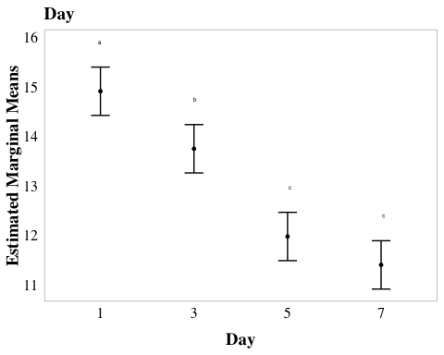

# Compute CLD letters for 'microbes'  
cld_microbes <- emmeans(aov_4b, pairwise ~ microbes, adjust = "tukey") %>%  
 cld(Letters = letters, reverse = TRUE)

NOTE: Results may be misleading due to involvement in interactions

cld_microbes_4b <- ggplot(cld_microbes, aes(x = microbes, y = emmean)) +  
 geom_point(size = 1) + # Plot the estimated means  
 geom_errorbar(aes(ymin = lower.CL, ymax = upper.CL), width = 0.2) + # Error bars  
 geom_text(aes(label = .group), nudge_y = 0.5, size = 1.75, color = "black") + # Add CLD letters  
 xlab("Microbes present") +  
 ylab("Estimated Marginal Means") +  
 scale_y_continuous(labels = scales::label_number(accuracy = 1)) +  
 ggtitle("Microbes") +  
 scale_x_discrete(labels= c("1%TB+AEbiofilm" = "1%TB", "PW+AEBiofilm" = "PW - MO", "MQ+AEbiofilm" = "MQ")) +  
 myCustomTheme() + # Use minimal theme for clean look  
theme(axis.title.y = element_text(margin = margin(r = 1)))  
cld_microbes_4b

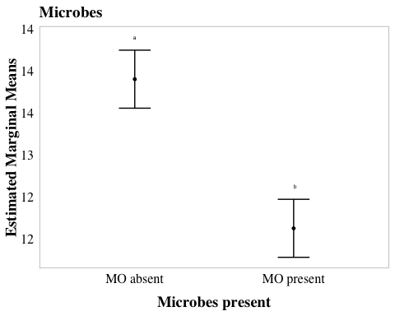

# Compute CLD letters for 'day * microbes'  
cld_day_microbes <- emmeans(aov_4b, pairwise ~ day * microbes, adjust = "tukey") %>%  
 cld(Letters = letters, reverse = TRUE)

NOTE: Results may be misleading due to involvement in interactions

# Create the plot with custom labels for 'TB'  
cld_day_microbes_4b <- ggplot(cld_day_microbes, aes(x = day, y = emmean)) +  
 geom_point(size = 1) + # Plot the estimated means  
 geom_errorbar(aes(ymin = lower.CL, ymax = upper.CL), width = 0.2) + # Error bars  
 geom_text(aes(label = .group), nudge_y = 1, size = 1.75, color = "black") + # Add CLD letters  
facet_wrap(~ factor(microbes)) + # Custom facet labels and order  
 xlab("Day") +  
 ylab("Estimated Marginal Means") +  
 scale_y_continuous(labels = scales::label_number(accuracy = 1)) +  
 ggtitle("Day * Microbes") +  
 scale_x_discrete(labels= c("Day_1" = "1", "Day_3" = "3", "Day_5" = "5", "Day_7" = "7")) +  
 myCustomTheme() + # Use minimal theme for clean look  
theme(axis.title.y = element_text(margin = margin(r = 1)))  
cld_day_microbes_4b

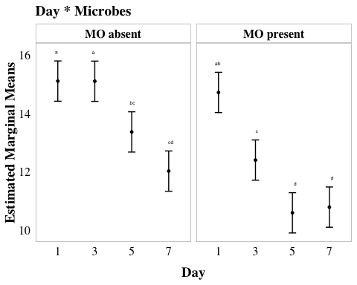

# Compute CLD letters for 'microbes * TB'  
cld_TB_microbes <- emmeans(aov_4b, pairwise ~ TB * microbes, adjust = "tukey") %>%  
 cld(Letters = letters, reverse = TRUE)

NOTE: Results may be misleading due to involvement in interactions

# Create the plot with custom labels for 'TB'  
cld_TB_microbes_4b <- ggplot(cld_TB_microbes, aes(x = TB, y = emmean)) +  
 geom_point(size = 1) + # Plot the estimated means  
 geom_errorbar(aes(ymin = lower.CL, ymax = upper.CL), width = 0.2) + # Error bars  
 geom_text(aes(label = .group), nudge_y = 1, size = 1.75, color = "black") + # Add CLD letters  
facet_wrap(~ factor(microbes)) + # Custom facet labels and order  
 xlab("TB Presence") +  
 ylab("Estimated Marginal Means") +  
 scale_y_continuous(labels = scales::label_number(accuracy = 1)) +  
 ggtitle("Microbes * TB") +  
 scale_x_discrete(labels= c("Day_1" = "1", "Day_3" = "3", "Day_5" = "5", "Day_7" = "7")) +  
 myCustomTheme() + # Use minimal theme for clean look  
theme(axis.title.y = element_text(margin = margin(r = 1)))  
cld_TB_microbes_4b

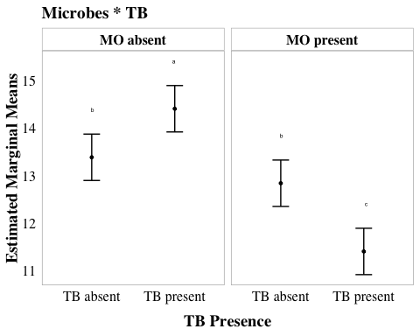

# cld_day_4b + cld_microbes_4b + cld_day_microbes_4b + cld_TB_microbes_4b

# *Publication figures

# set up custom theme  
myCustomTheme <- function() {  
 theme_light() +  
 theme(axis.text = element_text(size = 7, family = "Helvetica", color = "black"),  
 axis.title.x = element_text(margin = margin(t = 10), size = 7, face = "plain", family = "Helvetica", color = "black"), # Add space between x-axis label and axis  
 axis.title.y = element_text(margin = margin(r = 10), size = 7, face = "plain", family = "Helvetica", color = "black"), # Add space between y-axis label and axis  
 title = element_text(size = 7, face = "bold", family = "Helvetica"),  
 plot.caption = element_text(size = 7, face = "italic", family = "Helvetica"),  
 legend.text = element_text(size = 7, family = "Helvetica"), # Increase legend text size  
 panel.grid = element_blank(), # Remove all grid lines (both major and minor)  
 # axis.line.x = element_line(color = "grey"), # Keep the x-axis line  
 # axis.line.y = element_line(color = "grey"), # Keep the y-axis line  
 axis.ticks = element_line(color = "grey", size = 0.5), # Keep tick markers  
 axis.ticks.x = element_line(color = "grey", size = 0.5), # ensure bottom axis ticks  
 axis.ticks.y = element_line(color = "grey", size = 0.5), # <- ensure side axis ticks  
 strip.text = element_text(size = 7, face = "bold", family = "Helvetica", color = "black"), # Set strip text style  
 strip.background = element_rect(fill = "white", color = "grey", size = 0.5) # Set strip background to white, outline grey  
 )  
}

## SFEB Monolayer

fig_SFEB_monolayer <- eb_monolayer %>%   
 mutate(filter = factor(filter, levels = c("40um_filter", "0.22um_filter"))) %>% # Switch the order of levels  
 # plot it  
 ggplot(aes(y= bd_qty, x = filter, fill = filter)) +   
 geom_boxplot() +  
 geom_jitter(width = 0.2, alpha = 0.3) +  
scale_y_log10(labels = function(x) {gsub("e", "E", scales::scientific_format()(x))},   
 # update to consistent scale per reviewer request  
 limits = c(1e+02, 1e+08),  
 breaks = c(1e2, 1e3, 1e4, 1e5, 1e6, 1e7, 1e8)) +   
 facet_wrap(~day, labeller = labeller(day = c("Day_1" = "Day 1",  
 "Day_7" = "Day 7")))+  
 scale_fill_manual(values = c("40um_filter" = with_microbes_40_color,   
 "0.22um_filter" = no_microbes_.22_color)) +  
 myCustomTheme()+  
 theme(legend.position = "none",  
 strip.background = element_rect(fill = "white", color = "grey", size = 0.5)) + # Adjust the facet line thickness  
 scale_x_discrete (labels= c("40um_filter" = "+", "0.22um_filter" = "-")) +  
 xlab("AE Microorganisms in pond water") +  
 ylab("Bd quantity in monolayers (ZE/well)") +  
  
 # add controls ad x's  
geom_point(data = eb_ml_controls, aes(x = filter, y = bd_qty), shape = 4, size = 2)

Warning: The `size` argument of `element_line()` is deprecated as of ggplot2 3.4.0.  
ℹ Please use the `linewidth` argument instead.

Warning: The `size` argument of `element_rect()` is deprecated as of ggplot2 3.4.0.  
ℹ Please use the `linewidth` argument instead.

fig_SFEB_monolayer <- fig_SFEB_monolayer +  
 labs(tag = "A") +  
 theme(  
 plot.tag = element_text(family = "Helvetica", size = 20, face = "plain", hjust = -0.1, vjust = 1),  
 plot.tag.position = c(0, 1)  
 )  
  
fig_SFEB_monolayer

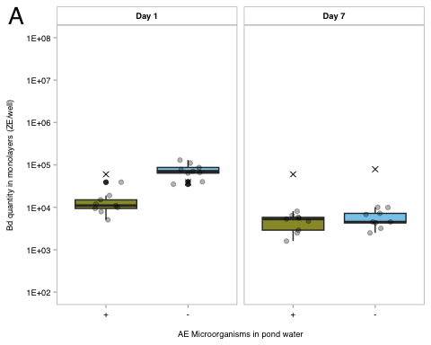

ggsave("paper-figures/expt4-SFEB_AE_monolayer_fig4a_updated.pdf", plot = fig_SFEB_monolayer, width = 3.46, height = 3.46)

fig_SBNCOS_monolayer <- monolayer_summary %>%   
 # reorder to match Renwei's plot  
 mutate(sample_ID = factor(sample_ID,   
 levels = c("TB+PW+microbes","PW+microbes",  
 "TB+PW-microbes", "PW-microbes"))) %>%   
 ggplot(aes(x = day_numeric,   
 y = mean_adh,   
 color = sample_ID)) +  
 geom_point(size = 2) +  
 geom_errorbar(aes(ymin = mean_adh - se, # plot the standard error  
 ymax = mean_adh + se),  
 width = 0.1) +  
 geom_line(aes(linetype = microbes), show.legend = FALSE) +   
   
 # # raw data  
 # geom_point(data = ml_noday0,   
 # aes(x = day_numeric,   
 # y = adh_plus_sup,   
 # color = sample_ID), # Raw data points  
 # position = position_jitter(width = 0.1, seed = 1),  
 # alpha = 0.3) +  
 scale_y_log10(labels = function(x) {gsub("e", "E", scales::scientific_format()(x))},   
 # update to consistent scale per reviewer request  
 limits = c(1e+02, 1e+08),  
 breaks = c(1e2, 1e3, 1e4, 1e5, 1e6, 1e7, 1e8)) +   
   
 # vibes  
 labs(x = "Incubation of Bd monolayers (day)",  
 y = "Bd quantity in monolayers (ZE/well)",  
 color = "Medium", # Title for color legend  
 linetype = "Microbes\nPresent") +  
 scale_color_manual(values = c("TB+PW+microbes" = "#4477AA",   
 "PW+microbes" = "#EE6677",   
 "TB+PW-microbes" = "#66CCEE",   
 "PW-microbes" = "#AA3377"),   
   
 labels = c("TB+PW+microbes" = "TB + PW + MO",  
 "PW+microbes" = "PW + MO",  
 "TB+PW-microbes" = "TB + PW - MO",  
 "PW-microbes" = "PW - MO")) + # Custom labels  
 myCustomTheme()+  
 theme(legend.position = "bottom",  
 panel.border = element_blank(),  
 legend.text = element_text(size = 5), # Set legend text font size to 5pt  
 legend.key.size = unit(0.4, "cm"), # Reduce size of legend keys  
 legend.spacing.y = unit(0.1, "cm"), # Reduce vertical spacing between legend items  
 legend.margin = margin(t = 0, r = 0, b = 0, l = 0),  
 axis.line.x = element_line(color = "grey", size = 0.5), # Keep the x-axis line  
 axis.line.y = element_line(color = "grey", size = 0.5)) + # Keep the y-axis line) + # Remove margins around legend  
guides(color = guide_legend(title = NULL)) +  
  
 scale_linetype_manual(values = c("n" = "dashed",   
 "y" = "solid"),  
 labels = c("n" = "N", "y" = "Y")) + # Change labels to uppercase N and Y  
 scale_x_continuous(breaks = c(0, 1, 3, 5, 7),  
 labels = c("Initial\nBd", "1", "3", "5", "7"))  
  
fig_SBNCOS_monolayer <- fig_SBNCOS_monolayer +  
 labs(tag = "B") +  
 theme(  
 plot.tag = element_text(family = "Helvetica", size = 20, face = "plain", hjust = -0.1, vjust = 1),  
 plot.tag.position = c(0, 1)  
 )  
  
ggsave("paper-figures/expt4-SBNCOS_AE_monolayer_fig4b_updated.pdf", plot = fig_SBNCOS_monolayer, width = 3.46, height = 3.46)

# *SI

## anova table

# anova table  
anova_output4b <- tidy(aov_4b)  
  
aov_4b_tbl <- anova_output4b %>%  
 dplyr::select(term, df, sumsq, meansq, statistic, p.value) %>%  
 gt() %>%  
 tab_header(  
 title = "4b ANOVA Table"  
 ) %>%  
 fmt_number(  
 columns = c(sumsq, meansq, statistic),  
 decimals = 2  
 ) %>%  
 cols_label(  
 term = "Term",  
 df = "Df",  
 sumsq = "Sum Sq",  
 meansq = "Mean Sq",  
 statistic = "F value",  
 p.value = "P-value"  
 ) %>% # scientific number format for values <0.001 in p values  
 fmt_scientific(  
 columns = c(p.value),  
 decimals = 1,  
 rows = p.value < 0.001  
 ) %>%  
 # 3 decimals for p values >=0.001  
 fmt_number(  
 columns = c(p.value),  
 decimals = 3,  
 rows = p.value >= 0.001  
 )  
aov_4b_tbl

Table 1: 4b ANOVA Table

| Term | Df | Sum Sq | Mean Sq | F value | P-value |
| --- | --- | --- | --- | --- | --- |
| day | 3 | 93.76 | 31.25 | 45.34 | 1.3 × 10^-11 |
| microbes | 1 | 37.80 | 37.80 | 54.84 | 2.0 × 10^-8 |
| TB | 1 | 0.51 | 0.51 | 0.75 | 0.394 |
| day:microbes | 3 | 12.21 | 4.07 | 5.90 | 0.003 |
| day:TB | 3 | 0.94 | 0.31 | 0.46 | 0.715 |
| microbes:TB | 1 | 18.12 | 18.12 | 26.28 | 1.4 × 10^-5 |
| day:microbes:TB | 3 | 1.61 | 0.54 | 0.78 | 0.516 |
| Residuals | 32 | 22.06 | 0.69 | NA | NA |

# prettier, simplified  
anova_output4b <- tidy(aov_4b)  
  
# Modify term to include degrees of freedom in *italics*  
anova_output4b <- anova_output4b %>%  
 mutate(term = gsub(":", " x ", term)) %>%   
 mutate (term = paste0(term, " (*df = ", df, ", ", anova_output4b[df == max(df), "df"], "*)")) %>%  
 filter(term != "Residuals (*df = 32, 32*)")  
  
# Create the gt table with selected columns  
aov_4b_tbl_b <- anova_output4b %>%  
 dplyr::select(term, statistic, p.value) %>%  
 gt() %>%  
 tab_header(  
 title = "4b ANOVA Table"  
 ) %>%  
 fmt_markdown(  
 columns = c(term)  
 ) %>%  
 fmt_number(  
 columns = c(statistic),  
 decimals = 2  
 ) %>%  
 cols_label(  
 term = "",  
 statistic = "F value",  
 p.value = "P-value"  
 ) %>%  
 fmt_scientific(  
 columns = c(p.value),  
 decimals = 1,  
 rows = p.value < 0.001  
 ) %>%  
 fmt_number(  
 columns = c(p.value),  
 decimals = 3,  
 rows = p.value >= 0.001  
 )  
  
aov_4b_tbl_b

Table 1: 4b ANOVA Table

|  | F value | P-value |
| --- | --- | --- |
| day (*df = 3, 32*) | 45.34 | 1.3 × 10^-11 |
| microbes (*df = 1, 32*) | 54.84 | 2.0 × 10^-8 |
| TB (*df = 1, 32*) | 0.75 | 0.394 |
| day x microbes (*df = 3, 32*) | 5.90 | 0.003 |
| day x TB (*df = 3, 32*) | 0.46 | 0.715 |
| microbes x TB (*df = 1, 32*) | 26.28 | 1.4 × 10^-5 |
| day x microbes x TB (*df = 3, 32*) | 0.78 | 0.516 |

## post hoc

# post hoc table  
# Convert Tukey emmeans results to data frames  
f4b_tukey_day_df <- as.data.frame(f4b_tukey_day)  
f4b_tukey_microbes_df <- as.data.frame(f4b_tukey_microbes)  
f4b_tukey_int_microbe_day_df <- as.data.frame(f4b_tukey_int_microbe_day)  
f4b_tukey_int_microbe_TB_df <- as.data.frame(f4b_tukey_int_microbe_TB)  
  
# Add labels to indicate which factor the comparison refers to  
f4b_tukey_day_df <- f4b_tukey_day_df %>% mutate(factor = "Day")  
f4b_tukey_microbes_df <- f4b_tukey_microbes_df %>% mutate(factor = "Medium")  
f4b_tukey_int_microbe_day_df <- f4b_tukey_int_microbe_day_df %>% mutate(factor = "Day x microbes")  
f4b_tukey_int_microbe_TB_df <- f4b_tukey_int_microbe_TB_df %>% mutate(factor = "Microbes x TB")  
  
f4b_all_tukey_df <- bind_rows(f4b_tukey_day_df, f4b_tukey_microbes_df, f4b_tukey_int_microbe_TB_df, f4b_tukey_int_microbe_day_df)  
  
f4b_all_tukey_df <- f4b_all_tukey_df %>%   
 mutate(contrast = gsub("MO present TB absent", "microbes only", contrast),  
 contrast = gsub("MO present TB present", "both microbes and TB", contrast),  
 contrast = gsub("MO absent TB absent", "neither microbes nor TB", contrast),  
 contrast = gsub("MO absent TB present", "TB only", contrast))  
  
  
ph4b_table <- f4b_all_tukey_df %>%  
 dplyr::select(factor, contrast, estimate, SE, df, t.ratio, p.value) %>%  
 gt() %>%  
 # change column names  
 cols_label(  
 factor = "Comparison",  
 contrast = "Group Comparison",  
 estimate = "Estimate",  
 SE = "Standard Error",  
 df = "Degrees of Freedom",  
 t.ratio = "t-Ratio",  
 p.value = "p-value"  
 ) %>%  
 # update header for table  
 tab_header(  
 title = "4b Emmeans Post-hoc Test Results"  
 ) %>%  
 # 3 decimal places  
 fmt_number(  
 columns = c(estimate, SE, t.ratio),  
 decimals = 3  
 ) %>%  
 # scientific number format for values <0.001 in p values  
 fmt_scientific(  
 columns = c(p.value),  
 decimals = 1,  
 rows = p.value < 0.001  
 ) %>%  
 # 3 decimals for p values >=0.001  
 fmt_number(  
 columns = c(p.value),  
 decimals = 3,  
 rows = p.value >= 0.001  
 ) %>%  
 #make the headers bold  
 tab_style(  
 style = list(  
 cell_text(weight = "bold")  
 ),  
 locations = cells_column_labels(everything()))  
  
ph4b_table

Table 1: 4b Emmeans Post-hoc Test Results

| Comparison | Group Comparison | Estimate | Standard Error | Degrees of Freedom | t-Ratio | p-value |
| --- | --- | --- | --- | --- | --- | --- |
| Day | Day_1 - Day_3 | 1.162 | 0.339 | 32 | 3.428 | 0.009 |
| Day | Day_1 - Day_5 | 2.934 | 0.339 | 32 | 8.657 | 4.0 × 10^-9 |
| Day | Day_1 - Day_7 | 3.509 | 0.339 | 32 | 10.352 | 5.7 × 10^-11 |
| Day | Day_3 - Day_5 | 1.772 | 0.339 | 32 | 5.229 | 5.8 × 10^-5 |
| Day | Day_3 - Day_7 | 2.347 | 0.339 | 32 | 6.924 | 4.5 × 10^-7 |
| Day | Day_5 - Day_7 | 0.574 | 0.339 | 32 | 1.694 | 0.343 |
| Medium | MO absent - MO present | 1.775 | 0.240 | 32 | 7.405 | 2.0 × 10^-8 |
| Microbes x TB | neither microbes nor TB - microbes only | 0.546 | 0.339 | 32 | 1.611 | 0.387 |
| Microbes x TB | neither microbes nor TB - TB only | -1.022 | 0.339 | 32 | -3.014 | 0.025 |
| Microbes x TB | neither microbes nor TB - both microbes and TB | 1.982 | 0.339 | 32 | 5.847 | 9.8 × 10^-6 |
| Microbes x TB | microbes only - TB only | -1.568 | 0.339 | 32 | -4.626 | 3.3 × 10^-4 |
| Microbes x TB | microbes only - both microbes and TB | 1.436 | 0.339 | 32 | 4.236 | 9.9 × 10^-4 |
| Microbes x TB | TB only - both microbes and TB | 3.004 | 0.339 | 32 | 8.862 | 2.4 × 10^-9 |
| Day x microbes | MO absent Day_1 - MO present Day_1 | 0.389 | 0.479 | 32 | 0.811 | 0.991 |
| Day x microbes | MO absent Day_1 - MO absent Day_3 | 0.005 | 0.479 | 32 | 0.010 | 1.000 |
| Day x microbes | MO absent Day_1 - MO present Day_3 | 2.708 | 0.479 | 32 | 5.649 | 7.5 × 10^-5 |
| Day x microbes | MO absent Day_1 - MO absent Day_5 | 1.742 | 0.479 | 32 | 3.635 | 0.019 |
| Day x microbes | MO absent Day_1 - MO present Day_5 | 4.515 | 0.479 | 32 | 9.419 | 2.6 × 10^-9 |
| Day x microbes | MO absent Day_1 - MO absent Day_7 | 3.086 | 0.479 | 32 | 6.437 | 7.9 × 10^-6 |
| Day x microbes | MO absent Day_1 - MO present Day_7 | 4.321 | 0.479 | 32 | 9.014 | 7.3 × 10^-9 |
| Day x microbes | MO present Day_1 - MO absent Day_3 | -0.384 | 0.479 | 32 | -0.801 | 0.992 |
| Day x microbes | MO present Day_1 - MO present Day_3 | 2.319 | 0.479 | 32 | 4.838 | 7.5 × 10^-4 |
| Day x microbes | MO present Day_1 - MO absent Day_5 | 1.354 | 0.479 | 32 | 2.824 | 0.124 |
| Day x microbes | MO present Day_1 - MO present Day_5 | 4.127 | 0.479 | 32 | 8.609 | 2.1 × 10^-8 |
| Day x microbes | MO present Day_1 - MO absent Day_7 | 2.697 | 0.479 | 32 | 5.626 | 8.0 × 10^-5 |
| Day x microbes | MO present Day_1 - MO present Day_7 | 3.932 | 0.479 | 32 | 8.203 | 6.1 × 10^-8 |
| Day x microbes | MO absent Day_3 - MO present Day_3 | 2.703 | 0.479 | 32 | 5.639 | 7.7 × 10^-5 |
| Day x microbes | MO absent Day_3 - MO absent Day_5 | 1.737 | 0.479 | 32 | 3.625 | 0.020 |
| Day x microbes | MO absent Day_3 - MO present Day_5 | 4.510 | 0.479 | 32 | 9.409 | 2.7 × 10^-9 |
| Day x microbes | MO absent Day_3 - MO absent Day_7 | 3.081 | 0.479 | 32 | 6.427 | 8.2 × 10^-6 |
| Day x microbes | MO absent Day_3 - MO present Day_7 | 4.316 | 0.479 | 32 | 9.003 | 7.4 × 10^-9 |
| Day x microbes | MO present Day_3 - MO absent Day_5 | -0.965 | 0.479 | 32 | -2.014 | 0.489 |
| Day x microbes | MO present Day_3 - MO present Day_5 | 1.807 | 0.479 | 32 | 3.771 | 0.014 |
| Day x microbes | MO present Day_3 - MO absent Day_7 | 0.378 | 0.479 | 32 | 0.788 | 0.993 |
| Day x microbes | MO present Day_3 - MO present Day_7 | 1.613 | 0.479 | 32 | 3.365 | 0.037 |
| Day x microbes | MO absent Day_5 - MO present Day_5 | 2.773 | 0.479 | 32 | 5.785 | 5.1 × 10^-5 |
| Day x microbes | MO absent Day_5 - MO absent Day_7 | 1.343 | 0.479 | 32 | 2.802 | 0.130 |
| Day x microbes | MO absent Day_5 - MO present Day_7 | 2.578 | 0.479 | 32 | 5.379 | 1.6 × 10^-4 |
| Day x microbes | MO present Day_5 - MO absent Day_7 | -1.430 | 0.479 | 32 | -2.983 | 0.089 |
| Day x microbes | MO present Day_5 - MO present Day_7 | -0.195 | 0.479 | 32 | -0.406 | 1.000 |
| Day x microbes | MO absent Day_7 - MO present Day_7 | 1.235 | 0.479 | 32 | 2.577 | 0.202 |

## cld

# cld_day_4b + cld_microbes_4b + cld_day_microbes_4b + cld_TB_microbes_4b  
  
pairwise_cld_4b <- cld_day_4b + cld_microbes_4b + cld_day_microbes_4b + cld_TB_microbes_4b +  
 plot_annotation(tag_levels = 'A')  
  
# Display the combined plot  
pairwise_cld_4b

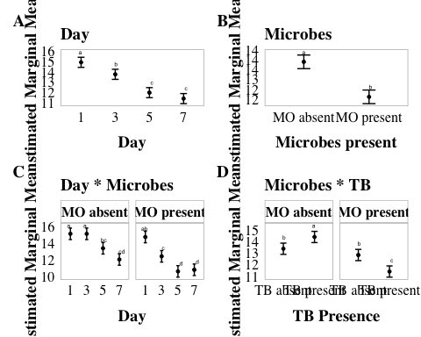

#ggsave("SI_4b.pdf", plot = pairwise_cld_4b, width = 7.09, height = 3.46)  
  
#ggsave("4b_pairwise_cld.png", plot = pairwise_cld_4b , width = 14, height = 8, dpi = 1000)

## Renwei y axis specs

global_y_limits <- c(9, 18)  
global_y_breaks <- seq(10, 18, by = 2)  
  
# Compute CLD letters for 'day'  
cld_day_4b <- ggplot(cld_day, aes(x = day, y = emmean)) +  
 geom_point(size = 1) +  
 geom_errorbar(aes(ymin = lower.CL, ymax = upper.CL), width = 0.2) +  
 geom_text(aes(label = .group), nudge_y = 1.5, size = 1.75, color = "black") +  
 xlab("Day") +  
 ylab("Estimated Marginal Means") +  
 scale_y_continuous(labels = scales::label_number(accuracy = 1), limits = global_y_limits, breaks = global_y_breaks) +  
 ggtitle("Day") +  
 scale_x_discrete(labels = c("Day_1" = "1", "Day_3" = "3", "Day_5" = "5", "Day_7" = "7")) +  
 myCustomTheme() +  
 theme(axis.title.y = element_text(margin = margin(r = 1)))  
  
# Compute CLD letters for 'microbes'  
cld_microbes_4b <- ggplot(cld_microbes, aes(x = microbes, y = emmean)) +  
 geom_point(size = 1) +  
 geom_errorbar(aes(ymin = lower.CL, ymax = upper.CL), width = 0.2) +  
 geom_text(aes(label = .group), nudge_y = 1.5, size = 1.75, color = "black") +  
 xlab("Microbes present") +  
 ylab("Estimated Marginal Means") +  
 scale_y_continuous(labels = scales::label_number(accuracy = 1), limits = global_y_limits, breaks = global_y_breaks) +  
 ggtitle("Microbes") +  
 scale_x_discrete(labels = c("1%TB+AEbiofilm" = "1%TB", "PW+AEBiofilm" = "PW - MO", "MQ+AEbiofilm" = "MQ")) +  
 myCustomTheme() +  
 theme(axis.title.y = element_text(margin = margin(r = 1)))  
  
# Compute CLD letters for 'day * microbes'  
cld_day_microbes_4b <- ggplot(cld_day_microbes, aes(x = day, y = emmean)) +  
 geom_point(size = 1) +  
 geom_errorbar(aes(ymin = lower.CL, ymax = upper.CL), width = 0.2) +  
 geom_text(aes(label = .group), nudge_y = 1.5, size = 1.75, color = "black") +  
 facet_wrap(~ factor(microbes)) +  
 xlab("Day") +  
 ylab("Estimated Marginal Means") +  
 scale_y_continuous(labels = scales::label_number(accuracy = 1), limits = global_y_limits, breaks = global_y_breaks) +  
 ggtitle("Day * Microbes") +  
 scale_x_discrete(labels = c("Day_1" = "1", "Day_3" = "3", "Day_5" = "5", "Day_7" = "7")) +  
 myCustomTheme() +  
 theme(axis.title.y = element_text(margin = margin(r = 1)))  
  
# Compute CLD letters for 'microbes * TB'  
cld_TB_microbes_4b <- ggplot(cld_TB_microbes, aes(x = TB, y = emmean)) +  
 geom_point(size = 1) +  
 geom_errorbar(aes(ymin = lower.CL, ymax = upper.CL), width = 0.2) +  
 geom_text(aes(label = .group), nudge_y = 1.5, size = 1.75, color = "black") +  
 facet_wrap(~ factor(microbes)) +  
 xlab("TB Presence") +  
 ylab("Estimated Marginal Means") +  
 scale_y_continuous(labels = scales::label_number(accuracy = 1), limits = global_y_limits, breaks = global_y_breaks) +  
 ggtitle("Microbes * TB") +  
 scale_x_discrete(labels = c("Day_1" = "1", "Day_3" = "3", "Day_5" = "5", "Day_7" = "7")) +  
 myCustomTheme() +  
 theme(axis.title.y = element_text(margin = margin(r = 1)))  
  
# Combine all plots  
pairwise_cld_4b <- cld_day_4b + cld_microbes_4b + cld_day_microbes_4b + cld_TB_microbes_4b +  
 plot_annotation(tag_levels = 'A')  
  
pairwise_cld_4b

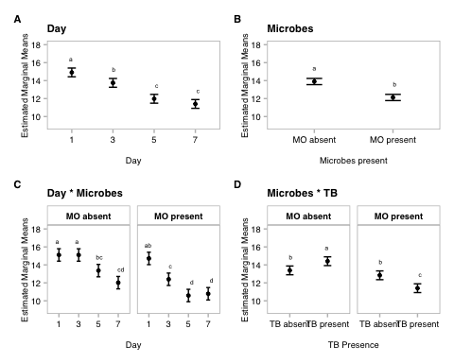

#ggsave("SI_4b_updated.pdf", plot = pairwise_cld_4b, width = 7.09, height = 3.46)

## 4a Raw EB data barplot

# Combine the two datasets (eb_pw and eb_pw_controls)  
eb_ml_controls <- eb_ml_controls %>%  
 mutate(site = case_when(  
 site == "MQ" ~ "sterile MQ",  
 TRUE ~ site )) %>%   
 mutate(filter = case_when(  
 filter == "40um_filter" ~ "sterile MQ 40um_filter",  
 filter == "0.22um_filter" ~ "sterile MQ 0.22um_filter",  
 TRUE ~ filter  
 ))  
  
eb_monolayer_nolog <- eb_monolayer %>%   
 dplyr::select(-log_bd)  
  
combined_data_4 <- bind_rows(  
 eb_monolayer_nolog,  
 eb_ml_controls) # controls data is already in the required format  
  
SI_4a <- combined_data_4 %>%  
ggplot(aes(y= bd_qty, x = site, fill = filter)) +   
 geom_col(position = position_dodge()) +  
 scale_y_continuous(expand = c(0.01, 0.01),  
 trans = "log", # Natural logarithmic scale  
 breaks = c(1e+01, 1e+03, 1e+05), # Set exact breaks  
 labels = scales::label_scientific()) + # Use scientific notation 1e+01, 1e+03, 1e+05  
 scale_x_discrete(limits = c("CABIN", "GRAMPS", "WEST", "GDPND005", "GDPND006", "GDPND009", "PRPND004", "PRPND009", "PRPND010", "sterile MQ")) +   
 facet_wrap(~day, labeller = labeller(day = c("Day_1" = "Day 1", "Day_7" = "Day 7"))) +  
 scale_fill_manual(values = c("40um_filter" = with_microbes_40_color,   
 "0.22um_filter" = no_microbes_.22_color,  
 "sterile MQ 40um_filter" = "darkgray",  
 "sterile MQ 0.22um_filter" = "lightgray")) +  
 myCustomTheme() +   
 theme(axis.text.x = element_text(angle = 90, vjust = 0.5, hjust = 1),  
 legend.position = "bottom",  
 panel.border = element_rect(color = "gray", size = 0.5, fill = NA),  
 legend.text = element_text(size = 5), # Set legend text font size to 5pt  
 legend.key.size = unit(0.4, "cm"), # Reduce size of legend keys  
 legend.spacing.y = unit(0.1, "cm"), # Reduce vertical spacing between legend items  
 legend.margin = margin(t = 0, r = 0, b = 0, l = 0)) +   
 xlab("Site") +  
 ylab("Bd Quantity \n (zoospore equivalents)") +  
 guides(fill=guide_legend(title=""))  
  
SI_4a

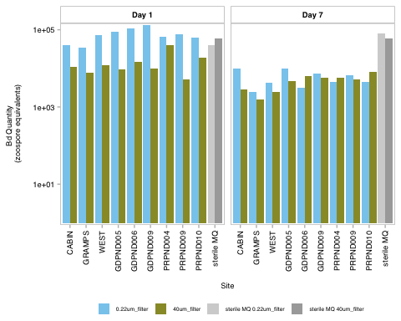

#ggsave("SI_4a.pdf", plot = SI_4a, width = 7.09, height = 3.46)