Box #____ (Name on Back)

Math 65 Section ___

Homework 2

11/2/18

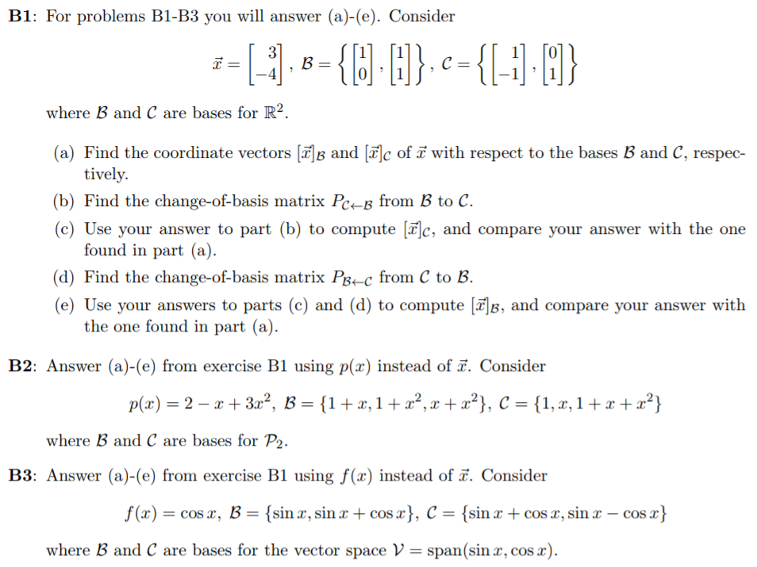

**Problem B1 Continued:**





