Box #____ (Name on Back)

Math 65 Section ___

Homework 4

11/9/18

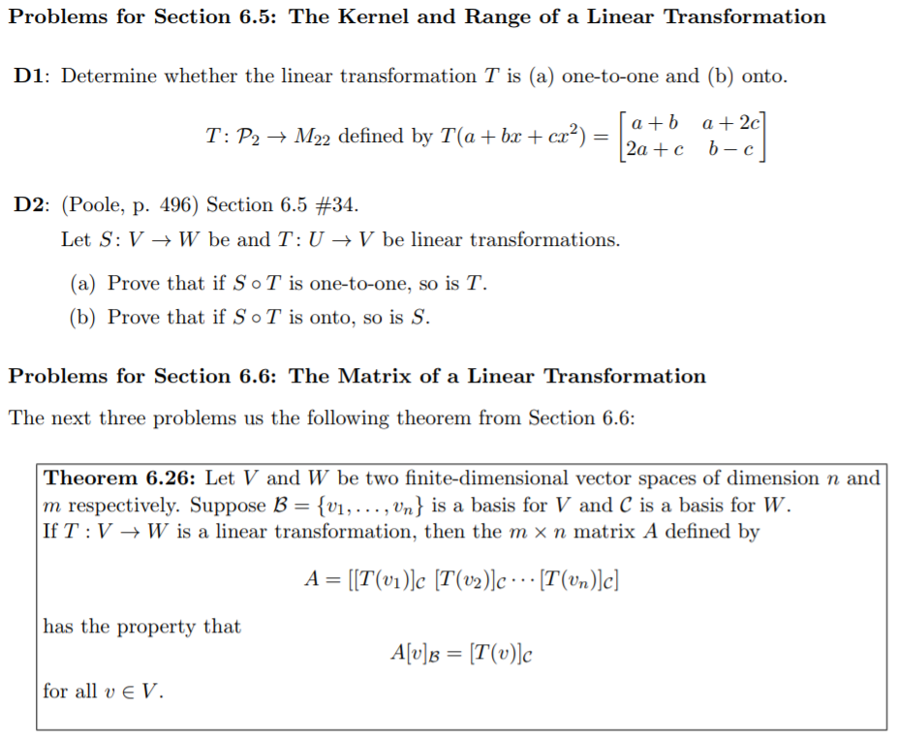









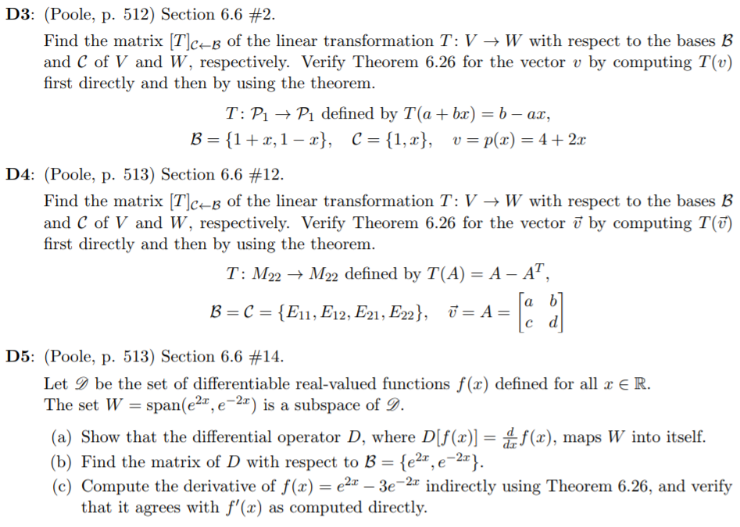

**Problem #3 Continued:**





