**ScrumBoard Application**

**Introduction:**

I have developed **ScrumBoard** Web Application in Visual Studio 2022 with the project template “ASP.NET Core Web App MVC” created using .NET CLI.

**Technology and Tools used:**

∙ Visual Studio 2022

∙ .Net 7

∙ C# and ASP.Net CoreMVC

∙ NUnit testing framework

∙ Azure APIs

∙ Bootstrap

**Design Pattern:**

I have used **Dependency Injection** as my design pattern with **Singleton** lifetime

**About the Application**

**Solution**:

The solution is named as “ScrumBoardApp” contains two projects

1. ScrumBoardApp

2. ScrumBoardUnitTest

**Projects Structure:**

1. **ScrumBoardApp**, is ASP.Net core Web Application with MVC. This projects contains: ⮚ Controllers contains HomeController.cs

⮚ Models contains CreateWorkItem.cs,WorkItem.cs and ErrorViewModel.cs

⮚ Views contains Home folder that contains WorkItems.cshtml and CreateWorkItem folder contains NewWorkItem.cshtml

⮚ Services contains IAzureApiService.cs and AzureApiService.cs

⮚ wwwroot contains the Javascript logic.

**General Specifications:**

The **ScrumBoardApp** project will show all the Tasks fetched from the

Azure API URL with following features:

⮚ Each Task shown as a card containing Name, Description and Deadline.

⮚ Create Work Item functionality for adding new Tasks .

⮚ Delete Item is for deleting task.

**Technical Specifications:**

∙ **IAzureApiService**.cs is the interface for the class **AzureApiService**.cs. **AzureApiService** class handles the http request to get the data from the api

∙ The Service is registered as Singleton in **Program**.cs.

∙ HomeController uses the **IAzureApiService** to get the data from the API

∙ WorkItems.cshtml, displays the data received from the controller.

**Screens**

**1. WorkItems**

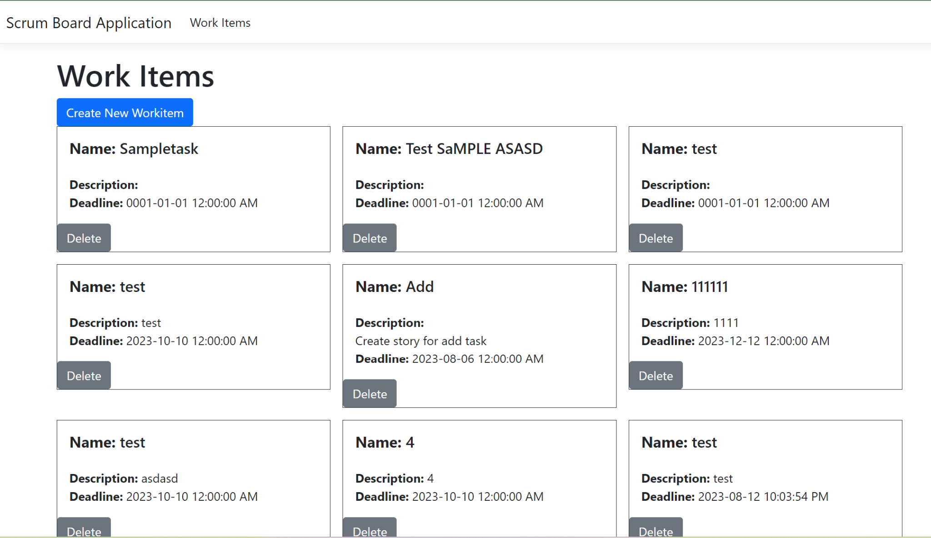

**2. Create New Item:**

