
Information Queensland
Technology Alignment Review
Volume 2 – QSIIS Managers’ Summary

Version: Draft 1.0.1
Date: March 2nd 2004
Authors:
Dr. Robert Starling
and
Michael Wilson
(OGC- Australasia)

Project Team
Tim Barker – QIO, OESR, Qld Treasury (Project Leader)
Graham McColm (Project Manager)
Dave Teufel – QSIIC Secretariat
David Zuill - DLGP
James Hinchcliffe - OESR
Perry Molloy - NR&M
Peter Hoffenberg – DIIE/DLGP
Steve Jones – EPA
Ian Lever – QPW
Michael Schoch – DIIE
Jeff Sangster – Emergency Services

NOTE: The Queensland Government was restructured following the February 2004 state elections, with the names and organizational affiliation of many departments being changed. It is to be determined whether or not this report will continue to reflect the previous structure.

Volume 2: Information Queensland
Technology Alignment Review:
QSIIS Managers’ Considerations

V2-1 Acknowledgements 1
V2-2 Objectives and Brief 2
V2-3 Methods 3
3.1. Consultations with QSIIS Agencies 3
3.2. Review of Documentation 4
3.3. Review of Existing Systems 4
3.4. Pre-Workshop Discussion Paper 5
3.5. Workshop 5
V2-4 Summary Results 6
4.1. Initial Findings 6
4.1.1. QSIIC Issues 7
4.2. Consultation Outcomes 8
4.3. Findings from the Workshop 9
4.3.1. Review of the Discussion Paper 9
4.3.2. Summary Recommendations 11
V2-5 Reviewing Policy Frameworks 13
5.1. The Government Information Architecture (GIA) Managed by DIIE 13
5.2. Government Security policy – Network Security 14
5.3. The QSIIS Data Queensland Concept 15
V2-6 Review of Existing Initiatives 16
6.1. Review of Existing Initiatives 16
6.1.1. GovNet 17
6.1.2. Smart Service Queensland initiative and its supporting infrastructure Custodian: DIIE 17
6.1.3. Spatial Link Clearinghouse Custodian: DIIE, delivered through GovNet 18
6.1.4. Government Services Locator Custodian: DIIE, delivered through GovNet 19
6.2. Reviewing Business Systems 20
6.2.1. ASDD Queensland node Custodian: NR&M 20
6.2.2. CRAB system Custodian: State Development 20
6.2.3. Ecomaps Custodian: EPA 20
6.2.4. Emergency Services Spatial Information System Custodian: DES 21
6.2.5. ENRII/SMIS Custodian: NR&M 22
6.2.6. Information Queensland, spatial statistical and economic services Custodian: OESR 22
6.2.7. IPA-GIS and PIFU-GIS Custodian: DLGP 23
6.2.8. NAP RIS Portal Custodian: NR&M 23
6.2.9. QBIS Custodian: QPW 24
6.2.10. Roster of Strategic Information (ROSI) Custodian: OESR 25
6.2.11. SmartMap Information Services Custodian: NR&M 25
6.2.12. Web Services Delivery Framework Custodian: NR&M 26
6.3. Other Discovery Mechanisms 26
6.4. Foreseeable Extensions 27
6.5. Consequences for QSIIS 28
6.5.1. Promoting the Shared Services Architecture 29
6.5.2. Notional Architecture and SDI 29
6.5.3. Augmenting Existing Systems and Infrastructure 29
6.5.4. Custodial Management 29
6.5.5. Service and Value Chaining 30
6.5.6. Recognizing Custodianship 30
6.5.7. Migratory Model for Custodianship 30
6.6. Consequences for Service Providers 30
6.6.1. Activating Existing OpenGIS Interfaces 31
6.6.2. Developing ‘wrappers’ 31
6.6.3. Authoring and Maintaining Service Metadata 31
6.6.4. Authoring and Maintaining Data Set Metadata 32
6.6.5. Security, Integrity and Availability 32
6.6.6. OpenGIS Back Ends 33
V2-7 Consideration of the Notional Architecture 34
7.1. Approach 34
7.2. Overview Architecture 34
7.3. An Instance of Architecture Implementation: GOS-P 35
7.4. Web Services and Web Agents 39
7.5. Predicates of the Notional Architecture 39
7.6. Viewpoints Concepts 40
7.6.1. Enterprise Viewpoint 40
7.6.2. Example Use Case Scenarios 42
7.7. Use Case Service and Value Chains 42
V2-8 Considerations for Aligning the Notional Architecture with Existing Initiatives 44
8.1. Approach 44
8.2. Notional Architecture for Information Queensland 45
8.2.1. Service Categories 46
8.2.2. Components 47
8.3. Example Use Case scenarios 48
8.3.1. Mapping components to scenarios 48
8.3.2. Status of Components 48
8.3.3. Alignment to National and International Initiatives 48
8.3.4. Migratory model for custodianship 49
8.3.5. Method for Recognizing Custodianship 49
8.4. Use Case Scenario 49
8.4.1. Requirements 50
8.4.2. The Scenario: Regional Reporting Process 50
8.4.3. The Regional Reporting Use Case 52
8.4.4. Capabilities Required 54
8.4.5. Components Required for the Regional Reporting Use Case 54
8.4.6. How this Aligns to the Component Levels of the Notional Architecture 57
8.4.7. Extensibility of the Use Case Method 57
8.4.8. Mapping Components to Scenarios 58
8.4.9. Status of Required Components 61
8.4.10. Alignment of Components to Existing Systems and Services 63
8.5. Justification for Approach 63
V2-9 References 65
9.1. Bibliography 65
9.2. Acronyms 68
9.3. Glossary 71

Table of Figures – Volume 2
Figure V2-1: ISO 3-tier model 35
Figure V2-2: Portal Concept 36
Figure V2-3: Services and Information Flows 37
Figure V2-4: GOS-P Multi-vendor Interoperability 38
Figure V2-6: Information Queensland Enterprise Viewpoint 41
Figure V2-7: Information Queensland Service and Value Chaining Concept 43
Figure V2-8: The Notional IQ Architecture 46
Figure V2-9: Regional Reporting – high-level use case portrayal 53
Figure V2-10: Indicative Regional Reporting Service Components 56
Tables – Volume 2
Table V2-1: Consultation Timetable 3
Table V2-2: The Regional Reporting Process 51
Table V2-3: Notional Components required for the Use Case Scenario 58
Table V2-4: Existing Components versus Required Capabilities 61

- Acknowledgements
The QSIIS Project Team acknowledges the support of their respective departments in this work and in maintaining the impetus to realize the one-month time frame allowed for this effort to be undertaken.
QSIIS appreciates the contribution of the Department of Land Information – Western Australia for allowing as yet unpublished materials to be used as background and for ideas in those materials to be extended for the purposes of this study.
Other organisations such as Geo-Connections Canada, the City of Cologne (Germany) and the Geo-Intel Conference (2003) Platinum Sponsor Team have also provided unpublished materials in relation to the description and definition of some of the open standards based software components outlined in Volume 3.

- Objectives and Brief
This study is the first in a series of three that QSIIC determined (in June 2003) were required in order to move forward with Information Queensland as an enabler for integrated service delivery. The series of studies to be completed are:
- Technology Alignment Review (Open Standards)
- Business Process Review (Integrated Service Models and Delivery)
- Paper to Treasury with innovative options concerning future funding models for intra and inter government geo-spatial data and technology.
The results of the Technology Alignment Review are to be documented in a report that:
- Provides an assessment of each of the targeted architectures for open standards compliance and support for a shared model based on Web Services and the flexibilities enabled through access on demand to internet-based services.
- Details an architecture able to provide a whole-of-government framework to support integrated services delivery and the desired shared services infrastructure
- Identifies opportunities in existing systems and infrastructure that could feasibly provide the bases for being enhanced to become Web Services
- Evaluates the impacts on the target systems, including security, reliability, availability, and performance and where possible makes recommendations as to how these might be managed
- Recommends a migration strategy for adoption of the architecture, and where possible includes suggested key components and services to be prioritized on the basis of common need, impact, ease of implementation and related factors
- Provides evidence of findings and justification for the recommended strategy.
Findings of the Review are to be presented to a workshop of the project team.
The required time frame is:
- To receive briefings from representative QSIIS stakeholders November 17-27th , 2003
- Prepare a draft report and suggestions for an outline of the workshop by December 15th;
- Attend the workshop December 18th and
- Submit the Draft Report by December 22nd 2003.
A subsequent workshop was held on 13th February 2004 to review version 1 of this draft report.
- Methods
Development of the notional architecture for the Information Queensland, and its technical alignment with current and projected Queensland Government capabilities has taken the form of:
- Consultation with QSIIS members as volunteer members of the Project Team;
- Review of documentation;
- Preparation of a discussion paper capturing the initial findings and the framework of the notional architecture;
- Review of the discussion paper in a workshop with the Project Team;
- Development of this report.
A basic tenet of the Technology Alignment Review is that the resulting model is signed-off by each of the participants in the Review Committee. Therefore, as the project has progressed from hypothetical and theoretical to practical it has been essential that certain basic principals were endorsed.
  - Consultations with QSIIS Agencies
Consultations took the form of informal briefings from project personnel who summarised the objectives for their projects:
Table V2-1: Consultation Timetable
Schedule of Briefings | Agency and Contact(s)  am | Agency and Contact(s)  pm
Mon 17th Nov | QIO – Tim Barker  OESR –James Hinchcliffe | OESR/NR&M ASDD nodes  Peter Danaher, Geoff Hunter
Tue 18th Nov | QPW – Ian Lever | QSIIS Data Qld – Graham McColm
Wed 19th Nov | NR&M – Perry Molloy | DIIE  GIA implementation - Don Ashown  SSQ/SII model - Jeff Peters  GovNet model – Michael Schoch
Thur 20th Nov | DES – Jeff Sangster | DIIE  GovNet Security & Connections - Adam Garner
Fri 21st Nov | DIIE  Spatial Link- Peter Hoffenberg  Services Locator – Tony O'Rourke  GovNet model – Michael Schoch | DIIE – BPR  Karen Dennis  Greg Sonter  Byron Ramsden
Mon 24th Nov | Consultants discussion on progress so far with Tim Barker & G McColm | Caloundra Council  Ben Pow
Tue 25th Nov | DLGP – David Zuill | Brisbane City Council  Bob Peters
Wed 26th Nov | EPA – Steve Jones | DIIE  Don Ashdown
Thur 27th Nov | DES – Jeff Sangster
  - Review of Documentation
The consultants were provided with many documents describing Government policy initiatives, previous strategic analyses, and current and envisioned developments.
- GIA Draft Version 2.5 (17/09/99)
- GIS Overview document (20.11.2003)
- Data Queensland Concept Paper 2002
- Queensland Government Standard S.10 – Network Security
  - Review of Existing Systems
The focus of the technical alignment review is interoperability and sharing of spatial data and spatially referenced information services. From this perspective, consideration must given to existing key infrastructure:
- Smart Service Queensland initiative and its supporting infrastructure – in DIIE
- GovNet
- Spatial Link Clearinghouse – in DIIE and delivered through GovNet
- Government Services Locator – in DIIE and delivered through GovNet
Included in the review are architectures of the following business systems:
- Information Queensland, spatial statistical and economic services - OESR
- Ecomaps – EPA
- IPA-GIS and PIFU-GIS – DLGP
- ASDD Queensland node – managed by NR&M and ROSI – OESR
- ENRII / SMIS projects –NR&M
- QBIS – QPW, and
- Emergency Services Spatial Information System – (DES).
These business systems, applications and initiatives provide a cross section of current geospatially-enabled technologies. They also contain authoritative source spatial data that can be re-used in a broad range of business information services for Government. The agencies listed have a need to use and share data and information between themselves and with others inside and outside state government.
The alignment between these systems and the notional architecture are considered in more detail in following sections.
  - Pre-Workshop Discussion Paper
Information provided by QSIIS agencies and the documentation were amalgamated into a pre-workshop discussion paper incorporating the consultants’ initial findings, outstanding issues, and an outline of the framework for a notional architecture. This was distributed to the QSIIS project team.
  - Workshop
A basic tenet of the Technology Alignment Review is that the resulting model is signed-off by each of the participants in the Review Committee. Therefore, as the project progressed from hypothetical and theoretical to practical is was essential that certain basic principals be endorsed. A workshop with the QSIIS Project Team on 18th December reviewed the discussion paper and a number of written responses that had been received before the workshop.
- Summary Results
Each consultation revealed issues affecting the ease or difficulty of implementation and operation. All session participants seemed keenly involved with both the present undertaking and future options.
  - Initial Findings
The exchanges during the consultations, as well as review of the relevant documentation provided, made it abundantly clear that:
- There is an extraordinarily rich resource of expertise, technology, enterprise and spatial data within the community of creators and users of geo-spatial data information services within the State and Local Governments of Queensland;
- There are numerous data and information products, many as printed output. There is no shortage of information, and more is pouring in all the time;
- Geo-spatial data is a pre-requisite for the majority of government work. It is the common reference framework for the majority of information integration;
- Exchange of geo-spatial data – and, more importantly, familiarity with meaningful methods for its application – across department and agency boundaries tends to occur on the basis of ad hoc relationships negotiated amongst individual staff members, and carries the risks to ‘survivability’ should those staff be lost or relocated;
- GIS have been used in many of the Queensland government agencies for over 20 years – so the pool of experience is deep;
- Expertise is diffused across nearly all agencies;
- Differences in budgets and the maturity of the use of the technologies varies;
- Many of the issues raised during the briefings have existed for about as long as the technology has been used.
These observations, and the issues raised in Section 4.1.1 “QSIIC Issues” (below) provided a set of requirements for the notional architecture i.e. identify problems to be resolved in the short term.
Network security policies, while crucial to ensuring the reliability and availability of Departments’ production systems, were repeatedly identified as a bottleneck to inter-departmental services because firewalls and routing filters blocked access between GovNet nodes.
The vision of an Information Queensland operating on the basis of shared services, and accessing authoritative sources as points of truth, requires careful consideration, and reconsideration of these issues. Section 4.3.1 “Review of the Discussion Paper” presents discussion of these.
This report is not intended to go over old ground, although consideration is of course made of previous QSIIS findings and recommendations. It is to explore new means to conceptualize and recommend solutions that address key issues exposed as being inherent in the current operational environment.
The process involved consulting with managers, production staff, infrastructure operators and clients of a wide variety of geo-information services. It also required considering how best to build on the current project initiatives occurring in Queensland State and Local governments, especially their significance to broader intra and inter-government requirements.
Doing so allows us to identify real or potential barriers to adoption of the notional architecture and to suggest a mechanism by which to move whole process forward.
    - QSIIC Issues
QSIIS provides an invaluable cross agency forum for consensus-based decisions amongst a group of senior personnel. They provide a perspective on the issues facing all QSIIC members. The issues are well known and were outlined in briefings, and include but are not limited to:
- Lack of a common understanding as to the broader or strategic context within which many of the current projects are being undertaken;
- Projects are addressing specific business goals and requirements without consideration of the potential impacts on other efforts;
- Few of the projects share awareness of the inputs and outputs for their external users, or are independently building external customer base without considering whether other members could benefit;
- Projects, irrespective of scale, seem to follow a similar pattern: Acquire technology, acquire data, load data, build applications, deliver data, maintain applications, make some aspects web accessible (and, maybe, move data to a following project);
- Technology acquisitions, enhancements and applications are built to fit an expedient but narrow purpose;
- Data custodianship is acknowledged but the distribution and support mechanisms and customer feedback loops appear to be convoluted, meaning that much data exchange goes on behind the scenes;
- Project data does not have a custodial model and only ad hoc archiving into repositories takes place to make data available for verification, update or re-use; integration between spatial data and document repositories appears limited.
- Individual agencies base decision support on numerous versions of the same source data, with the risks of inconsistencies with other agencies’ conclusions based on the ‘same’ sources, and the added costs for service delivery arising from duplicated effort.
- Institutional issues regarding data and service access, pricing and so remain problematic and contribute to duplicative processes.
- There are a number of production systems within the projects that post data to users, but no group offered to provide a list of the organisations to which data is supplied either on a one-off or regular basis. Records of cost structures and accounting for data provision (where they exist) are kept in separate systems so the data suppliers were not aware of the standing of any of the customers.
- Metadata seemed to be of marginal importance, whether describing data sets, services or institutions.
- Many projects were confronting operational limits due to:
  - Lack of an accessible system of linked catalogues describing data sets available within and between agencies, available from Commonwealth agencies, or available from commercial or community suppliers;
  - The unresolved need for an agreement on common identifiers (or a thesaurus of identifiers) to enable linking between different data sets and environments;
  - Lack of agreement on standardised symbolisation of data, a result of each data rendering exercise being taken in isolation;
  - Lack of convergence in strategic efforts majority of projects are tactical, there appears to belittle consideration of continuity, as such there is little incentive for innovation within government and/or their private sector consultants and suppliers.
  - Consultation Outcomes
Briefings from QSIIS agencies and departments yielded the following observations:
- There was broad recognition that validity remains in the previous assessments of policy and business drivers that lead to change in ways geo-spatial data are collected, managed, maintenance, lodged and supplied.
- A number of individual State Government agencies and local governments have made significant progress in exploring and providing localized services
  - This indicates that the Consensus Points (referred to above) are achievable within a Whole-of-Government context.
- There is a willingness to share the results of lessons learnt and local applications and core technology development
  - This supports prospects for remote lodgment and supply of geo-spatial data and geo-processing services within Queensland, to adjacent jurisdictions and nationally, as appropriate.
  - Findings from the Workshop
The workshop with the Project Team yielded comments arising from the pre-workshop discussion paper, and recommendations for the development of this report. Further inputs were received in writing following the workshop and have also been incorporated in this draft.
    - Review of the Discussion Paper
Consensus was reached on the following key issues to underpin the technology alignment and go-forward model that must:
- Improve All-of-Government efficiencies in spatial information servicing
- Align with Australian national Spatial Data Infrastructure (SDI) and Queensland policies, guidelines and standards,
- Be distributed, decentralized (i.e. allow for distributed data management and information processing)
- Be bi-directional, interactive (i.e. allow for user interaction and for the lodgment of data and processes as well as providing for supply)
- Be secure, accountable, auditable (i.e. meet Queensland policies)
- Allow for a components-based approach (i.e. consist of a series of well defined modules which can be developed or acquired separately)
- Allow for progressive, incremental development
- Preserve value of existing systems
- Existing services and business practices considered ‘black box’, not to be tampered with. We hold that there are existing systems that have value. This does not preclude there being different future systems with different values. The goal is to preserve and enhance the value of existing systems where appropriate.
  - Add wrappers/middleware for open interfaces (i.e. provide mechanisms by which existing systems can interact within the proposed model without re-engineering internal business processes and workflows)
- Support message-based transactions to communicate between computers and computer processes by asking questions and receiving answers in an increasingly refined manner rather than only being able to request large volumes of data and having to re-process to get the specific answer)
  - Also caters for batch (large volume transfers)
  - Allow for small data volumes, high recurrence as well as high data volumes
- Allow for service integration, not just data exchange (e.g. allow a computer holding the data to pre-process the data and deliver the answer in response to a request, or have the data sent to another computer for processing before the answer is returned to the requestor)
- Built on a notional architecture model (Notional refers to an architecture which meets the following criteria):
  - Standards-based, vendor neutral
  - Process/service focus, not data focus
  - Institution neutral
  - Technology neutral
- Able to accommodate off-the-shelf components (i.e. the architecture should allow for the use of existing software components, where available either):
  - Commercially,
  - Through open source, or
  - As freeware.
Un-reserved agreement was given to the above points. This consensus is important because it provides the foundation on which the report is developed.
The workshop participants from the Review Committee also required that the work include reference to:
- Risk Management
  - Concern that data being provided, or used by an organisation or individual, is out-of-date and as such affect the outcomes of an analysis or advice given on the basis of such data, and
- Barriers to adoption such as:
  - Jargon
  - Lack of Institutional Interoperability and if needs be, policies for cooperation,
  - Existing policies in relation to data licensing, computer system management, network management and allocation of funding
  - Lack of confidence in colleagues to deliver within and between organisations
  - Lack of funding for collaborative inter-agency work to provide this critical infrastructure and to incorporate the requirements of the infrastructure into their own internal business and computing processes to realize the benefits to the State through participation of their own organisations;
- Conformance to business objectives of Access Queensland and the BPR process.
The Report is to provide:
- An assessment of each of the targeted architectures for open standards compliance and support for a shared services model
- An open standards compliant shared services architecture to support integrated services delivery and the desired shared services infrastructure
- Identification of opportunities to lever off existing systems and infrastructure
- An assessment of the impacts on the target systems
- A recommended migration strategy forward to adopt the architecture
- Evidence of findings and justification of the recommended strategy.
    - Summary Recommendations
These points derive from the fuller discussion of policy frameworks and existing capabilities that will govern the strategy for developing the Information Queensland. Fuller discussion is provided in Section V2-5 “Reviewing Policy Frameworks”
- Update the GIA to include (if not emphasise) open standards based web services and their role in whole-of-government spatial information servicing.
- Update the IS.18 Government Network Security Policies in light of government business requirements based on shared, open standards web services.
- QSIIC develop and initiate a staged implementation project to bring into operation the desired sharing a of services and infrastructure to support the enunciated integrated services delivery needs.
- Enable the Data Queensland Project to provide an initial focus for a number of basic web services in collaboration with the Whole of Government GIS (DIIE) and the DIIE Access Queensland Government Directory (user identification) and Government Services Locator projects.
- Support Access Queensland in deploying Authentication Services, information product and service catalogue and pricing services, order management, fulfillment, track and trace, and settlement services of use to the wider QSIIS agencies.
- Nurture the creation of mutually accessible data and processing services focused on business graphics and allocation modeling.
- Empower EPA to provide on-demand web services to business and the community and create its services to the mining industry as open web services.
- Support DLGP to continue its development of planning and related information products, especially to local government, the development industry and community interest groups.
- Assess ROSI for possible re-implementation as a web service.
- Put in place more stringent policies to ensure that data and processing assets of the public purse are recorded and realized.
- Expand on the lessons learned from the ENRII and Access Queensland projects to proposed registry services.
- QPW consider collaborating in commissioning data alignment services.
- QSIIS review existing services able to provide components to service shared requirements, and assess the feasibility of designing and prototyping demonstrators of open web service interfaces.
- QSIIS build upon the good will and capabilities to establish guidelines for a quick-win demonstrator(s) delivering a small number of key web services of wide common interest to QSIIS members.
- QSIIS establish technical watch teams to assess the progress and development of specifications, standards and technologies.
- Reviewing Policy Frameworks
A review was made of each of a number of policy instruments and their relevance to open standards compliance and support for a shared services model.
  - The Government Information Architecture (GIA)
Managed by DIIE
The Government Information Architecture sets a comprehensive scenario for systems’ architectural and operational characteristics. This is a very high level document and remains as a draft undergoing constant revision. As such it provides the broadest of frameworks governing development of notional architectures.
The GIA is an expression of the requirement for information to flow within government and between levels of government, to businesses, communities and the general public meeting the business requirements of government. It recognizes high-level criteria including:
- Communication between systems based on an open systems approach,
- Information is held in re-usable formats
- Information systems and technology infrastructure support inter-operability and the sharing of information
- “Share before you re-use before you buy before you build”
GIA assumptions include:
- A “federated” environment of cooperating independent systems each meeting defined business criteria.
- Separation between Data, Business Rules and Presentation (i.e. the ISO 3 Layer Model).
- Engagement of re-usable “services” or components within a Cooperative Object Request Broker Architecture (CORBA) style environment employing cross-platform tools such as Enterprise Java Beans.
- Communications to use standard messaging, message brokers, repositories (registries) and transformation engines.
The GIA documents provided were from Draft Version 2.5 (17/09/99). As far as they go, they are consistent with the notional architecture. However, three years of Internet development have overtaken the GIA documents with the result that they no longer provide a complete framework for specifying Information Queensland.
The rise of the use of the Internet as an extended intranet has accelerated since 1999. The formalization of messages in the Extensible Markup Language (XML) and associated Simple Object Application Protocol (SOAP), Web Services Description Language (WSDL) and the UDDI, along with enhanced internet security and encryption have greatly enriched the tools available to deliver the vision of the GIA.
A number of initiatives are underway which illustrate the application of these tools, for example, the Whole of Government GIS project supported by GovNet and its extension to LGAQNet.
As GIA moves to include web service access to its infrastructure, QSIIS Agencies will be aligning their work to utilize services and provide input, experience and suggestions for updating policies as the GIA evolves. Agency projects will coordinate with GIA in extending their applications data and services to increase utilization of the network for web services.
Recommendation
A recommendation of this work is that the GIA to be updated to incorporate reference to open standards based web services and their role in whole-of-government spatial information servicing.
  - Government Security policy – Network Security
Network security is a paramount concern for all QSIIS members. It was not clear from discussions the degree to which this concern was precautionary and how much was based on prior experience.
Network Security issues commonly comprise:
- Reliability – that a service is available and protected from interference that prevents access (‘denial of service’);
- Integrity – that the content of the system is truthful and reliable and not falsified;
- Accessibility – that a reliable service presents access interfaces that in fact bind to the selected service and not to some third-party service (‘spoofing’);
- Non-repudiation – that transactions made through a service cannot subsequently be repudiated or denied by either party;
- Recoverability – that interrupted transactions result in the service returning to its state prior to starting the transaction.
Queensland Government standard IS.18 provides guidelines to service providers regarding some but not all of these aspects of network security.
Many QSIIS participants reported - both during consultations and in the Workshop - departmental policies in place governing inter-agency online access at the moment are effective for managing and protecting critical production systems. They are however overly restrictive to implementing shared web-based services.
Departmental IP security policies, including client identification and authentication, represent an obstacle to achieving the goal of streamlined whole-of-Government spatial information access because of the constraints in bi-directional access through individual agency network firewalls.
A number of Agencies are undertaking integrated service delivery projects within the guidelines of the GIA but are having to look to other web deployment models because of constraints in arising from current administration of their network environments.
Recommendation
A recommendation of this work is that the Network Security Policies be updated in the light of open standards based web services. There is an urgent need to reach consensus over guidelines for implementation of web services that will meet the business requirements of government and Network Security Policies.
At the second workshop it was recommended that departmental security managers meet with GovNet staff to reconcile the requirements for open web services, such as application proxy servers, IP filtering consistent with rolling out Information Queensland.
The BPR process can be used to specify the requirements for whole of government spatial services and thereby the criteria that network administrators will need to meet.
  - The QSIIS Data Queensland Concept
The Data Queensland Concept grew out of a number of previous initiatives over many years starting in November 2001.It was a project initiated by QSIIC as a priority to do something tangible to implement a shared services model to meet business efficiencies discussed and workshopped through various QSIIS forums.
The Concept paper draft (Aug 2002) sets out the business context for such a model and overviews an environment that could deliver the desired outcomes from the initiatives referenced in that document.
At the same time, through the ASAP / SIM and Access Queensland initiatives, the Queensland Government is striving to seek the same efficiencies for services delivery.
This current Technical Alignment Review and the subsequent BPR process is intended to build upon the work already undertaken to move forward to an open web services implementation strategy and investigating the role and ramifications of using open standards for the distribution of geo-spatial and related attribute data.
The Data Queensland Concept provides a business context for integrated services delivery that is still relevant and is a useful reference for developing a strategy forward.
Recommendation
QSIIC should, as a result of this review and the subsequent BPR process, develop and initiate a staged implementation project to bring into operation the desired sharing a of services and infrastructure to support enunciated integrated services delivery needs.
- Review of Existing Initiatives
A key design aspect of any notional architecture is to capitalize on the investment value of the existing systems - their establishment costs, lifetime amortization and on-going operations and maintenance - by incorporating them to form part of the base infrastructure to be implemented in the Information Queensland architecture.
QSIIS members are highly experienced GIS technology users and have considerable experience in providing services to executive-level government officials, customers within their respective departments, between departments, to local government, community organisations and to the public.
Within Queensland, GIS has evolved from a set of tasks capturing and supplying data in digital and printed forms, to a set of intensive intellectual tasks creating complex domain specific predictive models addressing needs such as bushfire modeling to public building maintenance scheduling.
Projects underway in a number of departments seek to streamline the supply of information to the right organisation in the right time frame. Creating the services that generate targeted products with added value, and that meet the demands of specific areas of responsibility and to their communities of interest, are key aspirations.
These continuing efforts highlight the need for an operational whole-of-government architecture that must align with and take consideration of contextual factors including:
- The Queensland Government Information Architecture (GIA) – managed by DIIE
- Government Security policy – network security
- The QSIIS Data Queensland Concept.
- The principles of Integrated Service Delivery
  - Review of Existing Initiatives
The focus of the technical alignment review is interoperability and sharing of spatial data and spatially referenced information services. From this perspective, we must consider the existing key infrastructure including:
- Smart Service Queensland initiative and its supporting infrastructure – (DIIE)
- GovNet
- Spatial Link Clearinghouse – in DIIE and delivered through GovNet
- Government Services Locator – in DIIE and delivered through GovNet
Included in the review are architectures of the following business systems:
- ASDD Queensland node – managed by NR&M
- Information Queensland, spatial statistical and economic services (OESR)
- Ecomaps – EPA
- ENRII / SMIS –NR&M
- PIP (cadastre plus titling etc.)
- IPA-GIS and PIFU-GIS – DLGP
- QBIS – QPW
- ROSI (OESR),
- Emergency Services Spatial Information System – (DES).
    - GovNet
GovNet is the Government network infrastructure.It links all Government departments and agencies as an intranet using tcp/ip. It is maintained by an outsourced operator.
GovNet provides switched interlinkages amongst departments, each of which also maintains a network firewall supporting the IS.18 Government Standard – Network Security managed by local IT network staff. The commercial outsource provider also manages firewalled access between GovNet and the external Internet, and supports web servers accessible to the public Internet.
IP filtering is implemented to constrain the connectivity between departments. Specific routing policies must be coordinated between staff of the commercial outsource provider and departmental IT staff.. IP filtering rules tend to be exclusive, according to comments during the workshop with the Project Team.
Individual departments implement exclusive filters that reject all IP packets other than those destined for a single pre-defined server. Therefore, each new server, or service operating on a non-standard network port, that is to be visible to other departments or the public internet must have new routing policies implemented. Each of these changes requires coordination, time, effort and introduces opportunity for error. As routing filters grow more complex they require increasingly demanding maintenance.
    - Smart Service Queensland initiative and its supporting infrastructure
Custodian: DIIE
The Smart Services Queensland initiatives are providing basic infrastructure to realise the high level aspirations.
The services are founded on the common sense approach that data within government is private to government unless a decision is made to release and publish such data and documents or expose services to brokers, the private sector and/or public.
Therefore, the information system needs capability to know who is using the system (Identity), to verify that they are indeed whom they portend to be (Authentication), the type of user they are (Role) and the types of activities and resources an individual can access (Authorisation).
Activities and resources include over-the-counter services delivered by government to populations outside government, as well as computational.
SSQ projects are being developed as examples of shared services wherein, for example, the billing system for camping permits is designed to use the GovNet whole of government employee and contractor index as a means of verifying the identification of individuals logging on to the system. It is intended that the bill presentment and account settlement systems will also be available to other applications, in the future.
This work has shown that it is essential that agencies have the ability to have known (identified and authenticated) users so that transactions that create revenue can be migrated to the Internet. Such a series of business services will have to be developed by just about every agency separately if no accessible mechanism is created.
SSQ’s Service Integration Infrastructure system and its Integrated Receipting System are designed to meet the needs of sparse, simple transactions with individual citizens. They are not designed to support high-volume high-frequency system-to-system transaction management.
The basis for Information Queensland’s user authentication, authorization and accounting will most plausibly derive from the developments occurring in OASIS and due for release in the first quarter of 2004.
Recommendation
It is a recommendation of this work that Access Queensland be supported in the development and deployment of web-accessible Authentication Services, information product and service catalogue and pricing services, order management, fulfillment, track and trace, and settlement services to be used by QSIIS agencies where feasible
It is further recommended that the Access Queensland SSI be reviewed for means to upgrade to OASIS open standards when they are published..
    - Spatial Link Clearinghouse
Custodian: DIIE, delivered through GovNet
The Clearinghouse (also referred to as the Whole of Government GIS or WOG-GIS) is providing a valuable service to agencies supplying information with State Government and to Local Government i.e. to those eligible to use GovNet and the Local Government Access Queensland Network (LGAQNet).
The Clearinghouse allows for supplier organisations to lodge data with the clearinghouse and for known authenticated customers to view the data and those with appropriate license agreements with the suppliers can download whole data sets of information –for free. From an architectural perspective it endorses open standards and these are being introduced to complement the proprietary implementations that are currently operational.
The system has been extended using lessons learnt from the Integrated Planning and Assessment System, PIFU-GIS initiatives of the Department of Local Government and Planning, and the EcoMaps service provided by EPA.
Open source software and open web services standards Web Mapping Service (WMS) have been employed although work on providing full access by processes external to the project is still in progress.
The Clearinghouse uses the Access Queensland Authentication module to validate users and supplies services to other Smart Queensland deliverables such as the Government Service Locator. This is the first project encountered which is using XML for messaging and provides solid experience in developing operational interoperability driven web services.
In other ways, however, WOG-GIS appears to be a somewhat disconnected application, vis-à-vis the GIA, at this point in time. It does not use the directory services; it does publish information that has been authorised for release but, at this time, does not have bi-directional interoperability with its data sources.
The architecture of the Clearinghouse is contrary to the principles underlying the notional architecture for Information Queensland:
- It requires duplicative, centralized storage and management of copies of datasets, rather than supporting decentralized management data by authoritative custodians.
- It only provides for download of entire datasets, rather than support transactional access.
- It is only accessible through manually operated bespoke web interfaces, rather than supporting message-based web services using open standard protocols.
- It does not provide data content in vendor-neutral formats, rather than using GML.
Recommendation
It is a recommendation of this study that the work undertaken by the Clearinghouse be acknowledged as a successful demonstration of some of the demand for data content likely to be sought for Information Queensland, but that future effort be brought under the QSIIS umbrella and data services established at appropriate host sites to provide for transactional web service delivery of content.
    - Government Services Locator
Custodian: DIIE, delivered through GovNet
The Government Service Locator is a “yellow pages” directory of government services provided through various outlets.
GSL is an essential support tool for Government Call Centres and illustrates the benefits afforded by the GIA. The GSL currently uses the Whole of Government mapping software via a customized web service provided specifically for use by the Service Locator software developed by CiTR (GIS Overview document 20.11.2003)
The mapping software accepts addresses from the Government Services Directory and provides a geographic coordinate for the location. The coordinate is added to the location of the service that enables the system to be able to show which government services are either at a specific location or in the vicinity of such a location e.g. electoral district.
This service is referred to as a “geo-coding” service, an essential component in any geo-spatial and related information management environment. It is understood that the geo-coder contains the official place names, addresses and boundaries of a number of types of administrative districts.
However, the geocoding does not appear to be accessible as a web service despite the benefits that would accrue from such a service. In fact NR&M is proposing, through its Web Features Initiative to create a geocoder as a web service. With NR&M being the custodian of the Geographic Names and proxy for local governments with addresses, it appears that convergence here could be beneficial. Such convergence would further the Smart Queensland, QBIS, GAMS, OESR document geocoding, and Integrated Service Delivery work by providing an early “win” for inter-departmental collaboration with a defined public benefit to the Call Centres (GSL), government web site and Government employees (authentication) directory.
Recommendation
Despite using a non-standard proprietary interface, it is recommended that the work on the Government Services Locator being undertaken in collaboration with the Clearinghouse, be specified in such a way that the “geocoding” service be enabled as a web service and be made accessible to the QSIIS community in the near term.
It is also recommended that the web feature services project underway within NR&M collaborate with the Clearinghouse to develop complementary Gazetteer and Geocoding services to be extensible and accessible to the GovNet community.
  - Reviewing Business Systems
Included in the review are architectures of the following business systems
    - ASDD Queensland node
Custodian: NR&M
The ASDD provides discoverable metadata – a “yellow pages” – on the Internet describing data sets held in various repositories around Australia. It interoperates with similar directories around the world.
The Queensland ASDD node, managed by OESR and NR&M is established.
NRMmeta provides an extended ANZLIC metadata schema.
Recommendation
It is recommended that more stringent policies be put into place to ensure that data and processing assets of the public purse are recorded and realized.
    - CRAB system
Custodian: State Development
This system was not reviewed.
    - Ecomaps
Custodian: EPA
EPA has been a pioneer in the distribution of data sets to its user community within the Department, State Government and to Local Government through the Clearinghouse.
EPA presents a clear vision of where it is going and a clear focus on reaching its service goals. EPA is aware of the benefits of sticking to its core business; access to and distribution of data and information are the key enablers for timely communications.
The variety and quality of sources of data for environmental inventory and monitoring is expected to grow as environment awareness becomes increasingly under public scrutiny and the number of amateurs and special interest groups multiplies.
The current information architecture is based around proprietary systems which support open standards based interfaces. EPA is a prime example of an organisation ready willing and able to acquire and supply data on an as needed basis with optimal overheads.
The Notional Architecture includes services to support standards based sensor webs, which allows the flow of data from real-time sensors in a well-known structure
Recommendation
It is recommended that EPA be empowered to provide on-demand web services to business and the community and create its services to the mining industry as open web services, possibly in conjunction with the Predictive Minerals Assessment CRC and CSIRO facilitated through QSIIS.
    - Emergency Services Spatial Information System
Custodian: DES
DES has the most time critical demands of any of the QSIIS users.
In recent exercises the Agency catalogued over 300 data sets that were required to underpin the decision support and dispatch systems.
Emergency incidents know no geographic borders therefore the Agency requires access to information from other States and Territories and as such is a proponent for the National Spatial Data Infrastructure and alignment of the State’s efforts with those of neighbouring jurisdictions.
A vital issue is to know whether the base data sets, sourced externally, are current with the custodial/reference data sets.
External sources include State and local government as well as data from agencies not traditionally involved with geo-spatial information namely Health and Social Services.
The technology platform for DES operates with a high degree of efficiency and flexibility and is driven by a very clear and realistic mandate. However, a number of existing constraints could be addressed through distributed web services:
- The timely maintenance of the ASDD and ROSI metadata catalogues would provide a most useful source for determining when updates needed to be acquired.
- Providing only the updates/changes to the data sets, rather than re-loading the entirety of each updated data set, would reduce DES’ effort in reprocessing complete data sets.
- Data sets from multiple sources often do not align well and have to be manually edited, suggesting that an on-line alignment service could have value.
Operational services cannot rely entirely on on-demand web access; high levels of performance of reliable are demanded in emergency situations, and the internet is not a sufficiently reliable environment. However, web services have a role by running background, interrogation of metadata catalogues and service registries to assist in maintaining of the concurrency of DES base data sets.
Open web services also hold the promise for future enhancement of DES services and situation management. The ‘sensor web’ specifications under development within the OGC will, when implemented, provide means for real time environmental sensors, vehicle status monitors and other types of data loggers to integrate their output with other web services.
Recommendation
It is recommended that this most demanding user is a focus for collaboration and support in the timely and comprehensive maintenance of geo-spatial and related metadata catalogues and service registries as well as data alignment services (with QPW) and real-time sensor communications. In order to “run in background” to support maintenance of the base data sets DES will require that a number of web services operate in pre-defined workflows, along with being responsive to ad hoc demands, in the event of an incident. Service chaining and workflow management will evolve rapidly as data and services become accessible. Such initiatives may be a focus for contributions to the SDI at some stage.
    - ENRII/SMIS
Custodian: NR&M
These initiatives ground the critical importance of metadata about data and processes primarily within the Business Processes of a single Department
Sustainability depends on cumulative value and the recognition of the value through use and re-use.
These projects demonstrate the inter-disciplinary and inter-departmental value of data and data processing to deliver defined products and services to their communities of interest and to the public in a highly heterogeneous and distributed environment.
The projects recognize the importance of applying standards to information and information processing and align well with the GIA and proposed Notional Architecture.
Recommendation
It is recommended that the lessons learned from the ENRII project be shared across the QSIIS community and as plans are realized for implementation that maximum collaboration be sought within the QSIIS community to allow subscription to, and uptake of, the services as they come on line. A number of the services are already in process within the other agencies, as noted above. The proposed registry services however need to be developed in such a way that they are accessible across the community and become available to the State and National Spatial Data Infrastructure.
    - Information Queensland, spatial statistical and economic services
Custodian: OESR
OESR, as custodian of statistical data, has extensive requirements for spatial data as a basis for inquiry, modeling and display.
Ability to acquire and manage attribute data are key capabilities, meaning that data services for spatially related items and the graphical and geographical display processes will be of high priority.
The DLGP is also a provider of allocation modeling services, especially in relation to green-acre calculations.
Recommendation
It is recommended that the inter-dependencies of these groups be explored to nurture the creation of mutually accessible data and processing services focused on business graphics and allocation modeling open web services from interoperable data repositories of aspatial data.
    - IPA-GIS and PIFU-GIS
Custodian: DLGP
Planning and local government are highly demanding of data, processing and service provision to a highly diversified customer base
The Integrated Planning and Assessment Act has placed focused requirements for service provision with mandated response times
The diversity of base data requirements as well as input from political, industrial and public forums and the state of the art requirement for interactive modeling means that DLGP is a potential short term beneficiary of data and processing services on-demand and is positioned to take advantage of open standards based interoperable data sets and processing
The allocation modeling undertaken by the Department appears to have a number of data sources and processing/ modeling requirements in common with OESR and the Information Queensland initiatives
Although data is provided via the Clearinghouse and IPA-GIS a requirement of local governments is for current data on an as needed basis.
IPA-GIS and PIFU-GIS are examples of enabling web-based inquiries and supporting web based delivery of information. The introduction of a transaction based infrastructure, through the work of the QSIIS agencies, will provide options for DLGP and similarly provide an infrastructure which would be supportive for the lodgment of requests and data for DLGP and the supply of answers to users on an as needed basis
Recommendation
It is recommended that DLGP be supported to continue its development of planning and related information products, especially to local government, the development industry and community interest groups. The interaction being through expanding its web enabled services to include allocation modeling and receiving and responding to ad hoc queries about planning issues and constraints for specific locations.
    - NAP RIS Portal
Custodian: NR&M
The National Action Plan (NAP) Regional Information Service (RIS) portal is an Internet tool developed to enable Queensland’s six NAP Regional Natural Resource Management Bodies to discover, access and download data and information for use in the development of their natural resource management plans. There are currently 62 datasets available via the portal. Some of these are from other agencies such as Queensland’s Environmental Protection Agency (EPA).
Users are able to discover available data and information, evaluate its usefulness for their purpose from the accompanying metadata, view and integrate data layers over their area of interest, download and use the data to make informed decisions. Mechanisms are also provided for users to order or download copies of data to their local systems, subject to the department’s pricing and access policies.
Current methods of dealing with network security means users do not have direct access to “point-of-truth” data and information sources inside the department. They instead access services and their underlying data from an “authoritative source” repository outside of the department’s firewall. The data and services in this external repository are replicated from the internal “points-of-truth” on an automated regular basis.
The NAP RIS portal shares the existing infrastructure of the Integrated Resource Tenure Maps (IRTM) system. IRTM is a web portal that provides relevant spatial information to the minerals exploration and mining industry. It is based on ESRI’s ArcIMS, Spatial Data Engine and an ORACLE database. The functions of the NAP-RIS portal and IRTM will be incorporated into a future Natural Resources portal delivered through Information Queensland.
Recommendation
That ESRI’s OGC interoperability extensions be installed so that OGC compliant non-ESRI clients can utilise the site. This will also allow data from a future Internet available Ecomaps from EPA to be provided directly from the portal.
    - QBIS
Custodian: QPW
The business requirements of QPW are driven by engineering and facilities management criteria.
All assets are located somewhere so the geocoding and positioning of assets in relation to buildings and other physical infrastructure are crucial to the efficient operation of QPW
Most of the data requirements for setting the context to a particular asset are met be acquiring data from other agencies.
The amount of time and effort required for the import and maintenance of externally sourced data is perceived as “low return” but provides and essential service.
On-demand access to ancillary data would be of considerable benefit to the organisation, along with alignment services that would retain continuity between the positional accuracy of the assets and the changing positional designation of the cadastre of the state.
The technology platform for GIS in QPW supports open web services as well as data store interoperability with a range of GIS and CAD products
Recommendation
It is recommended that QPW be a user of services provided by other QSIIS Agencies and may consider collaborating in commissioning alignment services that are important processes for the Agency and for others such as the utilities and local authorities.
    - Roster of Strategic Information (ROSI)
Custodian: OESR
ROSI is a whole-of-Government directory to strategic government information maintained by OESR on the intranet for Government users. As such it is not an interoperable web service, though plausibly could be implemented as one
ROSI could also conceivably be implemented as a selective front-end to other Government-operated catalogues.
ROSI is critical infrastructure components for the lodgment and maintenance for metadata about data.
Recommendation
It is recommended that ROSI be assessed for possible re-implementation as a web service.
    - SmartMap Information Services
Custodian: NR&M
SmartMap Information Services Project will progress electronic delivery of products and services, utilising a Web-based facility for provision of quicker, more efficient and readily accessible service delivery via the intranet, extranet and Internet.
The outcomes of the project will be a Web delivery channel that provides spatial search services to access NR&M property information and a range of map based information services. The project will position the department to deliver these services via Access Queensland’s Smart Service Queensland. In addition the project will improve internal business process through profiling and provide the ability for NR&M to quickly deploy new products both internally and externally with minor impact.
This project will use an iterative approach to Web based service delivery. The first stages to be included within the scope of this project are the development and implementation of protocols and designs for a Web based service delivery channel; establishment of suitable information infrastructure, and; integration with Smart Services Queensland infrastructure.
Recommendation
Ensure alignment with NR&M Web Services Delivery Framework initiative, ENRII Corporate Registry Services project and the Whole of Government Information Queensland initiative, including the adopting and implementing services described in the notional architecture.
    - Web Services Delivery Framework
Custodian: NR&M
The Web Services Delivery Framework (WSDF) project will develop a framework to deliver NR&M departmental information and services both internally and externally.
The project will be run in conjunction with the ENRII Registry Services initiative and will identify the requirements of a Web Service framework to fulfill business and customer expectations. Web services developed within this framework will be discoverable through the ENRII Registry Service.
WSDF will form collaborations with other operational systems and developments throughout the Department, including SmartSearch, ATS and MERLIN within NR&M and DIIE’s Smart Service Queensland initiative. Synergies have been identified between these systems and WSDF is seen as the framework that is common to all of these developments.
The objective of the framework is to provide a consistent service based methodology for the delivery of NR&M information across the Internet.
Recommendation
Ensure alignment between NR&M Web Services Delivery Framework initiative and the Whole of Government Information Queensland initiative, particularly the adoption and implementation of Services described in the notional architecture.
  - Other Discovery Mechanisms
All agencies are wrestling with issue of licensing data, application and licensing associated with project based funding. Although there are efforts underway to create and maintain AGLS and/or ANZLIC metadata records, as a basis for Discovery Services, there is not a systematic approach across the QSIIS community. The informal network of officers appears to be the most effective way of knowing what is going on where in most agencies. The value of such Discovery Services has to be demonstrated before broader sign-off will occur. Each of these efforts is being complemented by the ENRII series of projects. Other agencies are keen to contribute but do not have funded projects which would kick-start their active participation.
QPW highlighted the requirement for integration of geo-spatial data with that from other sources especially document and plan management systems. The need for the creation of semantic interoperability services is obvious. It is envisaged that there will be similar requirements when considering alignment of primary keys for data sets from the environmental and planning agencies as well as for the re-development of MERLIN.
Local governments are incurring expense in relation to data administration through not receiving timely and appropriate service from a number of other members of the QSIIS community. Similarly, local governments are the authoritative source of a number of critical geo-spatial data items and need to be able to transmit source data to state government. There is no single point of lodgment so that all authorised users can pick up new or revised data in a timely manner to update their own data holdings.
Many of the issues relate to data transfer. Data transfer is traditionally been seen as a one-way process of supply. The requirements for lodgment of data from external sources are being treated separately. Data discovery, access and transfer need to be considered holistically. Data supply issues are compounded by the supply of data on a “whole of data set” basis, the approach adopted by the Whole of Government GIS project. Data requirements are often specific to a property, adjacent properties or restricted locality. Receiving a statewide, or more extensive data set than needed, immediately imposes the requirement to have facilities and skills to re-process the data and then maintain it as the source data changes. Updates are usually supplied in bulk hence requiring reprocessing and re-integration with project data sets incurring considerable costs to the receiving organisation. Similarly, demands for data from local government are increasing. Local governments, spear-headed by Caloundra, have provided data freely, for specified purposes. This has resulted in adoption by community and private businesses that has proven to be of mutual best interest.
The Department of Emergency Services DES is at the apex of the demand chain for timely data and access to ad hoc modeling services. Their requirements extend across all levels of government and increasingly to the private sector, for example, for building as-built information, bus services. Their needs are also cross border as highlighted by bush fires.
The cross border issue emphasizes the need to consider Queensland's spatial data infrastructure in relation to that of the adjacent states and territories, hence the national SDI. South Australia and WA are beginning to collaborate on scheduling data collection and update projects to provide cumulative benefits for both jurisdictions. Addressing Queensland’s requirements needs to be achieved in the context of National efforts underway within which state Governments, can be expected to both interact and benefit. Immediate instances are the Australian Spatial Data Directory and related elements of the ASDI. Instances that can be anticipated include exchange of statistical data services, the national action plans on salinity, reporting infectious diseases (people, animals and plants), Pest alerts (e.g. Locusts), LandCare and related community-based actions, native title issues and the National Land and Water Audit as well as those related to Emergency Services.
  - Foreseeable Extensions
Compliance by Information Queensland to ASDI and OpenGIS specified web services also raises the spectre that Queensland state and local government services could be being invoked by Web Agents launched from the other side of the world. A relatively trivial example might involve a student in Germany invoking a coverage representation from a recent MODIS image of Cape York from the USGS Sioux Falls global repository, and then invoking a public access Queensland gazetteer web service to provide location name portrayal so as to make better sense of the image.
The same scenario could easily be re-told using a student in Melbourne instead of Germany. Or an environmental scientist in Canberra. Or a council worker in Caloundra. Setting arbitrary demarcations on the ‘legitimacy’ or ‘relevance’ of such users and usage is difficult, and perhaps pointless.
The information Queensland BPR will need to address the fact that dynamic requirements – or service opportunities - such as these do not readily fit into ‘stovepipe’ analyses models. Services and products will be used for many more purposes than can be anticipated. These new environments will conceivably open new service opportunities and provide the basis for new industries. It is crucial that these opportunities not be precluded by inappropriate structured planning methods.
Traditional project-based load planning methods, predicated on business cases and used to build justification major GIS system development, are ill-equipped to deal with these public access examples where the end users may rarely if ever be identified, and very likely will have no prior or continuing business relationship with any Queensland government entity. Interactions with the services would be monitored to measure use.
A flip side to this scenario is that Queensland agencies will have access to data and processing facilities provided by others. For example, the US Navy has published a web service to provide for coordinate re-projection as an open web service. The re-projection service could be incorporated into a process chaining instigated by, for example, Queensland EPA. As further services become available, and Queensland based services are published, the community of geo-spatial users will adapt to accommodate initiatives of mutual best interest.
Other possible extensions could incorporate collaboration with other national and international public sector agencies with similar aspirations. A number of examples are appearing such as the Pathfinder Project in Europe where organisations from Scotland, England, Holland and Germany are undertaking a joint-project, others in the US include the Bay Area Local Governments, the Geo-Connections initiative in Canada and cross-border demonstration projects such as the Critical Infrastructure Protection Initiative between Canada and the US. Closer to home NZ land agencies are actively involved in incorporating geo-spatial data into their e-government interoperability framework and e-lodgment using LandXML, WALIS is publishing the WA Atlas as a series of WMS enabled services, WA Agriculture is pursuing interoperability tests for pest outbreaks and the Predictive Minerals Discovery CRC is actively developing collaborative relationships and demonstration projects, using open standards, in mineral exploration.
The pool of expertise is increasing in extent and depth as web services, within the context of the ASDI, are clarifying the role of the web as a channel for transaction based interactions within and between communities of interest.
  - Consequences for QSIIS
The foregoing analysis and recommendations provide the basis for implementing the Information Queensland in accordance with international best practices. They embody the principles of shared distributed web services - based on open standards such as OpenGIS, OASIS and the likes - to deliver user-driven specified spatial information products drawn from authoritative data sources managed by custodial domain experts.
These innovations provide QSIIS, should its members accept this report, with opportunity take the lead in key coordination roles including:
- Establishing the standards and principles defining a government-wide framework for serving spatially-related requirements;
- Elaborating the notional architecture for implementation consistently with the spatial data infrastructure;
- Augmenting existing government services and infrastructure to support web services, assessing possible operational impacts, and selecting mechanisms for prioritizing their upgrading;
- Developing a custodial model acceptable to QSIIS agencies and the strategy for its uptake. Promoting custodial management of data and services and the development of the mechanisms enabling their use;
- Developing the principles and methods for service and value changing;
    - Promoting the Shared Services Architecture
The architecture, an open standards compliant framework supporting integrated services delivery and the desired shared services infrastructure, needs to be elaborated by QSIIS members with views to its incremental implementation.
    - Notional Architecture and SDI
Based on the OpenGIS Consortium Open Reference Model with open links to international standards including those forwarded by the International Standards Organisation (ISO), World Wide Web Consortium (W3C), the Organisation for the Advancement of Structured Information Standards (OASIS) and the Australia New Zealand Land Information Council (ANZLIC).
Endorsing development of the Information Queensland aligned with best practices found in existing global, regional national and state spatial data infrastructure (SDI) initiatives.
The concepts underlying the SDI’s is summarized in Volume 4 appendix A-9 “Information Queensland and Global SDI”
    - Augmenting Existing Systems and Infrastructure
Opportunities exist for further elaborating the identification of existing capabilities within agencies that can be augmented to provide shared standards-based services of common interest to QSIIS members and other government bodies. This also requires assessment of the impacts on the target systems and identifying means for optimizing these;
QSIIS will also need to negotiate an acceptable agreed method for choosing and prioritizing components for instantiation of the Information Queensland initiative. This will be based on the maturity of various specifications and standards, by providing a collaborative forum to maintain a balance between service priorities, demand and cost-effective and timely implementation within the context of the distributed autonomy sought by the individual QSIIS members and their business goals.
    - Custodial Management
Member agencies require encouragement to adopt a culture of custodial management of shared resources by recognized and authoritative providers of data, data services and computer-based processing services. Part of this encouragement includes education in the value of high-quality metadata and the crucial value added when previously obscure services and data are brought into wider accessibility.
Agencies also require the tools to facilitate this, such tools including:
- Policy instruments governing the conditions governing authorized use of services and data;
- Negotiated specifications of access authorities that can be interpreted consistently by different agencies;
- Operational facilities to implement these including applications for user management and authorization, service monitoring and billing, embodying abstract policy in defined operational service filters;
- Selecting and promoting tools for metadata authoring, maintenance and quality assurance
- Shared capabilities for sharing and aggregating user records from distributed systems and data repositories.
    - Service and Value Chaining
QSIIS will need to develop a strategy of integrated service delivery. Value chains implemented through distributed, custodial components and services will realize efficiencies by eliminating duplication, duplicative maintenance of data and repetitive development of applications and processes.
    - Recognizing Custodianship
Custodianship for processes is anticipated to extend to the private sector providers as well. Advice will be sought as to how this should be pursued in an appropriate manner.
A category of authoritative source should be discussed in the context of the provision of services in the same way that the role is applied to data providers.
    - Migratory Model for Custodianship
The merits of the concept discussed in the workshop – if deemed to be appropriate then participants will be asked to provide an indication as to which of the components in the matrix they would be interested in participating in a) development, b) testing and/or c) providing on an operational basis.
  - Consequences for Service Providers
Service accesses do represent a cost to be borne or recovered by the service provider. The cost may simply be as a result of increased use of network bandwidth, increased processing load on servers, increased maintenance addressing the completeness and accuracy of data exposed to increased scrutiny, or the effort required to manage increased levels of exposure to security threats inherent in exposing services on the internet.
The operators and providers of services must determine, within their own business contexts, the point of balance between these costs and the increased convenience across government, the private sector and society for open web services.
A major consideration will need to be off-setting the costs of acquiring and maintaining copies of data locally which are better served on demand from their authoritative sources, however, any costs to the data custodian are likely to be off-set by reduced costs to their users. Indications are that these costs are very considerable but are not, at this time, readily accounted. One major advantage of transaction-based access to services is that each transaction provides the opportunity to capture usage records that may, or may not, be used as the basis for cost recovery, but at least give a measure of the utility and demand for the service.
Bringing an existing service forward as a candidate for Web Service operation may involve any combination of the following:
- Activating vendor-provided OpenGIS interfaces where these are available;
- Developing ‘wrappers’ for systems that do not have the necessary OGC hooks;
- Authoring and maintaining the metadata describing processing services, their usage policies and capabilities;
- Authoring and maintaining the metadata describing the data sets exploited by the service, including their fitness for particular application purposes.
It also requires consideration of the security, integrity and availability issues inherent in providing web services.
    - Activating Existing OpenGIS Interfaces
Late-generation software for many GIS and database systems, whether commercial, open source or freeware, is pre-equipped with OpenGIS hooks for services such as WMS. This is less so the case concerning other OpenGIS interfaces and for earlier releases of software. It is almost certainly not the case with bespoke legacy systems.
    - Developing ‘wrappers’
The degree of effort required to retrofit an existing legacy system with the necessary wrappers to provide OpenGIS interfaces is highly variable. Many popular GIS and DBMS releases dating from the ‘90s have had wrappers developed either by the originators or third parties, and these are generally well tested. Common development environments include Java, PHP and Python. However, correctly and completely configuring such wrappers can be time consuming, but does represent a one-time cost.
Highly customized bespoke systems are unlikely to have interoperability interfaces and the feasibility of developing wrappers from scratch is very sensitive to the operating environment. In some cases it will be well nigh impossible, for lack of appropriate tools, to retrofit and some form of migration might be necessary. Where older systems are to be re-developed, support for message based open distributed architectures, web services and open interoperability standards are becoming standard mandatory requirements.
    - Authoring and Maintaining Service Metadata
Although mechanisms for authoring and maintaining metadata about data sets are well established, there are no agreed complete specifications for describing processing services and their capabilities. However, the OpenGIS Web Registry Service specification is due to be published in early 2004.
That assumed, the next issue would be the provision of appropriate tools for authoring and maintaining these descriptions. Supporting toolsets are traditionally released by vendors soon after the publication of specifications, and this will likely be the case with the OCS 2.0 specification. the .
The availability of authoring tools will leave the perennial problem of all metadata exercises - actually getting high-quality descriptions of services and their capabilities written and maintained. The only feasible solution lies in a culture that realizes – in fact, seeks – value through discoverability and re-use of these services. Motivations may be promoting community service, or realizing cost recovery, or establishing service demand that cements a valued position. A new dynamic may also be to support the geo-enabling of a wide range of government services that are yet to benefit from ready access to spatial information for their planning, operational support and reporting.
    - Authoring and Maintaining Data Set Metadata
A variety of agreed complete specifications exist for describing data sets, such as the FGDC CSDGM, its Australian variant the ANZLIC metadata standard, and ISO 19115. There are also a variety of commercial and freeware authoring tools.
Again, however, we are left with the problem of authoring and maintaining content, and again we can only appeal to a culture where discoverability of data sets is considered valuable enough to warrant the effort of procedures for creating and maintaining high-quality descriptions.
These requirements already exist for the ASDD and its nodes in Queensland, and are apparently rarely met satisfactorily. This points to a lack of incentive and custodianship based on a perceived business need. As with all change there is general acceptance but it does take time for a critical mass of content to become accessible. Unforeseen stimuli such as emergency situations, as exemplified by recent successive bush fire seasons and international events such as terrorist activities can be the catalyst to cross the threshold to having a critical mass of content available.
    - Security, Integrity and Availability
Many system administrators and managers expressed well-founded concerns over the unknown impacts of web servicing on their internal production processes.
One ready solution lies in recognizing that external service requirements are inherently separable from internal applications. One obvious dimension of this is that web service users receive performance governed by the slowest link between their agent and the web service provider. This is not the case with internal users connected by local, protected network links. Web service users’ expectations are different. The tasks they seek to perform may also generally be different – less maintenance, more visualization or analysis
Therefore:
- Web services can be used exclusively within the government intranet and then exposed outside corporate firewall providing accessibility to broader communities of users,
- Use hardware appropriate to non-production web services, which are unlikely to be as demanding as internal production services;
- Publish data from production servers to the web server as appropriate,
- Consider using freeware OpenGIS-compliant spatially-enable DBMS that perhaps do not have the guaranteed performance required of internal productions systems, but can be rebuilt quickly and cheaply if compromised;
- Use freeware WMS and WFS server applications that, again, can be rebuilt quickly and cheaply if compromised;
    - OpenGIS Back Ends
The principles that underlie SDI and OpenGIS public services can also apply to intranet situations by providing in-house back-end connections amongst stovepipe systems. Such efforts will provide a verifiable demonstration of content if web services are planned that require access to data representations or services originating in different systems. They can also provide a means for implementing a web-based bus architecture connecting systems in a manner that is likely to be less prone to the vagaries of vendors’ shifting future component specifications.
During the workshop there will be the opportunity to discuss relative priorities of intranet delivered services and those that would be made available “outside the firewall”.
- Consideration of the Notional Architecture
Having considered the policy and service context of Queensland Government spatially related information services, the consultants were next to determine the nature of the notional architecture for Information Queensland.
The architecture is notional in that it makes no assumptions towards vendors and institutions other than their support and acceptance of open, non-proprietary standards. It provides an explanatory framework within which a distributed service managed by authoritative custodians can be implemented to support an expanding set of spatial services for the whole of the Queensland government, commercial re-sellers and citizens.
  - Approach
The approach used in this analysis will emphasize interoperability, which is to be achieved through component-based services orientated architecture drawing on data-driven data modeling processes.
It is based on deploying and enabling transaction-based service request delivery, especially for creation of just-in-time products in response to external requests. It will embody a components-based architecture based on OpenGIS encoding protocols and interface specifications.
  - Overview Architecture
The recommended notional architecture applies the OpenGIS Web Services Architecture [38], which is consistent with but incorporates developments unforeseen in the GIA at the time it was drafted (1999).
The web services architecture uses an ISO/OSI three-tier model that separates presentation from processes governed by business rules, and processes from the underlying methods for accessing persistent data repositories (whether relational databases, file systems, structured text files such as XML, etc).
This model also corresponds to a pattern of an architecture definition widely recognized in the object-oriented analysis and development communities, that of the Model-View-Controller-Pattern, or the Boundary-Control-Entity-Schema. According to this, an architecture is constructed in three layers.
- The Boundary is responsible for representing information to the user and receiving interactions. Users of the system interact with this layer only.
- Control contains the rules on how to combine information and how to deal with interaction. It is responsible for transferring control based on the input received from the Boundary layer.
- The Entity layer holds the data and is responsible for its persistence.
Either of the ISO/OSI or OO viewpoints may be taken in considering the notional architecture, though the latter lends some advantage to later discussions of services, components and their interfaces.

Figure V2-1: ISO 3-tier model
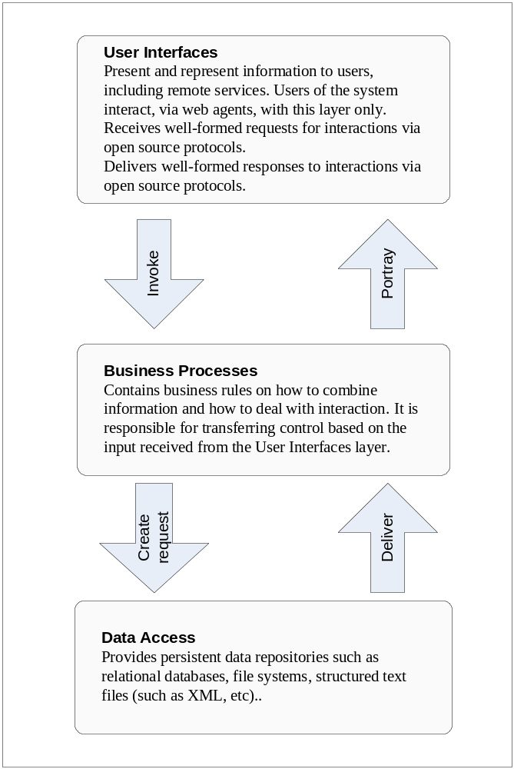

  - An Instance of Architecture Implementation: GOS-P
The OpenGIS Web Services Architecture [38] which is evolving from concepts forwarded by OGC and the Federal Geographic Data Centre (FGDC) in the US to implementations undergoing trials by the Canadian Department of Natural Resources and Mines, Ordnance Survey (UK), Pathfinder (EU), the Geo-Spatial One Stop Portal Initiative (US) and the City of Cologne (Germany).
The following diagram (Figure V2-2) presents a high level view of the architecture.
Figure V2-2: Portal Concept
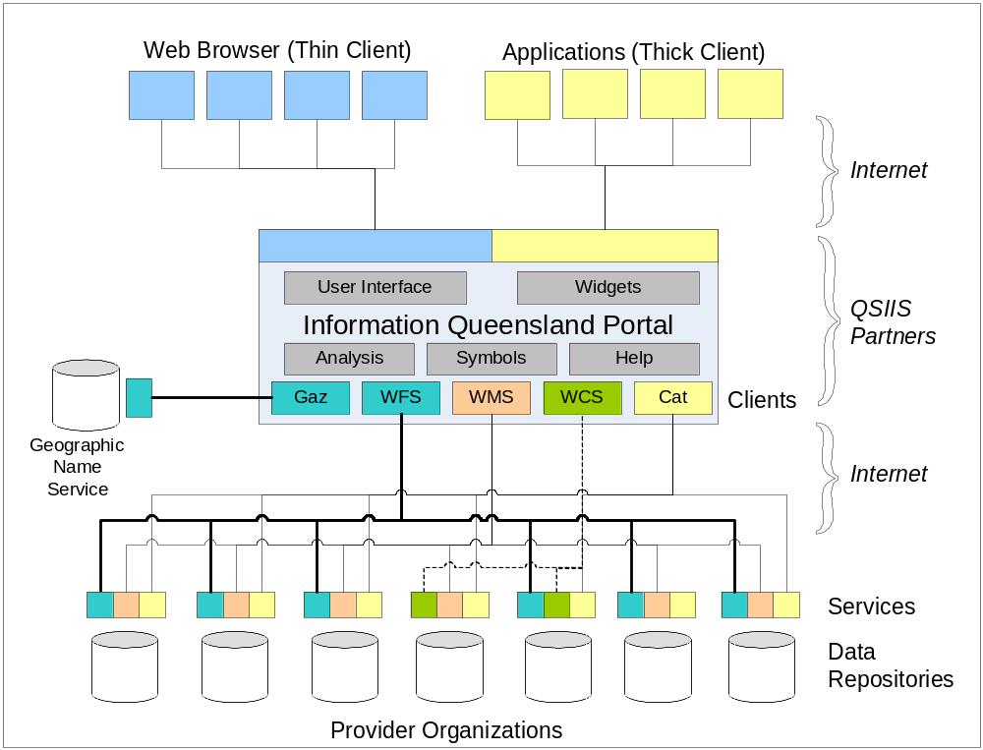
The salient points for IQ are that:
- “Thin” clients are web browsers acting as agents for people accessing IQ services through the World Wide Web. Behind the scenes, these peoples’ agents are using the open http protocol to exchange well-structured messages with a web platform configured to act as an interface to IQ web services
- “Thick” clients are remote applications acting as their own web agents an able to invoke according to agreed message standards and protocols. Thick clients can be remote GIS desktop applications used directly by people. They can also be autonomous tasks such as statistical analysis and modeling engines.
- QSIIS partners configure the IQ web services to conduct business processes such as analysis, data manipulation, presentation of products according to designated symbologies and layouts, and plausibly also to provide interactive help for users.
- Catalogue services support publication of service and data characteristics (metadata) and their discovery by appropriate agents. Catalogues also provide information about the language structures and interface capabilities supported by each service. All services in IQ require catalogue references.
- The gazetteer services support searches and other applications (such as portrayal) requiring the names of locations and feature.
- The web feature services (WFS) abstract data as topographic features encoded in geographic markup language (GML) that are amenable to further analytical or representational processing, such as may be done with “thick” clients. WFS tend to deliver vector data content, but can also treat content such as gazetteer services as point data.
- The web coverage services (WCS) similarly abstract coverage data (including raster data, but not constrained to rectangular reticules) to thick clients or for portrayal through WMS.
- The web mapping services (WMS) provide pictorial portrayals of data as maps which are readily visualized and manipulated in “thin” clients but they are not amenable to further manipulation. WMS may stream and portray content from WFS.
Figure V2-3 following illustrates the services involved and the paths by which information flows between the services.
Figure V2-3: Services and Information Flows
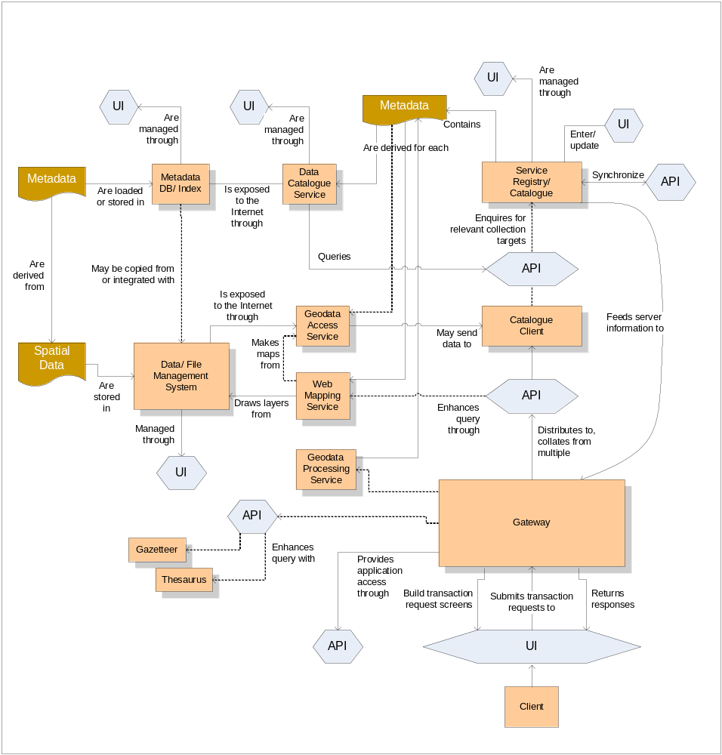
Referring to the previous figure, the salient points for Information Queensland are that:
- User interfaces (UIs in the diagram) and application programme interfaces (APIs) interact with the world wide web – or the internet in general – according to public standard protocols and interface specifications
- All interactions between users via their web agents, are transactional in nature
- Information flow occurs between numerous independent services managed by independent custodians
- All data assets are delivered via services
- Services and data descriptions are published into registries and catalogues available for search-driven discovery by web agents
Many standards-based Commercial off the Shelf and Open Source products are now available. A feature of a number of Conference Exhibitions is the demonstration of such products in interoperability scenarios relevant to the theme of the conference e.g. GITA (2003) and GeoIntel (2003) and ones which are planned for GITA (2004 US and Australia), Geo-Intel (2004).
Figure V2-4 shows how this inter-service information model has been applied in one particular multi-vendor interoperability case, the Geospatial One Stop Portal (GOS-P) initiative demonstration project of the US Government, now available on-line.
Figure V2-4: GOS-P Multi-vendor Interoperability
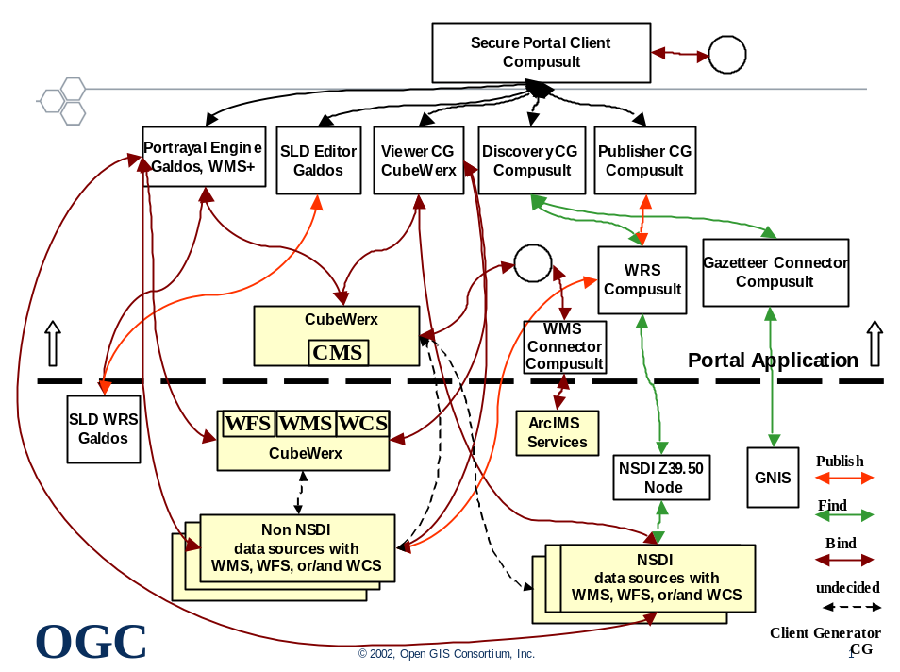
  - Web Services and Web Agents
The World Wide Web (WWW, or simply Web) is an information space in which resources, the items of interest, are identified by global identifiers called Uniform Resource Identifiers (URIs).
A Web Service is application logic accessible across a network using standard Internet protocols. Web Services combine the best aspects of component-based development and the Web. Like components, Web Services represent functionality that can be easily reused without knowing how the service is implemented. Unlike current component technologies that are accessed via proprietary protocols, Web Services are accessed via ubiquitous Web protocols (e.g. http) using universally accepted data formats (e.g.: XML).
Web agents are people or software that act on this information space. Software agents include browsers, servers, proxies, spiders, and multimedia players mediating interactions on behalf of a person, entity, or process.
Figure 5: Web Services, Web Agents, Protocols and Messaging
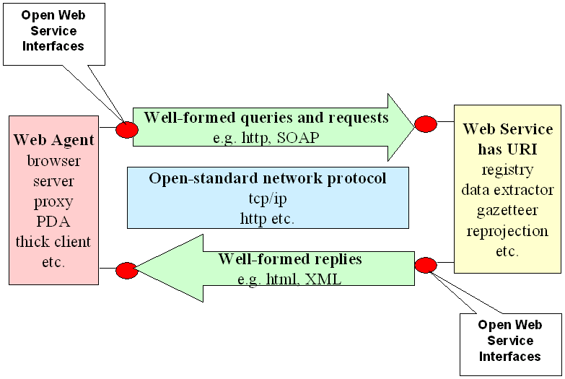
  - Predicates of the Notional Architecture
The notional architecture is based on the following predicates:
- That there exist as Web Services a number of Resources
- That Resources include:
- Data sets
- Processes that manipulate data sets
- Services that ‘chain’ processes
- All resources are accessible only as services accessed by web agents
- That Users can only use Web Agents to access these Resources to create useful Products.
- That providers of Resources may need to Account for, and possibly charge for, their use.
- That Resources are offered in a distributed manner by a variety of Custodians.
  - Viewpoints Concepts
The Notional Architecture uses the ISO Reference Model of Open Distributed Processing [3] using five mutually consistent design viewpoints:
- The Enterprise Viewpoint describing business perspective, purpose, scope and policies;
- The Information Viewpoint concerning the semantics of information and information processing;
- The Computational Viewpoint concerning the interaction between computational components linked by communication networks, their interfaces, operations and binding rules;
- The Engineering Viewpoint describing the hardware and software components and infrastructure used in a distributed system.
- The Technical Viewpoint considers the choice and suitability of physical implementation.
These are further considered in Volume 2 and discussed in detail in sections Volume 3 sections 3.3 to 3.6.
    - Enterprise Viewpoint
QSIIS require common facility across all the Government, commercial and civil Lines of Business that have a requirement for geospatial data and services.
The vision is to allow users to discover, view and obtain desired services for a particular part of the state or country, without needing to know the details of how the data are stored and maintained by independent organizations. Other portal services can co-exist to provide additional functionality or more specialized views of the information because these providers support standardized protocols for accessing their services. Indeed, interfaces could run at multiple sites in order to provide redundancy, allow for fail-over and avoid bottlenecks at a single location.
Users should be able to view detailed standards-based documentation about the data service products and their provenances if desired.
The QSIIS Architecture builds upon facilities such as the Australian Spatial Data Directory (ASDD) and its existing nodes in Queensland, the USGS Clearinghouse Network, and/or any other catalogues implemented in Australian Spatial Data Infrastructures (ASDI) and that have been documented according to the metadata standard. Information Queensland will enhance existing Clearinghouse capabilities by providing direct access to a subset of the data in the catalog-specifically, to those data services that use specific types of standardized access methods.
Figure V2-6: Information Queensland Enterprise Viewpoint
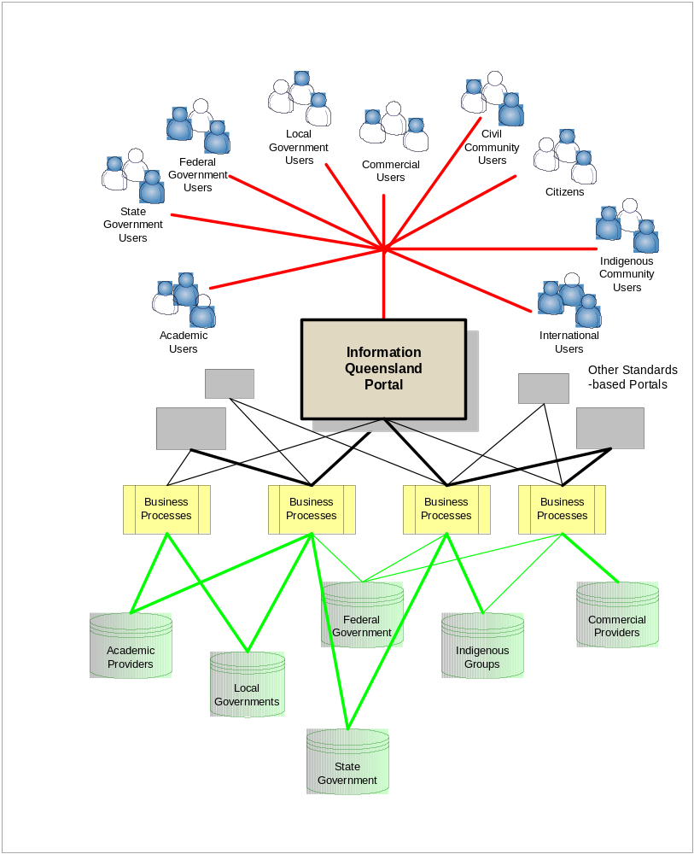
Referring to the above diagram:
- Users from all sectors of government and society being able to access The Information Queensland Portal via the Internet
- The IQ Portal, in turn, is able to access services embodying business processes relevant to a variety of Providers distributed across the network.
- The business process can conduct request-and-response transactions, using standardized protocols, with the data access services for relevant data repositories. Only appropriate portions of data need to be delivered, and data is in an open standard format, GML.
- Data returned requesting business processes can be manipulated and processed to generate the user’s required products.
- Because these providers support standardized protocols for accessing their services, other Portals can co-exist with The IQ Portal to provide additional functionality or more specialized views of the information.
- Indeed, The IQ Portal itself could run at multiple sites in order to provide redundancy and avoid bottlenecks at a single location.
The Information Queensland method shall be based on open standards and specifications that are defined collaboratively by a variety of interested parties, are freely published, and are able to be implemented by any vendor or organization. Three broad classes of standards and specifications are relevant at the Enterprise Viewpoint and the services it accesses.
    - Example Use Case Scenarios
Use Case scenarios provide a means of illustrating the enterprise viewpoint, and testing the validity of the information and computational viewpoint.
During the workshop with the Project Team the intent was to map the services and the components into a matrix to assess priorities, status and ascertain which QSIIS community projects are, or could, be aligned to provide services to a Information Queensland.
These would have been developed but for insufficient time. However, one of the workshop suggestions has been developed in section V2-8 following.
  - Use Case Service and Value Chains
One or more elaborated Use Case scenarios would then be portrayed as service and value chains, using the identified components to form the basis for assigning costs to implementing and maintaining the services used to create products, and hence the cost of those products.
A generic portrayal is shown in Figure V2-7 below.
A particular service value chain analysis was carried out during the second QSIIS Project Group workshop (Feb. 2004) concerning regional reporting requirements to the office of the Premier and to the Cabinet.
[James to provide text for this bit]
Figure V2-7: Information Queensland Service and Value Chaining Concept
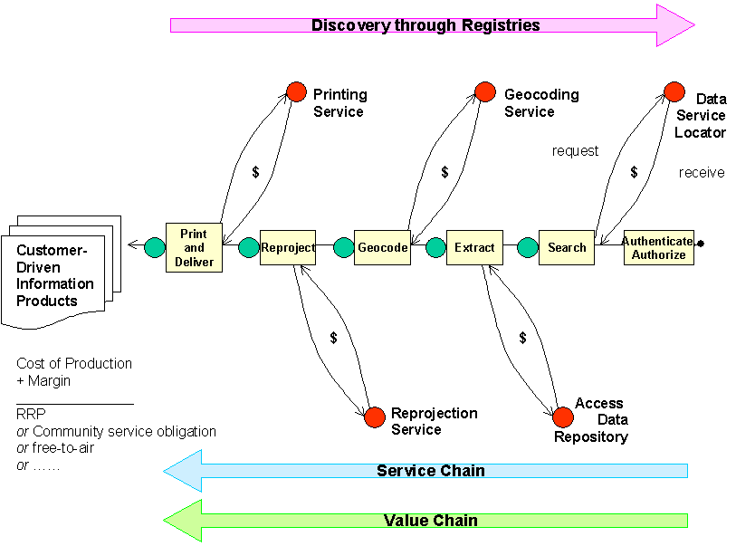

- Considerations for Aligning the Notional Architecture with Existing Initiatives
  - Approach
Consultations during Nov 17-21 provided diverse and stimulating use-case scenarios to be harnessed into a forward-looking strategic framework against which the Technical Alignment issues could be addressed.
- OGC Open Reference Model
- ISO 10746, Information technology -- Open Distributed Processing
- OGC specifications
- Web Map Service,
- Web Feature Service,
- Web Catalog Service,
- Web Registry Service
- Complementary existing standards
- OASIS, W3C, IETF and ISO
- SDI best practices
The approach taken is to apply the principles of the ISO Open Distributed Computing Reference Model, harmonised with the OpenGIS Reference Model [26].
The Open Reference Model adopts the definition of enterprise, information and computational viewpoints for analysis, which are elaborated in following sections. It also adapts best practices from related spatial data infrastructure initiatives (in Australia and from overseas), not only as a means for verifying anticipated strategies but also as a means by which future implementations may be developed in less time and at lower cost through distributed partnerships.
The approach also considers how to address the requirements for migrating from the current environment of closed, duplicative ‘stovepipe’ implementations to culture of custodianship of shared services managed by recognized authoritative providers.
In summary, based on our knowledge of the requirements and issues in Queensland, we suggest that the Notional Architecture:
- Apply as a domain instance of the OGC Open Web Services reference architecture;
- Expand the notional architecture enterprise viewpoint to also include business requirements and business instruments;
- Develop a computational viewpoint consistent with the enterprise viewpoint for the State of Queensland;
- Adapts best practices for architecture definition and implementation, including the work of:
- GeoConnections (Canada)
- GINIE (EU)
- GOS-P (USA)
- LandOnline (New Zealand)
- OGC-E North Rhine/ Westphalia (OGCE)
- Ordnance Survey (UK)
- Census (USA)
- CANRI (Australia)
- LandGate (Australia)
- Considers the requirements for migration to shared custodianship
  - Notional Architecture for Information Queensland
A proposed Notional Architecture provides a logical place to start an approach to synthesis given that a number of the observations and issues referred to in Section 4.2 devolve to the requirement for a notional architecture i.e. an architecture which is vendor independent and which, in the case of the QSIIS agencies acknowledges custodial autonomy but allows collaboration to support intra- and inter-agency business processes.
The notional architecture is also required to accommodate the following.
- The ASDI, ASDD and e-GIF are driven by international standards for distributed computing and interoperability within a web services architecture;
- The Information Queensland notional architecture draws upon standards and specifications already developed by ISO, W3C, IETF, OASIS and OGC, and which in a number of cases are embodied in widely used open-source and commercial software packages;
- The standards and specifications align with the requirements of the GIA,
- Uphold the security policies and
- Build on the QSIIS Data Queensland concept and
- Integrated service delivery requirements are based on business processes and workflows for which project and departmental boundaries are irrelevant.
The focus for this review, and therefore the Notional Architecture for Information Queensland, is on seamless and virtual access and use of geo-spatial data and processing services. Therefore, the work of the OpenGIS Consortium (OGC) and a number of OGC documents are the primary reference materials. Additional documentation from ANZLIC, ISO, W3C, OASIS and related groups complement these.
The principles of the Notional Architecture are open standards, web services, organisational neutrality and vendor independence.
The Notional Architecture, represented in the following figure, provides a frame of reference against which scenarios can be run in order to test the robustness, scalability and extensibility of the model. The status of existing enterprises and efforts can be assessed, and it provides a benchmark for convergence to be achieved through stakeholder consensus.
Figure V2-8: The Notional IQ Architecture
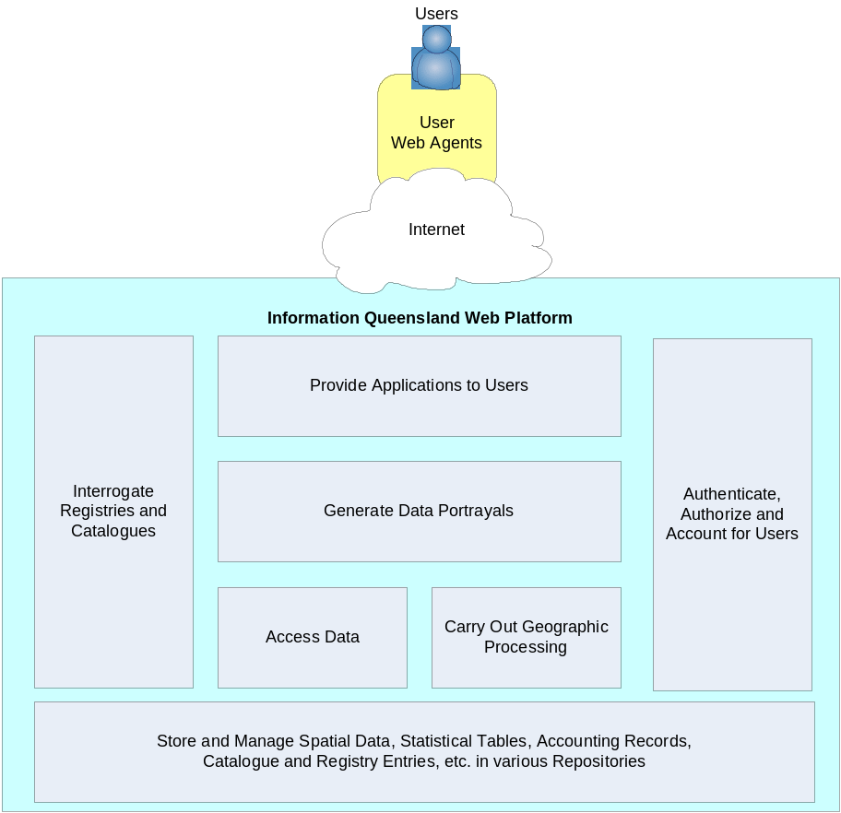
The IQ notional architecture envisages a platform comprising seven major service segments that support the requirements identified in Volume 1, and the principles of distributed standards based web-servicing.
    - Service Categories
The Notional Architecture is predicated on the availability of Web Services for implementation. It therefore provides context for defining Categories of Services, where Categories will also be defined to provide placeholders for services that might best be provided by custodians and managers not participating directly in QSIIS such as DIIE, Commonwealth bodies, international groups and commercial bodies.
Referring to the previous diagram, the IQ notional architecture calls for service categories supporting:
- Transactions between users and services being conducted by web agents and mediated through the Internet;
- Agents’ bona fides being authenticated, their authority to access specific services are established according to services’ access policies, and that usage is accounted for;
- Applications providing transactional interfaces to users’ agents, whether ‘thin’ browsers or ‘thick’ remote processes such as desktop GIS, to specify required actions and to receive results;
- Descriptions of services and content (metadata) being available for interrogation so as to allow discovery and, in the case of services, provide detailed interface specifications that allow agents to bind to the described service;
- Means for accessing data required data stored in repositories but not directly accessible to user agents;
- Performing a variety of geographic processes, many of which remain to be defined, but can include reprojection, sub-sampling, analysis, comparison and amalgamation, and
- Operational data repositories which collectively provide storage, modification and access to spatial data, geo-linked data, metadata descriptions, policy and authority specifications, and user accounts.
    - Components
Progressively decomposing the Notional Architecture model leads from definitions of Service Categories to the description of components comprising them. These can be mapped onto existing or proposed specifications prepared by the different international standards organisations, in this case, those of OGC. Components will necessarily have a number of inter-dependencies.
The final decomposition of service categories into components, and the appropriate priorities to assign to development of each, remains to be undertaken by QSIIS. A plausible list may run to dozens or hundreds of components, and hence appear daunting – see Table V2-4: Existing Components versus Required Capabilities for example. Discussions of the capabilities and requirements for each notional component are provided in Volume 3 section 5.3 “Components”.
However, it must be emphasised that this plethora of individual components contains a high degree of similarity.
For example:
- A number of registry services are presented in Vol.3 sec. 5.3.7, and each would require its own client generators (Vol.3 sec. 5.3.1) yet, in practice, the first registry service established would provide 80% of the effort needed for each other registry services;
- Repositories (Vol.3 sec. 5.3.1) break down as datastores (for the ‘real’ data), libraries (that store the systematic reference descriptors used in each type of datastore) and registries (that store fairly static descriptors of components). Setting up each datastore and library pair will be much like setting up any other. Setting up each registry will be very similar to each other.
Portrayal service components (see Vol.3 sec. 5.3.6) are largely available in the public and commercial domains, and do not require development by QSIIS agencies, although they may require implementation investment for agencies lacking prior experience.
On the other hand, application service components (especially the client generators other than registry managers – see Vol.3 sec. 5.3.1) are likely to be highly customized to each envisaged user group’s requirements. Each will require binding to specific services and will need to present different, appropriate interfaces. Applications therefore require QSIIS to carefully consider their relative merits, collective priority, reusability and investment.
Similarly, each geodata process (see Vol.3 sec. 5.3.5) will be individual and provide little opportunity for re-use, and likely to require significant intellectual input. Again, QSIIS well need to carefully consider their relative merits, collective priority, reusability and investment, and likely actively seek collaboration with other open service providers.
  - Example Use Case scenarios
Determining user scenarios prepares the way for the first major iteration of the model. Use-case scenarios are described which indicate real world business requirements. For the purpose of this work the business processes exemplified are presented as supply and value chains for consistency with the requirement for continuity of the business process review in phase 2 of this three-part analysis. The example user scenarios were to be detailed during the workshop held on December 18th.
The BRP will include identifying and specifying specific services for implementation. Modeling the Use Case Scenarios provides an example of how the application of the notional architecture and the BPR can be achieved to realise real business outcomes.
    - Mapping components to scenarios
Mapping components to the value chains allows iteration against the model i.e. to ensure that all critical components are identified and linked to Service Categories and the Notional Architecture (i.e. have referential integrity). Such mapping also helps to recognize priority components (see Section 6.8), evaluate their alignment with existing initiatives and provide the basis of a strategy for moving forward.
    - Status of Components
Not all recognised components may yet have been specified by standards bodies such as the OGC, W3C or OASIS. However, identifying such requirements allows a watching brief to be kept on developments. Alternatively, QSIIS may elect to be pro-active in the Standards Organisations to push for prioritisation of standards to meet its requirements.
    - Alignment to National and International Initiatives
QSIIS will become part of an increasingly broad range of organisations moving towards increasing the data richness and processing capabilities of Spatial Data Infrastructures (SDIs), especially the Australian Spatial Data Infrastructure (ASDI).
Consistency with the ASDI not only ensures future interoperability between Queensland State Government bodies, but between them (individually or collectively) and Commonwealth government services, as well as SDI-compliant services being implemented in other states. These include the WALIS Atlas, SLIP and LandGate in Western Australia and CANRI in New South Wales.
SDIs are based not only on collaboration within their jurisdictions but between jurisdictions evolving towards the Global Spatial Data Infrastructure (GSDI). The scalability, convergence and extent of such efforts are summarised in the Volume 4 Appendix A-9 “QSIIS and Global SDI”.
    - Migratory model for custodianship
Where appropriate technology is not available, or available within a required time frame, then work could be commissioned to fill the gap with the resulting service being made available to others through the definition and use of standard interfaces.
Our approach includes an expansion of the concept of custodianship to include groups or organisations electing to take responsibility for components and/or chained components that deliver a defined product as a service.
The approach also recognises that an organisation commissioning a service for the purpose of a specific business need may not be the logical custodian of the service on an on-going basis. Therefore, a mechanism is proposed for the migration of custodianship to ensure continuity and that cumulative benefits accrue.
    - Method for Recognizing Custodianship
Recognizing and accepting the notion of custodianship of services and processes allows a mechanism to be proposed for taking responsibility for different stages in the life cycle of a service or process.
For example, Agency A may define a scenario that requires business processes dependent on a component that is not currently available. Commissioning the development of the component fills a blank in the component status matrix and sees the project requirements met. However, others may undertake further use or enhancement of the service (Agency B). QSIIC may have determined, through consultation and/or in-line with a master plan, that the operational custodian of the service may be a different agency (Agency C) or that a private sector organisation may be engaged to provide an outsourced service on an on-going basis.
The method would allow for re-use and for cumulative benefits to accrue. Services, initially available within government may be exposed for wider use to appropriately authenticated and authorised users.
  - Use Case Scenario
The consultants originally anticipated that three scenarios, to be identified by the Project Team members, would be worked through in workshop so as to:
- Identify opportunities for shared, distributed web services;
- Identify the most-needed components of the notional architecture;
- Provide a gap analysis between existing and required capabilities;
- Consider the custodial arrangements by which services could evolve from design concept to prototype demonstrator to operational stability.
This was not possible in the time available. However, one of the proposals made in the workshop has been elaborated, that of Regional Reporting.
    - Requirements
The Project Team Workshop (Dec 18th 2003) discussed options for scenarios that would provide:
- A pragmatic example of the application of the Notional Architecture to a business problem.
- An example which could be used to communicate the opportunities, benefits and potential issues associated with adopting the Notional Architecture model
- Instances where existing infrastructure policies might be a barrier to adoption
- Focus on issues relating to information product licensing and pricing,
- A prioritised list of the web services (components) which would be required to create the scenario as a demonstration project
- An opportunity to align the list of components to leverage off existing projects and experience
- A list of targets which Agencies could incorporate into future project plans to contribute re-usable web services to the QSIIS community for testing
- A point of convergence with the up and coming business process review which could undertake a full analysis of the scenario as an example in its work
- A cross-government and cross-levels of government model to include non State government suppliers and customers of the data
- An example which would be applicable to Executive Government as a means of communicating the strategic direction of the QSIIS agencies and its potential contribution to Whole of Government efforts in Integrated Service Delivery with real benefits to the community and individual members of the public.
The scenario also brings in an important additional requirement of the Project Team and that is that the QSIIS Strategy (hence the scenario) needs to address Risk Management – especially in the context of providing “out of date” data, when more current sources exist.
Regional Reporting was selected as the basis for a scenario.
    - The Scenario: Regional Reporting Process
The regional reporting process is initiated if someone in the Department of Premier and Cabinet requires a report on a regional economy in Queensland. Assuming that a particular report template is to be undertaken for the first time the following process sequence is initiated.
Table V2-2: The Regional Reporting Process
- Define the geographic area.  Examples of different regional reporting areas include administrative and political; watersheds and drainage; emergency management including fire control; education administration regions; healthcare catchments.  An inherent problem is that these regional boundaries, defined independently for operation al and historic reasons within or between departments and different levels of government, do not necessarily coincide or align. In fact, area or regional boundaries are dynamic and regularly change between statistical reporting periods. | 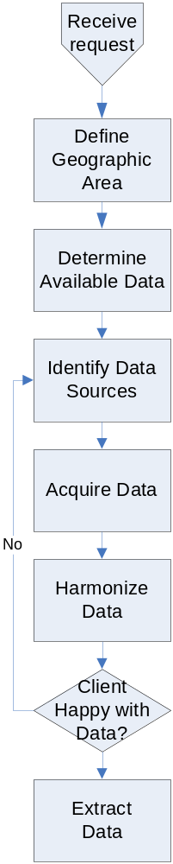
- Determine available data (data scanning)
What data are available for inclusion in the report? The sensitivity here depends on the level of geography is required i.e. a town, a Local Government Authority, a Statistical Division or what have you.
- Identify Data Sources
Data may be sourced from Commonwealth Departments (in particular the ABS), other State Government Agencies and Local Government Authorities and special interest group such as Professional Associations.
- Acquire the data.
Data not already held by OESR need to be ordered from the relevant agencies. This may require payment.
- Harmonize the data.
Data is received from agencies and converted into a suitable format. OESR usually stores data in SAS or ORACLE databases; smaller datasets may be delivered as spreadsheets. The datasets acquired may require post processing to extract information for the area of interest and allocation modeling to align different data sets to a common definition of a boundary for the “region”.
Feedback sought from the client regarding data sources.
- Extract Data.

- Analyze and Interpret  These are undertaken on an as needed basis. For example, statistical analysis would be used to calculate a median weekly household income for the particular region. This figure would then be compared with the Queensland figure. Another example would be to calculate the percentage increase in the number of employed persons in the region; again, this would be compared with a Queensland figure. Results of the analyses are stored for audit purposes and may also be used as input to further analyses. | 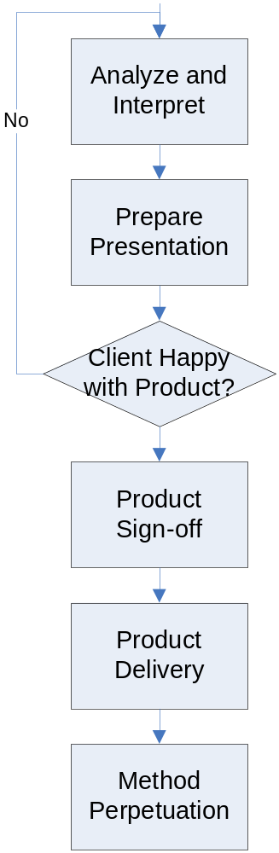
- Prepare Presentation.
The report is then written which includes graphs, tables, and maps. The result is a printable document.
- Validate and Assure Quality
The draft report is completed including the quality assurance of data in the report and the textual interpretation of the data.
Feedback is sought from the client regarding report layout and style.
- Product Sign-off.
Report is then submitted for approval from either team leader or a member of OMT.
- Product Delivery
Report is delivered to client.
- Method Perpetuation
The procedure used to generate the report is formalised so that the information product can be re-generated with current data and/or different data for the same or different areas with similar data inventories.
    - The Regional Reporting Use Case
Only high-level use case analysis is undertaken here.
Full, definitive elaboration of the Regional Reporting use case, in the accepted narrative forms for system analysis and design, are beyond the scope of this report because:
- The variety of potential requests sought by the Department of Premier and Cabinet is very broad, each instance of which require its own definitive analysis;
- The variety of data source available as input to reporting is likely to increase rather rapidly in the near future, with an increased sophistication in clients’ requirements
- The types of analyses to be prepared for interpretation will also likely increase in sophistication as distributed custodial services become the accepted norm.
For current purposes, a high-level use case portrayal may be envisaged as per the following figure:
Figure V2-9: Regional Reporting – high-level use case portrayal
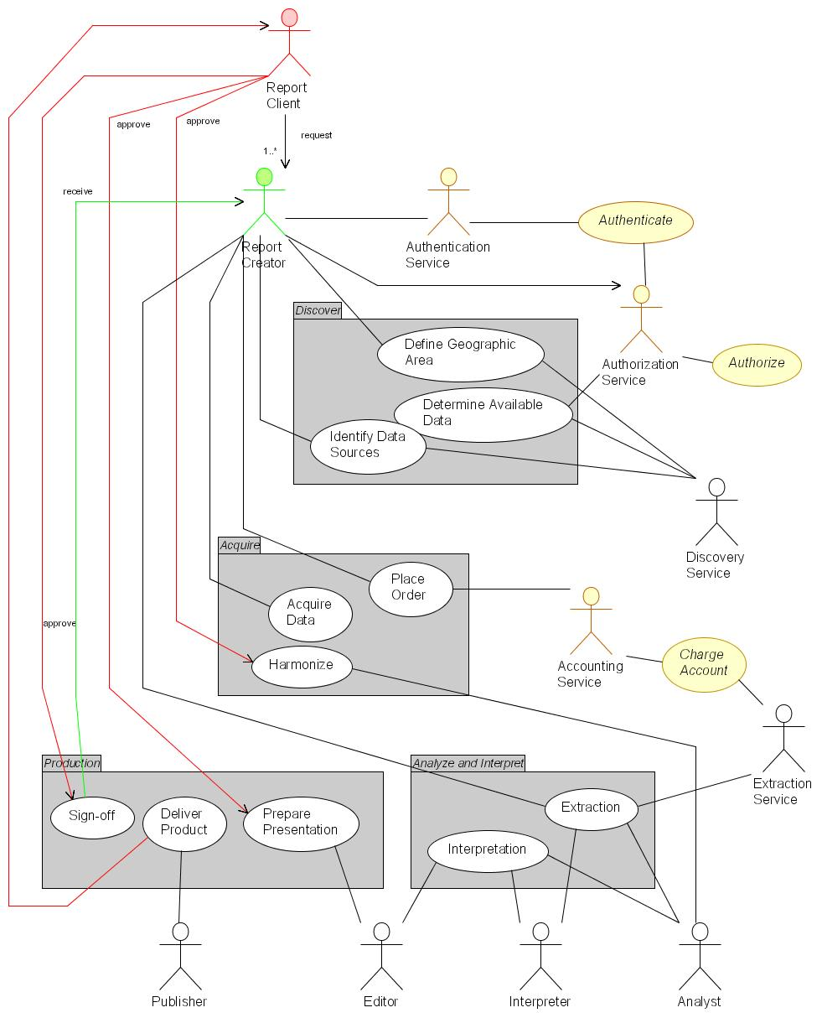
It should be apparent that considerably more actors are involved than those apparent in the process description in section 8.4.2 The Scenario: Regional Reporting Process above – for authorization, authentication, accounting, discovery, analysis, editing and publishing, as well as for requesting and creating a particular report.
The sequence and timing for automation of any or all of these actors is a matter for consideration of QSIIS. It is feasible, for example, that any one of authentication, authorization or accounting, while likely to fully automated in future, could be deferred to manual management while nonetheless delivering examples of regional reporting. Certain actions, such as data extraction, are good candidates for immediate automation and could be analyzed further immediately. Other, highly intellectual actions such as interpretation are likely to be manually implemented into the foreseeable future.
    - Capabilities Required
Authentication service to identify logon characteristics and to determine eligibility to see certain information products
Workflow definitions need to be established which describes the options for available information products and directs the process of data and process discovery, acquisition, processing and presentation
A directory of data accessible by each contributor and the terms and conditions for access and use (fit for purpose) of the data (meta data catalogue services)
A directory of the services that provide data processing, modeling and display options available from which computer on the network and its conditions of access and use (registry services).
Once located the data has to be accessed through data access services.
Data may need to be harmonised (re-projected, aligned for the scale of display dictated by the information product) and/or generalised (to fit on the screen or map window in a document).
Models may need to be executed such as population projections for the area or trend analysis of residential development or age profiles – weather predictions in the event of long term conditions such as drought or drastic short term such as a cyclone. (Modeling Services)
All the information has to be presented to the compiler as well as to the user (Portrayal Services including Style layer descriptors, symbology standardisation etc).
Messaging services will be required not just to communicate between the processes in the work flow but as notifications if certain data is not available, or errors occur in the chained processes, escalation rules might need to be included if response times (in service level agreement registry) are not met
Messages will also need to be sent and received from the customer about the state of the product and/or any issues that arise as a result of the presentation of the product (Customer Services).
    - Components Required for the Regional Reporting Use Case
It was noted above that a full elaboration of the Regional Reporting use case was not possible at the present time because of the volatility of the problem space. Similarly, a rigorous definition of the service components that to be implemented to support Regional Reporting must await further analysis of requirements.
However, the high-level use case suggests a minimum set of service components that would have to be available for Regional Reporting to be feasible in the IQ context. These suggested components are portrayed in the following figure.
Referring to the following components, the following points should be noted:
- The view is that of the reporting invoker
- Numerous data repositories are assumed to already be existence and are not portrayed explicitly. These include data set catalogues (metadata), authority and authentication metrics, accounting records and portrayal definitions such as style layer descriptors and symbology libraries
- Many of the above data set repositories could also likely require references libraries of allowed types to assist and constrain authoring of the appropriate metadata
- Each of the above repositories and libraries will require additional components to implement means for their management i.e. creation, modification, rescinding and so on.
- Many of the portrayal services are also available off-the-shelf as WMS and WFS implementations in the public domains and as SCOTS products
- The interfaces portrayed are all defined according to OpenGIS specifications
- Some external components, such as the clearinghouse connector, already exist and are available in both the public domain and the SCOTS world
As noted in earlier sections, the investment required to develop the first of each class of these components will yield payback in developing subsequent instances – the first library manager will stand as a model for each subsequent library manager, for example.
Finally: the apparent complexity visible in the flowing figure belies the fact that at least half of these components – data location, gazetteer discovery, portrayal services - will be required for any distributed services envisaged under Information Queensland. Regional Reporting is likely to be as good user driver of IQ requirements as any other.
Figure V2-10: Indicative Regional Reporting Service Components
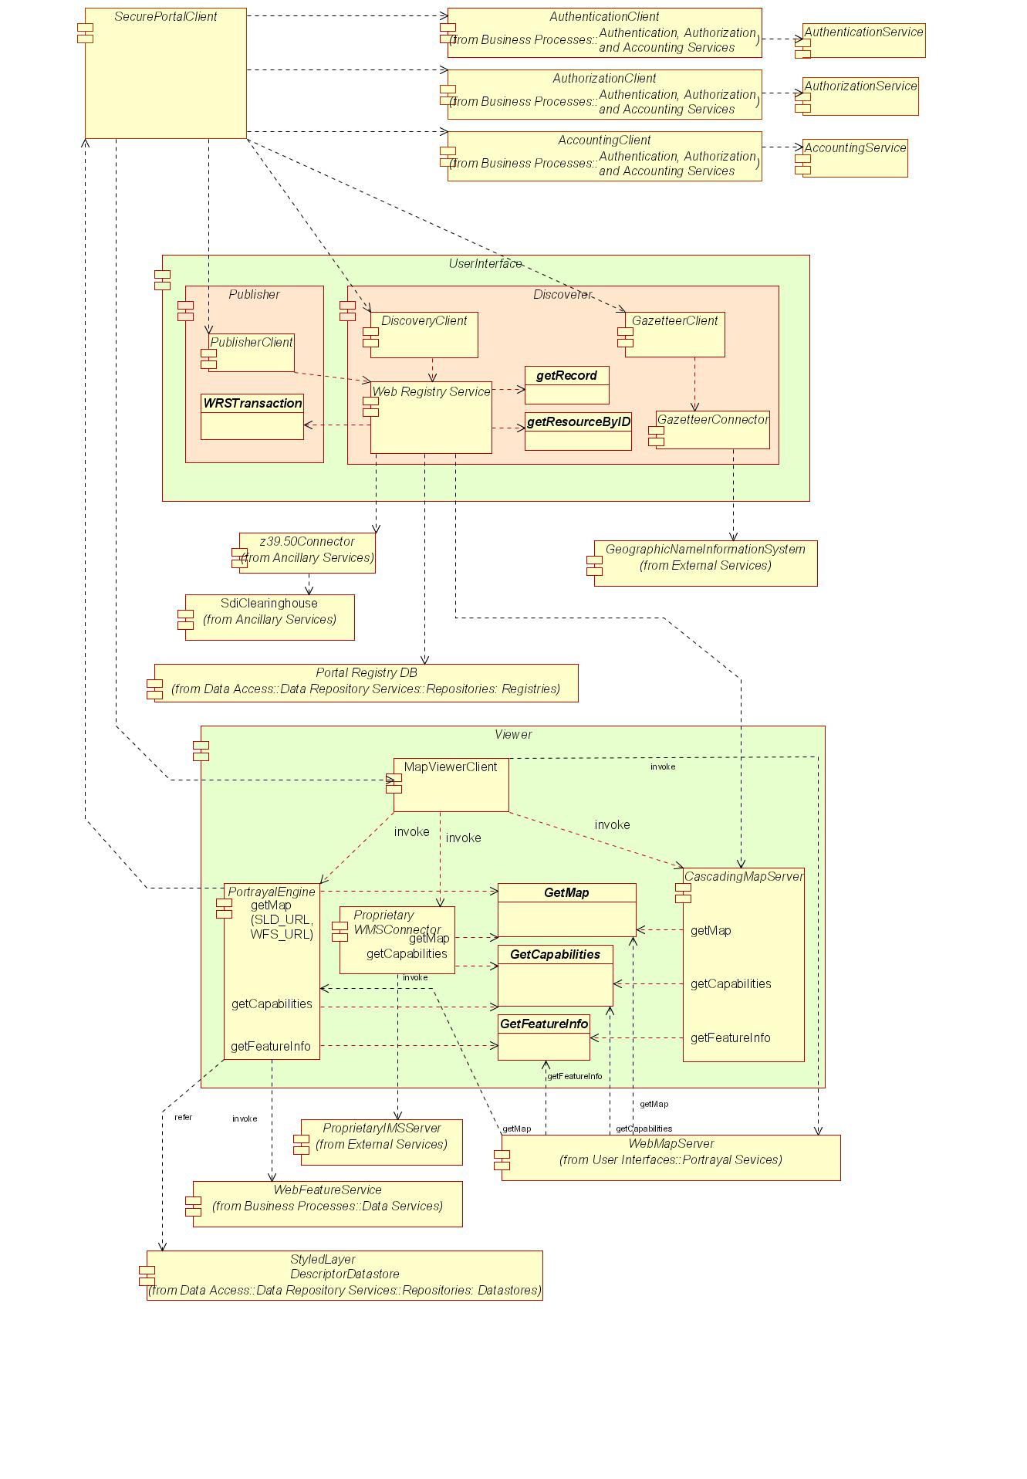
    - How this Aligns to the Component Levels of the Notional Architecture
Each of the components portrayed in the previous figure is an element of the notional architecture elaborated more fully in Volume 3. The current elaboration encompasses about 90 components; the Regional Reporting analysis encompasses about 40, as tabulated below (see Table V2-3: Notional Components required for the Use Case Scenario) and in fact will number significantly more than this should a full implementation be required for elements like authentication, authorization, accounting, workflow management and other ‘non GIS’ elements.
    - Extensibility of the Use Case Method
The current model could be extended to provide information for school children (to which they could contribute). Economic development profiles detailing available industrially zoned land, labour profiles etc and, being an electronic web document could link the IPA for detail of any particular site.
The extensibility of the model is indicative of the requirement that the notional architecture be:
- Scalable
- Provide for user identification, authentication and authorisation security and role management.
- Some of the profiles could attract fees and as such the scenario can be expanded to include on line ordering and payment processing. Fees could be scaled between profiles for different target customers with discounts for multiple purchases. Therefore the scenario can be extended beyond the scope of this project yet provide a common frame of reference.
Scalability is both up, and down, in the sense that a profile for a fire fighter at an office block could be included. Such a profile would use the same web services as the other scenarios but could have different extension to meet these specific requirements.

    - Mapping Components to Scenarios
The capabilities described above are now compared to a common suite of spatial information service components as identified by from various best practice implementations of spatial data infrastructures to identify those required. A priority is assigned to each of these.

Table V2-3: Notional Components required for the Use Case Scenario
Priority ratings are ✓ for ‘needed later on’, ✓✓ for ‘needed soon’
and ✓✓✓ for ‘needed immediately or sooner’;
no ✓ means ‘optional, not in the scope of the Use Case scenario’
Service |  | Component | Priority | Originator | Developer | Operator | Notes
Application Service Components |  | Data Extraction Client Generator | ✓
 |  | Discovery Client Generator | ✓✓✓
 |  | Gazetteer Client Generator | ✓✓✓
 |  | Map Viewer Client Generator | ✓✓✓
 |  | Publisher Client Generator | ✓✓
 |  | Symbol/Style Management Client Generator | ✓
 |  | Workflow Definition Client Generator | ?
Audit and Management Service Components
Data Repository Service | Datastore | Accounting Records Datastore | ✓✓
Data Repository Service | Datastore | Coverage Datastore
Data Repository Service | Datastore | Feature Datastore | ✓✓✓
Data Repository Service | Datastore | Gazetteer Datastore | ✓✓✓
Data Repository Service | Datastore | Geolinked Datastore | ✓✓✓
Data Repository Service | Library | Map Style Library | ✓✓
Data Repository Service | Library | Map Symbol Library | ✓✓
Data Repository Service | Library | Service Type Library | ✓✓
Data Repository Service | Registry | Component Registry | ✓✓✓
Data Repository Service | Registry | Geodata Resource Registry | ✓✓✓
Data Repository Service | Registry | Service Registry | ✓✓✓
Data Repository Service | Registry | Type/Schema Registry | ✓✓✓
Data Repository Service | Registry | User Registry | ✓✓✓
Data Service Components |  | Coordinate Transformation Service
 |  | Data Extraction Service
 |  | Format Conversion Service | ✓
 |  | Geolinked Data Access Service | ✓✓✓
 |  | Web Coverage Service
 |  | Web Feature Service | ✓✓✓
Geodata Processing Service Component |  | Coverage Analysis Service
 |  | Data Reallocation Service
 |  | Feature Association Service
 |  | Gazetteer Service
 |  | Geolinking Service | ✓✓✓
 |  | Geoparsing Service | ✓✓✓
 |  | Portrayal Service Component
 |  | Cascading SLD-enabled Web Map Service | ✓✓
 |  | Coverage Portrayal Service
 |  | Web Map Service | ✓✓✓
Registry and Catalogue Service Component |  | Components Registry Service | ✓✓✓
 |  | Event Registry Service
 |  | Geodata Resource Registry Service | ✓✓✓
 |  | Map Style Management Service | ✓
 |  | Map Styles Registry Service | ✓
 |  | Service Registry Service | ✓✓✓
 |  | Symbol Library Service
 |  | User Registry Service | ✓✓✓
Ancillary Component |  | Clearinghouse Connector | ✓✓
 |  | Discovery Service | ✓✓
 |  | Workflow Enactment Service | ✓✓

    - Status of Required Components
The components identified above are now reviewed to consider their status of implementation as existing services in Queensland, or as web services elsewhere in the world. Where no reference implementations exist, an indication is given of the state of development of their open specifications.
Components already implemented as web services receive the ✓ and show the custodian and specification.
Components likely to be implemented in the near future show an indicative date and the agency developing it.
Components not even on the horizon as web services get the 
Table V2-4: Existing Components versus Required Capabilities
Service |  | Component | Priority | Implementation
 |  | Component | Priority | Qld | Global
Application Service Components |  | Data Extraction Client Generator | ✓ |  | Geoconnections
 |  | Discovery Client Generator | ✓✓✓ | ✓ NR&M  OCS 1.1 | ✓ Many  OCS 1.1
 |  | Gazetteer Client Generator | ✓✓✓ | NR&M 2004 | Many  Soon
 |  | Map Viewer Client Generator | ✓✓✓ | ✓✓✓  EPA, NR&M | ✓✓✓  Many
 |  | Publisher Client Generator | ✓✓ |   Clearinghouse | ✓✓✓  Many
 |  | Symbol/Style Management Client Generator | ✓ |  | ?
 |  | Workflow Definition Client Generator | ✓✓✓ |  | ?
Audit and Management Service Components |  | Authorization Type Service | ✓✓✓ |   DIIE | OASIS 2004
 |  | Usage Policy Decision Points Service | ✓✓✓ |  | OASIS 2004
 |  | Usage Policy Service | ✓✓✓ |  | OASIS 2004
 |  | User Authentication Service | ✓✓✓ |  | OASIS 2004
 |  | User Authorization Service | ✓✓✓ |  | OASIS 2004
Repository Components | Datastore | Accounting Record Datastore | ✓✓✓ |   GLS | OASIS 2004
Repository Components | Datastore | Feature Datastore | ✓✓✓ | ✓  NR&M 2004 | ✓✓✓  Many
Repository Components | Datastore | Gazetteer Datastore | ✓✓✓ | ✓  NR&M 2004 | ✓✓✓  Many
Repository Components | Datastore | Geolinked Datastore | ✓✓✓ | ? | ✓✓✓  Many
Repository Components | Datastore | Management Records Datastore | ✓ |  | ?
Repository Components | Datastore | Workflow Datastore | ✓✓✓ |  | OASIS 2004
Repository Components | Library | Authority Type Library | ✓✓ |  | OASIS 2004
Repository Components | Library | Component Type Library | ✓✓ |  | OGC 2004
Repository Components | Library | Custodian Type Library | ✓✓ |  | OGC 2004
Repository Components | Library | Institution Type Library | ✓✓ |  | OGC 2004
Repository Components | Library | Map Style Library | ✓✓ |  | OGC 2004
Repository Components | Library | Map Symbol Library | ✓✓ |  | OGC 2004
Repository Components | Library | Service Type Library | ✓✓ |  | OGC 2004
Repository Components | Library | Type/Schema Library | ✓✓ |  | OGC 2004
Repository Components | Library | Utilization Policy Type Library | ✓✓✓ |  | OGC 2004
Repository Components | Registry | Component Registry | ✓✓✓ |  | OGC 2004
Repository Components | Registry | Custodian Registry | ✓✓✓ |  | OGC 2004
Repository Components | Registry | Geodata Resource Registry | ✓✓✓ |  | ✓✓✓  Many
Repository Components | Registry | Institutions Registry | ✓✓✓ |  | OGC 2004
Repository Components | Registry | Service Registry | ✓✓✓ |  | OGC 2004
Repository Components | Registry | Type/Schema Registry | ✓✓✓ |  | OGC 2004
Repository Components | Registry | User Registry | ✓✓✓ |   Clearinghouse | OASIS 2004
Data Service Components |  | Data Extraction Service | ✓✓✓ |   Clearinghouse  whole data sets only | ✓✓✓  Geobase (Canada)
 |  | Format Conversion Service | ✓ |  | ✓
 |  | Geolinked Data Access Service | ✓✓✓ |  | ✓✓✓  Many
 |  | Web Coverage Service |  |  | ✓✓✓  EROS
 |  | Web Feature Service | ✓✓✓ | NR&M 2004 | ✓✓✓  Many
Geodata Processing Service Component |  | Data Alignment Service | ✓✓ |  | ?
 |  | Feature Generalization Service | ✓ |  | ?
 |  | Geolinking Service | ✓✓✓ |  | ✓✓✓  Many
 |  | Geoparsing Service | ✓✓✓ |  | 
 |  | Modeling Service | ✓ |   DLGP? | ???  Many?
 |  | Cascading SLD-enabled Web Map Service | ✓✓ |  | ✓✓✓  Many
Registry and Catalogue Service Component |  | Components Registry Service | ✓✓✓ |  | OGC 2004
 |  | Custodian Registry Service | ✓✓✓ |  | OGC 2004
 |  | Geodata Resource Registry Service | ✓✓✓ | ✓✓✓  ASDD | ✓✓✓  Many
 |  | Institutions Registry Service | ✓✓✓ |  | OGC 2004
 |  | Map Style Management Service | ✓ |  | OGC 2004
 |  | Map Styles Registry Service | ✓ |  | OGC 2004
 |  | Service Registry Service | ✓✓✓ |  | OGC 2004
 |  | Types/Schemas Registry Service | ✓✓✓ |  | OGC 2004
 |  | User Registry Service | ✓✓✓ |  | OASIS 2004
 |  | Workflow Definition Service | ✓✓✓ |  | OASIS 2004
Ancillary Component |  | Clearinghouse Connector | ✓✓ | ✓✓✓  ASDD | ✓✓✓  Many
 |  | Discovery Service | ✓✓ |  | 
 |  | Workflow Enactment Service | ✓✓ |  | 
    - Alignment of Components to Existing Systems and Services
Reviewing Table V2-4: Existing Components versus Required Capabilities makes it clear that few web service components are available in Queensland. It makes it equally clear that there are a number of necessary components that could be leveraged from existing services, especially geolinking, geocoding, user registration, authentication and authorization.
A third observation is that many of the required components are awaiting specification by bodies such as OGC and OASIS. Conversely, there is a high and reasonable expectation that many of these will be published in 2004 i.e. consistent with the timescale for development of an Information Queensland – remember, an incremental components-based approach does not require that everything be committed to at once.
A fourth, inescapable observation is that there are numerous components to be developed from scratch. Each of these represents an opportunity for QSIIS to provide the forum by which these be prioritized, distributed, and the custodial authority identified for each stage from design through prototype to operation.
Recommendation
It is recommended that the QSIIS Project Team give serious consideration to reviewing the existing services able to provide components to service shared requirements, and assessing the feasibility of designing and prototyping demonstrators of open web service interfaces.
Recommendation
It is also recommended that QSIIS build upon the good will and capabilities summarized elsewhere to establish guidelines for a quick-win demonstrator funded at agencies’ own expense delivering feasible implementations of a small number of key web services of wide common interest to QSIIS members.
Recommendation
Further, it is recommended that QSIIS establish technical watch teams to assess the progress and development of specifications, standards and technologies related to interoperability, both in geo-information as well as neighbouring areas concerning transactional processing, rights management and so on.
  - Justification for Approach
The proposal in the following section does not start from scratch but builds existing systems already delivering products, services and business outcomes, and can be used or adapted to provide implementation of elements within the components-based architecture. This then will help deliver the outcomes identified in V2-4 “Summary Results”.
The approach proposed above builds on initiatives that are already underway in a number of departments. It aligns with policies emanating from DIIE and extends the Information Queensland model to be founded in open distributed processing principles. The Information Queensland model takes full advantage of the Internet as is, and is positioned to take up grid computing as it becomes available.
This proposed approach therefore provides a:
- Framework for the development of a web services master plan derived through an inclusive and consensus based process;
- Procedure for aligning business process requirements against components and services
- Process for progressively filling service requirements on an as-needed basis
- Basis for users to describe their requirements through a mutually understood process
- Modeling method using supply/value chain definitions to assess the impact of pricing of data and processing services on the cost-of-production of products rather than cost recovery of past decisions
- Framework for enabling cumulative benefits through re-use of data and processing functionality
Examples of the way in which accessibility of custodial data, data of known provenance, with an accumulating history of use (fitness for purpose) would impact current practices and, through the Business Process review, costs.
- References
  - Bibliography
[1] | ANZLIC Metadata Guidelines (v2 – February 2001). Available at http://www.anzlic.org.au/download.html?oid=2358011755
[2] | FGDC-STD-001-1988, Content Standard for Digital Geospatial Metadata (version 2), US Federal Geographic Data Committee, http://www.fgdc.org/metadata/contstan.html
[3] | ISO 10746, Information technology -- Open Distributed Processing -- Reference model, see http://www.iso.ch/iso/en/ittf/PubliclyAvailableStandards/c020696e.zip for overview
[4] | ISO/PDTR 19103, Geographic Information – Conceptual Schema Language, see http://www.isotc211.org/pow.htm for a brief description.
[5] | ISO/CD 19107.3, Geographic Information - Spatial Schema, see http://www.isotc211.org/pow.htm for a brief description.
[6] | ISO 19108, Geographic Information - Temporal Schema, see http://www.isotc211.org/pow.htm for a brief description.
[7] | ISO/DIS 19109, Geographic Information – Rules for Application Schema, see http://www.isotc211.org/pow.htm for a brief description.
[8] | ISO/CD 19115 (ISO TC 211 N 1024, 2001-01-30) Geographic Information – Metadata, see http://www.isotc211.org/pow.htm for a brief description.
[9] | ISO 19118, Geographic Information – Encoding, see http://www.isotc211.org/pow.htm for a brief description.
[10] | ISO/CD 19119 (ISO TC 211 N 1044, 2001-01-29) Geographic Information – Services, see http://www.isotc211.org/pow.htm for a brief description.
[11] | ISO 23950 Information Retrieval (Z39.50): Application Service Definition and Protocol Specification, see http://lcweb.loc.gov/z3950/agency/document.html
[12] | OASIS ebXML see http://www.ebxml.org/
[13] | OASIS ebXML Registry Information Model v2.0 available at http://www.oasis-open.org/committees/regrep/documents/2.0/specs/ebrim.pdf
[14] | OASIS Public Key Infrastructure development, see http://www.pkiforum.org
[15] | OASIS SAML v1.0 specification set available at http://www.oasis-open.org/committees/download.php/2290/oasis-sstc-saml-1.0.zip
[16] | OASIS Universal Discovery Description and Integration see http://www.uddi.org/
[17] | OGC AS 1, The OpenGIS Abstract Specification Topic 5: OpenGIS Feature Geometry (ISO 19107 Spatial Schema), available at: http://www.opengis.org/techno/abstract.htm
[18] | OGC AS 2, The OpenGIS Abstract Specification Topic 2: Spatial Reference Systems, available at: http://www.opengis.org/techno/abstract.htm
[20] | OGC AS 5, The OpenGIS Abstract Specification Topic 5: OpenGIS Feature, available at: http://www.opengis.org/techno/abstract.htm
[21] | OGC AS 12, The OpenGIS Abstract Specification Topic 12: OpenGIS Service Architecture, available at: http://www.opengis.org/techno/abstract.htm
[22] | OpenGIS Catalog Services Implementation Specification, version 1.1.1, available at: http://www.opengis.org/techno/implementation.htm
[23] | OpenGIS Filter Encoding Implementation Specification, version 1.0, available at: http://www.opengis.org/techno/implementation.htm
[24] | OpenGIS Coordinate Transformation Services Implementation Specification, version 1.0, available at: http://www.opengis.org/techno/implementation.htm
[25] | OpenGIS Geography Markup Language (GML) Implementation Specification, version 3.0, available at: http://www.opengis.org/techno/implementation.htm
[26] | OpenGIS Reference Model (ORM), available at http://www.opengis.org/docs/03-040.pdf
[27] | OpenGIS Service Information Model (SIM) Discussion Paper, OGC document 03-026. Available at: http://www.opengis.org/info/discussion.htm
[28] | OpenGIS Simple Feature Specification for COM, version 1.1, available at: http://www.opengis.org/techno/implementation.htm
[29] | OpenGIS Simple Feature Specification for CORBA, version 1.0, available at: http://www.opengis.org/techno/implementation.htm
[30] | OpenGIS Simple Feature Specification for SQL, version 1.0, available at: http://www.opengis.org/techno/implementation.htm
[31] | OpenGIS Styled Layer Descriptor (SLD) Implementation Specification, version 1.0, available at: http://www.opengis.org/techno/implementation.htm
[32] | OpenGIS Style Management Services Discussion Paper, OGC document 03-031. Available at: http://www.opengis.org/info/discussion.htm
[33] | OpenGIS Web Coverage Server (WCS) Request for Comment, OGC document 02-024r1. Available at: http://www.opengis.org/techno/requests.htm
[34] | OpenGIS Web Feature Server (WFS) Implementation Specification, version 1.0, available at: http://www.opengis.org/techno/implementation.htm
[35] | OpenGIS Web Mapping Server (WMS) Implementation Specification, version 1.1.1, available at: http://www.opengis.org/techno/implementation.htm
[36] | OpenGIS Web Pricing & Ordering Service (WPOS) Discussion Paper, OGC document 02-0391r. Available at: http://www.opengis.org/info/discussion.htm
[37] | OpenGIS Web Registry Service (WRS) Interoperability Program Report, OGC document 03-024. Available at: http://member.opengis.org/tc/archive/arch03.htm
[38] | OpenGIS Web Services Architecture (OWS), OGC document 03-025. Available at: http://www.opengis.org/docs/03-025.pdf
[39] | OpenGIS Web Terrain Service (WTS), OGC document 01-061. Available at http://www.opengis.org/docs/01-061.pdf
[40] | OpenLDAP Foundation, see http://www.openldap.org/
[41] | World Wide Web Consortium Extensible Markup Language (XML) 1.0 available at http://www.w3.org/XML/Core/#Publications
[42] | World Wide Web Consortium Simple Object Access Protocol (SOAP) 1.1 available at http://www.w3.org/TR/SOAP/
[43] | World Wide Web Consortium Web Services Description Language (WSDL) 1.1 available at http://www.w3.org/TR/2001/NOTE-wsdl-20010315
  - Acronyms
ABS | Australian Bureau if Statistics
ACXML | Access Control Extensible Markup Language: see http://www.oasis-open.org/committees/tc_home.php?wg_abbrev=xacml
AGI | Association for Geographic Information (UK): see http://www.gigateway.org/
AGLS | Australian Government Locator System
ALGA | Australian Local Government Association: see http://www.alga.com.au/
ANZLIC | Australian New Zealand Land Information Council: see http://www.anzlic.org.au/
ASDD | Australian Spatial Data Directory: see http://asdd.ga.gov.au/asdd/
ASDI | Australian Spatial Data Infrastructure
ASIBA | Australian Spatial Industry Business Association: see http://www.asiba.com.au/
AUSLIG | Australian Survey and Land Information Group
BPR | Business Process Review (Queensland State Government)
CANRI | Community Access to Natural Resource Information (NSW) see http://www.canri.nsw.gov.au/
CMS | Cascading Map Server (OGC WMS)
COTS | Commercial off-the-shelf
CQL | Common Catalogue Query Language
CSDGM | Content Standard for Digital Geospatial Metadata (USA FGDC)
CRC | Cooperative Research Centre (Australia): see https://www.crc.gov.au/
DACS | Distributed Access Control System (OGC): see http://dacs.dss.bc.ca/arch-spec.html
DES | Department of Emergency Services (Qld)
DIIE | Department of Innovation and the Information Economy (Qld): see http://www.iie.qld.gov.au/
DLGP | Department of Local Government and Planning (Qld): see http://www.dlgp.qld.gov.au/
EbRIM | ebXML registry information model (OASIS) see http://www.ebxml.org/specs/ebRIM.pdf
EbXML | E-business Extensible Markup Language (OASIS): see http://www.ebxml.org/
EROS | Earth Resources Observation Systems
EC | European Commission
EU | European Union
FGDC | Federal Geographic Data Committee (USA): see http://www.fgdc.gov/
e-GIF | E-Government Interoperability Framework
EPA | Environment Protection Agency (Qld)
GIA | Government Information Architecture (DIIE, Qld))
GILS | Government Information Locator System (USA) see http://www.access.gpo.gov/su_docs/gils/
GINIE | Geographic Information in Europe (EC): see http://www.ec-gis.org/ginie/
GIS | Geographic Information System
GML | Geography Markup Language (OGC): see http://www.opengis.org/docs/02-023r4.pdf
GNIS | Geographic Name Information Service
GOS-P | Geo-spatial One-Stop Portal (US Government): see http://www.geo-one-stop.gov/
GSDI | Global Spatial Data Infrastructure
GSL | Government Services Locator
HDF | Hierarchical Data Format: see http://hdf.ncsa.uiuc.edu/
HTML | Hypertext Markup Language (W3C): see http://www.w3.org/MarkUp/
http | Hypertext Transport Protocol (W3C): see http://www.w3.org/Protocols/
IETF | Internet Engineering Task Force: see http://www.ietf.org/
IPA | Integrated Planning and Assessment (Qld)
IRTM | Integrated Resource Tenure Maps
ISCGM | International Standing Committee for Global Map http://www.iscgm.org/
ISO | International Organization for Standardization http://www.iso.org/
LandXML | An XML schema for land planning: see http://www.landxml.org/
LDAP | Lightweight Directory Access Protocol: see http://www.openldap.org/
MIME | Multipurpose Internet Mail Extension (IETF)
NAP | National Action Plan
NCSA | National Center for Supercomputing Applications
NIST | National Institute of Standards and Technology (USA): see http://www.nist.gov/
NR&M | Department of Natural Resources and Mines: see http://www.nrm.qld.gov.au/
NSDI | National Spatial Data Infrastructure initiatives
OASIS | Organization for the Advancement of Structured Information Standards: see http://www.oasis-open.org/who/
OCS | OpenGIS Catalog Services (OGC)
OECD | Organization for Economic Cooperation and Development
OESR | Office of Economics and Statistical Research (Qld)
OGC | Open GIS Consortium (USA)
OgcRIM | OGC registry information model
OSI | Open Source Initiative
OSS | Open-source software
OWS | Open Web Service (OGC)
PDA | Personal Digital Assistant
PKI | Public Key Infrastructure (NIST): see http://csrc.nist.gov/pki/
PNG | Portable Network Graphics (OGC) see http://www.w3.org/Graphics/PNG/
QIO | QSIIS Information Office
QPW | Department of Public Works (Qld): see http://www.publicworks.qld.gov.au/
QSIIC | Queensland Spatial Information Infrastructure Committee
QSIIS | Queensland Spatial Information Infrastructure Strategy: see http://www.qsiis.qld.gov.au/
RIS | Regional Information Service
ROSI | Roster of Strategic Information (OESR, Qld)
SAML | Security Assertion Markup Language (OASIS)
SCOTS | Standards-based Commercial off-the-shelf software
SDI | Spatial Data Infrastructure
SDTS | Spatial Data Transfer Standard (USGS): see http://mcmcweb.er.usgs.gov/sdts/
SFS | Simple Features Specification (OGC): see http://www.opengis.org/techno/specs/99-049.pdf
SLD | Styled Layer Descriptors (OGC): see http://ogc.cast.uark.edu/tnm/web/sld.html
SLIP | Shared Land Information Platform (Western Australia)
SOAP | Simple Object Access Protocol (W3C)
SSI | Services Integration Infrastructure (Qld)
SSQ | Smart Services Queensland
TCP/IP | Transport Control Protocol/ Internet Protocol (IETF)
UDDI | Universal Discovery Description and Integration (OASIS): see http://www.uddi.org/
UNEP | United Nations Environment Programme (Kenya): see http://www.unep.org/
UNGIWG | UN Geographic Information Working Group (USA): see http://www.ungiwg.org/
URI | Uniform Resource Indicator (W3C)
URL | Uniform Resource Locator (W3C)
USGS | US Geological Service (USA)
W3C | World-Wide Web Consortium
WALIS | Western Australian Land Information System: see http://www.walis.wa.gov.au/
WCS | Web Coverage Service (OGC)
WFS | Web Feature Service (OGC)
WMS | Web Mapping Service (OGC)
WPOS | OpenGIS Web Pricing & Ordering Service (OGC)
WSDF | Web Services Delivery Framework
WSDL | Web Services Description Language (W3C)
XML | Extensible Markup Language (W3C)

  - Glossary
Application | A program that performs a specific function directly for a user. Applications can make use of SDI.
Architecture | The organizational structure and operating environment of the SDI, including the relationships between its parts, and the principles and guidelines governing their design and evolution over time.
Binding | Specific syntax and parameter values used by a client to invoke a specific server operation
Capabilities schema | XML schema that prescribes and constrains the syntax and vocabulary for the expression of service capabilities in XML.
Capabilities XML | Specific instance of service-level metadata describing a service instance.
Client | A software component or an application that accesses a service.  Clients may be categorized in three ways:  Thin clients where the client supports only human-interface code, such as a web browser, and X-terminal, a text-only interface or a minimal PDA or WiFi handset, and must support non-proprietary standards. Typically, lack long-tem memory such as disk drives. Application code and data access both run remotely, and so are entirely dependant on external network connection.  Thick clients where the client supports all the human interface and application code, may support some or all data access code, and may support long-term data memory. Human interface code may be entirely customized and not conform to non-proprietary standards. May not even support human interfaces i.e. may be entirely automated emote processes. May operate at times without network connection.  Chubby clients have capabilities somewhere on the spectrum between thick and thin clients i.e. may support some application and data code, and may store limited amounts of data. Will usually but not necessarily support human interfaces. May operate well for limited time without network connection.
Component | Software that packages the client or server implementation of a service and can provide the realization of a set of interfaces. A component consists of software code (source, binary or executable) or other equivalents such as scripts or command files.
Conceptual Architecture | An overview of the services, data, technology and institutional environment of SDI. It describes, in general terms, both what the SDI will include, and how it will operate.
Core Service | A service that is critical to the ongoing operations of the SDI. The Service Registry Service is an example of a core service. It is used to keep track of where SDI services can be found, so if this service were unavailable, client applications would not be able to locate the services required in order to complete a task.
Coverage | A continuous representation of a portion of the earth's surface. A coverage may be a collection of features (like a vector dataset) or it may be a raster or gridded surface representing one or more attributes.
Coverage Data | Gridded data, imagery, swath data, and continuous functions. Contains values for every point in a geospatial data. Relevant specifications for Information Queensland coverage data formats may include:  - SDTS - Spatial Data Transfer Standard  - GeoTIFF - Georeferenced Tagged-Image File Format  - HDF – Hierarchical Data Format
Custodian | The authoritative manager of an SDI resource, whether data set, service or component, who is responsible for declaration of the policies regarding utilization and accounting for the resource.
Datastore | Any type of persistent storage for Information Queensland components and data. Content may be static or dynamic.  May include database systems, file systems, structured text storage, XML repositories etc.
Event | An occurrence of interest to users or developers of the SDI. Events can be things such as the adjustment of a feature in a framework data layer, a flood in the Red River basin, or the release of a new specification for a SDI service.
Framework Data | The set of geospatial data that provides the reference framework for all other SDI compliant geodata. See the SDI Framework Data Definition.  Seven geospatial data themes may be considered to be of fundamental importance to many applications. Known as "Framework Data," these themes are: Elevation, Orthoimagery, Hydrography, Transportation, Government Units (administrative boundaries), Cadastral (property boundaries), and Geodetic Control.  Framework Data shall, at minimum, are able to exchange data in a manner that complies with these emerging standards. Information Queensland shall be able to access both Framework Data sources and other, non-Framework data.
Geodata | Georeferenced spatial data such as a road network or a satellite image. Geodata explicitly describes the spatial extent of a set of features or describes a measurable surface. It includes both geospatial data and geolinked data.
Geodata Resource Registry | Peer registries that contain metadata about geodata resources. These registries identify the agencies that are responsible each attribute dataset, and descriptions of that attribute data. They also contain information on how to access the data.
Geolinked Data | Geodata that are referenced to an identified set of geographic features without including the spatial description of those features. Geolinked data is normally attribute data in tabular data (such as population counts) that refers to a known framework (such as municipalities), where their unique identifier (such as the municipality name) refer to the elements (the municipalities). Geolinked data refers to all attribute data that is not directly attached and bundled with the geographic coordinates to which it applies.
Geospatial Data | Geodata with explicit geographic positioning information included, such as a road network from a GIS, or a georeferenced satellite image. Geospatial data may include attribute data that describes the features found in the dataset.
GeoTIFF | Georeferenced Tagged-Image File Format
Information Queensland | The concept of an all-of-government, distributed system of services providing added-value spatial information products to users in all sectors of society in Queensland and beyond
Interface | The named set of related operations that structures how a client interacts with a server. The state and functionality of the underlying component is hidden, and is only made externally accessible through its interface (i.e. the interface is the only "public" or "visible" part of the component). The same interface may be provided by several components and used by many components or applications.
LandXML | Facilitates the exchange of data created during the Land Planning, Civil Engineering and Land Survey process. LandXML is an XML application that utilizes XML Schema to define relationships and custom data types. Much like GML, LandXML is a fairly robust application of XML as a data format, targeted specifically towards land planning, engineering and survey applications.
Library | A type of registry intended for recording references to entity types (as distinct from recording instances) i.e. a look-up. Content is generally static once instantiated
Map | A pictorial representation or portrayal of geographic data
Master System | A primary system that is mirrored to other identical systems, so as to ensure that any important information or services can be accessed in an identical fashion from multiple sites.
Metadata Standard | Data will be documented according the FGDC Content Standard for Digital Geospatial Metadata (CSDGM) and/or the ISO 19115
Notional Architecture | A design framework based on vendor-neutral, open standards.
Operation | An interaction between a client and a server, resulting in a transfer of information or an action. An operation can be either an interrogation (i.e. request-response) or an announcement (i.e. notification).
Portal Services | Provide "one-stop" access to the Provider Services.  An online access point to a collection of geospatial data -- more precisely, to a collection of services that provide data or relevant functionality.  A Portal does not store or maintain the data and its associated services; rather, these are distributed in many computers nationwide and maintained by the agency or organization that is responsible for its data and services.  Portals shall be based on open standards and specifications that are defined collaboratively by a various interested parties, are freely published, and are able to be implemented by any vendor or organization.
Primary System | A system that provides a core service and thus is critical to the operations of the SDI. Although a primary system may not be mirrored to other sites, or even the most popular implementation of a particular service, they are publicly identified and funded to ensure that core services are implemented on at least one system.
Process | A system offering a single interface for the execution of a single task creating one or more products.  Processes may be grouped to provide a service.
Provider Services | Include map, data, gazetteer, catalog and any other services hosted and maintained at remote sites independently of Information Queensland and are accessed by the it. The role of the Portal Services is to provide "one-stop" access to the Provider Services.
Reference Architecture | A technical blueprint that identifies and defines the services that comprise the SDI, and specifies the interfaces to those services.
Registry | A listing of the specific, individual services, components, datasets, or other things that comprise the SDI or are relevant to its users. Instance registries are used to identify, locate, and describe individual instances.  Many registries refer to associated Type Libraries that record the allowed types within registry classes e.g. types of services, types of user authorities.
Request | Invocation of a server operation by a client
Response | Result of an operation returned from a server to a client
Schema | A schema is an expression of the type using a particular data modeling language. Put another way types can be seen as a classification taxonomy for a set of schema definitions. In the OGC the application data modeling language is GML and each schema fragment corresponding to a given type is defined in GML.
Server | (a) A software component that delivers a service.  (b) A physical implementation of such a component, that provides the realization of its operations.
Service | A collection of operations, accessible through one or more interfaces, that allows a user to evoke a behavior of value to that user. A server is delivers each service.  A service may encapsulate may processes.  A "service instance" is another name for a server (b).
Service capabilities | Service-level metadata describing the types, operations, content, and bindings available at a service instance. Organization, classification, and presentation of those entities may also be conveyed by the capabilities information.
Service Registry | Contains metadata about individual services, including the type of service, and information about how to access the service.  A Service Registry Service provides a mechanism to:  - Register the characteristics of certain types of services (in a Service Type Registry) and register the existence of specific services (in a Service Registry);  - Search Service Registries; and  - Retrieve detailed information (metadata) that describes a service, in order to evaluate its suitability to meet a need.  A Service Type Registry contains information about specific types of services, including the name of the service type, and its definition.  A Service Type Registry is being maintained manually, at http://www.geoconnections.org/architecture/systems/ServiceTypeRegistry
Site | A location (e.g. URL) at which a system is accessed.
Spatial reference system (SRS or CRS) | A projected or geographic coordinate reference system
Styled Layer Descriptor | Metadata describing presentation of geographical types for portrayal in WMS and WFS  Addresses the need for geospatial consumers (either humans or machines) to control the visual portrayal of data. It can be used to portray the output of Web Map Servers, Web Feature Servers and Web Coverage Servers.  Uses consistent XML-based methods persisting in an SDL library.
System | Servers and data organized to accomplish one or more Services. A system may be accessible at more than one site.
Type | A type refers to a kind or class of geographic entity. Types are meaningful elements in a particular universe of discourse.
Web Agent | People or software that act on the web information space. Software agents include browsers, servers, proxies, spiders, and multimedia players mediating interactions on behalf of a person, entity, or process.
Web Service | Application logic accessible across a network using standard Internet protocols. Web Services combine the best aspects of component-based development and the Web. Like components, Web Services represent functionality that can be easily reused without knowing how the service is implemented. Unlike current component technologies that are accessed via proprietary protocols, Web Services are accessed via ubiquitous Web protocols (e.g. http) using universally accepted data formats (e.g. XML).

This is not an uncommon paradox – most custodians see little value in providing descriptions of the data and services they use in-house, and rely on their experience to know where to go and who to ask for data and services. Experience shows that these attitudes change rapidly once a Web Services approach is adopted.
Numerous projects are underway under the auspices of the W3C, OASIS, NASA, DARPA and academic institutions to address semantic interoperability. See http://musil.uni-muenster.de/documents/Ontology_based_Search_and_Semantic_Translation_in_Spatial_Data_Infrastructures.pdf for a pertinent discussion. See http://www.w3.org/2001/sw/ for status of W3C technical actions.
See http://www.opengis.org/functional/?page=swe
See http://www.geo-one-stop.gov/
One type (amongst many) of URI is the Uniform Resource Locator (URL such as http://whatever.wherever.com) with which web users are familiar.
Using Web Services means that it does not necessarily matter where a service is implemented provided it as accessible and performs adequately.

